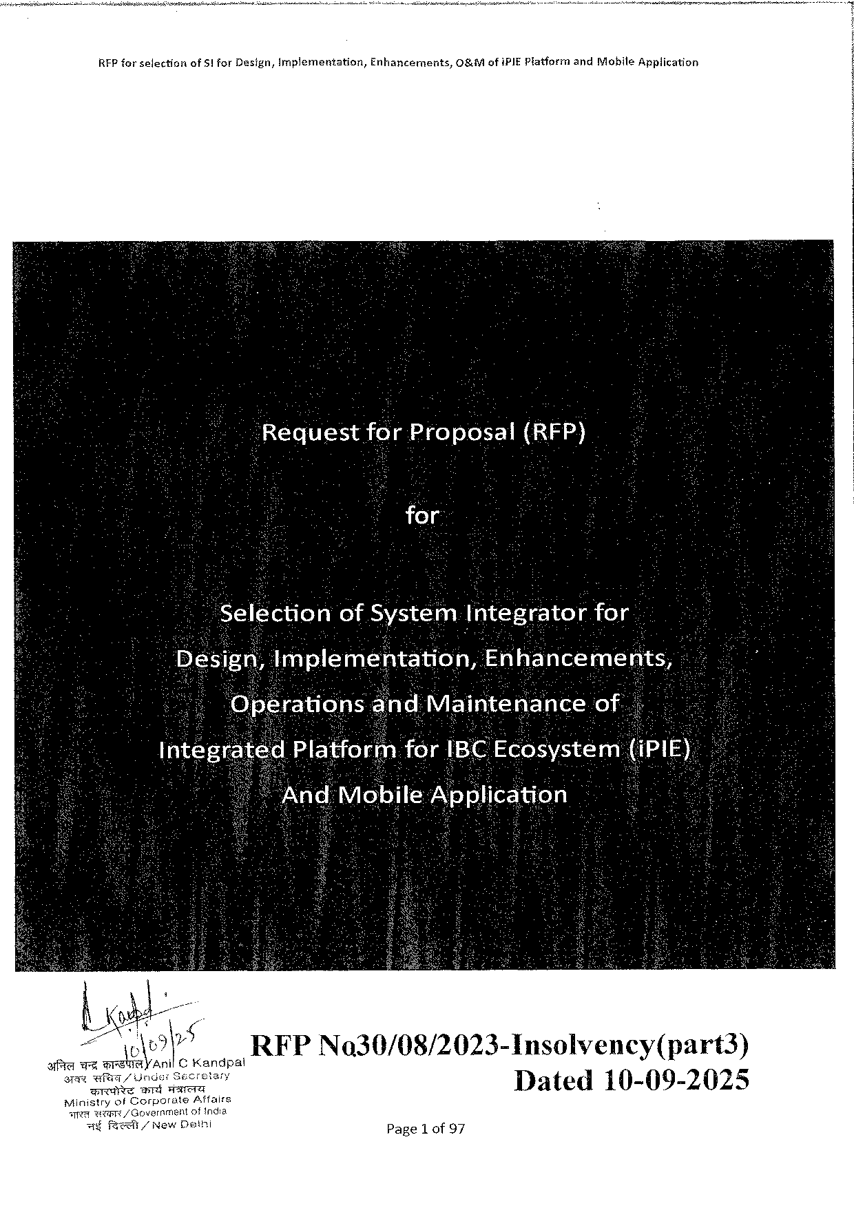

|  |  |  |  |
| --- | --- | --- | --- |
| RFPforselection | ofS| forDesign,Implementation, | Enhancernents, | 0&MofiPIE PlatformandMobileApplication |

for:

electionofSyStémIntegratorfor

RFPNo30/08/2023-Insolvency(part3)

Dated10-09-2025

Page1 of97

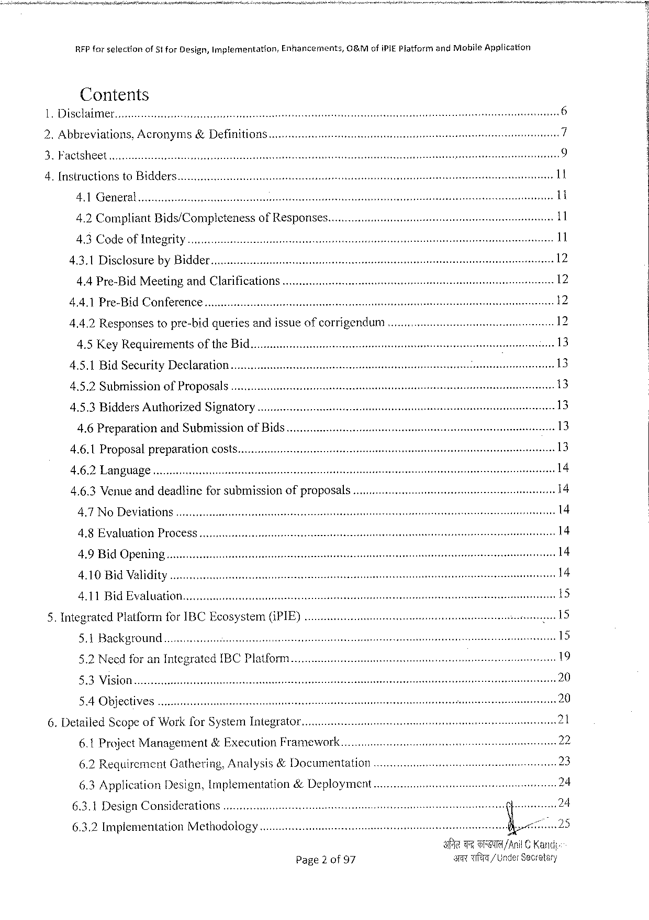

|  |  |  |  |
| --- | --- | --- | --- |
| RFPforselection | of51forDesign,Implemantation, | Enhancements, | OBMofiPIEPlatformandMobileApplication |

Contents   
Disclaimer..

|  |  |  |  |  |  |  |  |  |  |  |  |  |  |  |  |  |  |  |  |  |  |
| --- | --- | --- | --- | --- | --- | --- | --- | --- | --- | --- | --- | --- | --- | --- | --- | --- | --- | --- | --- | --- | --- |
| b | Abbreviations,Acronyms&Definition | | | | | | | | | 5585VS T | | | S | | e | g | e | A | 1 | | 9 |
| AU | Brorvarrsrssrsmeamessversmsey | | | | orT e¥3 | | S | |
| bbb | | | | | | | s11 | | |
| [NSEUCHIONS10BIAAEIS.....voviveveeerecerinet | | | | | | | | |
| s | enss peassies11 | |
| A1} BT | | bz | rmmemsrsremmmresem o | | | e | o | FT | TS | T | | S As | | se | |
| es | e | S | | sss | | | 11 | | |
| 4.2 Compliant Bids/Completeness0fRESPONSES...uv.i | | | | | | | | |
| AWCOAETOTR NG | | | | ressevwvrosssvemrremmevessves | | | sovsi7omsssy | | enas absns11 | | |

4.3.1DisclosurebyBidder

4.4 Pre-BidMeetingandClarifications

4.4.1Pre-BidConference..........cocovviivinnniiimnsnninenns

4.4.2Responsestopre-bidqueriesandissueofcorrigendum

4.5 Key Requirementsofthe Bid.

4.5.1BidSecurityDeclaration....

|  |  |  |  |  |  |
| --- | --- | --- | --- | --- | --- |
| 4.5.2SubmisSion0fPrOPOSALS..ot | | s | i | s | 13 |
| 4.5.3BiddersAuthorized | SIZRAtOTY.....covviiviiiesesice | 13 |
| 4.6PreparationandSubmissionofBids...t | | 13 |
| 13 |
| 4.6.1ProposalPreparation | COSES ...ttt |

4.6.2Language

4,6.3Venue anddeadlinefor submissionofproposals

4.7 NoDeviations.......cooveinriviinnnisninnns

4.8EvaluationProcess

4.9BidOpening

4.10 BidValidity

4.11BidEvaluation.

|  |  |  |  |  |  |  |  |  |  |  |  |  |  |  |  |  |
| --- | --- | --- | --- | --- | --- | --- | --- | --- | --- | --- | --- | --- | --- | --- | --- | --- |
| 5. | IntegratedPlatformforIBCEcosystem((PIE)..o | | | | | | | | | | | RSSOSRSS NeS s | e | s | 15 | 15 |
| 5.1BACKETOUNA..o | | | | v | | | | s | | |
| 6. | 5.2Needfor anIntegratedIBCPIatform ... | | | | | | | | | | | Sng | 19 |
| S BV | S G | szrmsmrssmesressoo | | | | e | TS | TS | | T | 20 |
| 5.4OBJECLIVES | | | ..reeververiescoreaemeeseemeeiesee | | | | | st | bbbb | | 20 |
| DetailedScopeofWork forSystemIntegrator | | | | | | | | | | |
| 6.1ProjectManagement | | | | | &ExecutionFramework....... | | | | | |

6.2RequirementGathering,Analysis&Documentation

|  |  |  |  |  |  |  |  |  |  |
| --- | --- | --- | --- | --- | --- | --- | --- | --- | --- |
| 6.3Application | Design,lmplementation&Deployment | | | | s | e | R | ! | |
| 6.3.1DesignConsiderations | | ........ccuiorrirociire | | i |
| 6.3.2ImplementationMethodology | | | ooovvvvieinreimieer | |
| Page2 of97 | | | | | TT | /Anil© Kand |
| T/UnderSeveatsry | |

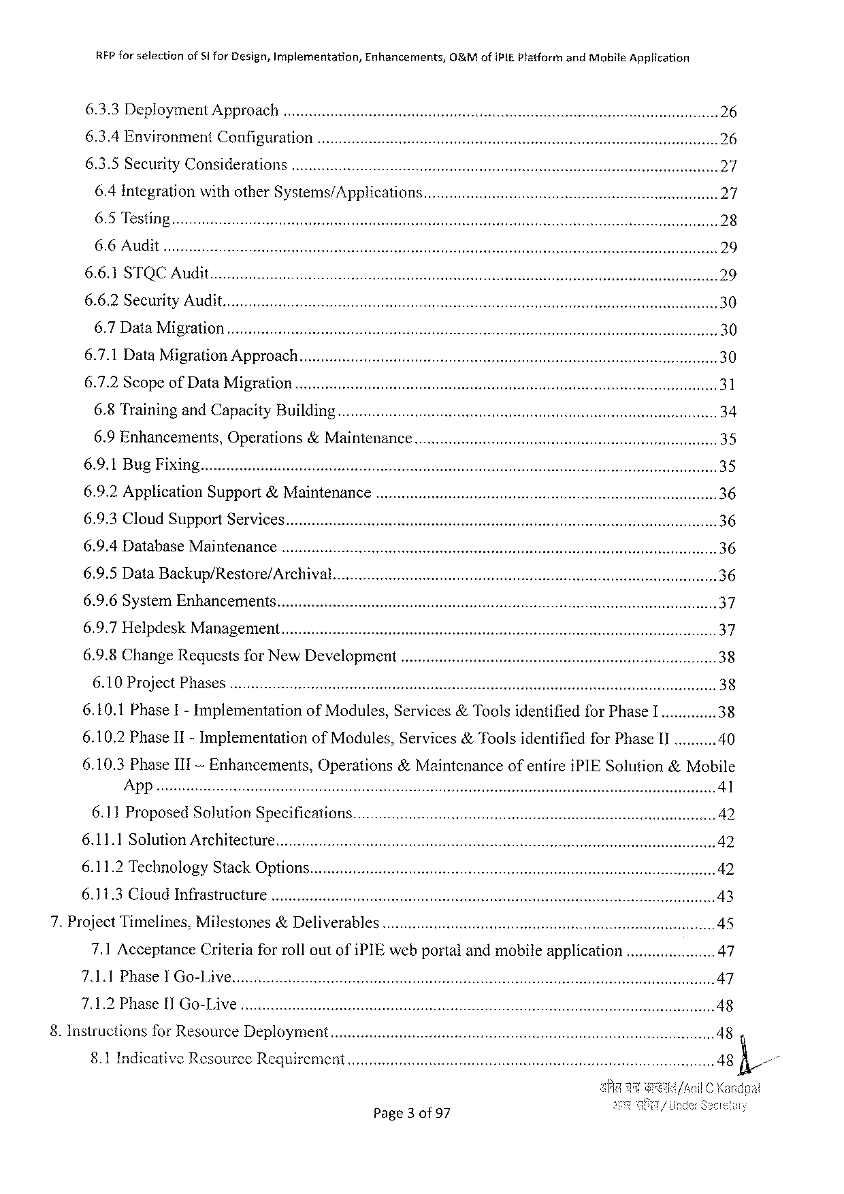

RFPfor selectionofSi forDesign,Implementation,Enhancements,&MofiPIEPlatformandMobile Application

|  |  |  |  |
| --- | --- | --- | --- |
| 6.3.3DeploymentAPPIOaCh.. .......oo.uicericionicnccceenie | e | ssars e | 26 |
| 6.3.4Environment ConfIguration ..o | 26 |

6.3.5SecurityConsiderations

6.4IntegrationwithotherSystems/APPHCAtONS......ovvvvrorriernrornerienrareesoreesr s 27

6.5Testing

6.6Audit

6.6.1STQCAud

6.6.2SecurityAudit.

6.7 DataMIIATON..v.evorveecreicis ot ssns eav s st st 30

6.7.1DataMigrationAPProach.............cc.cccumieriinciicnececneecr e sssessssnsesssss 30

6.7.2Scopeof DataMIIAION.........c.iuiierieriecteciccenees e ss s 31

6.8 TrainingandCapacityBUIlding........cccocooerimcriininiinie i 34

6.9Enhancements, Operations&MaINTENaNCe.........ovvreevernrenreiiossassreseenems s s ssnenn 35

6.9.2ApplicationSupport&Maintenan

6.9.3CloudSupportServices

6.9.4DatabaseMaintenance .

6.9.5DataBackup/Restore/Archival

6.9.6SystemEnhancements

6.9.7HelpdeskManagemient...........ccoouccvivnrnireroesserienn s cessesmssssssssssssssssessneeens37

6.9.8 ChangeRequests forNew Development .......iierieneeernssmssonsinesones 38

6.10ProjectPRASES .....c.ooriec ittt s 38

6.10.1PhaseI-Implementation 6.10.2PhaseII-Implementation

ofModules,Services&ToolsidentifiedforPhaseI .............38 of Modules,Services&ToolsidentifiedforPhaseII..........40

|  |  |  |
| --- | --- | --- |
| 6.10.3PhaseIII-Enhancements, | Operations&Maintenance | ofentireiPIESolution&Mobile |

App

|  |  |  |  |  |  |  |  |  |
| --- | --- | --- | --- | --- | --- | --- | --- | --- |
| 6.11ProposedSolutionSPecifications....... | | | e | emsssesse e | | | | 42 |
| 6.11.1SolutionATCAIIECIUTE....ttt | | |
| 42 | | | | |
| 6.11.2TechnologyStackOPONS...........ccrwuiveiiiiicricie | | |
| eessesssessesessssesesessssos es | | | ssnns 42 | |
| 6.11.3CLoUGINFTASIIUCIUIE...o..eoiees | e | eve |
| sases st | et | rs e | sssenes | |

7.ProjectTimelines,Milestones&Deliverables   
 7.1AcceptanceCriteriaforrolloutofiPIEwebportalandmobileapplication ..........cc.........47 7.1.1PhaseIGo-Live   
 7.1.2PhaseIlGo-Live.

8.Instructionsfor ResourceDeployment  
 §.1IndicativeResourceRequirement

Page3of97

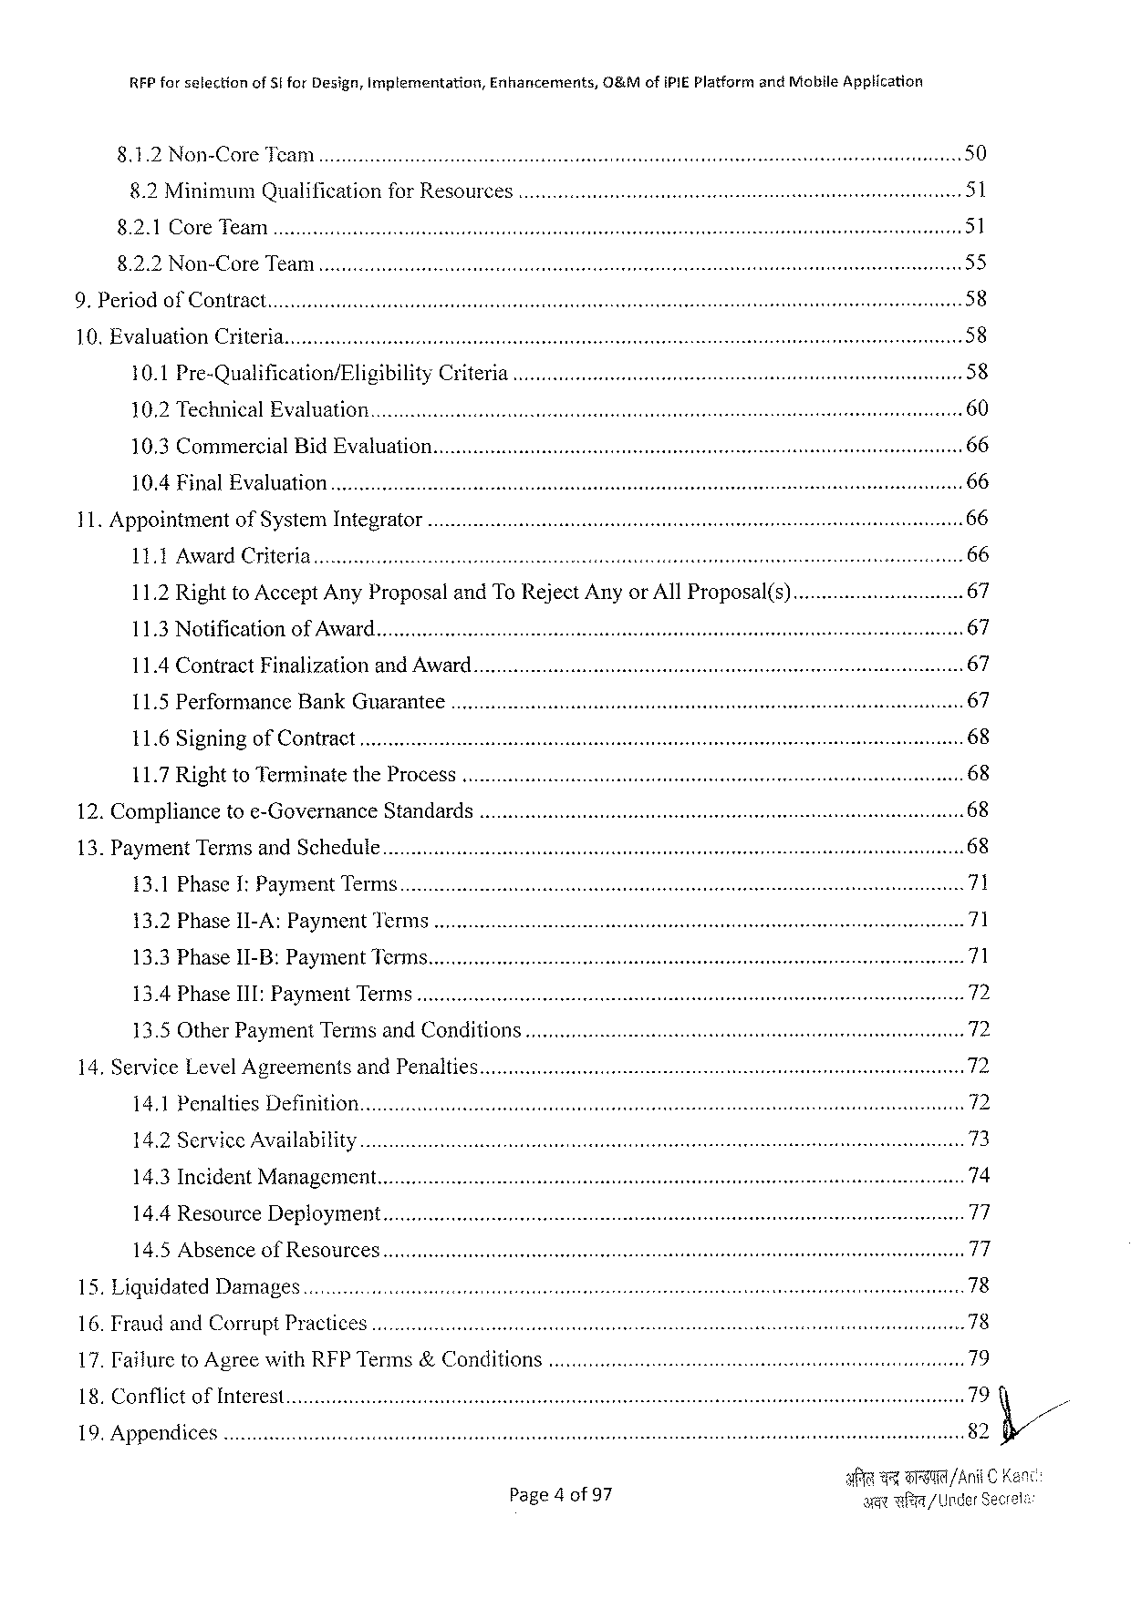

|  |  |  |  |  |  |  |  |  |  |  |  |  |  |  |  |  |  |  |  |  |
| --- | --- | --- | --- | --- | --- | --- | --- | --- | --- | --- | --- | --- | --- | --- | --- | --- | --- | --- | --- | --- |
| xR | RFPforselection | | | | ofSi forDesign,implementation, | | | | Enhancements, | 0&MofIPIEPlatformandMobileApplication | | | | | | | | | | 50 |
| SR | N o | | oTee AN | | | | s | e | e | e | | | T | | | TR | TS | |
| s | | | | | | | | | | 51 |
| 8.2MinimumQualificationforRESOUICES..ot | | | | | | | | |
| 8921©OTEMeai | | | | | e | | | e | T | S | | T R | | STS | | ST | | | 51 |
| 89250\Oy | | C T e | | | TA | o | | TT | se | s | TR | s AT | | | os W TSRSTS | | | AT | 55 |
| TR | | | | | | | T | | | 58 |
| OAI0ECOTT At s | | | | | | | | |

10. EvaluationCriteria.

|  |  |  |  |  |
| --- | --- | --- | --- | --- |
| 10.1Pre-Qualification/Eligibility | CrIteria | . ....cccrverirerierimmeissiesiiissss | s | 58 |

10.2TechnicalEvaluation   
10.3CommercialBidEvaluation.

10.4FinalEvaluation   
11.AppointmentofSystemIntegrator

|  |  |  |  |  |
| --- | --- | --- | --- | --- |
| LIkAWaTd, ChileTiT | e | e | e | 66 |

11.2RighttoAcceptAnyProposalandToRejectAnyorAllProposal(s).........c.cocovriercmucns67

|  |  |  |  |  |  |  |  |  |  |  |
| --- | --- | --- | --- | --- | --- | --- | --- | --- | --- | --- |
| 1183Netification | of/AWaAIls | e | e | | e | Te | S | T | I | 67 |
| s | 67 |
| 11.4ContractFinalizationand AWard............coocooiiiiiiiiiii | | | | |
| 11.5PerformanceBankGUAKANTEE ... | | | | | T | e(e | st | 67 |
| LI6+SiznINEIoTCONtTat | | s | T | T | sST ST |

11.7RighttoTerminatetheProcess   
12.Compliancetoe-Governance Standards   
13.PaymentTermsandSchedule   
 13.1PhaseI: PaymentTern

|  |  |  |  |  |  |  |  |  |  |
| --- | --- | --- | --- | --- | --- | --- | --- | --- | --- |
| 132}PhasellLA | SR EyMEnCICT St | | e | T | | | S | ST | S71 |
| R | TR | 71 |
| 13:3Phasejl EB: | Paymentilicin | e | | e | | R |
| s | | 72 |
| 13.4PhaseIII:PaymentTIMIS..ottt | | | | | | |
| 13.5OtherPaymentTermsandConditions.....c..vocioiniiies | | | | | | | 72 |
| 14. ServiceLevelAgreementsandPenalties.......oieircimriiconiicsisscninnsnses | | | | | | | 72 |
| sb st | | 72 |
| 14.1PenaltiesDefIMHON.«.....oiiiriiiiiier | | | | s | | |
| 14.2ServiceAVAHIADIHLY..ot | | | | | | | 73 |
| 14.3IncidentManagement........co.oooivieiiiineiiiniciie | | | | s | sssas st | s | 74 |

14.4ResourceDeployment   
14.5AbsenceofResources   
15. LiquidatedDamages.

16. Fraud and CorruptPractices

|  |  |  |  |  |  |  |  |  |
| --- | --- | --- | --- | --- | --- | --- | --- | --- |
| 17.FFailure toAgreewithRFPTerms&Conditions..o | | | east | 7 | B | 79 | | . |
| 79 | |
| 18,CONTIICE | OFINEETES...ittt | ettt |
| 82fi// | |
| 1O,APPENAICES..ottt | | |
| /Ani | C |
| Page4of 97 | | | ageil | | / UnderSec | |

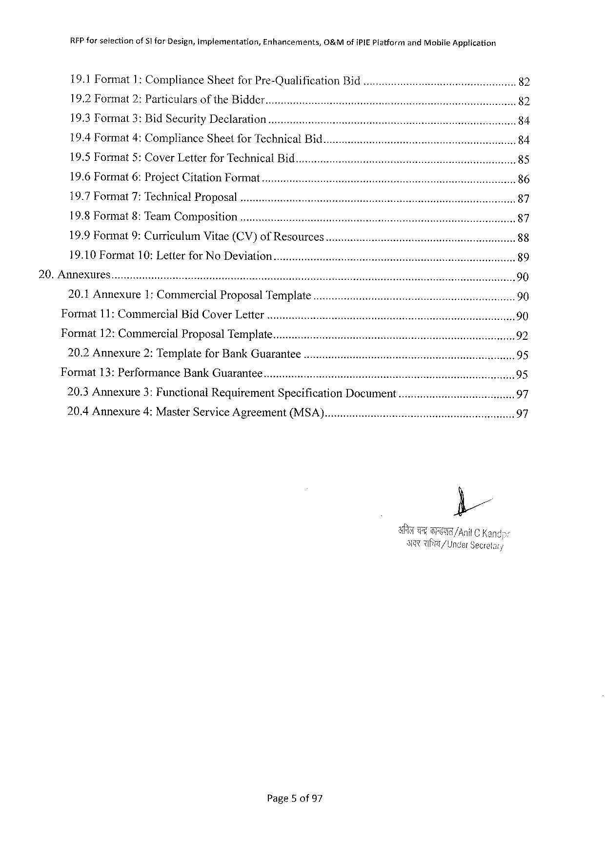

|  |  |  |  |  |  |  |  |  |  |
| --- | --- | --- | --- | --- | --- | --- | --- | --- | --- |
| RFPforsetection | of51 forDesign,implementation, | | Enhancements, | O&MofiPIEPlatformandMobileApplication | | | | s | 82 |
| 19.1Format1:ComplianceSheetforPre-Qualification | | | | | Bid«...o...coooovvvoo | | |
| 19.2Format2:Particulars | | of theBIAder.......oic.orreiiriiiiriiiiosseesoesees | | | | e | | 82 |
| 19.3Tormat3: BidSecurityDeclaration | | | ..........ccoouewieeevvrmeriroonsisssensoooeeeeeeeeeeeecesssiesssees | | | | |
| 84 |
| 19.4Format4:ComplianceSheetforTechnicalBid.......cco.ccovveriionvoiieeeeeeseeeeces | | | | | | | e, | 84 |
| 19.5Format5:CoverLetterfor TechnicalBid...c.ooociovvionronniniensonioeceeresvoneessi | | | | | | | | 85 |

19.6Format6:ProjectCitationFormat   
19.7Format7:TechnicalProposal   
19.8 Format8:TeamComposition   
19.9Format9:CurriculumVitae(CV)of Resources.

19.10Format10: LetterforNoDeviation   
20.Annexures   
 20.1 Annexure1: Commercial ProposalTemplate..........coooovrmrmrinrrimsinreosresssieonn90 Format11:CommercialBidCOVErLEter ........o..coimumrrivmrivnniriisssieisnessoesesresssssons sossseeens90 Format12:Commercial ProposalTemMPIALe.............cc.wwerrueriemmecrieniasinnsisninnssssssssiossissensonnses 92 20.2Annexure2:TemplateforBankGUATANTEE...........evrvveernieiosiesiensreisiesiessssessiessessaones95 Format13: Performance BankGUATANTEE ...........overeriisrmniiaisisesinessessecesrssssssesessosssseseeeeesns95 20.3 Annexure3: FunctionalRequirementSpecification DOCUMENt.............crvorerversrerernnes 97 20.4Annexure4:MasterServiceAgreement (MSA).......ovvriuiirenieosesrrssosssseeessconsenene 97

Page5 of97

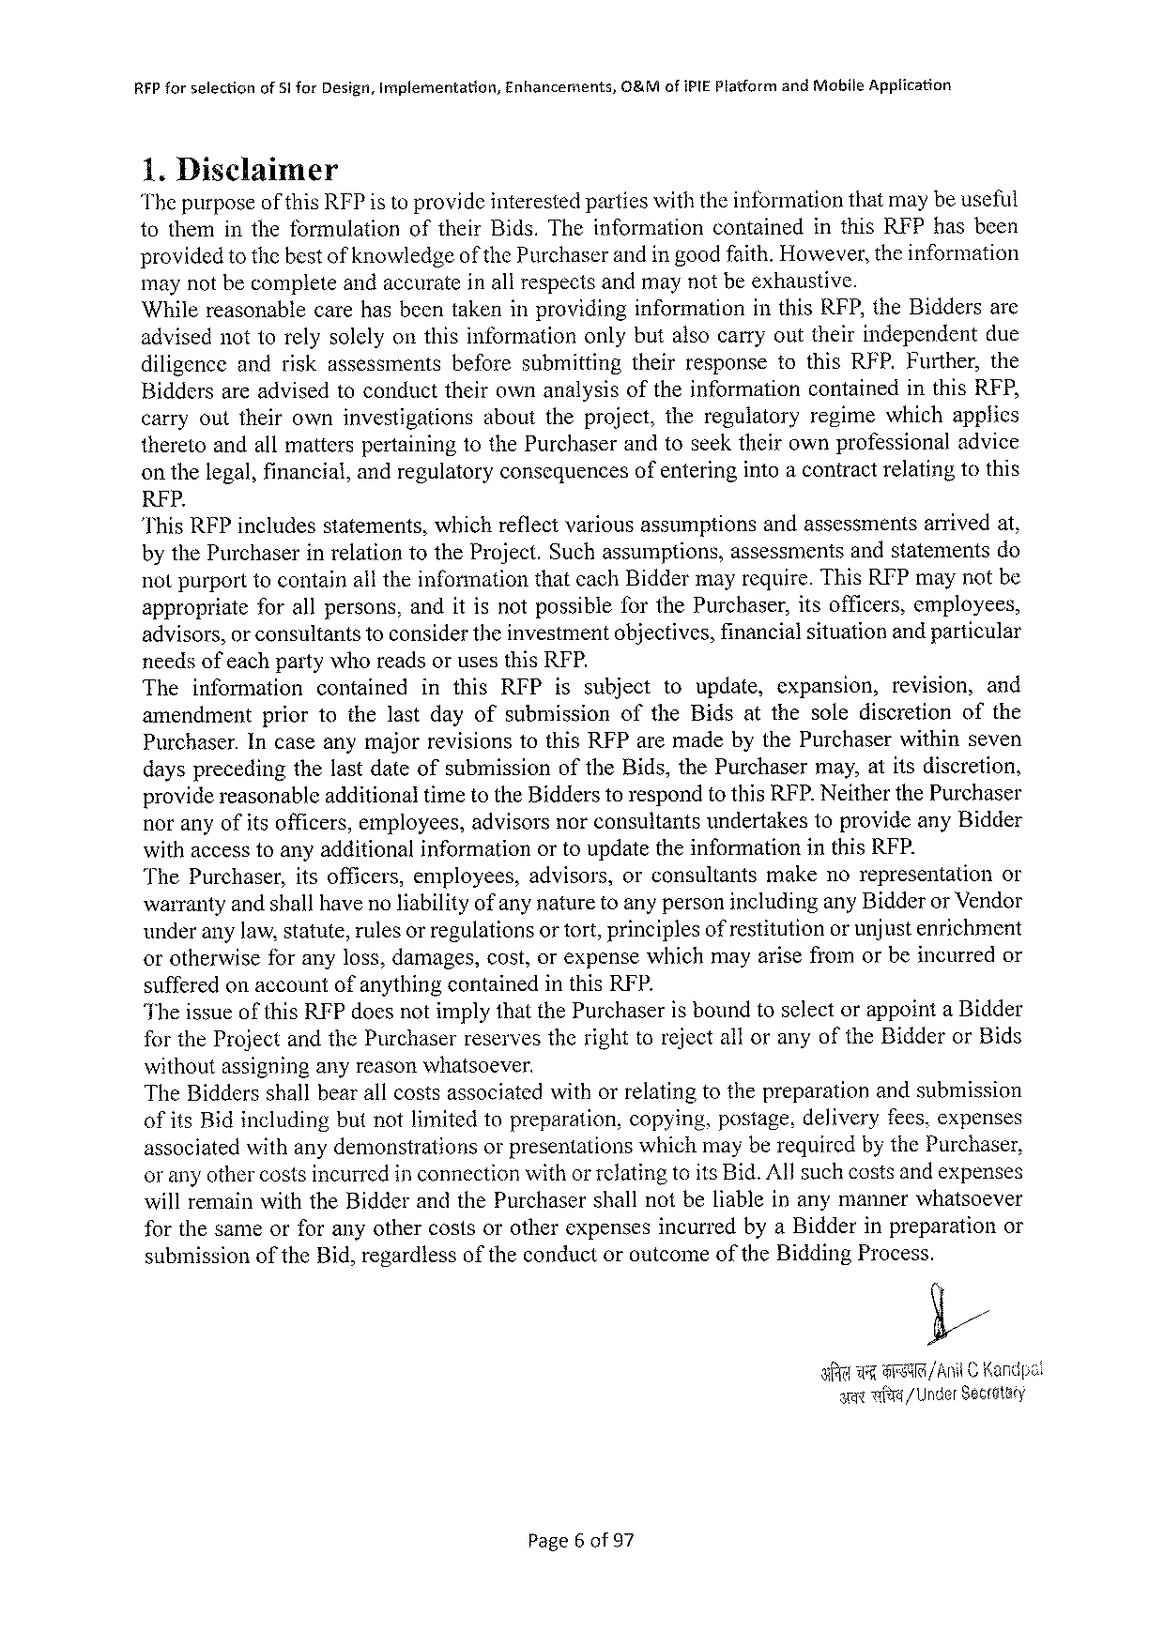

RFPforselection ofSi forDesign,Implementation, Enhancerents, O&MofiPIE PlatformandMabileApplication

1.Disclaimer   
Thepurposeofthis RFPis toprovideinterestedpartieswiththeinformationthatmaybeuseful tothemintheformulation oftheirBids.Theinformation contained inthisRFPhasbeen providedtothebestof knowledgeof thePurchaserandin goodfaith.However,theinformation maynotbecompleteandaccurateinall respectsandmaynotbeexhaustive.

Whilereasonablecarehas beentakeninprovidinginformation inthisRFP,theBiddersare advisednottorelysolelyonthisinformationonlybutalsocarryouttheirindependent due

diligence andriskassessments beforesubmitting theirresponsetothisRFP.Further,the

Biddersareadvisedtoconducttheirownanalysisoftheinformation containedinthisRFP,

carryouttheirowninvestigations abouttheproject,theregulatory regimewhichapplies theretoandallmatterspertainingtothePurchaserandtoseektheirownprofessionaladvice onthelegal,financial,andregulatoryconsequencesofenteringintoa contractrelatingtothis

RFP.

"ThisRFPincludes statements, which reflect various assumptions andassessments arrived at,

bythePurchaserinrelationtotheProject.Suchassumptions, assessmentsandstatementsdo notpurporttocontainalltheinformationthateachBiddermayrequire.ThisRFPmaynotbe appropriate forallpersons,anditisnotpossibleforthePurchaser,itsofficers,employees, advisors,or consultantstoconsidertheinvestmentobjectives,financialsituationand particular needsofeachpartywhoreadsorusesthisRFP.

The information contained inthisRFPissubject toupdate, expansion, revision, and

amendment priortothelastdayofsubmission oftheBidsatthesolediscretion ofthe

Purchaser.IncaseanymajorrevisionstothisRFParemadebythePurchaserwithinseven daysprecedingthelastdateofsubmissionoftheBids,thePurchasermay,atitsdiscretion, providereasonableadditionaltimetotheBidderstorespondtothisRFP.Neitherthe Purchaser noranyofitsofficers,employees,advisorsnorconsultantsundertakestoprovideanyBidder withaccesstoanyadditionalinformationortoupdatetheinformationinthisRFP.

ThePurchaser, itsofficers,employees, advisors,orconsultants makenorepresentation or warrantyand shallhaveno liabilityof anynaturetoanypersonincludinganyBidderor Vendor underanylaw,statute,rulesor regulationsortort,principlesof restitutionor unjustenrichment orotherwiseforanyloss,damages,cost,orexpensewhichmayarisefromorbeincurredor sufferedonaccountofanythingcontainedinthisRFP.

TheissueofthisRFPdoesnotimplythatthePurchaseris boundtoselectorappointaBidder fortheProjectandthePurchaserreservestherighttorejectalloranyoftheBidderorBids

withoutassigninganyreasonwhatsoever.

TheBiddersshallbearallcostsassociatedwithorrelatingtothepreparationandsubmission ofitsBidincludingbutnotlimitedtopreparation,copying,postage,deliveryfees.expenses associatedwithanydemonstrations orpresentationswhichmayberequiredbythePurchaser, or anyothercostsincurredinconnectionwithor refatingtoitsBid.Allsuchcostsandexpenses willremainwiththeBidderandthePurchasershallnotbeliableinanymannerwhatsoever forthesameorforanyothercostsorotherexpensesincurredbyaBidderinpreparation or

submissionoftheBid,regardlessoftheconductoroutcome of the BiddingProcess.

E/,

|  |  |  |  |  |
| --- | --- | --- | --- | --- |
| e | e | i | S | /AniC Kandpal / Under Seceetary |

Page6 of97

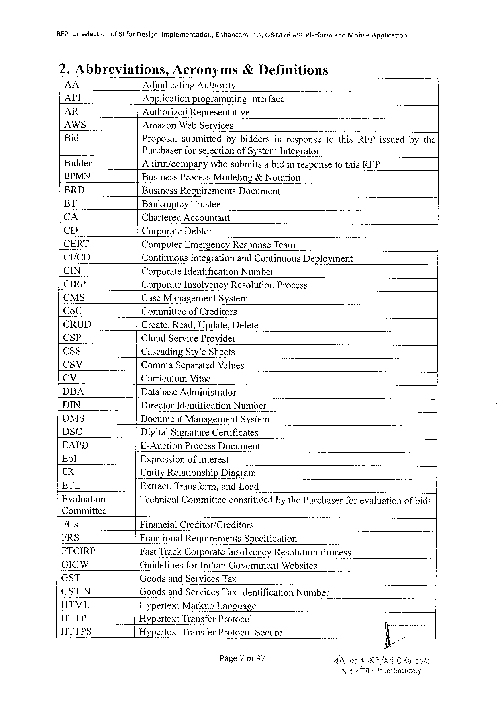

|  |  |  |  |
| --- | --- | --- | --- |
| RFPforselection | of§1forDesign,tmplementation, | Enhancements, | O&MofiPIEPlatformandMobileApplication |

2. Abbreviations,Acronyms& Definitions

|  |  |  |  |  |  |  |  |  |  |  |  |
| --- | --- | --- | --- | --- | --- | --- | --- | --- | --- | --- | --- |
| AA | - | AdjudicatingAuthority | | | | | | | | | |
| API |
| Applicationprogramming | | | | interface | | | | | |
| AR |
| AuthorizedRepresentative | | | | | | | | | |
| AWS |
| AmazonWebServices | | | | | | | | | |
| Bid |
| Proposal | submitted | bybiddersinresponsetothisRFPissuedbythe | | | | | | | |
| Bidder | PurchaserforselectionofSystemIntegrator | | | | | | | | | |
| A firm/companywhosubmitsabidinresponsetothisRFP | | | | | | | | | |
| BPMN |
| BusinessProcessModeling&Notation | | | | | | | | | |
| BRD |
| BusinessRequirements Document | | | | | | | | | |
| BT | BankruptcyTrustee | | | | | | | | | |
| CA | CharteredAccountant | | | | | | | | | |
| CD |
| CorporateDebtor | | | | | | | | | |
| CERT | ComputerEmergencyResponseTeam | | | | | | | | | |
| CI/CD |
| ContinuousIntegrationandContinuousDeployment | | | | | | | | | |
| CIN |
| CorporateIdentification Number | | | | | | | | | |
| CIRP | CorporateInsolvencyResolutionProcess | | | | | | | | | |
| CMS |
| CaseManagementSystem | | | | | | | | | |
| CoC |
| CommitteeofCreditors | | | | | | | | | |
| CRUD |
| Create,Read,Update,Delete | | | | | | | | | |
| CSP |
| CloudServiceProvider | | | | | | | | | |
| CSs |
| CascadingStyleSheets | | | | | | | | | |
| Ccsv |
| Comma SeparatedValues | | | | | | | | | |
| (&% | CurriculumVitae | | | | | | | | | |
| DBA |
| DatabaseAdministrator | | | | | | | | | |
| DIN |
| DirectorIdentificationNumber | | | | | | | | | |
| DMS |
| DocumentManagement | | | System | | | | | | |
| DSC |
| DigitalSignatureCertificates | | | | | | | | | |
| EAPD | E-AuctionProcessDocument | | | | | | | | | |
| Eol |
| ExpressionofInterest | | | | | | | | | |
| ER |
| EntityRelationship | | Diagram | | | | | | | |
| ETL |
| Extract,Transform,andLoad | | | | | | | | | |
| Fvaluation |
| TechnicalCommitieeconstitutedbythePurchaserforevaluationofbids | | | | | | | | | |
| Committee | FinancialCreditor/Creditors | | | | | | | | | |
| FCs |
| FRS |
| FunctionalRequirements Specification | | | | | | | | | |
| FICIRP | FastTrackCorporateInsolvencyResolutionProcess | | | | | | | | | |
| GIGW |
| GuidelinesforIndianGovernmentWebsites | | | | | | | | | |
| GST |
| GoodsandServicesTax | | | | | i | | | | | |
| GSTIN | GoodsandServicesTaxIdentificationNumber | | | | | | | | | |
| HTML |
| HypertextMarkupLanguage | | | | | | | | | |
| HTTP |
| HypertextTransferProtocol | | | | | o | | B | | |
| HTTPS |
| HypertextTransferProtocolSecure | | | | | . | . | “ | | ) |
| |28 | |
| Page7 of97 | | | | | A | | TB | /A | |
| s | | | | | | | wfa/U | | |

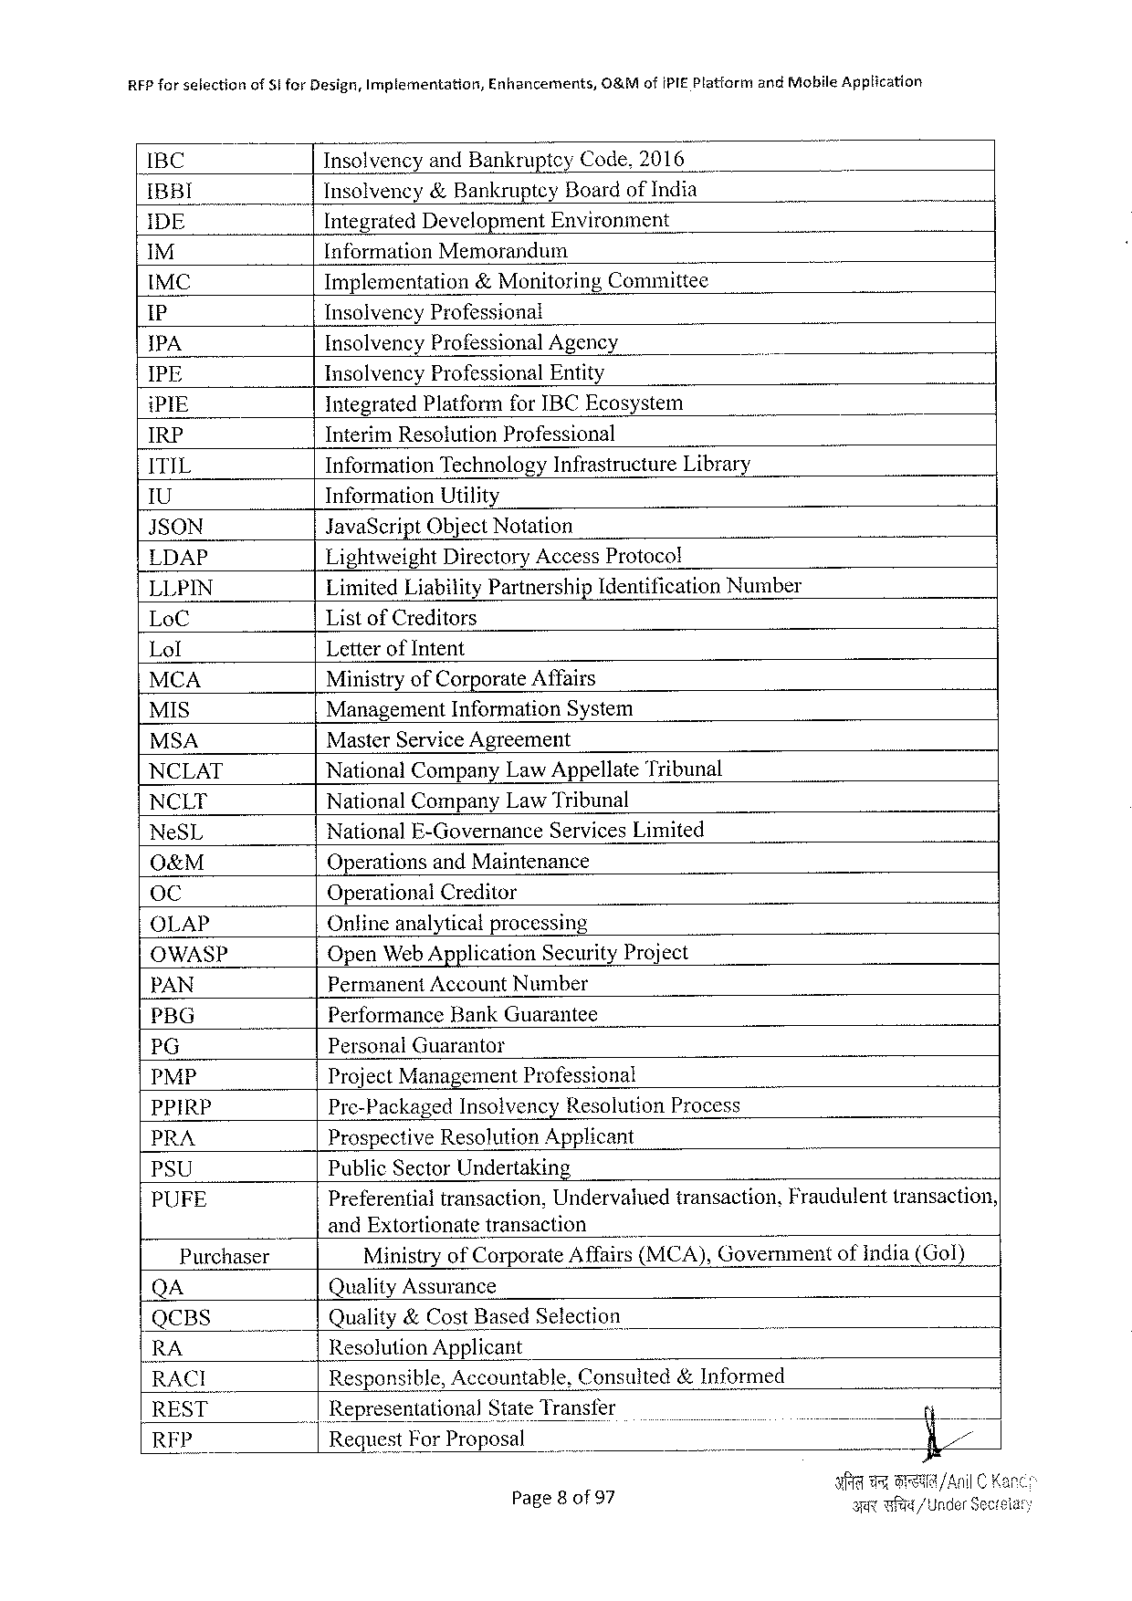

RFPforselection ofSforDesign,Implementation, Enhancements, O&MofIPIEPlatfarm andMobileApplication

IBC InsolvencyandBankrupteyCode,2016

IBBI Insolvency&BankrupteyBoardofIndia

IDE IntegratedDevelopment Environment

M [nformationMemorandum

IMC Implementation &MonitoringCommittee

1P InsolvencyProfessional

IPA InsolvencyProfessionalAgency

IPE InsolvencyProfessionalEntity

iPIE IntegratedPlatformforIBCEcosystem

IRP InterimResolutionProfessional

ITIL InformationTechnologyInfrastructure Library

U InformationUtility

JSON JavaScriptObjectNotation

LDAP LightweightDirectoryAccessProtocol

LLPIN Limited LiabilityPartnershipIdentificationNumber

LoC ListofCreditors

Lol Letterof Intent

MCA Ministryof CorporateAffairs

MIS ManagementInformationSystem

MSA MasterServiceAgreement

NCLAT NationalCompanyLawAppellateTribunal

NCLT NationalCompanyLawTribunal

NeSL NationalE-Governance ServicesLimited

O&M OperationsandMaintenance

oC OperationalCreditor

OLAP Onlineanalyticalprocessing

OWASP OpenWeb Application SecurityProject

PAN PermanentAccountNumber

PBG PerformanceBankGuarantee

PG PersonalGuarantor

PMP ProjectManagementProfessional

PPIRP Pre-Packaged Insolvency Resolution Process

PRA ProspectiveResolutionApplicant

PSU PublicSectorUndertaking

PUFE Preferentialtransaction,Undervaluedtransaction,Fraudulenttransaction,

___|andExtortionatetransaction

Purchaser MinistryofCorporateAffairs(MCA),Governmentofindia(Gol)

QA QualityAssurance

QCBS Quality&CostBasedSelection

RA ResolutionApplicant

RACI Responsible,Accountable,Consuited&Informed

REST _|Representational StateTransfer

RFP Request For Proposal

Page8 of97 Y TR/ UnderSec

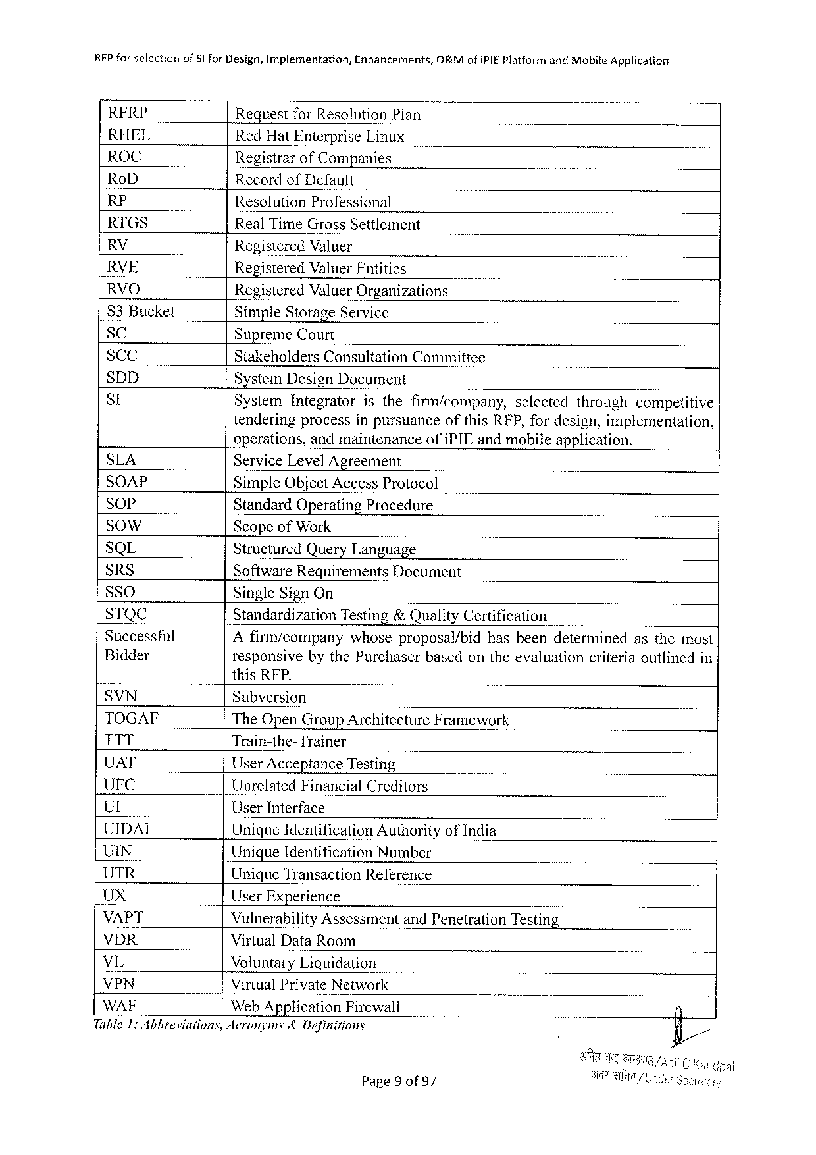

RFP for selectionof$1 forDesign,implementation,Enhancements,&MofiPIEPlatform andMobile Application

|  |  |  |  |  |  |
| --- | --- | --- | --- | --- | --- |
| RERP | RequestforResolution Plan | | | selected | throughcompetitive |
| RHEL | RedHatEnterpriseLinux | | |
| ROC |
| RegistrarofCompanies | | |
| RoD |
| Recordof Default | | |
| RP |
| ResolutionProfessional | | |
| RTGS |
| RealTimeGrossSettlement | | |
| RV |
| RegisteredValuer | | |
| RVE |
| RegisteredValuerEntities | | |
| RVO |
| RegisteredValuerOrganizations | | |
| S3Bucket | SimpleStorageService | | |
| SC |
| SupremeCourt | | |
| SCC | StakeholdersConsultation | | Committee |
| SDD |
| SystemDesignDocument | | |
| St | SystemIntegrator | isthefirm/company, | |

tenderingprocessinpursuanceofthisRFP,fordesign,implementation,

operations,andmaintenanceofiPIEandmobileapplication.

|  |  |  |  |
| --- | --- | --- | --- |
| SLA  SOAP  SOoP  SOwW  SQL  SRS  SSO  STQC  Successful Bidder | ServiceLevelAgreement  SimpleObjectAccessProtocol  StandardOperatingProcedure  ScopeofWork  StructuredQueryLanguage | | |
| SoftwareRequirements | | Document |
| SingleSignOn | | |
| Standardization | Testing&QualityCertification | |
| A firm/companywhoseproposal/bidhasbeendeterminedasthemost responsivebythePurchaserbasedontheevaluationcriteriaoutlinedin | | |

thisRFP.

SVN Subversion

TOGAF TheOpen GroupArchitectureFramework

TTT Train-the-Trainer

UAT UserAcceptance Testing

UFC UnrelatedFinancialCreditors

Ul UserInterface

UIDAI UniqueIdentification AuthorityofIndia

UIN Unique Identification Number

UTR UniqueTransaction Reference

Ux UserExperience

VAPT VulnerabilityAssessment andPenetrationTesting

VDR VirtualDataRoom

VL VoluntaryLiquidation

VPN VirtualPrivateNetwork B

WAF Web ApplicationFirewall

Tuble1:Abbreviations,Acronyms&Definitions

Page9 of97

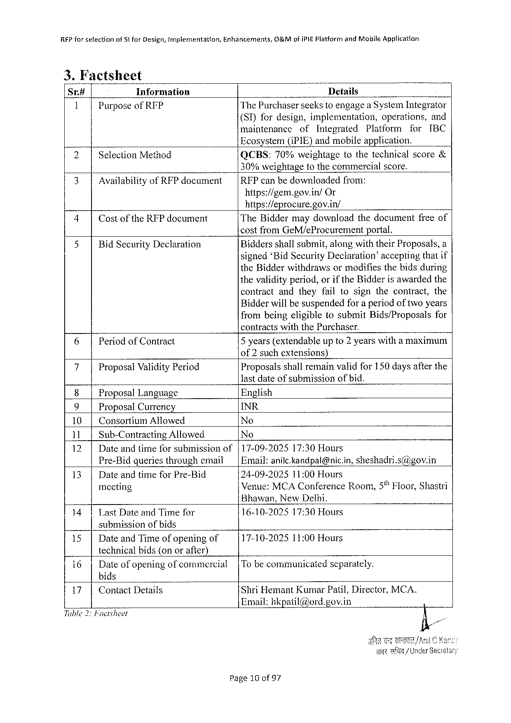

RFPfor setectionofStforDesign,Implementation,Enhancements,O&MofiPIEPlatform andMobileApplication

|  |  |  |  |  |  |  |  |  |  |  |
| --- | --- | --- | --- | --- | --- | --- | --- | --- | --- | --- |
| Sr.# | Information | Details | | | | | | | | |
| 1 | PurposeofRIP | ThePurchaserseekstoengagea SystemIntegrator | | | | | | | | |
| (SI)fordesign,implementation, | | | | | | operations, | | and |
| maintenance | | of | Integrated | | Platform | | for | IBC |
| 2 | SelectionMethod |
| Ecosystem(iPIE)andmobileapplication. | | | | | | | | |
| QCBS: | 70%weightage | | | tothetechnicalscore& | | | | |

30%weightagetothecommercialscore.

|  |  |  |  |
| --- | --- | --- | --- |
| 3 | AvailabilityofRFPdocument | |RFPcanbedownloadedfrom: | |
| https://gem.gov.in/ | Or |

https://eprocure.gov.in/

|  |  |  |  |
| --- | --- | --- | --- |
| 4 | CostoftheRFPdocument | TheBiddermaydownloadthedocumentfreeof | |
| 5 | BidSecurityDeclaration | costfromGeM/eProcurement | portal. |
| Biddersshallsubmit,alongwiththeirProposals,a | |
| signed‘BidSecurityDeclaration”acceptingthatif | |

theBidderwithdrawsormodifiesthebidsduring thevalidityperiod,orif theBidderisawardedthe

contractandtheyfailtosignthecontract, the

Bidderwillbesuspendedfor a periodoftwoyears frombeingeligibletosubmitBids/Proposals for

contractswiththePurchaser.

|  |  |  |
| --- | --- | --- |
| 6 | PeriodofContract | 5 years(extendableupto2 yearswitha maximum |

of2suchextensions)

|  |  |  |
| --- | --- | --- |
| 7 | Proposal ValidityPeriod | Proposalsshallremainvalidfor 150daysafterthe |

lastdateofsubmissionofbid.

|  |  |  |
| --- | --- | --- |
| 8 | ProposalLanguage | English |
| 9 | ProposalCurrency | INR |
| No |
| 10| | ConsortiumAllowed |
| No |
| 1il, | Sub-ContractingAllowed |
| 12| | Dateandtimeforsubmissionof | |17-09-202517:30Hours |
| 13| | Pre-Bidqueriesthroughemail | |Email:anilc.kandpal@nic.in, sheshadri.s@gov.in |
| DateandtimeforPre-Bid | 24-09-202511:00Hours |
| Venue:MCAConferenceRoom,5% Floor,Shastri |
| meeting |

Bhawan,NewDelhi.

141LastDateandTimefor submissionofbids

16-10-202517:30Hours

|  |  |  |
| --- | --- | --- |
| 15| | DateandTimeofopeningof | 17-10-202511:00Hours |

technicalbids(onorafter)

|  |  |  |  |
| --- | --- | --- | --- |
| 16| | Dateofopeningofcommercial | |Tobecommunicated | separately. |

bids

|  |  |  |  |
| --- | --- | --- | --- |
| 17| | ContactDetails | ShriHemantKumarPatil,Director,MCA. | N |
| Email:hkpatil@ord.gov.in |

Tible 2:Facisheet

e Wl/UnderSec

Page10 of97

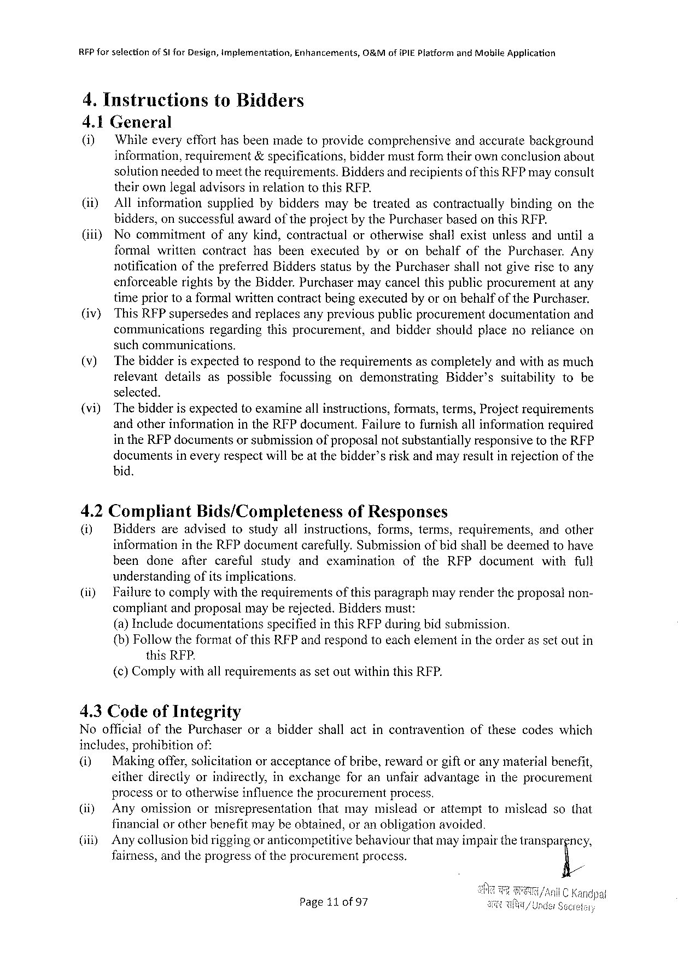

|  |  |  |  |
| --- | --- | --- | --- |
| RFPforselection | ofSI forDesign,implementation, | Enhancements, | O&MofiPIE PlatformandMobileApplication |

4. InstructionstoBidders

4.1General

|  |  |  |
| --- | --- | --- |
| (i) | Whileeveryefforthasbeenmadetoprovidecomprehensive | andaccuratebackground |

information,requirement&specifications,biddermustformtheirownconclusionabout

solutionneededtomeettherequirements.Biddersandrecipientsofthis RFPmayconsult

theirownlegaladvisorsinrelationtothisRFP.

|  |  |  |  |  |  |  |  |  |
| --- | --- | --- | --- | --- | --- | --- | --- | --- |
| (it)  (iii) | Allinformation | | suppliedbybiddersmaybetreatedascontractually | | | | bindingonthe | |
| bidders,on successful awardofthe projectbythe Purchaser basedonthisRFP. | | | | | | | |
| Nocommitment | | ofanykind,contractual | | orotherwise | shallexistunlessanduntila | | |
| formalwritten | | contract | hasbeenexecuied | byoronbehalfofthePurchaser. | | | Any |
| notification | ofthepreferredBiddersstatusbythePurchasershallnotgiverisetoany | | | | | | |

enforceablerightsbytheBidder.Purchasermaycancelthispublicprocurementatany

|  |  |  |  |  |  |
| --- | --- | --- | --- | --- | --- |
| (iv) | timepriortoaformalwrittencontractbeingexecutedbyoronbehalfofthePurchaser. | | | | |
| ThisRFPsupersedesandreplacesanypreviouspublicprocurementdocumentation | | | | and |
| communications | regarding | thisprocurement, | andbiddershouldplacenorelianceon | |

suchcommunications.

(v) Thebidderisexpectedtorespondtotherequirementsascompletelyandwithasmuch

relevant details aspossible focussing ondemonstrating Bidder’s suitability tobe

selected.

(vi) Thebidderisexpectedtoexamineallinstructions,formats,terms,Projectrequirements

andotherinformationintheRFPdocument.Failuretofurnishallinformationrequired

intheRFPdocumentsorsubmissionof proposalnotsubstantiallyresponsivetotheRFP

documentsineveryrespectwillbeat thebidder’sriskandmayresultinrejectionof the

bid.

4.2Compliant Bids/Completeness ofResponses

(i) Biddersareadvisedtostudyallinstructions, forms,terms,requirements, andother

informationintheRFPdocumentcarefully.Submissionofbidshallbedeemedtohave

beendoneaflercarefulstudyandexaminationoftheRFPdocumentwithfull

understandingofitsimplications.

(ii) Failuretocomplywiththerequirementsofthisparagraphmayrendertheproposalnon-

compliantandproposalmayberejected.Biddersmust:

(a)Includedocumentations specifiedinthisRFPduringbidsubmission.

{b) FollowtheformatofthisRFPandrespondtoeachelementintheorderassetoutin

thisRFP.

(c)ComplywithallrequirementsassetoutwithinthisRFP.

4.3CodeofIntegrity

|  |  |  |
| --- | --- | --- |
| NoofficialofthePurchaser | orabiddershallactincontravention | ofthesecodeswhich |

includes,prohibitionof:

|  |  |  |  |  |  |
| --- | --- | --- | --- | --- | --- |
| (i) | Makingoffer,solicitation | oracceptance | ofbribe,reward | orgiftoranymaterial | benefit, |

eitherdirectlyorindirectly,inexchangeforanunfairadvantageintheprocurement

processorto otherwise influencethe procurementprocess.

|  |  |  |  |  |  |
| --- | --- | --- | --- | --- | --- |
| (i) | Anyomission | ormisrepresentation | thatmaymislead | orattempt | tomisleadsothat |

financialor otherbenefitmaybeobtained,oranobligationavoided.

(i) Anycollusionbidriggingor anticompetitivebehaviourthatmayimpairthetranspargncy,

fairness,andtheprogressoftheprocurementprocess. E/

Page11 0f97

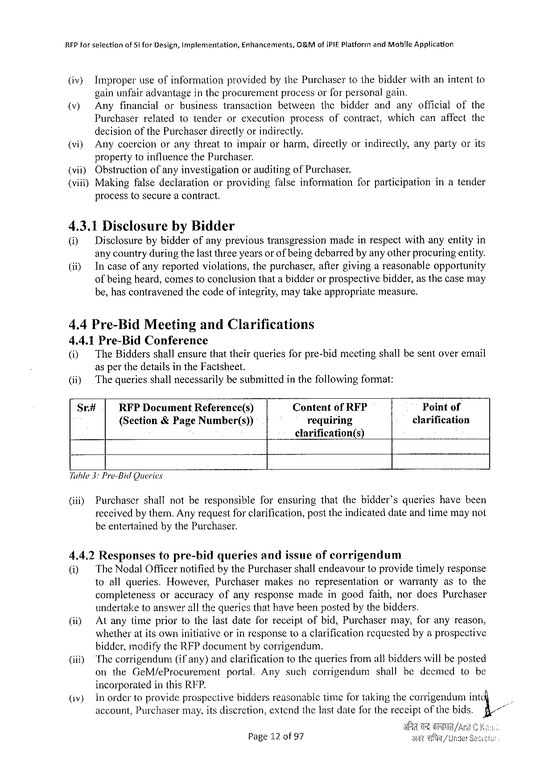

RFPforselection ofStforDesign,implementation, Enhancements, 0&MofiPIEPlatformandMohileApplication

(iv) Improperuseofinformation providedbythePurchasertothebidderwithanintentto

gainunfair advantagein the procurement process orforpersonal gain.

(v) Anyfinancial orbusiness transaction between thebidder andanyofficial ofthe

Purchaserrelatedtotenderorexecutionprocessofcontract,whichcanaffectthe

decisionofthe Purchaserdirectlyor indirectly.

(vi) Anycoercionoranythreattoimpairorharm,directlyorindirectly,anypartyorits

propertytoinfluencethePurchaser.

|  |  |  |  |  |  |  |
| --- | --- | --- | --- | --- | --- | --- |
| (vii) | Obstructionofanyinvestigation | | orauditingofPurchaser. | | forparticipation | inatender |
| (viii)Makingfalsedeclaration | | orproviding | | falseinformation |

processtosecurea contract.

4.3.1DisclosurebyBidder

|  |  |  |
| --- | --- | --- |
| () | Disclosurebybidderofanyprevioustransgression | madeinrespectwithanyentityin |

any countryduringthelastthreeyearsorofbeingdebarredby anyotherprocuringentity.

(i) Incaseofanyreportedviolations,thepurchaser,aftergivingareasonableopportunity

of being heard,comestoconclusionthata bidderorprospectivebidder,asthecasemay

be,hascontravenedthecodeofintegrity,maytakeappropriate measure.

4.4Pre-Bid Meeting andClarifications

4.4.1Pre-BidConference

(i) TheBiddersshallensurethattheirqueriesforpre-bidmectingshallbesentoveremail

asper thedetailsintheFacisheet.

|  |  |  |  |
| --- | --- | --- | --- |
| (ii) | The queriesshallnecessarilybesubmittedinthefollowingformat: | | Pointof |
| Sr# | RFPDocumentReference(s) | ContentofRFP |
| {Section&PageNumber(s)) | requiring | clarification |

clarification(s)

Tuble3:Pre-BidQueries

|  |  |  |  |  |
| --- | --- | --- | --- | --- |
| (i) | Purchaser | shallnotberesponsible | forensuring | thatthebidder’squerieshavebeen |

receivedbythem.Anyrequestfor clarification,posttheindicateddateandtimemaynot

beentertainedbythePurchaser.

4.4.2Responsestopre-bidqueriesandjssneofcorrigendum

|  |  |  |  |  |
| --- | --- | --- | --- | --- |
| @) | The NodalOfficernotifiedbythePurchasershallendeavourtoprovidetimelyresponse toallqueries.However,Purchasermakesnorepresentationorwarrantyastothe | | | |
| completeness | oraccuracy | ofanyresponse | madeingoodfaith,nordoesPurchaser |

undertaketoanswerall thequeriesthathavebeenpostedbythebidders.

(i) Atanytimepriortothelastdateforreceiptofbid,Purchasermay,foranyreason,

whetheratitsowninitiativeorinresponsetoaclarificationrequestedbyaprospective

bidder,modifytheRFPdocumentbycorrigendum.

|  |  |  |  |  |  |  |  |
| --- | --- | --- | --- | --- | --- | --- | --- |
| (i) | Thecorrigendum | (if any) | andclarificationtothequeriesfromallbidderswillbeposted | | | | |
| ontheGeM/eProcurement | | | portal.Anysuch | corrigendum | shallbedecmed | tobe |

incorporatedinthisRFP.

|  |  |  |
| --- | --- | --- |
| (iv) | Inordertoprovideprospectivebiddersreasonabletimefortakingthecorrigendumint | (1// |
| account,Purchasermay,itsdiscretion,extendthelastdateforthereceiptofthebids. |

Page12 of97

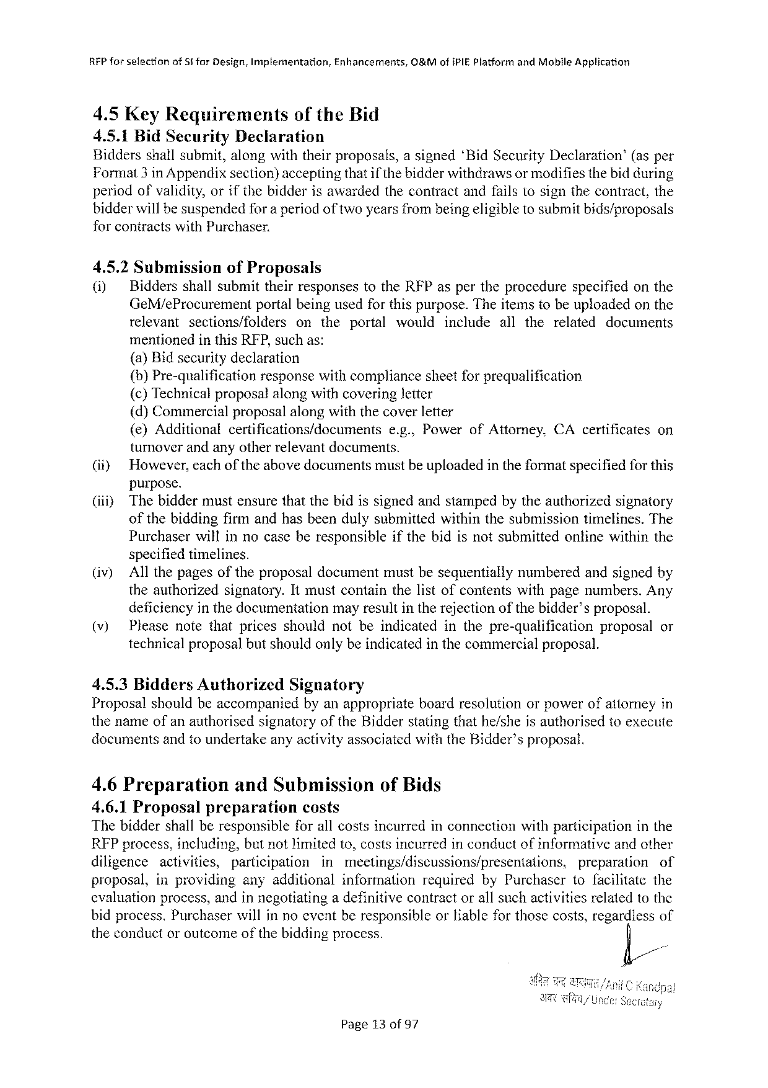

RFPforselection ofSt forDesign,Implementation, Enhancernants, G&MofiPIE PlatformandMobileApplication

4.5KeyRequirements oftheBid

4.5.1BidSecurityDeclaration

Biddersshallsubmit,alongwiththeirproposals,asigned‘BidSecurityDeclaration’ (asper

Format3in Appendixsection)acceptingthatif thebidderwithdrawsormodifiesthebidduring

periodofvalidity,orifthebidderisawardedthecontractandfailstosignthecontract,the

bidderwillbesuspendedfora periodoftwoyearsfrombeingeligibletosubmitbids/proposals

forcontractswithPurchaser.

4.5.2Submission ofProposals

(i) BiddersshallsubmittheirresponsestotheRFPaspertheprocedure specifiedonthe

GeM/eProcurement portalbeingusedforthispurpose.Theitemstobeuploadedonthe

relevant sections/folders ontheportal would include allthe related documents

mentionedinthisRFP,suchas:

(a)Bidsecuritydeclaration

{b)Pre-qualification responsewithcompliancesheetforprequalification

{c)Technicalproposalalongwithcoveringletter

(d)Commercialproposalalongwiththecoverletter

|  |  |  |  |  |
| --- | --- | --- | --- | --- |
| (e)Additional | certifications/documents | e.g.,PowerofAttorney, | CAcertificates | on |

turnoverandanyotherrelevantdocuments.

|  |  |
| --- | --- |
| (i)  (iiiy | However,eachoftheabovedocumentsmustbeuploadedintheformatspecifiedforthis purpose.  Thebiddermustensurethatthebidissignedandstampedbytheauthorizedsignatory |

ofthebiddingfirmandhasbeendulysubmittedwithinthesubmissiontimelines.The

Purchaserwillinnocaseberesponsible specifiedtimelines.

ifthebidisnotsubmittedonlinewithinthe

|  |  |  |
| --- | --- | --- |
| (iv) | Allthepagesoftheproposaldocumentmustbesequentially | numberedandsignedby |

theauthorizedsignatory.Itmustcontainthelistofcontentswithpagenumbers.Any

|  |  |  |  |  |  |
| --- | --- | --- | --- | --- | --- |
| (v) | deficiencyin thedocumentation | mayresultintherejectionofthebidder’sproposal. | | | or |
| Pleasenotethatpricesshouldnotbeindicated | | inthepre-qualification | proposal |

technicalproposalbutshouldonlybeindicatedinthecommercialproposal.

|  |  |  |  |
| --- | --- | --- | --- |
| 4.5.3BiddersAuthorized | Signatory | boardresolution | orpowerofattorneyin |
| Proposalshouldbeaccompanied | byanappropriate |

thenameofanauthorisedsignatoryoftheBidderstatingthathe/sheisauthorisedtoexecute documents andto undertakeanyactivityassociated withthe Bidder’sproposal.

4.6Preparation andSubmission ofBids   
4.6.1Proposal preparation costs   
Thebiddershallberesponsible forallcostsincurredinconnectionwithparticipation inthe REPprocess,including,butnotlimitedto,costsincurredinconductofinformativeandother

|  |  |  |  |  |  |  |  |
| --- | --- | --- | --- | --- | --- | --- | --- |
| diligence | activities, | participation | inmeetings/discussions/presentations, | | | preparation | of |
| proposal, | inproviding | anyadditional | | information | requiredbyPurchaser | tofacilitatethe | |

cvaluationprocess,andinnegotiatinga definitivecontractorallsuchactivitiesrelatedtothe bidprocess.PurchaserwillinnoeventberesponsibleorKableforthosecosts,regardlessof

|  |  |  |
| --- | --- | --- |
| theconductoroutcome | of the | biddingprocess. |

Page13of97

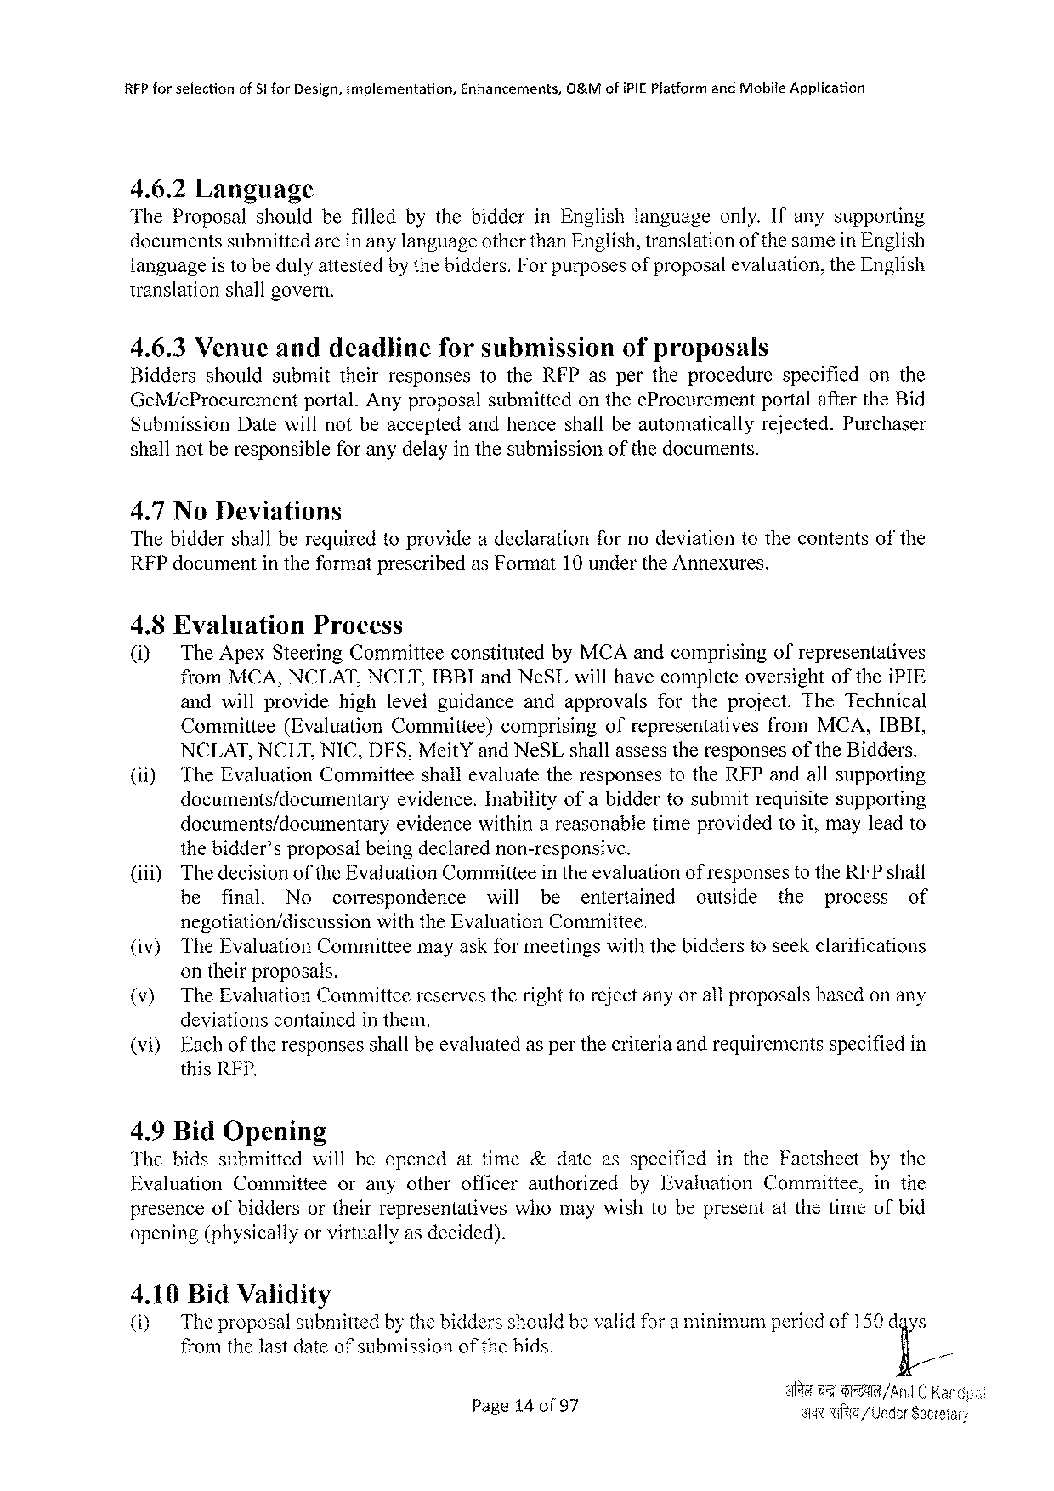

|  |  |  |  |
| --- | --- | --- | --- |
| RFPforselection | ofS! forDesign,implementation, | Enhancements, | 08&MofiPIEPlatformandMobifeApplication |

4.6.2Language

TheProposalshouldbefilledbythebidderinEnglishlanguageonly.Ifanysupporting

documentssubmittedareinanylanguageotherthanEnglish,translationof thesamein English

languageisto bedulyattestedbythebidders.Forpurposesof proposalevaluation,theEnglish

translationshallgovern.

4.6.3Venueanddeadlineforsubmission ofproposals

Bidders shouldsubmittheirresponsestotheRFPaspertheprocedure specified onthe

GeM/eProcurement portal.AnyproposalsubmittedontheeProcurement portalaftertheBid

SubmissionDatewillnotbeacceptedandhenceshallbeautomatically rejected.Purchaser

shallnotberesponsibleforanydelayinthesubmission of the documents.

4.7NoDeviations

Thebiddershallberequiredtoprovideadeclaration fornodeviationtothecontentsofthe

RFPdocumentin theformatprescribedasFormat10 undertheAnnexures.

4.8Evaluation Process

(i) TheApexSteeringCommitteeconstitutedbyMCAandcomprisingofrepresentatives

fromMCA,NCLAT,NCLT,IBBIandNeSLwillhavecompleteoversightoftheiPIE

andwillprovide highlevelguidance andapprovals fortheproject.TheTechnical

Cominittee (EvaluationCommittee) comprising ofrepresentatives fromMCA,IBBI,

NCLAT,NCLT,NIC,DFS,MeitYandNeSLshallassesstheresponsesoftheBidders.

(ii) TheEvaluationCommitteeshallevaluatetheresponsestotheRFPandallsupporting

documents/documentaryevidence. Inabilityofabiddertosubmitrequisitesupporting

documents/documentary evidencewithinareasonabletimeprovidedtoit,mayleadto

thebidder’sproposalbeingdeclarednon-responsive.

|  |  |  |  |  |  |  |  |  |  |  |  |
| --- | --- | --- | --- | --- | --- | --- | --- | --- | --- | --- | --- |
| (iii) | Thedecisionofthe EvaluationCommitteein theevaluationof responsesto theRFPshall | | | | | | | | | | |
| be | final. | No | correspondence | will | be | entertained | outside | the | process | of |

negotiation/discussionwiththe Evaluation Committee.

(iv) TheEvaluationCommitteemayaskformeetingswiththebidderstoseekclarifications

ontheirproposals.

(v) TheEvaluationCommittcereservestherighttorejectanyorallproposalsbasedon any

deviationscontainedinthem.

|  |  |  |  |
| --- | --- | --- | --- |
| (vi) | Each | of the | responsesshallbeevaluatedasperthecriteriaandrequirementsspecifiedin |

thisRFP.

4.9BidOpening

Thebidssubmitted willbeopenedattime&dateasspecified intheFactsheet bythe

Evaluation Committee oranyotherofficerauthorized byEvaluation Committee, inthe

presenceofbiddersortheirrepresentativeswhomaywishtobepresentatthetimeofbid

opening(physicallyorvirtuallyasdecided).

4.10BidValidity

(i) The proposalsubmittedby thebiddersshouldbevalidfora minimumperiedof150dgys

fromtheJastdateof submissionofthebids.

|  |  |  |
| --- | --- | --- |
| Page14of 97 | 3 | 9@R/AniLC K Av/ UnderSecre |

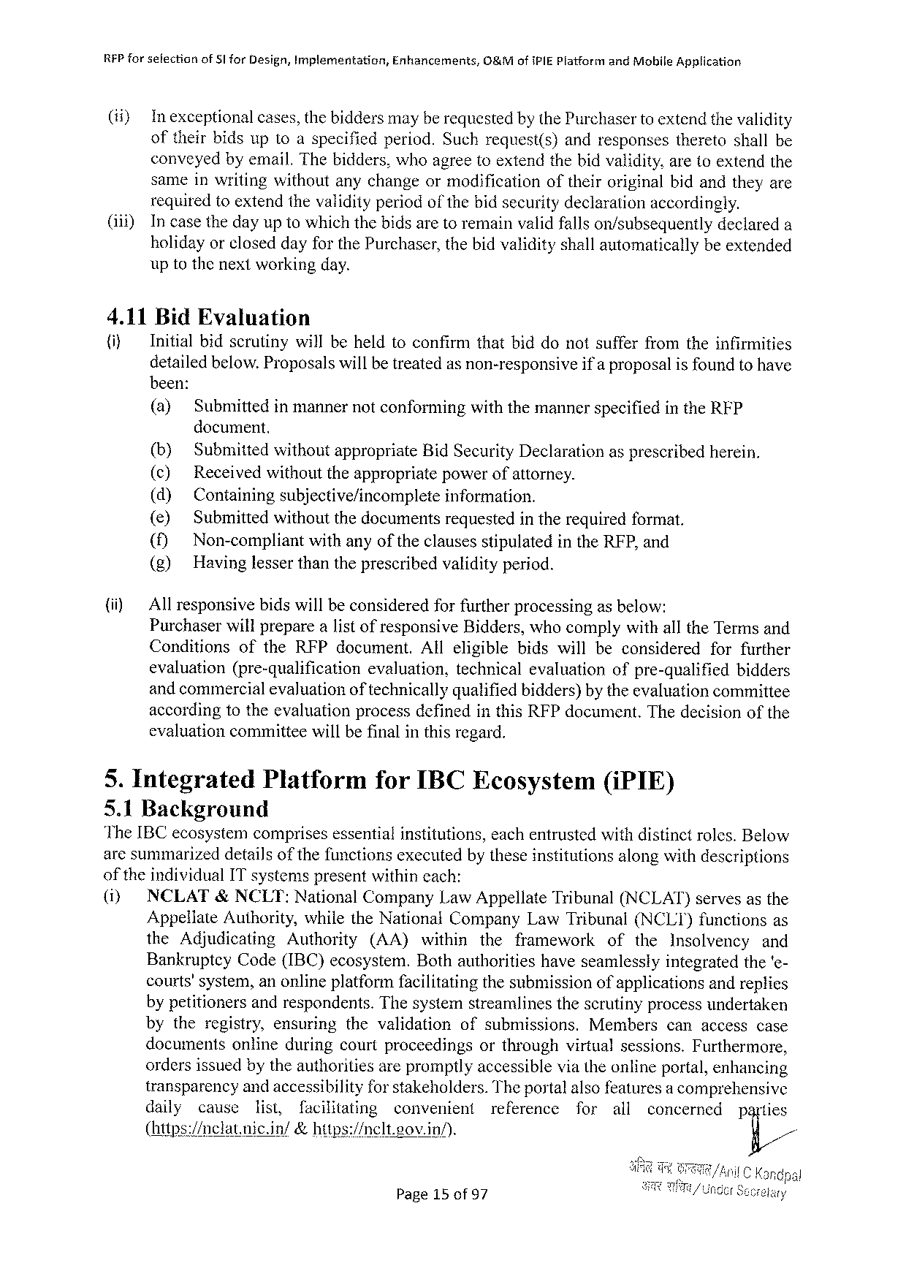

RFPforselfectionof§1forDesign,Implementation, Enhancements, O&MofIPIEPlatformandMobileApplication

(i) Inexceptional cases,thebiddersmayberequestedby thePurchasertoextendthevalidity

oftheirbidsuptoaspecifiedperiod.Suchrequest(s) andresponses theretoshallbe

conveyedbyemail.Thebidders,whoagreetoextendthebidvalidity,aretoextendthe

sameinwritingwithoutanychangeormodification oftheiroriginalbidandtheyare

requiredtoextendthevalidityperiod of thebidsecuritydeclarationaccordingly.

(i) Incasethedayuptowhichthebidsaretoremainvalidfallson/subsequently declareda

holidayorcloseddayforthePurchaser,thebidvalidityshallautomatically beextended

uptothenextworkingday.

4.11BidEvaluation

|  |  |  |  |
| --- | --- | --- | --- |
| {i) | Initialbidscrutinywillbeheldtoconfirmthatbiddonotsufferfromtheinfirmities | | |
| detailedbelow.Proposalswillbetreatedas non-responsive | | ifa proposalis foundtohave |
| been: | | |
| (a) | SubmittedinmannernotconformingwiththemannerspecifiedintheRFP | |

document.

|  |  |  |  |  |  |  |  |  |  |  |  |
| --- | --- | --- | --- | --- | --- | --- | --- | --- | --- | --- | --- |
| (i) | (b) | SubmittedwithoutappropriateBidSecurityDeclarationasprescribedherein. | | | | | | | | | |
| (c) | Receivedwithouttheappropriatepowerofattorney. | | | | | | | | | |
| (d) | Containingsubjective/incomplete | | | | | information. | | | | |
| (e) | Submittedwithoutthedocumentsrequestedintherequiredformat. | | | | | | | | | |
| () | Non-compliant | | withanyoftheclausesstipulatedintheRFP,and | | | | | | | |
| (g) | Havinglesserthantheprescribedvalidityperiod. | | | | | | | | | |
| Allresponsivebidswillbeconsideredforfurtherprocessingasbelow:  Purchaserwillpreparealistof responsiveBidders,whocomplywithalltheTermsand | | | | | | | | | | |
| Conditions | | oftheRFPdocument. | | | Alleligible | | bidswillbeconsidered | | forfurther | |
| evaluation | | (pre-qualification | | evaluation, | | technicalevaluation | | ofpre-qualified | | bidders |
| andcommercialevaluationof technicallyqualifiedbidders)by theevaluationcommittee accordingtotheevaluationprocessdefinedinthisRFPdocument.Thedecisionofthe evaluationcommitteewillbefinalinthisregard. | | | | | | | | | | |

5. IntegratedPlatformforIBCEcosystem(iPIE)

5.1Background

The[BC ecosystemcomprises essentialinstitutions, eachentrusted withdistinct roles.Below

aresummarizeddetailsofthefunctionsexecutedbytheseinstitutionsalongwithdescriptions

of the individualITsystems presentwithincach:

(i) NCLAT&NCLT:NationalCompanyLawAppellateTribunal(NCLAT)servesasthe

AppellateAuthority,whiletheNational CompanyLawTribunal(NCLT)functionsas

the Adjudicating Authority (AA) within the framework of the Insolvency and

BankrupteyCode(IBC)ecosystem.Bothauthoritieshaveseamlesslyintegratedthe‘e-

courts’system,anonlineplatformfacilitatingthesubmissionofapplicationsandreplies

bypetitionersandrespondents.Thesystemstreamlinesthescrutinyprocessundertaken

bytheregistry,ensuring thevalidation ofsubmissions. Members canaccesscase

documents onlineduringcourtproceedings orthroughvirtualsessions.Furthermore,

ordersissuedbytheauthoritiesarepromptlyaccessibleviatheonlineportal,enhancing

transparencyandaccessibilityfor stakeholders.Theportalalsofeaturesa comprehensive

daily cause list, facilitating convenient reference for all concerned parties

(https://clatnic.in/ &hitps:/nelt.eov.in/). y//

Page15of97

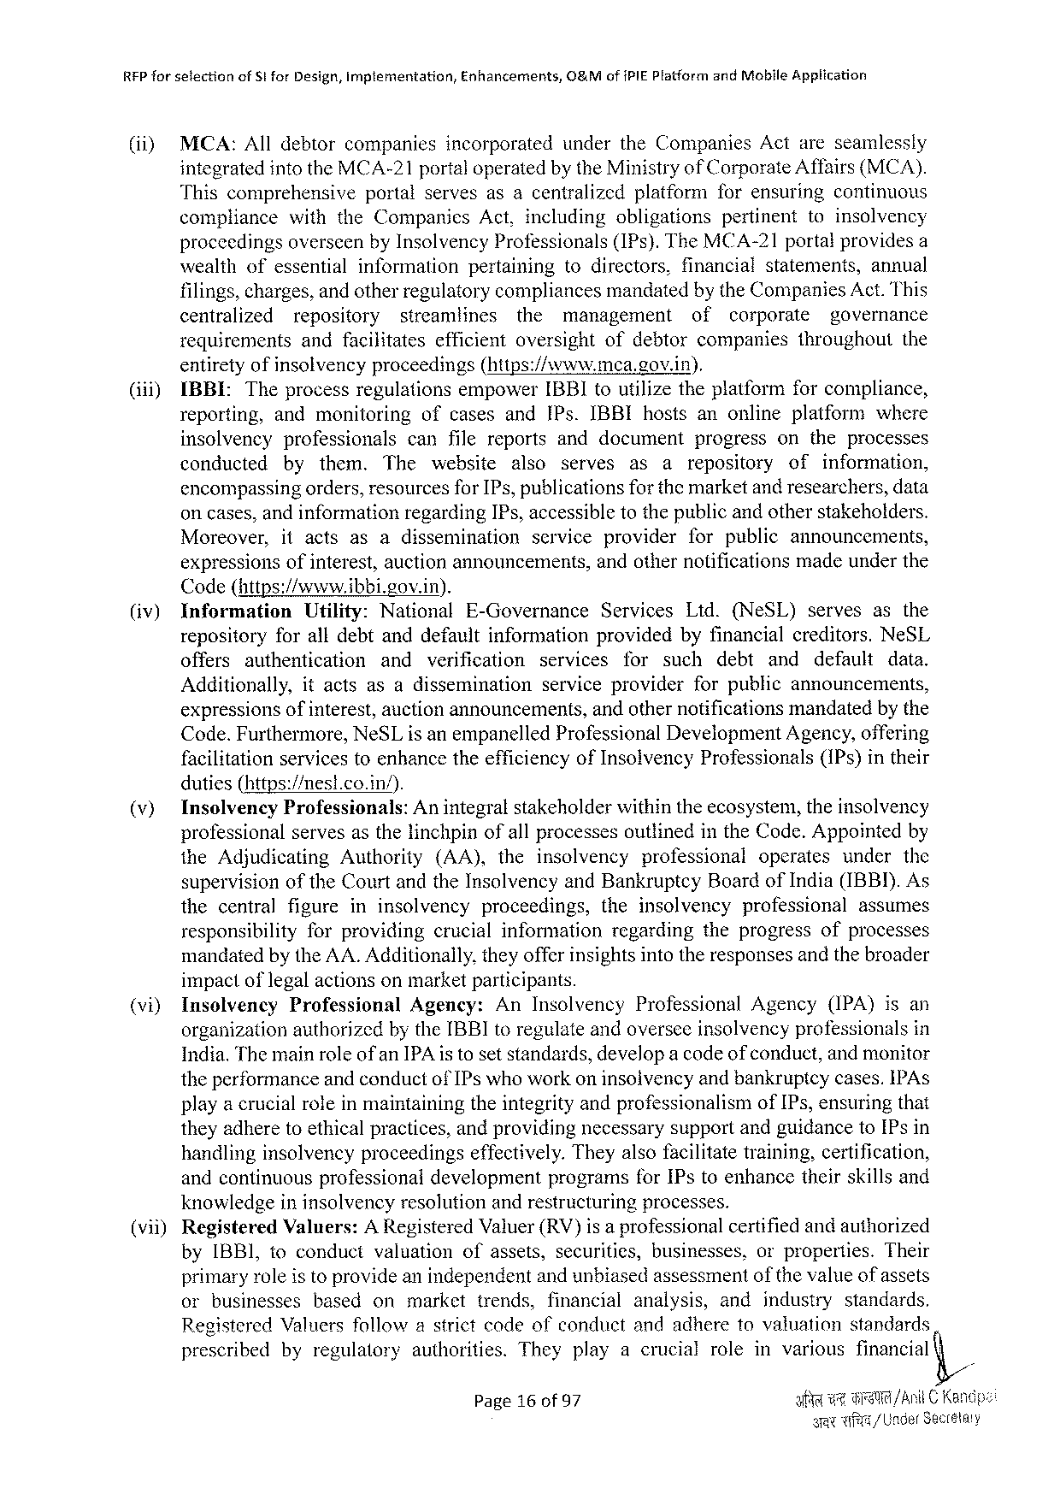

RFP for selectionofSi forDesign,Implementation,Enhancements,O&Mof PIEPlatform andMoblle Application

|  |  |  |  |
| --- | --- | --- | --- |
| (ii) | MCA:Alldebtorcompanies | incorporated | undertheCompaniesActareseamlessly |

integratedintotheMCA-21portaloperatedby theMinistryofCorporateAffairs(MCA).

Thiscomprehensive portalservesasacentralized platformforensuring continuous

compliance withtheCompanies Act,including obligations pertinent toinsolvency

proceedingsoverseenbyInsolvencyProfessionals(IPs).TheMCA-21portalprovidesa

|  |  |  |  |  |  |
| --- | --- | --- | --- | --- | --- |
| wealthofessential | information | pertaining | todirectors, | financialstatements, | annual |

filings,charges,and otherregulatorycompliancesmandatedby theCompaniesAct.This

centralized repository streamlines the management of corporate governance

requirements andfacilitates efficientoversight ofdebtorcompanies throughout the

entiretyofinsolvencyproceedings(https://www.mea.gov.in).

(iii) IBBIL:Theprocessregulations empowerIBBItoutilizetheplatformforcompliance,

reporting, andmonitoring ofcasesandIPs.IBBIhostsanonlineplatform where

insolvency professionals canfilereportsanddocument progress ontheprocesses

conducted by them. The website also serves as arepository of information,

encompassingorders,resourcesforIPs, publicationsforthemarketand researchers,data

oncases,andinformationregardingIPs, accessibletothepublicandotherstakeholders.

|  |  |  |  |  |  |
| --- | --- | --- | --- | --- | --- |
| Moreover, | itacts | asadissemination | service | provider | forpublicannouncements, |

expressionsofinterest,auctionannouncements, Code(https://www.ibbi.gov.in).

andothernotificationsmadeunderthe

|  |  |  |  |  |  |  |  |  |  |  |  |  |  |  |  |  |
| --- | --- | --- | --- | --- | --- | --- | --- | --- | --- | --- | --- | --- | --- | --- | --- | --- |
| (iv) | Information | | Utility: | National | | E-Governance | | | Services | | | Ltd.(NeSL) | | | serves | asthe |
| repositoryforalldebtanddefaultinformation providedbyfinancialcreditors.NeSL | | | | | | | | | | | | | | | |
| offers | authentication | | and | verification | | services | | | for | such | | debt | and | default | data. |
| Additionally, | | itactsasadissemination | | | | serviceprovider | | | | | forpublicannouncements, | | | | |
| expressionsofinterest,auctionannouncements, | | | | | | | andothernotificationsmandatedby the | | | | | | | | |

Code.Furthermore,NeSLisanempanelledProfessionalDevelopmentAgency,offering facilitationservicesfoenhancetheefficiencyofInsolvencyProfessionals(IPs)intheir duties(https:/mest.co.in/).

|  |  |  |  |
| --- | --- | --- | --- |
| (v) | Inselvency | Professionals: | Anintegralstakeholderwithintheecosystem,theinsolvency |

professionalservesasthelinchpinofallprocessesoutlinedintheCode.Appointedby

|  |  |  |  |  |  |  |  |
| --- | --- | --- | --- | --- | --- | --- | --- |
| theAdjudicating | Authority | (AA), | theinsolvency | professional | operates | under | the |

supervisionoftheCourtandtheInsolvencyandBankruptcyBoardofIndia(IBBI).As

|  |  |  |  |  |  |  |  |
| --- | --- | --- | --- | --- | --- | --- | --- |
| thecentral | figureininsolvency | | proceedings, | theinsolvency | | professional | assumes |
| responsibility | forproviding | crucialinformatjon | | regarding | theprogressofprocesses | | |

mandatedbytheAA.Additionally,theyofferinsightsintotheresponsesandthebroader impactoflegalactionsonmarketparticipants.

(vi) Insolvency Professional Agency: AnInsolvency Professional Agency (IPA)isan

organizationauthorizedby theIBBItoregulateandoverseeinsolvencyprofessionals in

India.Themainroleof anIPAistosetstandards,developa codeof conduct,andmonitor theperformanceandconductofIPs whoworkon insolvencyand bankruptcycases.IPAs playa crucialroleinmaintainingtheintegrityandprofessionalism ofIPs,ensuringthat

theyadheretoethicalpractices,andprovidingnecessarysupportandguidancetoIPsin

handlinginsolvencyproceedings

effectively.Theyalsofacilitatetraining,certification,

andcontinuousprofessionaldevelopment programsforIPstoenhancetheirskillsand

knowledgeininsolvencyresolutionandrestructuringprocesses.

(vii) Registered Valuers:ARegisteredValuer(RV)isa professionalcertifiedandauthorized

byIBBI,toconductvaluation ofassets,securities,businesses, orproperties. Their

primaryroleistoprovideanindependentandunbiasedassessmentofthevalueofassets

orbusinesses based onmarkettrends, financial analysis, andindustry standards.

RegisteredValuersfollowastrictcodeofconductandadheretovaluation standards

prescribed byregulatory authorities. Theyplayacrucial roleinvarious financial

Page16 of 97 i w7 G /ACKa

syWi/UnderSecestay

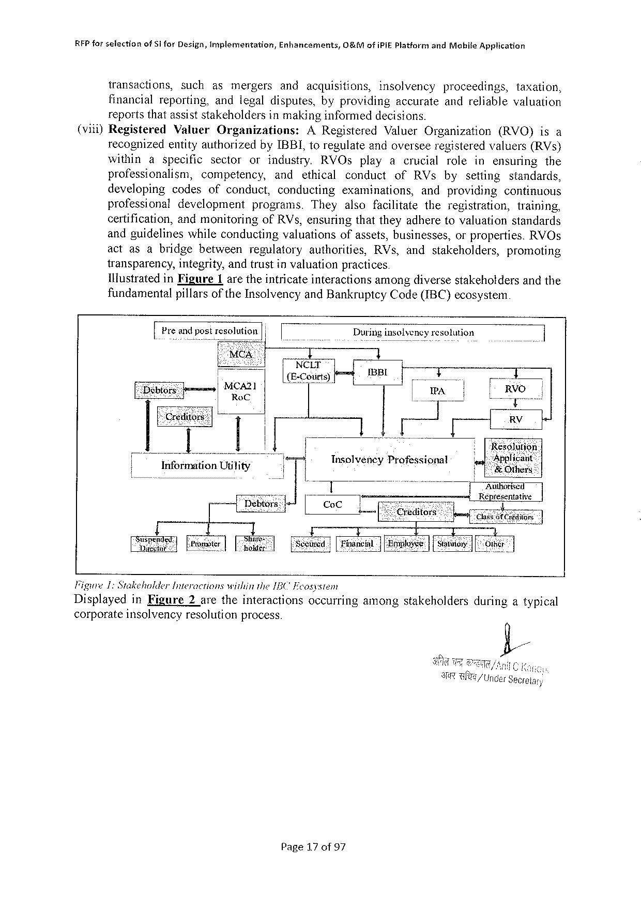

REP forsefection ofSl forDesign,inyplementation, Enhancements, O&MofiPIE PlatformandMabileApglication

transactions, such asmergers andacquisitions, insolvency proceedings, taxation,

financialreporting, andlegaldisputes,byproviding accurateandreliable valuation

reportsthatassiststakeholdersinmakinginformeddecisions.

(viil)Registered Valuer Organizations: ARegistered ValuerOrganization (RVO)isa

recognizedentityauthorizedbyIBBL,toregulateandoverseeregisteredvaluers(RVs)

within aspecific sector orindustry, RVOs playacrucial role inensuring the

professionalism, competency, and ethical conduct of RVsby setting standards,

developing codes ofconduct, conducting examinations, andproviding continuous

professional development programs. They alsofacilitate theregistration, training,

certification, andmonitoring ofRVs,ensuringthattheyadheretovaluationstandards

andguidelines whileconducting valuationsofassets,businesses, orproperties.RVOs

actasabridge between regulatory authorities, RVs,andstakeholders, promoting

transparency,integrity,andtrustinvaluationpractices

Ilustrated inFigure 1 aretheintricateinteractionsamongdiversestakehotdersandthe

fundamentalpillarsof the Insolvency andBankruptcy Code(IBC) ecosystem

IPrc’a solution|| | Duringinsolvency resolution

NCLT

|  |  |  |  |  |  |
| --- | --- | --- | --- | --- | --- |
| MCA2] | (E-Coiirts) | [ | T | ! | Atihorised |

Representative

|  |  |  |  |  |  |  |  |  |  |  |  |
| --- | --- | --- | --- | --- | --- | --- | --- | --- | --- | --- | --- |
| [s_;u;nznafitFrter ! 1 | | | | ||80 | I | i T  [Siduned |[nanel | | T  | [Bolosce| [y | T | [0 | 1  | |
| Figwre1:Stakeholder | | Interactions | | withinthe15C" Fcosysiem | | | | | | duringatypical | |
| Displayed | inFigure | | 2aretheinteractions | | | | occurringamongstakeholders | | |
| corporateinsolvency resolution process. | | | | | | | | | |

Page17of97

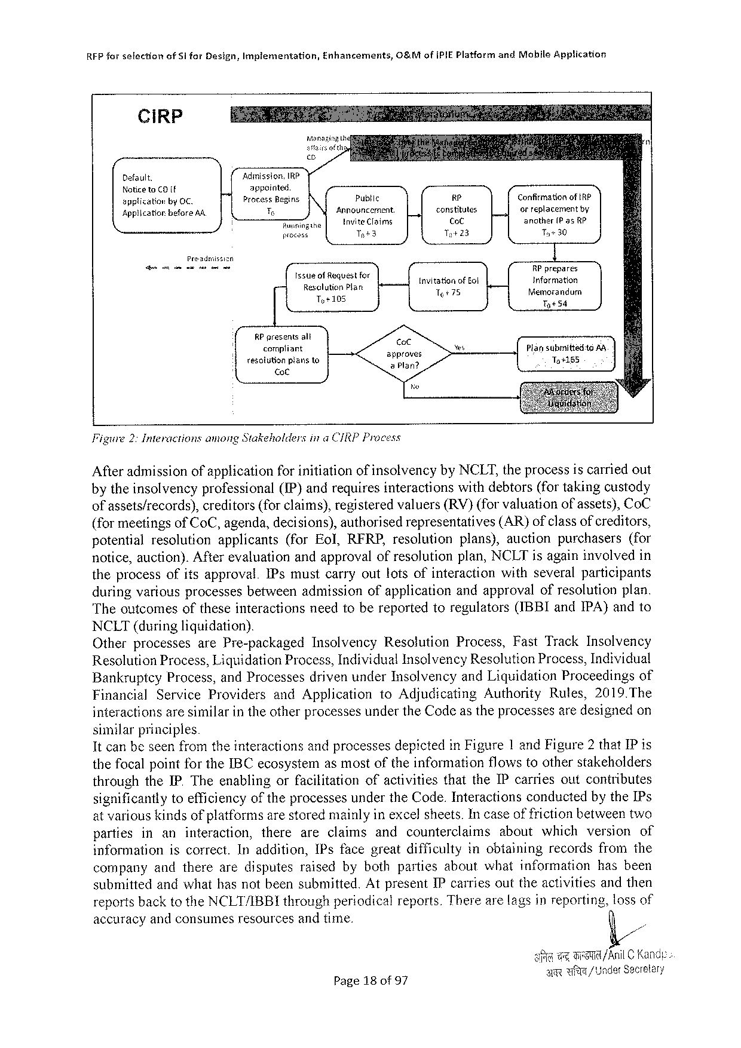

RFP for sslectionofS1 forDesign,Implementation,Enhancements,O&MofIPIEPlatformandMobileApplication

|  |  |  |  |  |
| --- | --- | --- | --- | --- |
| CiRP | m | | | ConfirmationofIRP  ofreplacementby  anather1Pas kP  Ty30  RP prapares  Information  fiemorandurm  TyS4  Piansubmittetitg AR To+185 |
| Default. | Adumission,IRP appointed  ProcessBegins T  Raninge  procass | Public | 4 |
| Noticeto CO {f  spplicationby OC.  AppiicatiorbeforeAA. |
| Announcement. Invite Claims | constitutes,   CoC |
| Tot3 | To+23 |
| Preadmissizn | | | |
| ssucotfeqvestioy   Re;s?in]agng fan  o | | | tnvitationof Eol Tt75 |
| RP presents alt   corpliant  resolitionpiansto   ot | | approves  & Plan? | |

Figure2:InteractionsamongStakeholdersina CIRPProcess

Afteradmissionofapplicationforinitiationof insolvencybyNCLT,theprocessiscarriedout

by the insolvencyprofessional(IP)andrequires interactions withdebtors(for takingcustody

ofassets/records),creditors(forclaims),registeredvaluers(RV)(forvaluationofassets),CoC

(formeetingsof CoC,agenda,decisions),authorisedrepresentatives (AR)ofclassofcreditors,

potential resolution applicants (forEol,RFRP,resolution plans),auctionpurchasers (for

notice,auction).After evaluationandapproval of resolutionplan,NCLTisagaininvolved in

theprocessofitsapproval.IPsmustcarryoutlotsofinteraction withseveralparticipants

duringvariousprocessesbetweenadmissionofapplicationandapprovalofresolutionplan.

Theoutcomesoftheseinteractionsneedtobereportedtoregulators(IBBIandIPA)andto

NCLT(during liquidation).

Otherprocesses arePre-packaged Insolvency Resolution Process,FastTrackInsolvency

ResolutionProcess,LiquidationProcess,IndividualInsolvencyResolutionProcess,Individual

Bankruptcy Process,andProcessesdrivenunderInsolvencyandLiquidationProceedings of

Financial Service Providers andApplication toAdjudicating Authority Rules,2019.The

interactionsaresimilarintheotherprocessesundertheCodeastheprocessesaredesignedon

similar principles

It canbeseenfromtheinteractionsandprocessesdepictedinFigure1andFigure2thatIP is

the focal point forthe IBC ecosystemasmostof theinformation flows toother stakeholders

throughtheIP. TheenablingorfacilitationofactivitiesthattheIPcarriesoutconiributes

significantlytoefficiencyoftheprocessesundertheCode.InteractionsconductedbytheIPs

at variouskindsof platformsarestoredmainlyin excel sheets.Incaseof frictionbetweentwo

partiesinaninteraction,thereareclaimsandcounterclaimsaboutwhichversionof

information iscorrect.Inaddition,IPsfacegreatdifficultyinobtainingrecordsfromthe

companyandtherearedisputesraisedbybothpartiesaboutwhatinformation hasbeen

submittedandwhathas notbeen submitted.Atpresent IP carriesoutthe activitiesandthen

reportsbacktotheNCLT/IBBIthroughperiodicalreports.Therearelagsinreporting,lossof

accuracyandconsumesresourcesandtime.

|  |  |  |  |
| --- | --- | --- | --- |
| Page18of97 | Bt | Fet | JAnilC Kandy- |
| ARwiE /UnderSecrelary | | |

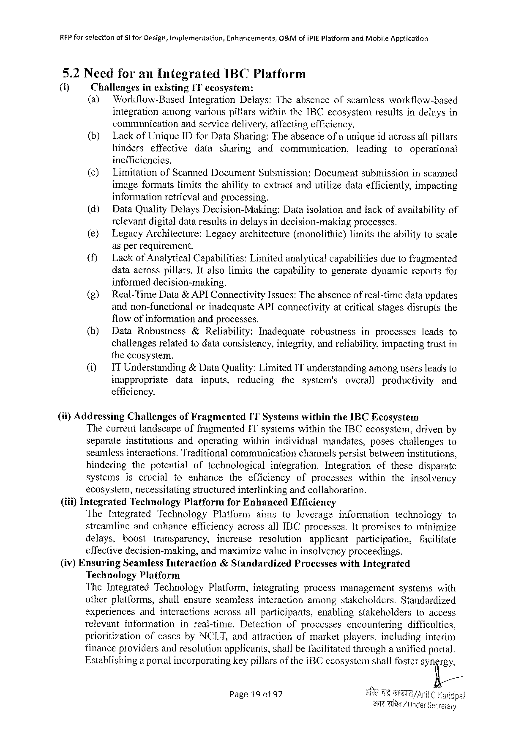

RFFforselection ofSt forDesign,Implementation, Enhancements, O&MofiPIEPlatformandMabileApplication

5.2NeedforanIntegrated IBCPlatform

(i) Challenges inexistingITecosystem:

(a) Workflow-Based Integration Delays:Theabsenceofseamlessworkflow-based

integrationamongvariouspillarswithintheIBCecosystemresultsindelaysin

communication andservicedelivery,affectingefficiency.

(b) LackofUniqueIDforDataSharing:Theabsenceofa unigueidacrossallpillars

hinders effective data sharing and communication, leading to operational

inefficiencies.

(¢) Limitation ofScanned Document Submission: Document submission inscanned

imageformatslimitstheabilitytoextractandutilizedataefficiently,impacting

informationretrievalandprocessing.

(d) DataQualityDelaysDecision-Making: Dataisolationandlackofavailabilityof

relevantdigitaldataresultsindelaysindecision-making processes.

(e) LegacyArchitecture: Legacyarchitecture (monolithic) limitstheabilitytoscale

asperrequirement.

(f) Lackof AnalyticalCapabilities:Limitedaralyticalcapabilities duetofragmented

dataacrosspillars.Italsolimitsthecapabilitytogeneratedynamicreportsfor

informeddecision-making.

|  |  |  |  |  |  |  |
| --- | --- | --- | --- | --- | --- | --- |
| (g)  (h) | Real-TimeData& APIConnectivityIssues:Theabsenceof real-timedataupdates | | | | | |
| andnon-functional | orinadequateAPIconnectivityatcriticalstagesdisruptsthe | | | | |
| flowofinformationandprocesses. | | | | | |
| DataRobustness | &Reliability: | Inadequate | robustness | inprocesses | leadsto |
| challengesrelatedtodataconsistency,integrity,andreliability,impactingtrustin | | | | | |

theecosystem.

|  |  |  |  |  |  |  |  |  |  |  |
| --- | --- | --- | --- | --- | --- | --- | --- | --- | --- | --- |
| (1) | ITUnderstanding | | &DataQuality:LimitedITunderstandingamongusersleadsto | | | | | | | |
| inappropriate | data | | inputs, | reducing | the | system's | overall | productivity | and |

efficiency.

|  |  |  |  |
| --- | --- | --- | --- |
| (ii)Addressing | Challenges | ofFragmented | ITSystemswithintheIBCEcosystem |

Thecurrentlandscapeoffragmented1TsystemswithintheIBCecosystem,drivenby

separate institutions andoperating withinindividual mandates, poseschallengesto

seamlessinteractions.Traditionalcommunication channelspersistbetweeninstitutions,

hindering thepotential oftechnological integration. Integration ofthesedisparate

systems iscrucial toenhance thecfficiency ofprocesses within theinsolvency

ecosystem,necessitatingstructuredinterlinkingandcollaboration.

(iii)Integrated Technology Platform forEnhanced Efficiency

TheIntegrated Technology Platform aimstoleverage information technology to

streamlineandenhanceefficiencyacrossallIBCprocesses. Itpromisestominimize

delays, boost transparency, increase resolution applicant participation, facilitate

effectivedecision-making, andmaximizevalueininsolvencyproceedings.

(iv)Ensuring SeamlessInteraction &Standardized ProcesseswithIntegrated

TechnologyPlatform

TheIntegrated Technology Platform, integrating process management systemswith

otherplatforms,shallensureseamlessinteractionamongstakeholders.Standardized

experiences andinteractions acrossallparticipants, enabling stakeholders toaccess

relevant information inreal-time. Detection ofprocesses encountering difficulties,

prioritization ofcasesbyNCLT,andattractionofmarketplayers,inciuding interim

financeprovidersandresolutionapplicants,shailbefacilitatedthrougha unifiedportal.

Establishinga portalincorporatingkeypillarsof theIBCecosystemshallfostersyngrg;

Page19of97

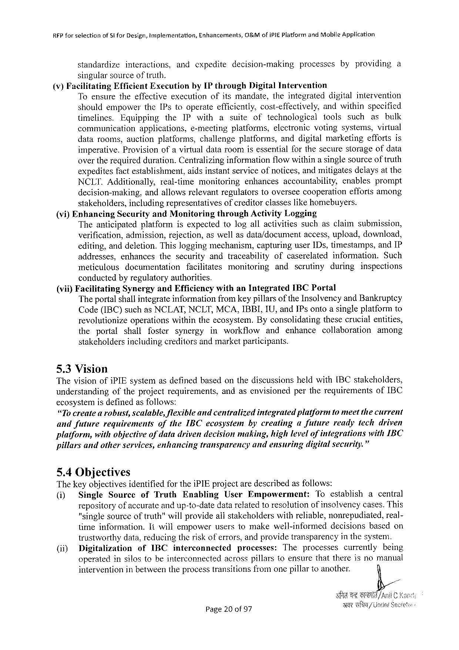

RFPforselection ofSi forDesign,tmplementation, Enhancements, O&MofiPIEPlatformandMobileAppiication

standardize interactions, andcxpedite decision-making processes byproviding a

singularsource of truth.

(v)Facilitating EfficientExecution byIPthrough DigitalIntervention

Toensuretheeffectiveexecution ofitsmandate, theintegrated digitalintervention

shouldempower theIPstooperateefficiently,cost-effectively, andwithinspecified

timelines. Equipping the IPwith a suite of technological tools such as bulk

communication applications, e-meeting platforms, electronic votingsystems,virtual

datarooms,auctionplatforms, challengeplatforms, anddigitalmarketing effortsis

imperative.Provision ofa virtualdataroomisessentialforthesecurestorageofdata

overtherequiredduration.Centralizinginformationflowwithinasinglesourceof truth

expeditesfactestablishment, aidsinstantserviceofnotices,andmitigatesdelaysatthe

NCLI. Additionally, real-time monitoring enhances accountability, enables prompt

decision-making, andallowsrelevantregulatorstooverseecooperation effortsamong

stakeholders,includingrepresentatives ofcreditorclasseslikehomebuyers.

(vi)Enhancing Security andMonitoring throughActivityLogging

Theanticipated platform isexpectedtologallactivities suchasclaimsubmission,

verification,admission,rejection,aswellasdata/document access,upload,download,

editing,anddeletion.Thisloggingmechanism,capturinguser1Ds,timestamps, andIP

addresses, enhances thesecurity andtraceability ofcaserelated information. Such

meticulous documentation facilitates monitoring and scrutiny during inspections

conductedbyregulatoryauthorities.

(vii)Facilitating SynergyandEfficiencywithanIntegrated IBCPortal

Theportal shallintegrateinformationfromkey pillarsof theInsolvencyandBankruptcy

Code(IBC)suchasNCLAT,NCLT,MCA,IBBI,IU,andIPsontoasingleplatformto

revolutionize operationswithintheecosystem.Byconsolidating thesecrucialentities,

the portal shall foster synergy inworkflow and enhance collaboration among

stakeholdersincludingcreditors andmarket participants.

5.3Vision

ThevisionofiPIEsystemasdefinedbasedonthediscussions heldwith[BCstakeholders,

understanding oftheprojectrequirements, andasenvisioned pertherequirements ofIBC

ecosystemisdefinedasfollows:

“Tocreatea robust,scalable,flexibleandcentralized integratedplatformtomeetthecurrent

andfuture requirements oftheIBCecosystem bycreating afuture readyfechdriven

platform, withobjectiveofdatadrivendecisionmaking,highlevelofintegrations withIBC

pillarsandotherservices,enhancing transparency andensuring digitalsecurity.”

5.4Objectives

ThekeyobjectivesidentifiedfortheiPIEprojectaredescribedasfollows:

(i) SingleSourccofTruth Enabling UserEmpowerment: Toestablishacentral

repositoryofaccurateandup-to-datedatarefatedtoresolutionofinsolvencycases.This

"singlesourceoftruth"willprovideallstakeholderswithreliable,nonrepudiated, real-

timeinformation. Itwillempoweruserstomakewell-informed decisions basedon

trustworthydata,reducingtheriskoferrors,andprovidetransparency in thesysten.

(ii) Digitalization ofIBC interconnected processes: The processes currently being

operatedinsilostobeinterconnected acrosspillarstoensurethatthereisnomanual

intervention inbetweentheprocesstransitionsfromonepillartoanother.

Page20of 97

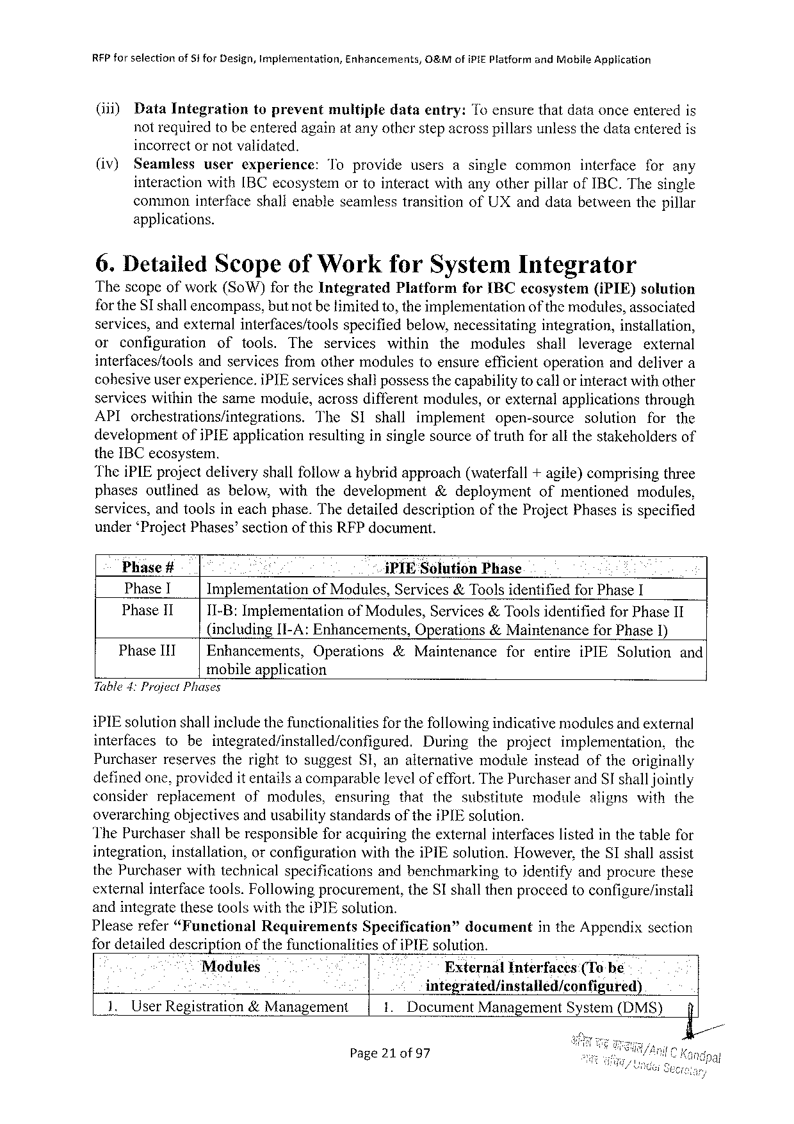

REP for selectionof81 forDesign,Implermentation, Enhancements,O&MofiPIEPlatform andMobileApplication

(iii) DataIntegration toprevent multiple dataentry: To ensurethatdataonceenteredis

notrequiredtobeenteredagainat anyotherstepacrosspillarsunlessthedataenteredis

incorrectornotvalidated.

(iv) Seamlessuserexperience: Toprovideusersasinglecommoninterfaceforany

interactionwith[BCecosystem ortointeractwithanyotherpillarofIBC,Thesingle

commoninterfaceshallenableseamlesstransitionofUXanddatabetweenthepillar

applications.

6.DetailedScopeofWorkforSystemIntegrator

Thescopeofwork(SoW)fortheIntegrated Platform forIBCecosystem(iPIE) solution

for theSI shallencompass,butnotbetimitedto, theimplementation ofthe modules,associated

services,andexternalinterfaces/tools specifiedbelow,necessitating integration,installation,

or configuration of tools. The services within the modules shall leverage external

interfaces/tools andservicesfromothermodulestoensureefficientoperationanddelivera

cohesiveuserexperience.iPIEservicesshall possessthecapabilityto callorinteractwithother

serviceswithinthesamemodule,acrossdifferentmodules,orexternalapplications through

API orchestrations/integrations. The SIshall implement open-source solution for the

development ofiPIEapplicationresultinginsinglesourceoftruthforallthestakeholdersof

theIBCecosystem.

TheiPIEprojectdeliveryshallfollowahybridapproach(waterfall+agile)comprisingthree

phasesoutlined asbelow,withthedevelopment &deployment ofmentioned modules,

services,andtoolsineachphase.Thedetaileddescription oftheProjectPhasesisspecified

under ‘ProjectPhases’sectionofthisRFPdocument.

Phase # * iPIE SolutionPhase

Phase1 Implementation ofModules,Services&ToolsidentifiedforPhaseI

Phase11 11-B:Implementation ofModules, Services &Toolsidentified forPhaseII

(including[I-A:Enhancements, Operations&MaintenanceforPhase1)

PhaseIIT Enhancements, Operations &Maintenance forentire iPIESolution and

mobileapplication

Table4:Project Phases

iPIEsolutionshallincludethefunctionalitiesfor thefollowingindicativemodulesand external

interfaces tobeintegrated/installed/configured. During theproject implementation, the

Purchaserreservestherightfosuggest SI,analternative moduleinsteadoftheoriginally

definedone,providedit entailsa comparablelevelofeffort.ThePurchaserand SI shalljointly

consider replacement ofmodules, ensuring thatthesubstitute module alignswiththe

overarchingobjectivesandusabilitystandards of the iPIEsolution.

The Purchasershall beresponsible foracquiringthe external interfaceslisted inthe tablefor

integration,installation,orconfigurationwiththeiPIEsolution.However,theSIshallassist

thePurchaserwithtechnicalspecifications andbenchmarking toidentifyandprocurethese

externalinterfacetools.Followingprocurement,theSI shallthenproceedtoconfigure/install

and integrate these toolswiththeiPIEsolution.

Pleaserefer“Funetional Requirements Specification” document intheAppendixsection

fordetaileddescriptionofthefunctionalities ofiPIEsolution.

Modules External Interfaces (Tobe

e integrated/installed/configured)

1.UserRegistration&Management . DocumentManagementSystem(DMS) f

Page21 of97

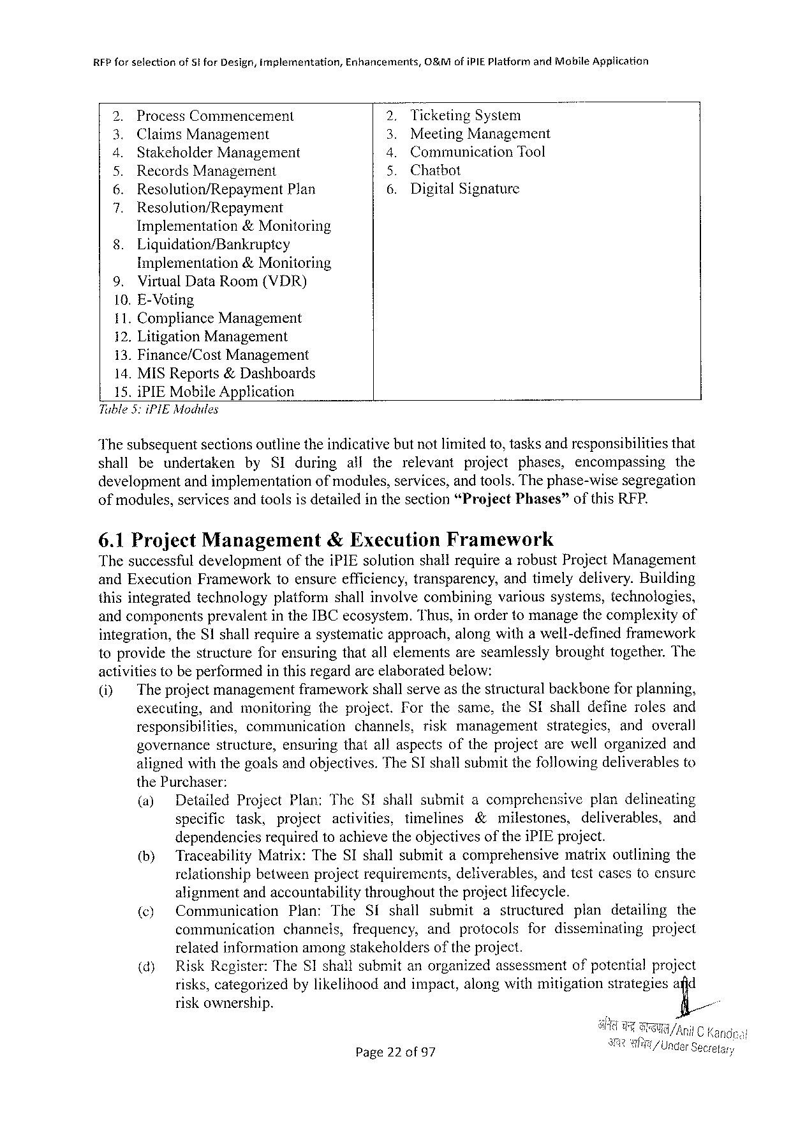

RFP for selectionofStforDesign,Implementation,Enhancements,O&MofiPIEPlatform andMobileApplication

|  |  |  |  |  |  |
| --- | --- | --- | --- | --- | --- |
| LR | ProcessCommencement | | S | TicketingSystem | |
| MeetingManagement | |
| ClaimsManagement | |
| StakeholderManagement | | Communication | Tool |
| RecordsManagement | | Chatbot | |
| Resolution/Repayment | Plan | 6. | DigitalSignature | |
| N | Resolution/Repayment | |
| 8. | Implementation &Monitoring | |
| Liquidation/Bankruptey | |

Implementation&Monitoring

9. VirtualDataRoom(VDR)

10. E-Voting

11. ComplianceManagement

12. Litigation Management

13. Finance/CostManagement

14. MISReports&Dashboards

15. iPIEMobileApplication

Tuble3:iPIEModules

Thesubsequentsectionsoutlinetheindicativebutnotlimitedto,tasksandresponsibilitiesthat

shall beundertaken by SIduring alltherelevant project phases, encompassing the

developmentandimplementation ofmodules,services,and tools.Thephase-wisesegregation

ofmodules, services andtoolsisdetailed inthesection “Project Phases” ofthisREP.

6.1Project Management &Execution Framework

Thesuccessfuldevelopment oftheiPIEsolutionshallrequirearobustProjectManagement

andExecutionFrameworktoensureefficiency,transparency, andtimelydelivery.Building

thisintegratedtechnology platformshallinvolvecombining varioussystems,technologies,

andcomponentsprevalentintheIBCecosystem.Thus,inordertomanagethecomplexityof

integration,theS1shallrequireasystematicapproach,alongwithawell-definedframework

toprovidethestructureforensuringthatallelementsareseamlesslybroughttogether.The

activitiestobeperformedinthisregardarcelaboratedbelow:

|  |  |  |  |  |  |  |  |  |  |
| --- | --- | --- | --- | --- | --- | --- | --- | --- | --- |
| (i) | The projectmanagementframeworkshallserveasthestructuralbackboneforplanning, | | | | | | | | |
| executing, | andmonitoring | | | theproject.Forthesame,theSIshalldefinerolesand | | | | |
| responsibilities, | | communication | | | channels, | riskmanagement | strategies, | andoverall |
| governance | structure, | | ensuringthatallaspectsoftheprojectarewellorganizedand | | | | | |

alignedwiththegoalsandobjectives.TheSIshallsubmitthefollowingdeliverablesto

thePurchaser:

|  |  |  |  |  |  |  |  |  |  |  |  |  |  |  |  |  |  |  |  |  |  |
| --- | --- | --- | --- | --- | --- | --- | --- | --- | --- | --- | --- | --- | --- | --- | --- | --- | --- | --- | --- | --- | --- |
| (a)  (h)  (¢)  (d) | Detailed | ProjectPlan:TheS!shallsubmitacomprehensive | | | | | | | | | | | | | | | | plandelineating | | | |
| specific | task, | | project | activities, | | | | timelines | | | &milestones, | | | | | deliverables, | | | | and |
| dependencies | | | requiredtoachievetheobjectivesoftheiPIEproject. | | | | | | | | | | | | | | | | | |
| TraceabilityMatrix:TheSIshallsubmitacomprehensive | | | | | | | | | | | | | | | | matrixoutliningthe | | | | |
| relationship | | betweenprojectrequirements, | | | | | | | | deliverables, | | | | | andtestcasestoensure | | | | | |
| alignmentandaccountabilitythroughouttheprojectlifecycle. | | | | | | | | | | | | | | | | | | | | |
| Communication | | | Plan: | The | | Si | shall | | submit | | | a | structured | | | plan | | detailing | | the |
| communication | | | channels, | | frequency, | | | | andprotocols | | | | | fordisseminating | | | | | project | |
| relatedinformationamongstakeholders ofthe project. | | | | | | | | | | | | | | | | | | | | |
| RiskRegister:TheSIshallsubmitanorganizedassessment | | | | | | | | | | | | | | | | ofpotentialproject | | | | |
| risks,categorizedbylikelihoodandimpact,alongwithmitigationstrategiesafid | | | | | | | | | | | | | | | | | | | | |
| riskownership. | | | | | | | | | | | | | | | | fi/ | | | | |

Page22 of97

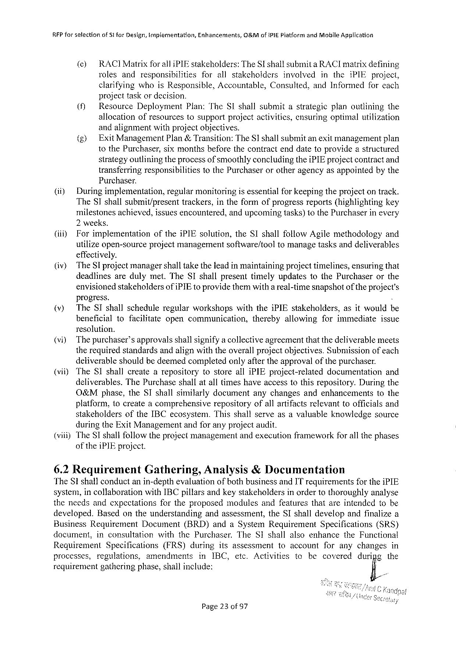

RFP forsefectionofSt forDesign,implementation,Enhancements,O&MofIPIEPlatform andMobileApplication

() RACIMatrix for all iPIEstakeholders:TheSI shallsubmita RACImatrixdefining

rolesand responsibilities forallstakeholders involved intheiPIEproject,

clarifying whoisResponsible,Accountable, Consulted,andInformedforcach

projecttaskordecision.

|  |  |  |  |
| --- | --- | --- | --- |
| (i | Resource | Deployment | Plan:TheSIshallsubmitastrategicplanoutliningthe |
| allocationofresourcestosupportprojectactivities,ensuringoptimalutilization | | |

andalignmentwithprojectobjectives.

|  |  |  |
| --- | --- | --- |
| (&) | ExitManagement | Plan&Transition:TheSI shallsubmitanexitmanagementplan |

tothePurchaser,sixmonthsbeforethecontractenddatetoprovideastructured

strategyoutliningtheprocessofsmoothlyconcludingtheiPIEprojectcontractand

transferringresponsibilities Purchaser.

tothePurchaserorotheragencyasappointedbythe

(i) Duringimplementation, regularmonitoringisessentialforkeepingtheprojectontrack.

TheSIshallsubmit/present trackers,intheformofprogressreports(highlighting key

milestonesachieved,issuesencountered,andupcomingtasks)tothePurchaserinevery

2weeks.

|  |  |  |  |
| --- | --- | --- | --- |
| (i) | Forimplementation | oftheiPIEsolution,theSIshallfollowAgilemethodology | and |

utilizeopen-sourceprojectmanagement effectively.

software/tooltomanagetasksanddeliverables

|  |  |  |  |  |  |  |  |  |  |
| --- | --- | --- | --- | --- | --- | --- | --- | --- | --- |
| (iv)  (v) | The SIprojectmanagershalltaketheleadin maintainingprojecttimelines,ensuringthat | | | | | | | | |
| deadlinesaredulymet.TheSIshallpresenttimelyupdatestothePurchaser | | | | | | | | orthe |
| envisionedstakeholdersofiPIEtoprovidethemwitha real-timesnapshotof theproject's | | | | | | | | |
| progress. | | | | | | | | ) |
| TheSIshallscheduleregularworkshops | | | withtheiPIEstakeholders, | | | | asitwouldb | |
| beneficial | tofacilitate | opencommunication, | | thereby | allowing | forimmediate | | issue |

resolution.

(vi) Thepurchaser’sapprovalsshallsignifya collectiveagreementthatthedeliverablemeets

therequiredstandardsandalignwiththeoverallprojectobjectives.Submissionofeach

deliverableshouldbedeemedcompletedonlyaftertheapprovalofthepurchaser.

(viiyTheSIshallcreatearepository tostorealliPIEproject-related documentation and

deliverables. ThePurchaseshallatalltimeshaveaccesstothisrepository.Duringthe

O&Mphase,theSIshallsimilarlydocument anychangesandenhancements tothe

platform,tocreate acomprehensive repositoryofallartifactsrelevant toofficialsand

stakeholders oftheIBCecosystem.Thisshallserveasavaluableknowledgesource

duringtheExitManagementandforanyprojectaudit.

(viii)TheSI shallfollowtheprojectmanagementandexecutionframeworkforall thephases

oftheiPIEproject.

|  |  |  |
| --- | --- | --- |
| 6.2Requirement | Gathering, | Analysis&Documentation |

TheSlshallconductanin-depthevaluationofbothbusinessandITrequirementsfortheiPIE

system,incollaboration withIBCpillarsandkeystakeholdersinordertothoroughlyanalyse

theneedsandexpectations fortheproposedmodulesandfeaturesthatareintendedtobe

developed. Basedontheunderstanding andassessment, theSIshalldevelopandfinalizea

BusinessRequirement Document (BRD)andaSystemRequirement Specifications (SRS)

document, inconsultation withthePurchaser. TheSIshallalsoenhance theFunctional

Requirement Specifications (FRS) during itsassessment toaccount foranychanges in

processes, regulations, amendments inIBC, etc.Activities to becovered duripg the

requirement gatheringphase,shallinclude: fi/

Page23 of97

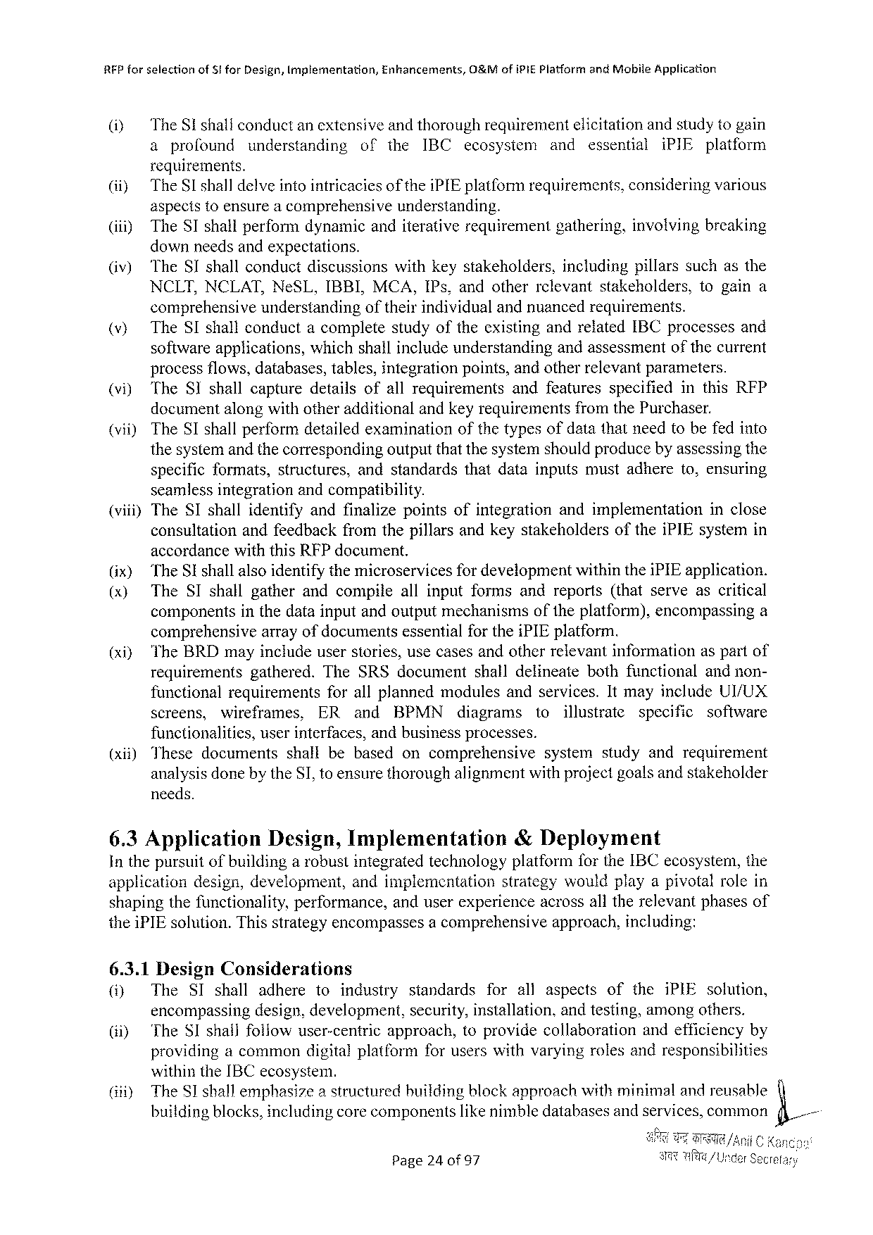

RFPforselection ofStforDesign,Implementation, Enhancements, O&MofiPIEPlatformandMobileApplication

i TheSishallconductanextensiveandthoroughrequirementelicitationandstudytogain

a profound understanding of the IBC ecosysiem and essential iPIE platform

requirements.

|  |  |  |  |
| --- | --- | --- | --- |
| (ii}  (ii) | TheSlshalldelveintointricaciesof theiPIEplatformrequirements,consideringvarious | | |
| aspectstoensurea comprehensive | understanding. | |
| TheSIshallperformdynamicanditerativerequirement | | gathering,involvingbreaking |

downneedsandexpectations.

|  |  |  |  |  |
| --- | --- | --- | --- | --- |
| @) | TheSIshallconductdiscussions | withkeystakeholders, | includingpillarssuchasthe | |
| NCLT,NCLAT,NeSL,IBBI,MCA,IPs,andotherrclevantstakeholders, | | | togaina |

comprehensiveunderstandingoftheirindividualandnuancedrequirements.

|  |  |  |  |
| --- | --- | --- | --- |
| )  S  (vii) | TheSIshallconductacompletestudyoftheexistingandrelatedIBCprocessesand | | |
| softwareapplications, | whichshallincludeunderstandingandassessmentofthecurrent | |
| processflows,databases,tables,integrationpoints,andotherrelevantparameters. TheSIshallcapturedetailsofallrequirementsandfeaturesspecifiedinthisRFP documentalongwithotheradditionalandkeyrequirementsfromthePurchaser. TheSIshallperformdetailed examinationof the typesofdata thatneed tobefedinto | | |
| thesystemandthecorrespondingoutputthatthesyster | | shouldproducebyassessingthe |

specificformats,structures,andstandardsthatdatainputsmustadhereto,ensuring

seamlessintegrationandcompatibility.

(viii) TheSIshallidentifyandfinalizepointsofintegration andimplementation inclose

consultation andfeedbackfromthepillarsandkeystakeholders oftheiPIEsystemin

accordancewiththisRFPdocument.

|  |  |  |  |  |  |  |  |  |  |  |  |  |  |
| --- | --- | --- | --- | --- | --- | --- | --- | --- | --- | --- | --- | --- | --- |
| (x) (x)  (xi)  (xii) | TheSI shallalsoidentifythemicroservices | | | | | | | | for developmentwithintheiPIEapplication. | | | | |
| TheSIshallgatherandcompile | | | | | | | allinputformsandreports(thatserveascritical | | | | | |
| components | | inthedatainputandoutputmechanismsoftheplatform),encompassinga | | | | | | | | | | |
| comprehensive | | | arrayofdocumentsessentialfortheiPIEplatform. | | | | | | | | | |
| TheBRDmayincludeuserstories,usecasesandotherrelevantinformationaspartof requirementsgathered.TheSRSdocumentshalldelineatebothfunctionalandnon- | | | | | | | | | | | | |
| functionalrequirements | | | | | forallplannedmodulesandservices.ItmayincludeUI/UX | | | | | | | |
| screens, | wireframes, | | | | ER | and | BPMN | diagrams | to | illustrate | specific | software |
| functionalities, | | | userinterfaces,andbusinessprocesses. | | | | | | | | | |
| Thesedocuments | | | | shallbebased | | | oncomprehensive | | systemstudyandrequirement | | | |

analysisdonebytheSI,toensurethoroughalignmentwithprojectgoalsandstakeholder

needs.

|  |  |  |
| --- | --- | --- |
| 6.3Application | Design,Implementation | &Deployment |

InthepursuitofbuildingarobustintegratedtechnologyplatformfortheIBCecosystem,the

|  |  |  |  |
| --- | --- | --- | --- |
| application | design,development, | andimplementation | strategywouldplayapivotalrolein |

shapingthefunctionality,performance,anduserexperienceacrossalltherelevantphasesof

theiPIEsolution.Thisstrategyencompassesacomprehensive 6.3.1DesignConsiderations

approach,including:

|  |  |  |  |  |  |  |  |  |  |  |  |
| --- | --- | --- | --- | --- | --- | --- | --- | --- | --- | --- | --- |
| ) | The | SIshall | adhere | toindustry | | standards | forall | aspects | of | theiPIEsolution, | L |
| encompassingdesign,development, | | | | | security,installation.andtesting,amongothers. | | | | |
| (i) |
| TheSIshallfollowuser-centric | | | | approach,toprovidecollaboration | | | | | andefficiencyby |
| providingacommondigitalplatformforuserswithvaryingrolesandresponsibilities | | | | | | | | | |
| (iti} | withintheIBCecosystem. | | | | | | | | | |
| TheS1 shallemphasizeastructuredbuildingblockapproachwithminimalandreusable | | | | | | | | | |
| buiidingblocks,includingcorecomponentslikenimbledatabasesand services,common | | | | | | | | | |
| Page24 0f97 | | | | | | | | | |

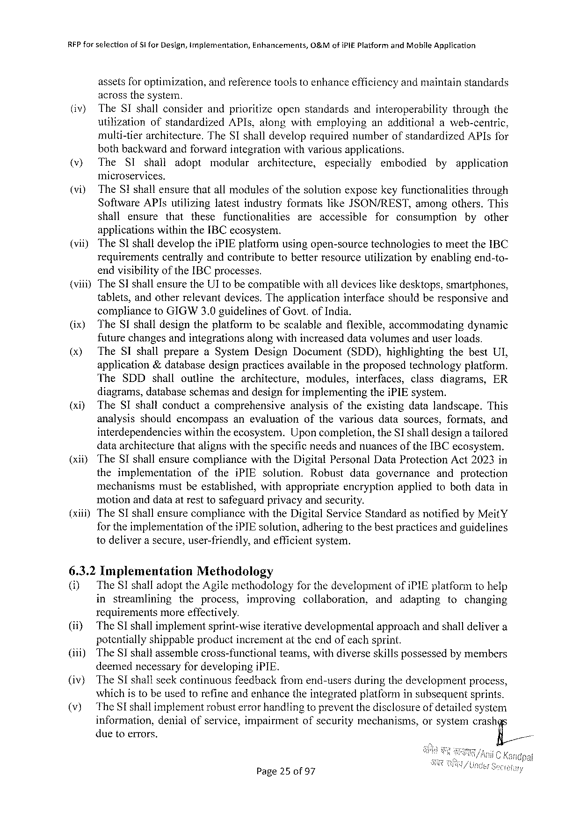

RFP farselectionofSi forDesign,tmplementation,Enhancements,O&MofiPIE Platform andMobileApplication

assetsfor optimization,andreferencetoolstoenhanceefficiencyandmaintainstandards

acrossthesystem.

|  |  |  |
| --- | --- | --- |
| (iv) | TheSIshallconsiderandprioritizeopenstandardsandinteroperability | throughthe |
| utilizationofstandardizedAPIs,alongwithemployinganadditionalaweb-centric, | |

multi-tierarchitecture.TheST shalldeveloprequirednumberofstandardizedAPIsfor

bothbackwardandforwardintegrationwithvariousapplications.

|  |  |  |  |  |  |  |  |  |  |
| --- | --- | --- | --- | --- | --- | --- | --- | --- | --- |
| (v) | TheSI | shall | adopt | modular | architecture, | especially | embodied | by | application |

microservices.

(vi) TheSIshallensurethatallmodulesofthesolutionexposekeyfunctionalities through

SoftwareAPIsutilizinglatestindustryformatslikeJSON/REST, amongothers.This

shall ensure that these functionalities areaccessible for consumption by other

applicationswithintheIBCecosystem.

(vit) TheSI shalldeveloptheiPIEplatformusingopen-sourcetechnologiestomeettheIBC

requirements centrallyandcontributetobetterresourceutilizationbyenablingend-to-

endvisibilityof theIBCprocesses.

(viii)TheSIshallensuretheUT tobecompatiblewithall deviceslikedesktops,smartphones,

|  |  |  |
| --- | --- | --- |
| tablets,andotherrelevantdevices.Theapplication | interfaceshouldberesponsive | and |

compliancetoGIGW3.0guidelinesofGovt.ofIndia.

|  |  |  |
| --- | --- | --- |
| (ix) | The SIshalldesigntheplatformtobescalableandflexible,accommodating | dynamic |

futurechangesandintegrationsalongwithincreaseddatavolumesanduserloads.

|  |  |  |  |  |
| --- | --- | --- | --- | --- |
| (x) | TheSIshallprepare | aSystemDesignDocument | (SDD),highlighting | thebestUI, |

application&databasedesignpracticesavailableintheproposedtechnologyplatform.

|  |  |  |  |  |  |  |  |
| --- | --- | --- | --- | --- | --- | --- | --- |
| The | SDDshall | outline | thearchitecture, | modules, | interfaces, | classdiagrams, | ER |

diagrams,databaseschemasanddesignforimplementingtheiPIEsystem.

{xiyTheSIshallconductacomprehensive analysisoftheexistingdatalandscape. This

analysisshouldencompass anevaluation ofthevariousdatasources,formats,and

interdependencies withintheecosystem. Uponcompletion,theSI shalldesigna tailored

dataarchitecturethatalignswiththespecificneedsandnuancesoftheIBCecosystem.

(xiiyTheSIshallensurecompliance withtheDigitalPersonalDataProtectionAct2023in

theimplementation oftheiPIEsolution. Robust datagovernance and protection

mechanisms mustbeestablished, withappropriate encryption appliedtobothdatain

motionanddataatresttosafeguardprivacyandsecurity.

(xiii)TheSIshallensurecompliancewiththeDigitalServiceStandardasnotifiedbyMeitY

for theimplementation of theiPIEsolution,adheringtothebestpracticesandguidelines

todeliverasecure,user-friendly,andefficientsystem.

6.3.2Implementation Methodology

(i) TheSIshalladopttheAgilemethodology forthedevelopment ofiPIEplatformtohelp

in streamlining theprocess, improving collaboration, and adapting tochanging

requirements more effectively.

(if) TheSI shallimplementsprint-wiseiterativedevelopmental approachandshalldelivera

potentiallyshippableproductincrementat theendofeachsprint.

|  |  |  |
| --- | --- | --- |
| (iii) | TheSI shallassemblecross-functional | teams,withdiverseskillspossessedbymembers |

deemednecessaryfordevelopingiPIE.

|  |  |  |  |  |
| --- | --- | --- | --- | --- |
| (iv) (v) | TheSIshallseekcontinuousfeedbackfromend-usersduringthedevelopmentprocess, whichistobeusedtorefineandenhancetheintegratedplatforminsubsequentsprints. | | | |
| TheSE shallimplementrobusterrorhandlingtopreventthedisclosure | | of detailed | system |
| information, | denialofservice,impairmentofsecuritymechanisms, | orsystemcrash | |
| duetoerrors. | | F;,/ | |

Page25 of97

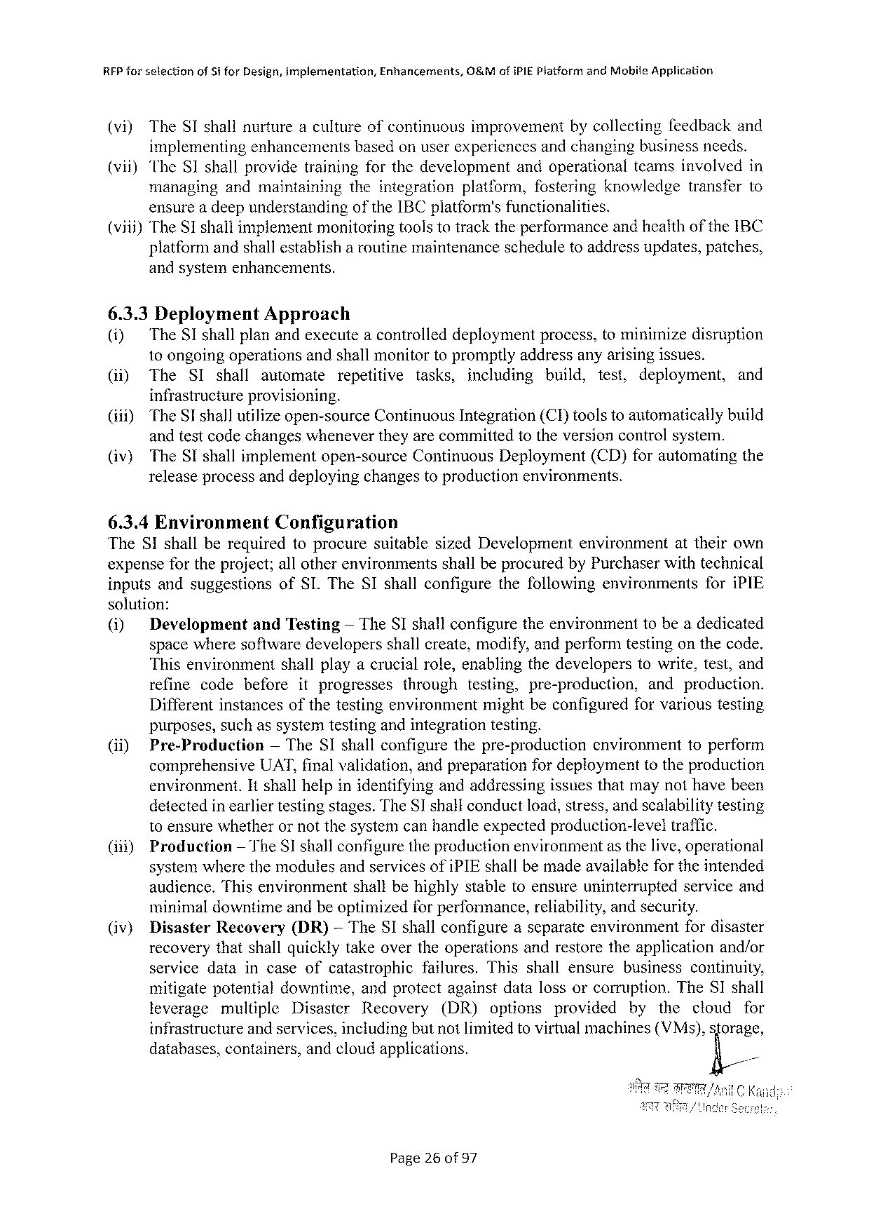

RFPforselection of$iforDesign,Implerentation, Enhancements, O&MofiPIE PlatformandMobileApplication

(vi) TheSIshallnurtureacultureofcontinuousimprovement bycollectingfeedbackand

implementingenhancementsbasedonuserexperiencesandchangingbusinessneeds.

(vii) TheSIshallprovidetrainingforthedevelopment andoperationalteamsinvolvedin

managing andmaintaining theintegration platform,fostering knowledge transferto

ensurea deepunderstandingoftheIBCplatform'sfunctionalities.

(viii)TheS1shallimplementmonitoringtoolstotracktheperformanceandheaithoftheIBC

platformandshallestablish a routinemaintenancescheduletoaddressupdates, patches,

andsystemenhancements,

6.3.3Deployment Approach

(i) TheSIshallplanandexecutea controlleddeploymentprocess,tominimizedisruption

toongoingoperationsandshallmonitortopromptlyaddressanyarisingissues.

|  |  |  |  |  |  |  |  |  |  |  |
| --- | --- | --- | --- | --- | --- | --- | --- | --- | --- | --- |
| (i) | The | SIshall | automate | repetitive | tasks, | including | build, | test, | deployment, | and |

infrastructureprovisioning.

|  |  |  |
| --- | --- | --- |
| (ii)) (iv) | TheSI shallutilizeopen-sourceContinuousIntegration(CI)toolstoautomaticallybuild andtestcodechangeswhenevertheyarecommittedtotheversioncontrolsystem. | |
| TheSIshallimplementopen-source | ContinuousDeployment(CD)forautomatingthe |

releaseprocessanddeployingchangestoproductionenvironments.

6.3.4Environment Configuration

TheSIshallberequiredtoprocuresuitable sizedDevelopment environment attheirown

expensefortheproject;allotherenvironments shallbeprocuredbyPurchaserwithtechnical

inputsandsuggestions ofSI.TheSIshallconfigure thefollowing environments foriPIE

solution:

|  |  |  |  |  |
| --- | --- | --- | --- | --- |
| (i) | Development | andTesting | — TheSIshallconfiguretheenvironment | tobeadedicated |

spacewheresoftwaredevelopersshallcreate,modify,andperformtestingonthecode.

Thisenvironment shallplayacrucialrole,enablingthedeveloperstowrite,test,and

refine codebefore itprogresses through testing, pre-production, andproduction.

Differentinstancesofthetestingenvironmentmightbeconfiguredforvarioustesting

purposes,suchassystemtestingandintegrationtesting.

|  |  |  |  |
| --- | --- | --- | --- |
| (ii) | Pre-Production | — TheSIshallconfigurethepre-production | environmenttoperform |

comprehensiveUAT,finalvalidation,andpreparationfordeploymenttotheproduction

environment.Itshallhelpinidentifyingandaddressingissuesthatmaynothavebeen

detectedinearliertestingstages.TheSshalconductload,stress,andscalabilitytesting

toensurewhetherornotthesystemcanhandleexpectedproduction-level traffic.

(i11)Production — TheSIshallconfiguretheproductionenvironmentasthelive,operational

systemwherethemodulesandservicesofiPIEshallbemadeavailabjefortheintended

|  |  |  |
| --- | --- | --- |
| audience.Thisenvironment | shallbehighlystabletoensureuninterrupted | serviceand |

minimaldowntimeandbeoptimizedforperformance,reliability,andsecurity.

|  |  |  |  |  |
| --- | --- | --- | --- | --- |
| (iv) | Disaster | Recovery | (DR) | — TheSIshallconfigureaseparateenvironmentfordisaster |

recoverythatshallquicklytakeovertheoperationsandrestoretheapplicationand/or

servicedataincaseofcatastrophic failures. Thisshallensure businesscontinuity,

mitigatepotentialdowntime, andprotectagainstdatalossorcorruption.TheSIshall

leverage multiple Disaster Recovery (DR) options provided by the cloud for

infrastructureandservices,includingbutnotlimitedto virtualmachines(VMs),sforage,

databases,containers,andcloudapplications. fi/

Page26of97

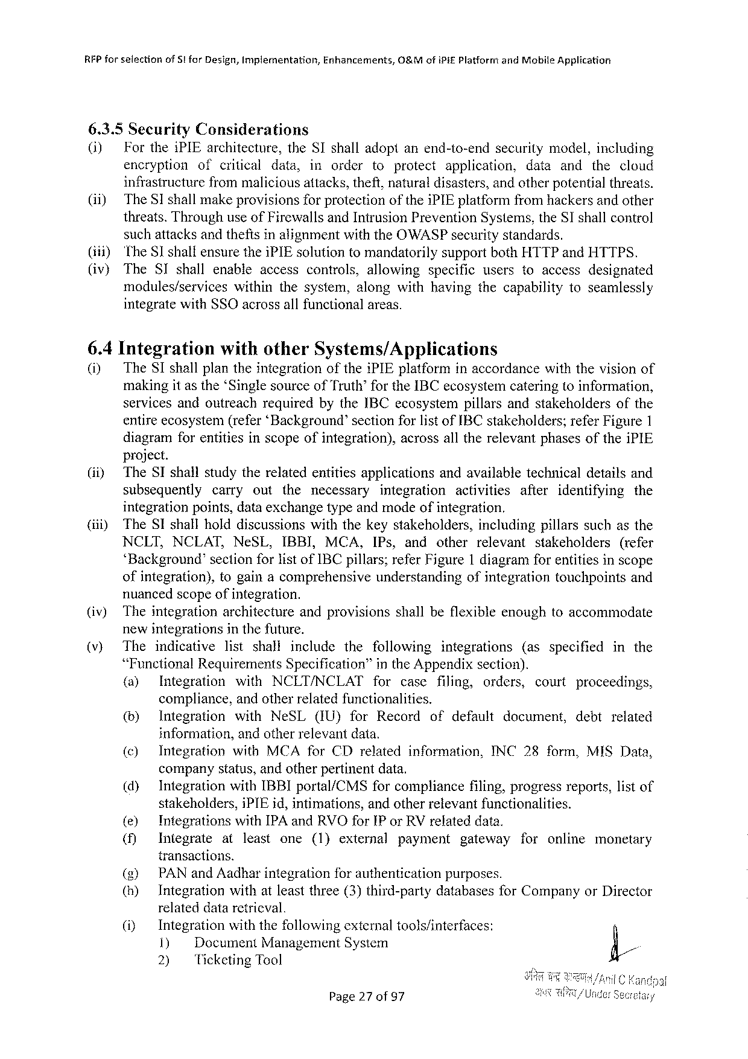

RFPfor selectionof51 forDesign,Implementation,Enhancements,&MofiPi£Platform andMobileApplication

6.3.5Security Considerations

(i) FortheiPIE architecture, theSIshall adopt anend-to-end security model, including

encryption ofcritical data, inorder toprotect application, dataand thecloud

infrastructure frommaliciousattacks,theft,naturaldisasters,andotherpotentialthreats.

(ii)~ TheSIshallmakeprovisions forprotectionoftheiPIEplatform fromhackersandother

threats.ThroughuseofFirewallsandIntrusionPreventionSystems,theSI shallcontrol

suchattacksand thefts inalignmentwiththeOWASPsecuritystandards.

(1) TheSIshalfensuretheiPIEsolutiontomandatorily supportbothHTTPandHTTPS.

(iv) The SIshallenableaccess controls, allowing specific userstoaccess designated

modules/services within thesystem,alongwithhavingthecapabilitytoseamlessly

integratewithSSOacrossallfunctionalareas.

6.4Integration withotherSystems/Applications

(i) TheSIshallplantheintegrationoftheiPIEplatforminaccordancewiththevisionof

makingit asthe‘SinglesourceofTruth’fortheIBCecosystemcateringtoinformation,

servicesandoutreachrequiredbytheIBCecosystempillarsandstakeholdersofthe

entireecosystem(refer‘Background’sectionforlistofIBCstakeholders;referFigure1

diagramforentitiesinscopeofintegration), project.

acrossalltherelevantphasesoftheiPIE

(i) TheSIshallstudytherelatedentitiesapplications andavailabletechnicaldetailsand

subsequently carry out the necessary integration activities after identifying the

integrationpoints,dataexchangetypeandmodeofintegration.

(iii) TheSIshallholddiscussionswiththekeystakeholders, includingpillarssuchasthe

NCLT,NCLAT, NeSL, IBBI, MCA, IPs, and other relevant stakeholders (refer

‘Background’ sectionforlistofIBCpillars;referFigure1 diagramforentitiesinscope

ofintegration), togainacomprehensive understanding ofintegrationtouchpointsand

nuancedscopeofintegration.

|  |  |  |  |  |
| --- | --- | --- | --- | --- |
| (iv) | Theintegration | architecture | andprovisions | shallbeflexibleenoughtoaccommodate |

newintegrationsinthefuture.

|  |  |  |  |  |  |  |  |  |  |  |  |  |  |  |  |
| --- | --- | --- | --- | --- | --- | --- | --- | --- | --- | --- | --- | --- | --- | --- | --- |
| (v) | The | indicative | | list | shall | | include | the | following | | integrations | | (asspecified | | inthe |
| “Functional | | Requirements | | | | Specification” | | intheAppendixsection). | | | | | | |
| (a) | Integration | | with | | NCLT/NCLAT | | |
| for | case | filing, | orders, | court | proceedings, | |

compliance,andotherrelatedfunctionalities.

|  |  |  |  |  |  |  |  |  |  |  |  |
| --- | --- | --- | --- | --- | --- | --- | --- | --- | --- | --- | --- |
| (&) | Integration | with | NeSL | (IU) | for | Record | of | default | document, | debt | related |

information,andotherrelevantdata.

|  |  |  |  |
| --- | --- | --- | --- |
| (©) | Integration | withMCAforCDrelatedinformation, | INC28form,MISData, |

companystatus,andotherpertinentdata.

|  |  |  |  |
| --- | --- | --- | --- |
| (d) | IntegrationwithIBBIportal/CMS | forcompliance | filing,progressreports,listof |

stakeholders,iPIEid,intimations,andotherretevantfunctionalities.

|  |  |  |  |  |  |  |  |  |  |  |
| --- | --- | --- | --- | --- | --- | --- | --- | --- | --- | --- |
| (&) | Integrations | at | withIPAandRVOforIPorRVrelated | | | | | data. | foronline | monetary |
| (f) | Integrate | least | one | (1)external | payment | gateway | |

transactions.

() PANand Aadharintegration forauthenticationpurposes.

() Integrationwithatleastthree(3)third-party databasesforCompanyorDirector

relateddataretricval.

|  |  |  |  |  |  |  |  |
| --- | --- | --- | --- | --- | --- | --- | --- |
| (i) | Integration | | | withthefollowing | external | tools/interfaces: | fi/ |
| 1) | | DocumentManagement | | System |
| 2) | Ticketing Tool | | |

Page27of97

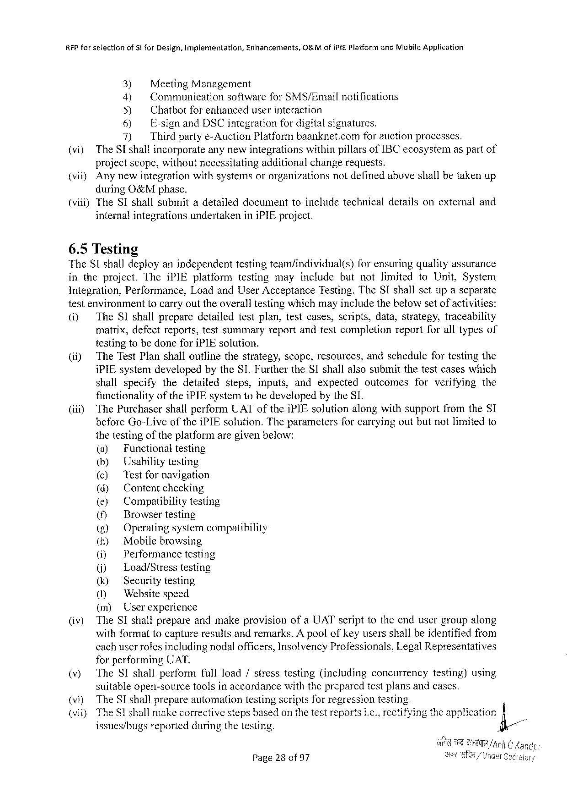

RFPforselection ofStforDesign,Implementation, Enhancements, O&MofiPIEPlatformandMobileApplication

3) MeetingManagement

4) CommunicationsoftwareforSMS/Emailnotifications

5) Chatbotfor enhanceduserinteraction

6) E-signandDSCintegrationfor digitalsignatures.

7) Thirdpartye-AuctionPlatformbaanknet.comfor auctionprocesses.

(vi) TheSshallincorporateanynewintegrationswithinpillarsofIBCecosystemas partof

projectscope,withoutnecessitatingadditionalchangerequests.

(viiyAnynewintegrationwithsystemsororganizationsnotdefinedaboveshallbetakenup

duringO&Mphase.

(viii)TheSIshallsubmitadetaileddocumenttoincludetechnicaldetailsonexternaland

internalintegrationsundertakeniniPIEproject.

6.5Testing

TheSIshalldeployanindependenttestingteam/individual(s) forensuringqualityassurance

intheproject. TheiPIEplatform testingmayincludebutnotlimited toUnit,System

Integration, Performance, LoadandUserAcceptanceTesting.TheSIshallsetupaseparate

testenvironmenttocarryouttheoveralltestingwhichmayincludethebelowsetofactivities:

(i) The SIshallpreparedetailedtestplan,testcases,scripts,data,strategy,traceability

matrix,defectreports,testsummaryreportandtestcompletionreportforalltypesof

testingtobedoneforiPIEsolution.

(ii) TheTestPlanshalloutlinethestrategy,scope,resources,andschedulefortestingthe

iPIEsystem:developedbytheSI.FurthertheSIshallalsosubmitthetestcaseswhich

|  |  |  |  |  |  |  |
| --- | --- | --- | --- | --- | --- | --- |
| shallspecify | thedetailed | steps, | inputs, | andexpected | outcomes | forverifyingthe |

functionalityoftheiPIEsystemtobedevelopedby theSI.

(iiiy ThePurchasershallperformUAToftheiPIEsolutionalongwithsupportfromtheSI

beforeGo-Live of the iPIEsolution.Theparameters for carryingoutbutnotlimitedto

thetestingoftheplatformaregivenbelow:

|  |  |  |  |  |
| --- | --- | --- | --- | --- |
| (iv) | (a) | Functionaltesting | | |
| (by | Usabilitytesting | | |
| (c) | 'Testfornavigation | | |
| (d) | Content | checking | |
| () | Compatibilitytesting | | |
| () | Browsertesting | | |
| (g) | Operatingsystemcompatibility | | |
| (h) | Mobilebrowsing | | |
| (i) | Performance | | testing |
| () | Load/Stresstesting | | |
| (k) | Securitytesting | | |
| () | Websitespeed | | |
| (m) | Userexperience | | |
| TheSIshallprepareandmakeprovisionofa UATscripttotheendusergroupalong | | | |

withformattocaptureresultsandremarks.Apoolofkeyusersshallbeidentifiedfrom

eachuserrolesincludingnodalofficers,InsolvencyProfessionals,LegalRepresentatives

forperforming UAT.

|  |  |  |  |  |
| --- | --- | --- | --- | --- |
| (v) | TheSIshallperformfullload/stresstesting(including | concurrency | testing)using | =~ |
| (vi) | suitableopen-source tools in accordancewith the prepared testplansandcases. | | |
| TheSI shallprepareautomationtestingscriptsforregressiontesting. | | |
| (vii) | TheSI shallmakecorrectivestepsbasedon thetestreportsi.c., rectifyingtheapplication | | |
| issues/bugsreportedduringthetesting. | | |

Page28of97

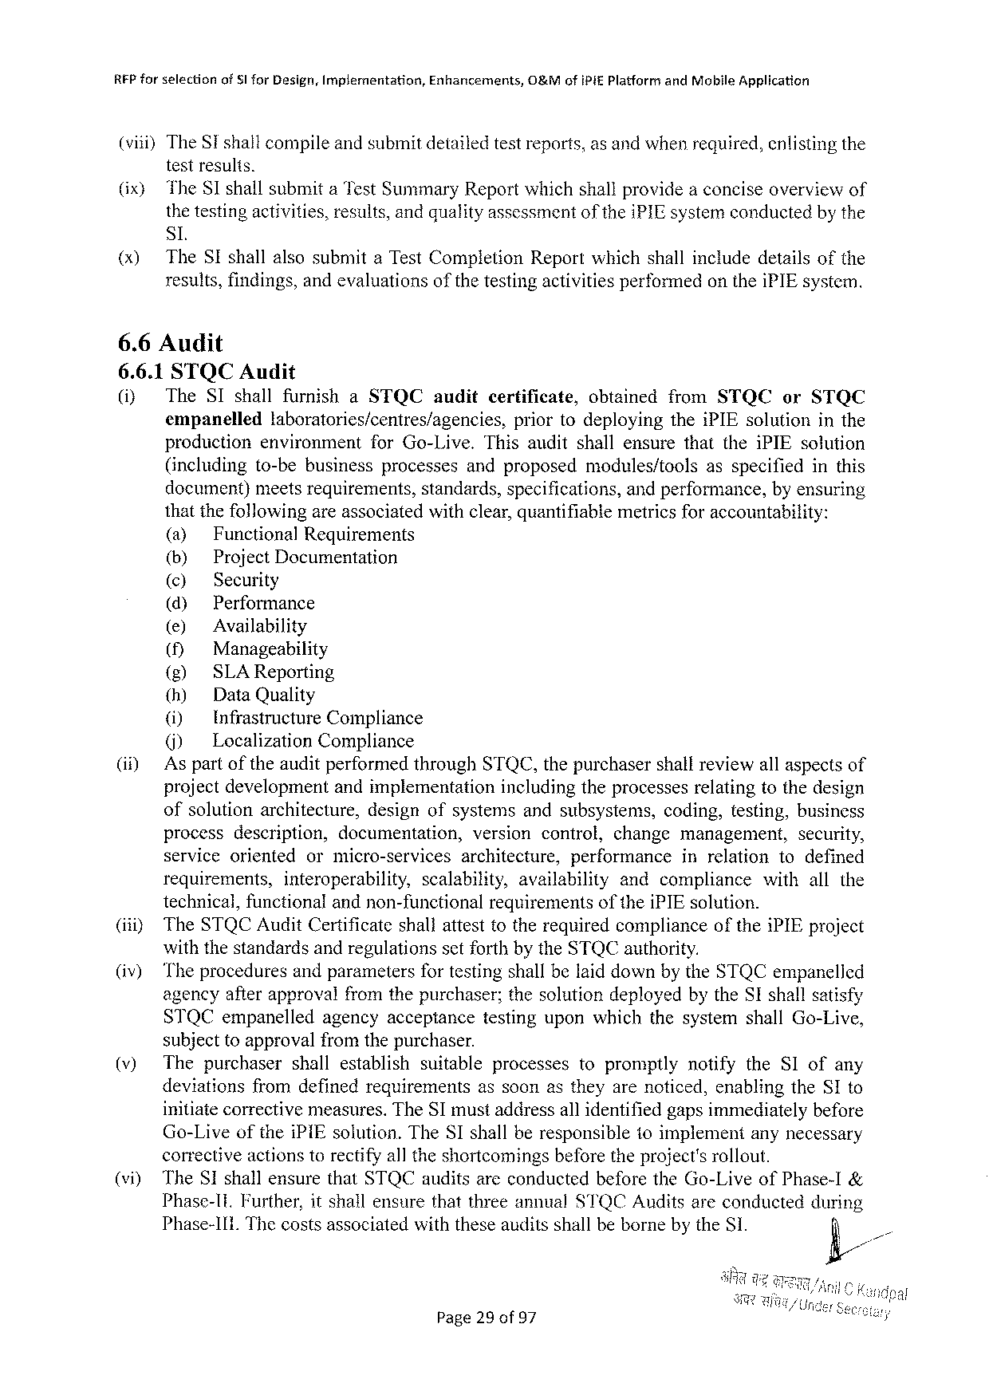

|  |  |  |  |
| --- | --- | --- | --- |
| REP forselection | ofSI forDesign,Implementation, | Enhancements, | O&MofiPiE PlatformandMobileApplication |

(viii)TheSishallcompileandsubmitdetailedtestreports,as andwhenrequired,enlistingthe

testresults.

|  |  |  |  |  |  |  |  |  |  |
| --- | --- | --- | --- | --- | --- | --- | --- | --- | --- |
| (ix)  (x) | TheSIshallsubmitaTestSunimaryReportwhichshallprovidea conciseoverviewof | | | | | | | | |
| thetestingactivities,results,andqualityassessment | | | | of the | iPIEsystemconductedby the | | | |
| SL | | | | | | | | |
| TheSIshall | alsosubmit | aTestCompletion | Report | which | shall | include | details | ofthe |

results,findings,andevaluationsofthetestingactivitiesperformedontheiPIEsystem.

6.6Audit

6.6.1STQCAudit

(i) TheSIshallfurnish aSTQC audit certificate, obtained fromSTQC or STQC

empanelled laboratories/centres/agencies, priortodeploying theiPIEsolutioninthe

production environment forGo-Live. ThisauditshallensurethattheiPIEsolution

(including to-bebusinessprocesses andproposed modules/tools asspecifiedinthis

document)meetsrequirements, standards,specifications, andperformance, byensuring

thatthefollowingareassociatedwithclear,quantifiablemetricsforaccountability:

(a) FunctionalRequirements

(b) Project Documentation

(©) Security

(d) Performance

(e) Availability

() Manageability

(g) SLAReporting

(h) DataQuality

(i) Infrastructure Compliance

() LocalizationCompliance

(i) AspartoftheauditperformedthroughSTQC,thepurchasershallreviewallaspectsof

projectdevelopment andimplementation includingtheprocessesrelatingtothedesign

ofsolutionarchitecture, designofsystemsandsubsystens, coding,testing,business

process description, documentation, versioncontrol, changemanagement, security,

serviceorientedormicro-servicesarchitecture,performanceinrelationtodefined

|  |  |  |  |  |  |  |  |  |
| --- | --- | --- | --- | --- | --- | --- | --- | --- |
| (iiiy | requirements, | interoperability, | scalability, | | availability | andcompliance | | withallthe |
| technical,functionalandnon-functional | | | requirementsof theiPIEsolution. | | | | iPIEproject |
| TheSTQCAuditCertificateshallattesttotherequiredcompliance | | | | | | of the |

withthestandardsandregulationssetforthbytheSTQCauthority.

(iv) TheproceduresandparametersfortestingshallbelaiddownbytheSTQCempanelled

agencyafterapprovalfromthepurchaser;thesolutiondeployedbytheSIshallsatisfy

|  |  |  |
| --- | --- | --- |
| STQCempanelled | agencyacceptance | testinguponwhichthesystemshallGo-Live, |

subjecttoapprovalfromthepurchaser.

|  |  |  |  |  |  |  |  |
| --- | --- | --- | --- | --- | --- | --- | --- |
| (v) | Thepurchaser | | shallestablish | suitable | processes | topromptly | notifytheSIofany |
| deviations | fromdefinedrequirements | | | assoonastheyarenoticed,enablingtheSIto | | |

initiatecorrectivemeasures.TheSTmustaddressallidentifiedgapsimmediatelybefore

Go-LiveoftheiPIEsolution.TheSIshallberesponsible toimplementanynecessary

correctiveactionstorectifyalltheshortcomingsbeforetheproject'srollout.

(vi) TheSIshallensurethatSTQCauditsareconductedbeforetheGo-LiveofPhase-I&

Phase-1t.Further,itshallensurethatthreeannualSTQCAuditsareconductedduring

Phase-1I1. ThecostsassociatedwiththeseauditsshallbebornebytheSI.

Page29of97

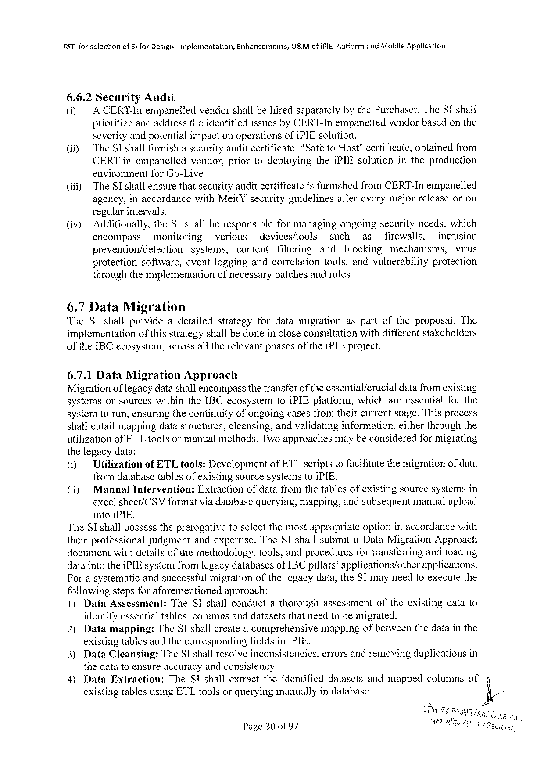

|  |  |  |
| --- | --- | --- |
| REPforsefectionofStforDesign,Implementation, | Enhancements, | O&MofiPIEPlatformandMobileApplication |

6.6.2SecurityAudit

(i) A CERT-InempanelledvendorshallbehiredseparatelybythePurchaser.TheSIshall

prioritizeandaddresstheidentifiedissuesbyCERT-Inempaneliedvendorbasedonthe

severityandpotentialimpactonoperationsofiPIEsolution.

@iy TheSIshallfurnish asecurity auditcertificate, “SafetoHost"certificate, obtained from

CERT-inempanelled vendor,prior(odeploying theiPIEsolutionintheproduction

environmentfor Go-Live.

(iii) TheSIshallensurethatsecurityauditcertificateisfurnishedfromCERT-Inempanelled

agency,inaccordancewithMeitYsecurityguidelines regularintervals.

aftercverymajorreleaseoron

(iv) Additionally,theSIshallberesponsible formanagingongoingsecurityneeds,which

encompass monitoring various devices/tools such as firewalls, intrusion

prevention/detection systems, content filtering

protection software,cventloggingandcorrelation

and blocking mechanisms, virus

tools,andvulnerability protection

throughtheimplementation of necessary patchesandrules.

6.7DataMigration

TheSIshallprovideadetailed strategyfordatamigration aspartoftheproposal. The

implementation ofthisstrategyshallbedoneincloseconsultationwithdifferentstakeholders

of the IBCecosystem,acrossalltherelevantphasesoftheiPIEproject.

6.7.1DataMigration Approach

Migrationof legacydatashallencompassthetransferof theessential/crucial datafromexisting

systemsorsources withintheIBCecosystemtoiPIEplatform,whichareessentialforthe

systemtorun,ensuringthecontinuityofongoingcasesfromtheircurrentstage.Thisprocess

shal} entailmappingdatastructures,cleansing,andvalidatinginformation,eitherthroughthe

utilizationofETLtoolsor manualmethods.Twoapproachesmaybeconsideredformigrating

thelegacydata:

(i) UtilizationofETLtools:DevelopmentofETLscriptstofacilitatethemigrationof data

fromdatabasetablesofexistingsourcesystemstoiPIE.

|  |  |  |  |
| --- | --- | --- | --- |
| (i) | Manual | Intervention: | Extractionofdatafromthetablesofexistingsourcesystemsin |

excelsheet/CSVformatviadatabasequerying,mapping,andsubsequentmanualupload

intoiPIE.

TheSIshallpossesstheprerogativetosclectthemostappropriateoptioninaccordancewith

theirprofessional judgmentandexpertise.TheSIshallsubmitaDataMigrationApproach

documentwithdetailsofthemethodology,tools,andproceduresfortransferringandloading

dataintotheiPIEsystemfromlegacydatabasesof IBCpillars®applications/other applications.

Forasystematicandsuccessfulmigrationofthelegacydata,theSI mayneedtoexecutethe

followingstepsforaforementioned approach:

1)DataAssessment: TheS shallconductathoroughassessment oftheexistingdatato

identifyessentialtables,columnsanddatasetsthatneedtobemigrated.

|  |  |  |  |  |  |  |  |
| --- | --- | --- | --- | --- | --- | --- | --- |
| 2) | Datamapping: | TheSIshallcreateacomprehensive | | | mappingofbetweenthedatainthe | | }, |
| existingtablesandthecorresponding | | | | fieldsiniPIE. | | |
| 3) | DataCleansing: | TheSIshallresolveinconsistencies, | | | | errorsandremovingduplicationsin |
| thedatatoensureaccuracyandconsistency. | | | | | | |
| 4)DataExtraction: | | | TheSIshallextracttheidentifieddatasetsandmappedcolumnsof | | | |
| existingtablesusingETLtoolsorqueryingmanuallyindatabase. | | | | | | |

Page30of97

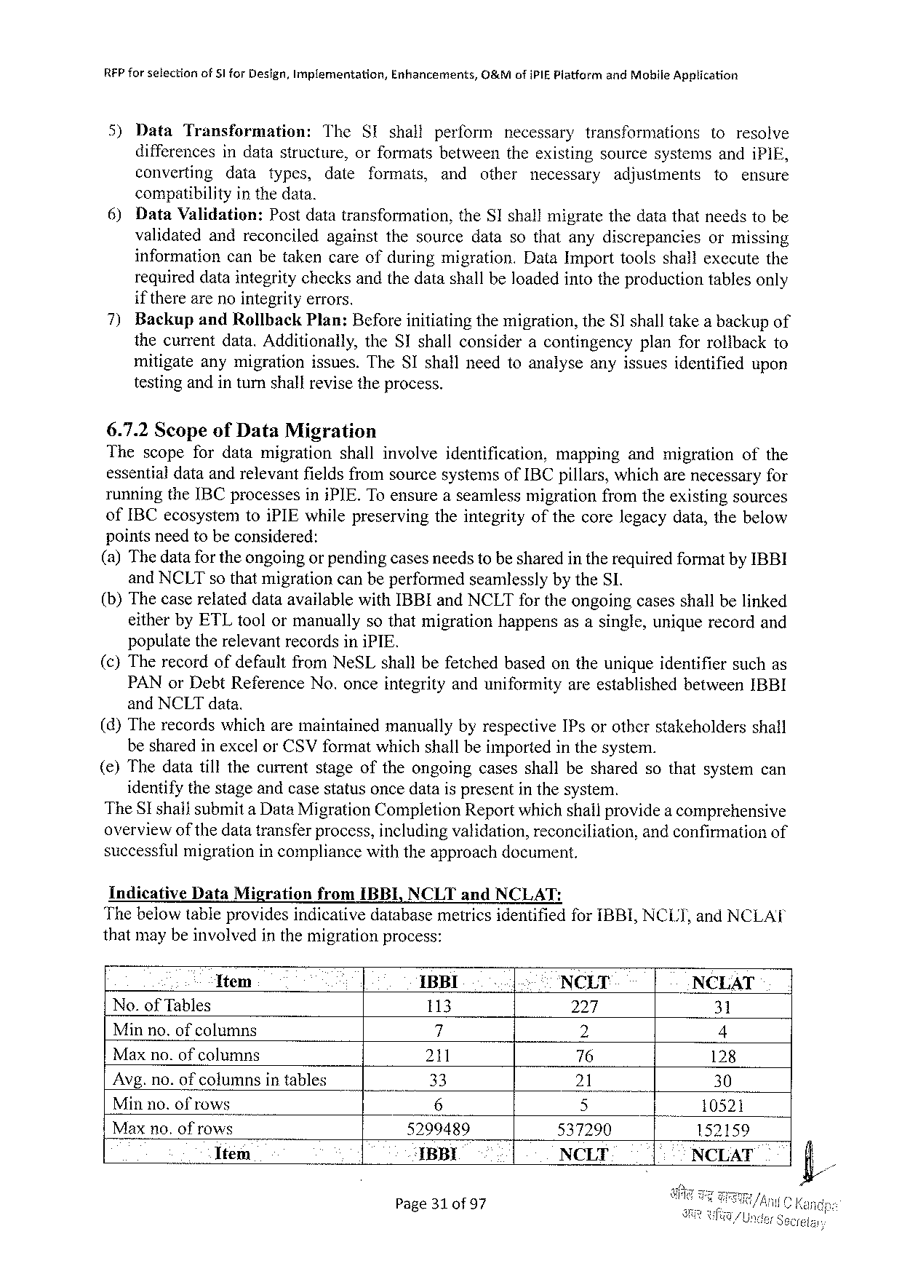

REP forselection of§l forDesign,Implementation, Enhancements, O&MofiPIEPlatformandMohileApplication

5) Data Transformation: The SIshall perform necessary transformations toresolve

differencesindatastructure, orformatsbetweentheexistingsourcesystemsandiPIE,

converting data types, date formats, and other necessary adjusiments to ensure

compatibilityinthedata.

6) DataValidation: Postdatatransformation, theSIshallmigratethedatathatneedstobe

validatedandreconciled againstthesourcedatasothatanydiscrepancies ormissing

information canbetakencareofduringmigration. DataImporttoolsshailexccutethe

requireddataintegritychecksandthedatashallbeloadedintotheproductiontablesonly

if therearenointegrityerrors.

7) Backup andRollbackPlan:Beforeinitiatingthemigration,theSI shalltakea backupof

thecurrentdata.Additionally,theSIshallconsideracontingency planforrolibackto

mitigateanymigrationissues.TheSIshallneedtoanalyseanyissuesidentified upon

testing andin turnshallrevise the process.

6.7.2ScopeofDataMigration

Thescopefordatamigration shallinvolve identification, mapping andmigration ofthe

essentialdataandrelevantfieldsfromsourcesystemsofIBCpillars,whicharenecessaryfor

runningtheIBCprocessesiniPIE.Toensureaseamlessmigrationfromtheexistingsources

ofIBCecosystemtoiPIEwhilepreservingtheintegrityofthecorelegacydata,thebelow

pointsneedtobeconsidered:

(a)Thedatafor theongoingor pendingcasesneedstobesharedintherequiredformatbyIBBI

andNCLTso thatmigrationcanbeperformedseamlesslybytheSI.

(b)ThecaserelateddataavailablewithIBBIandNCLTfortheongoingcasesshallbelinked

eitherbyETLtoolormanuallysothatmigrationhappensasasingle,uniquerecordand

populatetherelevantrecordsiniPIE.

(c)TherecordofdefaultfromNeSLshallbefetchedbasedontheuniqueidentifiersuchas

PANorDebtReferenceNo.onceintegrityanduniformityareestablishedbetweenIBBI

andNCLTdata.

(d)TherecordswhicharemaintainedmanuallybyrespectiveIPsorotherstakeholders shall

besharedinexcelorCSVformatwhichshallbeimportedinthesystem.

() Thedatatillthecurrentstageoftheongoingcasesshallbesharedsothatsystemcan

identifythestageandcasestatusoncedatais presentin thesystem.

TheSI shallsubmita DataMigrationCompletionReportwhichshallprovidea comprehensive

overviewofthedatatransferprocess,includingvalidation,reconciliation, andconfirmationof

successfulmigrationincompliancewiththeapproachdocument.

Indicative DataMigration fromIBBI,NCLTandNCLAT:

ThebelowtableprovidesindicativedatabasemetricsidentifiedforIBBI,NCLT,andNCLAT

thatmaybeinvolvedinthemigrationprocess:

Ttem : IBBI. .| NCLT NCLAT

No.of Tables 113 224, 31

Minno.ofcolumns 7 2 4

Maxno.ofcolumns 211 76 128

Avg.no.ofcolumnsintables 33 21 30

Minno.ofrows 6 5 10521 N

Maxno.of rows 5299489 537290 152159

Item ‘IBBI NCLT - NCLAT

Page310f97

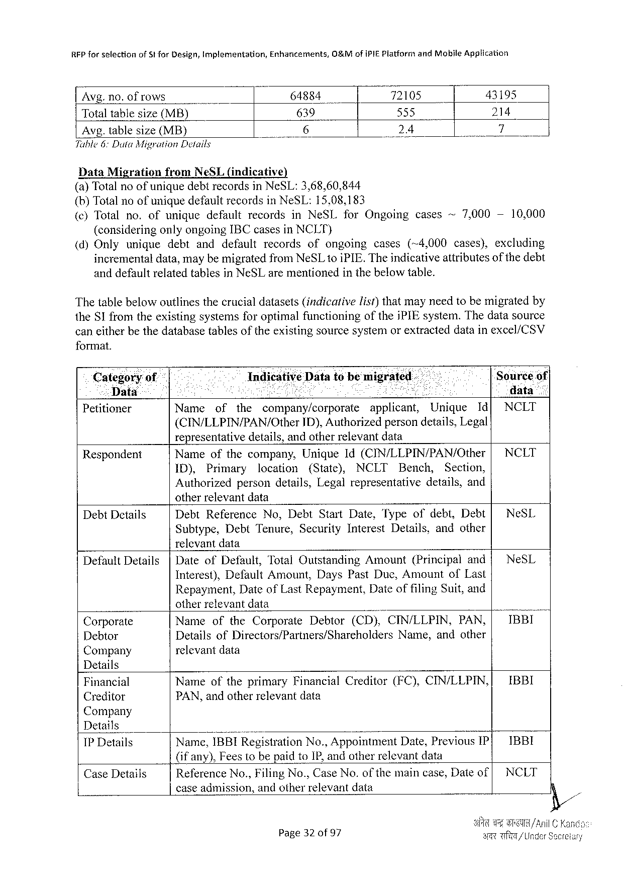

RFP for selectionofStforDesign,Implementation,Enhaticements,0&M ofiPIEPlatform andMobileApplication

|  |  |  |  |  |  |  |
| --- | --- | --- | --- | --- | --- | --- |
| Avg.no. ofrows | - | .6 | 64884 | 72105 | | | 43195 |
| Totaltablesize(MB) | 639 | 535 | 214 |
| 24 | 7 |
| Avg.tablesize(MB) |

Tuble6:DutaMigrationDetails

DataMigration fromNeSL(indicative)   
(a)TotalnoofuniquedebtrecordsinNeSL:3,68,60,844

(b)TotalnoofuniquedefaultrecordsinNeSL:15,08,183

|  |  |  |  |  |  |
| --- | --- | --- | --- | --- | --- |
| (¢)Totalno.ofunique | defaultrecords | inNeSLforOngoing | cases | ~7,000- | 10,0600 |

(consideringonlyongoingIBCcasesinNCLT)

|  |  |  |  |  |  |  |  |  |  |
| --- | --- | --- | --- | --- | --- | --- | --- | --- | --- |
| (d)Only | unique | debt | anddefault | records | ofongoing | cases | (~4,000 | cases), | excluding |

incrementaldata,maybemigratedfromNeSL1o iPIE.Theindicativeattributesofthedebt anddefaultrelatedtablesinNeSLarementionedinthebelowtable.

Thetablebelowoutlinesthecrucialdatasets(indicartivelist)thatmayneedtobemigratedby theSI fromtheexistingsystemsforoptimalfunctioning of thejPIEsystem.Thedatasource

caneitherbethedatabasetablesoftheexistingsourcesystemorextracteddatainexcel/CSV

format.

|  |  |  |  |  |  |  |  |  |  |  |
| --- | --- | --- | --- | --- | --- | --- | --- | --- | --- | --- |
| Categoryof | IndicativeData tobe migrated. | | | | | | | | | ‘Sourceof| |
| Data | R | | | | AN | | | | | data” |
| Petitioner | Name | of | the | company/corporate | | | applicant, | Unique | Id[ | NCLT |
| (CIN/LLPIN/PAN/Other | | | | | ID),Authorizedpersondetails,Legal | | | |

representativedetails,andotherrelevantdata

|  |  |  |  |  |  |  |  |  |  |  |  |
| --- | --- | --- | --- | --- | --- | --- | --- | --- | --- | --- | --- |
| Respondent | Nameofthecompany, | | | | Unique1d(CIN/LLPIN/PAN/Other | | | | | | | NCLT |
| ID), | Primary | | location | (State), | NCLT | Bench, | | Section, |
| Authorized | | persondetails,Legalrepresentative | | | | | details,and | |

otherrelevantdata

|  |  |  |  |  |  |  |  |
| --- | --- | --- | --- | --- | --- | --- | --- |
| DebtDetails | DebtReference | | No,DebtStartDate,Typeofdebt,Debt[ | | | | NeSL |
| Subtype, | DebtTenure, | | SecurityInterest | Details, | andother |

relevantdata

|  |  |  |  |  |  |  |  |
| --- | --- | --- | --- | --- | --- | --- | --- |
| DefaultDetails | |DateofDefault,TotalOutstanding | Amount | | (Principal | | and{ | NeSL |
| Interest),DefaultAmount,DaysPastDue,AmountofLast | | | | | |
| Repayment,DateofLastRepayment,Date | | of filing | | Suit,and | |

otherrelevantdata

|  |  |  |  |  |  |  |
| --- | --- | --- | --- | --- | --- | --- |
| Corporate | NameoftheCorporate | Debtor | (CD),CIN/LLPIN, | | PAN, | IBBI |
| Debtor | DetailsofDirectors/Partners/Shareholders | | | Name,andother | |
| Company | relevant data | | | | |

Details

|  |  |  |  |  |
| --- | --- | --- | --- | --- |
| Financial | NameoftheprimaryFinancial | Creditor | (FC),CINLLPIN,| | IBBI |
| PAN,andotherrelevantdata |
| Creditor |

Company

|  |  |  |  |  |  |  |
| --- | --- | --- | --- | --- | --- | --- |
| Details | Name, | ; | No.,Appointment | Date,Previous | IP| | 1BBI |
| 1BBIRegistration |
| 1PDetails |

(ifany),Fees(o bepaidtoIP,andotherrelevantdata

|  |  |  |  |  |  |
| --- | --- | --- | --- | --- | --- |
| CaseDetails | ReferenceNo.,FilingNo.,CaseNo. | of the | maincase,Dateof| | NCLT | |
| caseadmission,andotherrelevantdata | | %/, | | |
| ART | | /Under Secreiary |
| Page320f97 | |

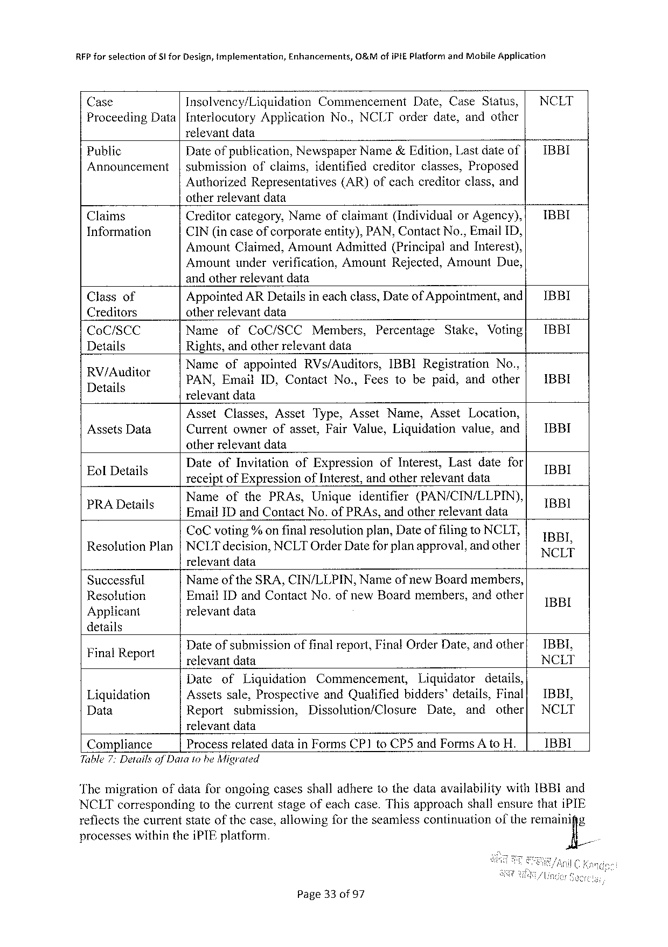

RFPforselection ofSI forDesign,implementation, Enhancements, O&MofiPIEPlatformandMobileApplication

Case Insolvency/Liquidation Commencement Date,CaseStatus, | NCLT

ProceedingData |InterlocutoryApplication relevantdata

No.,NCLTorderdate,andother

|  |  |  |  |  |  |
| --- | --- | --- | --- | --- | --- |
| Public | Dateof publication,NewspaperName&Edition,Lastdateof| | | | | IBBI |
| Announcement | |submission | ofclaims,identified | creditor | classes,Proposed |

AuthorizedRepresentatives otherrelevantdata

(AR)ofeachcreditorclass,and

|  |  |  |  |
| --- | --- | --- | --- |
| Claims | Creditorcategory,Nameofclaimant(Individual | orAgency),{ | IBBI |
| Information | CIN(in caseofcorporateentity),PAN,ContactNo.,EmailID, | |

AmountClaimed,AmountAdmitted(PrincipalandInterest), Amountunderverification,AmountRejected,Amount Due, andotherrelevantdata

|  |  |  |  |  |  |  |  |  |  |  |  |  |
| --- | --- | --- | --- | --- | --- | --- | --- | --- | --- | --- | --- | --- |
| Classof | AppointedARDetailsineachclass,Dateof Appointment,and[ | | | | | | | | | | | IBBI |
| Creditors | otherrelevantdata | | | | | | | | | | | IBBI |
| CoC/SCC | Name | | of | CoC/SCC | | Members, | | Percentage | Stake, | | Voting| |
| Details | Rights,andotherrelevantdata | | | | | | | | | | | IBBI |
| RV/Auditor | Nameofappointed | | | | | RVs/Auditors, | | IBBIRegistration | | | No., |
| .  Details | PAN,EmailID,Contact | | | | | | No.,Feestobepaid,andother| | | | | |
| relevantdata | | | | | | | | | | |
| AssetsData | Asset | Classes, | | | Asset | Type,AssetName, | | | Asset | Location, | | IBBI |
| Currentownerofasset,FairValue,Liquidation | | | | | | | | | value,and | |

otherrelevantdata

|  |  |  |  |  |  |  |  |  |  |
| --- | --- | --- | --- | --- | --- | --- | --- | --- | --- |
| n | DateofInvitation | | ofExpression | | | ofInterest, | | Lastdatefor | IBBI  il  BRI  NCL'l!‘ |
| EolDetails | receiptofExpressionofInierest,andotherrelevantdata | | | | | | | |
| i | Name | ofthePRAs, | | Unigue | identifier | | (PAN/CIN/LLPIN), | |
| PRADetails | EmaifIDandContactNo.ofPRAs,andotherrelevantdata | | | | | | | |
| CoCvoting%onfinalresolutionplan,DateoffilingtoNCLT, Resolution Plan|NCLTdecision,NCLTOrderDatefor planapproval,andother | | | | | | | | |

relevantdata

|  |  |  |  |  |  |  |
| --- | --- | --- | --- | --- | --- | --- |
| Successful | Name | of the | SRA,CIN/LLPIN, | Name | ofnewBoardmembers, | IBBI |
| Resolution | EmailIDandContactNo.ofnewBoardmembers,andother | | | | |
| Applicant | relevant data | | | | |

details

|  |  |  |  |  |  |  |  |  |  |
| --- | --- | --- | --- | --- | --- | --- | --- | --- | --- |
| FinalReport | Dateofsubmissionoffinalreport,FinalOrderDate,andother| | | | | | | | | IBBL, |
| relevantdata | | | | | | | | NCLT |
| Liquidation | Date | of | Liquidation | Commencement, | | Liquidator | | details, |
| IBBI, |
| Assetssale,Prospective | | | | andQualifiedbidders’details,Final| | | | |
| Data | Report | submission, | | Dissolution/Closure | | Date, | and | other| | NCLT |

relevantdata

|  |  |  |
| --- | --- | --- |
| Compliance | ProcessrelateddatainFormsCP1toCP5andFormsA toH. | 1BBI |

Table7:Detailsof Dataiohe Migrated

ThemigrationofdataforongoingcasesshalladheretothedataavailabilitywithIBBIand NCLTcorresponding tothecurrentstageofeachcase.ThisapproachshallensurethatiPIE reflectsthecurrentstateof thecase,allowingfortheseamlesscontinuation oftheremain‘ig% processeswithintheiPTEplatform.

Page330f 97

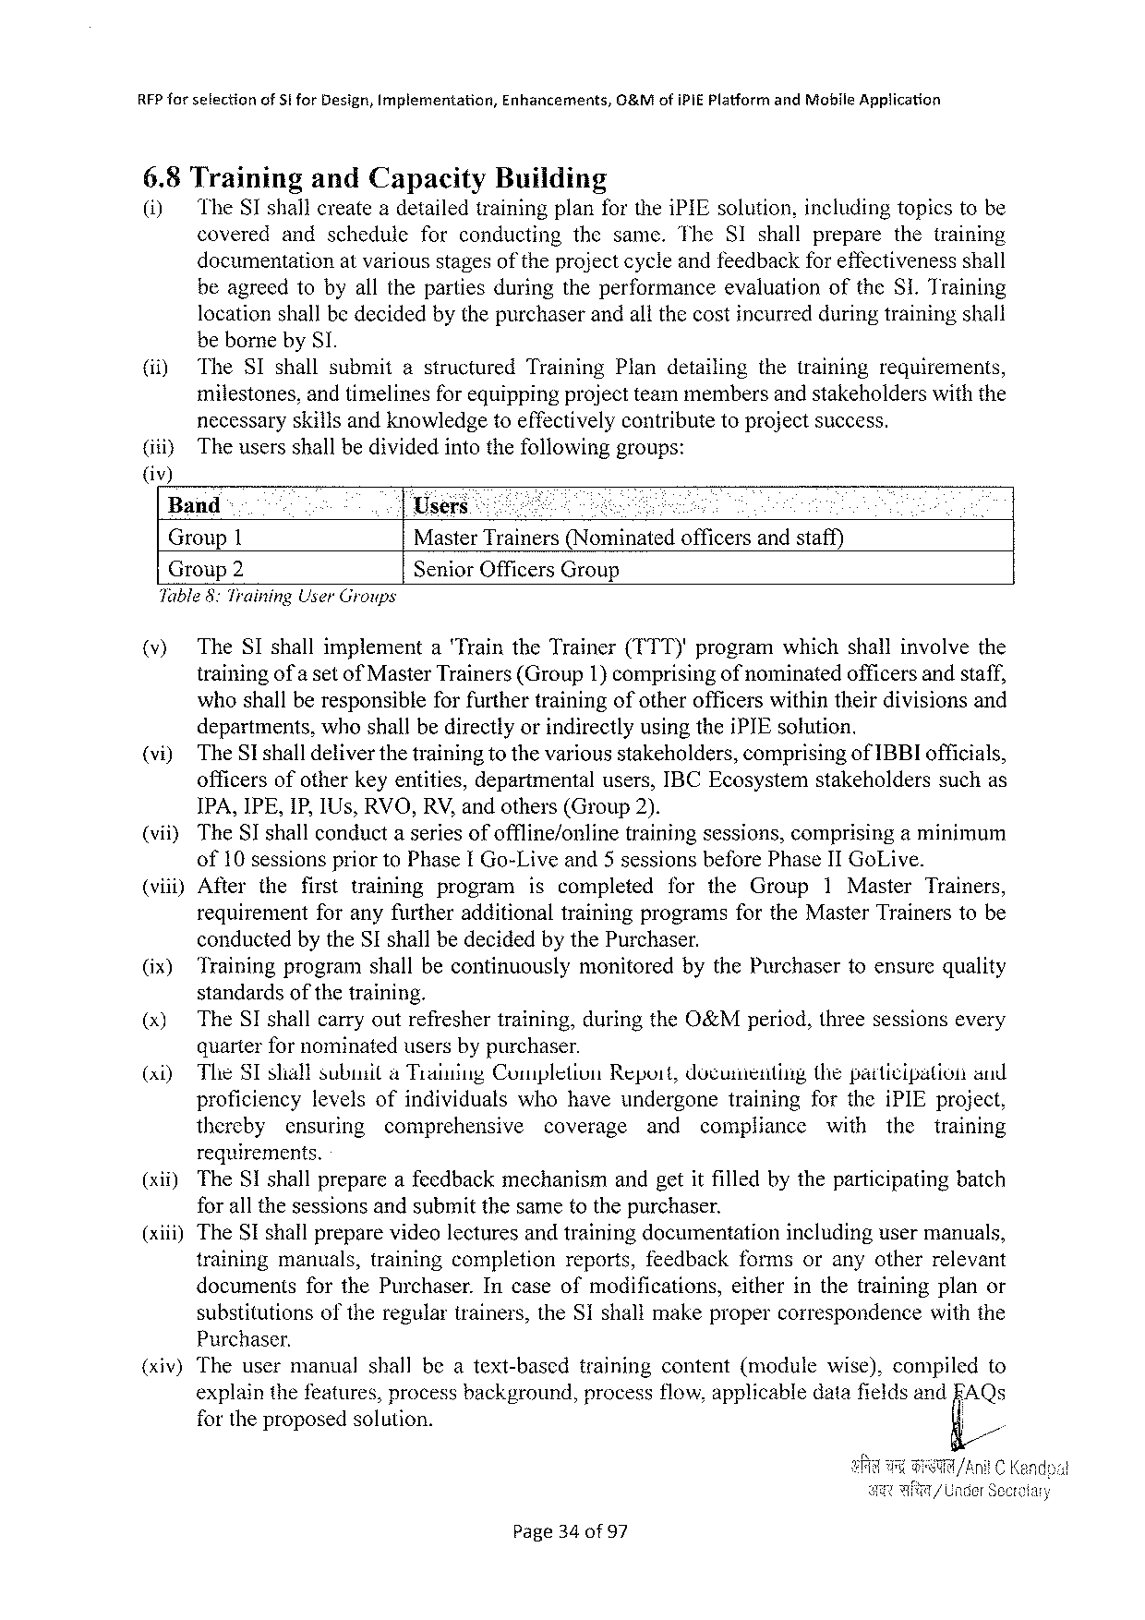

RFP for sefectionofStforDesign,Implementation,Enhancements,O&MofIPIEPlatform andMoblleApplication

6.8Training andCapacity Building

(1) TheSTshallcreateadetailedtrainingplanfortheiPIEsolution,includingtopicstobe

covered andschedule forconducting thesame.The SIshallprepare thetraining

documentationatvariousstagesof theprojectcycleandfeedbackfor effectivenessshall

beagreedtobyallthepartiesduringtheperformance evaluationoftheSI.Training

locationshallbedecidedbythepurchaserandallthecostincurredduringtrainingshall

bebornebySI.

|  |  |  |  |  |
| --- | --- | --- | --- | --- |
| (i) | TheSIshallsubmit | astructured | TrainingPlandetailing | thetrainingrequirements, |

milestones,andtimelinesfor equippingprojectteammembersand stakeholderswiththe

necessaryskillsandknowledgetoeffectivelycontributetoprojectsuccess.

(itiy The usersshallbedividedintothefollowinggroups:

()

Band Users1 Mty

Group1 MasterTrainers(Nominatedofficersandstaff)

Group2 SeniorOfficersGroup

Table8:Training User Groups

(v) TheSIshallimplement aTraintheTrainer(TTT)'programwhichshallinvolvethe

trainingof a setof MasterTrainers(Group1)comprisingof nominatedofficersandstaff,

whoshallberesponsible for furthertrainingofotherofficerswithintheirdivisionsand

departments,whoshallbedirectlyorindirectlyusingtheiPIEsolution.

(vi) TheSIshalldeliverthetrainingtothevariousstakeholders,comprisingofIBBIofficials,

officersofotherkeyentities,departmentalusers,IBCEcosystemstakeholders suchas

IPA,IPE,IP,IUs,RVO,RV,andothers(Group 2).

(vii) TheSIshallconduct aseries of offline/online training sessions, comprising aminimum

of10 sessionsprior toPhaseI Go-Live and 5 sessionsbeforePhaseII GoLive.

(vii) After thefirsttraining program iscompleted fortheGroup 1Master Trainers,

requirement foranyfurtheradditionaltrainingprogramsfortheMasterTrainerstobe

conductedbytheSIshallbedecidedbythePurchaser.

(ix) Trainingprogramshallbecontinuously monitored bythePurchasertoensurequality

standards of the training.

(x) TheSIshallcarryoutrefreshertraining,duringtheO&Mperiod,threesessionsevery

quarterfor nominatedusersbypurchaser.

|  |  |  |  |  |  |  |  |  |  |  |  |  |  |
| --- | --- | --- | --- | --- | --- | --- | --- | --- | --- | --- | --- | --- | --- |
| (xi) | TheSIsliallsubusila TraiuingCompletion | | | | | Repoit,documentiig | | | | thepatticipation | | | and |
| proficiency | | levelsofindividuals | | whohaveundergone | | | | training | fortheiPIEproject, | | | |
| thereby | ensuring | | comprehensive | coverage | | and | compliance | | with | the | training | |

requirements.

|  |  |  |
| --- | --- | --- |
| (xii) | TheSIshallprepareafeedbackmechanism | andgetitfilledbytheparticipatingbatch |

forall thesessionsandsubmitthesametothepurchaser.

(xiii)TheSI shallpreparevideo lectures andtrainingdocumentationincludingusermanuals,

training manuals,trainingcompletion reports,feedback formsoranyotherrelevant

documents forthePurchaser. Incaseofmodifications, eitherinthetrainingplanor

substitutionsoftheregulartrainers,theSIshallmakepropercorrespondence withthe

Purchaser.

(xiv) The user manual shall beatext-based training content (module wise), compiled to

explainthefeatures,processbackground,processflow,applicabledatafieldsand FAQs

fortheproposedsolution. g/

Page34of97

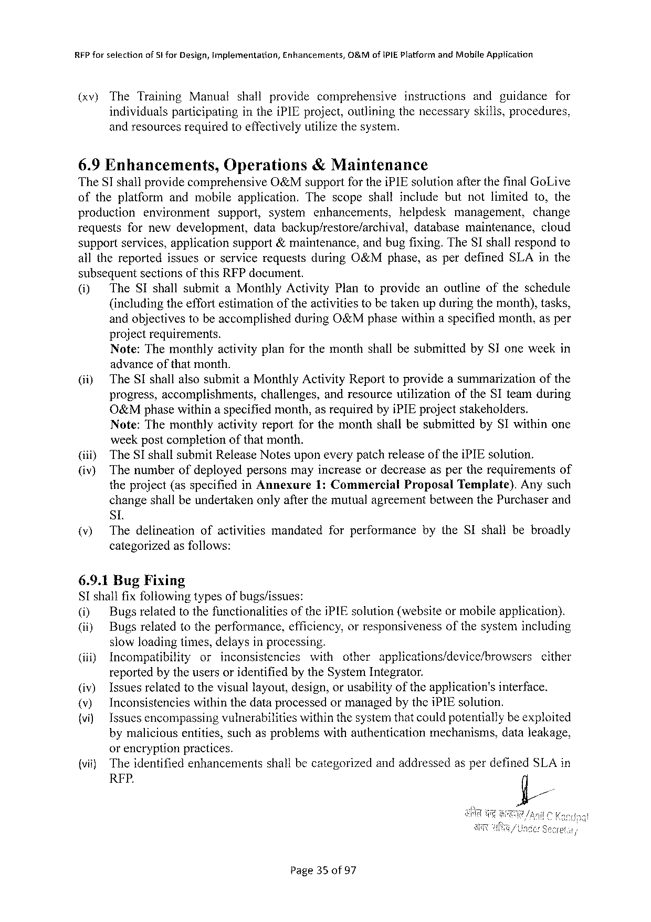

RFPforselection ofSt forDesign,Implementation, Enhancements, O&MofIPIEPlatfarm andMobileApptication

(xv) TheTraining Manual shall provide comprehensive instructions andguidance for

individualsparticipating intheiPIEproject,outliningthenecessaryskills,procedures,

andresourcesrequiredtoeffectivelyutilizethesystem.

6.9Enhancements, Operations &Maintenance

TheSI shallprovidecomprehensive O&MsupportfortheiPIEsolutionafterthefinalGoLive

oftheplatform andmobileapplication. Thescopeshallincludebutnotlimited to,the

production environment support, system enhancements, helpdesk management, change

requests fornewdevelopment, databackup/restore/archival, database maintenance, cloud

supportservices,applicationsupport&maintenance,andbugfixing.TheSIshallrespondto

allthereported issuesorservicerequestsduringO&Mphase,asperdefinedSLAinthe

subsequentsectionsofthisRFPdocument.

|  |  |  |
| --- | --- | --- |
| (i) | TheSIshallsubmitaMonthlyActivity | Plantoprovideanoutlineoftheschedule |

(includingtheeffortestimationoftheactivitiestobetakenupduringthemonth),tasks,

andobjectivestobeaccomplished projectrequirements.

duringO&Mphasewithinaspecifiedmonth,asper

Note:ThemonthlyactivityplanforthemonthshallbesubmittedbySIoneweekin

|  |  |  |  |
| --- | --- | --- | --- |
| (i) | advanceof thatmonth.  TheSIshallalsosubmitaMonthlyActivityReporttoprovideasummarizationofthe | | |
| progress,accomplishments, | challenges, | andresourceutilizationoftheSIteamduring |

O&Mphasewithinaspecifiedmonth,as requiredbyiPIEprojectstakeholders.

Note:ThemonthlyactivityreportforthemonthshallbesubmittedbySI withinone

weekpost completion of that month.

(i) TheSIshallsubmitReleaseNotesuponeverypatchreleaseoftheiPIEsolution.

(iv) Thenumberofdeployedpersonsmayincreaseordecreaseaspertherequirements of

theproject(asspecifiedinAnnexure 1:Commercial Proposal Template). Anysuch

changeshallbeundertakenonlyafterthemutualagreementbetweenthePurchaserand

SL

|  |  |  |  |  |  |
| --- | --- | --- | --- | --- | --- |
| (v) | Thedelineation | ofactivities | mandated | forperformance | bytheSIshallbebroadly |

categorizedasfollows:

6.9.1BugFixing

SIshailfixfollowingtypesofbugs/issues:

|  |  |  |  |
| --- | --- | --- | --- |
| (i) | Bugsrelatedtothefunctionalities | oftheiPIEsolution(websiteormobileapplication). | |
| (i) | Bugsrelatedtotheperformance, | cfficiency,orresponsiveness | ofthesystemincluding |

slowloadingtimes,delaysinprocessing.

|  |  |  |  |  |  |  |  |
| --- | --- | --- | --- | --- | --- | --- | --- |
| (iiiy | Incompatibility | or | inconsistencies | with | other | applications/device/browsers | cither |

reportedby theusersoridentifiedbytheSystemIntegrator.

|  |  |  |  |  |  |  |
| --- | --- | --- | --- | --- | --- | --- |
| (iv)  (v)  {vi) | Issuesrelatedtothevisuallayout,design,orusabilityoftheapplication's | | | | interface. | |
| Inconsistencies | withinthedataprocessedormanagedbytheiPIEsolution. | | | | |
| Issuesencompassingvulnerabilities | | withinthe systemthatcouldpotentiallybeexploited | | | |
| bymaliciousentities,suchasproblemswithauthentication | | | mechanisms, | | dataleakage, |

orencryptionpractices.

{vit)Theidentifiedenhancements RFP.

shallbecategorizedandaddressedasperdefinedSLAin

Page35 0f97

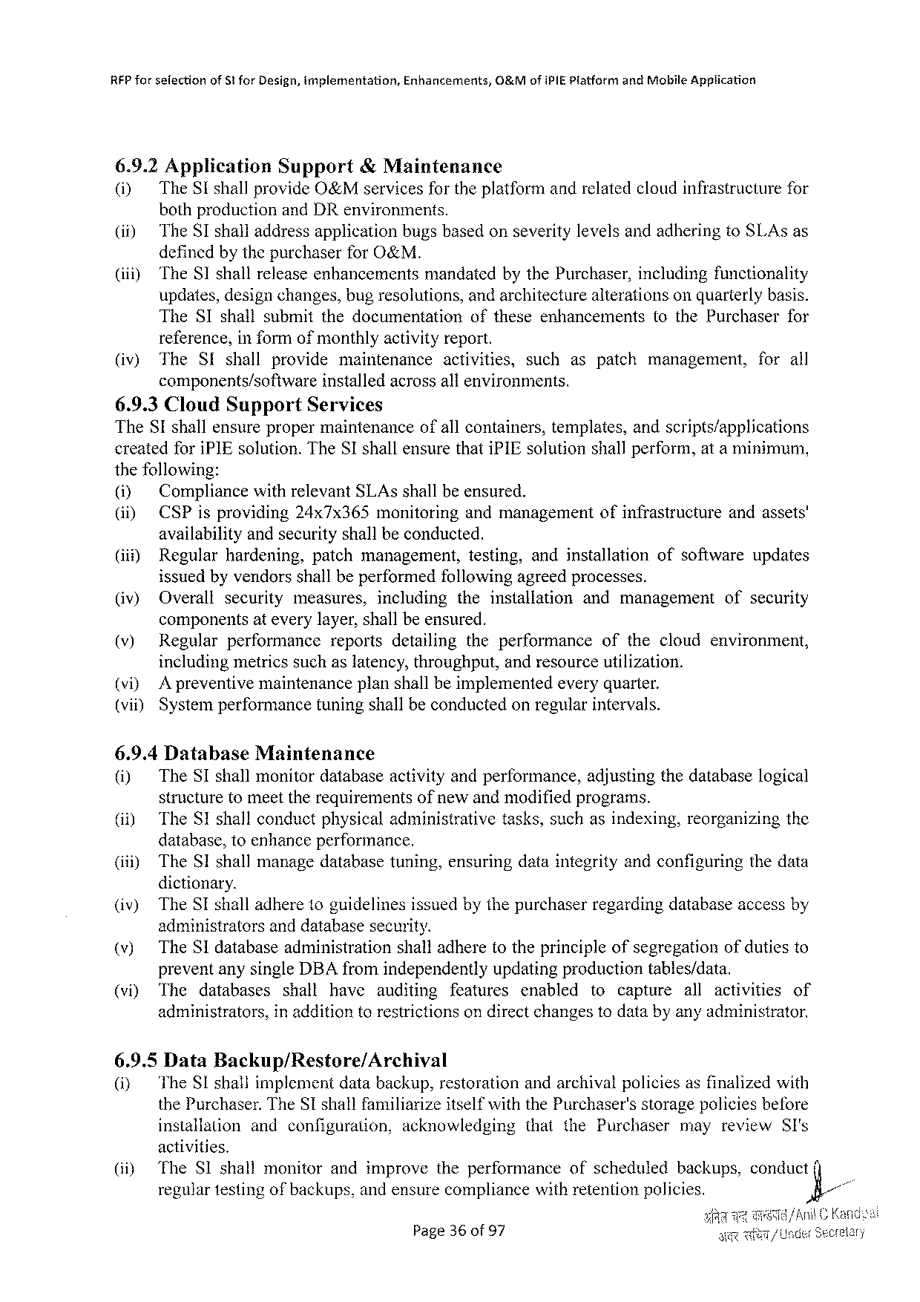

RFP forselectionof5tforDesign,implementation,Enhancements,O&MofiPIEPlatform andMobileApplication

6.9.2Application Support &Maintenance   
(i) TheSIshallprovide O&M services fortheplatform andrelatedcloudinfrastructurefor bothproductionandDRenvironments.

(i) TheSIshalladdressapplicationbugsbasedonseveritylevelsandadheringtoSLAsas definedbythepurchaserforO&M.

|  |  |  |
| --- | --- | --- |
| (iiiy | TheSIshallreleaseenhancements | mandatedbythePurchaser,includingfunctionality |

updates,designchanges,bugresolutions,andarchitecturealterationsonquarterlybasis.

|  |  |  |  |
| --- | --- | --- | --- |
| TheSIshallsubmitthedocumentation | oftheseenhancements | tothePurchaser | for |

reference,informofmonthlyactivityreport.

(iv) The SI shall provide maintenance activities, such aspatch management, for all components/software installedacrossallenvironments.

6.9.3CloudSupport Services   
TheSIshallensurepropermaintenance ofallcontainers,templates,andscripts/applications createdforiPIEsolution.TheSIshallensurethatiPIEsolutionshallperform,ata minimum, thefollowing:

|  |  |  |  |
| --- | --- | --- | --- |
| (i) | CompliancewithrelevantSLAsshallbeensured. | ofinfrastructure | andassets' |
| (i) | CSPisproviding24x7x365monitoringandmanagement |

availabilityandsecurityshallbeconducted.

|  |  |  |  |  |  |
| --- | --- | --- | --- | --- | --- |
| (i) | Regularhardening, | patchmanagement, | testing, | andinstallation | ofsoftwareupdates |

issuedbyvendorsshallbeperformedfollowingagreedprocesses.

|  |  |  |  |  |  |  |  |
| --- | --- | --- | --- | --- | --- | --- | --- |
| (iv) | Overall | security | measures, | including | theinstallation | andmanagement | ofsecurity |

componentsateverylayer,shallbeensured.

|  |  |  |  |  |  |
| --- | --- | --- | --- | --- | --- |
| (v) | Regularperformance | reports | detailing | theperformance | ofthecloudenvironment, |

includingmetricssuchas latency,throughput,andresource utilization. (vi) A preventivemaintenanceplanshallbeimplementedeveryquarter. (vii) Systemperformancetuningshallbeconductedonregularintervals.

6.9.4Database Maintenance   
(i) TheSIshallmonitordatabaseactivityandperformance,adjustingthedatabaselogical structuretomeettherequirementsofnewandmodifiedprograms.

|  |  |  |
| --- | --- | --- |
| (i) | TheSIshallconductphysicaladministrative | tasks,suchasindexing,reorganizingthe |

database,toenhanceperformance.

(iti) TheSIshallmanagedatabasetuning,ensuringdataintegrityandconfiguringthedata dictionary.

(iv) TheSIshalladheretoguidelinesissuedbythepurchaserregardingdatabaseaccessby administrators anddatabasesecurity.

(v) TheSIdatabaseadministration shalladheretotheprincipleofsegregationofdutiesto preventanysingleDBAfromindependentlyupdatingproductiontables/data.

|  |  |  |  |  |  |  |  |  |  |  |  |
| --- | --- | --- | --- | --- | --- | --- | --- | --- | --- | --- | --- |
| (vi) | The | databases | shall | have | auditing | features | enabled | tocapture | all | activities | of |
| administrators, | | inadditiontorestrictionson directchangestodatabyanyadministrator. | | | | | | | | |

6.9.5DataBackup/Restore/Archival   
(i) TheSIshallimplementdatabackup,restorationandarchivalpoliciesasfinalizedwith thePurchaser.TheSI shallfamiliarizeitselfwith thePurchaser'sstoragepoliciesbefore

|  |  |  |  |  |  |
| --- | --- | --- | --- | --- | --- |
| installation | andconfiguration, | acknowledging | thatthePurchaser | mayreview | SI's |

activities.

|  |  |  |  |  |  |  |  |  |  |  |
| --- | --- | --- | --- | --- | --- | --- | --- | --- | --- | --- |
| (iiy | TheSIshall | monitor | and | improve | theperformance | ofscheduled | backups, | conduct | (] | - |
| regulartestingofbackups,andensurecompliancewithretentionpolicies. | | | | | | | ’&/ |

Page36of 97

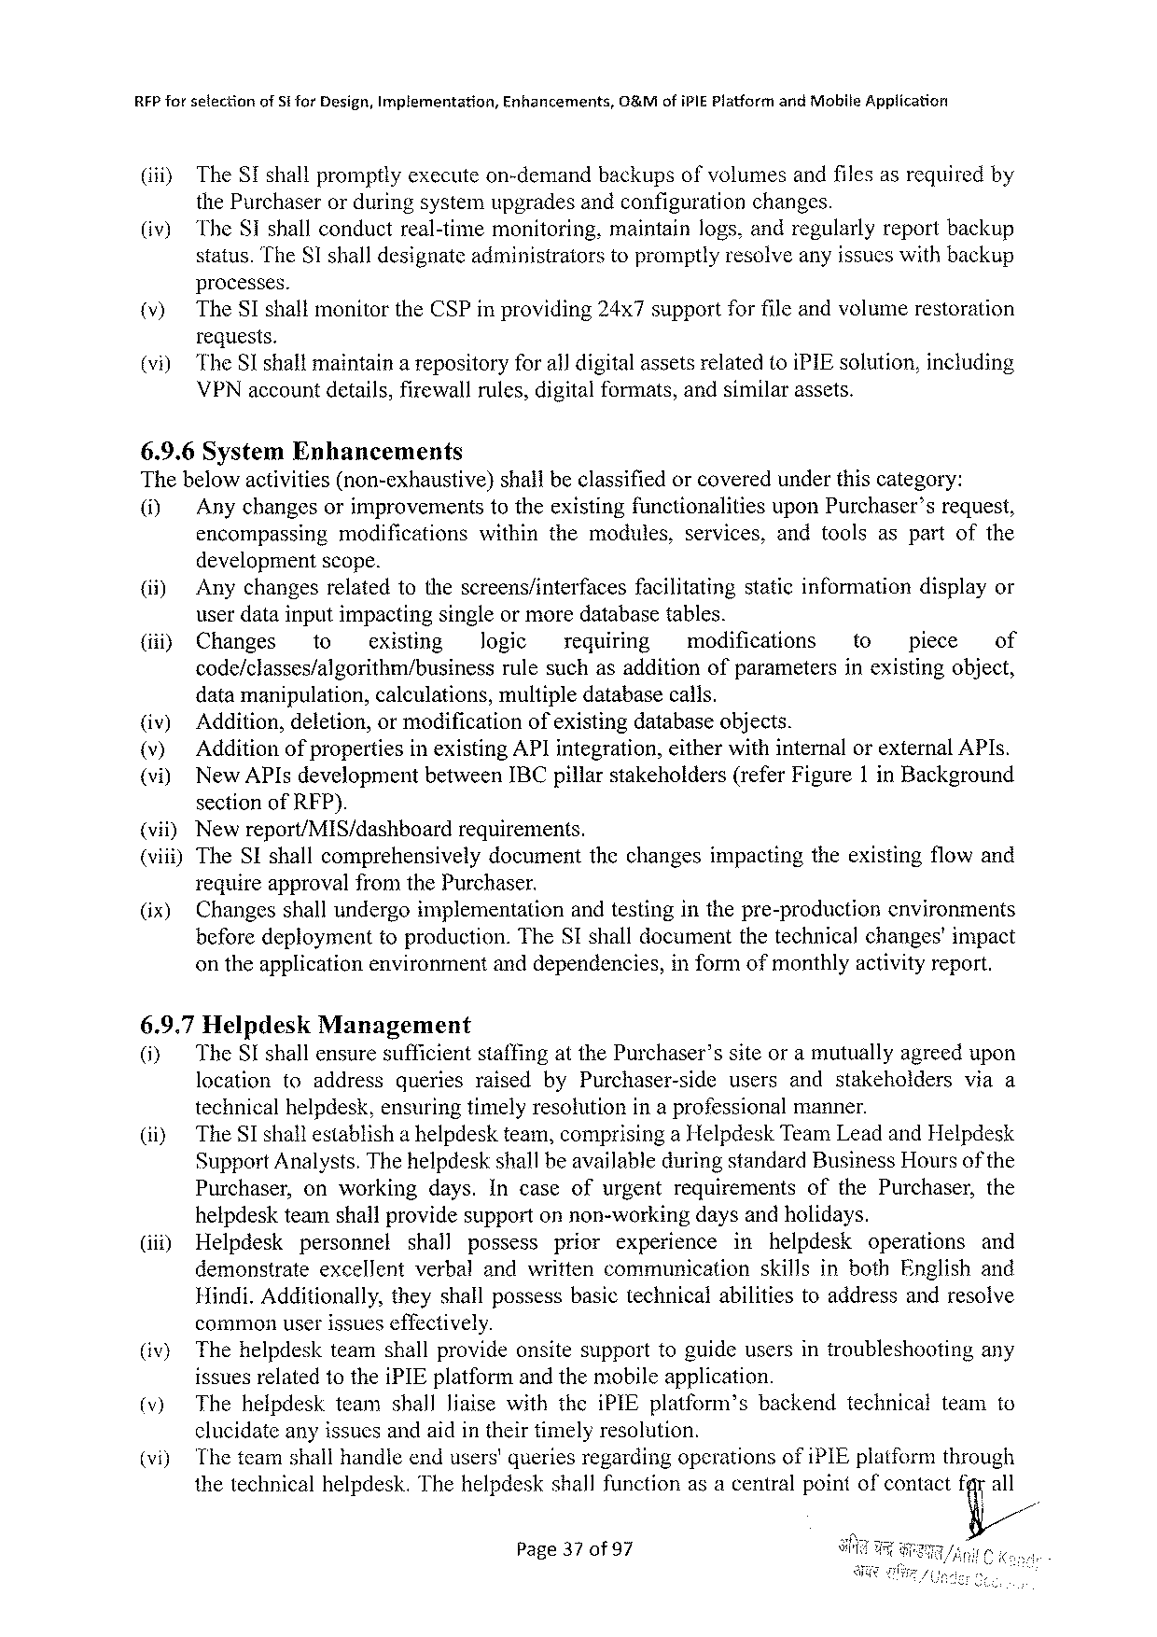

RFP for selectionofS forDesign,Implementation,Enhancements,O&MofiPIEPlatform andMobile Application

(i) TheSTshallpromptlyexecuteon-demandbackupsofvolumesandfilesasrequiredby

thePurchaserorduringsystemupgradesandconfigurationchanges.

|  |  |  |
| --- | --- | --- |
| (iv) | TheST shallconductreal-timemonitoring, | maintainlogs,andregularlyreportbackup |
| status.TheSI shalldesignateadministratorstopromptlyresolveanyissueswithbackup | |

processes.

|  |  |
| --- | --- |
| )  i) | TheSTshallmonitortheCSPinproviding24x7supportforfileandvolumerestoration requests.  TheSshallmaintainarepositoryforall digitalassetsrelatedtoiPIEsolution,including VPNaccountdetails,firewallrules,digitalformats,andsimilarassets. |

6.9.6SystemEnhancements   
Thebelowactivities(non-exhaustive) shallbeclassifiedorcoveredunderthiscategory:

ol Anychangesorimprovements totheexistingfunctionalities uponPurchaser’srequest, encompassingmodificationswithinthemodules,services,andtoolsaspartofthe

developmentscope.

|  |  |  |  |  |  |  |  |  |  |  |  |
| --- | --- | --- | --- | --- | --- | --- | --- | --- | --- | --- | --- |
| (ii) (i) | Anychangesrelatedtothescreens/interfaces | | | | | facilitating | | staticinformationdisplayor | | | |
| userdatainputimpactingsingleor moredatabasetables. | | | | | | | | | | |
| Changes | to | existing | Jogic | requiring | | modifications | | to | piece | of |
| code/classes/algorithm/business | | | rulesuchasadditionofparameters | | | | | inexistingobject, | | |

datamanipulation,calculations,multipledatabasecalls.

|  |  |  |  |
| --- | --- | --- | --- |
| (iv) v  vi)  {vii)  (vii) | Addition,deletion,ormodification | | ofexistingdatabaseobjects. |
| Additionof propertiesinexistingAPIintegration,eitherwithinternalorexternalAPIs. NewAPIsdevelopmentbetweenIBCpillarstakeholders(referFigure1 inBackground sectionofRFP).  Newreport/MIS/dashboard requirements. | | |
| TheSIshallcomprehensively | documentthechangesimpactingtheexistingflowand | |

requireapprovalfromthePurchaser.

|  |  |  |  |
| --- | --- | --- | --- |
| (ix) | Changesshallundergeimplementation | andtestinginthepre-production | environments |
| beforedeploymenttoproduction.TheSIshalldocumentthetechnicalchanges'impact | | |

ontheapplicationenvironmentanddependencies,

6.9.7Helpdesk Management

informofmonthlyactivityreport.

|  |  |  |  |  |  |  |  |
| --- | --- | --- | --- | --- | --- | --- | --- |
| 0}  (ii) | TheSIshallensuresufficientstaffingatthePurchaser’ssiteoramutuallyagreedupon | | | | | | |
| location | toaddress | queries | raisedbyPurchaser-side | users | andstakeholders | viaa |
| technicalhelpdesk,ensuringtimelyresolutionina professional | | | | | manner. | |
| TheSIshallestablisha helpdeskteam,comprisinga HelpdeskTeamLeadandHelpdesk SupportAnalysts.ThehelpdeskshallbeavailableduringstandardBusinessHoursofthe Purchaser,onworkingdays.IncaseofurgentrequirementsofthePurchaser,the | | | | | | |

helpdeskteamshallprovidesupportonnon-workingdaysandholidays.

(iii) Helpdesk personnel shall possess prior experience in helpdesk operations and

demonstrate excellent verbalandwrittencommunication skillsinbothEnglishand

Hindi.Additionally, theyshallpossessbasictechnicalabilitiestoaddressandresolve

commonuserissueseffectively.

|  |  |  |
| --- | --- | --- |
| (iv) v) | Thehelpdeskteamshallprovideonsitesupporttoguideusersintroubleshooting | any |
| issuesrelatedtotheiPIEplatformandthemobileapplication.  ThehelpdeskteamshallliaisewiththeiPIEplatform’sbackendtechnicalteamto | |

clucidateanyissucsandaidintheirtimelyresolution.

|  |  |  |
| --- | --- | --- |
| i) | Theteamshallhandleendusers'queriesregardingoperationsofiPIEplatformthrough thetechnicalhelpdesk.Thehelpdeskshallfunctionasacentralpointofcontactt%a/ll | |
| Page37 of97 | § |

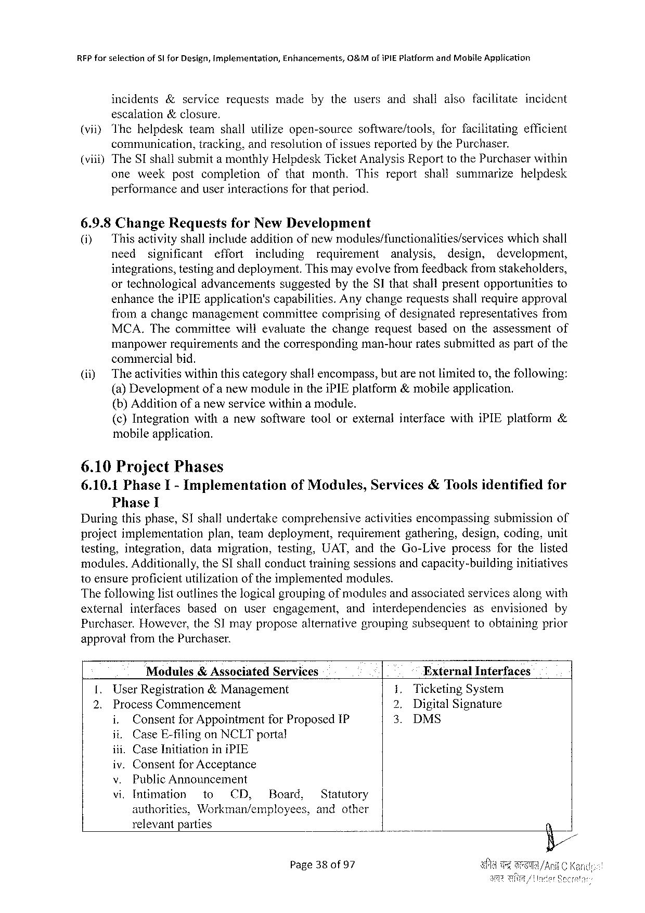

|  |  |  |  |  |  |  |  |  |
| --- | --- | --- | --- | --- | --- | --- | --- | --- |
| RFPforselection | of5lforDesign,implementation, | | | Enhancements, | | 0&MofiPIEPiatfarm | andMabileApplication | incident |
| incidents | | &service | requests | made | bytheusersandshallalsofacilitate | | |

escalation&closure,

|  |  |  |  |  |
| --- | --- | --- | --- | --- |
| (viiyThehelpdesk | teamshallutilizeopen-source | software/tools, | forfacilitating | efficient |
| communication, | tracking,andresolutionofissuesreportedbythePurchaser. | | |

(vii))TheSIshallsubmita monthlyHelpdeskTicketAnalysisReporttothePurchaserwithin

|  |  |  |  |  |
| --- | --- | --- | --- | --- |
| oneweek | postcompletion | ofthatmonth.This | reportshallsummarize | helpdesk |

performanceanduserinteractionsforthatperiod.

6.9.8ChangeRequests forNewDevelopment

(i) Thisactivity shallinclude addition ofnewmodules/functionalities/services whichshall

need significant effort including requirement analysis, design, development,

integrations,testinganddeployment.Thismayevolvefromfeedbackfromstakeholders,

ortechnological advancements suggestedbytheSIthatshallpresentopportunities to

enhancetheiPIEapplication's capabilities.Anychangerequestsshallrequireapproval

fromachangemanagement committeecomprisingofdesignatedrepresentatives from

MCA.Thecommittee willevaluatethechangerequestbasedontheassessment of

manpowerrequirementsandthecorresponding commercialbid.

man-hourratessubmittedaspartofthe

(ii) Theactivitieswithinthiscategoryshallencompass,butarenotlimitedto,thefollowing:

(a)Developmentofa newmoduleintheiPIEplatform&mobileapplication.

(b)Additionofa newservicewithina module.

|  |  |  |
| --- | --- | --- |
| (¢)Integration | withanewsoftwaretoolorexternalinterfacewithiPIEplatform | & |

mobileapplication.

6.10ProjectPhases

6.10.1PhaseI- Implementation Phase 1

ofModules,Services&Toolsidentifiedfor

Duringthisphase,SIshallundertakecomprehensive activitiesencompassingsubmissionof

projectimplementation plan,teamdeployment, requirement gathering,design,coding,unit

testing, integration, datamigration, testing, UAT,andtheGo-Liveprocess forthelisted

modules.Additionally,theSIshallconducttrainingsessionsandcapacity-building initiatives

10 ensureproficientutilizationoftheimplementedmodules.

Thefollowinglistoutlinesthelogicalgroupingofmodulesandassociatedservicesalongwith

|  |  |  |  |  |  |  |
| --- | --- | --- | --- | --- | --- | --- |
| external | interfaces | based | onuserengagement, | andinterdependencies | asenvisioned | by |

Purchaser.However,theSImayproposealternativegroupingsubsequenttoobtainingprior

approvalfromthePurchaser.

|  |  |  |  |  |  |
| --- | --- | --- | --- | --- | --- |
| [. | Modules& AssociatedServices | | | ExternalInterfaces | |
| UserRegistration&Management | | | 1.TicketingSystem | |
| 2. | ProcessCommencement | | | 2. | DigitalSignature |
| i. | Consentfor Appointment | forProposedIP | 3. | DMS |

ii.CaseE-filingonNCLTportal

iii.CaseInitiationiniPIE

iv.Consentfor Acceptance

v. PublicAnnouncement

vi,Intimation to CI, Board, Statutory

authoritics, Workman/employees, andother

relevantparties

Page380of 97

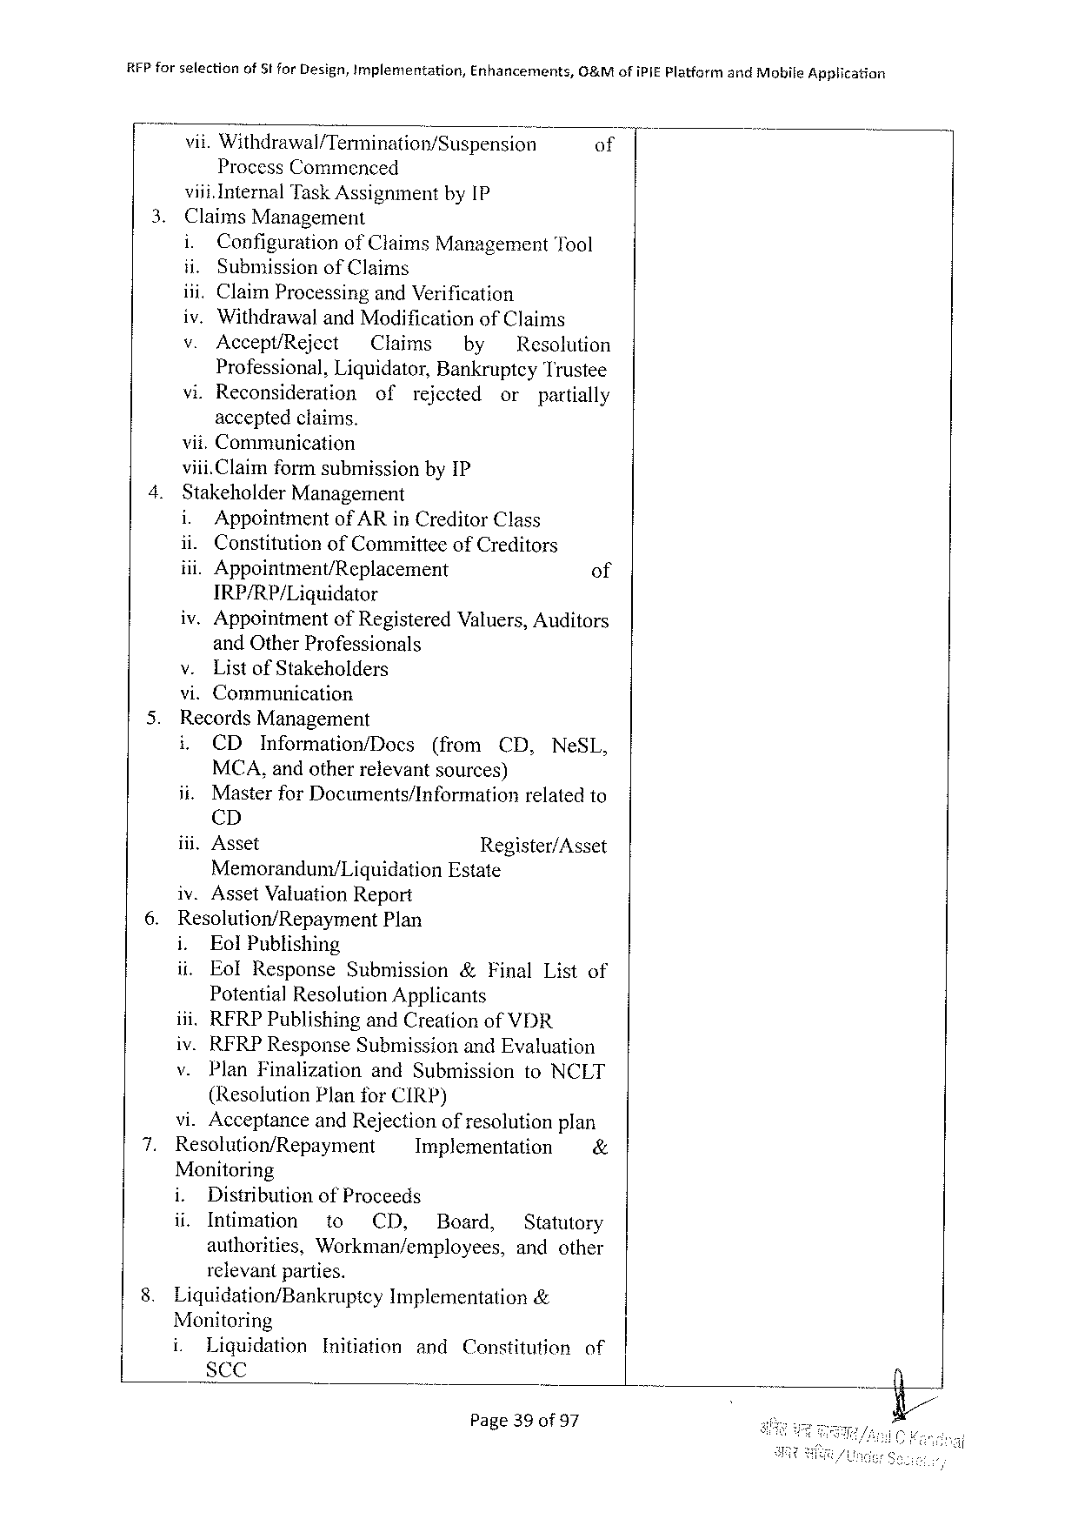

|  |  |  |  |  |
| --- | --- | --- | --- | --- |
| RFPforselection | ofStforDesign,Implementation, | Enhancements, | G&MofiPIEPlatfarm | andMobifeApplication |
| vii.Withdrawal/Termination/Suspension | | | of |
| ProcessCommenced | | |

viii.InternalTaskAssignmentby1P

|  |  |  |  |  |  |  |  |
| --- | --- | --- | --- | --- | --- | --- | --- |
| 3. | ClaimsManagement | | | | | | |
| i. | Configuration | ofClaimsManagementTool | | | | |
| ii. | SubmissionofClaims | | | | | |
| iii.ClaimProcessingandVerification  iv.WithdrawalandModificationofClaims | | | | | | |
| v. | Accept/Reject | Claims | | by | Resolution | |
| Professional,Liquidator,BankruptcyTrustee | | | | | | |
| vi.Reconsideration | | of | rejected | | or | partially |
| acceptedclaims. | | | | | | |

vii.Communication

|  |  |  |  |  |  |
| --- | --- | --- | --- | --- | --- |
| 4. | viii.ClaimformsubmissionbyIP  StakeholderManagement | | | | |
| i. | Appointment | | ofAR inCreditorClass | |
| ii. | | ConstitutionofCommitteeofCreditors | | |
| iii.Appointment/Replacement | | | | of |
| IRP/RP/Liguidator | | | | |
| iv.Appointment | | | ofRegisteredValuers,Auditors | |

andOtherProfessionals   
v. ListofStakeholders   
vi.Communication

|  |  |  |  |  |  |  |  |  |  |  |  |
| --- | --- | --- | --- | --- | --- | --- | --- | --- | --- | --- | --- |
| 5.  6. | RecordsManagement | | | | | | | | | | |
| i, | CD | Information/Docs | | | (from | | | CD, | | NeSL, |
| MCA,andotherrelevantsources) | | | | | | | | | | |
| ii. | MasterforDocuments/Information | | | | | | | relatedto | | |
| CD | | | | | | | | | | |
| iii.Asset | | | | Register/Asset | | | | | | |
| Memoranduny/Liquidation | | | | | | Estate | | | | |
| iv.AssetValuationReport | | | | | | | | | | |
| Resolution/Repayment | | | | Plan | | | | | | |
| i. | EolPublishing | | | | | | | | | |
| ii. | EolResponse | | Submission | | | | &FinalListof | | | |
| PotentialResolutionApplicants | | | | | | | | | | |
| ili.RFRPPublishingandCreationof | | | | | | | | VDR | | |
| iv.RFRPResponse Submission andEvaluation | | | | | | | | | | |
| v. | PlanFinalization | | | andSubmission | | | | | toNCLT | |

(ResolutionPlanforCIRP)

|  |  |  |  |  |  |  |  |
| --- | --- | --- | --- | --- | --- | --- | --- |
| 7. | vi.AcceptanceandRejectionofresolutionplan | | | | | | |
| Resolution/Repayment | | | Implementation | | | & |
| Monitoring | | | | | | |
| i. | Distributionof Proceeds | | | | | |
| ii. | Intimation | to | CD, | DBoard, | Statutory | |
| authorities, | | Workman/employees, | | | andother | |

relevantparties.

|  |  |  |  |
| --- | --- | --- | --- |
| 8. | Liquidation/Bankruptcy | Implementation | & |

Monitoring

|  |  |  |  |  |  |
| --- | --- | --- | --- | --- | --- |
| i. | Liquidation | Initiation | and | Censtitution | of |
| ScC |

Page39of 97

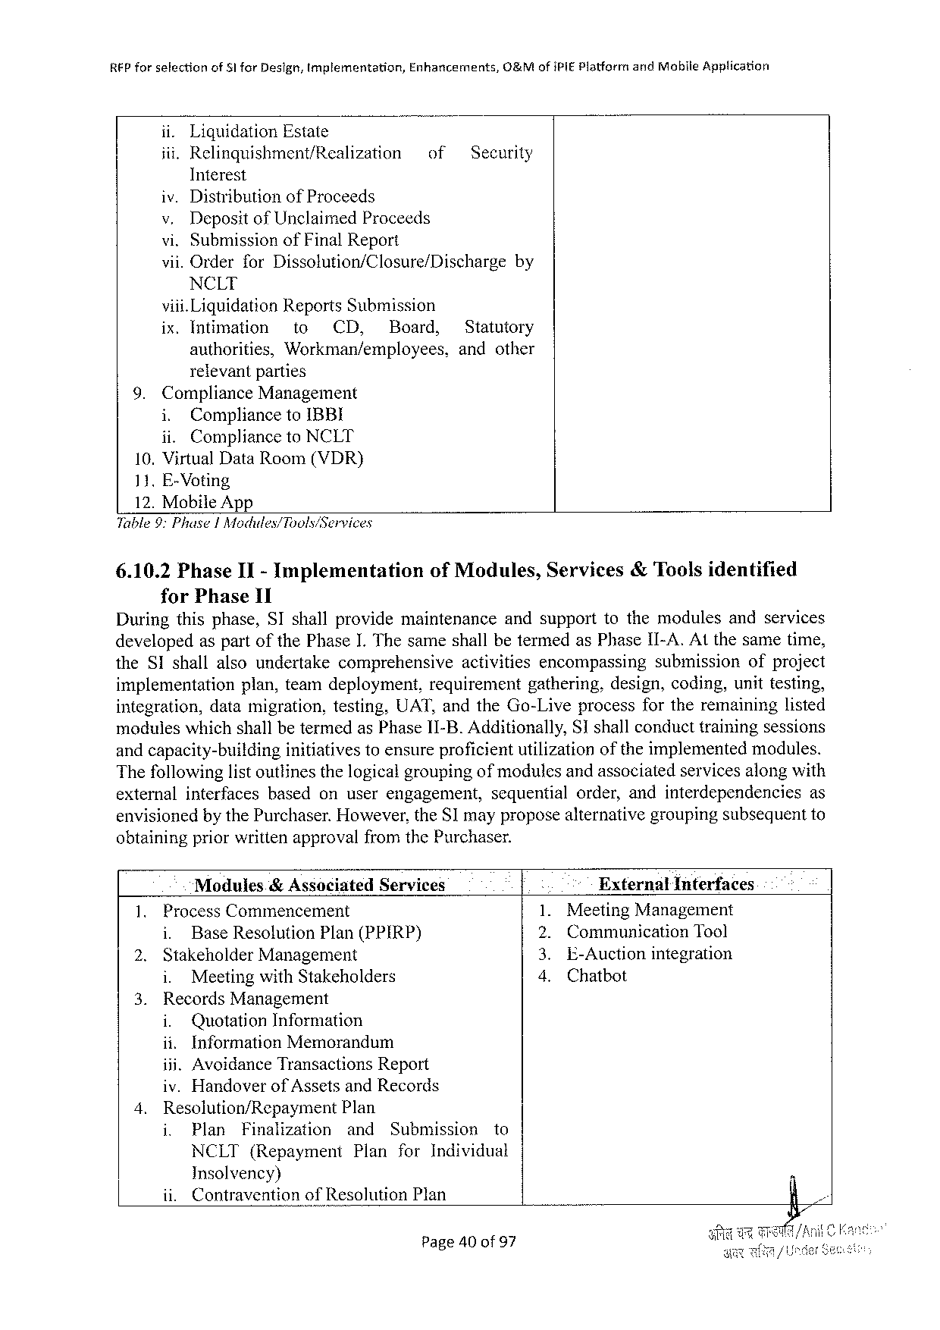

|  |  |  |  |  |
| --- | --- | --- | --- | --- |
| REP forselection | of51 forDesign,Implementation, | Enhancements, | O&MofiPIEPlatforr | andMobileApplication |

ii.LiquidationEstate

|  |  |  |
| --- | --- | --- |
| iii.Relinquishment/Realization | of | Security |

Interest   
iv.DistributionofProceeds   
v.DepositofUnclaimedProceeds   
vi.SubmissionofFinalReport   
vii. OrderforDissolution/Closure/Dischargeby NCLT   
viii.LiquidationReportsSubmission

|  |  |  |  |  |
| --- | --- | --- | --- | --- |
| ix.Intimation | to | CD, | Board, | Statutory |
| authorities, | Workman/employees, | | | andother |

relevantparties   
 9. ComplianceManagement   
 i. CompliancetoIBBI   
 ii. CompliancetoNCLT   
 10. VirtualDataRoom(VDR)   
 11. E-Voting   
 12. MobileApp   
Table9:Phuse|Modules/Tools/Services

6.10.2PhaseII- Implementation forPhase11

ofModules,Services&Toolsidentified

Duringthisphase,SIshallprovidemaintenance andsupporttothemodulesandservices

developedas part ofthe PhaseI. The sameshall betermedasPhase II-A.Atthe sametime,

theSIshallalsoundertake comprehensive activities encompassing submission ofproject

implementation plan,teamdeployment, requirement gathering,design,coding,unittesting,

integration,datamigration,testing,UAT,andtheGo-Liveprocessfortheremaininglisted

moduleswhichshallbetermedasPhase11-B. Additionally,Sshallconducttrainingsessions

andcapacity-building initiativestoensureproficientutilizationoftheimplementedmodules.

Thefollowinglistoutlinesthelogicalgroupingof modulesandassociatedservicesalongwith

externalinterfaces basedonuserengagement, sequentialorder,andinterdependencies as

envisionedby thePurchaser.However,theSImayproposealternativegroupingsubsequentto

obtainingpriorwrittenapprovalfromthePurchaser.

|  |  |  |  |  |
| --- | --- | --- | --- | --- |
| 1. | Modules& AssociatedServices | | . | ExternalInferfaces |
| ProcessCommencement | | MeetingManagement |
| i. | BaseResolutionPlan(PPIRP) | 129 | CommunicationTool |
| 2. |
| StakeholderManagement | | E-Auctionintegration |
| e | Chatbot |
| i. | MeetingwithStakeholders |
| 3. |
| RecordsManagement | |
| i. | QuotationInformation |

ii.InformationMemorandum

iii.AvoidanceTransactionsReport

iv.Handoverof AssetsandRecords

|  |  |  |  |  |  |  |
| --- | --- | --- | --- | --- | --- | --- |
| 4. | Resolution/Repayment Plan | | | | Submission | to |
| i. | Plan | Finalization | and |
| NCLT(Repayment | | | Plan | forIndividual | |

Insolvency)

ii. ContraventionofResolutionPlan

Page40of 97

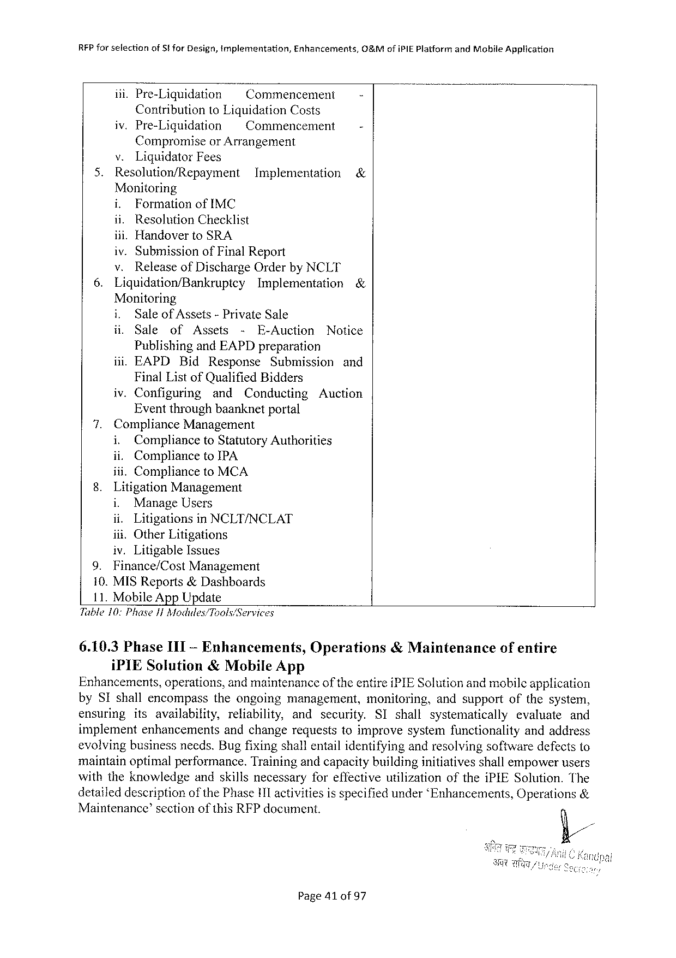

|  |  |  |  |  |
| --- | --- | --- | --- | --- |
| RFPforselection | ofSforDesign,tmplementation, | | Enhancements, | G&MofiPIEPlatformandMobileApplication  -  - |
| iii.Pre-Liquidation | | ~Commencement | |
| ContributiontoLiquidationCosts | | | |
| iv.Pre-Liquidation | | =~ Commencement | |

Compromiseor Arrangement

v.Liquidator Fees

|  |  |  |  |
| --- | --- | --- | --- |
| 5. | Resolution/Repayment | Implementation | & |

Monitoring

i. FormationofIMC

ii.ResolutionChecklist

iii.HandovertoSRA

iv.SubmissionofFinalReport

|  |  |  |  |  |
| --- | --- | --- | --- | --- |
| 6. | v. | ReleaseofDischargeOrderbyNCLT | | & |
| Liquidation/Bankrupicy | | Implementation |

Monitoring

|  |  |  |  |  |  |  |
| --- | --- | --- | --- | --- | --- | --- |
| i, | Saleof Assets-PrivateSale | | | | | Notice |
| il. | Sale | of | Assets | - | E-Auction |

PublishingandEAPDpreparation

|  |  |  |  |  |
| --- | --- | --- | --- | --- |
| iii.EAPD | Bid | Response | Submission | and |

FinalListofQualifiedBidders

iv.Configuring and Conducting Auction

Eventthroughbaanknetportal

7.ComplianceManagement

i. Complianceto StatutoryAuthorities

ii. CompliancetoIPA

iii.CompliancetoMCA

8.LitigationManagement

i. ManageUsers

ii. Litigationsin NCLT/NCLAT

iit.OtherLitigations

iv.LitigableIssues

|  |  |  |
| --- | --- | --- |
| 9. | Finance/Cost | Management |

10. MISReports&Dashboards

11. MobileAppUpdate

Table10: PhaseJ1 Modudes/Tools/Services

|  |  |  |  |
| --- | --- | --- | --- |
| 6.10.3PhaseIIT-Enhancements, | Operations | &Maintenance | ofentire |
| iPIESolution& MobileApp |

Enhancements,operations,andmaintenanceoftheentireiPIESolutionandmobileapplication

bySIshallencompass theongoing management, monitoring, andsupportofthesystem,

ensuring itsavailability, reliability, and security. SIshall systematically evaluate and

implementenhancements andchangerequeststoimprovesystemfunctionality andaddress

evolvingbusinessneeds.Bugfixingshallentailidentifyingandresolvingsoftwaredefectsto

maintainoptimalperformance.Trainingandcapacitybuildinginitiativesshallempowerusers

withtheknowledge andskillsnecessaryforeffectivewtilizationoftheiPIESolution.The

detaileddescriptionof thePhasei1l activitiesis specifiedunder‘Enhancements,Operations&

Maintenance’sectionofthisRFPdocument.

Page41of97

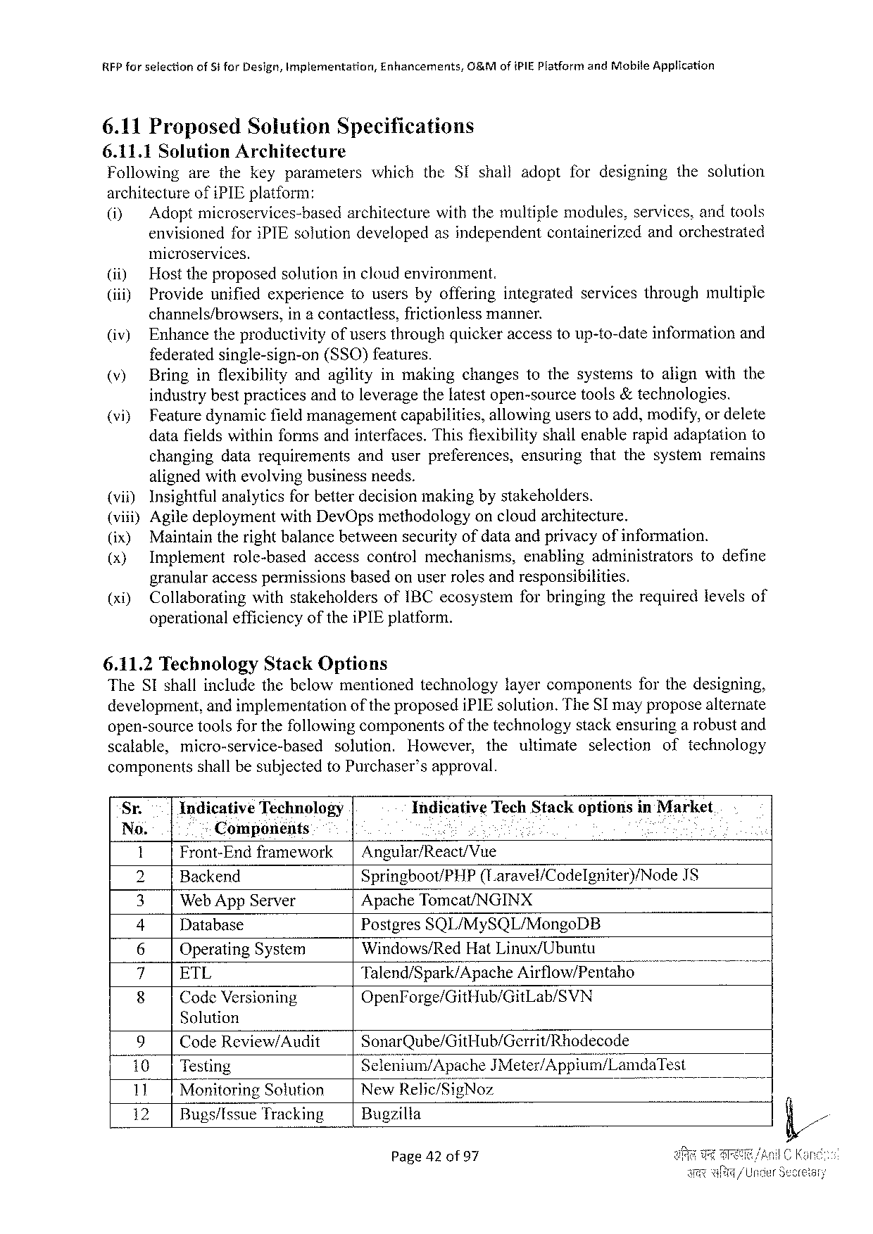

REPforselection of5tforDesign,Implementation, Enhancements, G&MofiPIE PlatformandMobileApplication

6.11Proposed Solution Specifications

6.11.1SolutionArchitecture

Following arethekeyparameters which theSIshalladoptfordesigning thesolution

architectureofiPIEplatform:

(i) Adopt microservices-basedarchitecturewith themultiplemodules,services,andtools

envisionedforiPIEsolution developedasindependent containerizedandorchestrated

microservices.

(i) Hosttheproposedsolutionincloudenvironment.

(iii) Provideunifiedexperience tousersbyofferingintegrated servicesthroughmultiple

channels/browsers, ina contactless,frictionlessmanner.

(iv) Enhancetheproductivityofusersthroughquickeraccesstoup-to-dateinformationand

federatedsingle-sign-on (SSO)features.

(v) Bringinflexibility andagilityinmakingchangestothesystemstoalignwiththe

industrybestpracticesandtoleveragethelatestopen-sourcetools&technologies.

|  |  |  |  |  |  |  |
| --- | --- | --- | --- | --- | --- | --- |
| (vi} | Feature | dynamic | fieldmanagement | capabilitics, | allowing | userstoadd,modify,ordelete |

datafieldswithinformsandinterfaces.Thisfiexibilityshallenablerapidadaptationto

|  |  |  |
| --- | --- | --- |
| changingdatarequirements | anduserpreferences, | ensuringthatthesystemremains |

alignedwithevolvingbusinessneeds.

(vii) Insightfulanalyticsforbetterdecisionmakingbystakeholders.

(viii)AgiledeploymentwithDevOpsmethodologyoncloudarchitecture.

|  |  |  |  |  |  |  |  |  |
| --- | --- | --- | --- | --- | --- | --- | --- | --- |
| (ix) (x)  (xi) | Maintaintherightbalancebetweensecurityofdataandprivacyofinformation. | | | | | | | |
| Implement | role-based | | accesscontrolmechanisms, | | | enablingadministrators | todefine |
| granularaccesspermissionsbasedonuserrolesandresponsibilities. | | | | | | | |
| Collaborating | | withstakeholders | | ofIBCecosystem | forbringingtherequiredievelsof | | |

operationalefficiencyoftheiPIEplatform.

6.11.2TechnologyStackOptions

TheSIshallincludethebelowmentionedtechnology layercomponents forthedesigning,

development,andimplementation oftheproposediPIEsolution.TheSI mayproposealternate

open-sourcetoolsforthefollowingcomponentsofthetechnologystackensuringa robustand

scalable, micro-service-based solution. However, theultimate selection oftechnology

componentsshall be subjectedtoPurchaser’s approval.

Sr. Indicative Technology Indicative TechStackoptionsinMarket

No. Components S - o

1 Front-Endframework| Angular/React/Vue

2 Backend Springboot/PHP (Laravel/Codelgniter)/Node IS

3 Web AppServer ApacheTomcat/NGINX

4 Database PostgresSQL/MySQL/MongoDB

6 OperatingSystem Windows/RedHatLinux/Ubuntu

i ETL Talend/Spark/Apache Airflow/Pentaho o 7

8 CodeVersioning OpenForge/GitHub/GitLab/SVN

Solution

|  |  |  |  |  |  |
| --- | --- | --- | --- | --- | --- |
| 9 | CodeReview/Audit | | SonarQube/GitHub/Gerrit/Rhodecode | B | &// |
| 10|Testing | | | Sclenium/ApacheJMeter/Appium/LamdaTest |
| 11 | MonitoringSolution | | New]{e]ic/§igNoz |
| 12 | | | Bugs/IssueTracking | Bugzilla |

Page42of97

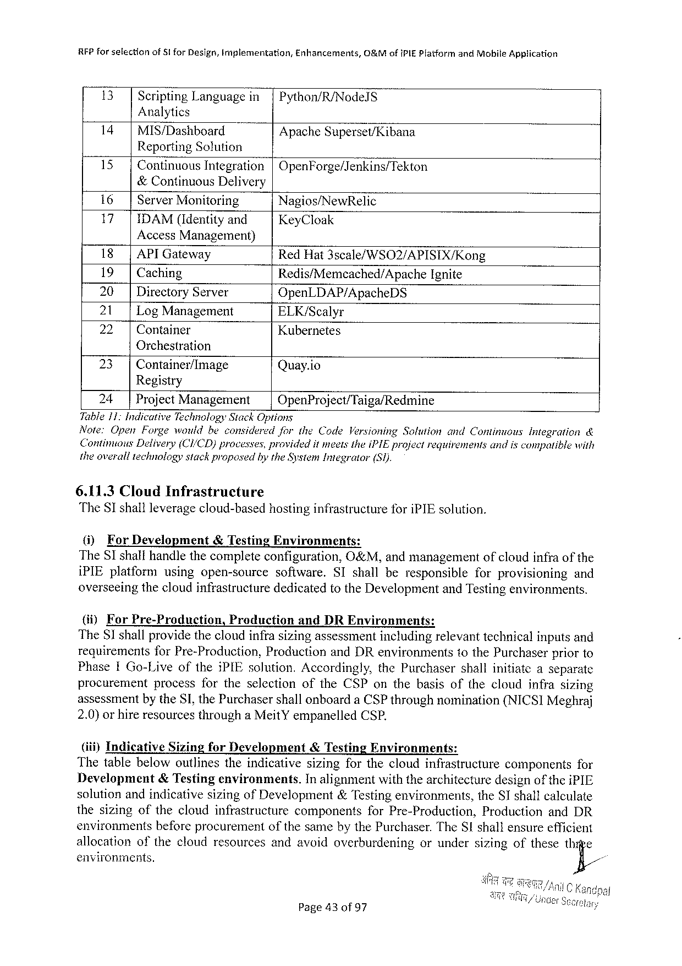

RFPforselection of8! forDesign,Implementation, Enhancements, 0&MofiPIEPlatformandMobileApplication

13 ScriptingLanguagein|Python/R/NodelS

Analytics

14|MIS/Dashboard Apache Superset/Kibana

ReportingSolution

15| ContinuousIntegration|OpenForge/Jenkins/Tekton

&ContinuousDelivery

|  |  |  |  |
| --- | --- | --- | --- |
| 16 | | | ServerMonitoring | Nagios/NewRelic |
| 17 | |IDAM(Identityand | |
| KeyCloak |

Access Management)

18|API Gateway RedHat3scale/WSO2/APISIX/Kong

19| Caching Redis/Memcached/Apache Ignite

20 | DirectoryServer OpenLDAP/ApacheDS

21 | LogManagement ELK/Scalyr

22 | Container Kubernetes

Orchestration

|  |  |  |  |
| --- | --- | --- | --- |
| 23 | | | Container/Image | Quay.io |

Registry

24 | ProjectManagement OpenProject/Taiga/Redmine

Table11: IndicativeTechnologyStack Options

Note:OpenForgewouldbeconsidered fortheCodeVersioningSotutionandContinuousIntegration&

ContinousDelivery(CI/CD)processes,providedit meetstheiPIEprojectrequivementsandiscompatible with

theoveralltechnologystackproposed bytheSystemIntegrator (S1).

6.11.3CloudInfrastructure

TheST shall leverage cloud-basedhostinginfrastructure for iPIEsolution.

(i) ForDevelopment &Testing Environments:

TheSIshallhandlethecompleteconfiguration, O&M,andmanagement ofcloudinfraofthe

iPIEplatform usingopen-source software. SIshallberesponsible forprovisioning and

overseeingthecloudinfrastructurededicatedtotheDevelopmentandTestingenvironments.

(ii) For Pre-Production, Praduction andDREnvironments:

The81 shallprovidethecloudinfrasizingassessmentincludingrelevanttechnicalinputsand

requirementsforPre-Production, ProductionandDRenvironments tothePurchaserpriorto

PhaseIGo-LiveoftheiPIEsolution.Accordingly, thePurchaser shallinitiateaseparatc

procurement process fortheselection oftheCSPonthebasisofthecloudinfrasizing

assessmentby theSI,thePurchasershallonboardaCSPthroughnomination(NICSIMeghraj

2.0)orhireresourcesthrougha MeitYempanelledCSP.

(iii)Indicative SizingforDevelopment &TestingEnvironments:

Thetablebelowoutlinestheindicativesizingforthecloudinfrastructure components for

Development &Testingenvironments. In alignmentwiththearchitecturedesignof theiPIE

solutionandindicativesizingofDevelopment&Testingenvironments, theSIshallcalculate

thesizingofthecloudinfrastructure components forPre-Production, Production andDR

environments beforeprocurement ofthesamebythePurchaser.TheSIshallensureefficient

allocation ofthecloudresourcesandavoidoverburdening orundersizingofthesethige

environments. fi/

Page43of97

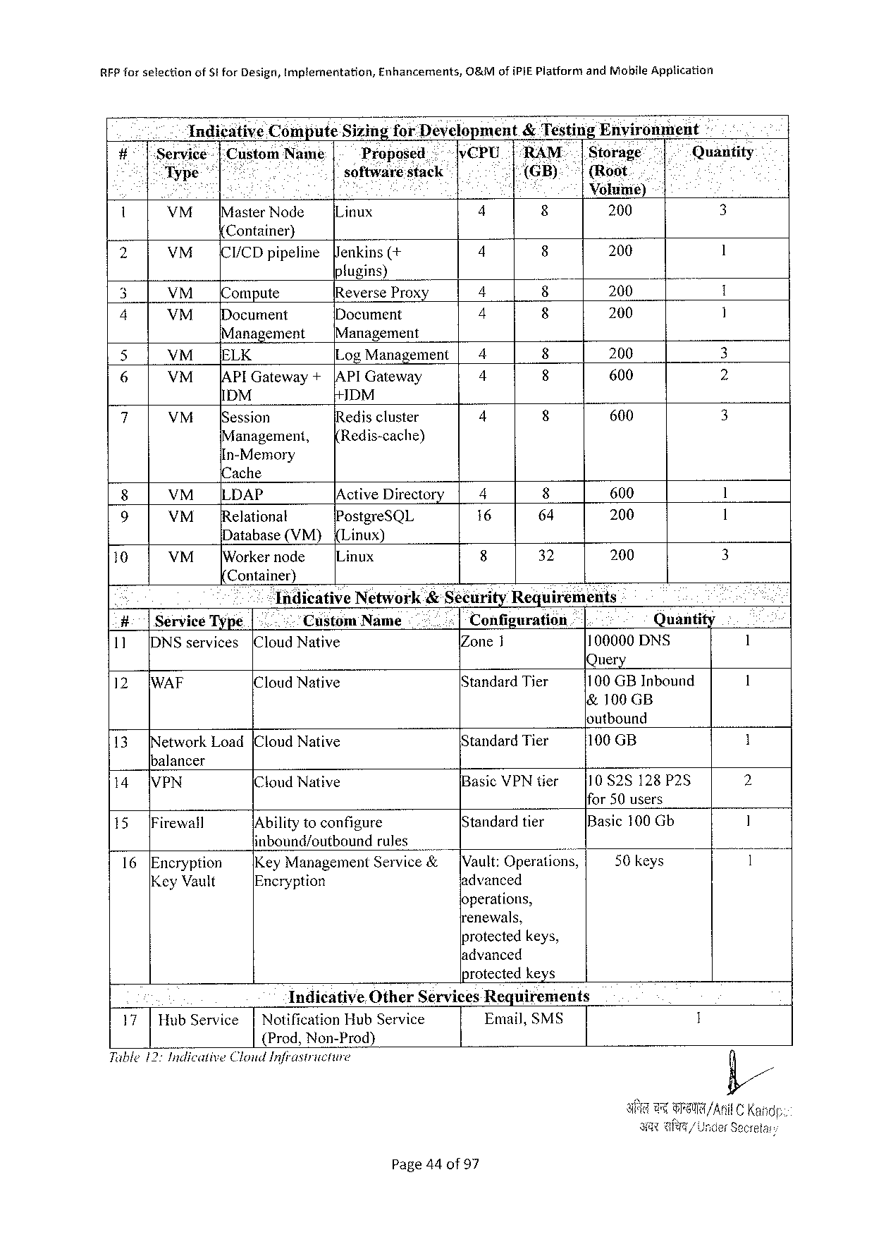

RFPforselection ofSt forDesign,Implementation, Enhancements, O&MofiPIEPlatformandMohileApplication

Indicative ComputeSizingforDevelopment&TestingEnvirenment -

#7158 ice : |:CustomName Proposed vCPU1“"RAM.|Storage Quantity

< Typ software:stack J(GB): |(Root.

Eos : . . Voluii¢)

. VM [MasterNode Linux 4 8 200 3

Container)

|  |  |  |  |  |  |  |  |
| --- | --- | --- | --- | --- | --- | --- | --- |
| 2 | VM | [CI/CD pipeline | enkins(+ | 4 | 8 | 200 | 1 |

fugins)

|  |  |  |  |  |  |  |  |
| --- | --- | --- | --- | --- | --- | --- | --- |
| 3 | VM | ompute | ReverseProx | 4 | 8 | 200 | 1 |
| Document | 4 | 8 | 200 | 1 |
| 4 | VM | Document |
| Management | | [Management | 4 | 8 | 200 | 3 |
| S |
| VM__[ELK | | LogManagement| |
| 6 | VM | |APIGateway + | |API Gateway | 4 | 600 | 2 |
| IDM | | DM |
| 7 | 4 | 600 | 3 |
| VM | [Session | Rediscluster |
| Management, | | Redis-cache) |

In-Memory

{Cache

|  |  |  |  |  |  |  |  |
| --- | --- | --- | --- | --- | --- | --- | --- |
| 8 | VM | LLDAP | /Active Directory | 4 | 8 | 600 | 1 |
| [Relationat | PostgreSQL | 16 | 64 | 200 | 1 |
| 9 | VM |
| Database(VM) | {Linux) | 8 | 32 | 200 | 3 |
| 10 | VM |
| [Workernode | ILinux |

Container)

|  |  |  |  |  |  |  |  |
| --- | --- | --- | --- | --- | --- | --- | --- |
| = | | TndicativeNetwork&SécurityRequirements | | | | | 1 |
| #:|ServiceType| | | .. | Custom | Name | Configuration | Quantity |
| (CloudNative | | Zone1 | | 100000DNS |
| 11 | [DNSservices |
| 12 | [WAF | Query | | | | | 1 |
| ICloudNative | | StandardTier | | 100 GBInbound |
| &100 GB | | | | |

loutbound

|  |  |  |  |  |
| --- | --- | --- | --- | --- |
| 13 | etworkLoad[CloudNative | StandardTier | 100 GB | 1 |

balancer

|  |  |  |  |  |  |  |
| --- | --- | --- | --- | --- | --- | --- |
| 14 | VPN | (CloudNative | | BasicVPNtier | {10 828128P25 | 2 |
| [Standard tier | ifor50 users | 1 |
| 15 | [Firewall | IAbilityto configure | |
| Basic100 Gb |
| inbound/cutbound | rules | [Vault:Operations, | 50keys | 1 |
| 16 | [Encryption |
| KeyManagement | Service& |
| KeyVault | Encryption | | advanced |

operations,

renewals,

protectedkeys,

ladvanced

protected keys

IndicativeOtherServicesRequirements

|  |  |  |  |  |
| --- | --- | --- | --- | --- |
| 17| | HubService | | | NotificationHubService | Email,SMS | 1 |

{Prod, Non-Prod)

Tuble12:IndicativeClonid Infrastricture

Page44of97

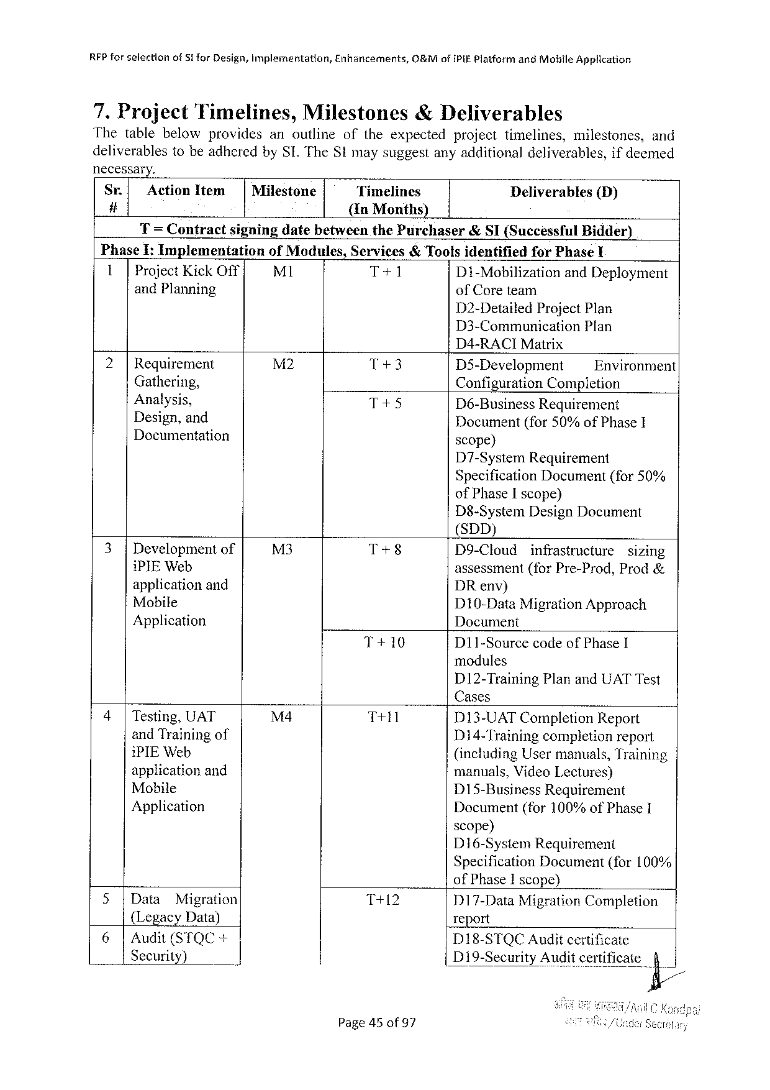

RFPforselection of51 forDesign,Implementation, Enhancements, O&MofiPiE PlatformandMobileApplication

7.ProjectTimelines,Milestones& Deliverables

Thetablebelowprovides anoutline oftheexpected projecttimelines, milestones, and

deliverablestobeadheredbySI.TheStmaysuggestanyadditionaldeliverables,ifdeemed

necessary.

Sr.| ActionItem | Milestone Timelines Deliverables (D)

# (InMonths)

T= ContractsigningdatebetweenthePurchaser&SI(SuccessfulBidder)

|  |  |  |  |  |  |
| --- | --- | --- | --- | --- | --- |
| PhaseI:Implementation | ofModules, | Services&Toolsidentified | | forPhase¥ | |
| 1|ProjectKickOff | M1 |
| T+1 | D1-Mobilization | | andDeployment |
| andPlanning |
| ofCoreteam | | | |

D2-DetailedProjectPlan

D3-Communication Plan

D4-RACIMatrix

|  |  |  |  |  |
| --- | --- | --- | --- | --- |
| 2|Requirement | M2 | T+3 | D5-Development | Environment |
| Gathering, | T+5 |
| ConfigurationCompletion | |
| Analysis, | D6-BusinessRequirement | |

Design,and   
Documentation

Document(for50%ofPhaseI scope)

D7-SystemRequirement   
Specification Document(for50% ofPhaseIscope)   
D8-SystemDesignDocument   
(SDD)

|  |  |  |  |  |  |
| --- | --- | --- | --- | --- | --- |
| 3|Developmentof | M3 | T+8 | D9-Cloud | infrastructure | sizing |

iPIEWeb   
applicationand   
Mobile   
Application

T+10 D11-SourcecodeofPhaseI

|  |  |  |  |  |
| --- | --- | --- | --- | --- |
| 4|Testing,UAT | M4 | T+11 | D13-UATCompletionReport | |
| andTrainingof | Di4-Training | completionreport |
| iPIEWeb | (includingUsermanuals,Training | |
| applicationand | manuals,VideoLectures) | |
| Mobile | D15-BusinessRequirement | |
| Application |
| Document(for100%ofPhase1 | |

scope)   
D16-SystemRequirement   
SpecificationDocument(for100%   
ofPhaseIscope)

|  |  |  |  |  |  |
| --- | --- | --- | --- | --- | --- |
| 5|Data | Migration | T+12 | D17-DataMigrationCompletion | | |
| {LegacyData) | | report | | |
| 6|Audit(STQC+ | |
| DI18-STQCAuditcertificate | | |
| Security) | | D19-Security | Audit certificate | fi/ |

Page45of97

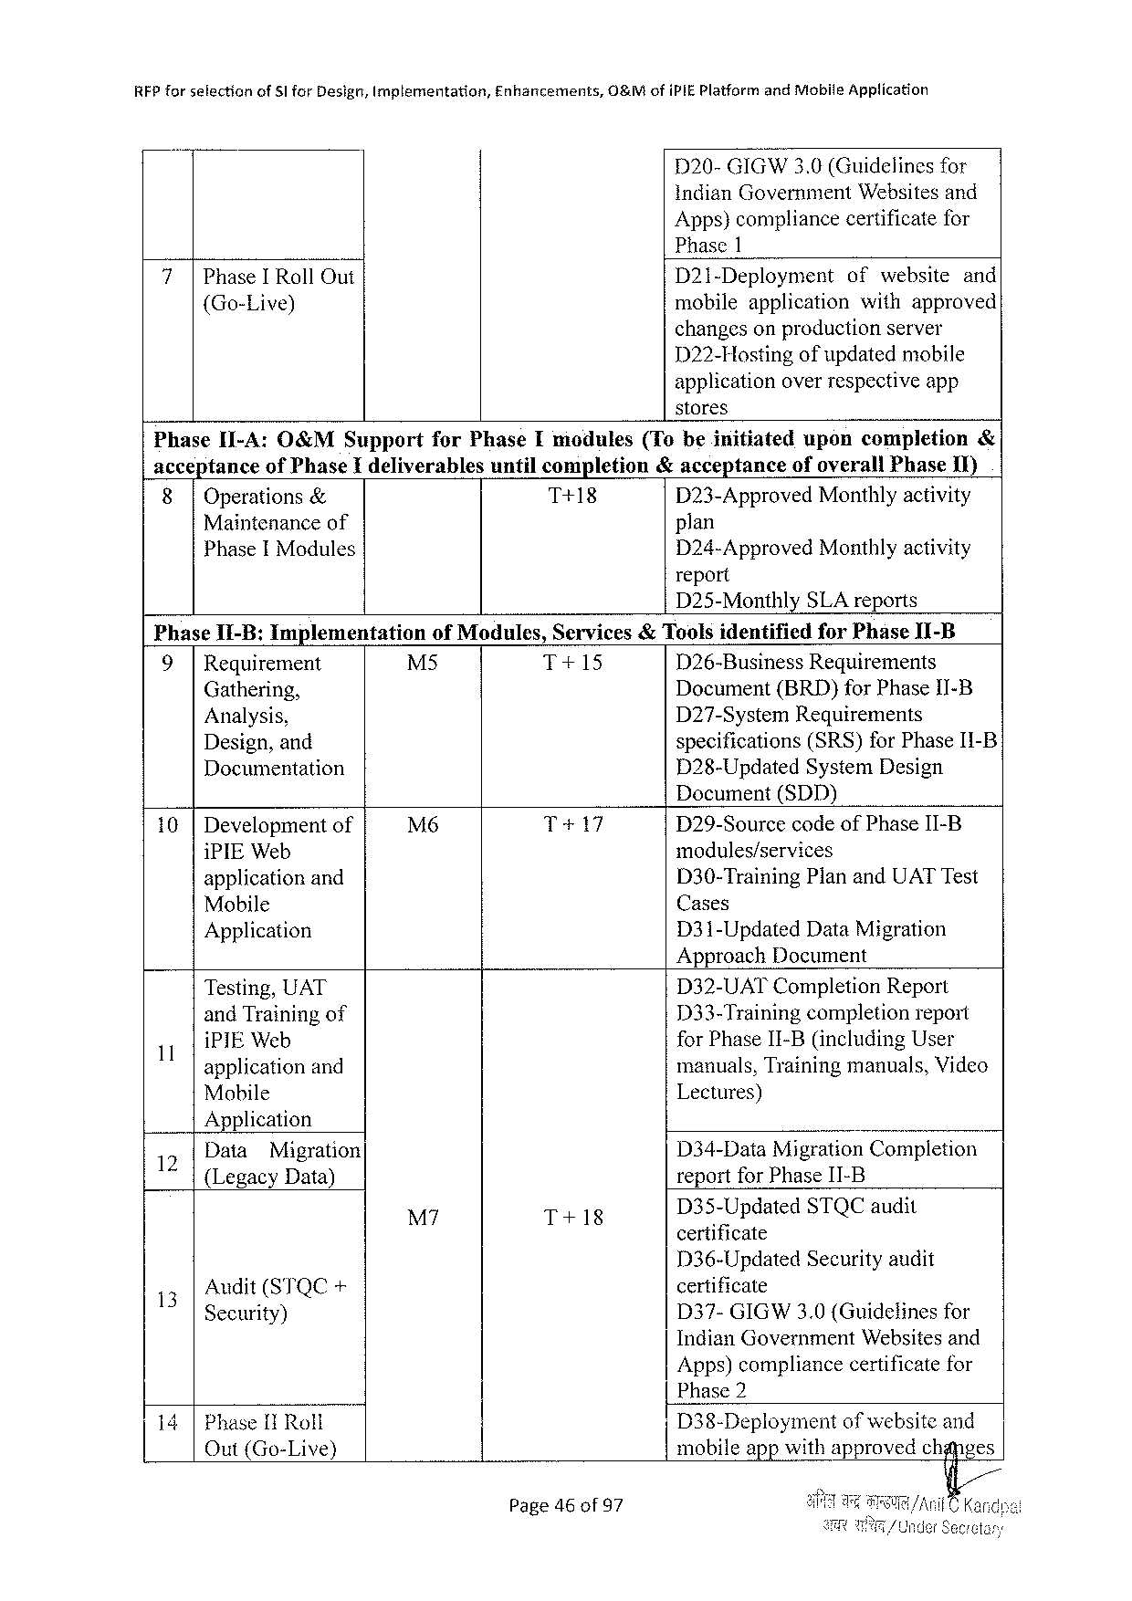

|  |  |  |  |
| --- | --- | --- | --- |
| REPforselection | of5lforDesign,Implementation, | Enhancements, | O&MofiPIEPlatformandMobileApplication |

D20-GIGW3.0(Guidelinesfor   
indianGovernmentWebsitesand   
Apps)compliancecertificatefor   
Phase1

|  |  |  |  |
| --- | --- | --- | --- |
| 7|PhaseIRollOut {Go-Live) | D21-Deployment | ofwebsite | and |
| mobileapplication | withapproved | |
| changeson productionserver | | |

D22-Hostingof updatedmobile   
applicationoverrespectiveapp   
stores

|  |  |  |  |  |  |  |  |  |
| --- | --- | --- | --- | --- | --- | --- | --- | --- |
| PhaseI1-A:O&MSupport | | | forPhaseImodules | | (Tobeinitiated | upon | completion | & |
| accepiance | | ofPhaseIdeliverables | | untilcompletion | &acceptance | ofoverallPhase1I) | |
| 8| | Operations& | | T+18 | | D23-ApprovedMonthlyactivity | | |
| Maintenanceof | | | | | plan | | |

PhaseIModules

PhaseI1-B:Implementation

D24-ApprovedMonthlyactivity report   
D25-Monthly SLA reports

ofModules,Services& ToolsidentifiedforPhaseII-B

|  |  |  |  |  |
| --- | --- | --- | --- | --- |
| 9| | Requirement | M5 | T+15 | D26-BusinessRequirements |
| Gathering, | Document(BRD)forPhaseI1I-B |
| Analysis, | D27-SystemRequirements |
| specifications(SRS)forPhaseI1-B |
| Design,and |

Documentation

D28-UpdatedSystemDesign Document(SDD)

|  |  |  |  |
| --- | --- | --- | --- |
| 10 |Developmentof | M6 | T+17 | D29-SourcecodeofPhaseII-B |
| modules/services |
| iPIEWeb |
| D30-TrainingPlanandUATTest |
| applicationand |
| Cases |
| Mobile |
| Application | D31-UpdatedData Migration |

ApproachDocument

|  |  |  |  |
| --- | --- | --- | --- |
| 1 | Testing,UAT | D32-UATCompletionReport | |
| andTrainingof | 133-Training | completionreport |
| iPIEWeb | forPhaseII-B(includingUser | |
| applicationand | manuals,Trainingmanuals,Video | |
| Mobile | Lectures) | |

Application

|  |  |  |  |
| --- | --- | --- | --- |
| 12 | Data | Migration | D34-DataMigrationCompletion |

{LegacyData)

|  |  |  |  |
| --- | --- | --- | --- |
| M7 | T+18 | D3§-Updated | STQCaudit |

|  |  |  |
| --- | --- | --- |
| 13 | Audit(STQC+ | certificate |
| D37-GIGW3.0 (Guidelinesfor |
| Security) |

IndianGovernmentWebsitesand   
Apps)compliancecertificatefor   
Phase2

14|Phase[IRoll Out(Go-Live)

Page46of97

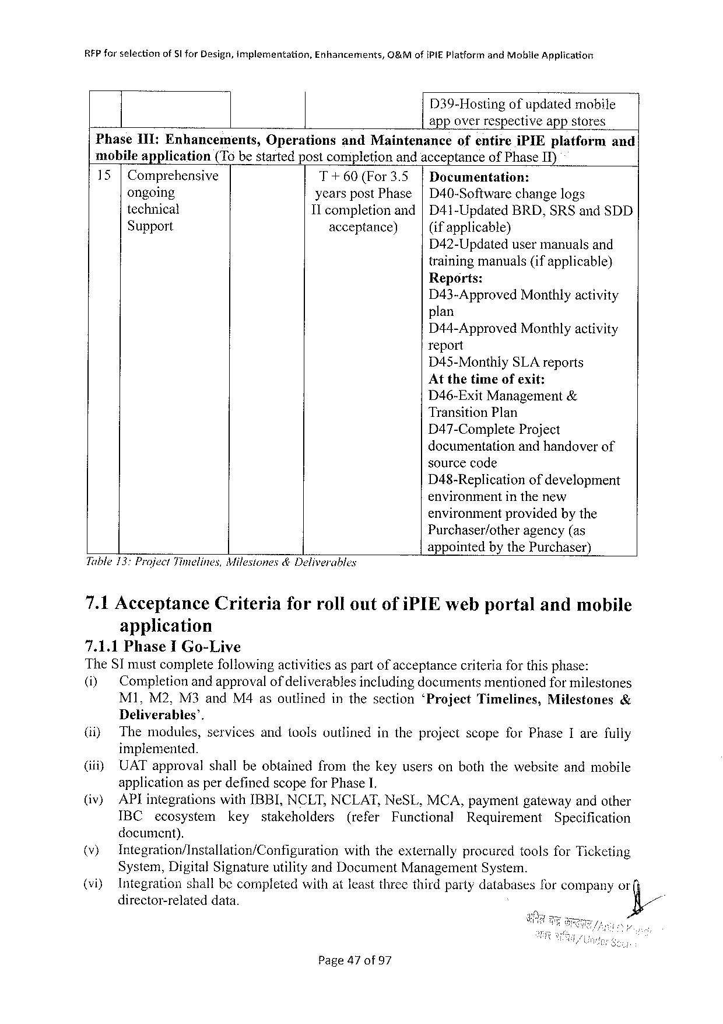

|  |  |  |  |
| --- | --- | --- | --- |
| RFPforselection | ofSl forDesign,implementation, | Enhancements, | C&MofiPIEPlatformandMobileApplication |

D39-Hostingofupdatedmobile

app overrespective appstores

Phase1II:Enhancements, Operations andMaintenance ofentire iPIEplatform and

mobileapplication (T6bestartedpostcompletionandacceptanceofPhaseIT)

15|Comprehensive T+60(For3.5 |Documentation:

ongoing yearspostPhase|D40-Softwarechangelogs

technical 11 completion and|D41-UpdatedBRD,SRSandSDD

Support acceptance) (ifapplicable}

D42-Updatedusermanualsand

trainingmanuals(ifapplicable)

Reports:

D43-Approved Monthlyactivity

plan

D44-Approved Monthlyactivity

report

D45-MonthlySLAreports

Atthetimeofexit:

D46-ExitManagement&

TransitionPlan

D47-Complete Project

documentationandhandoverof

sourcecode

D48-Replication ofdevelopment

environmentinthenew

environmentprovidedbythe

Purchaser/other agency(as

Tuble13: ProjectTimelines,Milestones&Deliverables

appointedbythePurchaser)

|  |  |  |  |
| --- | --- | --- | --- |
| 7.1Acceptance | Criteria | forrolloutofiPIEwebportal | andmobile |

application

7.1.1PhaseIGo-Live   
TheSTmustcompletefollowingactiviticsaspartof acceptancecriteriaforthisphase:

|  |  |  |  |  |  |  |
| --- | --- | --- | --- | --- | --- | --- |
| (i) | Completionandapprovalof deliverablesincludingdocumentsmentionedfor milestones | | | | | |
| M1,M2,M3andM4asoutlined | inthesection | ‘Project | Timelines, | Milestones | & |

Deliverables’.

|  |  |  |  |  |  |  |  |  |  |
| --- | --- | --- | --- | --- | --- | --- | --- | --- | --- |
| (i)  (iiiy (iv) | Themodules, | | servicesandtoolsoutlined | | | | intheprojectscopeforPhaseIarefully | | |
| implemented.  UATapprovalshallbeobtainedfromthekeyusersonboththewebsiteandmobile applicationasperdefinedscopeforPhase1.  APlintegrationswithIBBI,NCLT,NCLAT,NeSL,MCA,paymentgatewayandother | | | | | | | | |
| IBC | ecosystem | | key | stakeholders | (refer | Functional | Requirement | Specification |

document).

|  |  |  |  |  |
| --- | --- | --- | --- | --- |
| (v}  (viy | Integration/Installation/Configuration | | withtheexternally | procuredtoolsforTicketing |
| System,DigitalSignatureutilityandDocumentManagementSystem.  Integrationshallbecompletedwithatleastthreethirdpartydatabasesforcompanyor | | | |
| director-related | data. | &/ | |

Page47of97

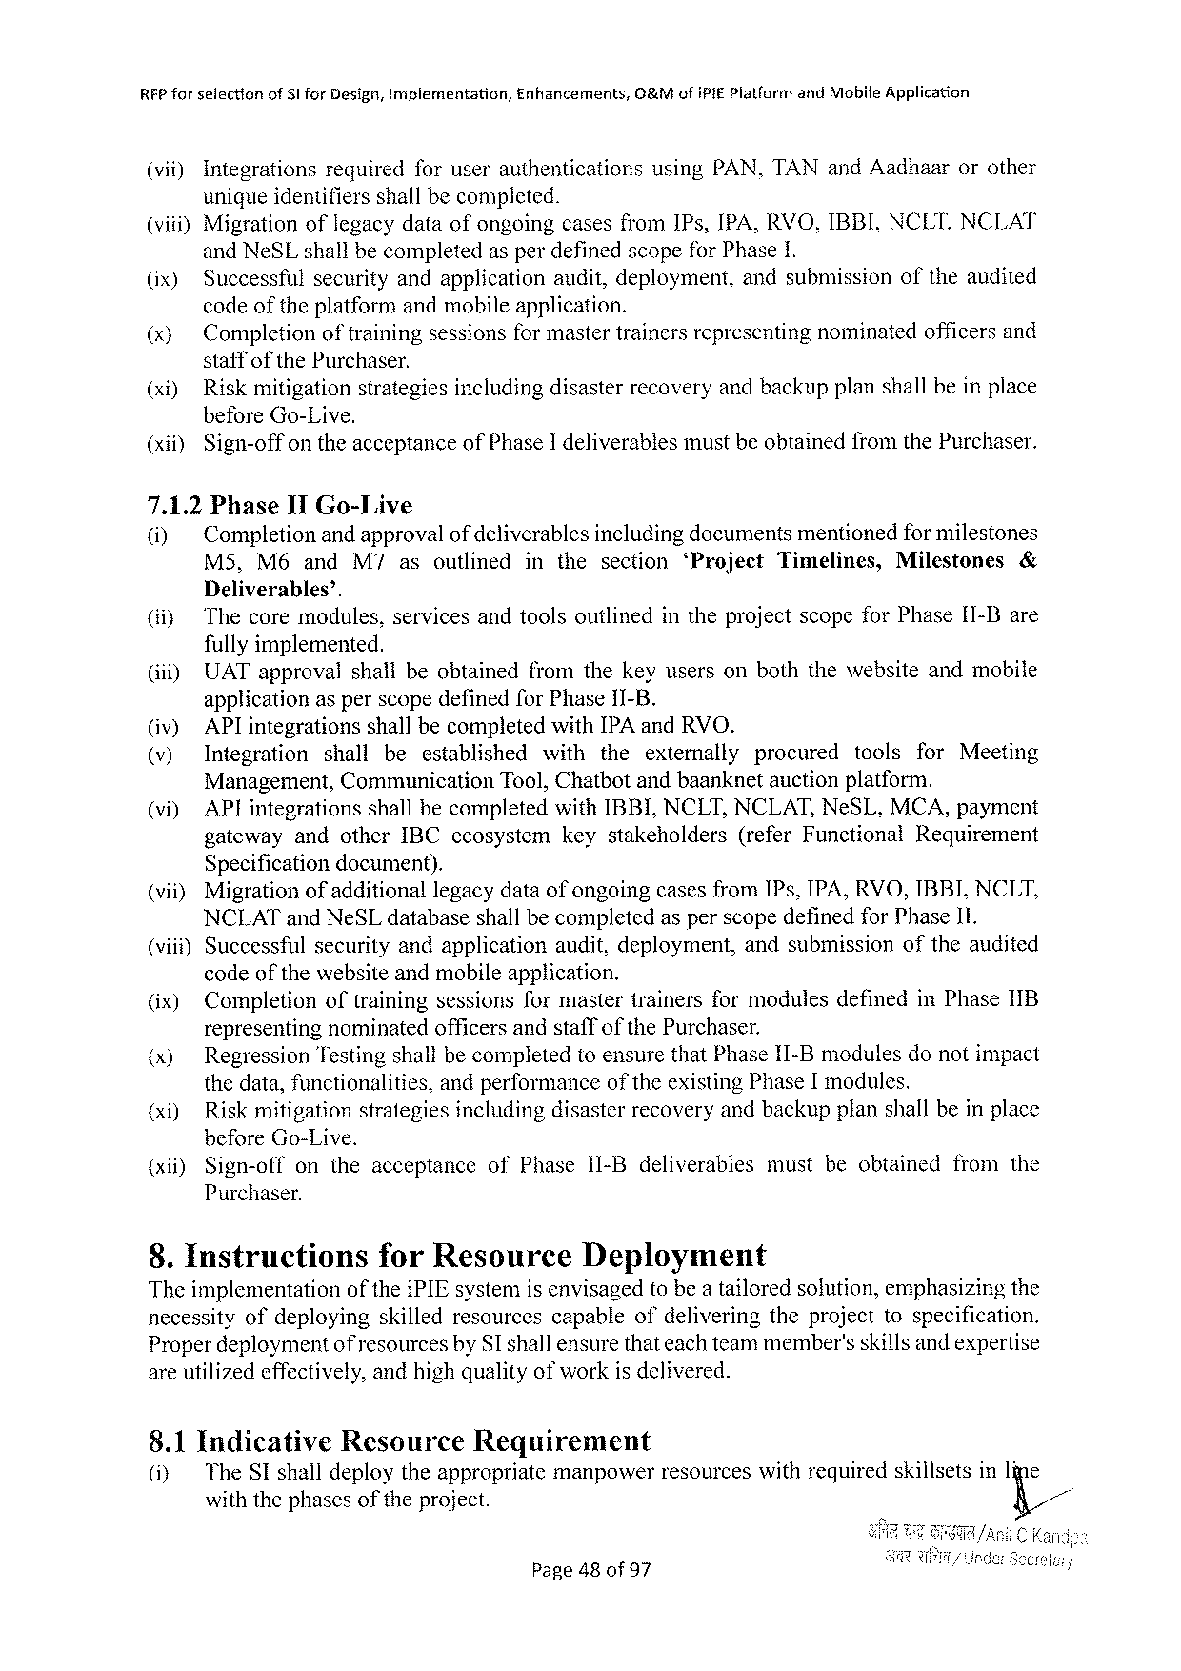

RFPforselection ofSlforDesign,Implernentation, Enhancements, O&MofiPIEPlatformandMobiteApplication

(vi) Integrationsrequiredforuserauthentications usingPAN,TANandAadhaarorother

uniqueidentifiersshallbecompleted.

(viii)MigrationoflegacydataofongoingcasesfromIPs,IPA,RVO,IBBI.NCLT,NCLAT

and NeSLshallbecompletedasperdefinedscopefor Phase1.

|  |  |
| --- | --- |
| (ix) (x) | Successfulsecurityandapplicationaudit,deployment,andsubmissionoftheandited codeofthe platformand mobileapplication.  Completionoftrainingsessionsformastertrainersrepresentingnominatedofficersand |

staffofthePurchaser.

(xi) Riskmitigationstrategiesincludingdisasterrecoveryandbackupplanshallbeinplace

beforeGo-Live.

(xil) Sign-off ontheacceptance ofPhase 1 deliverables mustbeobtained fromthePurchaser.

7.1.2PhaseIlGo-Live

(i) Completionandapprovalof deliverablesincludingdocumentsmentionedfor milestones

M5, M6andM7asoutlined inthesection ‘Project Timelines, Milestones &

Deliverables’.

(i) Thecoremodules,servicesandtoolsoutlinedintheprojectscopeforPhase[1-Bare

fullyimplemented.

(iii) UATapprovalshallbeobtainedfromthekeyusersonboththewebsiteandmobile

applicationasperscopedefinedforPhase1I-B.

(iv) APlintegrationsshallbecompletedwith[PA andRVO.

(v) Integration shall beestablished with theexternally procured tools for Meeting

Management, Communication Tool,Chatbotandbaanknetauctionplatform.

(vi) APIintegrations shallbecompleted withIBBI,NCLT,NCLAT, NeSL, MCA,payment

gateway andotherIBCecosystem keystakeholders (referFunctional Requirement

Specificationdocument).

|  |  |  |  |
| --- | --- | --- | --- |
| (vii) | Migration | of additional | legacydataof ongoingcasesfromIPs,IPA,RVO,IBBI,NCLT, |

NCLATandNeSLdatabaseshall becompletedasperscopedefinedforPhaseII.

(vii) Successfulsecurityandapplicationaudit,deployment,andsubmissionoftheaudited

code ofthe websiteandmobileapplication.

(ix) Completion oftraining sessions formaster trainers formodules defined inPhase 1IB

representingnominatedofficersandstaffofthePurchaser.

(x) RegressionTestingshallbecompletedtoensurethatPhaseII-Bmodulesdonotimpact

thedata,functionalities, andperformanceoftheexistingPhase[modules.

(xi) Riskmitigationstrategiesincludingdisasterrecoveryandbackupplanshallbeinplace

beforeGo-Live.

|  |  |  |  |  |  |  |  |  |  |  |  |
| --- | --- | --- | --- | --- | --- | --- | --- | --- | --- | --- | --- |
| (xii) | Sign-off | on | the | acceptance | of | Phase | 11-Bdeliverables | must | beobtained | from | the |

Purchaser.

8. InstructionsforResourceDeployment

Theimplementation oftheiPIEsystemisenvisagedtobea tailoredsofution,emphasizingthe

necessityofdeploying skilledresourcescapableofdeliveringtheprojecttospecification.

Properdeploymentof resourcesbySIshallensurethateachteammember’sskillsand expertise

areutilizedeffectively,andhighqualityofworkis delivered.

8.1Indicative Resource Requirement

(iy TheSIshalldeploytheappropriatcmanpowerresourceswithrequiredskillsetsinIine

withthephases of the project. K/

Page48of97

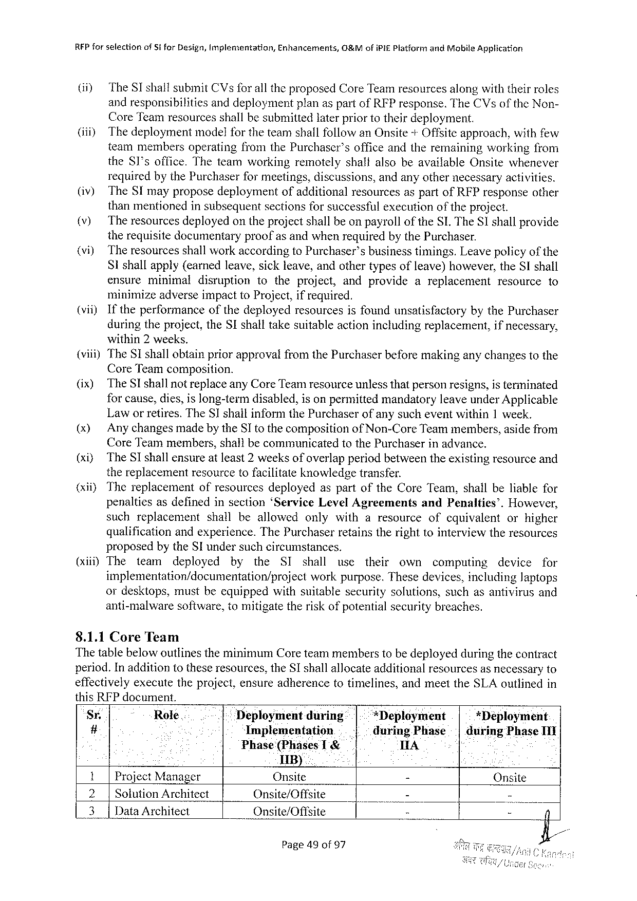

REP forselection ofStforDesign,Implementation, Enhancements, 0&MofiPifPlatformandMobileApplication

(i) TheSI shaitsubmitCVsfor alltheproposedCoreTeamresourcesalongwiththeirroles

andresponsibilities anddeploymentplanaspartofRFPresponse.TheCVsoftheNon-

CoreTeamresourcesshallbesubmittedlaterpriortotheirdeployment.

(i) Thedeploymentmodelfor theteamshallfollowanOnsite+Offsiteapproach,withfew

teammembersoperatingfromthePurchaser’sofficeandtheremainingworkingfrom

the8I’soffice.TheteamworkingremotelyshaltalsobeavailableOnsitewhenever

requiredbythePurchaserfor meetings,discussions,andanyothernecessaryactivities.

(iv) TheSImayproposedeploymentofadditionalresourcesaspartofRFPresponseother

thanmentionedinsubsequentsectionsforsuccessfulexecutionof theproject.

|  |  |  |  |  |  |  |  |  |  |  |
| --- | --- | --- | --- | --- | --- | --- | --- | --- | --- | --- |
| (v)  (vi)  (vii) | The resourcesdeployedontheprojectshallbeonpayrolloftheSL. TheSIshallprovide therequisitedocumentaryproofasandwhenrequiredbythePurchaser. | | | | | | | | | |
| The resourcesshallworkaccordingtoPurchaser’sbusinesstimings.Leavepolicy | | | | | | | | of the | |
| Sishallapply(earnedleave,sickleave,andothertypesofleave)however,theSIshall | | | | | | | | | |
| ensure | minimal | disruption | totheproject, | andprovide | areplacement | | resource | | to |
| minimizeadverseimpacttoProject,ifrequired. | | | | | | | | | |
| Iftheperformanceofthedeployedresourcesisfoundunsatisfactory | | | | | | bythePurchaser | | | |

duringtheproject,theSIshalltakesuitableactionincludingreplacement,ifnecessary,

within2weeks.

(viii)TheSIshallobtainpriorapprovalfromthePurchaserbeforemakinganychangestothe

CoreTeamcomposition.

(ix) TheSI shallnotreplaceanyCoreTeamresourceunlessthatpersonresigns,isterminated

forcause,dies,islong-termdisabled,isonpermittedmandatoryleaveunderApplicable

Laworretires.TheSIshallinformthePurchaserofanysucheventwithin1 week.

(x) Any changesmadeby theSI tothecomposition of Non-CoreTeammembers,asidefrom

CoreTeammembers,shallbecommunicated tothePurchaserinadvance.

(xi) TheSI shallensureatleast2weeksofoverlapperiodbetweentheexistingresourceand

thereplacementresourcetofacilitateknowledgetransfer.

(xii) Thereplacement ofresourcesdeployedaspartoftheCoreTeam,shallbeliablefor

penaltiesasdefinedinsection‘ServiceLevelAgreements andPenalties’. However,

suchreplacement shallbeallowed onlywitharesource ofequivalent orhigher

qualificationandexperience.ThePurchaserretainstherighttointerviewtheresources

proposedbytheSI undersuchcircumstances.

(xiii)The team deployed by the SI shall use their own computing device for

implementation/documentation/project workpurpose.Thesedevices,includingJaptops

ordesktops,mustbeequippedwithsuitablesecuritysolutions,suchasantivirusand

anti-malware software,tomitigatetheriskofpotentialsecuritybreaches.

8.1.1CoreTeam

ThetablebelowoutlinestheminimumCoreteammemberstobedeployedduringthecontract

period.Inadditiontotheseresources,theSshallallocateadditionalresourcesasnecessaryto

effectivelyexecutetheproject,ensureadherencetotimelines,andmeettheSLAoutlinedin

thisRFPdocument.

|  |  |  |  |  |  |  |  |  |
| --- | --- | --- | --- | --- | --- | --- | --- | --- |
| Sr. | Role.. | ... | Déployment | during | | | *Deployment | *Deployment |
| # | Implementation | | ..| | | -duringPhase| | duringPhaseIII |
| Phase(Phases 11B) | | T & | | A |
| Project Manager | |
| Onsite |
| - |
| Onsite | | | |
| 3| | SolutionArchitect | | Onsite/Offsite | | | | | - | - |
| Data Architect | | Onsite/Offsite | | | | - |

Page49of97

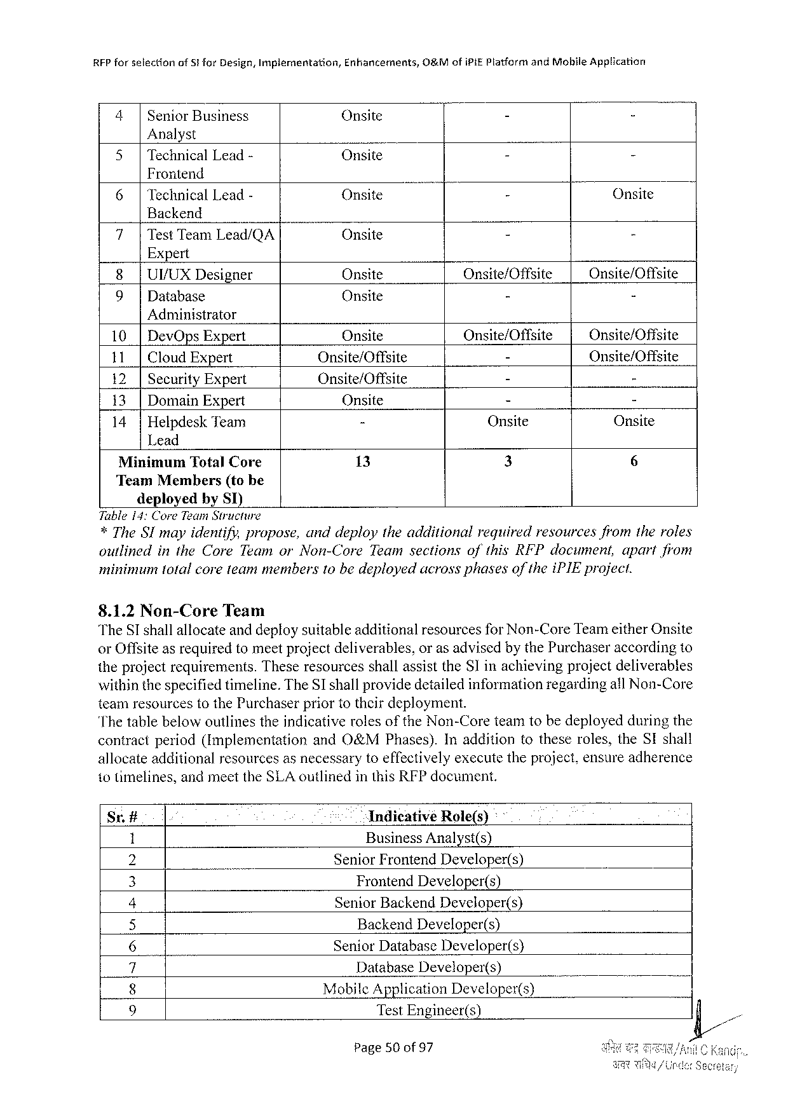

RFP forselectionof51forDesign,Implementation,Enhancements,O&MofiPIEPlatformandMobileApplication

|  |  |  |  |  |
| --- | --- | --- | --- | --- |
| 4| | SeniorBusiness | Onsite | - | - |

Analyst

|  |  |  |  |
| --- | --- | --- | --- |
| 5|TechnicalLead- | Onsite | B | h |

Frontend

|  |  |  |  |
| --- | --- | --- | --- |
| 6|TechnicalLead- | Onsite | - | Onsite |

Backend

|  |  |  |  |
| --- | --- | --- | --- |
| 7|TestTeamLead/QA | Onsite | - | - |

Expert

|  |  |  |  |  |
| --- | --- | --- | --- | --- |
| 8|UVUXDesigner | | Onsite | Onsite/Offsite | Onsite/Offsite |
| - |
| 9| | Database | Onsite | - |

Administrator

|  |  |  |  |  |
| --- | --- | --- | --- | --- |
| 10|DevOpsExpert | | Onsite | Onsite/Offsite | Onsite/Offsite |
| 11| | CloudExpert | Onsite/Offsite | - | Onsite/Offsite |
| Onsite/Offsite | - | - |
| 12| | SecurityExpert |
| 13|DomainExpert | | Onsite | - | - |
| 14|HelpdeskTeam | | - | Onsite | Onsite |

Lead

|  |  |  |  |  |
| --- | --- | --- | --- | --- |
| MinimumTotalCore | | 13 | 3 | 6 |
| TeamMembers | (tobe |
| deployedby ST) | |

Tuble14:CoreTeam Structure   
*TheSI mayidentify,propose,anddeploytheadditional requiredresourcesfromtheroles outlined intheCoreTeamorNon-Core TeamsectionsofthisRFPdocument,apartfiom minimumtotalcoreteammembers10bedeployedacrossphasesof theiPIEproject.

8.1.2Non-CoreTeam   
TheST shallaltocateand deploysuitableadditionalresourcesfor Non-CoreTeameitherOnsite orOffsiteasrequiredtomeetprojectdeliverables,oras advisedbythePurchaseraccordingto theprojectrequirements. TheseresourcesshallassisttheS]inachievingprojectdeliverables withinthespecifiedtimeline.TheSI shallprovidedetailedinformationregardingatl Non-Core teamresourcestothePurchaserpriortotheirdeployment.

Thetable belowoutlines theindicative roles ofthe Non-Core teamtobe deployed duringthe contractperiod(fmplementation andO&MPhases).Inadditiontotheseroles,theSIshall allocateadditionalresourcesasnecessarytoeffectivelyexecutetheproject,ensureadherence 1otimelines,andmeettheSLA outlinedinthisRFPdocument.

Sr.# Indicative Role(s)-

P BusinessAnalyst(s)

SeniorFrontendDeveloper(s)

|  |  |  |
| --- | --- | --- |
| VORI | FrontendDeveloper(s) | j/ |
| S |
| SeniorBackendDeveloper(s) |
| L |
| BackendDeveloper(s) |
| -\ |
| SeniorDatabaseDeveloper(s) |
| BN | DatabaseDeveloper(s) |
| U |
| MobileApplicationDeveloper(s) |
| R | TestEngineer(s) |

Page50of97

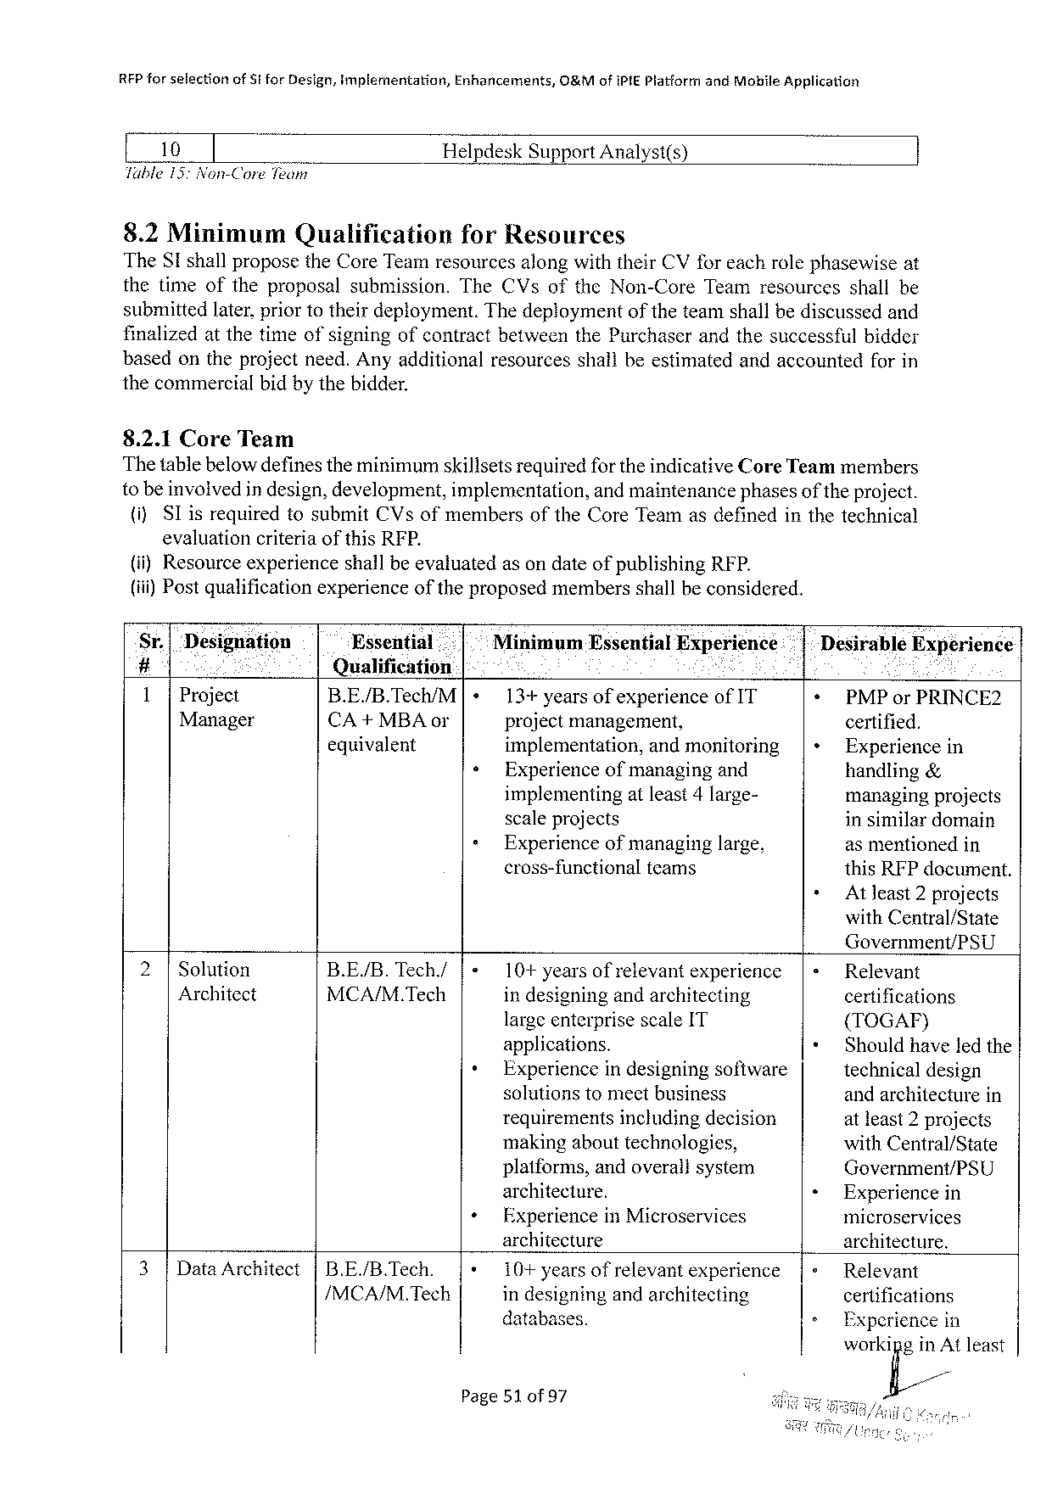

REP forselection ofSt forDesign,implementation, Enhancements, O8&M ofIPIEPlatformandMobileApplication

[ 10 ] HelpdeskSupportAnalyst(s)

Table15:Non-CoreTeam

8.2Minimum Qualification forResources

TheSI shallproposetheCoreTeamresourcesalongwiththeirCVfor eachrolephasewise at

thetimeoftheproposalsubmission.TheCVsoftheNon-CoreTeamresourcesshallbe

submittedlater,priortotheirdeployment.Thedeploymentoftheteamshallbediscussedand

finalizedat thetimeofsigningofcontract betweenthePurchaserandthesuccessfulbidder

basedontheprojectneed.Anyadditionalresourcesshallbeestimatedandaccountedforin

thecommercialbidby thebidder.

8.2.1CoreTeam

Thetablebelowdefinestheminimumskillsetsrequiredfor theindicativeCoreTeammembers

to beinvolvedin design,development,implementation, and maintenancephasesof the project.

(i)SIis requiredtosubmitCVsofmembersoftheCoreTeamasdefinedinthetechnical

evaluationcriteriaofthisRFP.

(i)ResourceexperienceshallbeevaluatedasondateofpublishingRFP.

(iii) Postqualificationexperienceoftheproposedmembersshallbeconsidered.

|  |  |  |  |  |  |  |  |  |  |  |  |  |  |
| --- | --- | --- | --- | --- | --- | --- | --- | --- | --- | --- | --- | --- | --- |
| Sr.| | Designation | | Essential | | | |+ | Minimum | Essential | | | Experience: | * |-Desirable | | Experience |
| # | ;i | o | Qualification | i | | | | | i | R | |
| 1|Project | | |
| B.E/B.Tec/M | 13+yearsofexperienceofIT | | | | | *+ PMPorPRINCE2 | | |
| Manager | | | CA+MBAor | « | projectmanagement, | | | | | certified. | | |
| equivalent | implementation, | | | andmonitoring | | |+ | Experiencein | |
| Experienceofmanagingand | | | | | handling& | | |
| » | implementing | | atleast4large- | | | managingprojects | | |
| scaleprojects | | | | | in similardomain | | |
| Experienceofmanaginglarge, | | | | | asmentionedin | | |
| cross-functional | | teams | | | thisRFPdocument. | | |
| + | Atleast2projects | |

withCentral/State

Government/PSU

|  |  |  |  |  |  |  |  |  |
| --- | --- | --- | --- | --- | --- | --- | --- | --- |
| 2|Solution | B.E/B. | Tech./ | |« | 10+ yearsofrelevantexperience | | |« | Relevant | |
| Architect | MCA/M.Tech | | indesigningandarchitecting | | certifications | |
| largeenterprisescaleIT | | + | ({TOGAF) | |
| + |
| applications. | | Shouldhaveledthe | |
| Experiencein designing software | | technical design | |
| 3|DataArchitect | |B.E/B.Tech. | | + | solutionstomeetbusiness | | « | andarchitecturein | |
| requirementsincludingdecision | | atleast2projects | |
| makingabouttechnologies, | | withCentral/State | |
| platforms,andoverallsystem | | Government/PSU | |
| architecture. | | Experiencein | |
| ExperienceinMicroservices | | microservices | |
| architecture | | |+ | architecture. | |
| |+ |
| 10+ yearsof | relevantexperience | Relevant | |
| /MCA/M.Tech | | indesigningandarchitecting | | » |
| certifications | |
| databases. | | Experiencein | |
| workifig/inm | least |

Page51of97

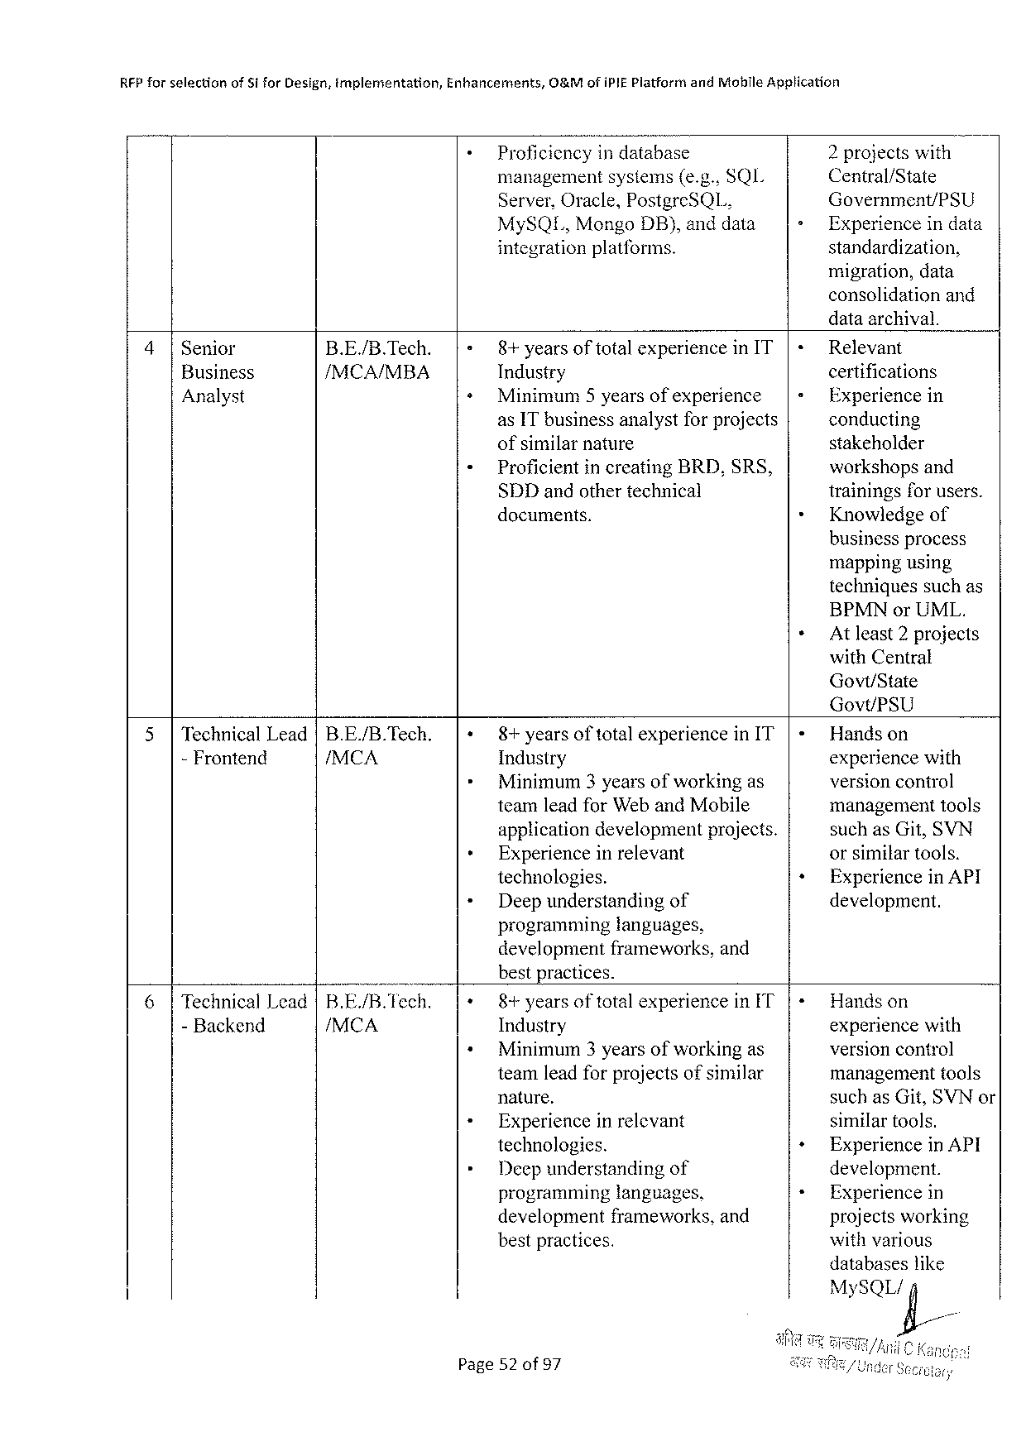

|  |  |  |  |  |
| --- | --- | --- | --- | --- |
| RFPforselection | ofSiforDesign,mplementation, | Enhancements, | O&MofiPIEPlatformandMohileApplication | |
| Proficiencyindatabase | | 2projectswith |
| managementsystems(e.g.,SQL | | Central/State |
| Server,Oracle,PostgreSQL, | | Government/PSU |
| MySQI.,MongoDB}, anddata | | Experienceindata |
| integrationplatforms. | | standardization, |

migration,data   
consolidationand   
dataarchival.

|  |  |  |  |  |  |
| --- | --- | --- | --- | --- | --- |
| 4|Senior | B.E./B.Tech. | 8+years | of total | experienceinIT | Relevant |
| certifications |
| Business | /MCA/MBA | Industry | | |
| Analyst | Minimum5yearsofexperience | | | Experiencein |
| asITbusinessanalystforprojects | | | conducting |
| ofsimilarnature | | | stakeholder |
| ProficientincreatingBRD,SRS, | | | workshopsand |
| SDDandothertechnical | | | trainingsfor users. |
| documents. | | | Knowledgeof |

businessprocess   
mappingusing   
techniquessuchas   
BPMNorUML.

AtJeast 2projects   
withCentral   
Govt/State   
Govt/PSU

|  |  |  |  |  |  |  |  |  |
| --- | --- | --- | --- | --- | --- | --- | --- | --- |
| 5|TechnicalLead|B.E./B.Tech. | | 8+years | of total | | experienceinIT | | Handson | |
| - Frontend | /MCA | Industry | | | | | experiencewith | |
| o | | Minimum3yearsofworkingas | | | | | versionconirol | |
| teamleadforWeb andMobile | | | | | management | tools |
| applicationdevelopmentprojects. | | | | | suchasGit,SVN | |
| Experienceinrelevant | | | | | orsimilartools. | |
| technologies. | | | | | Experiencein API | |
| Deepunderstanding | | | | of | development. | |
| programminglanguages, | | | | |
| developmentframeworks,and | | | | |
| bestpractices. | | | | |
| 6|TechnicalLead|B.E./B.Tech. | | 8+years oftotalexperience in[T | | | | | Handson | |
| - Backend | /MCA | Industry | | | | | experiencewith | |
| Minimum3 yearsofworkingas | | | | | versioncontrol | |
| teamleadforprojectsofsimilar | | | | | managementtools | |
| nature. | | | | | suchasGit,SVNor | |
| Experienceinrelevant | | | | | similartools. | |
| technologies. | | | | | Experiencein API | |
| Deepunderstanding | | | | of | development. | |
| programming | | languages, | | | Experiencein | |
| development | | frameworks,and | | | projectsworking | |
| bestpractices. | | | | | withvarious | |

databaseslike   
MySQLig/

Page52 of97

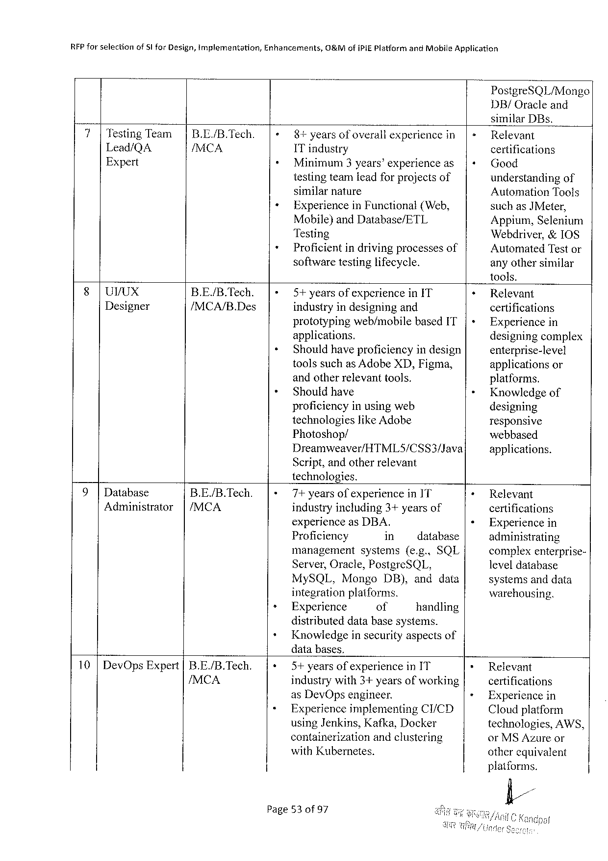

|  |  |  |  |
| --- | --- | --- | --- |
| RFPforselection | of5l forDesign,implementation, | Enhancements, | O&MofiPIEPlatformandMobileApplication |

PostgreSQL/Mongo   
DB/Oracleand   
similarDBs.

|  |  |  |  |  |  |  |  |  |  |
| --- | --- | --- | --- | --- | --- | --- | --- | --- | --- |
| 7|TestingTeam | | | B.E./B.Tech. | 8+years | of overall | experiencein|= | | | Relevant | |
| Lead/QA | /MCA | ITindustry | | | certifications | | | |
| Expert | Minimum 3years’experience as | | | |+ Good | | | |
| testingteamleadfor projectsof | | | understandingof | | | |
| similarnature | | | AutomationTools | | | |
| ExperienceinFunctional(Web, | | | suchas | | | JMeter, |
| Mobile)andDatabase/ETL | | | Appium,Selentum | | | |
| Testing | | | Webdriver,&10S | | | |
| Proficientindrivingprocessesof | | | | AutomatedTestor | | |
| softwaretestinglifecycle. | | | anyothersimilar | | | |

tools.

|  |  |  |  |  |
| --- | --- | --- | --- | --- |
| §|UVUX | B.E./B.Tech. | 5+yearsofexperienceinIT | + | Relevant |
| Designer | /MCA/B.Des |
| industryindesigningand | certifications |
| |+ |
| prototypingweb/mobilebasedIT | Experiencein |
| applications. | » | designingcomplex |
| Shouldhaveproficiencyindesign | enterprise-level |
| toolssuchas AdobeXD,Figma, | applicationsor |
| andotherrelevanttools. | platforms. |
| Shouldhave | Knowledgeof |
| proficiencyinusingweb | designing |
| technologieslike Adobe | responsive |
| Photoshop/ | webbased |
| Dreamweaver/HTML5/CSS3/Java |
| applications. |

Script,andotherrelevant   
technologies.

|  |  |  |  |  |  |  |  |  |  |
| --- | --- | --- | --- | --- | --- | --- | --- | --- | --- |
| 9|Database | B.E./B.Tech. | 7+yearsofexperienceinIT | | | | | | + | Relevant |
| Administrator | |/MCA | industryincluding3+yearsof | | | | | | certifications |
| ¢ |
| experienceasDBA. | | | | | | Experiencein |
| Proficiency | | in | | | database | administrating |
| management | | | systems(e.g..SQL | | | complexenterprise- |
| Server,Oracle,PostgreSQL, | | | | | |
| leveldatabase |
| MySQL, | Mongo | | | DB),anddata | | systemsanddata |
| integrationplatforms. | | | | | | warehousing. |
| Experience | | of | | | handling |

distributeddatabasesystems.

Knowledgeinsecurityaspectsof   
databases.

|  |  |  |  |  |  |
| --- | --- | --- | --- | --- | --- |
| 10|DevOpsExpert |B.E./B.Tech. | 5+ yearsofexperience inIT | | | * | Relevant |
| /MCA | industrywith3+yearsofworking | | | = | certifications |
| asDevOpsengineer. | | | Experiencein |
| Experienceimplementing | | CI/CD | Cloudplatform |
| usingJenkins,Kafka,Docker | | | technologies,AWS, |
| containerization | andclustering | | orMSAzureor |
| withKubernetes. | | | other equivalent |

platforms.

fl//

Page53 of97

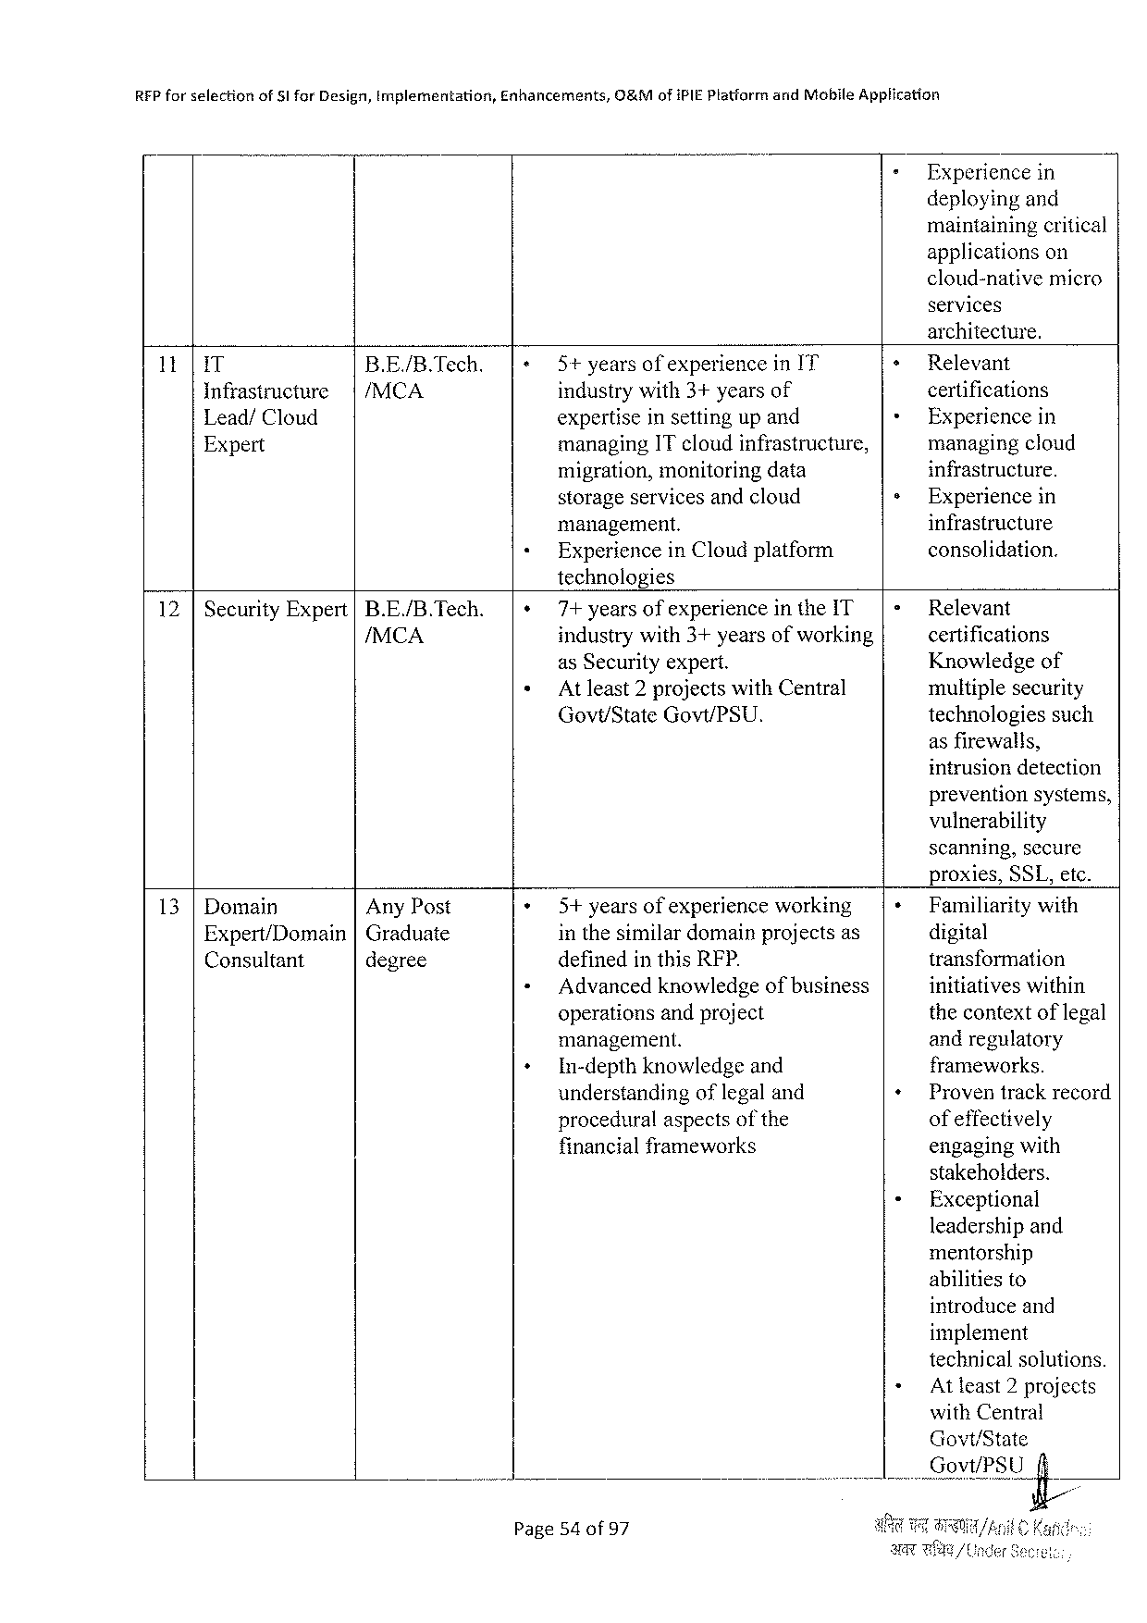

|  |  |  |  |
| --- | --- | --- | --- |
| REP forselection | of§IforDesign,implementation, | Enhancements, | O&MofiPIEPlatformandMobileApplication |

Experiencein   
deployingand   
maintainingcritical   
applications on   
cloud-native micro   
services   
architecture.

|  |  |  |  |  |  |
| --- | --- | --- | --- | --- | --- |
| 11| | IT | B.E./B.Tech. | 5+yearsofexperienceinI'T | + | Relevant |
| |/MCA | industrywith3+yearsof | + | certifications |
| Infrastructure |
| Lead/Cloud | expertiseinsettingup and | Experiencein |
| Expert | managingITcloudinfrastructure, | » | managingcloud |
| migration,monitoringdata | infrastructure. |
| storageservicesandcloud | Experiencein |
| infrastructure |
| management. |
| ExperienceinCloudplatform | consolidation. |

technologies

|  |  |  |
| --- | --- | --- |
| 12 |SecurityExpert|B.E./B.Tech. | 7+ yearsof experiencein theIT|= | Relevant |
| /MCA | industrywith3+yearsofworking | certifications |
| asSecurityexpert. | Knowledgeof |
| Atleast2projectswithCentral | multiplesecurity |
| Govt/StateGovt/PSU. | technologiessuch |

asfirewalls,   
intrusiondetection   
preventionsystems,   
vulnerability   
scanning,secure   
proxies,SSL,etc.

|  |  |  |  |  |
| --- | --- | --- | --- | --- |
| 13 |Domain | AnyPost | 5+yearsofexperienceworking | + | Familiaritywith |
| digital |
| Expert/Domain|Graduate | | inthesimilardomainprojectsas |
| transformation |
| Consultant | degree | definedinthisRFP. |
| Advancedknowledgeofbusiness | initiativeswithin |
| operationsandproject | thecontextoflegal |
| management. | andregulatory |
| In-depthknowledgeand | frameworks. |
| understanding oflegaland | Proventrackrecord |
| proceduralaspectsofthe | ofeffectively |
| financialframeworks | engagingwith |

stakeholders.

Exceptional   
leadershipand   
mentorship   
abilitiesto   
introduceand   
implement   
technicalsolutions.

Atleast2 projects   
 withCentral   
 Govt/State   
i V_QE_VI/J’fitLfi;

Page54of97

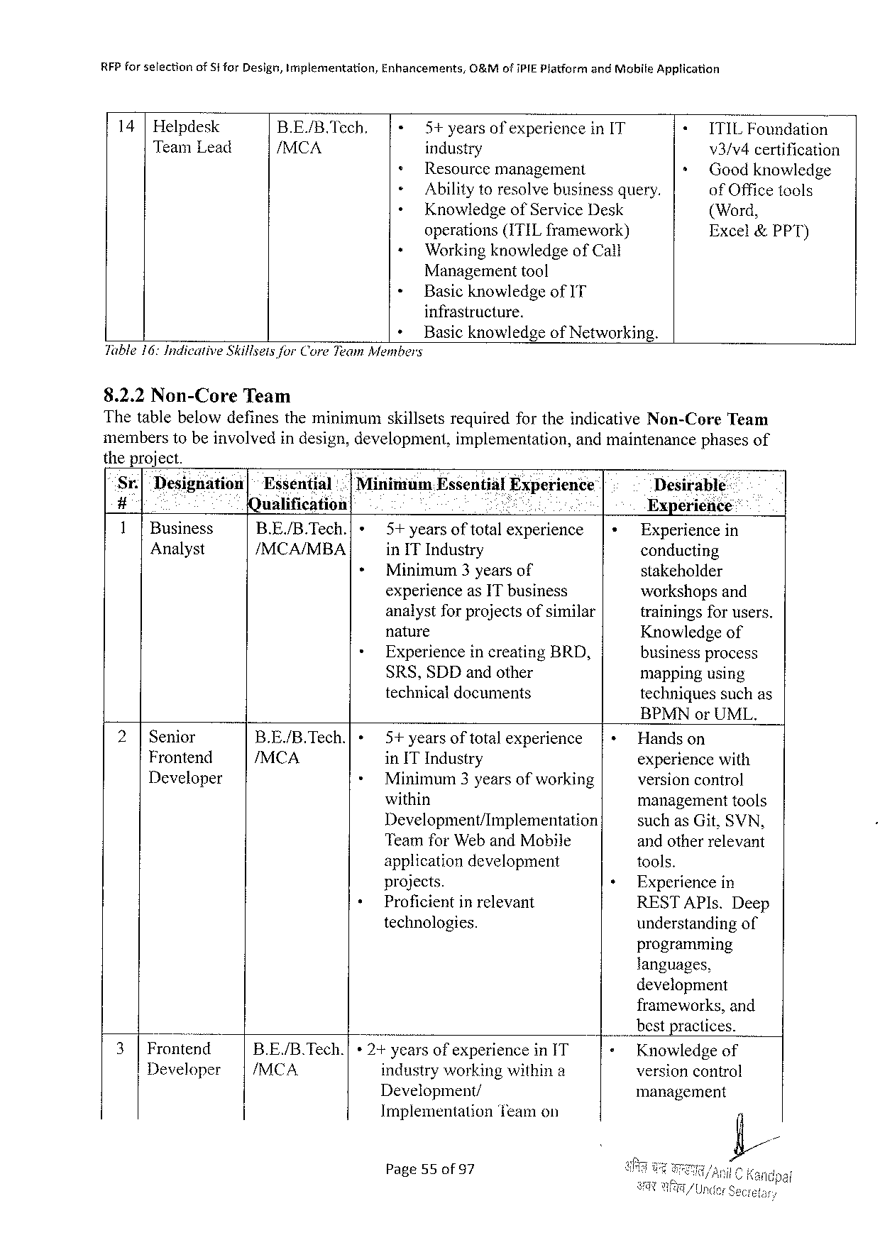

|  |  |  |  |  |  |  |  |
| --- | --- | --- | --- | --- | --- | --- | --- |
| RFPforselection | | ofSforDesign,Implementation, | | Enhancements, | G&MofiPIEPiatformandMobileApplication | | |
| 14 | Helpdesk | | B.E./B.Tech. | 5+yearsof experience | | in[T | ITILFoundation |
| TeamLead | | | /MCA | industry | | | v3/v4certification |
| Resourcemanagement | | | Goodknowledge |
| Abilitytoresolvebusinessquery. | | | ofOfficetools |
| KnowledgeofServiceDesk | | | (Word, |
| operations(ITILframework) | | | Excel&PPT) |
| Workingknowledge ofCall | | | |

Managementtool

« BasicknowledgeofIT

infrastructure.

+ Basicknowledgeof Networking.

Table16:IndicativeSkillseisforCore Team Members

8.2.2Non-Core Team

Thetablebelowdefinesthe minimumskillsets requiredfortheindicativeNon-CoreTeam

memberstobeinvolvedindesign,development, implementation, andmaintenancephasesof

theproject.

Sr.| Designdtion|~Essential .|MinimuamEssential Experience Desirable:

# Qualification Pkl : Experience::

1|Business B.E./B.Tech.| » 5+yearsoftotalexperience Experiencein

Analyst /MCA/MBA inITIndustry conducting

+ Minimum3yearsof stakeholder

experienceasITbusiness workshopsand

analystfor projectsofsimilar trainingsfor users.

nature Knowledgeof

+ Experiencein creatingBRD, business process

SRS,SDDandother mappingusing

technicaldocuments techniguessuchas

BPMNorUML.

|  |  |  |  |  |  |  |
| --- | --- | --- | --- | --- | --- | --- |
| 2|Senior | B.E/B.Tech.[ | » | 5+years | of total | experience | Handson |
| Frontend | /MCA | * | in ITIndustry | | | experiencewith |
| Developer | Minimum3yearsofworking | | | versioncontrol |
| + | within | | | managementtools |
| Development/Implementation | | | suchas Git,SVN, |
| TeamforWebandMobile | | | andotherrelevant |
| applicationdevelopment | | | tools. |
| projects. | | | Experience in |
| Proficientin relevant | | | RESTAPIs.Deep |
| technologies. | | | understandingof |

programming

languages,

development

|  |  |  |  |  |  |
| --- | --- | --- | --- | --- | --- |
| 3| | . | B.E./B.Tech.| | * 2+yearsofexperienceinIT | | frameworks,and |
| bestpractices. |
| Frontend | Knowledgeof |
| Developer | |/MCA | industryworking withina | | version control |
| Development/ | | management |
| Implementation | Teamon |

Page55of97

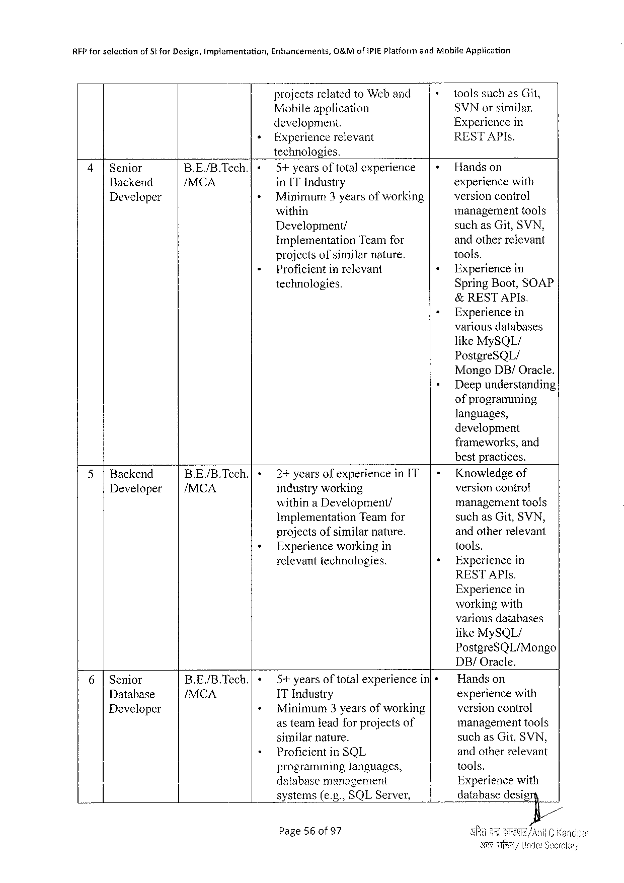

|  |  |  |  |  |  |  |
| --- | --- | --- | --- | --- | --- | --- |
| REP forselection | of5t forDesign,Implementation, | Enhancements, | O&MofIPIEPlatformandMotile | | | Application |
| + | projects relatedto Weband | | + | toolssuchasGit, | |
| Mobileapplication | | SVNorsimilar. | | |
| development. | | Experiencein | | |
| Experiencerelevant | | RESTAPIs. | | |

technologies.

|  |  |  |  |  |  |
| --- | --- | --- | --- | --- | --- |
| 4|Senior | B.E/B.Tech.|{» | 5+ yearsoftota)experience | |+Handson | | |
| Backend | /MCA | in IT Industry | experiencewith | | |
| Developer | « | Minimum3yearsofworking | versioncontrol | | |
| « | within | management | | tools |
| Development/ | suchasGit,SVN, | | |
| ImplementationTeamfor | andotherrelevant | | |
| projectsofsimilarnature. | tools, | | |
| Proficient in relevant | « | Experiencein | |
| technologies. | SpringBoot,SOAP | | |

&RESTAPIs.

» Experiencein   
 variousdatabases   
 likeMySQL/   
 PostgreSQL/   
 MongoDB/Oracle.

« Deepunderstanding   
 ofprogramming   
 languages,   
 development   
 frameworks,and   
 bestpractices.

|  |  |  |  |  |  |  |  |
| --- | --- | --- | --- | --- | --- | --- | --- |
| 5|Backend | | | B.E/B.Tech.| | + | 2+yearsofexperienceinIT | | |- | Knowledgeof |
| Developer | /MCA | industryworking | | versioncontro! |
| withina Development/ | | managementtools |
| » | Implementation | Teamfor | suchasGit,SVN, |
| + |
| projects ofsimilarnature. | | andotherrelevant |
| Experienceworkingin | | tools. |
| relevanttechnologies. | | Experiencein |

RESTAPIs.

Experiencein   
workingwith   
variousdatabases   
likeMySQL/   
PostgreSQL/Mongo   
DB/Oracle.

|  |  |  |  |  |  |  |  |
| --- | --- | --- | --- | --- | --- | --- | --- |
| 6|Senior | B.E/B.Tech.| | « | 5+years | | of total | experiencein[+ | Handson |
| /MCA | + | 1T Industry | | | | experiencewith |
| Database |
| Developer | Minimum3yearsofworking | | | | versioncontrol |
| + | asteamleadforprojectsof | | | | managementtools |
| similar | nature. | | | suchasGit,SVN, |
| Proficient | | inSQL | | andotherrelevant |
| \_H |
| programminglanguages, | | | | tools. |
| databasemanagement | | | | Experiencewith |
| systems(e.g.,SQLServer, | | | | databasedesigry |

Page56of 97

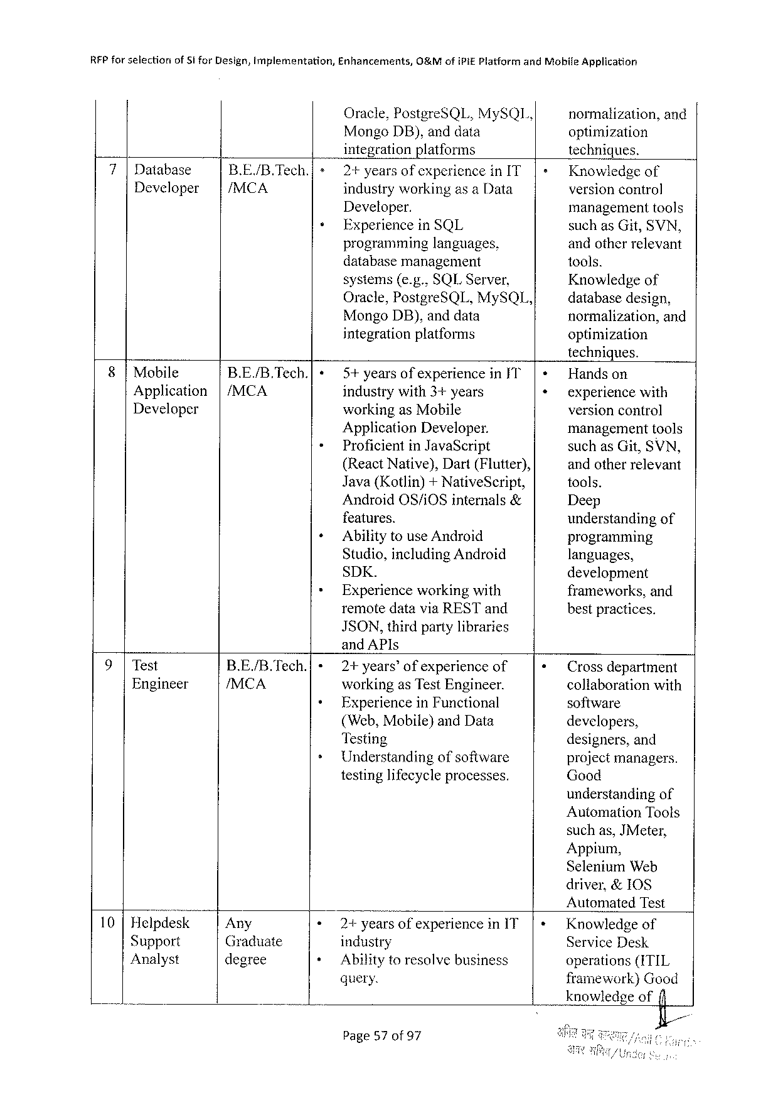

|  |  |  |  |  |  |  |  |  |
| --- | --- | --- | --- | --- | --- | --- | --- | --- |
| RFPforselection | of i | forDesign,Implementation, | | Enhancements, | O&MofiPiE PlatformandMohileApplication | | | |
| 7|Database | | B.E/B.Tech.] | » | Oracle,PostgreSQL,MySQL, | | | normalization, | and |
| MongoDB),anddata | | | optimization | |
| integrationplatforms | | | techniques. | |
| 2+yearsof experienceinIT | | | Knowledgeof | |
| Developer | | /MCA | | industryworkingas aData | | | versioncontrol | |
| « | |
| Developer. | | | management | tools |
| ExperienceinSQL | | | suchasGit,SVN, | |
| programming | | languages, | andotherrelevant | |
| databasemanagement | | | 100ls. | |
| systems(e.g.,SQLServer, | | | Knowledgeof | |
| Oracle,PostgreSQL,MySQL, | | | databasedesign, | |
| MongoDB),anddata | | | normalization, | and |
| integrationplatforms | | | optimization | |

techniques.

|  |  |  |  |  |
| --- | --- | --- | --- | --- |
| 8|Mobile | B.E/B.Tech.| | « | 5+yearsofexperienceinJT' | Handson |
| Application | |/MCA | » | industrywith3+years | experiencewith |
| Developer | workingasMobile | versioncontrol |
| ApplicationDeveloper. | managementtools |
| ProficientinJavaScript | suchasGit,SVN, |
| + | (ReactNative),Dart(Flutter), | andotherrelevant |
| Java(Kotlin)+NativeSeript, | tools. |
| AndroidOS/iOSinternals& | Deep |
| features. | understanding of |
| Ability touseAndroid | programming |
| » | Studio,includingAndroid |
| languages, |
| SDK. | development |
| Experienceworkingwith | frameworks,and |
| remotedataviaRESTand | bestpractices. |

JSON,thirdpartylibraries   
and APIs

|  |  |  |  |  |
| --- | --- | --- | --- | --- |
| 9|Test | B.E/B.Tech.| | »+2+years’of experienceof | | Crossdepartment |
| Engineer | /MCA | workingas TestEngineer. | | collaborationwith |
| + | ExperienceinFunctional | software |
| (Web,Mobile)andData | | developers, |
| Testing | |
| designers,and |
| + | Understandingofsoftware |
| projectmanagers. |
| testinglifecycleprocesses. | | Good |

understandingof   
AutomationTools   
suchas,JMeter,   
Appium,   
SeleniumWeb

|  |  |  |  |  |
| --- | --- | --- | --- | --- |
| . | Any | « | y | driver,&IOS |
| AutomatedTest |
| 10 |Helpdesk | 2+yearsofexperienceinIT |
| Knowledgeof |
| Support | Graduate | industry | ServiceDesk |
| + |
| Analyst | degree | Ability toresolvebusiness | operations(ITIL |
| query. | framework)Good |
| knowledgeofi |

Page57 of97

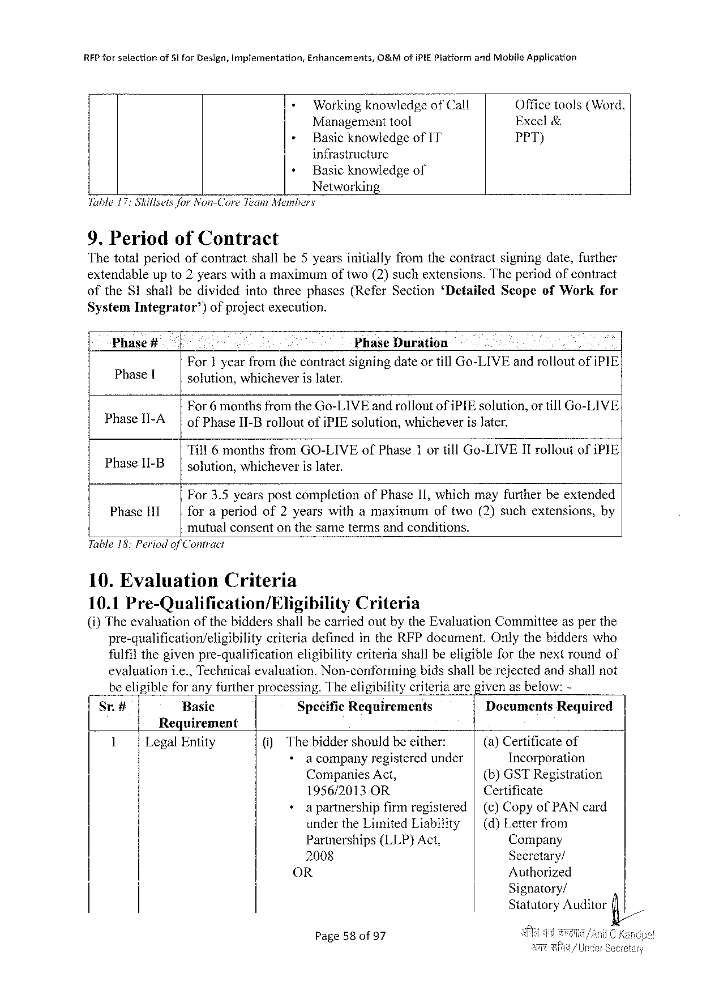

|  |  |  |  |  |
| --- | --- | --- | --- | --- |
| RFPforselection | of5!forDesign,implementation, | Enhancements, | O&MofiPIEPlatformandMobileApplication | |
| - | WorkingknowledgeofCall | | Officetools(Word, |
| » | Managementtool | | Excel& |
| BasicknowledgeofIT | | PPT) |

infrastructure  
 « Basicknowledgeof Networking   
Tuble17:SkilsetsforNon-Core Team Members

9. Periodof Contract   
Thetotalperiodofcontractshallbe5yearsinitiallyfromthecontractsigningdate,further extendableupto2yearswithamaximumoftwo(2)suchextensions.Theperiodofcontract

|  |  |  |  |  |
| --- | --- | --- | --- | --- |
| oftheSIshallbedividedintothreephases(ReferSection‘Detailed | | | ScopeofWork | for |
| SystemIntegrator’) | ofprojectexecution. | |
| Phase# | : | PhaseDuration |

For1 yearfromthecontractsigningdateortillGo-LIVEandrolloutofiPIE Phase[ solution,whicheverislater.

For6monthsfromtheGo-LIVEandrolloutofiPIEsolution,or tillGo-LIVE

|  |  |  |  |  |
| --- | --- | --- | --- | --- |
| PhaseII-A | | | ofPhaseII-Brollout | of{PIEsolution, | whichever | islater. |

Till6monthsfromGO-LIVEofPhase1 ortillGo-LIVEIIrolloutofiPIE PhaseII-B solution,whicheverislater.

For3.5yearspostcompletionofPhaseII,whichmayfurtherbeextended

|  |  |  |  |
| --- | --- | --- | --- |
| PhaseHI | foraperiodof2yearswithamaximum | oftwo(2)suchextensions, | by |

mutualconsentonthesametermsandconditions. Table18: Periodof Contract

10.Evaluation Criteria

10.1Pre-Qualification/Eligibility Criteria   
(i)TheevaluationofthebiddersshallbecarriedoutbytheEvaluationCommitteeasperthe

|  |  |  |
| --- | --- | --- |
| pre-qualification/eligibility | criteriadefinedintheRFPdocument. | Onlythebidderswho |

fulfilthegivenpre-qualification

eligibilitycriteriashallbeeligibleforthenextroundof

evaluationi.e.,Technicalevaluation.Non-conforming bidsshallberejectedandshallnot beeligibleforanyfurtherprocessing.Theeligibilitycriteriaarcgivenasbelow:-

|  |  |  |  |  |
| --- | --- | --- | --- | --- |
| Sr.# | Basic | SpecificRequirements | Documents | Required |

Requirement

|  |  |  |  |  |  |  |  |
| --- | --- | --- | --- | --- | --- | --- | --- |
| 1 | LegalEntity | (i) | Thebiddershouldbeeither: | | | (a)Certificateof | |
| »acompany | registeredunder | | Incorporation | |
| CompaniesAct, | | | (b)GSTRegistration | |
| 1956/2013OR | | | Certificate | |
| +apartnership | | firmregistered|(c)CopyofPAN card | | |
| undertheLimitedLiability | | | | | (d)Letterfrom |
| Partnerships(LLP)Act, | | | Company | |
| 2008 | | | Secretary/ | |
| OR | | | Authorized | |

Signatory/   
StatutoryAuditorfi/

Page58of 97 J

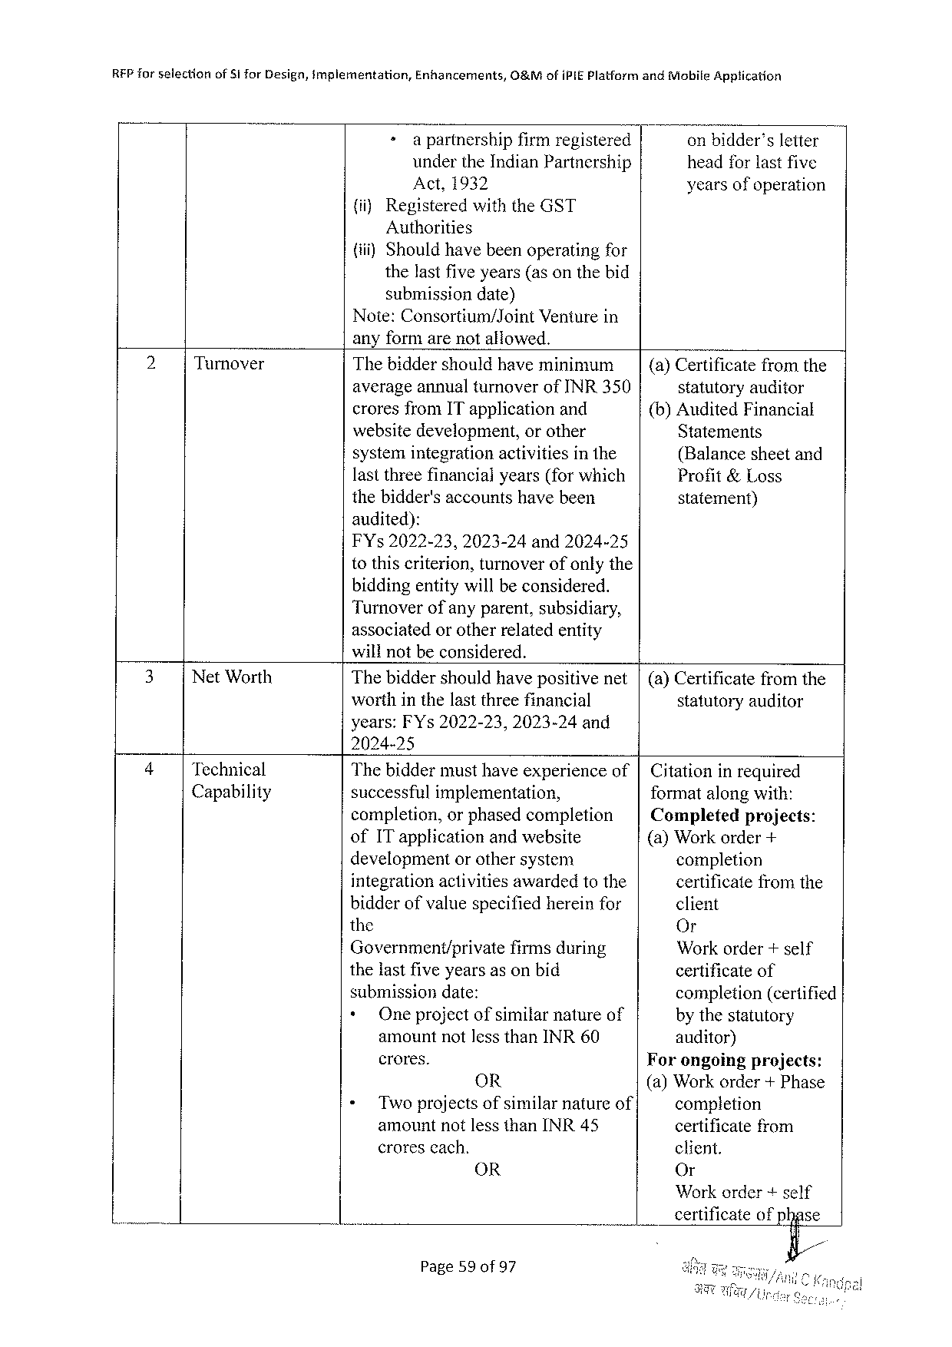

|  |  |  |  |  |  |
| --- | --- | --- | --- | --- | --- |
| REP forselection | of51forDesign,implementation, | Enhancements, | 0&MofiPIEPlatformandMobileApptication | | |
| + | a partnershipfirmregistered | | | onbidder’sletter |
| undertheIndianPartnership | | headforlastfive | |
| Act,1932 | | yearsofoperation | |

{ii)RegisteredwiththeGST   
 Authorities   
(i) Shouldhavebeenoperatingfor   
 thelastfiveyears(asonthebid   
 submissiondate)   
Note:Consortium/Joint Venturein   
anyformarenotallowed.

|  |  |  |  |
| --- | --- | --- | --- |
| 2 | Turnover | Thebiddershouldhaveminimum | (a)Certificatefromthe |
| averageannualturnoverofINR350 | statutoryauditor |
| croresfromITapplicationand | (b)AuditedFinancial |
| websitedevelopment,orother | Statements |
| systemintegrationactivitiesinthe | (Balancesheetand |
| lastthreefinancialyears(forwhich | Profit&Loss |
| thebidder'saccountshavebeen | statement) |

audited):   
FYs2022-23, 2023-24and2024-25   
tothiscriterion,turnoverofonlythe   
biddingentitywillbe considered.

Turnoverofanyparent,subsidiary,   
associatedorotherrelatedentity   
willnotbeconsidered.

|  |  |  |  |
| --- | --- | --- | --- |
| 3 | NetWorth | Thebiddershouldhavepositivenet|(a)Certificatefromthe | |
| worthinthelastthreefinancial | statutoryauditor |

years:FYs2022-23,2023-24and   
2024-25

|  |  |  |  |  |  |  |
| --- | --- | --- | --- | --- | --- | --- |
| 4 | Technical | Thebiddermusthaveexperienceof|Citationinrequired | | | | |
| Capability | successfulimplementation, | | | | formatalongwith: |
| completion,orphasedcompletion | | | | Completedprojects: |
| ofITapplicationandwebsite | | | | (a)Workorder+ |
| development | | | orothersystem | completion |
| integrationactivitiesawardedtothe | | | | certificate fromthe |
| bidderofvaluespecifiedhereinfor | | | | client |
| the | | | | Or |
| Government/private firmsduring | | | | Workorder+self |
| thelastfiveyearsasonbid | | | | certificateof |
| submissiondate: | | | | completion(certified |
| + | | Oneprojectofsimilarnatureof | | by thestatutory |
| amountnotlessthanINR60 | | | | auditor) |
| crores. | | | | Forongoingprojects: |
| OR | | | | (a)Workorder+ Phase |
| « | Two projectsofsimilarnatureof | | | completion |
| amountnotlessthanINR45 | | | | certificatefrom |
| crorescach. | | | | client. |
| OR | | | | Or |

Workorder+self   
certificateofphase   
 fi/

Page59of97

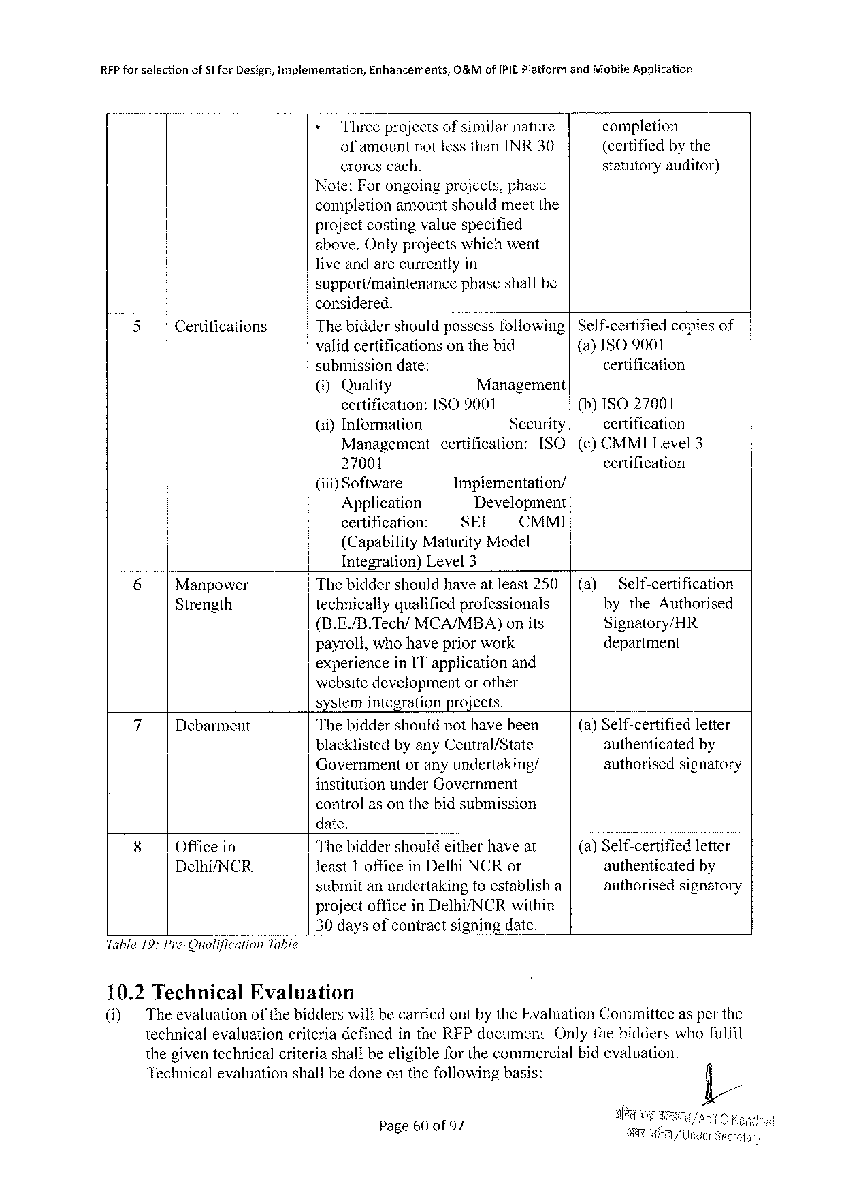

REP forselection ofSforDesign,implementation, Enhancements, O&MofiPIEPlatformandMobileApplication

» Threeprojectsof similarnature completion   
 ofamountnotlessthanINR30 (certifiedbythe croreseach. statutoryauditor} Note:Forongoingprojects,phase   
completionamountshouldmeetthe   
projectcostingvaluespecified   
above,Onlyprojectswhichwent   
liveandarecurrentlyin

support/maintenance   
considered.

phaseshallbe

|  |  |  |  |  |  |  |  |
| --- | --- | --- | --- | --- | --- | --- | --- |
| 5 | Certifications | Thebiddershouldpossess following | | | | | Self-certifiedcopiesof |
| validcertificationsonthebid | | | | | (a) ISO9001 |
| submissiondate: | | | | | certification |
| (i)Quality | Management | | | | (b)ISO 27001 |
| certification: | ISO 9001 | | | |
| (iiyInformation | Security | | | | certification |
| Management | | certification: | | [SO | (c)CMMILevel3 |
| 27001 | | | | | certification |
| (iti) Software | Implementation/ | | | |
| Application | Development | | | |
| certification: | SEI | | CMMI | |

(CapabilityMaturityModel   
Integration)Level3

|  |  |  |  |  |  |
| --- | --- | --- | --- | --- | --- |
| 6 | Manpower | Thebiddershouldhaveatleast250 | | (a) | Self-certification |
| Strength | technicallyqualifiedprofessionals | | bytheAuthorised |
| (B.E./B.Tech/MCA/MBA) | onits | Signatory/HR |
| payroll,whohavepriorwork | | department |

experienceinITapplicationand   
websitedevelopmentorother   
systemintegrationprojects.

|  |  |  |  |
| --- | --- | --- | --- |
| 7 | Debarment | Thebiddershouldnothavebeen | (a)Self-certifiedletier |
| authenticatedby |
| blacklistedbyanyCentral/State |
| Governmentoranyundertaking/ | authorisedsignatory |

institutionunderGovernment   
controlasonthebidsubmission   
date,

|  |  |  |  |
| --- | --- | --- | --- |
| 8 | Officein | Thebiddershouldeitherhaveat | (a)Self-certifiedletter |
| Delhi/NCR | Jeast1 officeinDelhiNCR or | authenticated by |
| submitanundertakingtoestablisha | authorisedsignatory |

projectoffice inDelhi/NCRwithin 30daysofcontractsigningdate. Table19:Pro-Oualification Table

10.2Technical Evaluation

(i) Theevaluation of thebidderswillbecarriedoutby theEvaluationCommitteeasper the technicalevaluationcriteriadefinedintheRFPdocument.Onlythebidderswhofuifil thegiventechnicalcriteriashallbeeligibleforthecommereialbidevaluation.

‘Technical evaluationshallbedoneonthefollowingbasis:

Page60of97

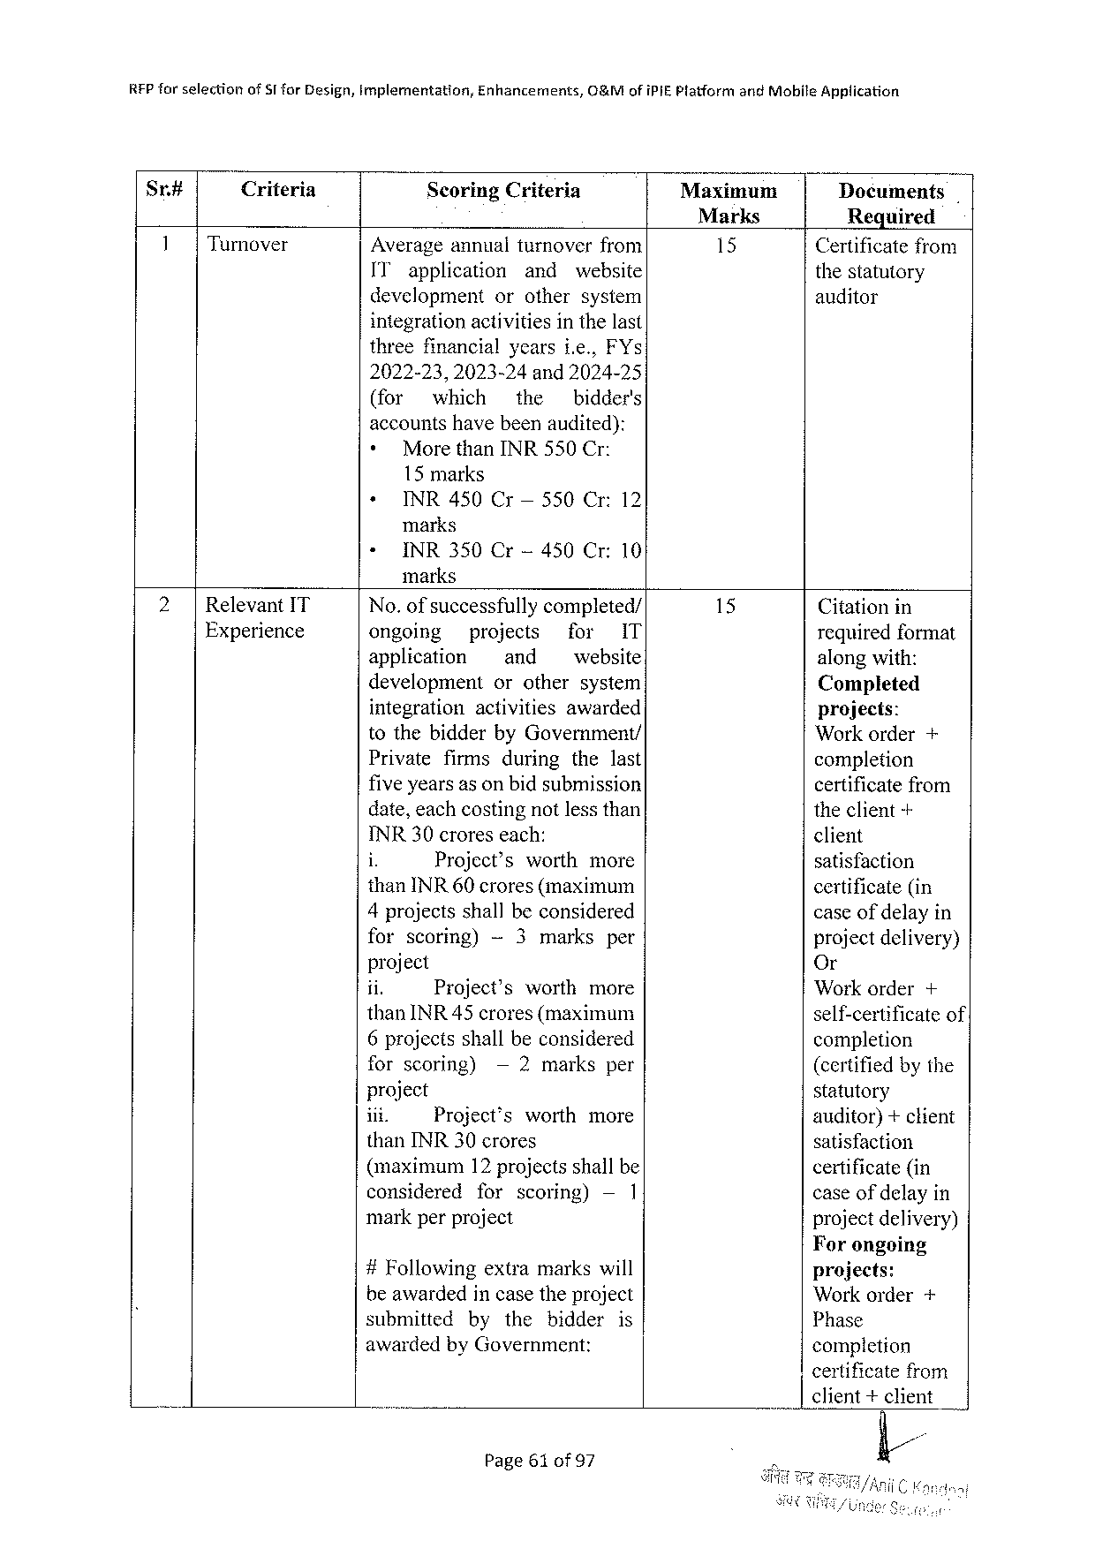

REP farselection ofSTforDesign,implementation, Enhancements, O&MofiPIEPlatformandMobileApplication

Sr# Criteria ScoringCriteria Maxinmuam Documents

Marks Required

Turnover Averageannualturnoverfrom 15 Certificatefrom

IT application and website thestatutory

development orothersystem auditor

integrationactivitiesin the last

threefinancialyearsie., FYs

2022-23,2023-24 and2024-25

(for which the bidder's

accountshavebeenaudited):

|  |  |
| --- | --- |
| +  + | MorethanINR550Cr:  15 marks  INR450Cr— 550Cr:12 |

marks

« INR350Cr-450Cr:10

marks

|  |  |  |  |  |  |  |  |  |  |  |
| --- | --- | --- | --- | --- | --- | --- | --- | --- | --- | --- |
| RelevantIT | No.of successfully | | | | completed/ | | | | Citationin | |
| Experience | ongoing | projects | | | | for | | IT |
| requiredformat | |
| application | | ~ and | | | website | | | along with: | |
| development | | orothersystem | | | | | | Completed | |
| integration | | activities | | | awarded | | | projects: | |
| tothebidderbyGovernment/ | | | | | | | | Workorder | + |
| Private | firms | | during | | thelast | | |
| completion | |
| fiveyearsas onbidsubmission | | | | | | | | certificatefrom | |
| date,eachcostingnotlessthan | | | | | | | | theclient-+ | |
| INR30croreseach: | | | | | | | | client | |
| i | Project’s | | | worth | | more | |
| satisfaction | |
| thanINR 60crores(maximum | | | | | | | |
| certificate(in | |
| 4projectsshall beconsidered | | | | | | | |
| caseof delayin | |
| forscoring) | | -~3marks | | | | per | | projectdelivery) | |
| project | | | | | | | | Or | |
| jin | Project’s | | | worth | | more | | Workorder | + |
| thanINR45crores(maximum | | | | | | | | self-certificateof | |
| 6projectsshallbeconsidered | | | | | | | |
| completion | |
| forscoring) | | —2marksper | | | | | |
| (certifiedbythe | |
| project | | | | | | | | statutory | |
| ii. | Project’sworthmore | | | | | | |
| auditor)+client | |
| thanINR30crores | | | | | | | | satisfaction | |
| (maximum | | 12 projectsshallbe | | | | | | certificate(in | |
| considered | | forscoring) | | | | —1 | | caseofdelayin | |
| markperproject | | | | | | | | projectdelivery) | |

Forongoing

|  |  |  |  |
| --- | --- | --- | --- |
| #Following | extramarkswill | projects: | + |
| beawardedincasetheproject | | Workorder |
| submittedbythebidderis | |
| Phase |
| awardedbyGovernment: | | completion |

certificatefrom

client+client

Page61 of97

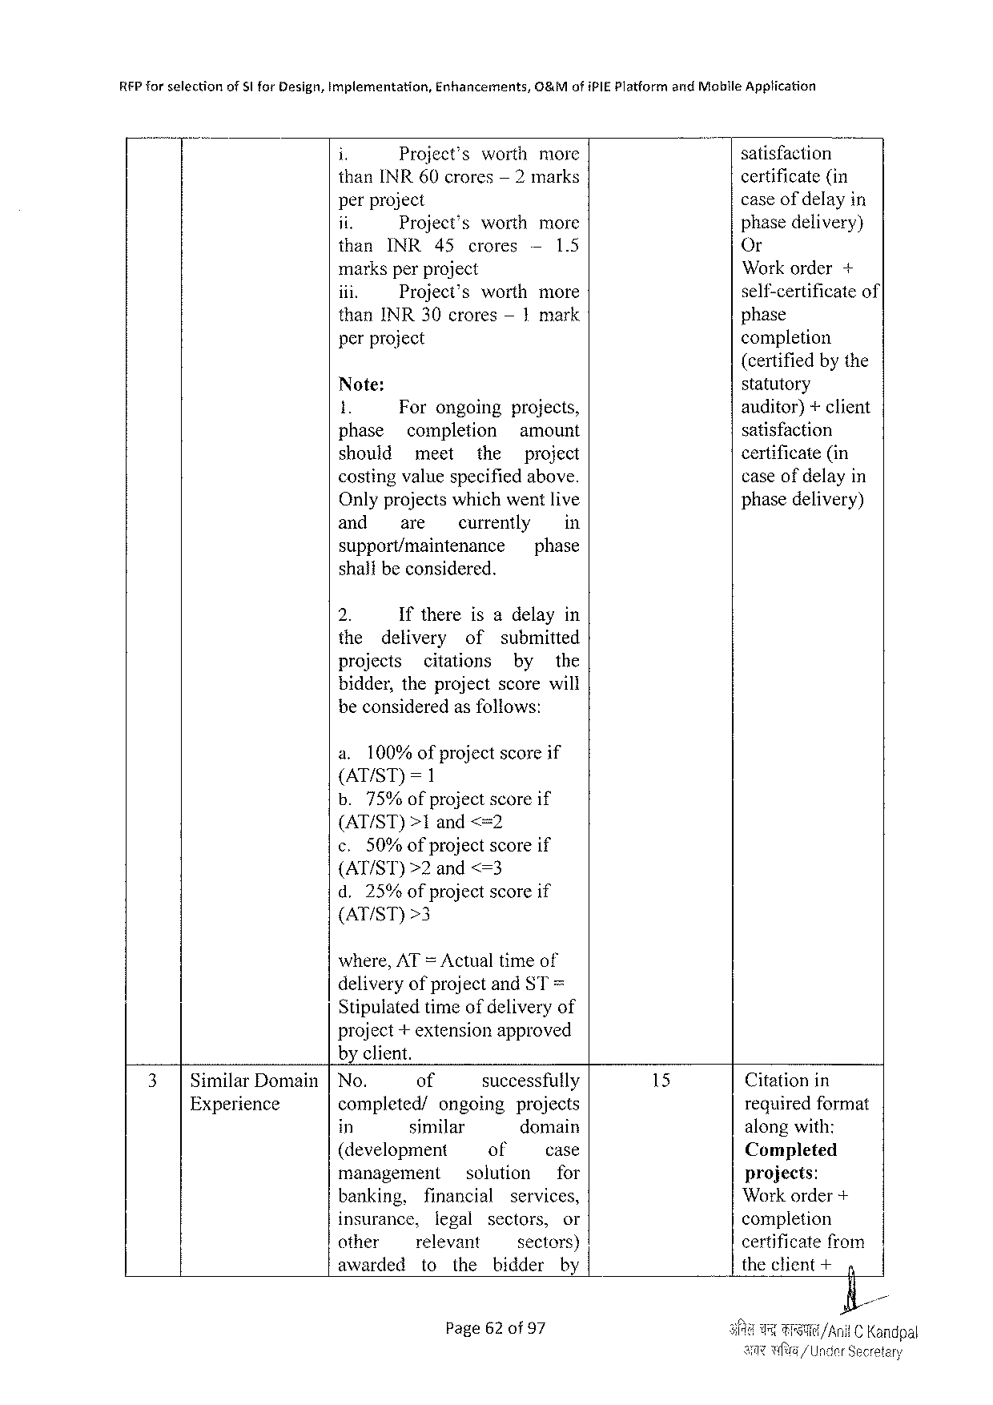

REP forselection ofS|forDesign,Implementation, Enhancements, O&MofiPIEPlatformandMobileApplication

i Project’s worth more satisfaction

thanINR60crores — 2marks certificate(in

perproject caseof delayin

it Project’s worth more phasedelivery)

than INR 45 crores — 1.5 Or

marksperproject Workorder+

iii. Project’s worthmore self-certificateof

thanINR30crores— 1mark phase

perproject completion

(certifiedby the

Note: statutory

1. Forongoing projects, auditor)+ client

phase completion amount satisfaction

should meet the project certificate(in

costingvaluespecifiedabove. caseof delayin

Onlyprojectswhichwentlive phasedelivery)

and are currently in

support/maintenance phase

shalibeconsidered.

2. Ifthereisadelayin

the delivery of submitted

projects citations by the

bidder,theprojectscorewill

beconsideredasfoliows:

a. 100%ofprojectscoreif

(AT/ST)=1

b.75%of project scoreif

(AT/ST)>1 and <=2

c. 50%ofprojectscoreif

(AT/ST)>2and<=3

d.25%ofprojectscoreif

(AT/ST)>3

where,AT =Actualtimeof

deliveryofprojectandST=

Stipulatedtimeofdeliveryof

project+extensionapproved

byclient.

|  |  |  |  |  |  |  |  |  |  |  |  |  |  |  |
| --- | --- | --- | --- | --- | --- | --- | --- | --- | --- | --- | --- | --- | --- | --- |
| 3| | SimilarDomain | No. | of | | | | | successfully | | | | 15 | Citationin | |
| Experience | completed/ | | | ongoing | | | | | projects | | requiredformat | |
| in | similar | | | | | domain | | | | alongwith: | |
| (development | | | | | | of | | | case | Completed | |
| management | | | | | solution | | | | for | projects: | |
| banking, | financial | | | | | | services, | | | Workorder+ | |
| insurance, | | legal | | | | sectors, | | | or | completion | |
| other | relevant | | | | | sectors) | | | | certificatefrom | |
| awarded | to | | | the | | bidder | | | by | theclient+ | 4 |
| Page62of 97 | | | | | | | | | | i/AnilC Kandpal | |

Secretary

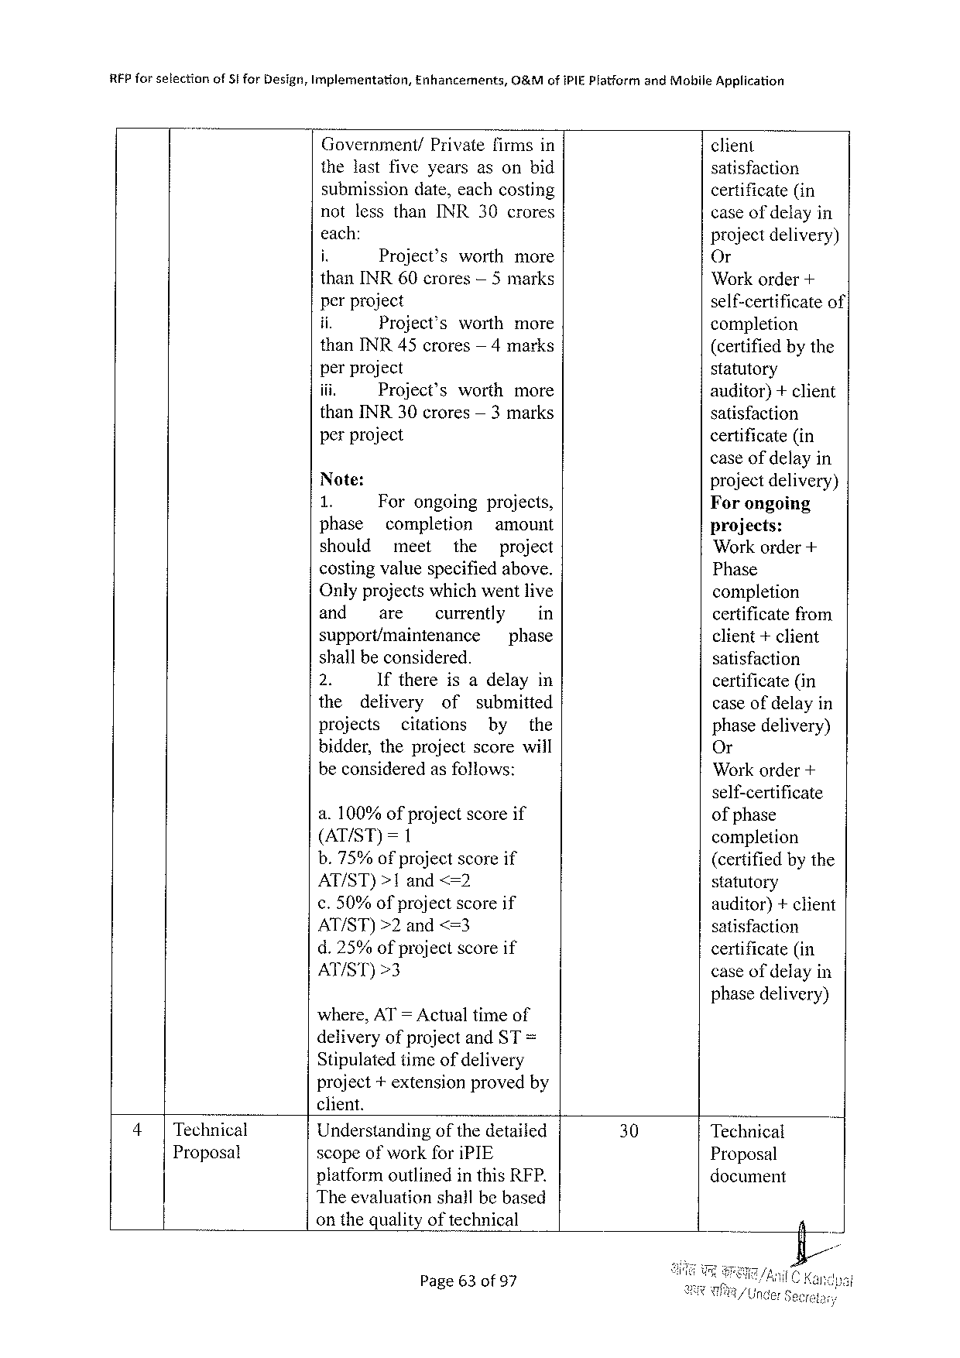

|  |  |  |  |  |  |  |  |  |
| --- | --- | --- | --- | --- | --- | --- | --- | --- |
| RFPforselection | ofSforDesign,Implementation, | | Enhancements, | | | O&MofiPIEPlatform | andMobileApplication | |
| Government/ | | | Privatefirmsin | | | client | |
| thelastfiveyearsasonbid | | | | | | satisfaction | |
| submissiondate,eachcosting | | | | | | certificate(in | |
| notlessthanINR30crores | | | | | | caseof delay | in |
| each: | | | | | | projectdelivery) | |
| i. | Project’s | | | worthmore | |
| Or | |
| thanINR60crores— 5marks | | | | | | Workorder+ | |
| perproject | | | | | | self-certificate | of’ |
| ii. | Project’s | | | worthmore | |
| completion | |
| thanINR45crores— 4marks | | | | | | (certifiedbythe | |
| perproject | | | | | | statutory | |
| iii. | Project’s | | | worth | more | auditor)+client | |
| thanINR30crores— 3marks | | | | | | satisfaction | |
| perproject | | | | | | certificate(in | |

caseof delayin

|  |  |  |  |  |  |  |  |  |
| --- | --- | --- | --- | --- | --- | --- | --- | --- |
| Note: | | | | | | | | projectdelivery) Forongoing  projects:  Workorder+  Phase  completion  certificatefrom client+client  satisfaction  certificate(in  caseofdelayin phase delivery) Or  Workorder+ |
| a8 | | Forongoing | | | projects, | | |
| phase | | completion | | | amount | | |
| should | | meet | | the | | project | |
| costingvaluespecifiedabove. Onlyprojects whichwent live | | | | | | | |
| and | | are | currently | | | | in |
| support/maintenance | | | | | phase | | |
| shallbeconsidered. | | | | | | | |
| 2. | | Ifthereisadelayin | | | | | |
| the | delivery | | of | | submitted | | |
| projects | | citations | | | by | | the |
| bidder,theprojectscorewill beconsideredasfollows: | | | | | | | |

self-certificate

|  |  |  |  |  |  |
| --- | --- | --- | --- | --- | --- |
| a.100% of project  (AT/ST)=1 | | | | scoreif | ofphase  completion  (certifiedbythe statutory  auditor)+client satisfaction  certificate(in  caseofdelayin |
| b.75% | | of project | | scoreif |
| AT/ST)>1and<=2 | | | | |
| ¢.50%of project | | | | scoreif |
| AT/ST)>2 | | | and<=3 | |
| d.25% | of project | | | scoreif |
| AT/ST)>3 | | | | |

phasedelivery) where,AT= Actualtimeof

deliveryofprojectandST =

Stipulatedtimeofdelivery   
project+extensionprovedby

|  |  |  |  |  |  |
| --- | --- | --- | --- | --- | --- |
| 4| | Technical | client. | 30 | Technical | R |
| Understandingofthedetailed |
| Proposal | scopeofworkforiPIE | Proposal |
| platformoutlinedin this RFP. | document |

Theevaluationshallbebased

onthequalityoftechnical

Page63of 97

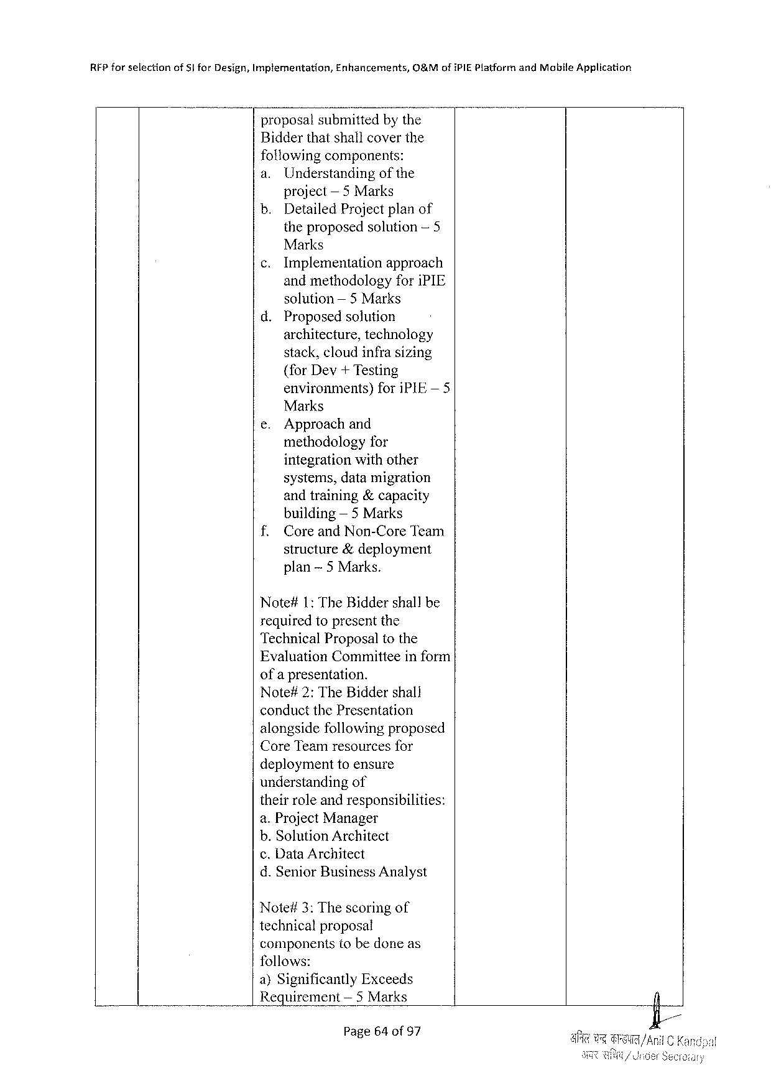

|  |  |  |  |
| --- | --- | --- | --- |
| RFPforselection | ofSiforDesign,Implementation, | Enhancements, | O&MofiPIEPlatformandMobileApplication |

proposalsubmittedbythe   
Bidderthatshallcoverthe   
followingcomponents:

|  |  |  |
| --- | --- | --- |
| a. | Understanding | of the |

project— 5Marks   
b. DetailedProjectplanof   
 theproposedsolution— 5   
 Marks  
¢.Implementation approach   
 andmethodologyforiPIE   
 solution— 5 Marks   
d.Proposedsolution   
 architecture,technology   
 stack,cloudinfrasizing   
 {forDev+ Testing   
 environments) foriPIE— 5   
 Marks

|  |  |  |
| --- | --- | --- |
| e. | Approachand | for |
| methodology |

integrationwithother   
 systems,datamigration   
 andtraining&capacity   
 building — 5 Marks   
f. CoreandNon-CoreTeam   
 structure&deployment   
 plan~5 Marks.

Note#1: TheBiddershallbe   
requiredtopresentthe   
TechnicalProposaltothe   
EvaluationCommitteeinform   
ofa presentation.

Note#2:TheBiddershall   
conductthePresentation   
alongsidefollowingproposed   
CoreTeamresourcesfor   
deploymenttoensure   
understandingof   
theirroleandresponsibilities:   
a.ProjectManager   
b.SolutionArchitect   
c.Data Architect   
d.SeniorBusinessAnalyst

Note#3:Thescoringof   
technicalproposal   
componentstobedoneas   
follows:   
a)SignificantlyExceeds   
Requirement — 5 Marks

Page64of 97

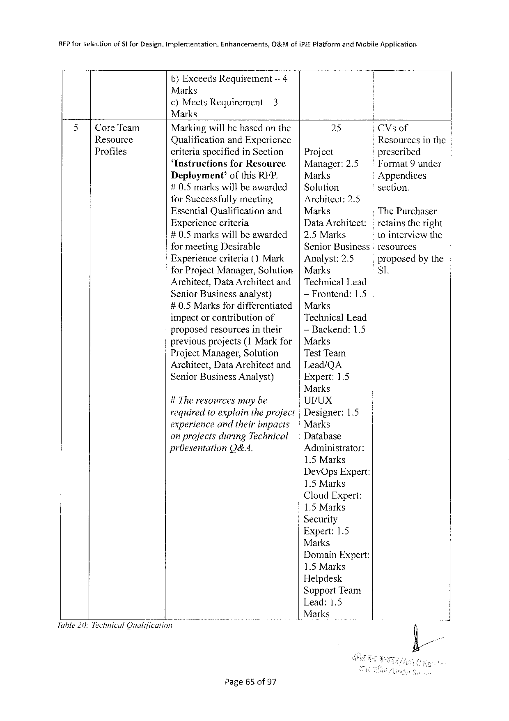

|  |  |  |  |
| --- | --- | --- | --- |
| RFPforselection | of5lforDesign,implementation, | Enhancements, | O&MofiPIEPlatformandMobileApplication |

b)ExceedsRequirement-4   
Marks  
¢)MeetsRequirement — 3   
Marks

|  |  |  |  |  |  |
| --- | --- | --- | --- | --- | --- |
| 5 | |CoreTeam | Markingwillbebasedonthe | | 25 | CVsof |
| Resource | QualificationandExperience | | Project | Resourcesinthe |
| Profiles | criteriaspecifiedinSection | | prescribed |
| ‘InstructionsforResource | | Manager:2.5 | TFormat 9under |
| Deployment’ofthis RFP. | | Marks | Appendices |
| #0.5markswillbeawarded | | Solution | section. |
| forSuccessfullymeeting | | Architect:2.5 | ThePurchaser |
| EssentialQualification | and | Marks |
| Experiencecriteria | | DataArchitect: | retainstheright |
| #0.5markswillbeawarded | | 2.5Marks | tointerviewthe |
| formeetingDesirable | | SeniorBusiness | resources |
| Experiencecriterja (1Mark | | Analyst:2.5 | proposedbythe |
| forProjectManager,Solution | | Marks | SI. |

Architect,DataArchitectand   
SeniorBusinessanalyst)

TechnicalLead  
— Frontend:1.5

#0.5Marksfor differentiated Marks   
 impactorcontribution of TechnicalLead proposedresourcesintheir — Backend:1.5 previousprojects{1 Markfor   
 Marks ProjectManager,Solution Test Team Architect,DataArchitectand Lead/QA SeniorBusinessAnalyst) Expert:1.5 Marks   
 #The resourcesmaybe Ur/ux   
 required 10 explaintheproject Designer:1.5 experienceandtheirimpacts Marks   
 on projectsduringTechnical   
 Database prOesentation O&A. Administrator: 1.5 Marks DevOpsExpert: 1.5 Marks CloudExpert: 1.5 Marks Security   
 Expert:1.5 Marks   
 DomainExpert: 1.5 Marks Helpdesk SupportTeam Lead:1.5 Marks   
Jable20:TechnicalQualification

Page65 of97

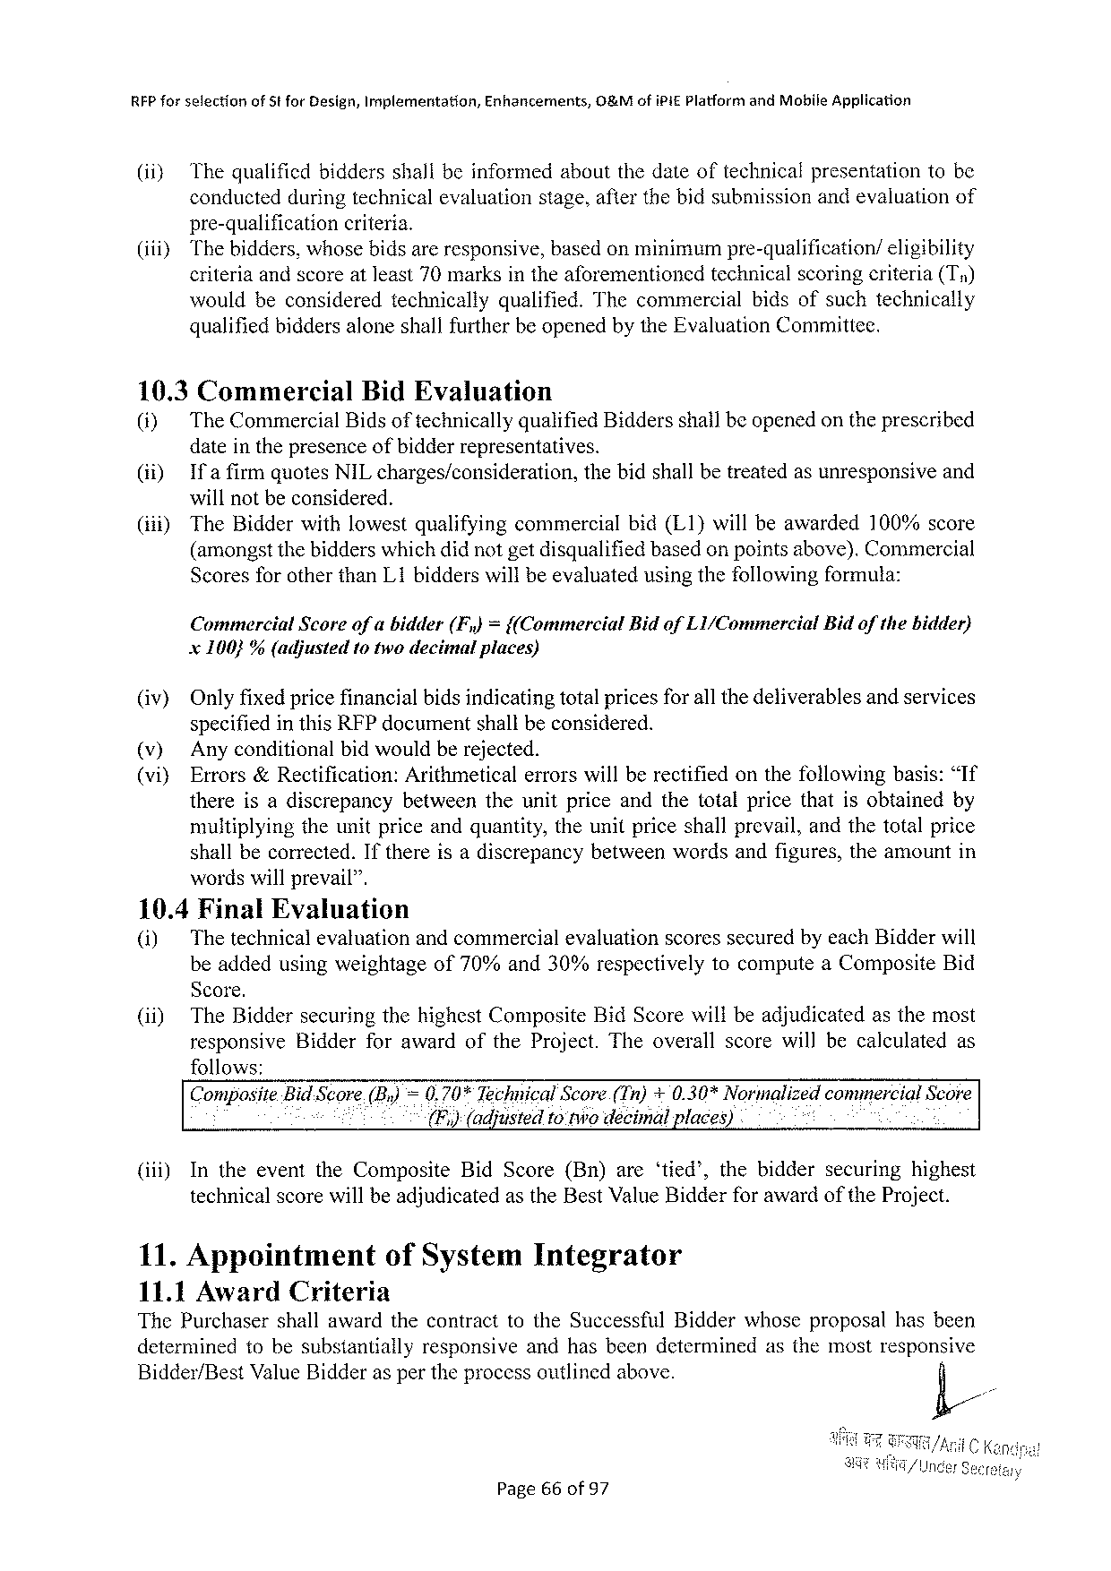

REP forselection ofStforDesign,Implementation, Enhancements, 0%MofiPiE PlatformandMobileApplication

(ii) Thequalificdbiddersshallbeinformedaboutthedateoftechnicalpresentationtobe

conductedduringtechnicalevaluationstage,afterthebidsubmissionandevaluationof

pre-qualification criteria.

(iiiy Thebidders,whosebidsareresponsive,basedonminimumpre-qualification/ eligibility

criteriaandscoreatleast70marksintheaforementioned technicalscoringeriteria(Ty)

wouldbeconsidered technically qualified. Thecommercial bidsofsuchtechnically

qualifiedbiddersaloneshallfurtherbe openedbytheEvaluationCommittee.

10.3Commercial BidEvaluation

(i) TheCommercialBidsoftechnicallyqualifiedBiddersshailbeopenedontheprescribed

dateinthepresenceofbidderrepresentatives.

|  |  |  |  |
| --- | --- | --- | --- |
| (i) | Ifafirm | quotesNILcharges/consideration, | thebidshallbetreatedasunresponsiveand |

willnotbeconsidered.

|  |  |  |
| --- | --- | --- |
| (i) | TheBidderwithlowestqualifyingcommercial | bid(L1}willbeawarded100%score |

(amongstthebidderswhichdidnotgetdisqualifiedbasedon pointsabove).Commercial

ScoresforotherthanL1bidderswillbeevaluatedusingthefollowingformula:

Commercial Scoreofabidder(F,)={(Commercial BidofL1/Commercial Bidofthebidder)

x100}% (adjusted totwodecimalplaces)

(iv) Onlyfixedpricefinancialbidsindicatingtotalpricesfor all thedeliverablesandservices

specifiedinthisRFPdocumentshallbeconsidered.

(v) Anyconditionalbidwouldberejected.

(vi) Errors&Rectification:Arithmeticalerrorswillberectifiedonthefollowingbasis:“If

thereisadiscrepancy betweentheunitpriceandthetotalpricethatisobtainedby

multiplyingtheunitpriceandquantity,theunitpriceshallprevail,andthetotalprice

shallbecorrected.Ifthereisadiscrepancybetweenwordsandfigures,theamountin

wordswillprevail”.

10.4FinalEvaluation

(i) ThetechnicalevaluationandcommercialevaluationscoressecuredbyeachBidderwill

beaddedusingweightageof70%and30%respectively tocomputeaCompositeBid

Score.

(ii) TheBiddersecuringthehighestCompositeBidScorewillbeadjudicatedasthemost

responsive BidderforawardoftheProject.Theoverallscorewillbecalculated as

follows:

CompmlteBid Score(By) =0.70%TechnicalScore(Tn)+0.30*NormalizedcommercialScore

(F,)(adjusted1o twodecimalplaces)

|  |  |  |  |
| --- | --- | --- | --- |
| (iii) | IntheeventtheComposite | BidScore(Bn)are‘tied’,thebidder | securinghighest |

technicalscorewillbeadjudicatedastheBestValueBidderfor awardoftheProject.

11.Appointment ofSystemIntegrator

11.1 AwardCriteria

ThePurchasershallawardthecontracttotheSuccessfulBidderwhoseproposalhasbeen

determinedtobesubstantially responsiveandhasbeendeterminedasthemostresponsive

Bidder/BestValueBidderaspertheprocessoutlinedabove. /&/

Page66of97

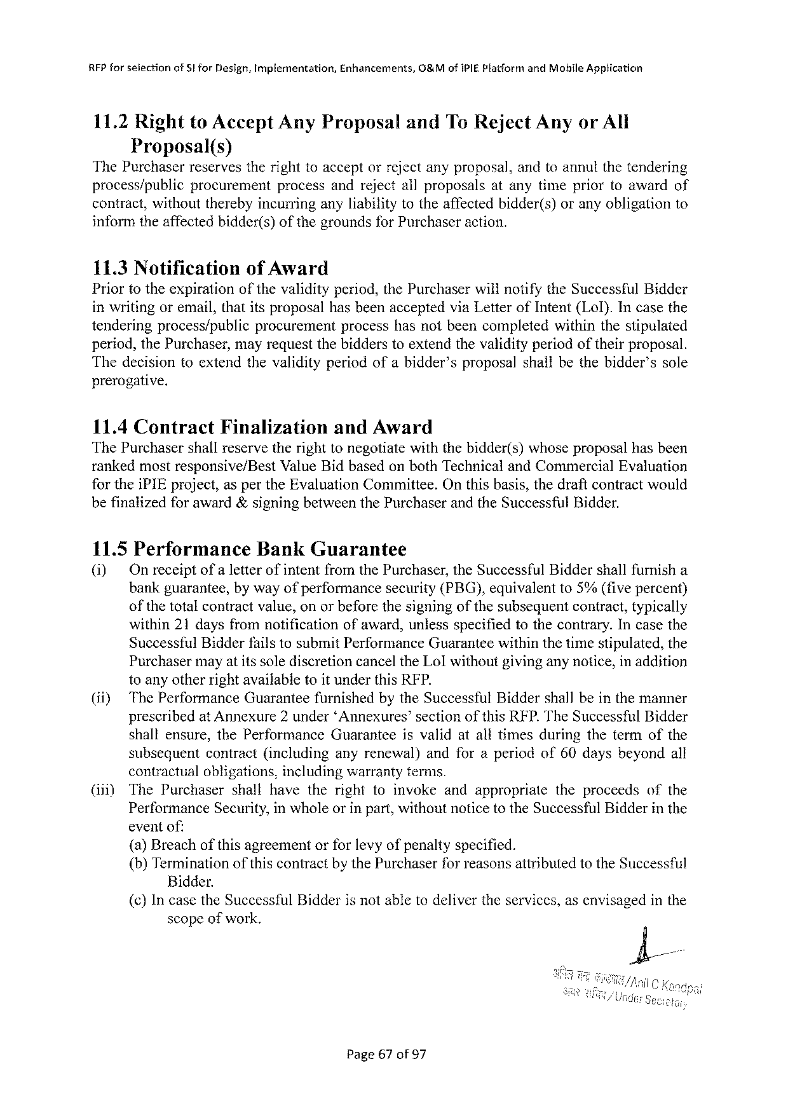

RFPforselection of 8lforDesign,Implementation, Enhancements, O&MofiPIE PlatformandMobhileApplication

11.2RighttoAcceptAnyProposal andToReject AnyorAll   
 Proposal(s)   
ThePurchaser reservesthe righttoaccept orreject anyproposal,andtoannutthe tendering

|  |  |  |  |
| --- | --- | --- | --- |
| process/public | procurement | processandrejectallproposals | atanytimepriortoawardof |

contract,withouttherebyincurringanyliabilitytotheaffectedbidder(s)oranyobligationto informtheaffectedbidder(s)ofthegroundsforPurchaseraction.

11.3 Notification ofAward   
Priortotheexpirationofthevalidityperiod,thePurchaserwillnotifytheSuccessfulBidder inwritingoremail,thatitsproposalhasbeenacceptedviaLetterofIntent(Lol).Incasethe

|  |  |  |  |
| --- | --- | --- | --- |
| tenderingprocess/public | procurement | processhasnotbeencompleted | withinthestipulated |

period,thePurchaser,mayrequestthebidderstoextendthevalidityperiodoftheirproposal. Thedecisiontoextendthevalidityperiodofabidder’sproposalshallbethebidder’ssole prerogative.

|  |  |  |
| --- | --- | --- |
| 11.4 Contract | Finalization | andAward |

The Purchaser shall reserve the right tonegotiate withthe bidder(s) whoseproposalhas been rankedmostresponsive/Best ValueBidbasedonbothTechnicalandCommercialEvaluation for theiPIEproject,aspertheEvaluationCommittee.Onthisbasis,thedraftcontractwould befinalizedforaward&signingbetweenthePurchaserandtheSuccessfulBidder.

11.5 Performance BankGuarantee   
(i) Onreceiptofa letterofintentfromthePurchaser,theSuccessfulBiddershallfurnisha bankguarantee,bywayofperformancesecurity(PBG),equivalentto5%(fivepercent) ofthetotalcontractvalue,onorbeforethesigningofthesubsequentcontract,typically within21daysfromnotification ofaward,unlessspecifiedtothecontrary.Incasethe SuccesstulBidderfailstosubmitPerformanceGuaranteewithinthetimestipulated,the PurchasermayatitssolediscretioncanceltheLolwithoutgivinganynotice,in addition toanyotherrightavailabletoitunderthisRFP.

|  |  |  |
| --- | --- | --- |
| (ity | ThePerformance | GuaranteefurnishedbytheSuccessfulBiddershallbeinthemanner |

prescribedat Annexure 2 under‘Annexures’sectionofthisRFP.TheSuccessfulBidder

|  |  |  |  |  |  |  |  |  |
| --- | --- | --- | --- | --- | --- | --- | --- | --- |
| shall | ensure, | thePerformance | Guarantee | isvalid | atalltimes | during | theterm | ofthe |

subsequentcontract(includinganyrenewal)andforaperiodof60daysbeyondall contractualobligations,includingwarrantyterms.

(iil) ThePurchasershallhavetherighttoinvokeandappropriatetheproceedsofthe Performance Security,inwholeorinpart,withoutnoticetotheSuccessfulBidderinthe eventof:   
 (a)Breachofthisagreementorforlevyofpenaltyspecified.

(b)Terminationofthiscontractby thePurchaserfor reasonsattributedtotheSuccessful Bidder.

{(¢)IncasetheSuccessfulBidderisnotabletodelivertheservices,asenvisagedinthe scopeofwork.

Page67of97

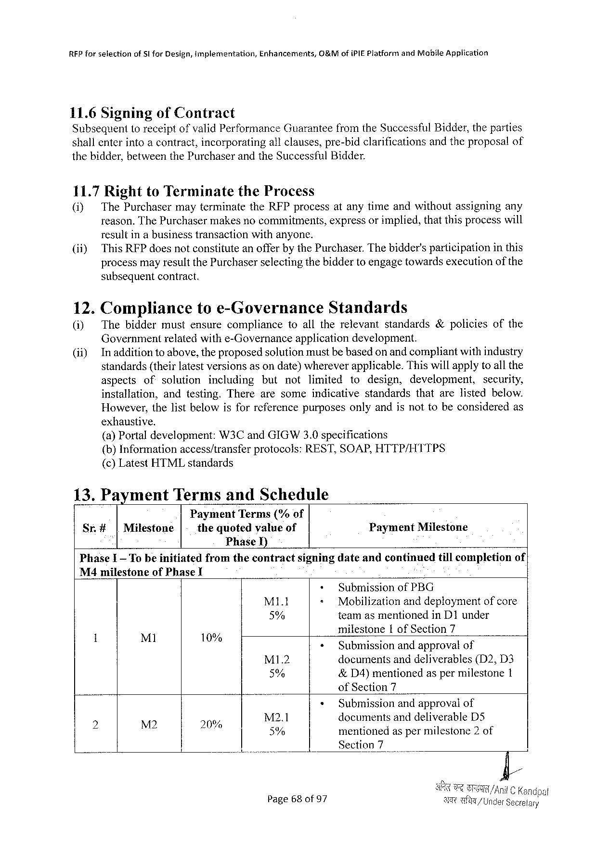

RFPforselection of 5|forDesign,implernentation, Enhancemerits, G&MofiPIEPlatformandMabileApplication

11.6Signing ofContract   
SubsequenttoreceiptofvalidPerformanceGuaranteefromtheSuccessfulBidder,theparties shallenterintoacontract,incorporatingallclauses,pre-bidclarifications andtheproposalof thebidder,betweenthePurchaserandtheSuccessfulBidder.

11.7RighttoTerminate theProcess

0] ThePurchasermayterminatetheRFPprocessatanytimeandwithoutassigningany reason.ThePurchasermakesnocommitments,expressorimplied,thatthisprocesswill resultinabusinesstransactionwithanyone.

|  |  |
| --- | --- |
| (if) | ThisRFPdoesnotconstituteanofferbythePurchaser.Thebidder'sparticipationinthis processmayresultthePurchaserselectingthebiddertoengagetowardsexecutionofthe |

subsequentcontract.

|  |  |  |  |  |  |  |  |  |  |  |  |  |  |
| --- | --- | --- | --- | --- | --- | --- | --- | --- | --- | --- | --- | --- | --- |
| 12.  (i) | Complianceto e-GovernanceStandards | | | | | | | | | | | | |
| Thebiddermustensurecompliance | | | | | toalltherelevant | | | | standards&policies | | | ofthe |
| Governmentrelatedwithe-Governance | | | | | applicationdevelopment. | | | | | | | |
| Inadditiontoabove,theproposedsolutionmustbebasedonandcompliantwithindustry standards(theirlatestversionsasondate)whereverapplicable.Thiswillapplytoall the | | | | | | | | | | | | |
| aspects | of | solution | including | but | not | limited | to | design, | | development, | security, | |
| installation, | | andtesting.Therearesome | | | | indicativestandards | | | | thatarelistedbelow. | | |
| However,thelistbelowisforreferencepurposesonlyandisnottobeconsideredas | | | | | | | | | | | | |

exhanstive.

(a)Portal development:W3Cand GIGW3.0specifications   
(b)Informationaccess/transferprotocols:REST,SOAP,HTTP/HTTPS (c)LatestHTMLstandards

|  |  |  |  |
| --- | --- | --- | --- |
| 13.Payment | | TermsandSchedule | PaymentMilestone |
| Sr.# | |Milestone | PaymentTerms(%of |
| thequotedvalueof |

PhaseI)

|  |  |  |  |  |
| --- | --- | --- | --- | --- |
| PhaseI—To beinitiated | fromthecontract | signingdateandcontmued | tillcompletion | of | |

M4milestoneofPhaseI

|  |  |  |  |  |  |  |  |  |  |
| --- | --- | --- | --- | --- | --- | --- | --- | --- | --- |
| ! | Ml | 3 | - | + | | SubmissionofPBG | | | |
| M1l | < | Mobilization | | anddeploymentofcore | |
| 5% | | teamasmentionedinD1under | | | |
| milestone | Iof Section7 | | |
| 10% | < | | Submissionandapprovalof | | | |
| . | MI1.2 | | documents | anddeliverables | | (D2,D3 |
| 5% | | &D4)mentioned aspermilestone I | | | |
| ofSection7 | | | |
| p: | N2 | « | |
| Submissionandapprovalof | | | |
| M2.1 | | documentsand deliverableDS | | | |
| 20 | 5% | | mentionedas permilestone2 of | | | |
| o | | Section7 | I | | |
| Page68 of 97 | | T/ | | | Under Seoretary |

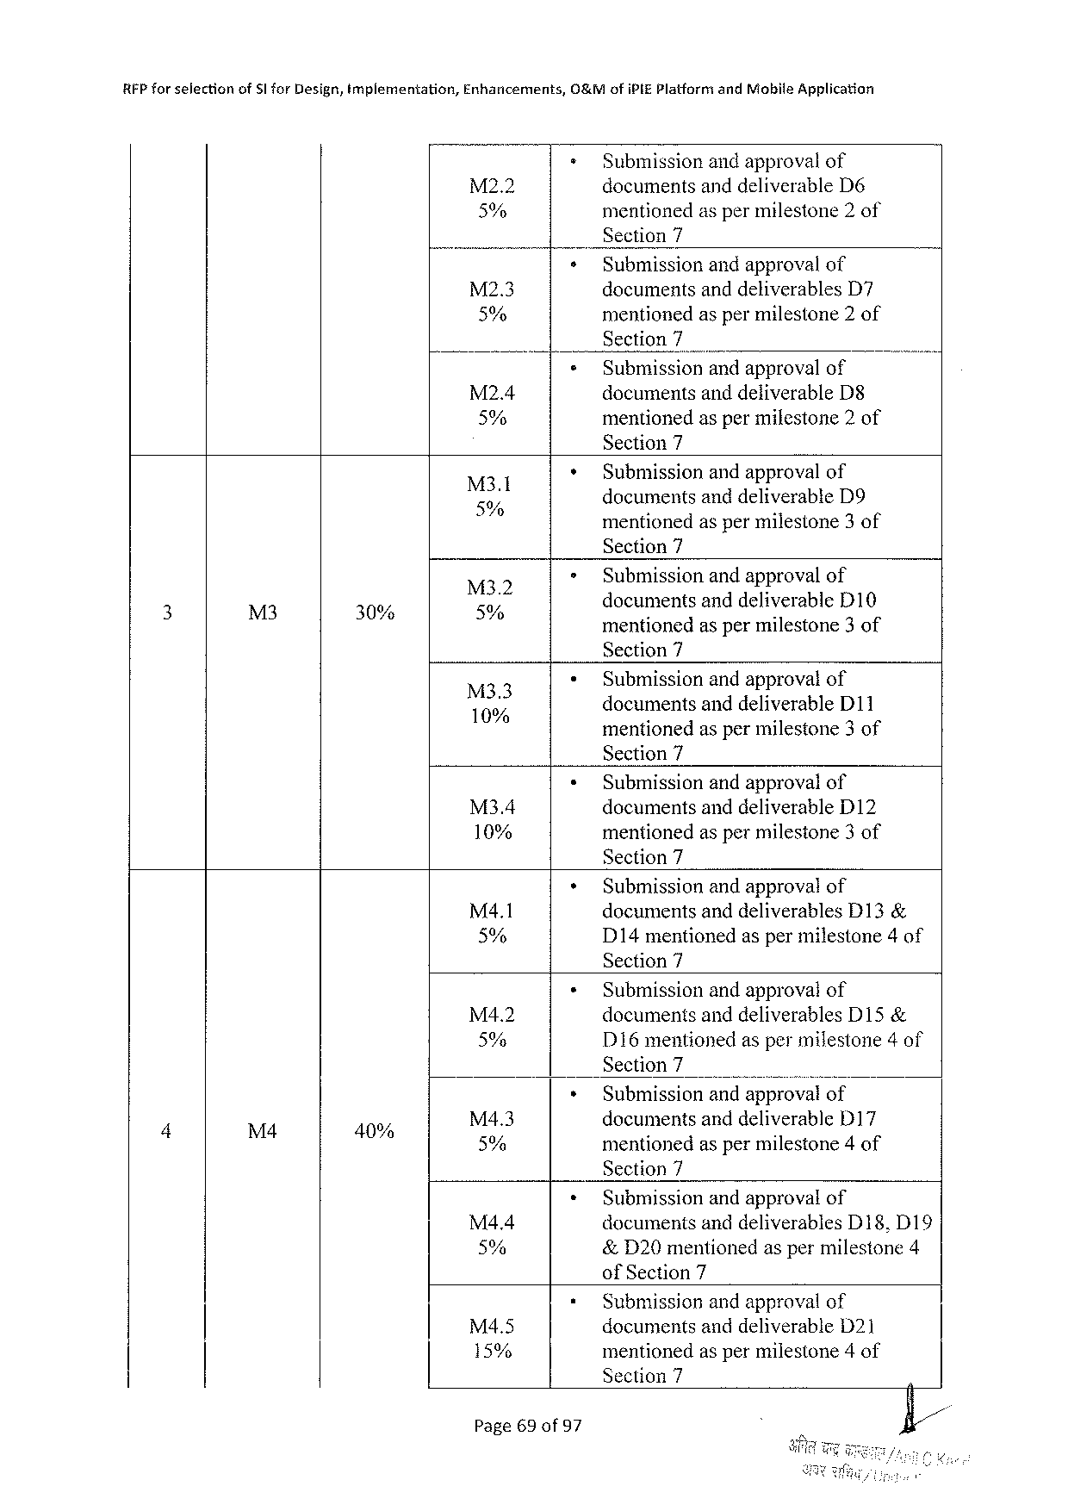

REP for selectionofSl forDesign,implementation,Enhancerments,

0&M ofiPIEPlatfornt andMobile Application

» Submissionandapprovalof

M2.2 documentsanddeliverableD6 5% mentionedaspermilestone2of Section7

|  |  |  |  |  |
| --- | --- | --- | --- | --- |
| M2.3 | + | Submissionandapprovalof | | . |
| documentsanddeliverables | D7 |
| 5% | ¢ | mentionedaspermilestone 2 of | |
| Section7 | |
| Submissionandapprovalof | |
| M2.4 | documentsanddeliverableD8 | |
| 5% | mentionedaspermilestone2of | |

Section7

|  |  |  |
| --- | --- | --- |
| M3.1 | » | Submissionandapprovalof |
| ;  5% | documentsanddeliverableD9 A .  mentionedaspermilestone3 of |

Section7

|  |  |  |  |  |  |
| --- | --- | --- | --- | --- | --- |
| 3 | M3 | 30% | e  5% | > | Submissionandapprovalof |
| documentsanddeliverableD10 5 3  mentionedaspermilestone3of |

Section7

|  |  |  |
| --- | --- | --- |
| 133 | ¢ | Submissionandapprovalof  d ocumentsand d deliverableD11 |

mentionedaspermilestone3of   
Section7

|  |  |  |
| --- | --- | --- |
| M34 | ¢ | Submissionandapprovalof |
| documentsanddeliverableD12 |
| 10% | mentionedaspermilestone3of |

Section7

|  |  |  |
| --- | --- | --- |
| M4.1 | * | Submissionandapprovalof |
| documentsanddeliverablesD13& |
| 5% | D14mentionedaspermilestone4of |

Section7

|  |  |  |  |  |  |  |
| --- | --- | --- | --- | --- | --- | --- |
| 4 | L& | 5 | M4.2 | « | Submissionandapprovalof | |
| documentsanddeliverablesD15& | |
| 5% | » | D16mentionedaspermilestone4of | |
| Section7 | o |
| Submissionandapprovalof | |
| M4.3 | documents anddeliverableD17 | |
| 0% | 5% | mentionedaspermilestone4of | |

Section7

|  |  |  |
| --- | --- | --- |
| M4.4 | * | Submissionandapproval of |
| documentsanddeliverablesD18,D19 |
| 5% | &D20mentionedaspermilestone4 |

ofSection7

|  |  |  |
| --- | --- | --- |
| M4.5 | « | Submissionandapprovalof |
| documentsanddeliverableD21 |
| 15% | mentionedaspermilestone4of |

Section7

Page69 of97

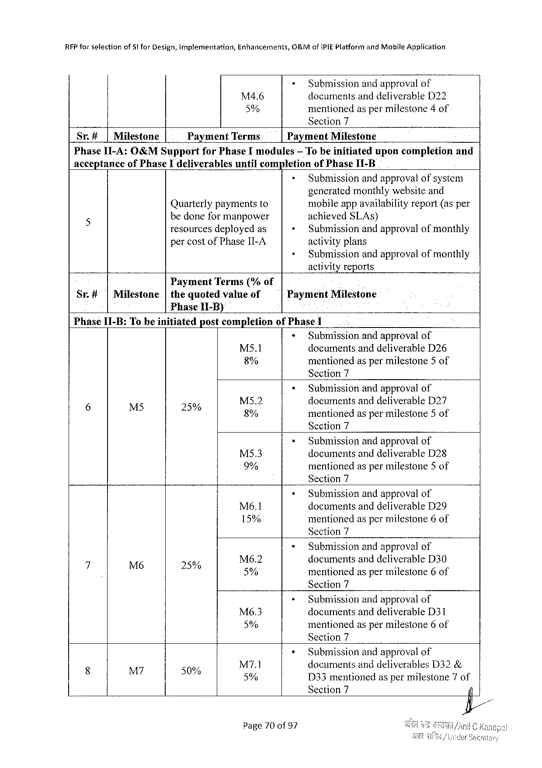

|  |  |  |  |  |
| --- | --- | --- | --- | --- |
| RFPforselection | ofStforDesign,implementation, | Enhancements, | O&MofiPIEPlatformandMohileApplication | |
| M4.6 | = | Submission andapprovalof |
| documentsanddeliverableD22 | |
| 5% | mentionedaspermilestone4of | |

Section7

|  |  |  |  |  |  |  |  |
| --- | --- | --- | --- | --- | --- | --- | --- |
| Sr.# | |Milestone | PaymentTerms | | PaymentMilestone | | uponcompletion | and |
| PhaseII-A:O&MSupport | | | forPhaseImodules | | — Tobeinitiated |

acceptanceofPhaseIdeliverablesuntilcompletionofPhaseII-B

> Submissionandapprovalofsystem   
 generatedmonthlywebsiteand

|  |  |  |  |
| --- | --- | --- | --- |
| 5 | Quarterlypaymentsto | + | mobileappavailabilityreport(asper |
| bedoneformanpower | achievedSLAs) |
| resourcesdeployedas | Submissionandapprovalofmonthly |
| percostofPhaseII-A | » | activityplans |
| Submissionandapprovalofmonthly |

activityreports

PaymentTerms(%of

|  |  |  |  |  |
| --- | --- | --- | --- | --- |
| Sr.#|Milestone | |thequoted | valueof | Payment | Milestone |

Phase[I-B)

PhaseII-B:To beinitiatedpostcompletionofPhaseI

|  |  |  |
| --- | --- | --- |
| M5.1 | « | Submissionandapprovalof |
| documentsanddeliverableD26 |
| 8% | mentionedas permilestone5 of |

Section7

|  |  |  |  |  |  |  |
| --- | --- | --- | --- | --- | --- | --- |
| g | £ | < | o | M52 | * | Submissionandapprovalof |
| documentsand deliverableD27 |
| L0 | 8% | mentionedas permilestone5 of |

Section7

|  |  |  |
| --- | --- | --- |
| M5.3 | » | Submissionandapprovalof |
| documentsanddeliverableD28 |
| 9% | mentionedas permilestone5 of |

Section7

|  |  |  |
| --- | --- | --- |
| Mé6.1 | + | Submissionandapprovalof |
| documentsanddeliverableD29 |
| 15% | mentionedas permilestone6of |

Section7

|  |  |  |  |  |  |
| --- | --- | --- | --- | --- | --- |
| d | M6 | o | Ms6.2 | « | Submissionandapprovalof |
| documentsand deliverableD30 |
| 2% | 5% | mentionedas permilestone6of |

Section7

|  |  |  |
| --- | --- | --- |
| M6.3 | + | Submissionandapprovalof |
| documentsanddeliverableD31 |
| 5% | mentionedas permilestone6of |

Section7

|  |  |  |  |  |  |  |
| --- | --- | --- | --- | --- | --- | --- |
| B | i | . | M7.1 | * | Submissionandapprovalof | |
| documentsanddeliverablesD32& | |
| 0% | 5% | D33mentionedaspermilestone7of | |
| Section7 | Iy |

Page70of97

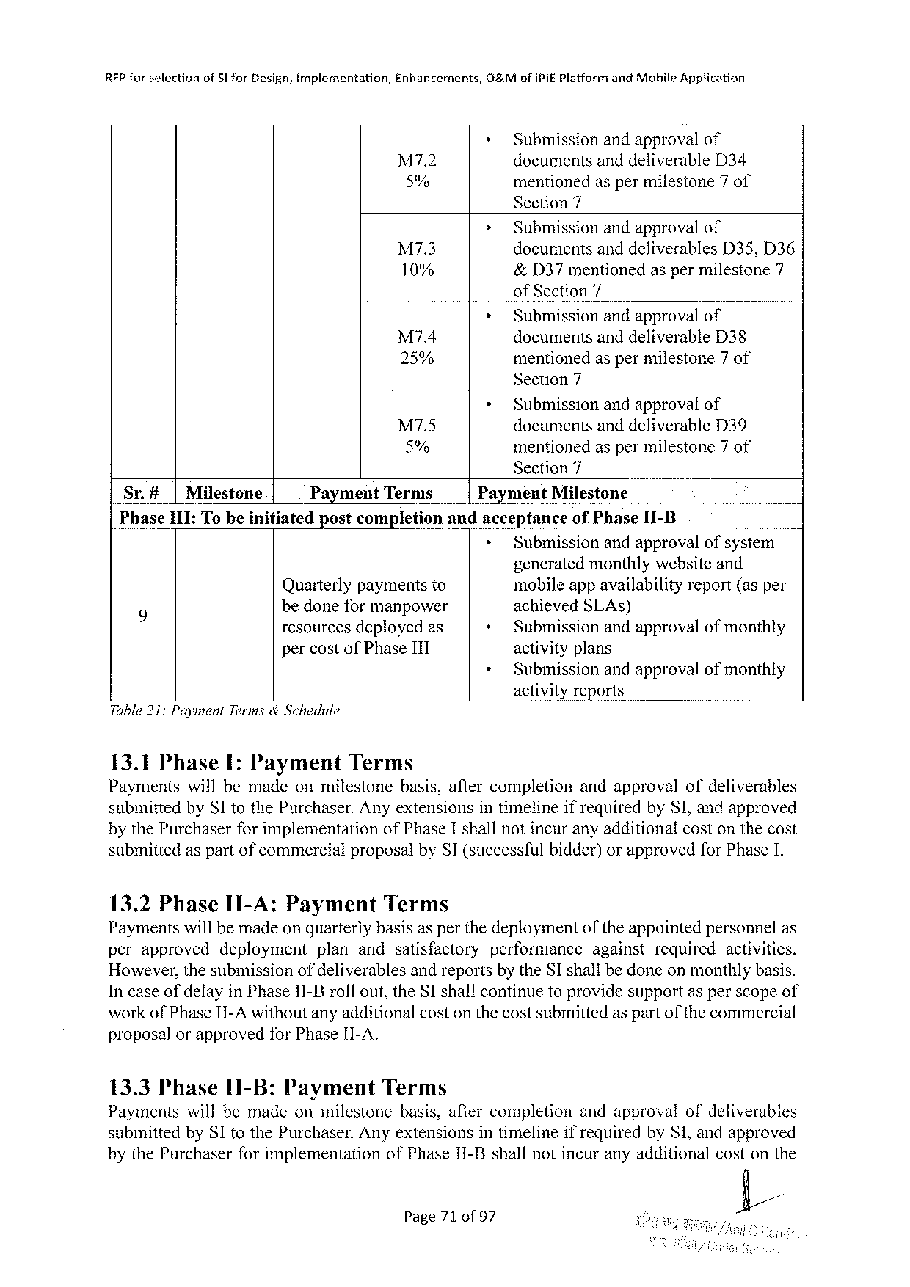

RFP forselectionof51 forDesign,Implementation,Enhancements,O&MofIPIEPlatform andMobile Apgtication

|  |  |  |
| --- | --- | --- |
| M7.2 | = | Submissionandapprovalof |
| documentsanddeliverableD34 |
| 5% | mentionedas permilestone7of |

Section7

|  |  |  |  |
| --- | --- | --- | --- |
| M7.3 | > | Submissionandapprovalof | |
| documentsanddeliverables | D33,D36 |
| 10% | &D37mentionedasper milestone 7 | |

ofSection7

|  |  |  |
| --- | --- | --- |
| M74 | + | Submissionandapprovalof |
| documentsanddeliverableD38 |
| 25% | mentionedas permilestone7of |

Section7

|  |  |  |  |
| --- | --- | --- | --- |
| M7.5 | ¢ | Submissionandapprovalof | |
| documentsanddeliverable | D39 |
| 5% | mentionedaspermilestone7of | |

Section7

|  |  |  |  |  |  |  |
| --- | --- | --- | --- | --- | --- | --- |
| Sr.#|Miléstone | Payment | Terms | Payment | | Milestone | |
| PhaseII1:Tobeinitiated | postcompletion | | andacceptance | | | ofPhaseI1-B |
| » | Submissionandapprovalofsystem | | |

generatedmonthlywebsiteand

Quarterlypaymentsto mobileappavailabilityreport(asper

9 bedoneformanpower achievedSLAs)

resourcesdeployedas + Submissionandapprovalofmonthly

percostofPhaseITI activityplans

« Submissionandapprovalofmonthly

activityreports

Table217 PaymentTerms& Schedule

13.1Phase I:Payment Terms

Paymentswillbemadeonmilestone basis,aftercompletion andapprovalofdeliverables

submittedbySI tothePurchaser.AnyextensionsintimelineifrequiredbySI,andapproved

bythePurchaserforimplementation ofPhaseIshallnotincuranyadditionalcostonthecost

submittedaspartofcommercialproposalbySI(successfulbidder)orapprovedforPhaseI.

13.2Phase1I-A:Payment Terms

Paymentswillbemadeonquarterlybasisasperthedeploymentoftheappointedpersonnelas

|  |  |  |  |  |  |  |  |
| --- | --- | --- | --- | --- | --- | --- | --- |
| perapproved | deployment | plan | andsatisfactory | performance | against | required | activities. |

However,thesubmissionofdeliverablesandreportsbytheSI shallbedoneonmonthlybasis.

Incaseof delayinPhaseII-Brollout,theSI shallcontinuetoprovidesupportasperscopeof

workofPhaseI1-A withoutanyadditionalcostonthecostsubmittedas partofthecommercial

proposalorapprovedforPhase[I-A.

13.3PhaseI1-B:Payment Terms

Paymentswillbemadeonmilestonebasis,aftercompletionandapprovalofdeliverables

submittedbySItothePurchaser.AnyextensionsintimelineifrequiredbySI,andapproved

bythePurchaserforimplementation

ofPhase1I-B shallnotincuranyadditionalcostonthe

Page71 of97 L

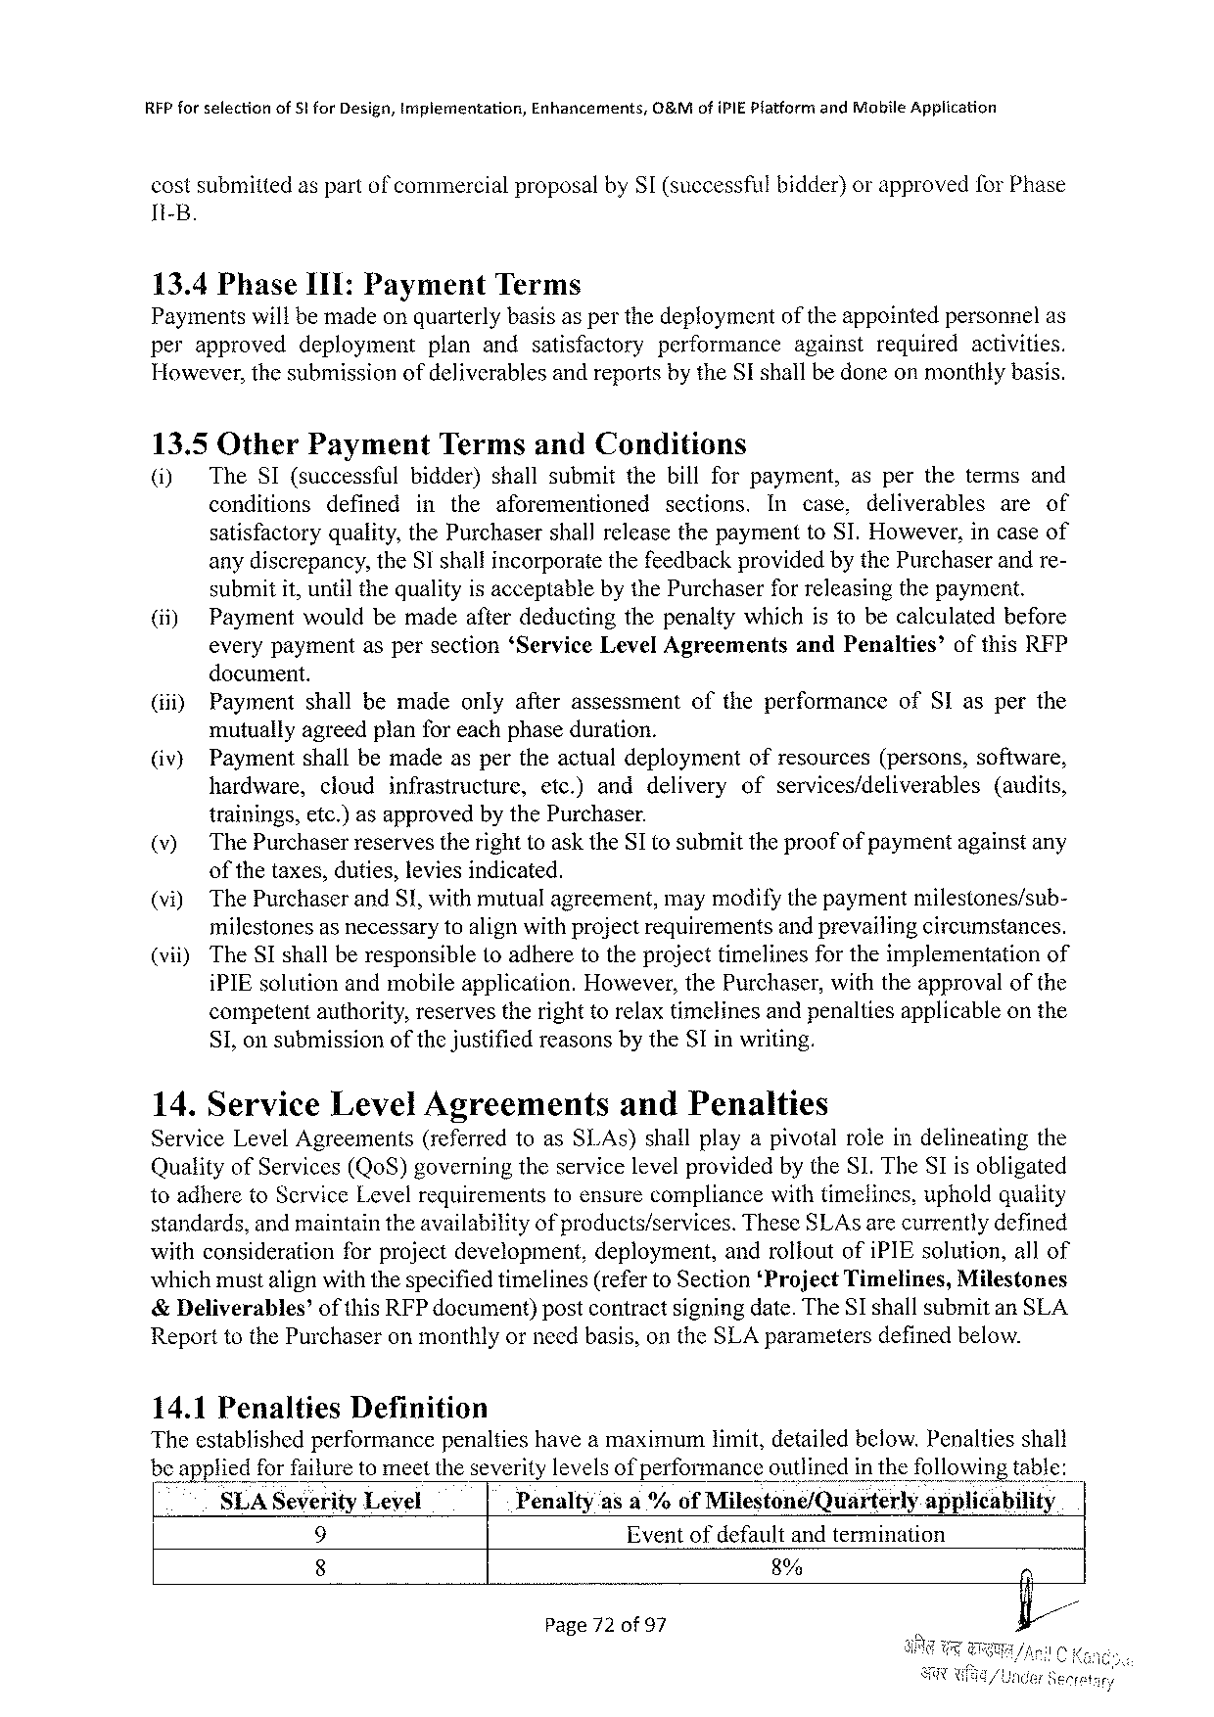

REP for selectionof5tforDesign,implementation,Enhancements,O&MofiPIEPlatform andMobileApplication

costsubmittedaspartof commercialproposalbySI (successfulbidder)orapprovedfor Phase

It-B.

13.4PhaseI1I:Payment Terms

Paymentswillbemadeonquarterlybasisas perthedeploymentof theappointedpersonnelas

|  |  |  |  |  |  |  |
| --- | --- | --- | --- | --- | --- | --- |
| perapproved | deployment | planandsatisfactory | performance | against | required | activities. |

However,thesubmissionofdeliverablesandreportsbytheSI shallbedoneonmonthlybasis.

13.5OtherPayment TermsandConditions

(i) TheSI(successful bidder)shallsubmitthebillforpayment, asperthetermsand

conditions defined intheaforementioned sections. In case, deliverables areof

satisfactoryquality,thePurchasershallreleasethepaymenttoSI.However,incaseof

anydiscrepancy,theSI shallincorporatethefeedbackprovidedbythePurchaserandre-

submitit, untilthequalityisacceptablebythePurchaserforreleasingthepayment.

(ii) Paymentwouldbemadeafterdeductingthepenaltywhichistobecalculatedbefore

everypaymentaspersection‘ServiceLevelAgreements andPenalties’ ofthisRFP

document.

|  |  |  |  |
| --- | --- | --- | --- |
| (iii) | Paymentshallbemadeonlyafterassessment | oftheperformance | ofSIasperthe |

mutuallyagreedplanforeachphaseduration.

|  |  |  |  |  |  |  |
| --- | --- | --- | --- | --- | --- | --- |
| (iv) | Paymentshallbemadeaspertheactualdeployment | | | | ofresources(persons,software, | |
| hardware, | cloud | infrastructure, | etc.)anddelivery | ofservices/deliverables | (audits, |

trainings,etc.)asapprovedby thePurchaser.

(v) The PurchaserreservestherighttoasktheSI tosubmittheproofofpaymentagainstany

ofthetaxes,duties,leviesindicated.

(vi) ThePurchaserandS!,withmutualagreement,maymodifythepaymentmilestones/sub-

milestonesas necessarytoalignwithprojectrequirementsand prevailingcircumstances.

|  |  |  |
| --- | --- | --- |
| (vii) | TheSIshallberesponsible(oadheretotheprojecttimelinesfortheimplementation | of |

iPIEsolutionandmobileapplication.However,thePurchaser,withtheapprovalofthe

competentauthority,reservestherighttorelaxtimelinesandpenaltiesapplicableonthe

S1,on submissionof thejustifiedreasonsbytheSI inwriting.

14.ServiceLevelAgreements andPenalties

ServiceLevelAgreements (referredtoasSI.As)shallplayapivotalroleindelineatingthe

QualityofServices(QoS)governingtheservicelevelprovidedby theS1. TheSIisobligated

toadheretoScrviceLevelrequirements standards,andmaintaintheavailability

toensurecompliancewithtimelines,upholdquality of products/services.TheseSLAsarecurrentlydefined

|  |  |  |
| --- | --- | --- |
| withconsiderationforprojectdevelopment, | deployment, | androlioutofiPIEsolution,allof |

whichmustalignwiththespecifiedtimelines(refertoSection‘ProjectTimelines,Milestones &Deliverables’ ofthisRFPdocument)postcontractsigningdate.TheSI shallsubmitanSLA ReporttothePurchaseron monthlyorneedbasis,ontheSLAparametersdefinedbelow.

|  |  |  |  |
| --- | --- | --- | --- |
| SLASeverityLevel | Penalty | asa%ofMllestone/Quarterly | appllcablhty |

9 Eventofdefaultandtermination

8 8%

Page72of 97

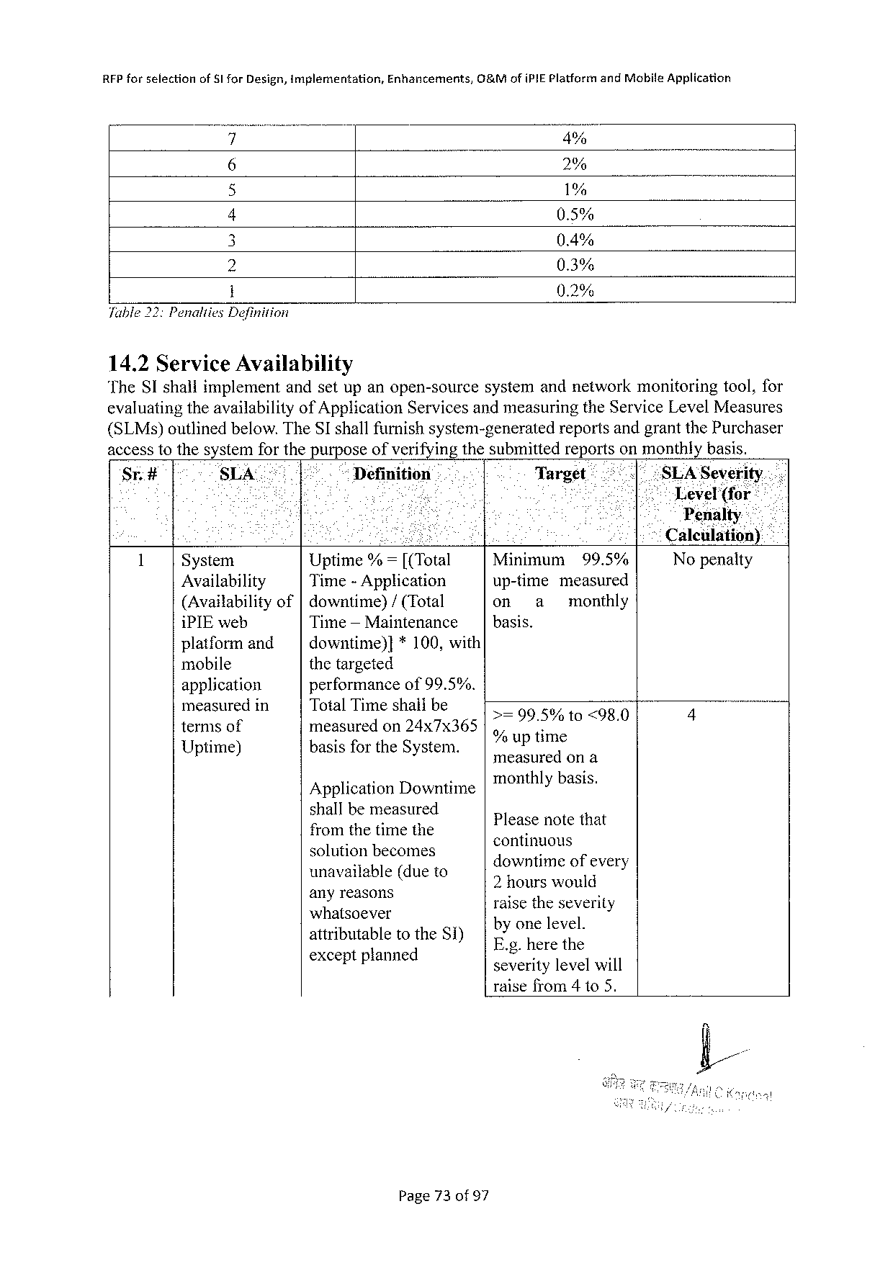

|  |  |  |  |
| --- | --- | --- | --- |
| RFPforselection | ofSl forDesign,implementation, | Enhancements, | 0&MofiPIEPlatformandMobiteApplication |

4% 2% 1% 0.5% 0.4% 0.3% 0.2% Table 22:Penalties Definition

14.2ServiceAvailability   
TheSIshaliimplementandsetupanopen-source systemandnetworkmonitoringtool,for evaluatingtheavailability of ApplicationServicesandmeasuringtheServiceLevelMeasures (SLMs)outlinedbelow.TheSIshallfurnishsystem-generated reportsandgrantthePurchaser accesstothesystemforthepurposeofverifyingthesubmittedreportsonmonthlybasis.

|  |  |  |  |  |  |  |  |  |  |  |  |
| --- | --- | --- | --- | --- | --- | --- | --- | --- | --- | --- | --- |
| Sr.# | SLA | Definition | | .. | Target | | | | “SLASeverity.. | | |
| 1 | - | | | | th | | | | Level | | (for |
| Penalty.--2o 15Caleulationy | | | | | | |
| e | | i | |
| System | Uptime%=[(Total | | | Minimum | | | 99.5% | | Nopenalty | |
| Availability | Time-Application | | | up-time | | measured | | | | |
| (Availabilityof|downtime)/(Total | | | | on | a | monthly | | | | |
| iPIEweb | Time— Maintenance | | | basis. | | | | | | |
| platformand | downtime)]*100,with | | | >=99.5% | | 10 <98.0 | | 2 | | 1 |
| mobile | thetargeted | | |
| application | performanceof99.5%. | | |
| measuredin | TotalTimeshatlbe | | |
| termsof | measuredon24x7x365 | | | % uni | | | | | | |
| Uptime) | basisfortheSystem. | | | ¢ uptime  measuredona | | | | | | |

ApplicationDowntime   
shallbemeasured   
fromthetimethe   
solutionbecomes   
unavailable(dueto   
anyreasons   
whatsoever   
attributable   
 totheSi) exceptptanned

monthlybasis.

Pleasenotethat   
continuous   
downtimeofevery   
2hourswould   
raisetheseverity   
byonelevel.

E.g.herethe   
severitylevelwill   
raisefrom4to5.

Page73of 97

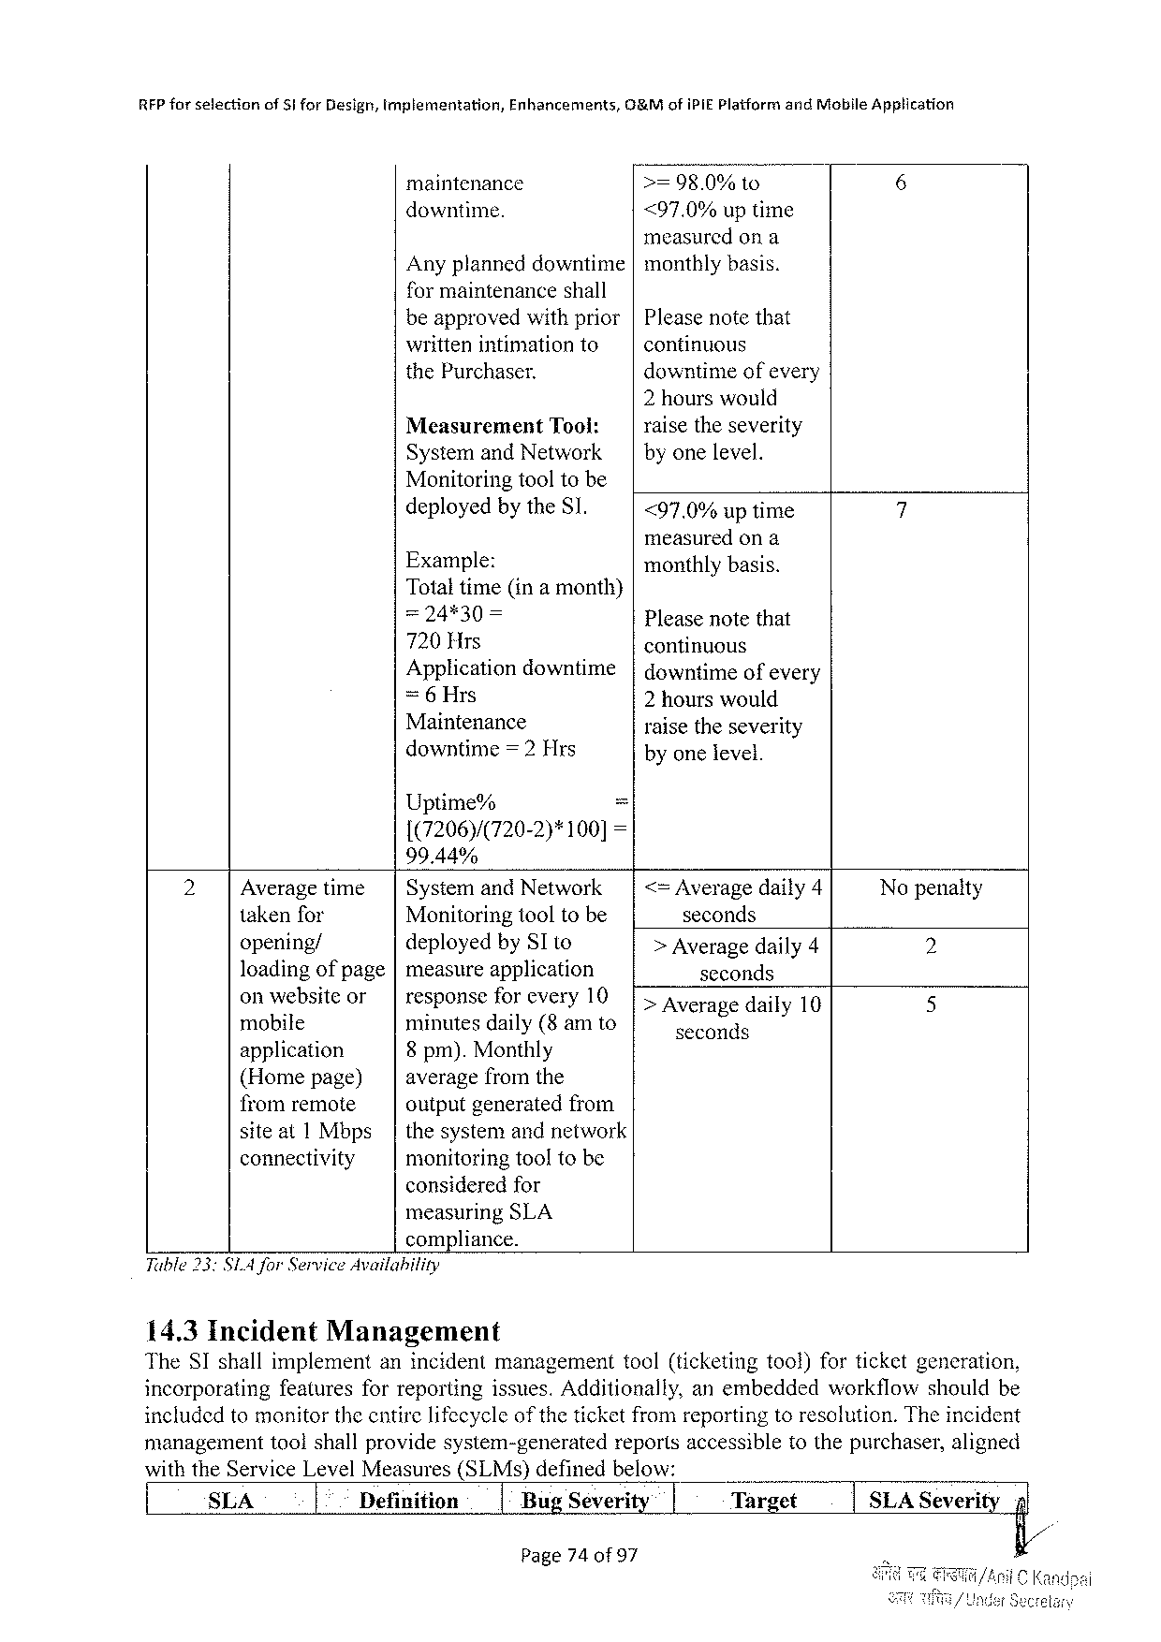

|  |  |  |  |  |  |
| --- | --- | --- | --- | --- | --- |
| RFPforselection | of $iforDesign,tmplementation, | Enhancements, | G&MofiPiE PlaiformandMobileApplication | | |
| maintenance | | >=98.0% | to | 6 |
| downtime. | | <97.0%uptime | | |

measuredona   
Anyplanneddowntime|monthlybasis.

formaintenanceshall   
beapprovedwithprior|Pleasenotethat   
writtenintimationto continuous   
thePurchaser. downtimeofevery   
 2hourswould

|  |  |  |  |
| --- | --- | --- | --- |
| Measurement | Tool: | | | raisetheseverity |
| SystemandNetwork | | byonelevel. |

Monitoringtooltobe

|  |  |  |
| --- | --- | --- |
| deployedbytheSI. | <97.0%uptime | 7 |

measuredona

|  |  |  |
| --- | --- | --- |
| Example:  Totaltime(ina month) | | monthlybasis. Pleasenotethat |
| =24*30 | = |

720Hrs   
Applicationdowntime

continuous   
|downtimeofevery

=6Hrs 2 hourswould

Maintenance   
downtime=2Hrs

raisetheseverity   
byonelevel.

Uptime% =

1(7206)/(720-2)*100]=

99.44%

|  |  |  |  |  |  |  |  |
| --- | --- | --- | --- | --- | --- | --- | --- |
| 2 | Averagetime | | | | SystemandNetwork | | | <= Averagedaily4 | Nopenalty |
| takenfor | Monitoringtooltobe | | | | seconds | 2 |
| opening/ | deployedbySIto | | | | > Averagedaily4 |
| loadingofpage|measureapplication | | | | | seconds |
| 5 |
| onwcbs:lcor | | | | responsefo_r every10 | | [Averagedaily10 |
| mobile | minutesdaily(8 amto | | | | seconds |
| application | 8 pm).Monthly | | | |
| (Homepage) | averagefromthe | | | |
| fromremote | outputgeneratedfrom | | | |
| siteat1 Mbps | | thesystemandnetwork | | |
| connectivity | monitoringtooltobe | | | |

consideredfor

measuringSLA

compliance.

Table 33SIA forServiceAvailability

14.3Incident Management

TheSTshallimplementanincidentmanagement tool(ticketingtool)forticketgeneration,

incorporating featuresforreportingissues.Additionally,anembedded workflowshouldbe

includedtomonitorthecntirelifecycle of the ticketfromreportingtoresolution.Theincident

management toolshallprovidesystem-generated reportsaccessibletothepurchaser,aligned

withtheServiceLevelMeasures(SLMs)definedbelow:

|  |  |  |  |  |  |  |
| --- | --- | --- | --- | --- | --- | --- |
| SLA | Definition | 1BugSeverity | i | Target | SLASeverity | nl |

Page740of 97

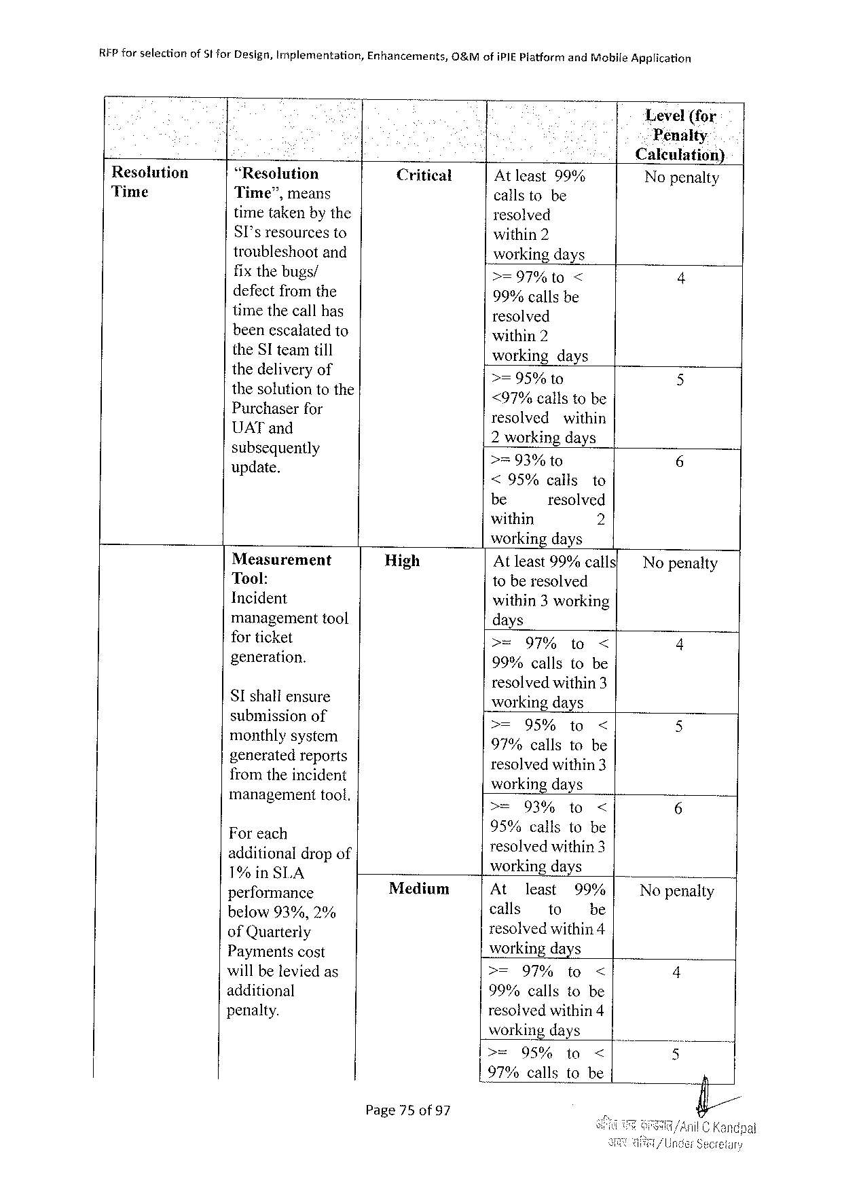

|  |  |  |  |  |
| --- | --- | --- | --- | --- |
| REP forselection | of5tforDesign,implementation, | Enhancements, | O&MofiPIEPlatfarm | andMobileApplication |

Level(for   
Penalty

Caleulation)

|  |  |  |  |  |  |  |  |
| --- | --- | --- | --- | --- | --- | --- | --- |
| Resolution | “Resolution | Critical | Atleast99% | | | | Nopenalty |
| Time | Time”,means |
| callstobe | | | |
| timetakenbythe | resolved | | | | 4 |
| SI'sresourcesto | within2 | | | |
| troubleshootand | workingdays | | | |
| fix thebugs/ |
| >=97%1t0 | | < | |
| defectfromthe | 99%callsbe | | | |
| timethecallhas | resolved | | | | 5 |
| beenescalatedto | within2 | | | |
| theSI teamtill | working | days | | |
| thedellv.cryof | >=95% | 1o | | |
| thesolutiontothe | <97%callstobe | | | |
| Pur’c‘haserfor | 6 |
| resolvedwithin | | | |
| UAT and  Ek(;zetguenlly | 2 working days >=93% to | | | |
| : | <95%calls | | | to |
| be | resolved | | |
| within | 2 | | |

workingdays

|  |  |  |  |  |  |  |  |  |
| --- | --- | --- | --- | --- | --- | --- | --- | --- |
| Measurement | | High | Atleast99%calls' | | | | | No penalty |
| Tool: | | toberesolved | | | | |
| Incident | |
| within3 working | | | | |
| 4 |
| managementtool | |
| days | | | | |
| for ticket | | >= | 97% | | to | < |
| generation. | |
| 99%callsto be | | | | |
| resolvedwithin3 | | | | |
| SIshaliensure | |
| workingdays | | | | |
| submission of | | >= | | 95%to | | < | 5 |
| monthlysystem | | 97%callstobe | | | | |
| generatedreports fromtheincident | | 5 |
| resolvedwithin3 workingdays | | | | |
| management | toof, | = | 039 | | 10< | |

Foreeh   
additional drap of 1%inSLA

95% callsllo‘b::

Iesolvedithins workingdays

|  |  |  |  |  |  |  |  |
| --- | --- | --- | --- | --- | --- | --- | --- |
| performance | | Medium | Atl 1least | | 99:? | | Nopenalty |
| 0 | 90, | calls | to | e | |
| E?B:Yai}efi;,e | | resol](Yed\évithin4 | | | | 4 |
| Paymentscost | | wWorkingidays | | | |
| will be leviedas additional | | >=97%to< 99%callstobe | | | |
| penalty. | | 5 |
| resolvedwithin4 | | | |
| working days | | | |
| >= | 95% | to | < |
| L97%callstobe | | | | n |

Page75of 97

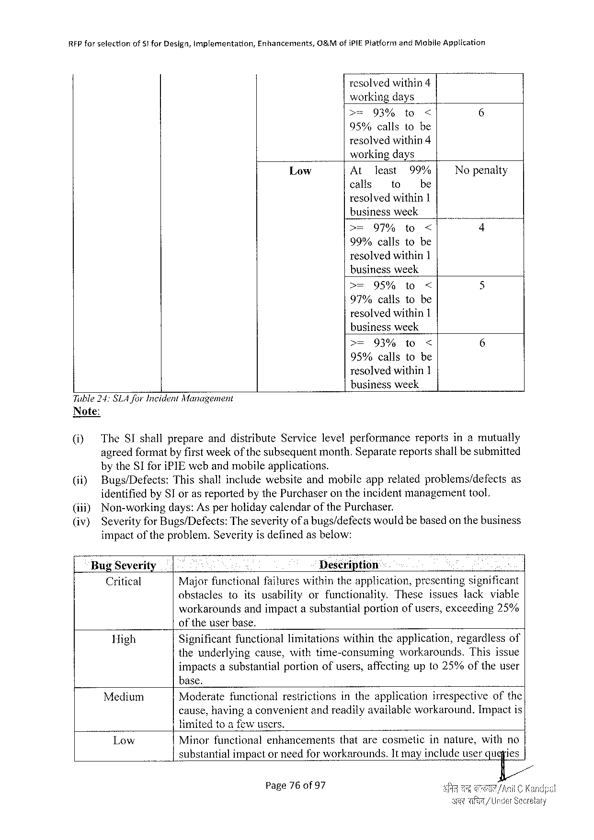

|  |  |  |  |
| --- | --- | --- | --- |
| REPforselection | of5tforDesign,implementation, | Enhancements, | O&MofiPIEPlatformandMobileApplication |

resolvedwithin4   
workingdays

|  |  |  |  |  |
| --- | --- | --- | --- | --- |
| >= | 93% | to | < | 6 |

95%callstobe   
resolvedwithin4   
workingdays

|  |  |  |  |  |
| --- | --- | --- | --- | --- |
| Low | At | least | 99% | Nopenalty |
| calls | to | be |

resolvedwithin1   
businessweek

|  |  |  |  |  |
| --- | --- | --- | --- | --- |
| >= | 97% | to | < | 4 |

99%callstobe   
resolvedwithin1   
businessweek

|  |  |  |  |  |
| --- | --- | --- | --- | --- |
| >= | 95% | to | < | 5 |

97%callstobe   
resolvedwithin1   
businessweek

|  |  |  |  |  |
| --- | --- | --- | --- | --- |
| >= | 93% | to | < | 6 |

95%callstobe   
resolvedwithin1   
businessweek

Tuble24: SLA forIncidentManagement   
Note:

|  |  |  |  |
| --- | --- | --- | --- |
| @ | TheSIshallprepareanddistribute | Servicelevelperformance | reportsinamutually |
| agreedformatbyfirstweekof thesubsequentmonth.Separatereportsshallbesubmitted | | |

by theSIforiPIEwebandmobileapplications.

|  |  |  |
| --- | --- | --- |
| (ii) | Bugs/Defects:Thisshallincludewebsiteandmobileapprelatedproblems/defects | as |

identifiedbySI orasreportedbythePurchaserontheincidentmanagementtool.

|  |  |  |  |  |  |  |
| --- | --- | --- | --- | --- | --- | --- |
| (ii)) (iv) | Non-workingdays:Asperholidaycalendar | | | of the | Purchaser. | |
| Severityfor Bugs/Defects:Theseverityofa bugs/defectswouldbebasedonthebusiness impactofthe problem.Severityis definedasbelow: | | | | | |
| BugSeverity | | | Description | | A |
| Critical | Majorfunctionalfailureswithintheapplication,presentingsignificant | | | | |
| obstacles | | toitsusability | orfunctionality. | | Theseissueslackviable |

workaroundsandimpactasubstantialportionofusers,exceeding25% of theuserbase.

|  |  |  |  |  |
| --- | --- | --- | --- | --- |
| High | Significantfunctionallimitationswithintheapplication,regardlessof | | | |
| theunderlying | cause,withtime-consuming | workarounds. | Thisissue |

impactsasubstantial   
base.

portionofusers,affectingupto25%oftheuser

Medium Moderatefunctional restrictions intheapplication irrespectiveofthe

cause,havinga convenijentandreadilyavailableworkaround. Impactis

limitedtoa fowusers.

|  |  |  |
| --- | --- | --- |
| Low | Minorfunctionalenhancements | thatarecosmeticinnature,withno |
| substantialimpactor needforworkarounds.It mayincludeuserqu}ies/ | |

Page76of97

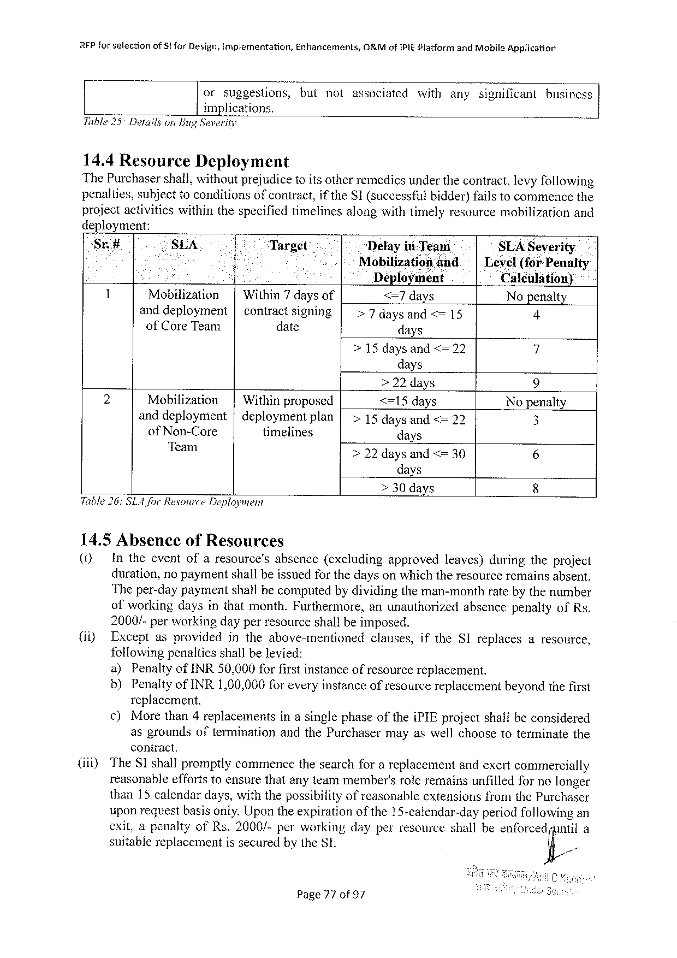

|  |  |  |  |
| --- | --- | --- | --- |
| RFPforselection | of 5forDesign,tmplementation, | Enhancements, | 0&MofiPIEPlatformandMobileApplication |

orsuggestions.butnotassociatedwithanysignificantbusincss

implications.

Table 25DetailsonBugSeverity

14.4Resource Deployment

ThePurchasershall,withoutprejudice1o itsotherremediesunderthecontract,levyfollowing

penalties,subjecttoconditionsof contract,if theSI(successfulbidder)failstocommencethe

projectactivitieswithinthespecifiedtimelinesalongwithtimelyresourcemobilization and

deployment:

Sr# “SLA Target Delayin-Team SLA Severity

e Mobilizationand | Level(forPenalty

Deployment Calculation) *

1 Mobilization | Within7daysof <=7days Nopenalty

anddeployment| contractsigning >7daysand<=15 4

ofCoreTeam date days

>15daysand<=22 i

days

|  |  |  |  |  |  |  |
| --- | --- | --- | --- | --- | --- | --- |
| 2 | Mobilization | | | Withinproposed | | | >22days | 9 |
| <=15days |
| Nopenalty |
| anddeployment | |deploymentplan | |
| >15 daysand<=22 | 8 |
| ofNon-Core | timelines | | days |
| 6 |
| Team | >22daysand <= 30 |

days

> 30days 8

Table 26:SLA JorResourceDeployment

14.5AbsenceofResources

() Intheeventofaresource's absence(excluding approved leaves)duringtheproject

duration,nopaymentshallbeissuedforthedayson whichtheresourceremainsabsent.

Theper-daypaymentshailbecomputedbydividingtheman-monthratebythenumber

ofworkingdaysinthatmonth.Furthermore, anunauthorized absencepenaltyofRs.

2000/-perworkingdayperresourceshallbeimposed.

(i) Exceptasprovided intheabove-mentioned clauses, iftheSIreplaces aresource,

followingpenaltiesshallbelevied:

a) PenaltyofINR50,000forfirstinstanceofresourcereplacement.

b) PenaltyofINR1,00,000for everyinstanceofresourcereplacementbeyondthefirst

replacement.

¢) Morethan4replacements inasinglephaseoftheiPIEprojectshalbeconsidered

asgroundsoftermination andthePurchasermayaswellchoosetoterminatethe

contract.

(iii) TheSI shallpromptlycommencethesearchforareplacementandexertcommercially

reasonableeffortstoensurethatanyteammember'sroleremainsunfilledfornolonger

than15 calendardays,withthepossibilityofreasonableextensionsfromthePurchaser

uponrequestbasisonly.Upontheexpirationofthe15-calendar-dayperiodfollowingan

cxit,apenaltyofRs.2000/-perworkingdayperresourceshallbeen(omcdfl;/nul

suitablereplacementissecuredbytheSL

Page77of97

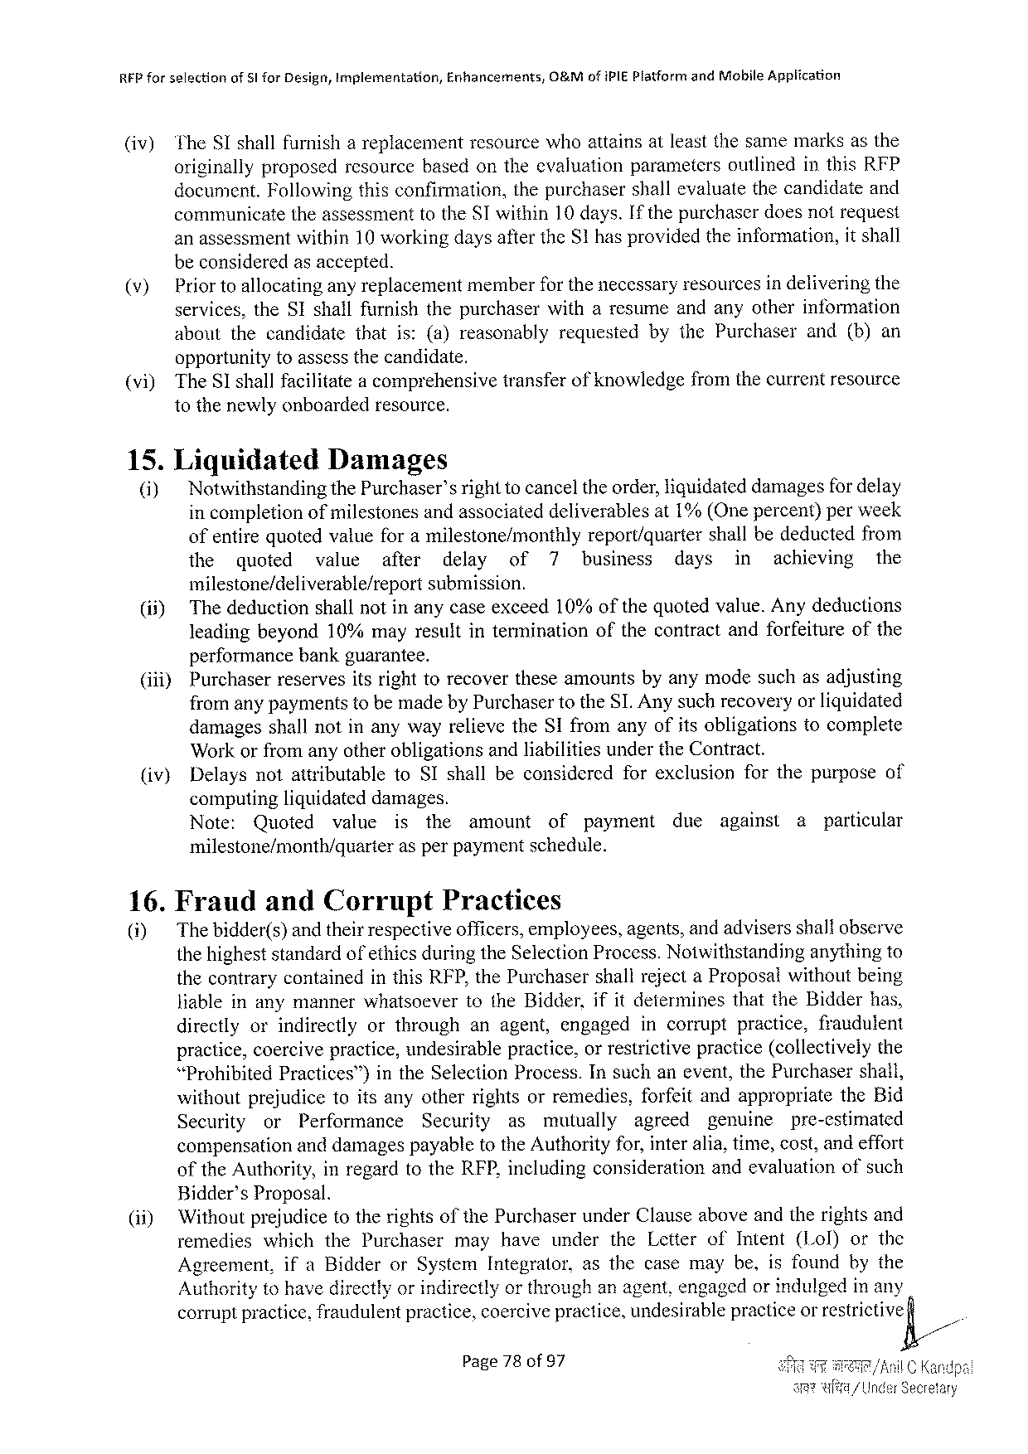

REP forselection of51 forDesigr, Implementation, Enhancements, O&Mof iPIEPlatformandMobileAppiication

(iv) TheSIshallfurnish areplacement resource whoattains atleastthesamemarks asthe

originallyproposedresourcebasedontheevaluationparameters outlinedinthisRFP

document.Followingthisconfirmation,the purchaser shallevaluate the candidateand

communicate theassessmenttotheSI within10 days.If thepurchaserdoesnotrequest

anassessmentwithin10 workingdaysaftertheS1hasprovidedtheinformation,it shall

beconsideredasaccepted.

(v) Priortoallocatingany replacementmemberfor thenecessaryresourcesindeliveringthe

services,theSIshallfurnishthepurchaserwitharesumeandanyotherinformation

aboutthecandidate thatis:(a)reasonably requested bythePurchaser and(b)an

opportunitytoassessthecandidate.

(vi) TheSshallfacilitatea comprehensivetransferof knowledgefromthecurrentresource

tothenewlyonboardedresource.

15.Liquidated Damages

(i) NotwithstandingthePurchaser’srighttocanceltheorder,liquidateddamagesfor delay

incompletionofmilestonesandassociateddeliverablesat1%(Onepercent)perweek

ofentirequotedvatueforamilestone/monthly report/quarter shallbedeductedfrom

the quoted wvalueafter delay of 7 business days in achieving the

milestone/deliverable/report submission.

(ii) Thedeductionshallnotinanycaseexceed10%ofthequotedvalue.Anydeductions

leadingbeyond10%mayresultintermination ofthecontractandforfeitureofthe

performancebankguarantee.

(iii) Purchaserreservesitsrighttorecovertheseamountsbyanymodesuchasadjusting

fromanypaymentstobemadebyPurchasertotheSLAnysuchrecoveryorliquidated

|  |  |  |  |  |  |
| --- | --- | --- | --- | --- | --- |
| (iv) | damagesshallnotinanywayrelievetheSIfromanyofitsobligations | | | | tocomplete |
| WorkorfromanyotherobligationsandliabilitiesundertheContract. | | | | |
| Delaysnotattributable | toSIshallbeconsidered | forexclusion | forthepurposeof | |

computingliguidateddamages.

Note: Quoted vatue is the amount of payment due against a particular

milestone/month/quarter asperpaymentschedule.

16.Fraud andCorrupt Practices

(i) The bidder(s)andtheirrespectiveofficers,employees,agents,andadvisersshallobserve

thehigheststandardofethicsduringtheSelectionProcess.Notwithstanding anythingto

thecontrarycontainedinthisRFP,thePurchasershallrejectaProposalwithoutbeing

Jiableinanymanner whatsoever totheBidder, ifitdetermines that theBidder has,

directlyorindirectly orthrough anagent,engaged incorrupt practice, fraudulent

practice,coercivepractice,undesirablepractice,orrestrictivepractice(collectivelythe

“Prohibited Practices™)intheSelection Process. Insuchanevent, thePurchaser shall,

withoutprejudicetoitsanyotherrightsorremedies, forfeitandappropriate theBid

Security or Performance Security as mutually agreed pgenuinepre-estimated

compensationanddamagespayabletotheAuthorityfor,interalia,time,cost,andeffort

oftheAuthority,inregardtotheRFP,includingconsiderationandevaluation ofsuch

Bidder’sProposal.

(i) WithoutprejudicetotherightsofthePurchaserunderClauseaboveandtherightsand

remedies whichthePurchaser mayhave under theLetterofIntent(Lol) orthe

Agreement, ifaBidderorSystemIntegrator,asthecasemaybe,isfoundbythe

Authoritytohavedirectlyorindirectlyorthroughanagent,engagedorindulgedinany

corruptpractice,fraudulentpractice,coercivepractice,undesirablepracticeor restrictive

Page78of97

|  |  |  |
| --- | --- | --- |
| e | it | /| |

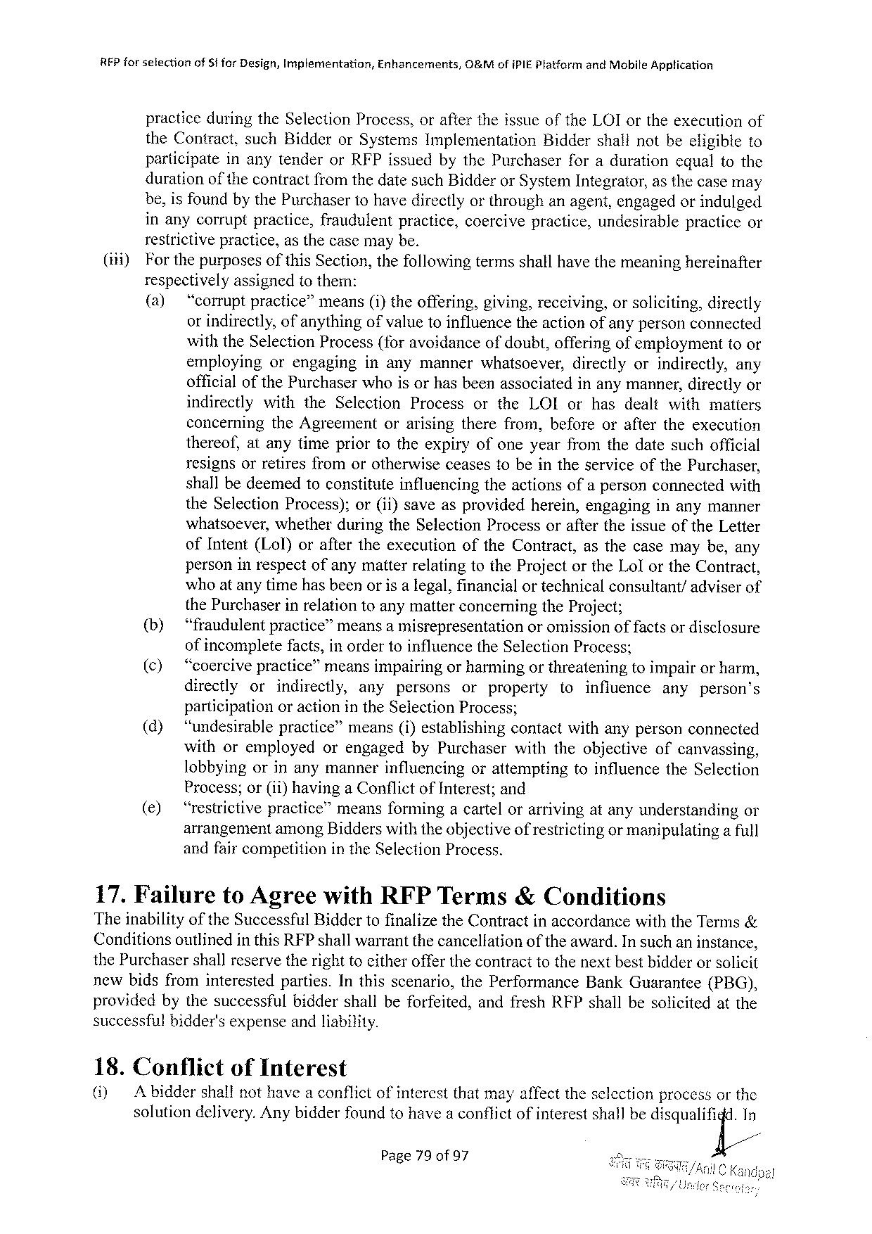

REP forselection of§i forDesign,Implementation, Enhancements, O&MofiPIEPlatformandMobileApplication

practiceduringtheSelectionProcess,oraftertheissueoftheLOIortheexecutionof theContract,suchBidderorSystemsImplementation Biddershallnotbeeligibleto participate inanytenderorRFPissuedbythePurchaserforadurationequaltothe duration ofthe contractfromthedatesuchBidderorSystemIntegrator,asthecasemay be,isfoundbythePurchasertohavedirectlyorthroughanagent,engagedorindulged inanycorruptpractice,fraudulentpractice,coercivepractice,undesirablepracticeor restrictivepractice,asthecasemaybe.

(i) Forthepurposes of this Section, thefollowing termsshallhavethemeaning hereinafter respectivelyassignedtothem:   
 (a) “corruptpractice”means(i)theoffering,giving,receiving,orsoliciting,directly orindirectly,ofanythingofvaluetoinfluencetheactionofanypersonconnected withtheSelectionProcess(foravoidanceofdoubt,offeringof emptoyment toor employing orengaging inanymannerwhatsoever, directlyorindirectly, any officialofthePurchaserwhoisorhasbeenassociatedinanymanner,directlyor indirectly withtheSelection Process ortheLOIorhasdealtwithmatters concerning   
 theAgreement orarisingtherefrom,beforeoraftertheexecution thereof,atanytimepriortotheexpiryofoneyearfromthedatesuchofficial resignsorretiresfromorotherwiseceasestobeintheserviceofthePurchaser, shallbedeemedtoconstituteinfluencingtheactionsofapersonconnectedwith theSelectionProcess);or(ii)saveasprovidedherein,engaginginanymanner whatsoever,whetherduringtheSelectionProcessoraftertheissueoftheLetter ofIntent(Lol)oraftertheexccutionoftheContract,asthecasemaybe,any personinrespectofanymatterrelatingtotheProjectortheLolortheContract, whoatanytimehasbeenorisa legal,financialortechnicalconsultant/adviserof thePurchaserinrelationtoanymatterconcerningtheProject;   
 (b) “fraudulentpractice”meansa misrepresentation or omissionoffactsor disclosure ofincompletefacts,inordertoinfluencetheSelectionProcess;   
 (¢)  
 “coercivepractice”meansimpairingorharmingorthreateningtoimpairorharm, directly or indirectly, any persons or property toinfluence any person’s participationoractionin theSelectionProcess;   
 (d) ‘“‘undesirablepractice”means(i)establishingcontactwithanypersonconnected withoremployed orengagedbyPurchaserwiththeobjectiveofcanvassing, lobbyingorinanymannerinfluencing orattempting toinfluencetheSelection Process;or(ii)havinga ConflictofInterest;and   
 (e) “restrictivepractice”meansformingacartelorarrivingatanyunderstanding or arrangementamongBidderswiththeobjectiveof restrictingormanipulatinga full andfaircompetitionintheSelectionProcess.

17.Failure toAgreewithRFPTerms&Conditions   
TheinabilityoftheSuccessfulBiddertofinalizetheContractinaccordancewiththeTerms& ConditionsoutlinedinthisRFPshallwarrantthecanceliationoftheaward.In suchaninstance, thePurchasershallreservetherighttoeitherofferthecontracttothenextbestbidderorsolicit newbidsfrominterestedparties.Inthisscenario,thePerformance BankGuarantee(PBG), providedbythesuccessful   
 biddershallbeforfeited,andfreshRFPshallbesolicitedatthe successful bidder's expense andliability.

18.Conflict ofInterest

(i) Abidder shallnothavea conflictofinterestthatmayaffecttheselectionprocessorthe solutiondelivery.Anybidderfoundtohavea conflictofinterestshallbedisqualiijd/n

Page79of97

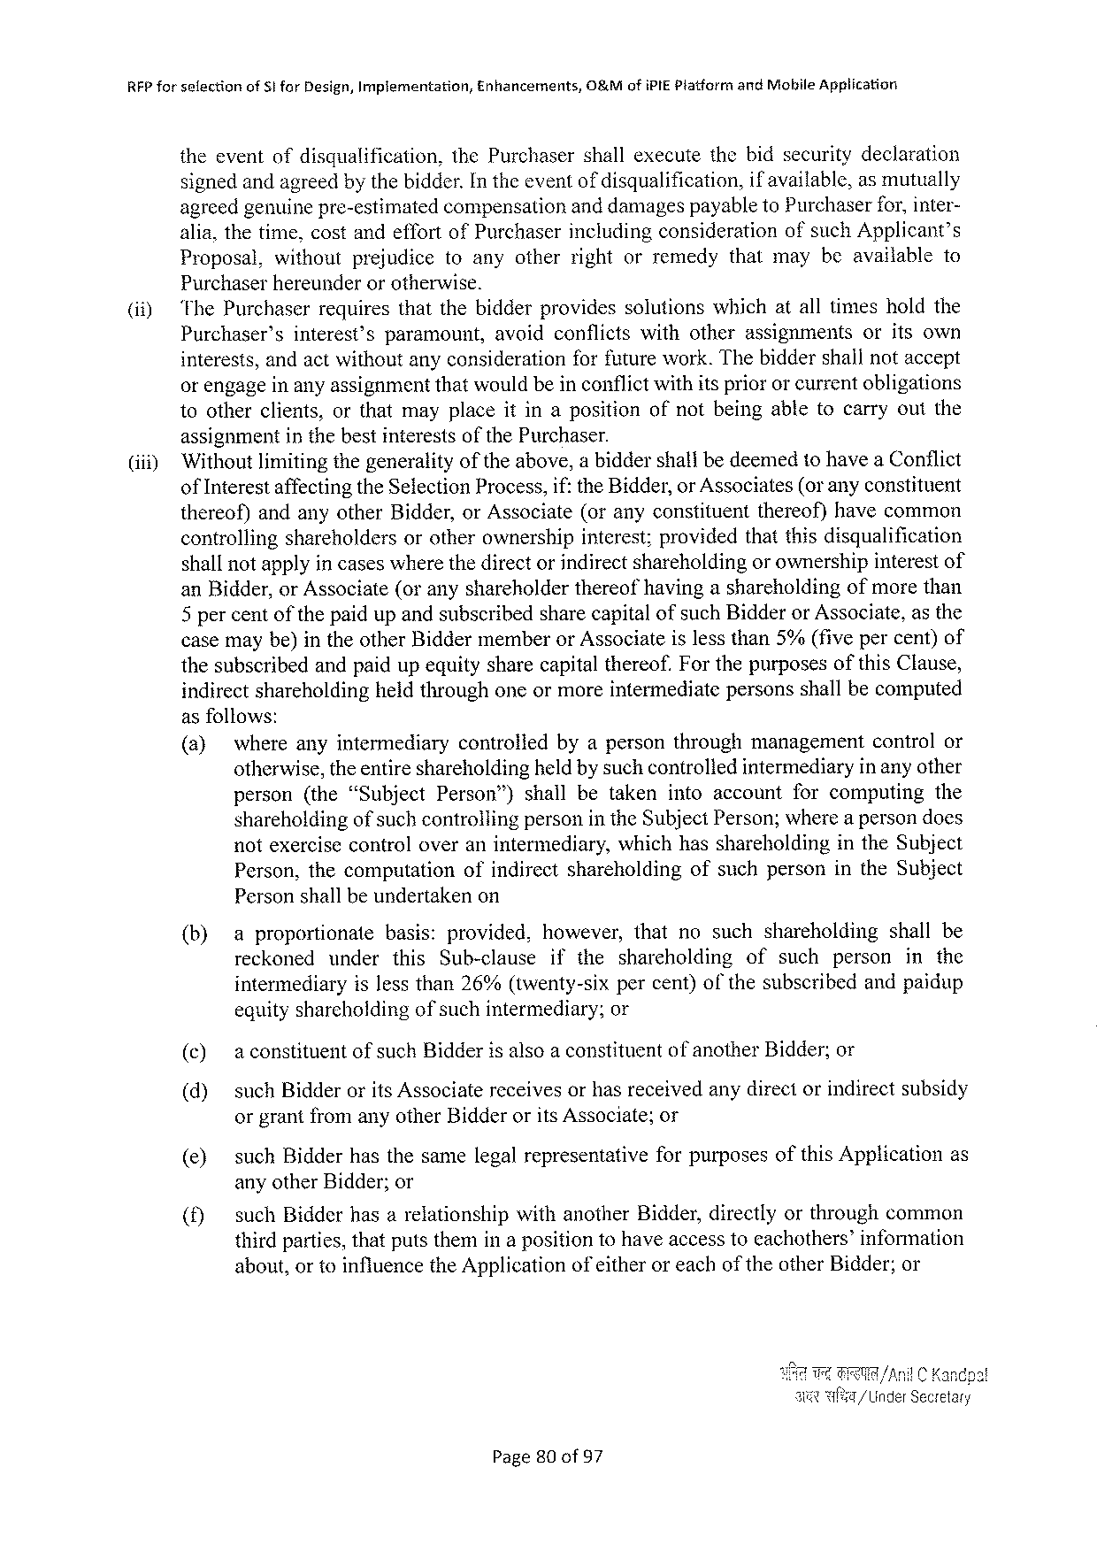

RFPforselection ofSiforDesign,Implementation, Enhancements, O&MofiPIEPlatformandMobileApplication

theeventofdisqualification, thePurchasershallexecutethebidsecuritydeclaration signedandagreedbythebidder.In theeventof disqualification, if available,asmutually

agreedgenuinepre-estimatedcompensationanddamagespayabletoPurchaserfor,inter-

|  |  |  |  |  |  |  |  |  |  |
| --- | --- | --- | --- | --- | --- | --- | --- | --- | --- |
| (i1) | alia,thetime,costandeffortofPurchaserincludingconsiderationofsuchApplicant’s | | | | | | | | |
| Proposal, | without | prejudice | toanyotherrightorremedy | | | thatmaybeavailable | | to |
| Purchaserhereunderorotherwise.  ‘The Purchaserrequiresthatthebidderprovidessolutionswhichatalltimesholdthe | | | | | | | | |
| Purchaser’s | interest’sparamount, | | | avoidconflicts | withotherassignments | | oritsown | |

interests,andactwithoutanyconsiderationforfuturework.Thebiddershallnotaccept orengageinanyassignmentthatwouldbeinconflictwithitspriororcurrentobligations tootherclients,orthatmayplaceitinapositionofnotbeingabletocarryoutthe

|  |  |
| --- | --- |
| (iii) | assignmentinthebestinterestsofthePurchaser.  ‘Withoutlimitingthegeneralityoftheabove,abiddershallbedeemedtohaveaConflict |

ofInterestaffectingtheSelectionProcess,if: theBidder,or Associates(or anyconstituent thereof)andanyotherBidder,orAssociate(oranyconstituentthereof)havecommon controllingshareholdersorotherownershipinterest;providedthatthisdisqualification shallnotapplyin caseswherethedirectorindirectshareholdingor ownershipinterestof anBidder,orAssociate(oranyshareholderthereofhavingashareholdingofmorethan 5percentofthepaidupandsubscribedsharecapitalofsuchBidderor Associate,asthe casemaybe)intheotherBiddermemberorAssociateislessthan5%(fivepercent)of thesubscribedandpaidupequitysharecapitalthereof.ForthepurposesofthisClause, indirectshareholdingheidthroughoneormoreintermediatepersonsshallbecomputed asfollows:

|  |  |  |  |  |  |  |  |
| --- | --- | --- | --- | --- | --- | --- | --- |
| (a) | whereanyintermediary | | controliedbyapersonthroughmanagement | | | controlor | |
| otherwise,theentireshareholdingheldby suchcontroliedintermediaryin anyother | | | | | | |
| person(the“Subject | Person”) | | shallbetakenintoaccount | forcomputing | | the |

shareholdingof suchcontrollingpersonin theSubjectPerson;wherea persondoes

notexercisecontroloveranintermediary, whichhasshareholding intheSubject

Person,thecomputation ofindirectshareholding ofsuchpersonintheSubject

Personshallbeundertakenon

|  |  |  |  |  |  |  |  |  |  |  |  |  |
| --- | --- | --- | --- | --- | --- | --- | --- | --- | --- | --- | --- | --- |
| (b)  (c)  (d) | aproportionate | | | basis: | provided, | however,thatnosuchshareholding | | | | | | shallbe |
| reckoned | under | | this | Sub-clause | ifthe | shareholding | | of | such | person | inthe |
| intermediaryislessthan26%(twenty-sixpercent)ofthesubscribedandpaidup | | | | | | | | | | | |
| equityshareholdingofsuchintermediary; | | | | | | or | | | | | |
| aconstituent | | of suchBidder1salsoa constituent | | | | | of another | | Bidder;or | | |
| suchBidderoritsAssociatereceivesorhasreceivedanydirectorindirectsubsidy | | | | | | | | | | | |

orgrantfromanyotherBidderorits Associate;or

|  |  |  |  |
| --- | --- | --- | --- |
| (e) | suchBidderhasthesamelegalrepresentative | forpurposesofthisApplication | as |

anyotherBidder;or

|  |  |  |  |
| --- | --- | --- | --- |
| (f) | suchBidderhasarelationshipwithanotherBidder,directlyorthroughcommon thirdparties,thatputsthemina positiontohaveaccesstoeachothers’information | | |
| about,ortoinfluencetheApplication | of either | oreachoftheotherBidder;or |

/AnilC Kandpa!

/UinderSecretary

Page80of57

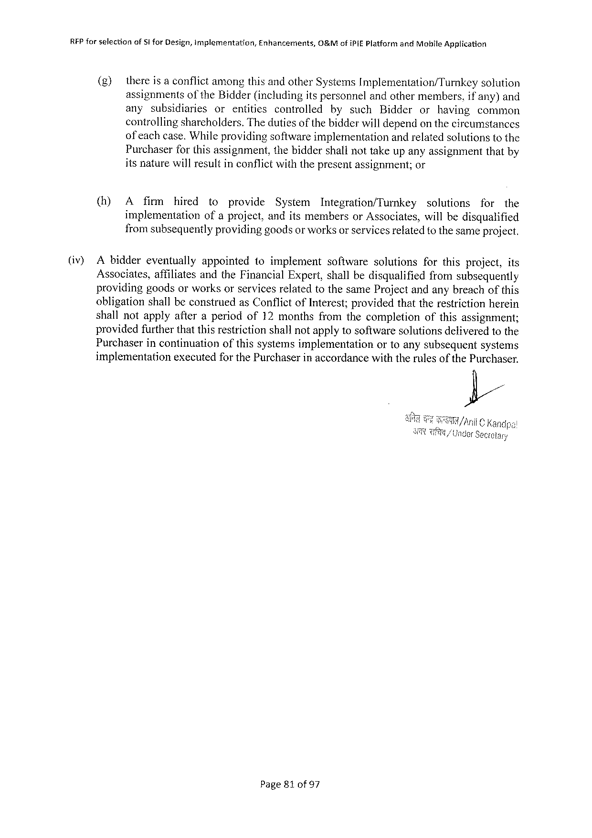

RFPforselection of§1 forDesign,implementation, Enhancements, G&MofiPIEPlatformandMobileApplication

(g) thereis aconflictamongthisandotherSystemsImplementation/Turnkey solution

assignments of theBidder(includingitspersonnelandothermembers,if any)and

any subsidiaries or entities controlled bysuch Bidder or having common

controllingsharcholders.Thedutiesof thebidderwilldependonthecircumstances

of eachcase.Whileprovidingsoftwareimplementation andrelatedsolutionstothe

Purchaserforthisassignment, thebiddershallnottakeupanyassignmentthatby

itsnaturewillresultinconflictwiththepresentassignment;or

(h) A firm hired to provide System Integration/Turnkey solutions for the

implementation ofaproject,anditsmembersorAssociates, willbedisqualified

fromsubsequentlyprovidinggoodsor worksorservicesrefatedtothe sameproject.

(iv) Abiddereventually appointed toimplement software solutions forthisproject,its

Associates, affiliatesandtheFinancialExpert,shallbedisqualified fromsubsequently

providinggoodsorworksorservicesrelatedtothesameProjectandanybreachofthis

obligationshallbeconstruedasConflictofInterest;providedthattherestrictionherein

shallnotapplyafteraperiodof12monthsfromthecompletion ofthisassignment;

providedfurtherthatthisrestrictionshallnotapplytosoftwaresolutionsdeliveredtothe

Purchaserincontinuation ofthissystemsimplementation ortoanysubsequentsystems

implementation executedfor thePurchaserinaccordancewiththerulesofthePurchaser.

Page810f 97

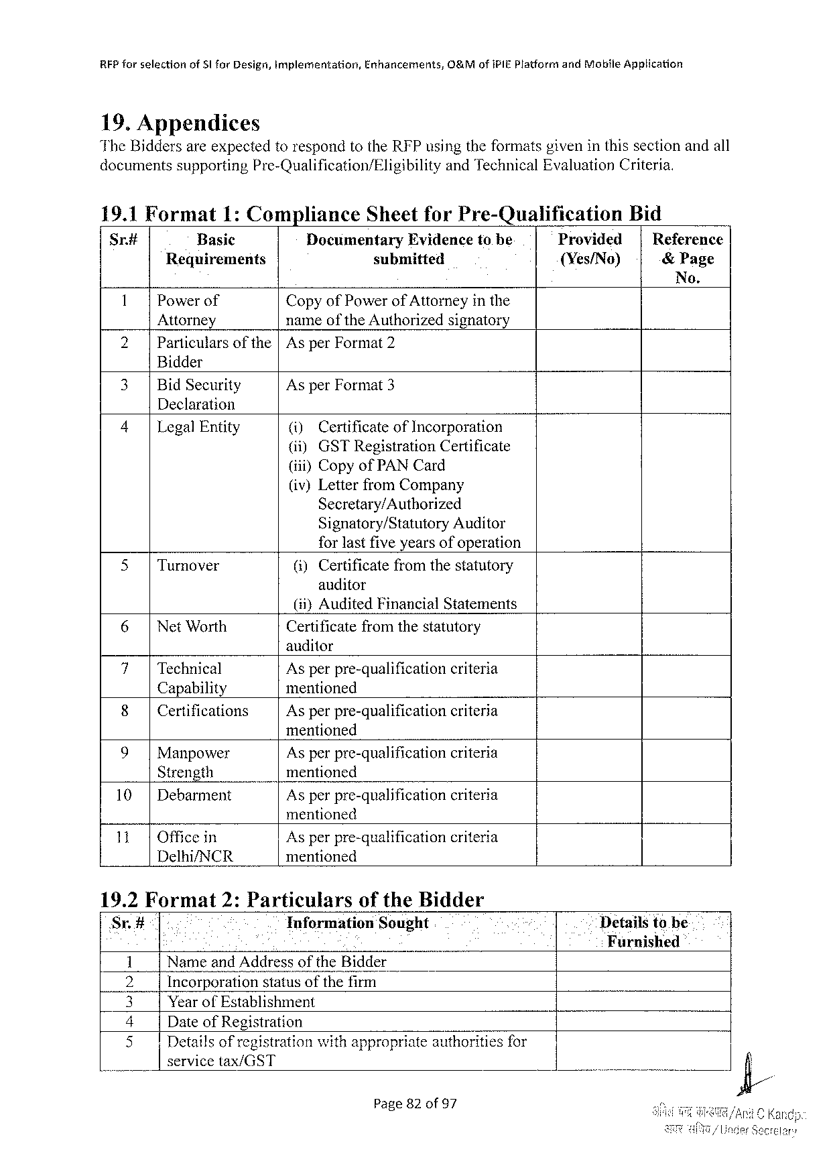

|  |  |  |  |
| --- | --- | --- | --- |
| RFPforselection | of31forDesign,implementation, | Enhancements, | O&MofiPIE PlatformandMobileApplication |

19.Appendices

TheBiddersareexpectedtorespondtotheRFPusingtheformatsgiveninthissectionandall

documentssupporting Pre-Qualification/Eligibility andTechnicalEvaluationCriteria.

19.1Format 1:Compliance SheetforPre-Qualification Bid

Sr# Basic DocumentaryEvidencetobe Provided Reference

Requirements submitted {Yes/No) &Page

No.

1 Powerof CopyofPowerof Attorneyinthe

Attorney nameoftheAuthorizedsignatory

2| Particularsofthe|AsperFormat2

Bidder

|  |  |  |
| --- | --- | --- |
| 3| | BidSecurity | AsperFormat3 |

Declaration

|  |  |  |  |  |
| --- | --- | --- | --- | --- |
| 4 | | | LegalEntity | (i) | Certificateof Incorporation |
| (i) | GSTRegistrationCertificate |

(iii)CopyofPAN Card

(iv)LetterfromCompany

Secretary/Authorized

Signatory/Statutory Auditor

forlastfiveyearsofoperation

|  |  |  |  |
| --- | --- | --- | --- |
| 5 | | | Turnover | (i)Certificatefromthestatutory |

anditor

|  |  |  |  |  |
| --- | --- | --- | --- | --- |
| 6| | NetWorth | (i)} Audited | Financial | Statements |
| Certificatefromthestatutory | | |

auditor

|  |  |  |  |
| --- | --- | --- | --- |
| 7| | Technical | Asperpre-qualification | criteria |
| 8| | Capability | mentioned | criteria |
| Certifications | Asperpre-qualification |

mentioned

|  |  |  |  |
| --- | --- | --- | --- |
| 9| | Manpower | Asperpre-qualification | criteria |
| Strength | mentioned | criteria |
| 10| |
| Debarment | Asperpre-qualification |

mentioned

|  |  |  |  |  |  |  |  |  |
| --- | --- | --- | --- | --- | --- | --- | --- | --- |
| 11| | | Officein | | Asperpre-qualification criteria | | | | Detailstobe Furnished |
| Delhi/NCR | | | | | mentioned | | |
| 19.2Format | | | 2:Particulars | | | oftheBidder | |
| Sr.# | Information | | | | | | Sought |
| f | Nameand AddressoftheBidder | | | | | | |
| 1Y | Incorporation | | | | statusofthefirm | | |
| I | YearofEstablishment | | | | | | |

DateofRegistration

|  |  |  |
| --- | --- | --- |
| [FYES | Detailsof registration | with appropriate authorities for |

servicetax/GST

Page82of97



REP forselection ofSiforDesign,implementation, Enhancements, O&MofiPIEPlatformandMobileApplication

6 Name,Address,email.phonenos.andmobilenumber

of contact person

Page83of97

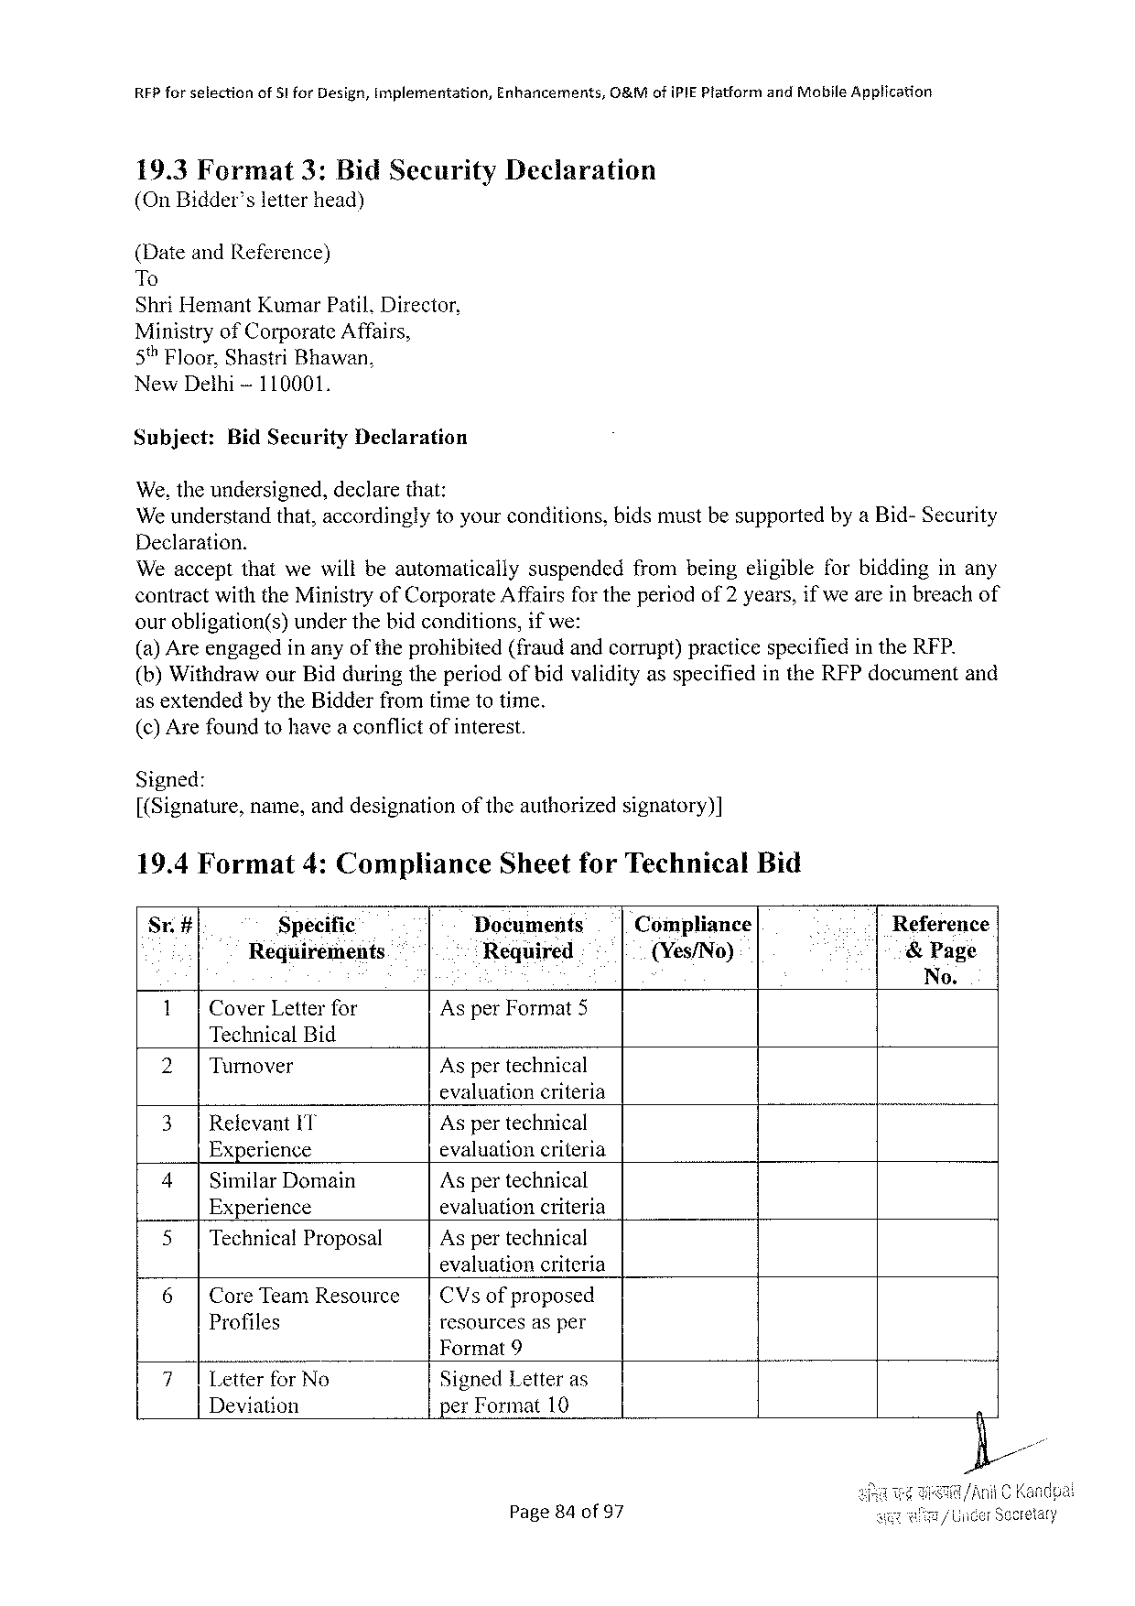

REPforselection of51forDesign,Implementation, Enhancements, O&MofiPIEPlatformandMobileApplication

19.3Format 3:BidSecurity Declaration (OnBidder’sletterhead)

(DateandReference)   
To   
ShriHemantKumarPatil,Director,   
MinistryofCorporateAffairs,   
5% Floor,ShastriBhawan,   
NewDethi-110001,

Subject: BidSecurityDeclaration

We,theundersigned, declare that:   
We understandthat,accordinglytoyourconditions,bidsmustbesupportedbya Bid-Security

|  |  |  |
| --- | --- | --- |
| Declaration. | suspended | frombeingeligibleforbiddinginany |
| Weacceptthatwewillbeautomatically |

contractwiththeMinistryofCorporateAffairsfor theperiodof2years,ifwe areinbreachof ourobligation(s) underthebidconditions,ifwe:   
(a) Areengagedinanyoftheprohibited(fraudandcorrupt)practicespecifiedintheRFP. (b)WithdrawourBidduringtheperiodofbidvalidityasspecifiedintheRFPdocumentand as extendedby theBidderfromtimetotime.

(c) Arefoundtohavea conflictofinterest.

Signed:   
[(Signature,name,anddesignationoftheauthorizedsignatory)]

|  |  |  |  |  |  |
| --- | --- | --- | --- | --- | --- |
| 19.4Format | 4:Compliance | SheetforTechnical | | Bid | Reference |
| St# | Specific | Documents | Compliance |
| Requirements | | Required | {(Yes/No) | &Page |

No.

|  |  |  |
| --- | --- | --- |
| 1| | CoverLetterfor | AsperFormat5 |

TechnicalBid

|  |  |  |
| --- | --- | --- |
| 2| | Turnover | Aspertechnical |

evaluationcriteria

|  |  |  |
| --- | --- | --- |
| 3|Relevant IT Experience | | Aspertechnical  evaluationcriteria  Aspertechnical  evaluationcriteria  Aspertechnical |
| 4| | SimilarDomain |
| Experience | |
| 5| | TechnicalProposal |

evaluationcriteria

|  |  |  |  |  |
| --- | --- | --- | --- | --- |
| 6| | CoreTeamResowrce | | | CVs | of proposed |
| Profiles | resourcesasper | |

Format9

|  |  |  |
| --- | --- | --- |
| 7| | Letterfor No | SignedLetteras |
| Deviation | perFormat10 |

Page84of97

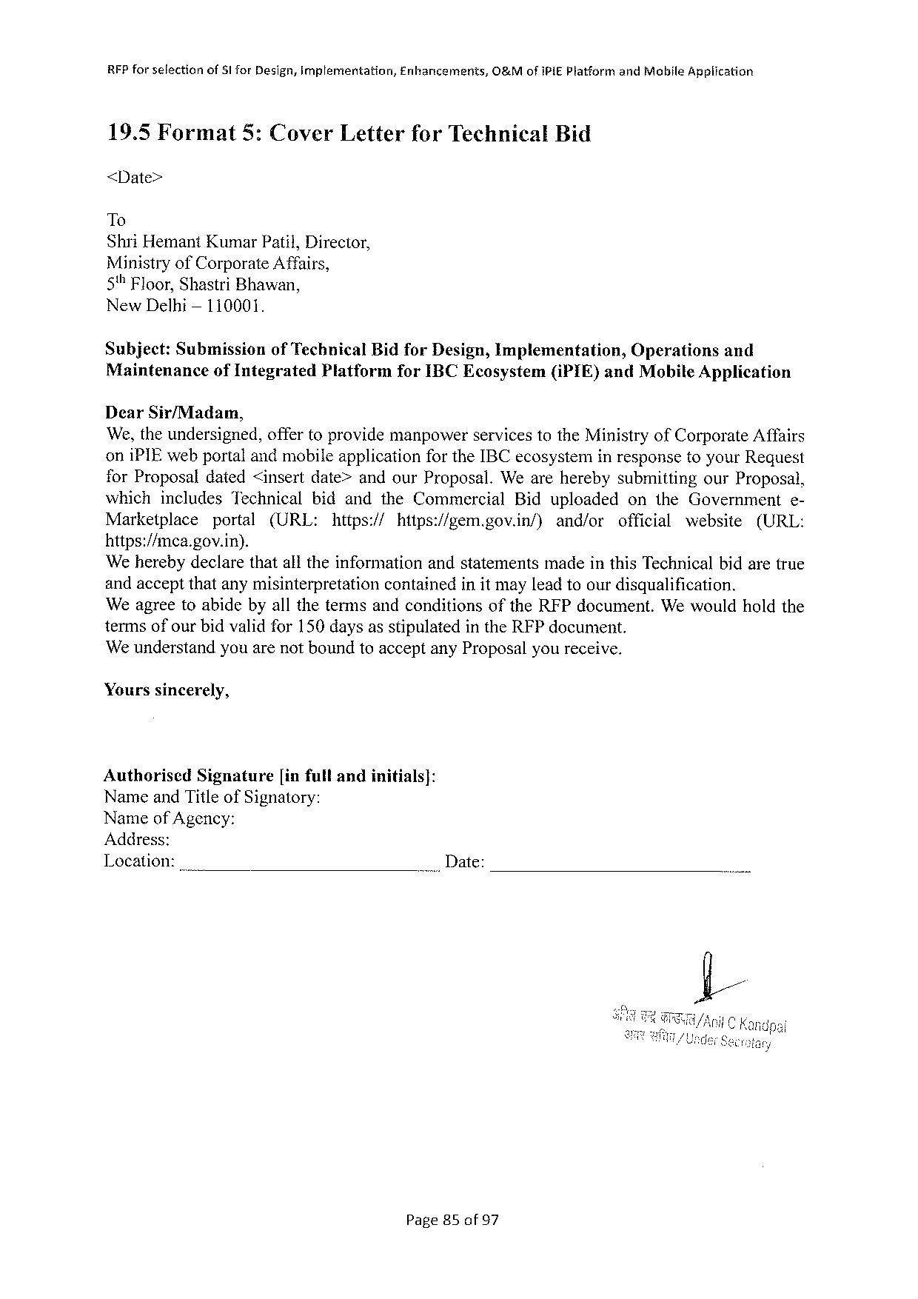

|  |  |  |  |
| --- | --- | --- | --- |
| RFPforselection | ofSlforDesign,implementation, | Enhancements, | O&MofIPIEPlatformandMabileApplication |

19.5Format5:CoverLetterforTechnicalBid

<Date>

To

ShriHemantKumarPatil,Director,

MinistryofCorporateAffairs,

5"Floor,ShastriBhawan,

NewDelhi— 110001.

Subject: Submission ofTechnicalBidforDesign,Implementation, Operations and

Maintenanceof IntegratedPlatformforIBCEcosystem(iPIE)andMobile Application

DearSir/Madam,

We,theundersigned,offertoprovidemanpowerservicestotheMinistryofCorporateAffairs

oniPIEwebportalandmobileapplicationfor theIBCecosysteminresponsetoyourRequest

forProposaldated<insertdate>andourProposal.Weareherebysubmitting ourProposal,

which includesTechnical bidandtheCommercial Biduploaded ontheGovernment e-

Marketplace portal (URL: https:// hitps:/gem.gov.in/) and/or official website (URL:

https://mca.gov.in).

‘WeherebydeclarethatalltheinformationandstatementsmadeinthisTechnicalbidaretrue

andacceptthatanymisinterpretation containedinit mayleadtoourdisqualification.

WeagreetoabidebyallthetermsandconditionsoftheRFPdocument. Wewouldholdthe

termsofourbidvalidfor150daysasstipulatedintheRFPdocument.

We understandyouarenotboundtoacceptanyProposalyoureceive.

Yourssincerely,

|  |  |  |
| --- | --- | --- |
| Authorised | Signature | [infullandinitials]: |

NameandTitleofSignatory:

Nameof Agency:

Address:

Location:_ .. Date:

Page85of97

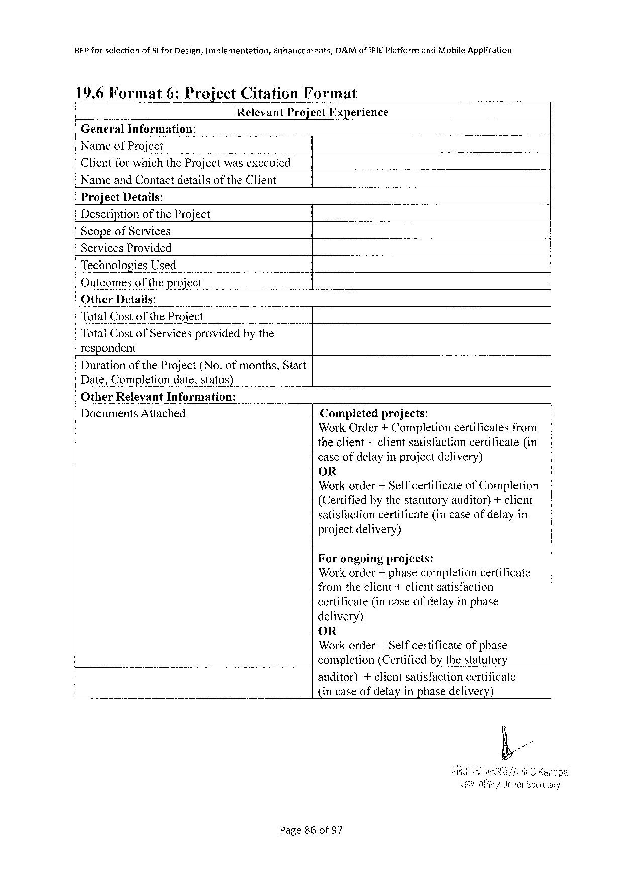

RFP forselectionofSIforDesign,implementation,Enhancements,O&MofIPIEPlatform andMobfleApplication

|  |  |  |  |
| --- | --- | --- | --- |
| 19.6Format | 6:Project | Citation | Format |

RelevantProjectExperience GeneralInformation:   
NameofProject   
ClientforwhichtheProjectwasexecuted

NameandContactdetailsoftheClient   
ProjectDetails:   
DescriptionoftheProject   
Scopeof Services   
ServicesProvided   
TechnologiesUsed   
Outcomesofthe project   
OtherDetails:

|  |  |  |
| --- | --- | --- |
| TotalCost | of the | Project |

TotalCostofServicesprovidedbythe   
respondent   
DurationoftheProject(No.of months,Start   
Date,Completiondate,status)   
OtherRelevantInformation:

DocumentsAttached

Completedprojects:   
WorkOrder + Completioncertificates from theclient+clientsatisfactioncertificate(in caseofdelayinprojectdelivery)   
OR   
Workorder+Selfcertificate of Completion (Certifiedbythestatutoryauditor)+client satisfactioncertificate(incaseofdelayin project delivery)

Forongoingprojects:   
Workorder+phasecompletioncertificate fromtheclient+clientsatisfaction   
certificate(incaseofdelayinphase   
delivery)   
OR   
Workorder+Self certificate ofphase   
completion (Certifiedby the statutory

auditor) +clientsatisfactioncertificate (incaseofdelayinphasedelivery)

Page86of97

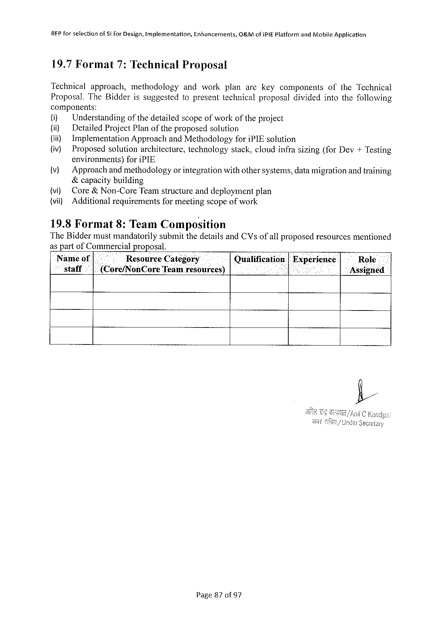

REP for selectionofStforDesign,implementation,Enhancements,O&MofIPIEPlatform andMobile Application

19.7Format 7:Technical Proposal

Technical approach, methodology andwork planarekeycomponents oftheTechnical

Proposal.TheBidderissuggestedtopresenttechnicalproposaldividedintothefollowing

components:

(i) Understanding of thedetailedscopeofworkof theproject

(i) DetailedProjectPlanoftheproposedsolution

(ii) ImplementationApproachandMethodologyforiPIEsolution

(iv) Proposedsolutionarchitecture,technology stack,cloudinfrasizing(forDev+Testing

environments)foriPIE

(v) Approach andmethodologyor integrationwithothersystems,datamigrationandtraining

&capacitybuilding

{vi) Core& Non-CoreTeamstructureanddeploymentplan

(vi) Additionalrequirementsformeetingscopeof work

19.8Format 8:TeamComposition

TheBiddermustmandatorilysubmitthedetailsandCVsofail proposedresourcesmentioned

as part ofCommercial proposal.

|  |  |  |  |  |  |  |
| --- | --- | --- | --- | --- | --- | --- |
| Nameof[.- | | . | ResourceCategory | Qualification|Experienice | | Role |
| staff | .|(Core/NonCoreTeam resources) | | | : | i | Assigned |

Page87of97

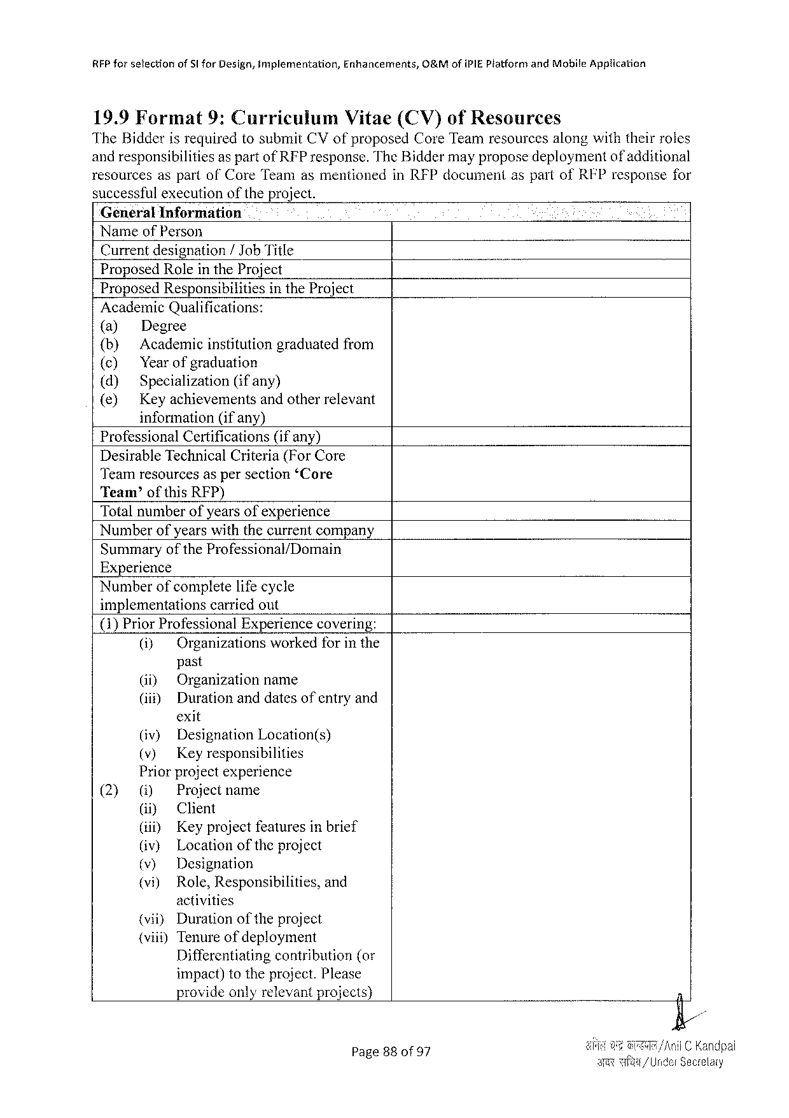

RFPforselection of§I forDesign,implementation, Enhancermments, O&MofiPIE PlatformandMobiteApplication

19.9Format 9:Cuarriculum Vitae(CV)ofResources

TheBidderisrequiredtosubmitCVofproposedCoreTeamresourcesalongwiththeirroles

andresponsibilitiesas partof RFPresponse.TheBiddermayproposedeploymentof additional

resourcesaspartofCoreTeamasmentioned successfulexecutionoftheproject.

GeneralInformation   
NameofPerson   
Currentdesignation/ JobTitle   
ProposedRolein theProject   
ProposedResponsibilities intheProject AcademicQualifications:   
(a)   
 Degree (b) Academicinstitutiongraduatedfrom {¢) Yearofgraduation   
(d) Specialization(ifany)   
(e)   
 Keyachievementsandotherrelevant information(ifany)   
ProfessionalCertifications (ifany)   
DesirableTechnicalCriteria(ForCore   
Teamresourcesaspersection‘Core   
Team’ofthisRFP)   
Totalnumberofyearsofexperience   
Numberofyearswiththecurrentcompany

|  |  |  |
| --- | --- | --- |
| Summary | of the | Professional/Domain |

Experience   
Numberofcompletelifecycle   
implementations carriedout   
(1)PriorProfessionalExperiencecovering: (i) Organizationsworkedforinthe past   
 (i) Organizationname   
 (iif) Duration anddatesofentryand exit   
 (iv) DesignationLocation(s)   
 (v) Keyresponsibilities   
 Priorprojectexperience

|  |  |  |  |  |
| --- | --- | --- | --- | --- |
| (2) | () | Projectname | | |
| i) | Client | | |
| (i) | Keyprojectfeaturesinbrief | | |
| (iv) | Location | oftheproject | |
| (v) | Designation | | |
| (vi) | Role,Responsibilities, | | and |

activities   
(vii) Duration of the project   
(viii) Tenureofdeployment   
 Differentiating   
 contribution{(or impact)totheproject.Please provideonlyrelevantprojects)

inRFPdocumentaspartofRFPresponsefor

|  |  |
| --- | --- |
| Page88of 97 | {andpai  1 Seceelary |

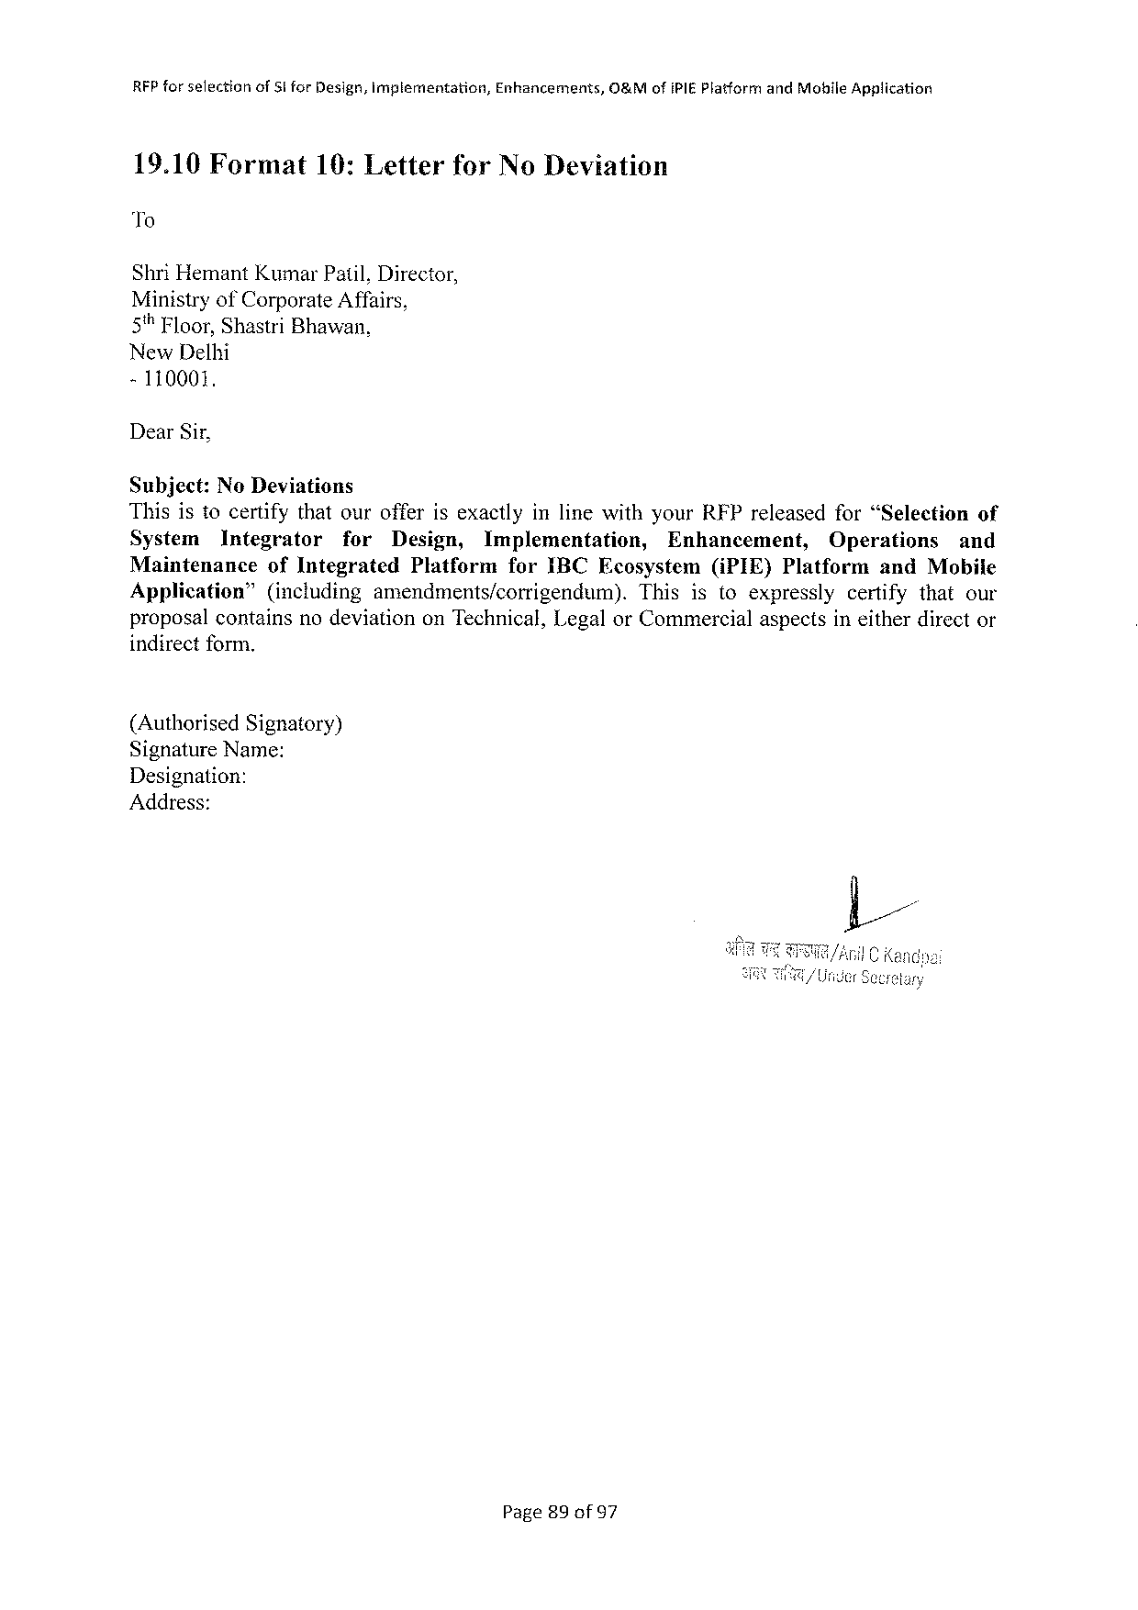

RFPforselection ofSi forDesign,implementation, Enhancements, O&MofiPIEPlatformandMobileApplication

19.10Format 19:Letter forNoDeviation

To

ShriHemantKumarPatil,Director,

MinistryofCorporateAffairs,

5% Floor,ShastriBhawan,

NewDelhi

-110001.

DearSir,

Subject:No Deviations

ThisistocertifythatourofferisexactlyinlinewithyourRFPreleasedfor“Selection of

System Integrator for Design, Implementation, Enhancement, Operations and

Maintenance ofIntegrated PlatformforIBCEcosystem(iPIE)PlatformandMobile

Application” (including amendments/corrigendum). Thisistoexpressly certifythatour

proposalcontainsnodeviationonTechnical,LegalorCommercialaspectsineitherdirector

indirectform.

(AuthorisedSignatory)

SignatureName:

Designation:

Address:

Page89of97

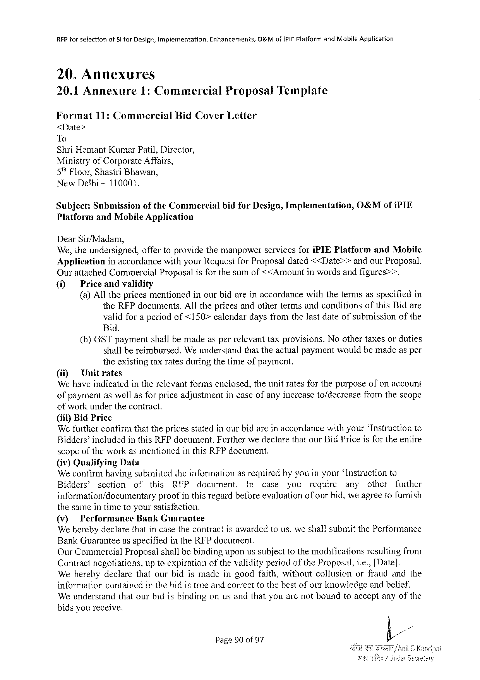

|  |  |  |  |
| --- | --- | --- | --- |
| RFPforselection | ofSlforDesign,Implementation, | Enhancements, | O&MofiPIEPlatformandMobileApplication |

20.Annexures

|  |  |  |  |  |  |
| --- | --- | --- | --- | --- | --- |
| 20.1Annexure | | 1:Commercial | | Proposal | Template |
| Format | 11:Commercial | | BidCover | Letter |

<Date>

To   
ShriHemantKumarPatil,Director,   
MinistryofCorporateAffairs,   
5% Floor,ShastriBhawan,   
NewDethi-110001.

|  |  |  |  |  |
| --- | --- | --- | --- | --- |
| Subject: | Submission | oftheCommercial | bidforDesign,Implementation, | O0&MofiPIE |
| PlatformandMobile Application | | |

DearSir/Madam,   
We,theundersigned,offertoprovidethemanpowerservicesforiPIEPlatform andMobile Application inaccordancewithyourRequestforProposaldated<<Date>>andourProposal.

Ourattached Commercial Proposal is forthe sum of<<Amount in words andfigures>>.

(1) Priceandvalidity   
 (a)Allthepricesmentionedinourbidareinaccordancewiththetermsasspecifiedin theRFPdocuments.AllthepricesandothertermsandconditionsofthisBidare validforaperiodof<150>calendardaysfromthelastdateofsubmissionofthe Bid.

(b)GSTpaymentshallbemadeasperrelevanttaxprovisions.Noothertaxesorduties shallbereimbursed.Weunderstandthattheactualpaymentwouldbemadeasper theexistingtaxratesduringthetimeofpayment.

(ii) Unitrates   
We haveindicatedintherelevantformsenclosed,theunitratesforthepurposeofonaccount ofpaymentaswellasforpriceadjustmentincaseofanyincreaseto/decreascfromthescope ofworkunderthecontract.

(iif)Bid Price   
We furtherconfirmthat the pricesstated inourbid arein accordance withyour‘Instructionto Bidders’includedinthisRFPdocument.FurtherwedeclarethatourBidPriceisfor theentire scopeofthe workasmentionedin thisRFPdocument.

{iv) Qualifying Data   
We confirmhavingsubmittedtheinformationasrequiredbyyouinyour‘Instructionto Bidders®section of this RFP document. In case you require any other further

information/documentary proofinthisregardbeforeevaluationofourbid,we agreetofurnish thesameintimetoyoursatisfaction.

|  |  |  |
| --- | --- | --- |
| (v) | Performance | BankGuarantee |

We herebydeclarethatincasethecontractisawardedtous,weshallsubmitthePerformance BankGuaranteeasspecifiedintheRFPdocument.

OurCommercialProposalshallbe bindinguponus subjectto the modificationsresultingfrom Contractnegotiations,uptoexpirationof thevalidityperiodoftheProposal,i.e.,[Date]. Weherebydeclarethatourbidismadeingoodfaith,withoutcollusionorfraudandthe informationcontainedinthebidistrueandcorrecttothebestofourknowledgeandbelief. Weunderstandthatourbidisbindingonusandthatyouarenotboundtoacceptanyofthe bidsyoureceive.

Page90of97



|  |  |  |  |
| --- | --- | --- | --- |
| RFPforsefection | of5t forDesign,Implementation, | Enhancements, | O&MofiPI£PlatformandMobileApplication |

Yourssincerely

AuthorizedSignature:

NameandTitle of Signatory:

Nameof Agency:

|  |  |  |  |  |
| --- | --- | --- | --- | --- |
| Address: | SR | /1) | b | |
| il | C Kandpal |

Page91of97

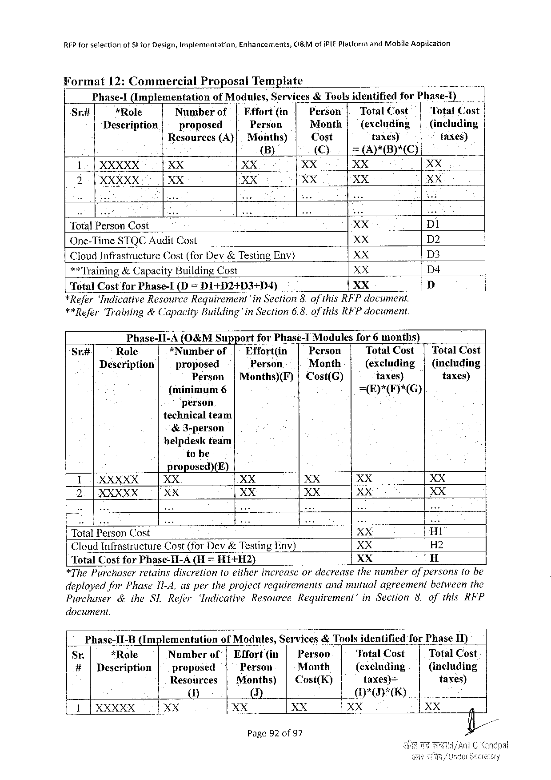

REPforselection ofSt forDesign,Implementation, Enhancements, O&MofiPIEPlatformandMobileApplication

Format 12:Commercial Proposal Template o

Phase-1(Implementation ofModules,Services&Toolsidentified forPhase-)

Sr# *Role Number of| Effort(in Person | TotalCost TotalCost

Description proposed Person Month| (excluding | (inclading

Resources (A)| Months) Cost taxesy taxes)

B) ©). [=APB)*C)

1| XXXXX XX XX XX XX XX

2 P XXXXX XX XX XX XX XX

TotalPersonCost XX DI

One-TimeSTQCAuditCost XX D2

CloudInfrastructure Cost(forDev&TestingEnv) XX D3

**Training&CapacityBuildingCost XX D4

TotalCostfor Phase-I(D = D1+D2+D3+D4) XX D

*Refer‘IndicativeResourceRequirement’in Section8.ofthisRFPdocument.

**Refer‘Training&CapacityBuilding'in Section6.8.of thisRFPdocument.

Phase-I1-A(O&MSupport forPhase-1Modules for6months)

Sr.# Role *Number of.| Effort(in Person TotalCost | TotalCost

Description proposed Person Month (excluding| (including

Person |Months)(F)|Cost(G) taxes) taxes)

(minimum6 =E)*(F)*(G)

person

technicalteam

&3-person

helpdeskteam

tobe

proposed)(E)

1|XXXXX XX XX XX XX XX

2.|XXXXX XX XX XX XX XX

TotalPersonCost XX H1

CloudInfrastructureCost(forDev&TestingEnv) XX H2

TotalCost forPhase-II-A(H = HI+H2) XX H

*ThePurchaser retainsdiscretionfo eitherincreaseordecreasethenumberofpersonstobe

deployedforPhase1I-4,aspertheprojectrequirements andmutualagreement betweenthe

Purchaser &theSLRefer ‘IndicativeResource Requirement’ inSection8.ofthisRFP

document.

Phase-II-B (Implementation ofModules,Services&Toolsidentified forPhaseII)

Sr. *Role Number of| Effort(in| Person TotalCost TotalCost

#|Description proposed Person Meonth (excluding (including

Resources |Months) | Cost(K) taxes)= taxes)

U] ()] MH*D*E)

1|XXXXX XX XX XX XX

Page92of97

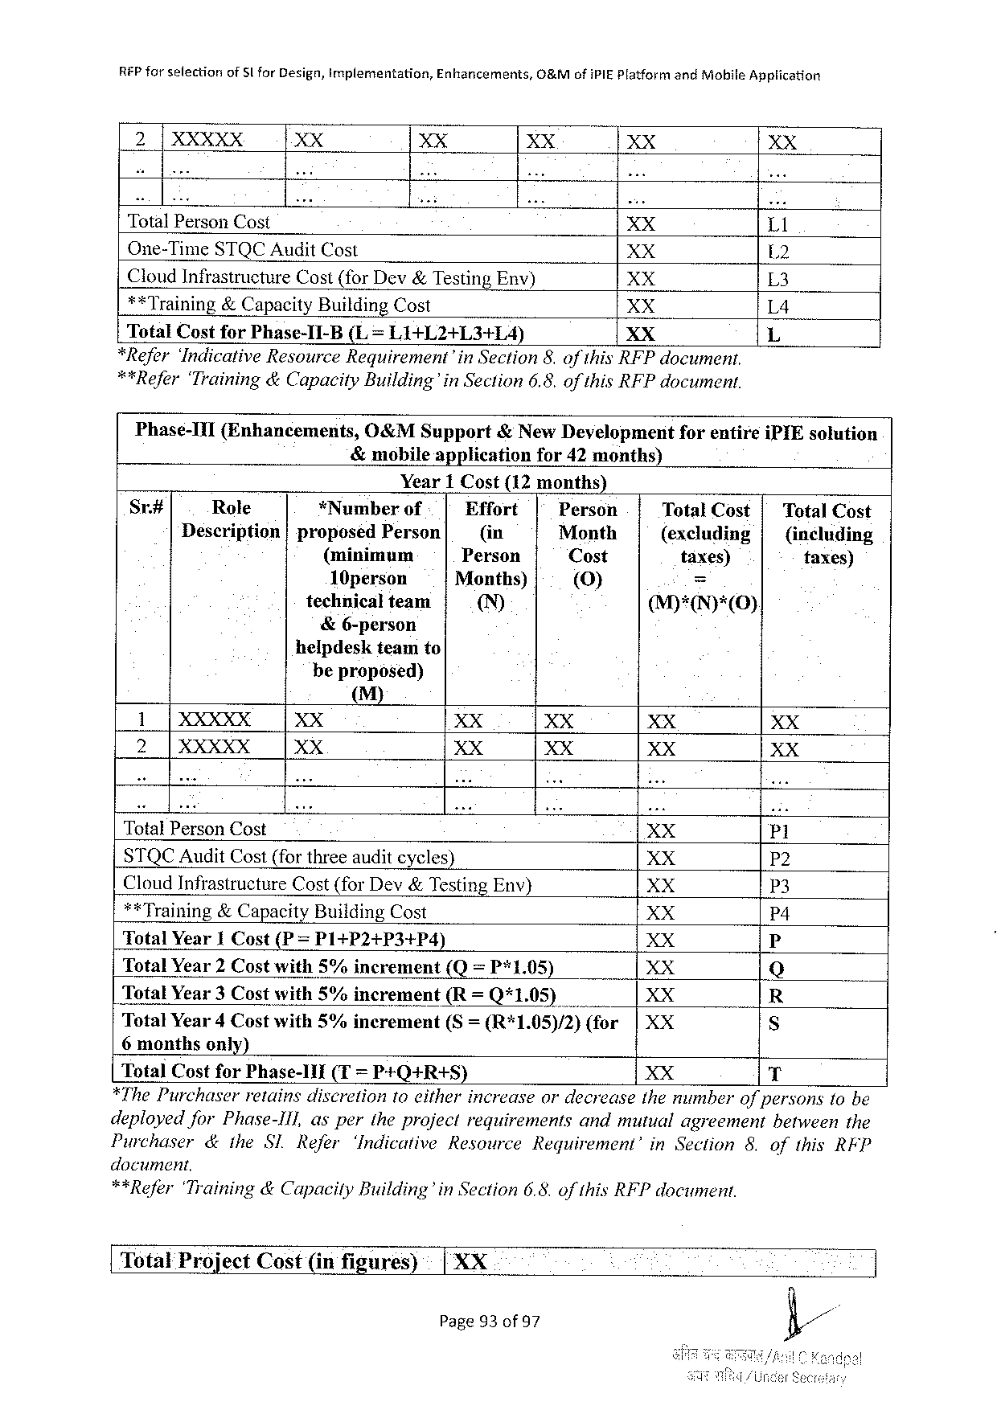

|  |  |  |  |  |  |  |  |  |  |  |
| --- | --- | --- | --- | --- | --- | --- | --- | --- | --- | --- |
| REP forselection | ofSlforDesign,implementation, | | | Enhancements, | | O&MofiPIEPlatformandiiobile | | | | Application  XX  Ll  L2  L3  L4  L |
| 2|XXXXX | | XX | XX | | | XX | | | XX |
| TotalPersonCost | | | | | | XX | | | |
| One-TimeSTQCAuditCost | | | | | | XX | | | |
| CloudInfrastructureCost(forDev&TestingEnv) | | | | | | | | XX | |
| **Training&CapacityBuildingCost | | | | | | XX | | | |
| TotalCostforPhase-1I-B(L= L1+L2+L3+1L4) | | | | | | | XX | | |
| *Refer‘IndicativeResourceRequirement’inSection8.of thisRFPdocument. | | | | | | | | | |
| **Refer‘Training&CapacityBuilding’in | | | | | Section6.8.of thisRFPdocument. | | | | |

Phase-III(Enhancements,O&MSupport&NewDevelopmeritforentireiPIEsolution

&mobileapplicationfor 42months)

Year1 Cost(12months)

|  |  |  |  |  |  |  |
| --- | --- | --- | --- | --- | --- | --- |
| Sr# | Role | *Numberof | Effort | Person | TotalCost| | TotalCost |
| Description|proposedPerson | | (in | Month | (excluding| | (including |
| (minimum | | Person | Cost | taxes) | taxes) |
| 10person | | Months) | [(V)] | = |
| technicalteam | | ™ | M)*(IN)*(0). |
| &6-person | |
| helpdeskteamto | |

beproposed)

M)

1T XXX XX XX XX XX XX

2 |XXXXX XX XX XX XX XX

TotalPersonCost XX P1

STQCAuditCost(forthreeauditcycles) XX P2

CloudInfrastructureCost(forDev&TestingEnv) XX P3

**Training&CapacityBuildingCost XX P4

TotalYear1 Cost(P = P1+P2+P3+P4) XX P

TotalYear2Costwith5%increment (Q=P*1.05) XX Q

TotalYear3 Costwith5%increment(R= Q*1.05) XX R

TotalYear4 Costwith5%increment(S= (R*1.05)/2)(for|XX S

6monthsonly)

TotalCostforPhase-11I (T= P+Q+R+S) XX T

*ThePurchaser retainsdiscretiontoeitherincrease ordecrease themumberofpersonstobe

deployedforPhase-Ill, aspertheprojectrequirements andmutualagreement betweenthe

Purchaser &itheSl Refer ‘IndicativeResource Requirement’ inSection 8.ofthisRFP

document,

**Refer‘Training&CapacilyBuilding’in Section6.8.of thisRFPdocument.

[ TotalProjectCost(infigares) | XX

Page93of 97

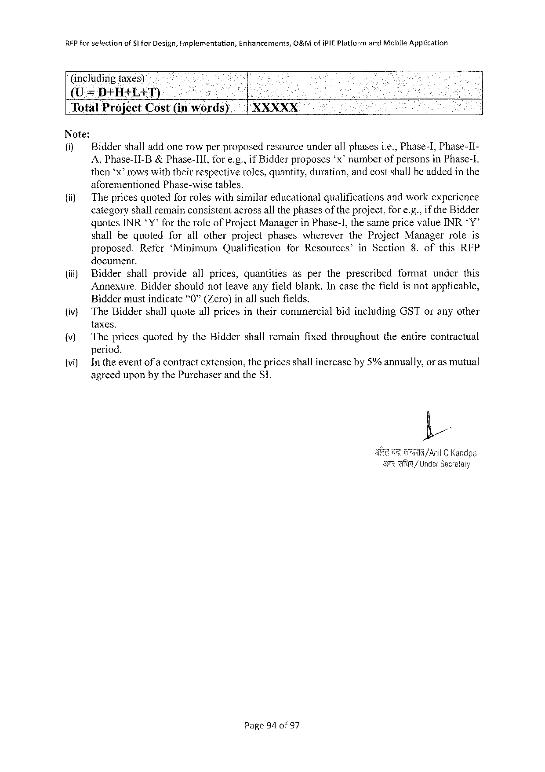

|  |  |  |  |
| --- | --- | --- | --- |
| RFPforselection | of51forDesign,implementation, | Enhancements, | G8&M ofiPIEPlatformandMobileApptication |

(includingtaxes)-

(U=DHHALAT).-

|  |  |  |
| --- | --- | --- |
| TotalProjectCost(in | words) | XXXXX |

Note:

(i) Biddershalladdonerowperproposedresourceunderallphasesi.e.,Phase-I,Phase-II-

A,Phase-1I-B&Phase-I11, fore.g.,if Bidderproposes‘x’ numberofpersonsinPhase-I,

then‘x” rowswiththeirrespectiveroles,quantity,duration,andcostshallbeaddedinthe

|  |  |  |  |
| --- | --- | --- | --- |
| (i) | aforementioned | Phase-wisetables, | andworkexperience |
| Thepricesquotedforroleswithsimilareducationalqualifications | |

categoryshallremainconsistentacrossall thephasesoftheproject,fore.g..if theBidder

quotesINRY’for theroleofProjectManagerinPhase-],thesamepricevalueINR*Y”

shallbequoted forallotherprojectphases wherever theProject Manager roleis

proposed. Refer‘Minimum Qualification forResources’ inSection 8.ofthisRFP

document.

|  |  |  |  |  |  |  |
| --- | --- | --- | --- | --- | --- | --- |
| (i} | Bidder | shallprovide | allprices, | quantities | aspertheprescribed | formatunderthis |
| Annexure.Biddershouldnotleaveanyfieldblank.Incasethe fieldisnotapplicable, | | | | | |

Biddermustindicate“0”(Zero)inallsuchfields.

{iv) TheBiddershallquoteallpricesintheircommercialbidincludingGSToranyother

taxes.

|  |  |  |
| --- | --- | --- |
| (v) | The pricesquotedbytheBiddershallremainfixedthroughout | theentirecontractual |

period.

{vi) Intheeventof a contractextension,thepricesshallincreaseby5%annually,oras mutual

agreeduponbythePurchaserandtheS1.

|  |  |  |
| --- | --- | --- |
| U | G | /AnilC Kandpal |

s wfte/Under Secrefary

Page94of97

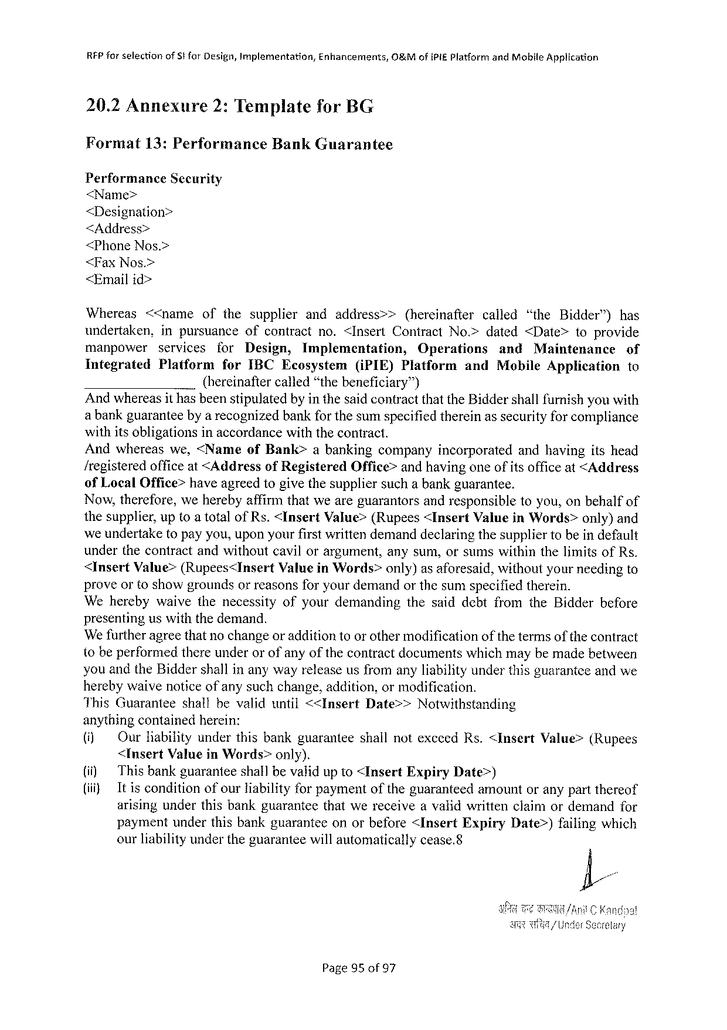

REP forselection ofStforDesign,Implementation, Enhancements, O&MofiPi£PlatformandMobileApplication

20.2Annexure 2:TemplateforBG

Format 13:Performance Bank Guarantee

PerformanceSecurity

<Name>

<Designation>

<Address>

<PhoneNos.>

<FaxNos.>

<Emailid>

Whereas <<name ofthesupplier andaddress>> (hereinafter called “theBidder”) has

undertaken, inpursuance ofcontractno.<InsertContractNo.>dated<Date> toprovide

manpower services for Design, Implementation, Operations and Maintenance of

Integrated Platform forIBCEcosystem(iPIE)Platform andMobileApplicationto

(hereinaftercalled“thebeneficiary™)

Andwhereasit hasbeenstipulatedbyinthesaidcontractthattheBiddershallfurnishyouwith

a bankguaranteebya recognizedbankfor thesumspecifiedthereinassecurityforcompliance

withitsobligationsinaccordancewiththecontract.

Andwhereaswe,<Name ofBank> abankingcompanyincorporated andhavingitshead

/registeredofficeat<AddressofRegistered Office>andhavingoneofitsofficeat<Address

ofLocalOffice>haveagreedtogivethesuppliersuchabankguarantee.

Now,therefore,weherebyaffirmthatweareguarantorsandresponsibletoyou,onbehalfof

thesupplier,uptoatotalofRs.<InsertValue>(Rupees<InsertValueinWords>only)and

weundertaketopayyou,uponyourfirstwrittendemanddeclaringthesuppliertobeindefault

underthecontractandwithoutcavilorargument,anysum,orsumswithinthelimitsofRs.

<InsertValue>(Rupees<Insert ValueinWords>only)asaforesaid,withoutyourneedingto

proveortoshowgroundsorreasonsforyourdemandorthesumspecifiedtherein.

Weherebywaivethenecessity ofyourdemanding thesaiddebtfromtheBidderbefore

presenting us with the demand.

We furtheragreethatnochangeoradditionto orothermodificationofthe termsofthe contract

tobeperformedthereunderorofanyofthecontractdocumentswhichmaybemadebetween

youandtheBiddershallinanywayreleaseusfromanyliabilityunderthisguaranteeandwe

herebywaivenoticeof anysuchchange,addition,ormodification.

|  |  |  |  |
| --- | --- | --- | --- |
| ThisGuarantee | shallbevaliduntil<<Insert | Date>> | Notwithstanding |

anythingcontainedherein:

|  |  |  |  |  |  |
| --- | --- | --- | --- | --- | --- |
| (i) (i) (i) | OurHabilityunderthisbankguaranteeshallnotexccedRs.<Insert | | | | Value>(Rupees |
| <InsertValueinWords>only). | | | | |
| Thisbankguaranteeshallbevaiidup 1o <Insert | Expiry | Date>) | | |
| Itisconditionofourliabilityforpaymentoftheguaranteedamountoranypartthereof arisingunderthisbankguaranteethatwereceiveavalidwrittenclaimordemandfor | | | | |
| paymentunderthisbankguaranteeonorbefore<Insert | | Expiry | Date>)failingwhich | |
| ourliabilityundertheguaranteewillautomaticallycease.8 | | | | |

Page95of97



RFPfor selectionofSiforDesign,Implementation,Enhancements,O8&MofiPIEPlatform andMobite Application

|  |  |  |  |
| --- | --- | --- | --- |
| 20.3Annexure3:Functional | Requirement | Specification | Decument |

ATTACHED

Page96of97



RFPforselection of SforDesign,Implementation, Enhancements, O&MofIPIEPlatformandMobileApplication

20.4Annexure4:MasterServiceAgreement (MSA)

ATTACHED

Page97of97



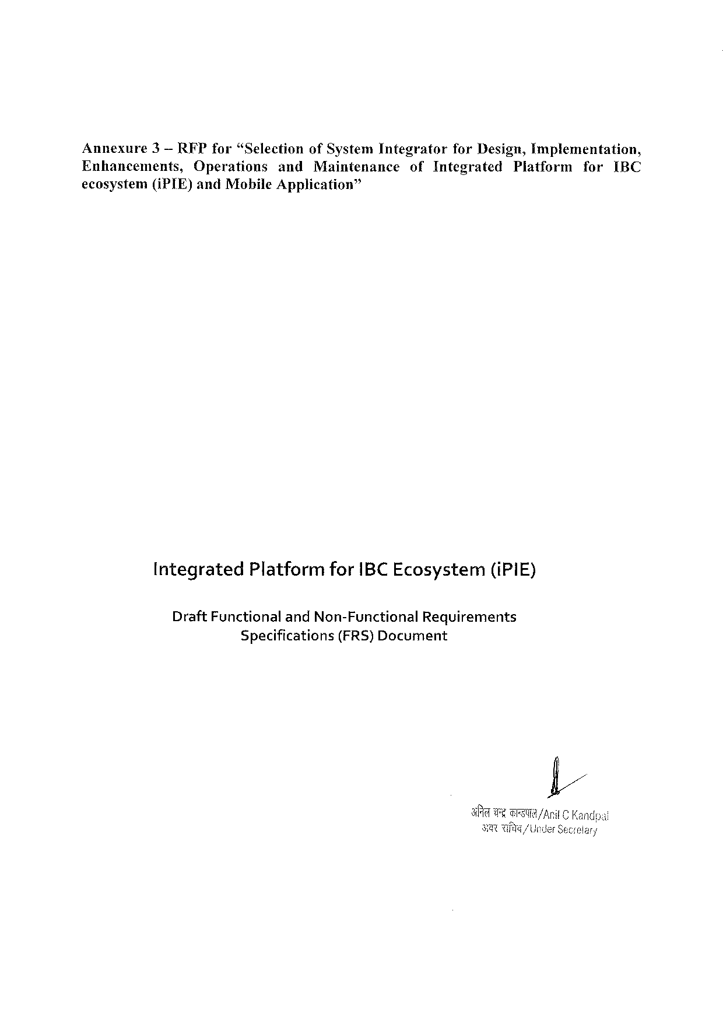

Annexure 3— RFPfor“Selection ofSystemIntegrator forDesign,Implementation,

Enhancements, Operations andMaintenance ofIntegrated Platform forIBC

ecosystem(iPTE) andMobileApplication”

Integrated PlatformforIBCEcosystem(iPIE)

Draft FunctionalandNon-FunctionalRequirements

Specifications (FRS)Document

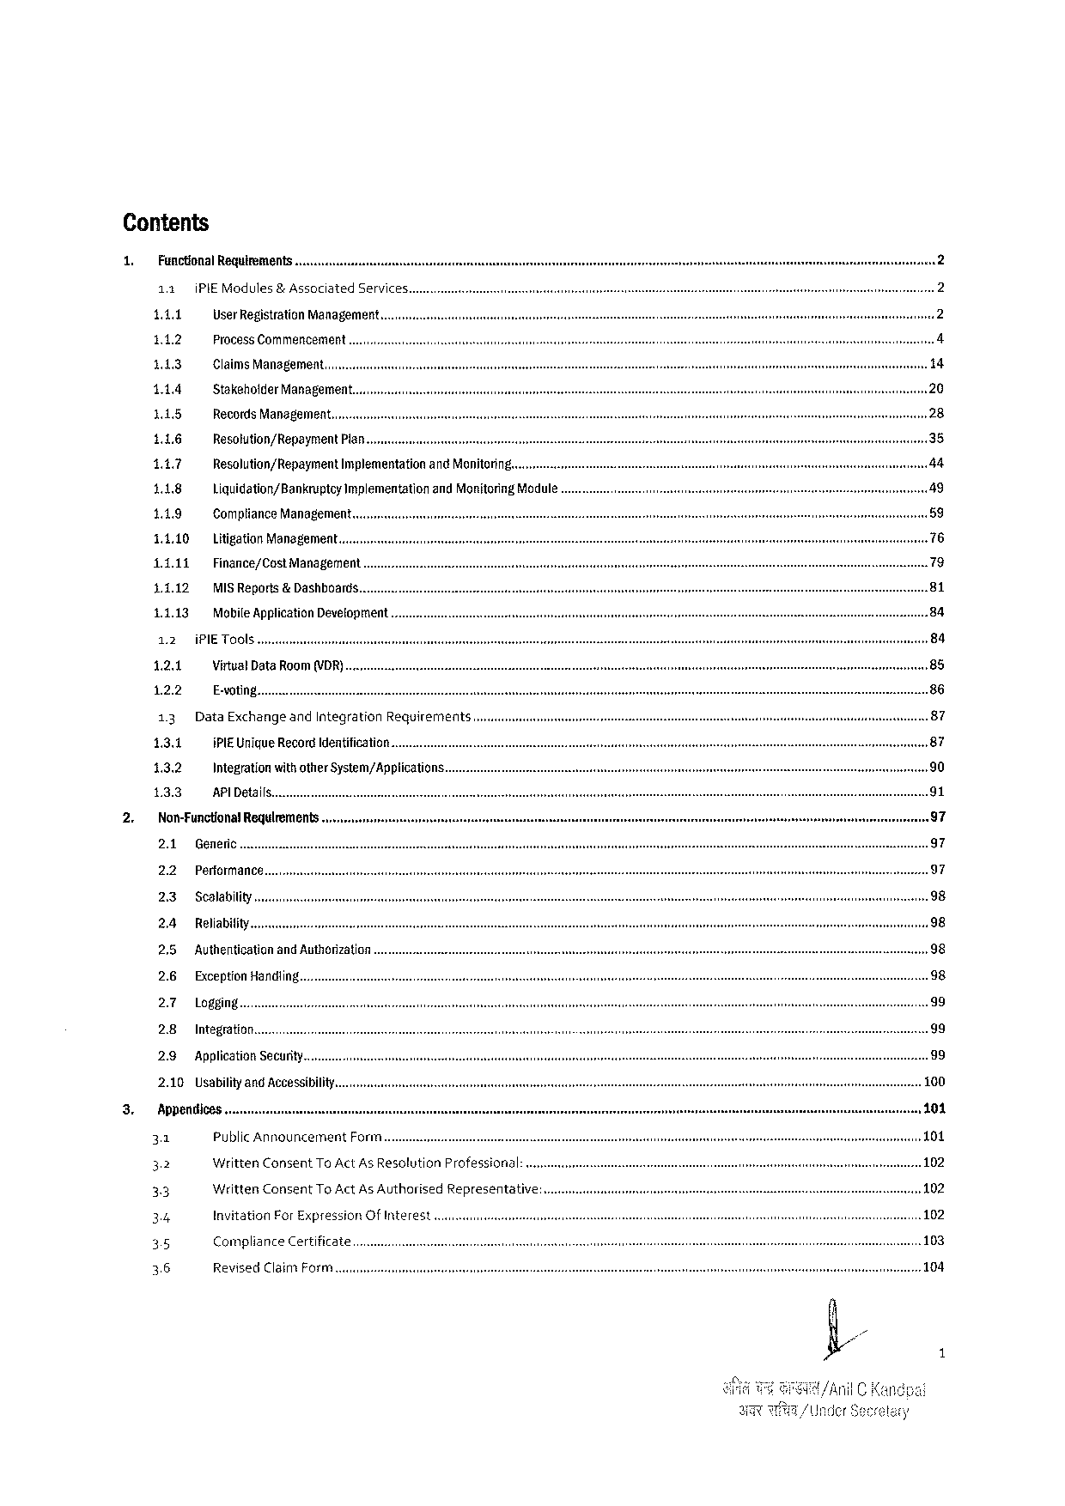

Contents

|  |  |  |  |  |  |  |
| --- | --- | --- | --- | --- | --- | --- |
| 1.  2. | Functional Requirements | | | | | |
| 11 | P | Modules | & Associated | | Services.. |
| 141 | UserRegistrationManagement.. | | | | |
| 112 | Process Commencement | | | | |
| 143 | Claims Management... | | | | |
| 114 | StakeholderManagement... | | | | |
| 115 | Records Management. | | | | |
| 116 | Resolution/RepoymentPlan... | | | | |
| 147 | Resolution/Repayment | | | Implementationand Monitoring. | |
| 118 | Liquidation/Banknptcy | | | ImplementationandMoniteringModule... | |
| 119 | ComplianceManagement... | | | | |
| 1110 | Litigation Management... | | | | |
| 1111 | Finance/CostManagement | | | | |
| 1112 | MISReporis& Dashboards. | | | | |
| 1113 | Mobile Application Development | | | | |
| 12 | iPIE Tools | | | | |
| 121 | VirtualData Room(VDR) . | | | | |
| 122 | E-voting | | | | |
| 13 | DataExchangeand IntegrationRequirements. | | | | |
| 131 | iPIE UnigueRecordIdentification. | | | | |
| 13.2 | Integrationwith otherSystem/Appiication: | | | | |
| 133 | APIDetalls | | | | |
| Non-Functiona!Requlrements | | | | ........... | |
| 2.1 | Generic .. | | | | |
| 2.2 | Performance... | | | | |

23Scalability.

2.4Reliabi   
25 Authenticationand Authorization   
2.6 Exception Handiin...

2.7 Logging..

28 Integration   
29 ApplicationSecurity   
2.10 Usabilityand Accessibilty.

|  |  |  |  |  |  |
| --- | --- | --- | --- | --- | --- |
| 3. | Appendices.. | | | s | e |
| 31 | PublicAnnouncementForrm.. | |
| g | WrittenConsentToActAs ResolutionProfessional:. | |
| 33 | WrittenConsentToActAsAuthorisedRepresentative:.... | |
| 34 | InvitationForExpression OfIMEETESt | e |
| 15 | Compliance Certificate...... | |
| 36 | RevisedClaimForm | |

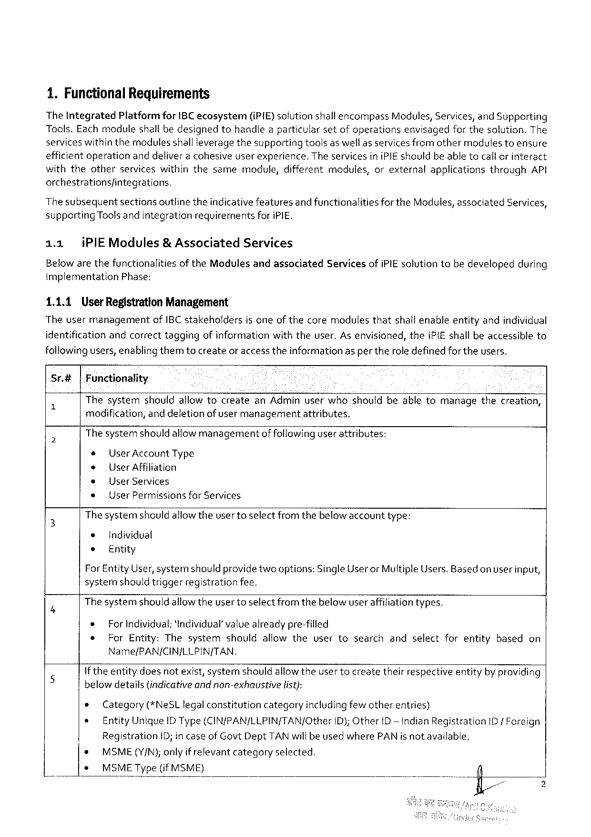

1.FunctionalRequirements

The IntegratedPlatformforIBCecosystem(iPIE) solutionshallencompassModules,Services,andSupporting Tools. Each moduleshall bedesignedtohandlea particularsetof operationsenvisagedfor thesolution.The services withinthemodules shallleveragethesupportingtoolsas well as servicesfromothermodules toensure efficientoperationanddeliver a cohesiveuser experience.The servicesiniPIEshouldbeable tocallorinteract withtheotherserviceswithinthesamemodule,differentmodules,orexternalapplicationsthroughAPI orchestrationsfintegrations,

|  |  |  |  |  |  |
| --- | --- | --- | --- | --- | --- |
| The subsequentsectionsoutlinetheindicativefeaturesand functionalitiesfortheModules,associatedServices | | | | | 3 |
| supporting | | Toolsandintegration | requirerents | foriPIE. |
| 1.1 | iPIEModules& Associated | | | Services |

Belowarethefunctionalitiesof theModulesandassociated implementationPhase:

1.1.1 User RegistrationManagement

ServicesofiPIEsolutiontobedevelopedduring

Theusermanagement ofIBC stakeholdersisoneof thecoremodulesthatshall enableentityandindividual

identificationandcorrecttaggingofinformationwiththeuser.Asenvisioned,theiPIE shall beaccessibleto

following users,enabling themtocreateor access theinformationasper theroledefinedfortheusers.

Sr.#|Functionality

" ThesystemshouldallowtocreateanAdminuserwhoshouldbeabletomanagethecreation,

modification,and deletionofusermanagementattributes.

o Thesystemshouldallowmanagementof followinguserattributes:

* User AccountType

* UserAffiliation

* UserServices

e UserPermissionsforServices

3 The systemshouldallowtheusertoselectfrom thebelow accounttype:

e Individval

e Entity

ForEntityUser,systemshouldprovidetwooptions:SingleUserorMultipleUsers.Basedon userinput,

systernshould triggerregistrationfee.

B Thesystemshould allowtheusertoselect fromthebelow user affiliationtypes.

* ForIndividual: ‘Individual’ value alreadypre-filled

e ForEntity:Thesystemshouldallowtheusertosearchandselectforentitybasedon

Name/PAN/CIN/LLPIN/TAN.

If theentitydoesnotexist, systemshouldallowtheusertocreatetheirrespectiveentityby providing

|  |  |  |  |  |  |
| --- | --- | --- | --- | --- | --- |
| 5 | belowdetails{indicativeandnon-exhaustive | | list): | | ID/ Foreign |
| e | Category(*NeSLlegalconstitutioncategoryincludingfewotherentries) | | |
| s | EntityUniqueIDType(CIN/PAN/LLPIN/TAN/Other | | ID);OtherD— indianRegistration |

RegistrationID;in case ofGovt Dept TANwill be usedwherePAN isnot available.

|  |  |  |  |
| --- | --- | --- | --- |
| * | MSME(Y/N);onlyif relevantcategory | selected. | T |
| s | MSMEType(ifMSME) |

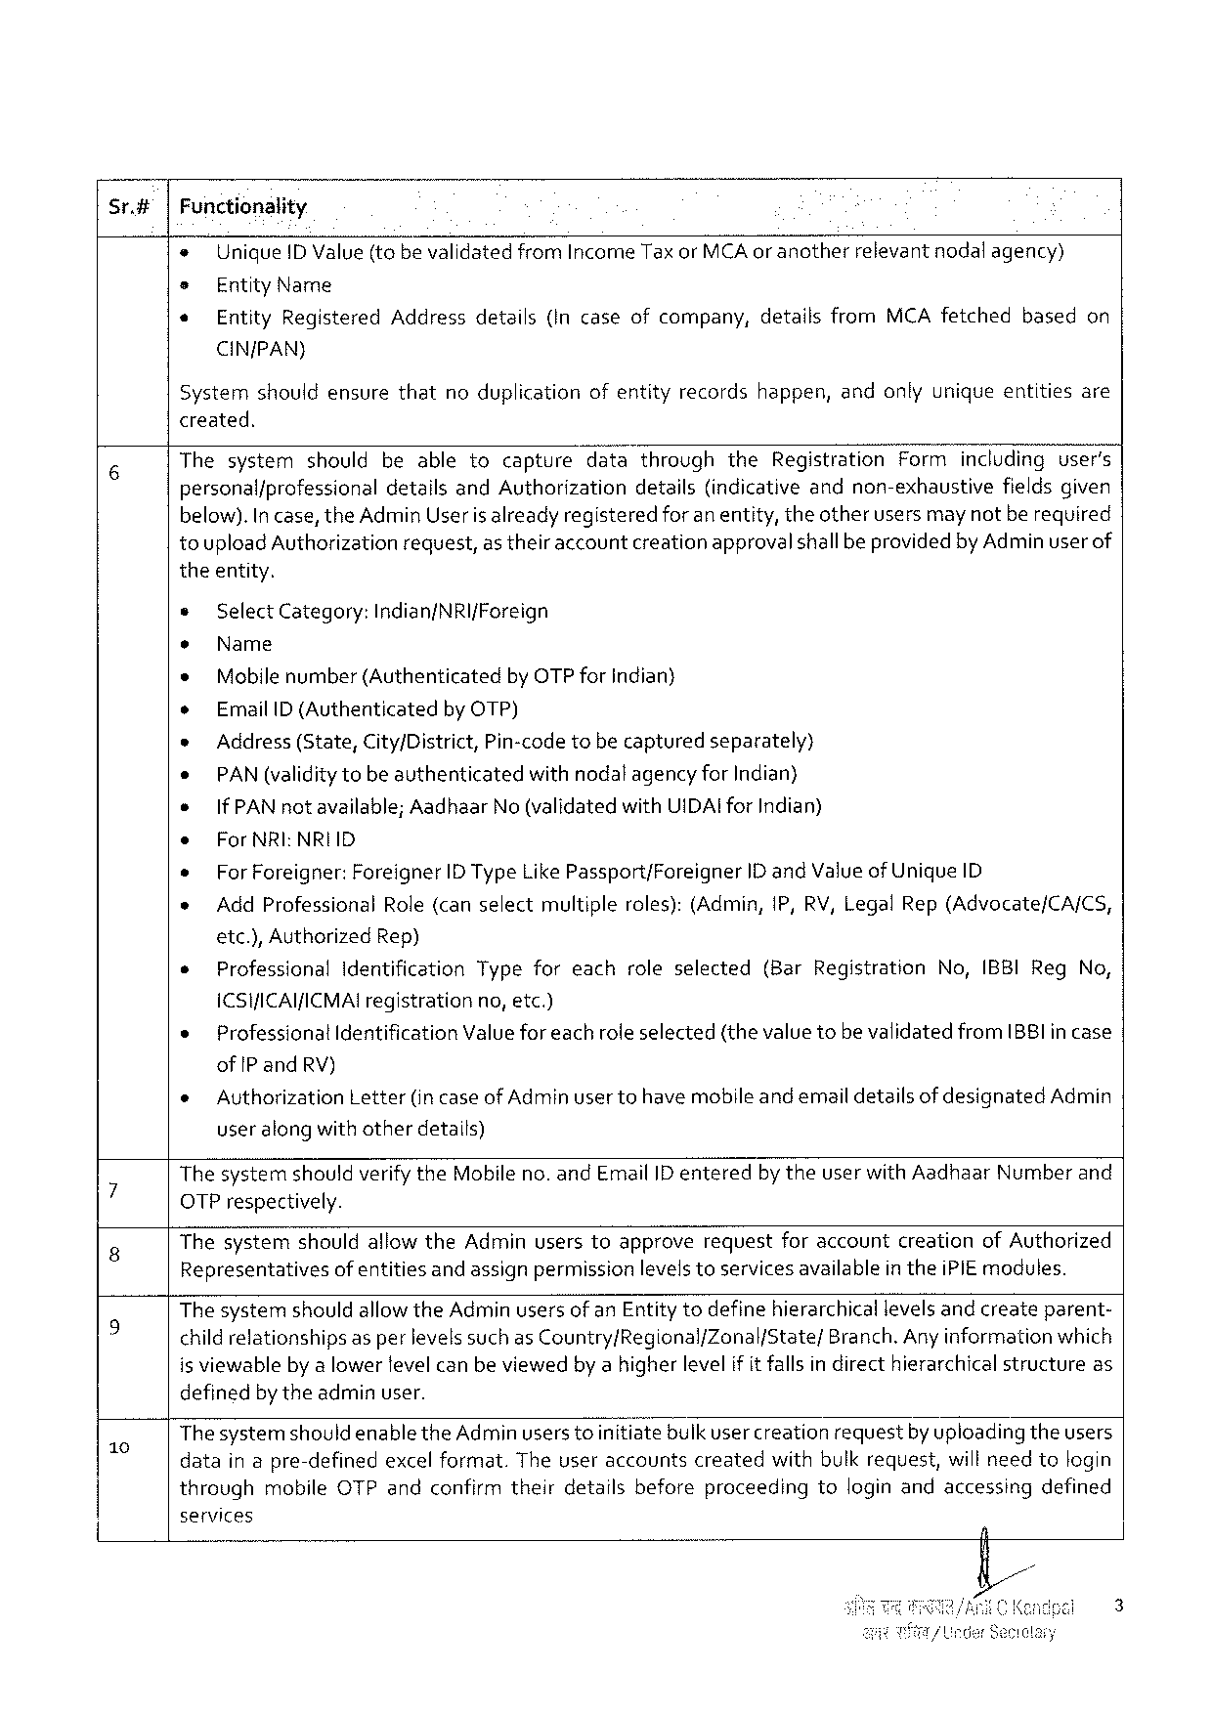

Sr.#|Functionality

e UniqueID Value(tobevalidatedfromIncomeTaxorMCAoranother relevantnodalagency)

= EntityName

« EntityRegisteredAddressdetails{Incaseofcompany,detailsfromMCA fetchedbasedon

CIN/PAN)

Systemshouldensurethatnoduplicationofentityrecordshappen,andonlyuniqueentitiesare

created.

|  |  |  |
| --- | --- | --- |
| 6 | Thesystemshouldbeabletocapture | datathroughtheRegistrationFormincludinguser’s |
| personal/professionaldetailsandAuthorizationdetails(indicativeandnon-exhaustivefieldsgiven | |

below).In case, theAdminUseris alreadyregisteredforanentity, theotherusersmaynotbe required

toupload Authorizationrequest,as theiraccountcreationapprovalshallbe providedby Adminuser of

theentity.

» Select Category:Indian/NRI{Foreign

¢ Name

* Mobilenumber(Authenticated by OTPforindian}

o EmailID (Authenticated by OTP)

s Address (State,City/District,Pin-code tobecapturedseparately)

e PAN (validitytobeauthenticatedwithnodalagency for Indian}

e IfPAN notavailable;Aadhaar No (validated withUIDAIforIndian)

e ForNRI:NRIID

* ForForeigner:Foreigner ID TypeLike Passport/Foreigner ID andValueof UniqueID

» AddProfessional Role(canselectmultiple roles):(Admin,1P, RV, LegalRep(Advocate/CA/CS,

etc.),Authorized Rep)

e ProfessionalIdentificationTypeforeachroleselected(BarRegistrationNo,IBBIRegNo,

ICSHICAI/ICMAIregistration no,etc.)

o Professional Identification Valueforeachroleselected(thevaluetobe validatedfromIB8Iincase

ofIP andRV)

|  |  |  |  |
| --- | --- | --- | --- |
| e | Authorization | Letter(in caseofAdminusertohavemobileandemaildetailsof designated | Admin |

useralong withotherdetails)

; ThesystemshouldverifytheMobileno. andEmailID enteredby theuserwithAadhaarNumberand

OTPrespectively.

8 ThesystemshouldallowtheAdminuserstoapproverequestforaccountcreationofAuthorized

Representativesof entitiesand assignpermissionlevelstoservicesavailable in theiPIEmodules.

The systemshouldallowtheAdminusersof anEntitytodefinehierarchical levelsandcreateparent-

|  |  |
| --- | --- |
| kS | childrelationshipsas perlevelssuch as Country/Regional/Zonal/State/Branch.Any information which is viewableby a lower fevelcan beviewedbya higherlevelif it fallsin directhierarchical structureas |

definedbytheadminuser.

- Thesystemshouldenablethe Adminusers toinitiatebulk usercreationrequestbyuploading theusers

datain apre-definedexcel format.Theuseraccountscreatedwithbulkrequest,willneedtologin

throughmobileOTPandconfirmtheirdetailsbeforeproceedingtologinandaccessingdefined

services

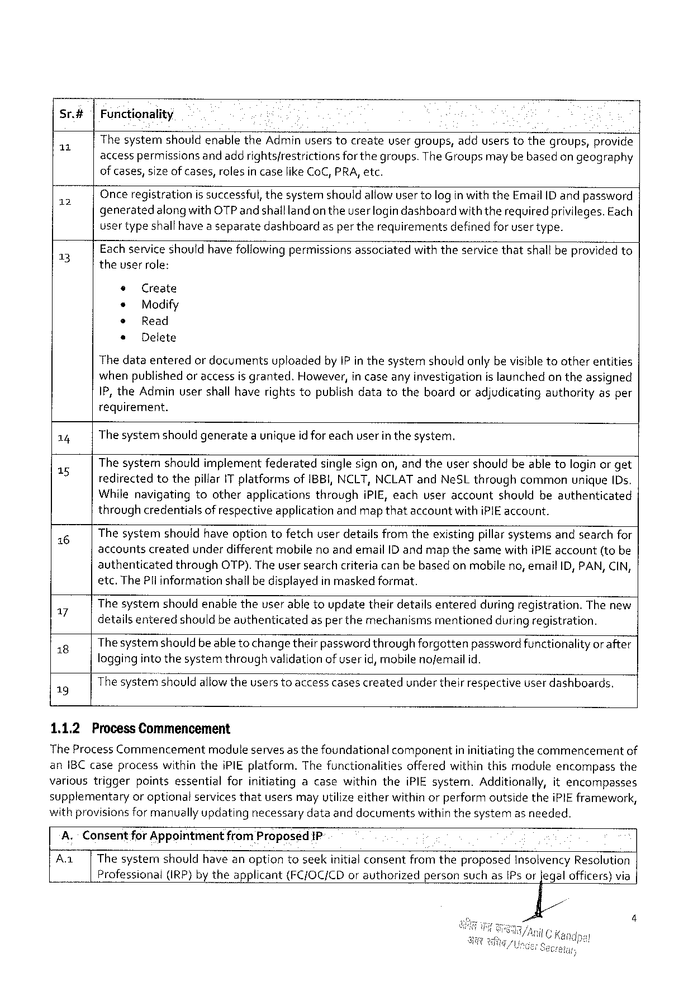

|  |  |  |  |
| --- | --- | --- | --- |
| Sr.#  L | Functionality  ThesystemshouldenabletheAdminuserstocreateusergroups,adduserstothegroups,provide | | |
| accesspermissions | andaddrightsfrestrictions | forthegroups.TheGroupsmaybebasedongeography |

ofcases,sizeofcases,rolesincaselikeCoC,PRA,etc.

|  |  |  |
| --- | --- | --- |
| 12  3] | Onceregistrationissuccessful,thesystemshould allowuser tologinwiththeEmailID andpassword generatedalong withOTP andshalllandon theuser logindashboardwith therequiredprivileges.Each usertypeshallhave a separatedashboardasper therequirementsdefinedforusertype.  Eachservice shouldhave following permissionsassociatedwiththeservice thatshall beprovidedto theuser role: | |
| ¢ | Create |
| * | Modify |
| ® | Read |
| s | Delete |

Thedataenteredor documentsuploadedby IPin thesystemshouldonlybe visibletootherentities whenpublished oraccessis granted.However,in caseany investigationis launchedon theassigned IP,theAdminusershall haverightstopublishdatatotheboardoradjudicatingauthorityasper requirement.

|  |  |  |  |
| --- | --- | --- | --- |
| 14  15  16  17  18  19  1.1.2 | The systemshould generatea uniqueid for eachuser in thesystem.  Thesystemshouldimplementfederatedsinglesignon,and theusershouldbeabletologinor get redirectedtothepillar1T platformsofIBBI,NCLT,NCLATandNeSLthroughcommonunique[Ds. WhilenavigatingtootherapplicationsthroughiPIE,eachuseraccountshouldbeauthenticated throughcredentialsof respectiveapplication andmap thataccountwithiPIE account.  Thesystemshouldhaveoptiontofetchuserdetailsfromtheexistingpillarsystemsandsearchfor accountscreatedunderdifferentmobileno andemailID andmapthesamewithiPIEaccount(tobe | | |
| authenticated | through | OTP).Theusersearchcriteriacanbebasedonmobileno,emailID,PAN,CIN, |
| etc.The Plinformationshallbedisplayedin maskedformat.  Thesystemshouldenabletheuser abletoupdatetheirdetailsenteredduring registration.The new detailsenteredshouldbe authenticatedasperthe mechanismsmentionedduring registration. Thesystemshouldbeable tochangetheirpassword throughforgottenpasswordfunctionalityor after loggingintothesystemthroughvalidationof user id,mobilenofemail id.  Thesystemshouldaliowtheusers toaccesscasescreatedunderthelir respectiveuser dashboards.  Process Commencement | | |

TheProcessCommencementmodule servesas thefoundationalcomponentin initiatingthecommencementof anIBC caseprocesswithintheiPIEplatform.Thefunctionalitiesofferedwithinthismoduleencompassthe varioustriggerpointsessentialforinitiatingacasewithintheiPIEsystem.Additionally,itencompasses supplementaryoroptionalservices thatusersmayutilizeeitherwithin orperformoutsidetheiPIEframework,

|  |  |  |  |
| --- | --- | --- | --- |
| withprovisionsformanuallyupdating | necessary | dataanddocuments | withinthesystemasneeded. |

A.- Consentfor AppointmentfromProposed1P

Aa ThesystemshouldhaveanoptiontoseekinitialconsentfromtheproposedInsolvency Resolution Professional (IRP) by theapplicant (FC/OC/CDorauthorized personsuchasIPsorJegalofficers)via

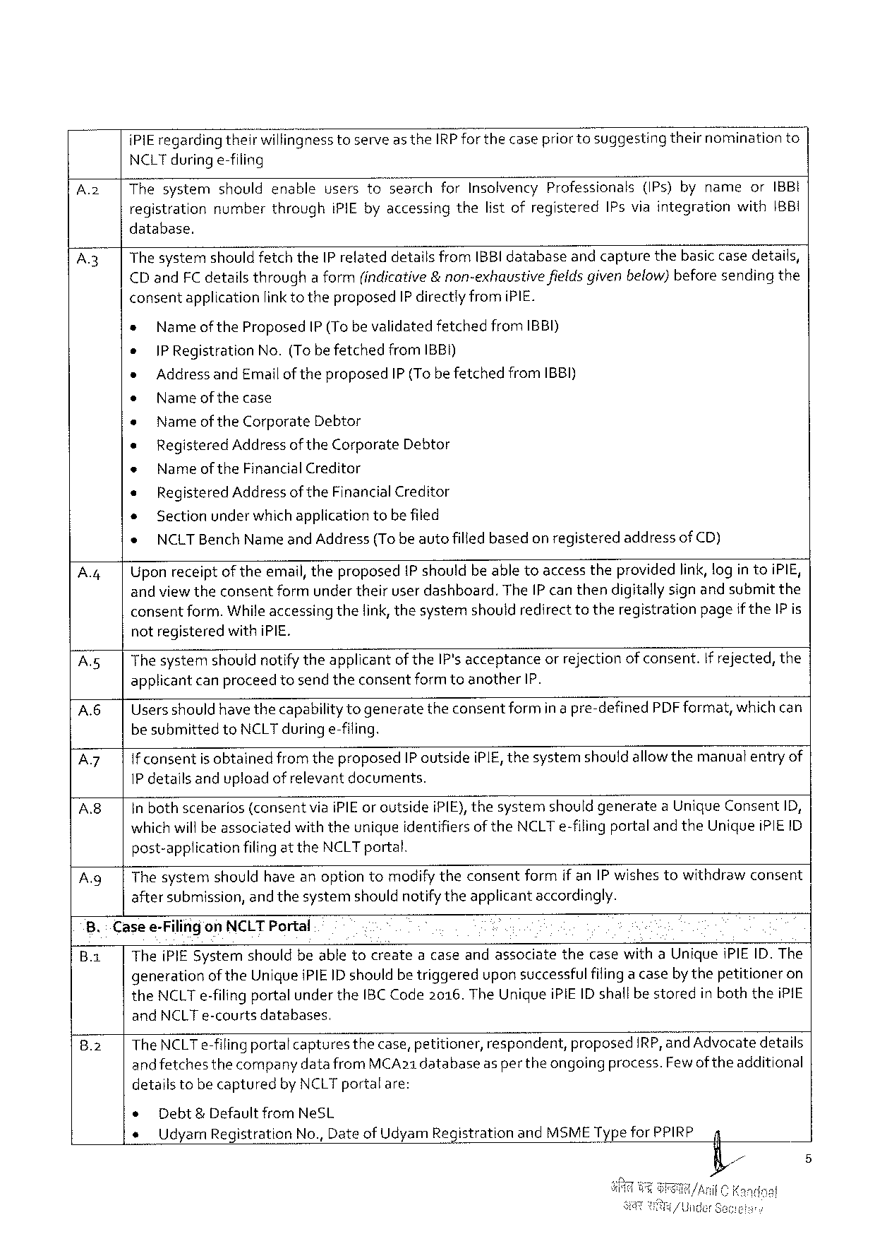

|  |  |  |
| --- | --- | --- |
| iPIEregardingtheirWi\iinanesstoserveas theIRPforthecasepriorto suggesting | theirnomination | to |

NCLTduringe-filing

|  |  |  |  |  |  |  |  |  |
| --- | --- | --- | --- | --- | --- | --- | --- | --- |
| A2 | | | Thesystemshouldenableusersto“searchforInsolvencyProfessionals(IPs)bynameorIBBI | | | | | | |
| registration | number | through | IPIE byaccessing | thelistofregistered | IPsviaintegration | with1BBI |

database.

|  |  |  |  |  |  |  |  |  |
| --- | --- | --- | --- | --- | --- | --- | --- | --- |
| A3  A.4| | The systemshould fetchtheIP relateddetailsfromIBBI databaseandcapturethebasic casedetails, | | | | | | | |
| CD andFCdetailsthrougha form(indicative&non-exhaustive | | | | | | fieldsgivenbelow)beforesendingthe | |
| consentapplicationlinkto theproposedIP directlyfromiPIE. | | | | | | | |
| » | NameoftheProposed | | | IP (TobevalidatedfetchedfromIBBI) | | | |
| e | |PRegistration | | No.(Tobe fetched | | from1BBI) | | |
| » | | Address andEmailoftheproposedIP (TobefetchedfromIBBI) | | | | | |
| o | | Name ofthecase | | | | | |
| e | Nameof theCorporateDebtor | | | | | | |
| « | | RegisteredAddress of theCorporateDebtor | | | | | |
| « | | Name of theFinancialCreditor | | | | | |
| * | | RegisteredAddress of theFinancialCreditor | | | | | |
| « | | Sectionunder whichapplication tobefiled | | | | | |
| e | NCLTBenchNameandAddress(Tobeautofilledbasedonregistered | | | | | | addressofCD) |
| Uponreceiptoftheemail,theproposed1Pshouldbeabletoaccesstheprovidedlink,log in toiPIE, andviewtheconsentformunder theiruserdashboard.TheIP canthendigitallysignand submitthe consentform.Whileaccessingthelink, thesystemshouldredirecttotheregistrationpageiftheIP is | | | | | | | |

notregisteredwith iPIE.

|  |  |
| --- | --- |
| Asg  A6 | The systemshouldnotifytheapplicantof theIP'sacceptanceorrejectionof consent.If rejected,the applicantcanproceedtosendtheconsentformtoanotherIP.  Usersshould have thecapabilityto generatetheconsentformin a pre-definedPDF format,whichcan |

be submittedtoNCLTduring e-filing.

Az If consentis obtainedfromtheproposedIP outsideiPIE,thesystemshouldallowthemanuatentryof

1P detailsandupload of relevantdocuments.

|  |  |
| --- | --- |
| A8 | In bothscenarios(consentviaiPIEor outsideiPIE),thesystemshouldgenerateaUniqueConsentID, whichwill beassociatedwith theuniqueidentifiersof theNCLTe-filingportaland theUniqueiPIEID |

post-applicationfilingat theNCLTportal.

A.g| The systemshouldhave anoptiontomodify theconsentformif anIP wishestowithdrawconsent

aftersubmission,and thesystemshouldnotifytheapplicantaccordingly.

8.: Casee-FilingonNCLT Portal 5

B.1 TheiPIE Systemshouldbeabletocreatea caseandassociatethecasewithaUniqueiPIEID. The

generationof theUniqueiPIEID shouldbetriggeredupon successfulfilinga caseby thepetitioneron

theNCLTe-filingportalunder theIBC Code2016.TheUnique iPIEID shallbe storedin boththeiPIE

andNCLTe-courtsdatabases,

|  |  |  |  |  |  |  |
| --- | --- | --- | --- | --- | --- | --- |
| 8.2 | TheNCLTe-filingportalcapturesthecase,petitioner, | | | respondent, | proposed | IRP,andAdvocatedetails |
| andfetches | thecompanydatafrom | MCA21databaseaspertheongoingprocess.Fewof theadditional | | | |

detailstobecapturedbyNCLTportalare:

|  |  |  |
| --- | --- | --- |
| e | Debt&DefaultfromNeSL | 4 |
| « | UdyamRegistrationNo.,Date of UdyamRegistration andMSMETypefor PPIRP |

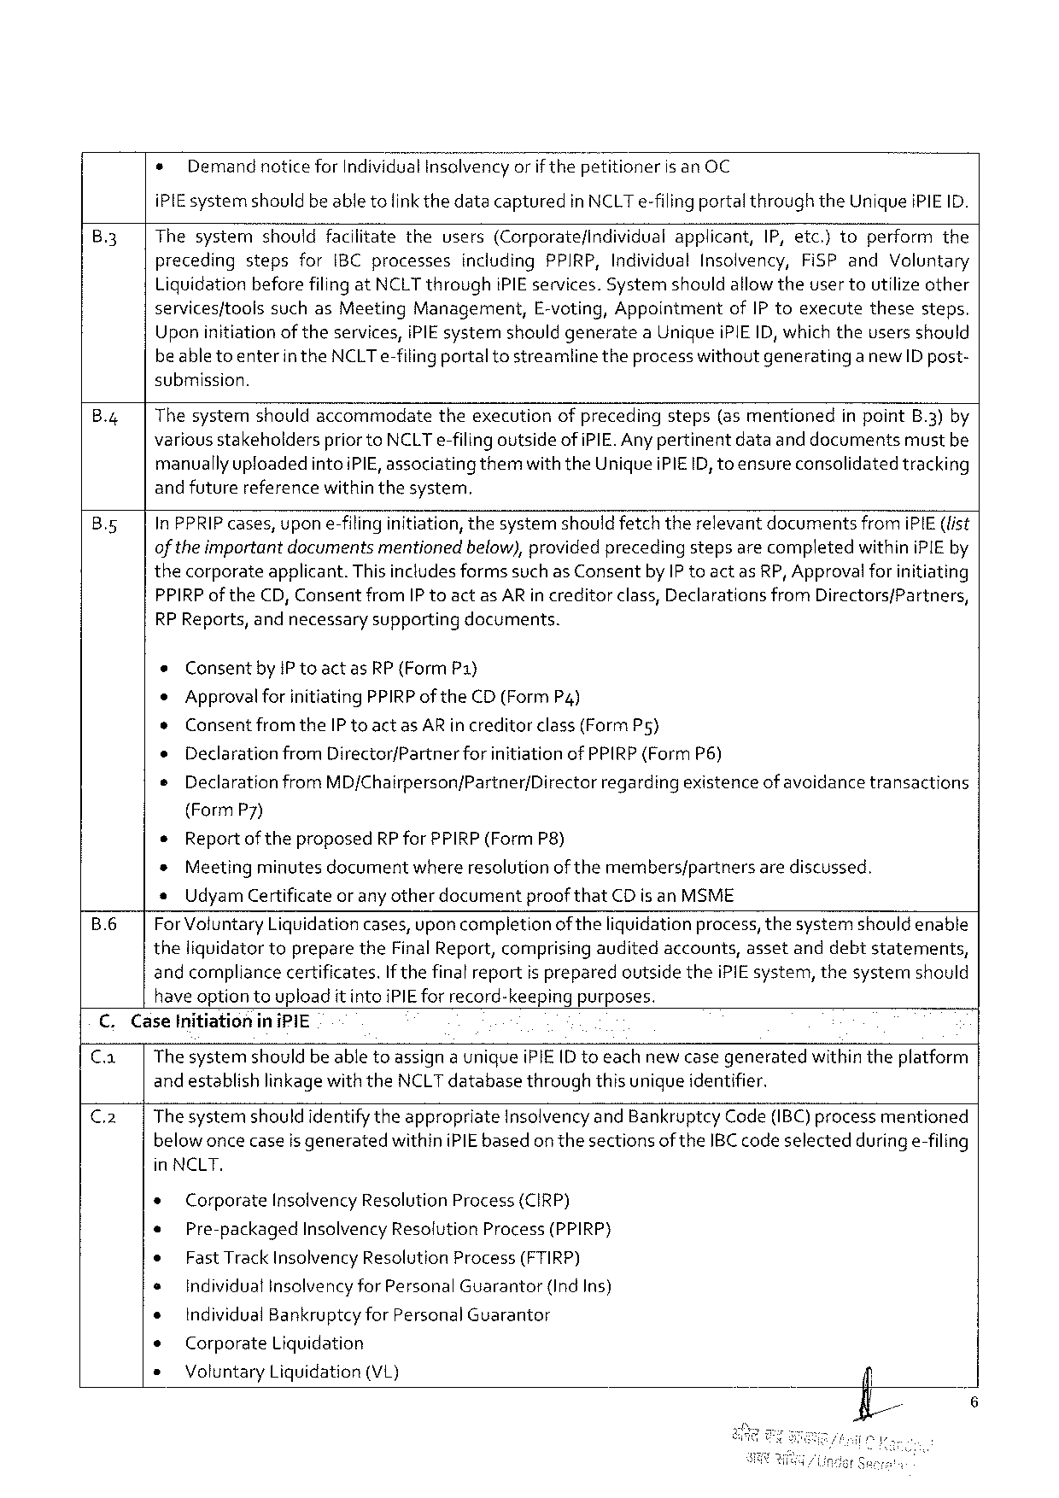

* Demandnotice forIndividualInsclvencyorif thepetitioneris anOC

iPIE systemshould beable tolinkthedatacapturedinNCLTe-filingportalthroughtheUniqueiPIEID.

|  |  |  |  |  |  |  |  |  |  |  |  |  |  |  |  |
| --- | --- | --- | --- | --- | --- | --- | --- | --- | --- | --- | --- | --- | --- | --- | --- |
| B3 | Thesystem | should | | facilitate | the | users | (Corporatefindividual | | applicant, | | IP,etc.)to | | perform | | the |
| preceding | steps | for | IBCprocesses | | including | | PPIRP,Individual | | Insolvency, | | FiSPand | | Voluntary | |

Liquidation beforefilingatNCLTthroughiPIEservices. Systemshouldallowtheuser toutilize other

|  |  |  |  |  |  |  |
| --- | --- | --- | --- | --- | --- | --- |
| servicesftools | suchasMeeting | Management, | E-voting,Appointment | ofIPtoexecute | these | steps. |

Upon initiationof theservices,iPIEsystemshouldgenerateaUniqueiPIEID, which theusersshould

beabletoenterin the NCLTe-filingportaltostreamlinetheprocess withoutgeneratinga new ID post-

submission.

B.4 Thesystemshouldaccommodatetheexecutionofprecedingsteps(as mentionedin pointB.3)by

various stakeholderspriortoNCLTe-filingoutside ofiPIE. Anypertinentdataanddocumentsmustbe

manuallyupfoadedintoiPIE, associatingthemwiththeUniqueiPIEID,toensureconsolidated tracking

andfuturereferencewithinthesystem,

|  |  |  |
| --- | --- | --- |
| Bs5 | In PPRIP cases,upon e-filinginitiation,thesystemshould fetchtherelevantdocumentsfromiPIE(fist ofthe importantdocumentsmentionedbelow),provided precedingstepsarecompletedwithiniPIEby | |
| thecorporate | applicant.ThisincludesformssuchasConsentbyIP toactasRP, Approvalforinitiating |

PPIRPof theCD, ConsentfromIP toact asARin creditorclass, DeclarationsfromDirectors/Partners,

RP Reports,andnecessary supporting documents.

e Consent byIP toactasRP (Form P1)

* ApprovalforinitiatingPPIRP oftheCD(FormP4)

* ConsentfromtheIP toactasAR increditorclass(FormPs)

o DeclarationfromDirector/Partner forinitiationofPPIRP(FormP6)

e Declaration fromMD/Chairperson/Partner/Directorregardingexistenceofavoidancetransactions

(FormP7)

* Reportof theproposedRP for PPIRP(FormP8)

* Meetingminutesdocumentwhereresolutionof themembers/partnersarediscussed.

* UdyamCertificateor anyotherdocumentproof thatCDis anMSME

B.6 ForVoluntaryLiquidationcases,uponcompletion of theliquidationprocess,thesystemshouldenable

theliquidator topreparetheFinalReport,comprisingauditedaccounts,assetanddebtstatements,

andcompliancecertificates.If thefinal reportis preparedoutsidetheiPIEsystem,thesystermn should

have optiontouploadit intoiPIEfor record-keepingpurposes.

C.CaseInitiationin iPIE

Ca Thesystemshouldbe abletoassigna uniqueiPIE(D toeachnewcasegeneratedwithintheplatform

and establishlinkagewiththeNCLTdatabasethroughthis uniqueidentifier.

C2 Thesystemshouldidentifythe appropriateInsolvencyandBankruptcy Code(IBC) processmentioned

belowoncecaseis generatedwithiniPIE basedon thesectionsof theIBC code selectedduringe-filing

in NCLT.

|  |  |  |  |  |  |
| --- | --- | --- | --- | --- | --- |
| * | Corporate | InsolvencyResolutionProcess(CIRP) | | | /fl/ |
| * | Pre-packaged | | InsolvencyResolutionProcess(PPIRP) | |
| * | FastTrackInsolvencyResolutionProcess(FTIRP) | | | |
| s | IndividualinsolvencyforPersonalGuarantor | | | (IndIns) |
| e | IndividualBankruptcyforPersonal Guarantor | | | |
| e | Corporate | Liquidation | | |
| * | VoluntaryLiquidation(VL) | | | |

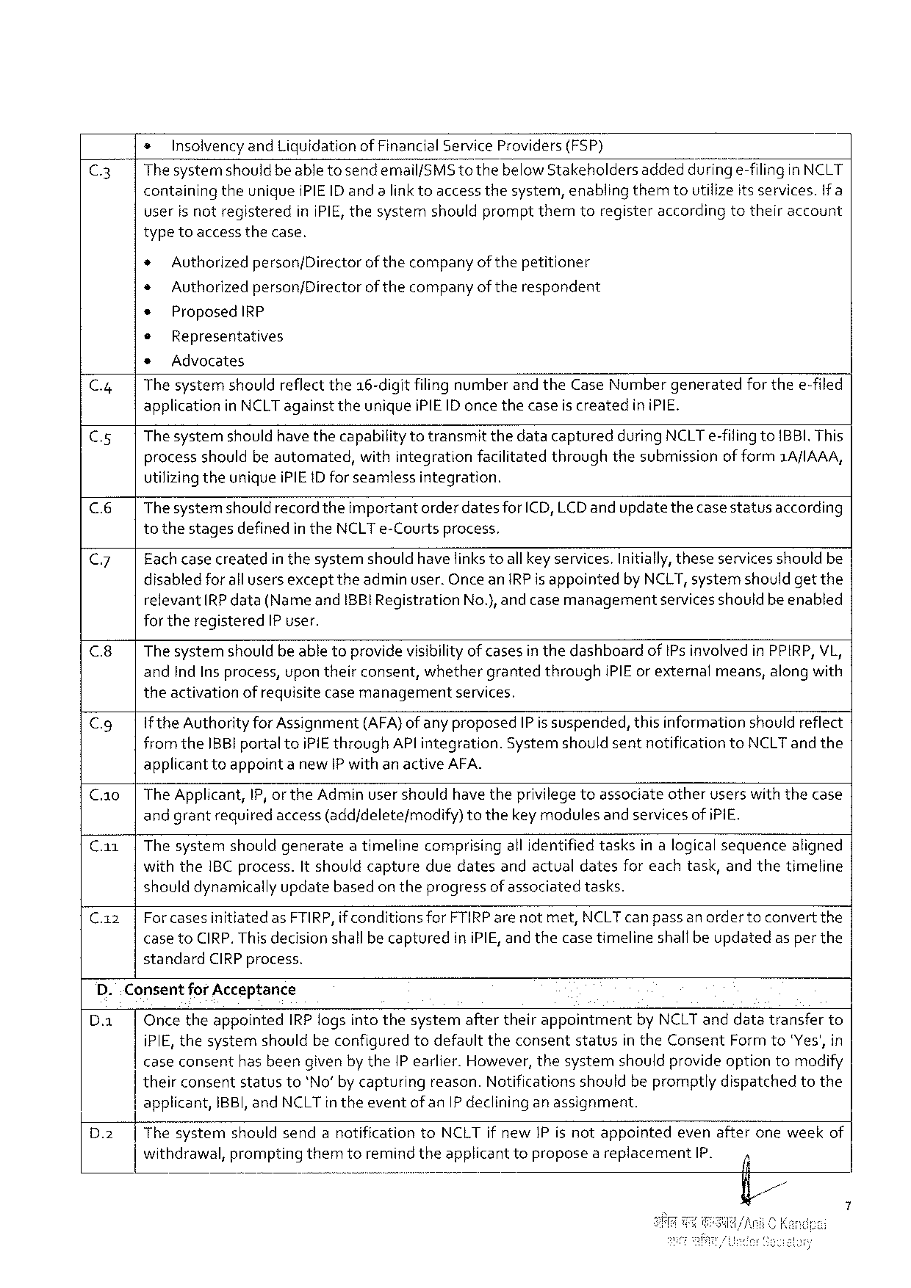

s InsolvencyandLiquidationof FinancialServiceProviders(FSP)

C3 Thesystemshould beabletosendemail/SMStothebelowStakeholdersaddeddun’r@e-filinginNCLT containing theuniqueiPIEID andalinktoaccessthesystem,enablingthemtoutilizeits services. if a

userisnotregistered inIPIE,thesystemshouldpromptthemtoregisteraccording totheiraccount

typetoaccess thecase.

* Authorizedperson/Directorof thecompanyof thepetitioner

* Authorizedperson/Directorof thecompanyoftherespondent

* ProposedIRP

© Representatives

* Advocates

C.4| Thesystemshouldreflectthe16-digitfilingnumberand theCaseNumbergeneratedfor thee-filed applicationinNCLTagainsttheuniqueiPIEID once thecaseis createdin iPIE.

C5 Thesystemshould have thecapabilitytotransmitthedatacapturedduring NCLTe-filingtoBBI.This processshouldbeautomated,withintegrationfacilitatedthroughthesubmissionof form1A/IAAA, utilizingtheuniqueiPIEID forseamless integration.

(& Thesystemshould recordtheimportantorder datesforICD,LCD and updatethecasestatusaccording tothestagesdefinedintheNCLTe-Courtsprocess,

C7 Fachcase createdin thesystemshould havefinks toallkey services.Initially,theseservicesshouldbe disabledforall usersexcepttheadminuser. OnceanIRPis appointedbyNCLT,systemshould getthe relevantRPdata(NameandIBBIRegistrationNo.),andcase managementservicesshouldbeenabled fortheregisteredIP user.

C.8| The systemshouldbe abletoprovidevisibilityof casesin thedashboardofIPs involvedinPPIRP,VL, andIndIns process,upon theirconsent,whethergrantedthroughIPIEor externalmeans,along with theactivationofrequisitecasemanagement services,

Cg If theAuthorityforAssignment(AFA)ofany proposedIPis suspended,thisinformationshouldreflect fromtheIBBI portaltoiPIE throughAPlintegration.Systemshould sentnotificationtoNCLTand the applicanttoappointa new IP withanactive AFA.

C.a0|The Applicant,IP, orthe Adminusershouldhave theprivilegetoassociateotheruserswiththecase andgrantrequiredaccess(add/deletefmodify)tothekeymodulesand services of iPIE.

Ca1|Thesystemshouldgenerateatimelinecomprisingall identifiedtasksinalogicalsequencealigned withtheIBC process.It shouldcaptureduedatesandactualdatesfor eachtask,andthetimeline shoulddynamically updatebasedon theprogressof associatedtasks.

C.az| ForcasesinitiatedasFTIRP,if conditionsforFTIRParenotmet,NCLTcan passanordertoconvert the case toCIRP.This decisionshallbe capturediniPIE,and thecase timelineshallbeupdatedas per the standardCIRPprocess.

D..ConsentforAcceptance

D.a| OncetheappointedIRP logsinto thesystemaftertheirappointmentbyNCLTanddatatransferto iPIE, thesystemshouldbeconfigured todefaulttheconsent status in theConsent Formto"Yes',in caseconsenthasbeengiven bytheIP earlier.However,thesystemshouldprovideoptiontomodify theirconsentstatusto*No’ bycapturingreason.Notificationsshouldbepromptlydispatchedtothe

|  |  |  |
| --- | --- | --- |
| D.2 | applicant, | IBBI, andNCLTintheeventofan IP declininganassignment. |
| Thesystem withdrawal, | shouldsendanotification toNCLTif newIPisnotappointed evenafteroneweekof  prompting themtoremindtheapplicant remnd! toproposeareplacement IP. i |

S

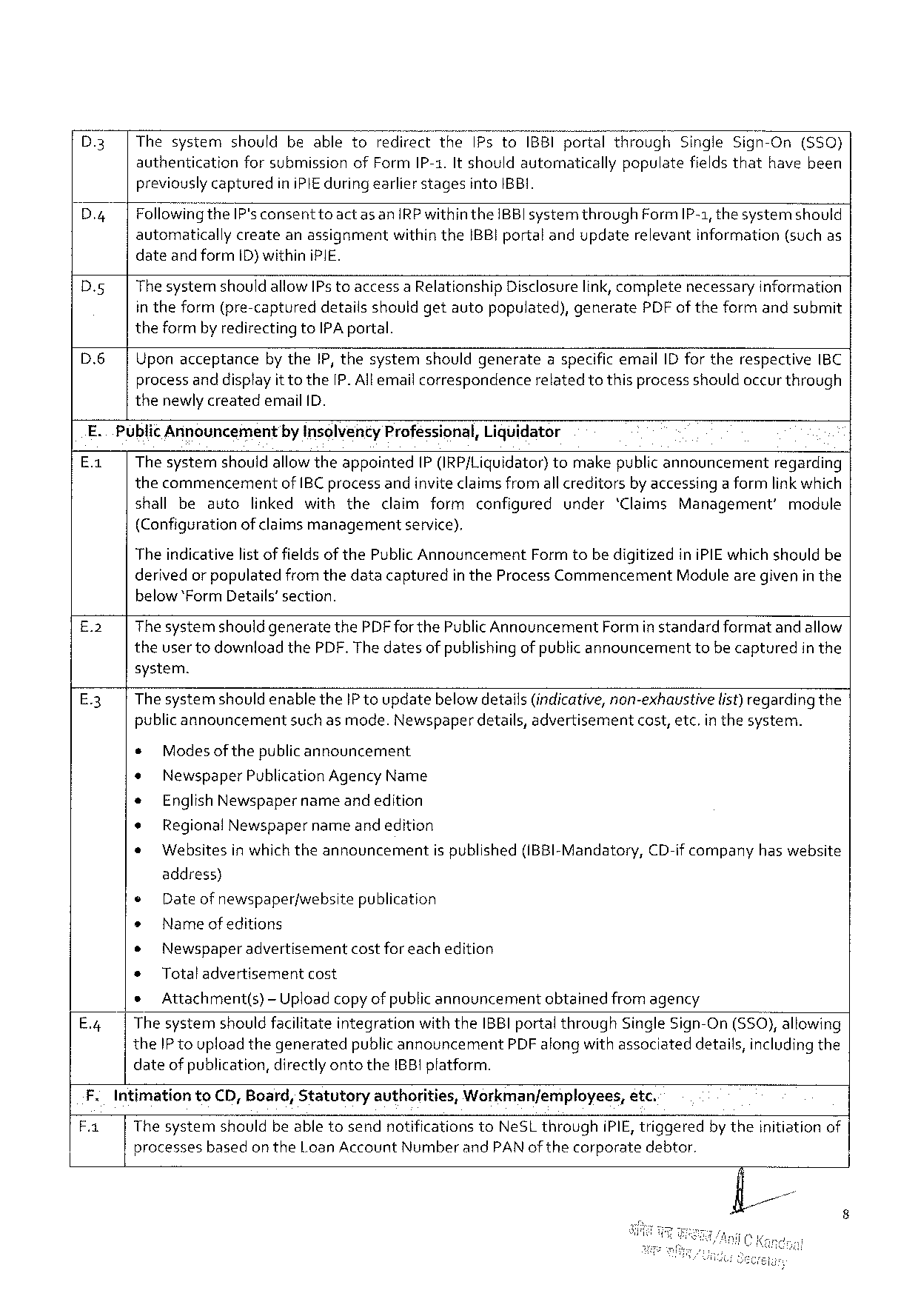

|  |  |  |
| --- | --- | --- |
| D.3 | |ThesystemshouldbeabletoredirecttheIPstoIBBIportalthrough | SingleSign-On(S50) |

authenticationforsubmissionofFormIP-1.It shouldautomaticallypopulatefieldsthathavebeen previouslycapturediniPIE during earlier stagesintoIBBI.

D.g Followin‘&theIP'sconsenttoact as anIRPwithintheIBBIsystemthroughFormIP-1, thesystemshould automaticallycreateanassignmentwithintheIBB}portalandupdaterelevantinformation(suchas dateandformID) withiniPIE.

|  |  |  |  |  |
| --- | --- | --- | --- | --- |
| D.g | ThesystemshouldallowIPs toaccessaRelationship | Disclosurelink,complete | necessary | information |

in theform(pre-captureddetailsshouldgetautopopulated),generatePDFof theformandsubmit theformby redirectingtoIPAportal.

D.6| Uponacceptanceby theIP,thesystemshouldgenerateaspecificemailIDfortherespectiveIBC

processanddisplayittothe[P.Allemailcorrespondence thenewlycreatedemail ID.

relatedtothisprocessshouldoccurthrough

|  |  |  |  |
| --- | --- | --- | --- |
| E.. | PublicAnnouncement | by InsolventyProfessional,Liquidator | regarding |
| E-: | The systemshouldallowtheappointedIP(IRP/Liquidator)tomakepublicannouncement | |

thecommencementofIBC processandinviteclaimsfromall creditorsby accessinga formlink which

|  |  |  |  |  |  |  |
| --- | --- | --- | --- | --- | --- | --- |
| shallbeauto | linkedwiththe | claimformconfigured | | under | ‘ClaimsManagement’ | module |
| (Configuration | of claimsmanagement | | service), |

The indicativelist of fields of thePublicAnnouncementFormtobe digitizediniPIEwhich shouldbe

derivedor populatedfromthedatacapturedin theProcessCommencementModulearegivenin the

below*Form Details’section.

|  |  |  |
| --- | --- | --- |
| E.2 | | | ThesystemshouldgeneratethePDF forthePublicAnnouncementFormin standardformatand allow |

theuser todownloadthePDF. The datesof publishing of publicannouncementtobecapturedin the

system.

E3 ThesystemshouldenabletheIP toupdatebelow details(indicative,non-exhaustive list)regardingthe

publicannouncementsuch as mode.Newspaperdetails,advertisementcost,etc.inthesystem.

|  |  |  |  |  |  |  |
| --- | --- | --- | --- | --- | --- | --- |
| s | Modesofthepublicannouncement | | is published | (IBBI-Mandatory, | CD-if company | haswebsite |
| * | NewspaperPublicationAgencyName | |
| * | EnglishNewspaper | nameandedition |
| * | RegionalNewspapername andedition | |
| * | Websitesinwhichtheannouncement | |

address)

© Dateofnewspaperfwebsite publication

* Name ofeditions

o Newspaper advertisement costforeachedition

* Totaladvertisementcost

s Attachment(s)-Uploadcopyof publicannouncementobtainedfrom agency

E.4 ThesystemshouldfacilitateintegrationwiththeIBBIportalthroughSingle Sign-On (SSO),allowing

theIP toupload thegeneratedpublicannouncementPDF alongwith associateddetails,includingthe

dateof publication,directlyontotheIBB1pfatform.

|  |  |  |  |  |  |  |
| --- | --- | --- | --- | --- | --- | --- |
| F. | IntimationtoCD,Board,Statutoryauthorities, | | Workman/employees, | | etc. | bytheinitiationof |
| B |
| Thesystemshouldbeabletosendnotifications | | toNeSLthrough | iPIE, triggered | |
| processes | basedon theLoanAccountNumberandPAN of thecorporate | | | debtor. |

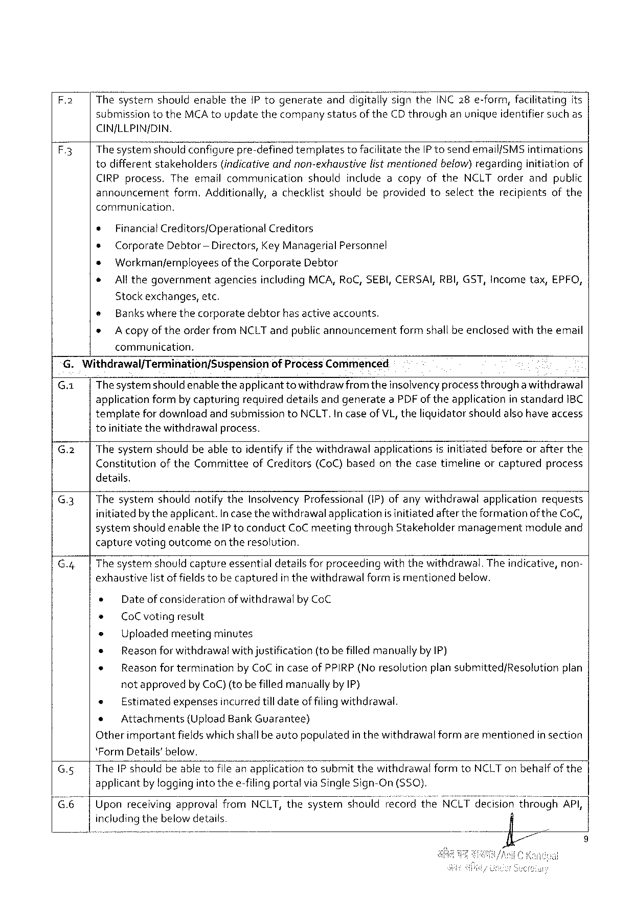

F.2 ThesystemshouldenabletheIPtogenerateandd‘\gitaliy‘signtheINC28 e-form,facilitatingits

submissiontotheMCAtoupdatethecompanystatusof theCDthroughanunique identifiersuchas

CIN/LLPIN/DIN.

A3 Thesystemshouldconfigurepre-definedtemplatestofacilitatetheIP tosendemail{SMSintimations

todifferent stakeholders (indicativeandnon-exhaustive listmentionedbelow)regarding initiation of

CIRP process.TheemailcommunicationshouldincludeacopyoftheNCLTorderandpublic

announcement form.Additionally,achecklistshouldbeprovidedtoselecttherecipientsofthe

communication.

* Financial Creditors/Operational Creditors

¢ Corporate Debtor — Directors,KeyManagerialPersonnel

» Workmanfemnployeesof theCorporateDebtor

* All thegovernment agencies includingMCA,RoC,SEBI,CERSAI,RBI,GST,Incometax,EPFO,

Stockexchanges,etc.

® Bankswhere thecorporatedebtorhasactive accounts.

* A copyof theorderfromNCLTandpublicannouncementformshallbeenclosedwiththeemail

communication,

G.Withdrawal/Termination/Suspension of ProcessCommenced

G.1| Thesystemshould enabletheapplicantto withdrawfromtheinsolvencyprocess througha withdrawal

applicationformbycapturingrequireddetailsandgenerateaPDF oftheapplicationin standard1BC

templatefordownloadand submissiontoNCLT. Incase ofVL, theliguidator should alsohave access

toinitiate thewithdrawalprocess.

G.2| Thesystemshouldbeabletoidentifyif thewithdrawalapplicationsisinitiatedbeforeorafterthe

Constitution oftheCommittee ofCreditors (CoC)based onthecasetimeline orcaptured process

details.

G.3| ThesystemshouldnotifytheInsolvencyProfessional(iP) ofanywithdrawalapplicationrequests

initiatedby theapplicant.Incasethewithdrawalapplicationis initiatedafter theformationof theCoC,

systemshouldenabletheIP toconductCoCmeetingthroughStakeholdermanagementmoduleand

capturevotingoutcome on theresolution.

G.4| The systemshouldcaptureessentialdetailsforproceedingwith thewithdrawal.Theindicative, non-

exhaustivelist of fieldstobecapturedin thewithdrawalformis mentionedbelow.

e Dateof considerationof withdrawalbyCoC

+ CoCvotingresult

* Uploadedmeetingminutes

* Reasonforwithdrawalwithjustification(to befilledmanuallyby IP)

e Reason for terminationby CoCin caseofPPIRP(No resolutionplan submitted/Resolutionplan

notapprovedby CoC) (to befilledmanuallyby IP)

e Estimatedexpensesincurredtill dateof filingwithdrawal.

e Attachments (UploadBankGuarantee)

Otherimportantfieldswhichshallbe autopopulatedin thewithdrawal formarementionedin section

*FormDetails’below.

G.5| TheIP shouldbeabletofileanapplicationtosubmitthewithdrawalformtoNCLTonbehalfof the

applicantby loggingintothee-filingportalvia SingleSign-On (S50).

G6 UponreceivingapprovalfromNCLT,thesystemshouldrecordtheNCLZIZHémslor?throuafii/Klgl,i

includingthebelow details

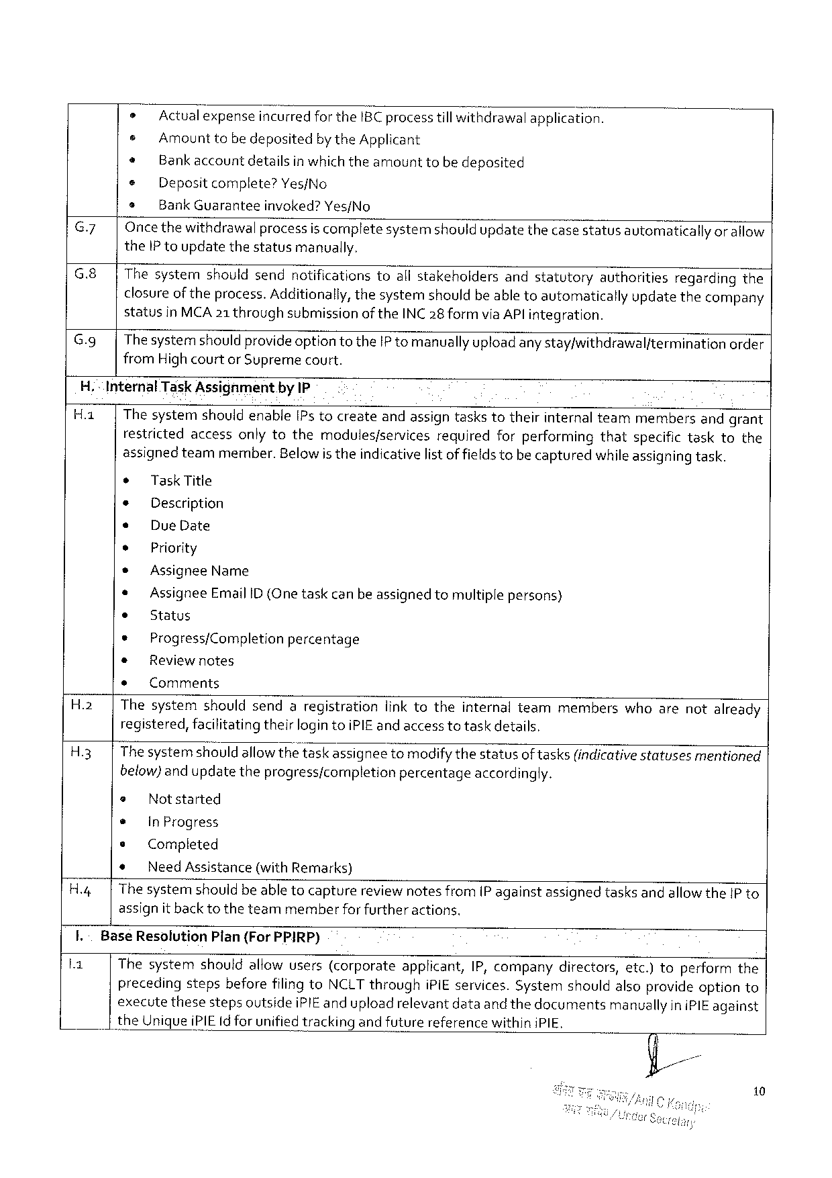

|  |  |  |  |  |  |
| --- | --- | --- | --- | --- | --- |
| G.7  G.8|  G.9| | » | | Actual expenseincurredfortheIBC processtill withdrawalapplication. | | |
| e | AmounttobedepositedbytheApplicant | | | |
| * | Bankaccount | | detailsinwhichtheamount | tobedeposited |
| e | Depositcomplete?Yes/No | | | |
| * | BankGuarantee | | invoked?Yes/No | |
| Oncethewithdrawalprocessis completesystemshouldupdatethecase statusavtomaticallyor allow theIP toupdatethestatusmanually.  Thesystemshouldsendnotificationstoallstakeholdersandstatutoryauthoritiesregardingthe closureoftheprocess.Additionally,thesystemshouldbeable toautomaticallyupdatethecompany statusinMCA21 throughsubmissionoftheINC28 formvia AP! integration.  Thesystemshould provideoptiontotheIP tomanually uploadanystay/withdrawalfterminationorder fromHigh courtor Supremecourt. | | | | |

H.“InternalTaskAssighment.byIP

Ha | Thesystemshouidenable[Ps tocreateandassigntaskstotheirinternalteammembersandgrant restrictedaccessonlytothemodules/servicesrequiredforperformingthatspecifictasktothe assignedteammember.Belowis theindicativelistoffieldstobecapturedwhileassigningtask.

* TaskTitle

* Description

e DueDate

e Priority

* AssigneeName

* AssigneeEmailID (One taskcan beassigned tomultiplepersons)

* Status

¢ Progress/Completionpercentage

® Reviewnotes

* Comments

H.2| Thesystemshouldsendaregistrationlink totheinternalteammemberswhoarenotalready registered,facilitatingtheirlogintoiPIEand access totaskdetails.

H3 Thesystemshould allowthetaskassigneetomodifythestatusoftasks(indicativestatusesmentioned below)and updatetheprogress/completionpercentageaccordingly.

@ Notstarted

* InProgress

s Completed

* NeedAssistance (withRemarks)

H.4| Thesystemshouldbeable tocapturereviewnotesfrom[P againstassignedtasksandallowtheIP to assignit back totheteammemberforfurtheractions.

I.-BaseResolution Plan(ForPPIRP)

Thesystemshouldallowusers(corporateapplicant,IP,companydirectors,etc.)toperformthe precedingstepsbeforefilingtoNCLT throughiPiEservices.Systemshouldalsoprovideoptionto executethesestepsoutsideiPIE anduploadrelevantdataand thedocumentsmanuallyiniPIE against

theUniqueiPIEIdforunifiedtracking andfuturereferencewithiniPIE,

10

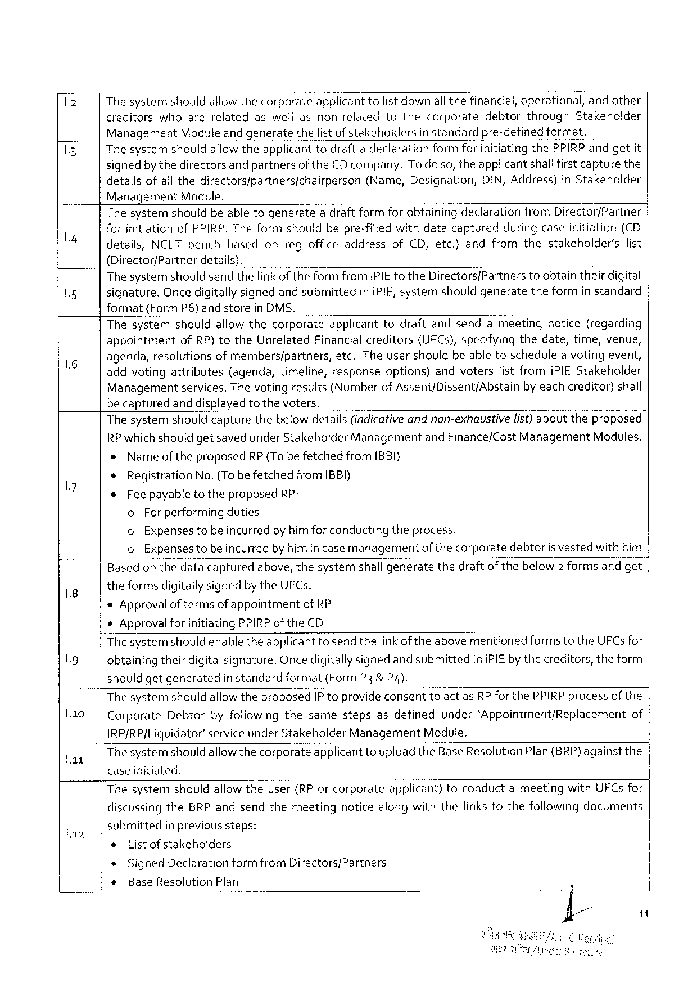

The systemshouldallowthecorporate"a‘ppficant 1o listdownallthefinancial,operational,andother

creditorswhoarerelatedaswellasnon-relatedtothecorporatedebtorthroughStakeholder

ManagementModuleand generatethelistof stakehoidersin standardpre-definedformat.

Thesystem shouldallowtheapplicant todraftadeclaration formforinitiatingthePPIRPandgetit

signedbythedirectorsand partnersof theCDcompany.To do so,theapplicantshallfirstcapturethe

detailsofallthedirectorsfpartnersfchairperson (Name, Designation, DIN,Address)inStakeholder

Management Module.

Thesystemshouldbeabletogenerateadraft formforobtainingdeclarationfromDirector/Partner

forinitiationofPPIRP.The formshouldbepre-filled withdatacapturedduringcaseinitiation(CD

|  |  |  |  |  |  |  |  |
| --- | --- | --- | --- | --- | --- | --- | --- |
| details, | NCLTbench | | based | onregofficeaddress | ofCD,etc.}andfromthe | stakeholder’s | list |
| {DirectorfPartner | | details). | |

The systemshouldsend thelinkof theformfromiPIEtotheDirectors/Partnerstoobtaintheirdigital

signature.OncedigitallysignedandsubmittediniPIE, systemshouldgeneratetheformin standard

format{FormP6)andstoreinDMS.

Thesystemshouldallowthecorporateapplicanttodraftandsendameetingnotice(regarding

appointment ofRP)totheUnrelated Financialcreditors (UFCs),specifyingthedate,time,venue,

agenda,resolutionsofmembers/partners,etc.Theusershouldbeabletoschedulea votingevent,

addvotingattributes (agenda,timeline,responseoptions)andvoterslistfromiPIEStakeholder

Managementservices. The votingresulis(Numberof Assent/Dissent/Abstainby eachcreditor)shall

be capturedand displayedto thevoters.

Thesystemshouldcapturethebelow details(indicativeand non-exhaustivelist}abouttheproposed

RPwhichshouldgetsavedunder StakeholderManagementandFinance/Cost ManagementModules.

« Nameoftheproposed RP{To befetchedfromIBBI}

* Registration No.(Tobe fetchedfromIBBI}

®Fee payableto theproposedRP:

o For performingduties

o Expensestobeincurredby himfor conductingtheprocess.

o Expensestobeincurredby himincase managementof thecorporatedebtoris vestedwithhim

Based on thedatacapturedabove,thesystemshallgeneratethedraftof thebelow2formsandget

theformsdigitallysignedbytheUFCs.

*Approvalof termsof appointmentof RP

*Approvalfor initiatingPPIRPof theCD

Thesystemshouldenabletheapplicanttosend thelink oftheabovementionedforms totheUFCsfor

obtainingtheirdigitalsignature.Oncedigitallysignedand submittediniPIEby thecreditors, theform

should getgenerated in standardformat(FormP3& P4).

The systemshouldallow theproposedIP toprovideconsenttoactasRP forthePPIRPprocessofthe

|  |  |  |
| --- | --- | --- |
| l.1o | CorporateDebtorbyfollowingthesamestepsasdefinedunder‘Appointment/Replacement | of |

IRP/RP/Liquidator’service underStakeholderManagementModule.

|  |  |
| --- | --- |
| a1 | ThesystemshouldallowthecorporateapplicanttouploadtheBaseResolutionPlan(BRP)againstthe caseinitiated. |

Thesystemshouldallow theuser(RPorcorporateapplicant)toconductameetingwithUFCsfor

discussingtheBRP andsendthemeetingnoticealongwiththelinkstothefollowingdocuments

|  |  |  |  |  |
| --- | --- | --- | --- | --- |
| la2 | submitted | | | in previoussteps: |
| s | List ofstakeholders | | |
| « | SignedDeclarationformfromDirectors/Partners | | |
| + | | BaseResolutionPlan | |

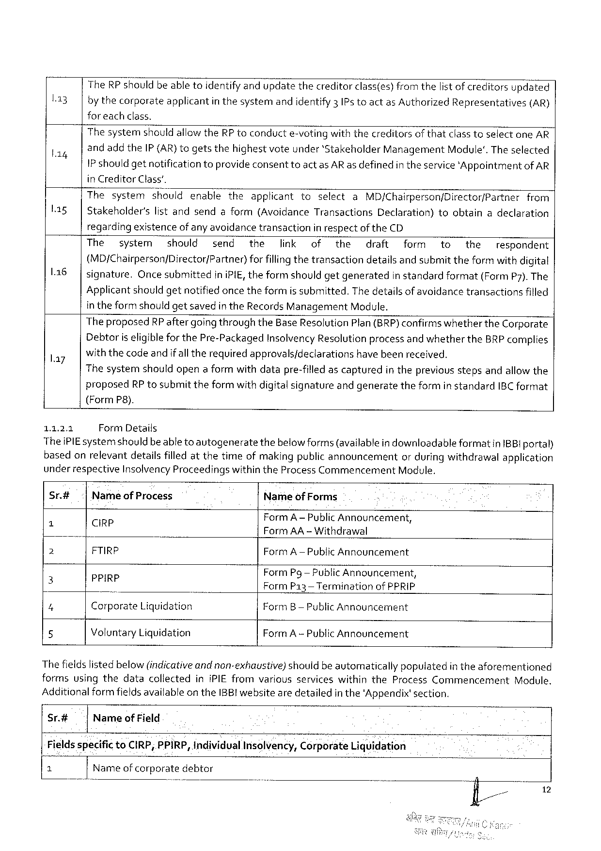

|  |  |
| --- | --- |
| l13 | TheRP shouldbe abletoidentify andupdatethecreditorclass(es) from thelist of creditorsupdated bythecorporateapplicantin thesystemandidentify3 IPs toactas AuthorizedRepresentatives(AR) |

for each class.

|  |  |  |  |  |  |  |  |  |  |  |  |
| --- | --- | --- | --- | --- | --- | --- | --- | --- | --- | --- | --- |
| L14  L1sg | The systemshould allowtheRP toconducte-votingwith thecreditorsof thatclasstoselectoneAR andadd theIP(AR)togetsthehighestvoteunder‘StakeholderManagementModule'. The selected IP shouldgetnotificationtoprovideconsenttoactasARas definedin theservice'AppointmentofAR in CreditorClass’. | | | | | | | | | | |
| Thesystem | | shouldenable | theapplicant | toselect | | a | MD/Chairperson/Director/Partner | | | from |
| Stakeholder's | listandsendaform(Avoidance | | | | Transactions | | Declaration) | toobtain | adeclaration | |

regardingexistenceofany avoidancetransactionin respectof theCD

|  |  |  |  |  |  |  |  |  |  |  |  |  |  |  |
| --- | --- | --- | --- | --- | --- | --- | --- | --- | --- | --- | --- | --- | --- | --- |
| 116 | The | system | should | send | the | link | of | the | draft | | form | to | the | respondent |
| (MD/Chairperson/Director/Partner)forfillingthetransactiondetailsandsubmit theformwith digital | | | | | | | | | | | | | |
| signature.Once submittediniPIE,theformshouldgetgenerated | | | | | | | | | in standardformat(FormP7).The | | | | |

Applicant shouldgetnotified oncetheformis submitted.The detailsof avoidancetransactionsfilled

in theform shouldgetsavedin theRecords ManagementModule.

TheproposedRP aftergoing throughtheBaseResolutionPlan(BRP)confirms whethertheCorporate

Debtoriseligiblefor thePre-PackagedInsolvencyResolutionprocessandwhethertheBRPcomplies

|  |  |
| --- | --- |
| l.ay | withthecodeandif alltherequiredapprovals/declarationshavebeenreceived.  Thesystemshouldopena formwithdatapre-filled ascapturedin thepreviousstepsandallowthe |

proposedRP tosubmittheformwith digitalsignatureandgeneratetheformin standardIBC format

(Form P8).

1.1.2.1 FormDetails

TheiPIEsystemshould beable to autogeneratethebelowforms(availablein downloadableformatinIBBI portal)

basedonrelevantdetailsfilled atthetimeofmakingpublic announcement orduringwithdrawalapplication

under respectiveInsolvencyProceedingswithintheProcessCommencementModule.

Sr.# NameofProcess NameofForms

N Cirp FormA—Pub‘hcAnnouncement,

) FormAA -Withdrawal

2 FTIRP FormA—PublicAnnouncement

FormPg— PublicAnnouncement,

5 PP{R? FormP13 —Terminationof PPRIP

4 CorporateLiquidation FormB— PublicAnnouncement

5 VoluntaryLiquidation FormA -PublicAnnouncement

Thefieldslisted below (indicativeandnon-exhaustivej shouidbe automaticallypopulatedin theaforementioned

formsusingthedatacollectediniPIE fromvariousserviceswithintheProcessCommencement Module.

Additionalformfieldsavailable on theIBB!websiteare detailedin the'Appendix'section.

Sr.# NameofField

FieldsspecifictoCIRP,PPIRP,IndividualInsolvency,CorporateLiquidation

|  |  |  |  |  |
| --- | --- | --- | --- | --- |
| T | Name ofcorporatedebtor o | o | 3fl// | 12 |

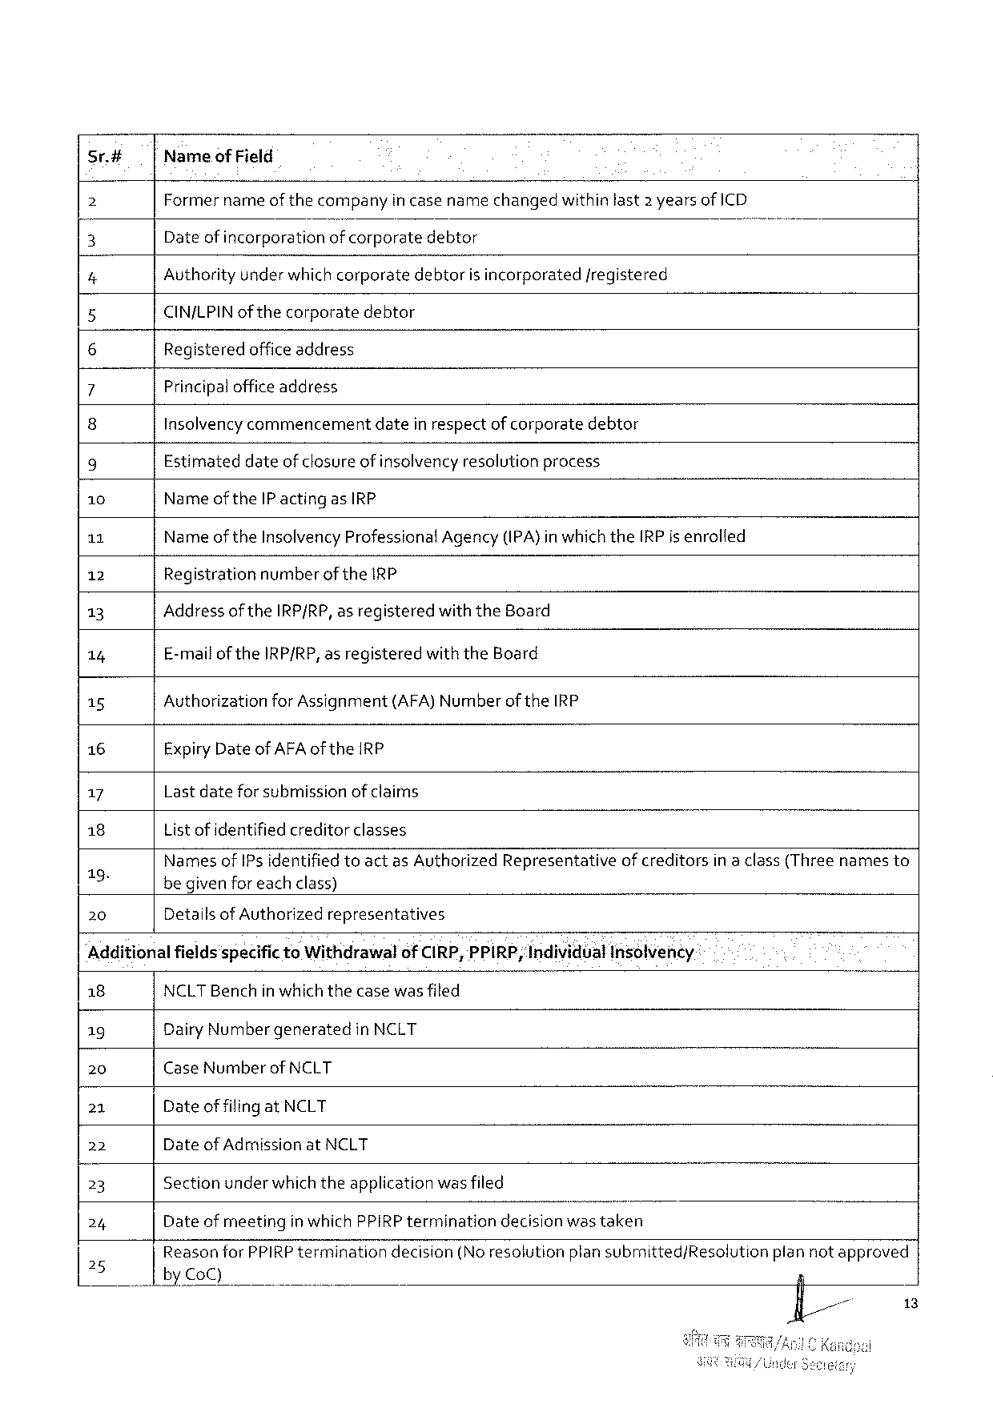

sr.# NameofField

2 Former nameof thecompanyin case namechangedwithin last2 yearsof ICD

3 Dateof incorporationof corporatedebtor )

4 Authority underwhichcorporatedebtoris incorporatedfregistered

5 CIN/LPINof thecorporatedebtor

6 Registeredofficeaddress

7 Principalofficeaddress

8 Insolvencycommencementdatein respectof corporatedebtor

9 Estimateddateof closure of insolvencyresolutionprocess

10 NameoftheIP actingasIRP

11 Nameof the InsolvencyProfessionalAgency(IPA)inwhichtheIRPis enrolfed

12 Registration numberof theIRP

13 AddressoftheIRP/RP, asregistered withtheBoard

14 E-mailof theIRP/RP,asregistered withtheBoard

15 Authorization forAssignment (AFA)Numberof theIRP

16 ExpiryDate ofAFA oftheIRP

17 Lastdateforsubmissionof claims

18 List ofidentified creditorclasses

7o) Nanjesof IPs identified toactas AuthorizedRepresentativeof creditorsin a class(Threenamesto

begivenforeachclass)

|  |  |  |
| --- | --- | --- |
| 20 | DetailsofAuthorized | representatives |

Additionalfields'specifictoWithdrawalof CIRP,PPIRP; IndividualInsolvency

|  |  |  |  |  |  |
| --- | --- | --- | --- | --- | --- |
| 18 | NCLTBenchinwhichthecasewasfiled | | | | plannotapproved |
| 19 | DairyNumbergeneratedin NCLT | | | |
| 20 | CaseNumber | ofNCLT | | |
| 21 | Dateof filingatNCLT | | | |
| 22 | Dateof AdmissionatNCLT | | | |
| 23 | Sectionunderwhich theapplicationwas filed | | | |
| 24 | Date of meetingin whichPPIRP terminationdecisionwastaken | | | |
| 25 | ReasonforPPIRPtermination by CoC) | | decision(Noresolution | plansubmitted/Resolution |

13

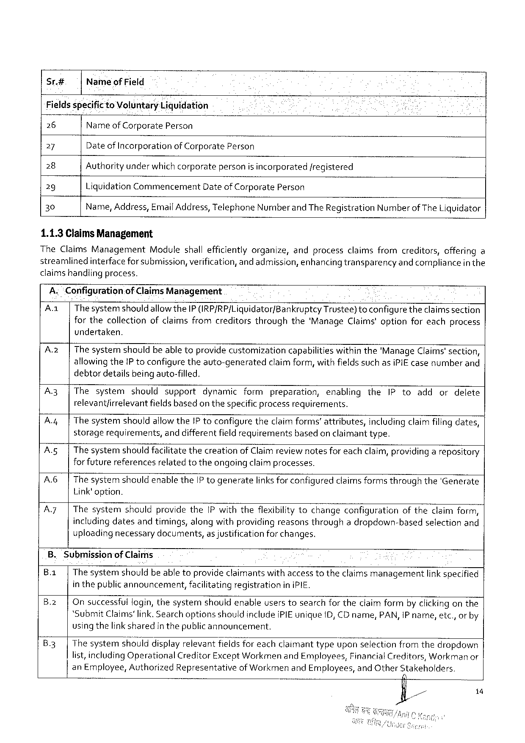

Sr.# Nameof Field

Fields specific toVoluntaryLicjuidation

26 Nameof Corporate Person

27 Date of Incorporationof CorporatePerson

28 Authorityunder whichcorporatepersonis incorporated/registered

29 LiquidationCommencement DateofCorporate Person

30 Name,Address,Email Address, TelephoneNumberandThe RegistrationNumberofTheLiquidator

1.1.3 ClaimsManagement

TheClaimsManagementModuleshallefficientlyorganize,andprocessclaimsfromcreditors,offeringa

streamlinedinterface forsubmission, verification,and admission,enhancingtransparencyand compliancein the

claims handlingprocess.

A.“Configuration.of Claims Management

Aa| Thesystemshould allowtheIP (IRP/RP/Liguidator/Bankruptcy Trustee)toconfiguretheclaimssection

forthecollectionofclaimsfromcreditorsthroughthe‘ManageClaims'optionforeachprocess

undertaken.

|  |  |  |  |  |  |  |  |  |  |  |  |  |
| --- | --- | --- | --- | --- | --- | --- | --- | --- | --- | --- | --- | --- |
| A.2z| | | Thesystemshouldbeabletoprovidecustomization | | | | | capabilities | | withinthe'ManageClaims'section, | | | |
| A3 | | | allowingtheIP toconfiguretheauto-generated | | | | claimform,withfields such asiPIEcasenumberand | | | | | | |
| debtordetailsbeingauto-filled, | | | | | | | | | | |
| Thesystem | shouldsupport | dynamic | formpreparation, | | | enabling | | the | IPtoadd | ordelete |
| A | | | relevantfirrelevantfieldsbasedon thespecificprocessrequirements. | | | | | | | | | | |
| Thesystem | shouldallowtheIP toconfiguretheclaimforms’attributes, | | | | | | | includingclaimfilingdates, | | |
| A.5| | | storagerequirements,and differentfield requirementsbased on claimanttype.  The systemshouldfacilitatethecreationof Claimreviewnotesfor eachclaim, providing a repository for futurereferencesrelatedtotheongoingclaimprocesses.  The systemshouldenabletheIP togeneratelinks for configuredclaimsformsthroughthe'Generate Link'option.  ThesystemshouldprovidetheIPwiththeflexibilitytochangeconfigurationoftheclaimform, includingdatesandtimings,alongwithproviding reasonsthroughadropdown-basedselectionand uploading necessarydocuments,as justificationforchanges. | | | | | | | | | | |
| A6 | | |
| A7| | |

B.Submissionof Claims

B.1| The systemshouldbe abletoprovideclaimantswithaccesstotheclaimsmanagementlinkspecified

inthepublicannouncement, facilitatingregistration in iPIE.

B.2| Onsuccessfulfogin, thesystemshouldenableuserstosearchfor theclaim formby clickingonthe

*SubmitClaims'link. Searchoptionsshouldinclude iPIEuniqueID,CDname,PAN,IP name,etc.,or by

usingthelink sharedin thepublicannouncement.

B.3|Thesystemshoulddisplayrelevantfields for eachclaimanttypeuponselectionfromthedropdown

list,includingOperationalCreditorExceptWorkmen andEmployees,FinancialCreditors, Workman or

anEmployee, AuthorizedRepresentativeofWorkmenand Employees,and OtherStakeholders.

o

/& P 1

7

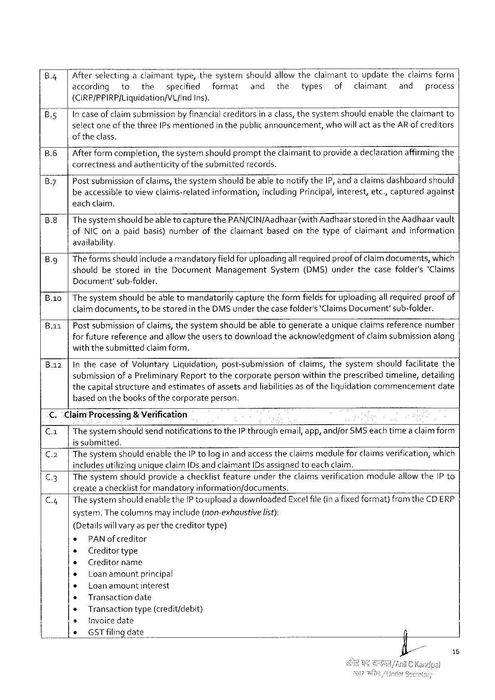

Afterselectingadaima;{twtype,thesystemshouldallowtheclaimanttoupdatetheclaimsform

according to the specified format and the types of claimant and process

(CIRP/PPIRP/Liquidation/VL{Ind ins).

In caseofclaimsubmission byfinancialcreditors ina class,thesystemshouldenabletheclaimant to

selectoneof thethreeIPs mentionedin thepublicannouncement,whowill act as theARof creditors

oftheclass.

B.6 Afterformcompletion,thesystemshouldprompttheclaimant toprovidea declarationaffirmingthe

correctnessand avthenticityof thesubmittedrecords.

|  |  |
| --- | --- |
| By | Post submissionof claims,thesystemshouldbe abletonotifytheIP, anda claimsdashboardshould beaccessibletoviewclaims-relatedinformation,includingPrincipal,interest,etc,,capturedagainst |

eachclaim,

B.8 ThesystemshouldbeabletocapturethePAN/CINfAadhaar(withAadhaarstored in theAadhaarvault

ofNIConapaidbasis)number oftheclaimant based onthetypeofclaimant andinformation

availability.

|  |  |  |  |  |  |  |  |  |  |
| --- | --- | --- | --- | --- | --- | --- | --- | --- | --- |
| B.g | Theformsshould includeamandatoryfieldfor uploadingall requiredproofofclaim documents,which | | | | | | | | |
| should | bestored | inthe | Document | Management | System | (DMS)under | thecasefolder's | ‘Claims |

Document’sub-folder.

|  |  |  |  |  |  |
| --- | --- | --- | --- | --- | --- |
| B.1io  Bai | Thesystemshouldbeabletomandatorilycapturetheformfieldsforuploadingall requiredproof of claimdocuments,tobestoredin theDMS underthecasefolder's‘ClaimsDocument’sub-folder. | | | | |
| Postsubmission | ofclaims,thesystem | shouldbeabletogenerate | auniqueclaimsreference | number |

forfuturereferenceandallowtheuserstodownloadtheacknowledgmentof claimsubmissionalong

withthesubmittedclaimform,

InthecaseofVoluntaryLiquidation,post-submissionofclaims,thesystemshouldfacilitatethe

submissionof aPreliminary Reporttothecorporatepersonwithin theprescribedtimeline,detailing

thecapitalstructureandestimatesof assetsandliabilitiesas of theliquidationcommencementdate

basedon thebooksof thecorporateperson.

C. “Claim Processing& Verification

C.a| The systemshould sendnotifications totheIP throughemail, app,andforSMSeach timea claimform

is submitted.

|  |  |
| --- | --- |
| C.2| C.3| | The systemshould enabletheIP tologin andaccess theclaims modulefor claims verification,which includesutilizinguniqueclaim[Ds andclaimantIDsassigned toeach claim.  Thesystemshouldprovidea checklistfeatureundertheclaimsverificationmoduleallowtheIP to |

createachecklistfor mandatoryinformation/documents.

|  |  |  |  |  |
| --- | --- | --- | --- | --- |
| C.4| | ThesystemshouldenabletheIP touploada downloaded | | | Exce!file(ina fixedformat)fromtheCDERP |
| system.Thecolumns | mayinclude(non-exhaustive | list): |

(Detailswillvaryas per thecreditortype)

|  |  |  |  |  |
| --- | --- | --- | --- | --- |
| * | PAN ofcreditor | | . | n |
| e | Creditortype | |
| e | Creditorname | |
| e |
| Loanamount | principal |
| e | Loanamountinterest | |
| + | Transactiondate | |
| e | Transactiontype(credit/debit) | |
| * |
| Invoicedate | |
| * |
| GSTfilingdate | |

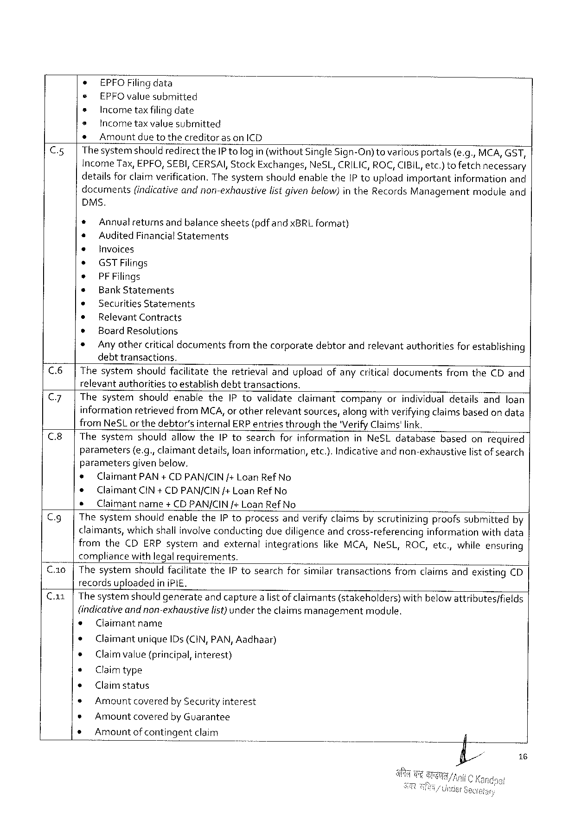

* EPFOFilingdata

e EPFOvalue submitted

s Incometaxfilingdate

e Incometaxvalue submitted

* Amountdue tothecreditoras onICD

C.5|ThesystemshouldredirecttheIP tologin(without SingleSign-On)tovariousportals(e.g.,MCA,GST,

IncomeTax,EPFO,SEBI,CERSAI,StockExchanges, NeSL,CRILIC,ROC,CIBIL,etc.)tofetchnecessary

detailsfor claimverification.ThesystemshouldenabletheIP touploadimportantinformationand

documents (indicativeandnon-exhaustive listgivenbelow)in theRecordsManagement module and

DMS.

|  |  |  |
| --- | --- | --- |
| *  e  *  *  *  e ® ¢ ¢ * | Annualreturns | andbalancesheets(pdfandxBRLformat) |
| AuditedFinancialStatements  Invoices  GSTFilings  PFFilings  BankStatements  SecuritiesStatements  RelevantContracts  Board Resolutions  Anyothercriticaldocumentsfromthecorporatedebtorandrelevantauthoritiesfor establishing debttransactions. | |

C.6|ThesystemshouldfacilitatetheretrievalanduploadofanycriticaldocumentsfromtheCDand

relevantauthoritiestoestablishdebttransactions.

|  |  |  |  |  |  |  |  |  |  |  |  |  |  |  |
| --- | --- | --- | --- | --- | --- | --- | --- | --- | --- | --- | --- | --- | --- | --- |
| || | C7 | | | ThesystemshouldenabletheIP tovalidateclaimantcompanyorindividualdetailsandloan informationretrievedfromMCA,or otherrelevantsources,alongwithverifyingclaimsbased ondata fromNeSLor thedebtor’sinternalERPentriesthroughthe'VerifyClaims'link. | | | | | | | | | | | |
| C8 | | | ThesystemshouldallowtheIP tosearchforinformationinNeSLdatabase | | | | | | | | | | basedonrequired | |
| C.g| | | parameters(e.g., claimantdetails,loan information,etc.).Indicativeandnon-exhaustivelistof search | | | | | | | | | | | |
| parameters | | | givenbelow, | | | | | | | | |
| * | | Claimant PAN+ CDPAN/CIN /+Loan Ref No | | | | | | | | | |
| e | ClaimantCIN+ CDPAN/CIN/+ LoanRefNo | | | | | | | | | | |
| s | Claimant | | | name | +CDPAN/CIN/+LoanRefNo | | | | | | |
| ThesystemshouldenabletheIPtoprocessandverifyclaimsbyscrutinizingproofssubmittedby | | | | | | | | | | | |
| claimants,which shallinvolveconductingduediligence andcross-referencinginformationwithdata | | | | | | | | | | | |
| fromthe | | | CDERPsystem | | | andexternal | integrations | likeMCA,NeSL, | ROC,etc., | | whileensuring |
| compliancewithlegalrequirements. | | | | | | | | | | | |

C.10|ThesystemshouldfacilitatetheIP tosearchforsimilartransactionsfromclaimsandexistingCD

recordsupioadedin iPIE.

Ca1|The systemshouldgenerateand capturea list ofclaimants(stakeholders)withbelow attributes/fields

(indicativeand non-exhaustivelist)under theclaims managementmodule.

s Claimantname

e ClaimantuniqueIDs(CIN,PAN,Aadhaar)

e Claimvalue (principal,interest)

« Claimtype

¢ Claimstatus

» Amountcoveredby Securityinterest

s AmountcoveredbyGuarantee

s Amountofcontingentclaim

16

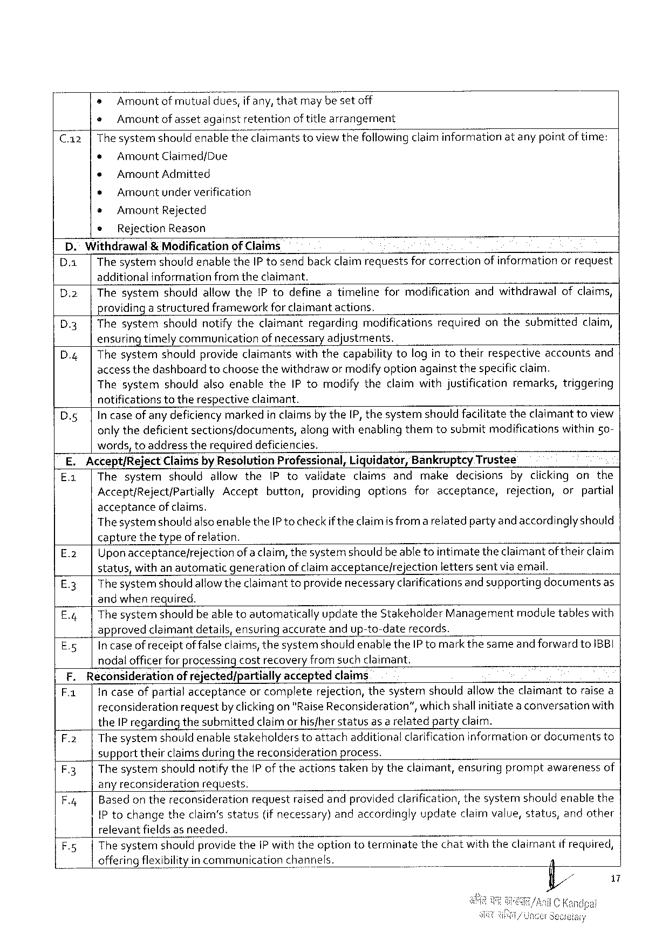

s Amountof mutualdues,if any,thatmaybesetoff

« Amountofassetagainstretention of title arrangement

Thesystemshouldenabletheclaimantstoviewthefollowingclaiminformationatanypointof time:

* AmountClaimed/Due   
* AmountAdmitted

» Amountunderverification

e AmountRejected

e RejectionReason

D." Withdrawal& Modificationof Claims   
D.a| ThesystemshouldenabletheIP tosendback claim requestsfor correctionof informationorrequest additionalinformationfrom theclaimant.

D.2|ThesystemshouldallowtheIP todefineatimelineformodificationandwithdrawalofclaims, providingastructuredframeworkfor claimant actions.

D.3|Thesystemshouldnotifytheclaimantregardingmodificationsrequiredonthesubmittedclaim, ensuring timely communicationof necessary adjustments.

D.4| Thesystemshouldprovideclaimantswiththecapabilitytologin totheirrespectiveaccountsand access thedashboardtochoosethewithdrawor modifyoption againstthespecificclaim.

ThesystemshouldalsoenabletheIP tomodifytheclaimwithjustificationremarks,triggering notificationstotherespectiveclaimant.

|  |  |  |
| --- | --- | --- |
| D.5| | Incaseof anydeficiency markedin claims by the[P,thesystemshouldfacilitatetheclaimanttoview | |
| onlythedeficientsections/documents, | alongwithenablingthemtosubmitmodificationswithin 5o~ |

words,toaddresstherequireddeficiencies.

|  |  |  |  |  |  |  |  |  |  |  |  |  |  |  |
| --- | --- | --- | --- | --- | --- | --- | --- | --- | --- | --- | --- | --- | --- | --- |
| | | E.Accept/RejectClaimsby ResolutionProfessional,Liquidator,BankrupteyTrustee | | | | | | | | | | | | | |
| Ea | | Thesystem | | shouldallowthe | | | IPtovalidateclaimsandmakedecisionsbyclickingonthe | | | | | | |
| Accept/Reject/PartiallyAccept | | | | | | | button, | | providingoptionsforacceptance, | | | rejection, | orpartial |
| acceptanceof claims.  ThesystemshouldalsoenabletheIP to checkif theclaimis from a relatedpartyand accordinglyshould capturethetypeof refation. | | | | | | | | | | | | | |
| E%3 | | Uponacceptance/rejectionofa claim,thesystemshould beable tointimatetheclaimantoftheirclaim | | | | | | | | | | | |
| status,withanautomatic | | | | | | generation | | of claimacceptance/rejection | | | letterssentvia email. | | |
| E3 | | Thesystemshould allowtheclaimanttoprovide necessaryclarificationsand supportingdocumentsas | | | | | | | | | | | |
| By | | andwhen required.  Thesystemshould beable toautomaticallyupdatetheStakeholderManagementmoduletableswith approvedclaimantdetails,ensuringaccurateandup-to-daterecords. | | | | | | | | | | | |
| Es | | In caseofreceiptof falseclaims,thesystemshould enabletheIP tomarkthesameand forward toIBBI | | | | | | | | | | | |
| nodal officerforprocessing costrecovery fromsuch claimant. | | | | | | | | | | | | | |
| F.Reconsiderationof rejected/partially | | | | | | | | acceptedclaims | | | | | |
| F1 | | | In caseofpartialacceptanceor completerejection,thesystemshouldallowtheclaimanttoraise a | | | | | | | | | | | |
| reconsiderationrequestby clickingon "RaiseReconsideration”,whichshallinitiateaconversationwith theIP regardingthesubmittedclaimor hisfherstatusas a relatedpartyclaim.  F.2|Thesystemshould enablestakeholderstoattachadditionalclarification information or documentsto supporttheirclaimsduringthereconsiderationprocess.  F.3|ThesystemshouldnotifytheIP of theactionstakenby theclaimant,ensuringpromptawarenessof any reconsiderationrequests. | | | | | | | | | | | | | |
| F.4| | | | Basedon thereconsiderationrequestraised andprovided clarification,thesystemshouldenablethe | | | | | | | | | | |
| IP tochangetheclaim’sstatus(ifnecessary)andaccordingly updateclaimvalue,status,andother | | | | | | | | | | | | | |
| [relevantfields | | | | | as needed. | | | | | | | | |
| F.5| | | Thesystem | | shouldprovidetheiP withtheoptiontoterminate | | | | | | thechatwiththeclaimantif required, | | | |
| offeringflexibilityincommunication | | | | | | | | channels. | | | | | |

17

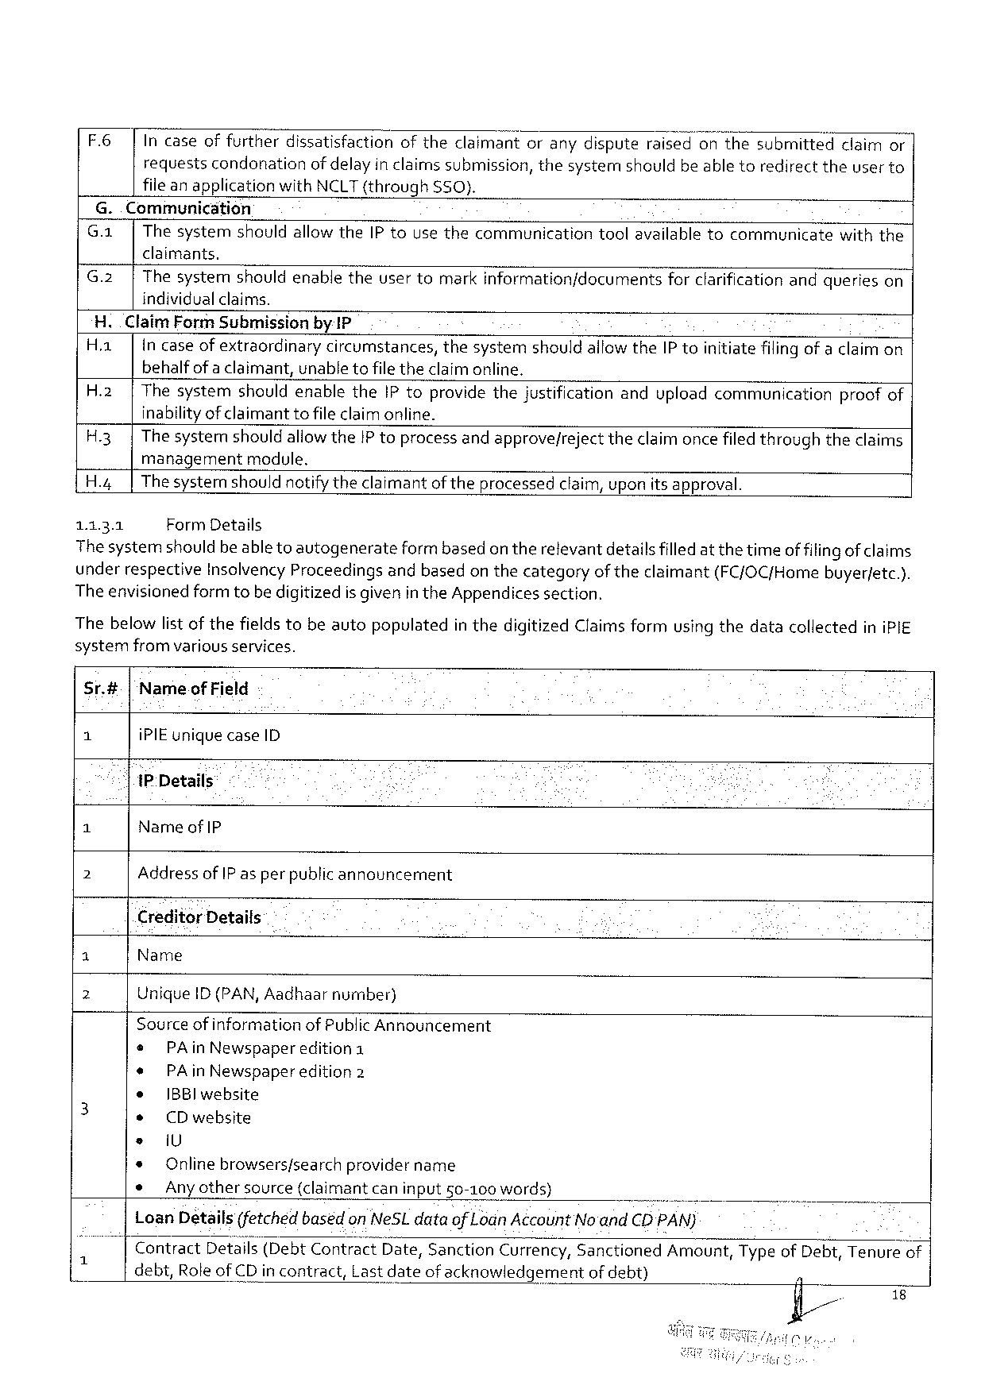

F6 | Incaseoffurtherdissatisfactionoftheclaimantoranydisputeraisedonthesubmittedclaimor requestscondonationofdelayin claims submission,thesystemshouldbe abletoredirecttheuser to fileanapplicationwithNCLT(through SSO}.

G.. Communication

G.a|Thesystemshouldallow theIP tousethecommunicationtoolavailabletocommunicatewiththe claimants.

|  |  |
| --- | --- |
| G.2| | Thesystemshouldenabletheusertomarkinformation/documentsforclarification andquerieson individualclaims. |

H.ClaimForm Submissionby IP

|  |  |  |
| --- | --- | --- |
| H.a| | Incase ofextraordinarycircumstances,thesystemshouldallowtheIP toinitiatefilingofa claim on | |
| behalfofaclaimant, | unabletofile theclaimonline. |

H.2|ThesystemshouldenabletheIPtoprovidethejustificationanduploadcommunicationproofof inabilityofclaimantto fileclaimonline.

H.3|ThesystemshouldallowtheIP toprocessandapprove/rejecttheclaimoncefiledthroughtheclaims managementmodule,

H.4| Thesystemshouldnotifytheclaimantof theprocessedclaim,uponitsapproval.

1131 FormDetails

Thesystemshould beabletoautogenerateform basedontherelevantdetails filledat thetimeof filingof claims underrespectiveInsolvencyProceedingsandbasedonthecategoryof theclaimant(FC/OC/Homebuyer/etc.). The envisionedformtobedigitizedis givenin theAppendicessection.

Thebelowlistofthefieldstobeautopopulatedin thedigitizedClaimsformusing thedatacollectediniPIE systemfromvariousservices.

Sr.#|‘Nameof Field

1 iPIEuniquecaseID

‘|1P Details

3 NameofIP

2 Address ofIP asper publicannouncement

CreditorDetails

1 Name

2 UniqueID (PAN,Aadhaarnumber)

Sourceof informationof PublicAnnouncement

|  |  |  |  |  |  |
| --- | --- | --- | --- | --- | --- |
| 3 | e | PAinNewspaper | edition1 | . | - |
| ¢ | PAinNewspaper | edition2 |
| ¢ |
| IBBlwebsite | |
| * |
| CDwebsite | |
| e | iU | |
| * |
| Onlinebrowsers/searchprovidername | |
| * |
| Any othersource(claimantcaninput50-100words) | |

LoanDetails(fetched based on NeSLdataof LodnAccountNo'andCD PAN)

|  |  |  |  |  |  |  |  |
| --- | --- | --- | --- | --- | --- | --- | --- |
| i | Contract | Detalls(DebtContract | | Date,Sanction | Currency,Sanctioned | | Amount,TypeofDebt,Tenureof| |
| debt,RoleofCDincontract, | | Lastdateofacknowledgement | | | ofdebt) |
| | |

18

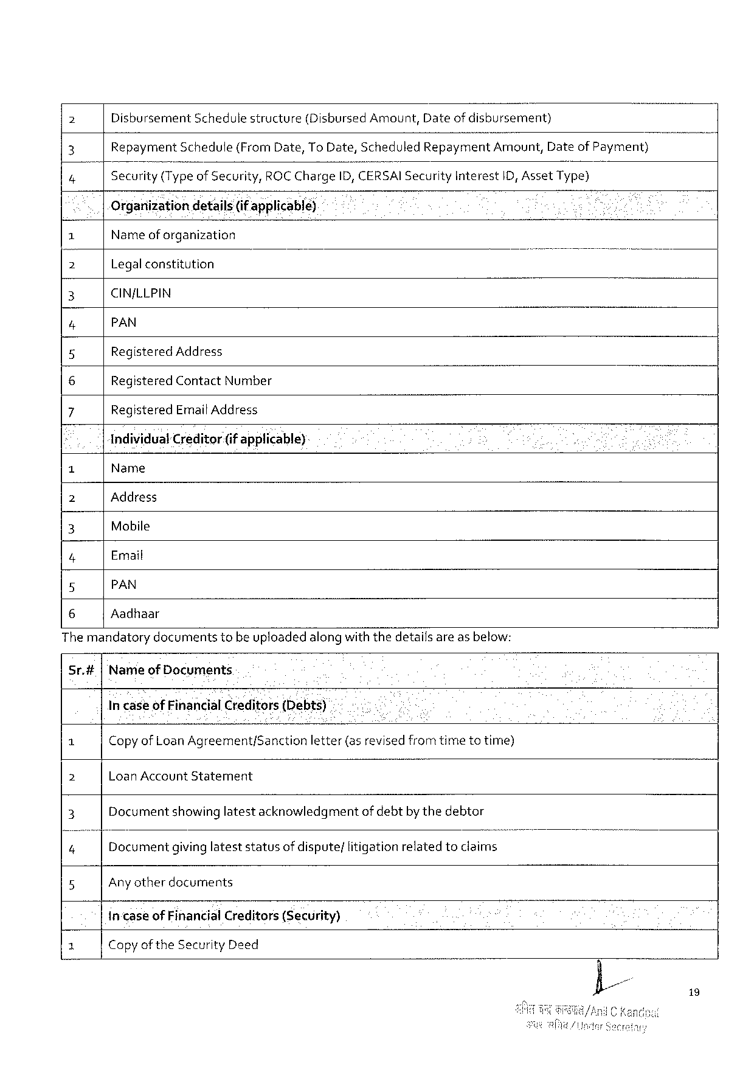

2 Disbursement Schedulestructure (DisbursedAmount,Dateof disbursement)

2 Repayment Schedule(FromDate,ToDate,Scheduled Repayment;rnount, DateofPayment)

4 Security(Typeof Security, ROCChargeID,CEéSAISecurityInterest 1D,AssetType)

Organizationdetails(if applicable)

|  |  |  |  |
| --- | --- | --- | --- |
| 1 | Nameof organization | N | - |
| 2 | Legalconstitution |
| 3 | CIN/LLPIN |
| 4 | PAN |
| 5 | RegisteredAddress |
| 6 | RegisteredContactNumber |
| 7 | RegisteredEmait Address |

IndividualCreditor(if applicable)-

o Name

2 Address

3 Mobile

4 Email

5 PAN

6 Aadhaar

The mandatorydocumentstobe uploadedalongwiththedetailsare asbelow:

Sr.# Nameof Documents

In caseofFinancialCreditoljs(Debts)

|  |  |  |  |
| --- | --- | --- | --- |
| 1 | CopyofLoanAgreement/Sanction | letter(asrevisedfromtimetotime) | o |
| 2 | LoanAccountStatement | |
| 3 | Documentshowinglatestacknowledgmentofdebtbythedebtor | |
| '4"” | Documentgivinglateststatusof dispute/litigationrelatedtoclaims | |
| 5 | Any otherdocuments | |

in-caseofFinancialCreditors(Security)

3 Copyof theSecurityDeed

i9

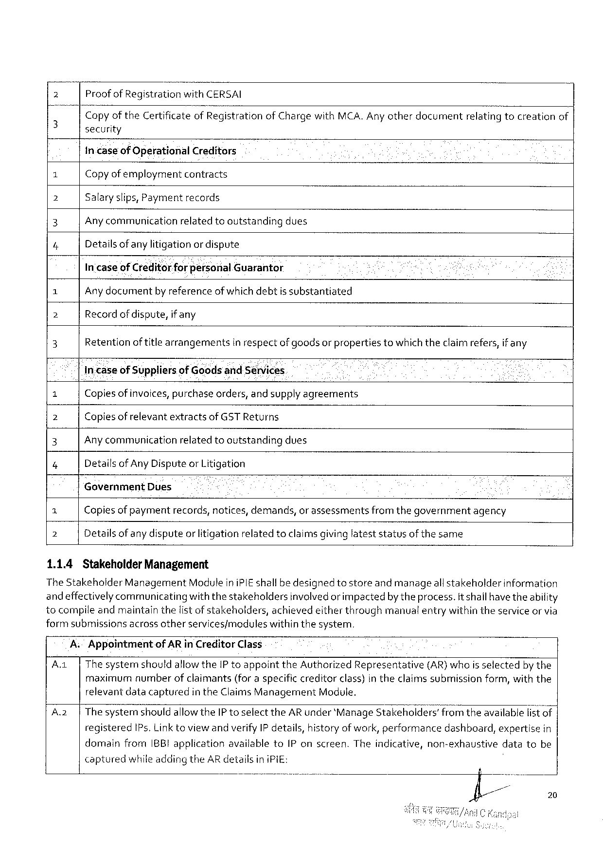

2 Proof of Registration wiht‘I:E:ERSAI

Copyof theCertificateof I‘?egistratlonof ChargewithMCA. Anyotherdocumentrelatingtocreationof

3 security

incaseof OperationalCreditors

ol Copyofemployment contracts

2 Salaryslips,Payment records

3 Anycommunicationrelatedtooutstandingdues

4 Detailsofany litigation or dispute

In'caseof CreditorforfiersonalGuarantor

1 Anydocumentby referenceofwhichdebtis substantiated

2 Recordof dispute,if any

3 Retentionof title arrangementsin respectof goodsor propertiestowhichtheclaimrefers,if any

Incaseof Suppliersof GoodsandSénvices

= Copiesof invoices,purchaseorders,and supplyagreements

] Copiesof relevantextractsof GSTReturns

3 Any communication relatedtooutstanding dues

7 Detailsof AnyDisputeor Litigation

GovernmentDues i

7 Copiesof paymentrecords,notices,demands,or assessmentsfrom thegovernmentagency

7 Detailsof anydisputeor litigationrelatedtoclaimsgivinglateststatusofthesame

1.1.4 StakeholderManagement

TheStakeholderManagementModuleiniPIEshallbe designedtostoreandmanageall stakeholderinformation

andeffectivelycommunicatingwiththestakeholdersinvolvedorimpactedbytheprocess.it shallhavetheability

tocompileandmaintainthelistof stakeholders,achievedeitherthroughmanualentrywithintheserviceor via

formsubmissions acrossotherservices/moduleswithinthesystem.

A:Appointment of AR in CreditorClass

A.1| ThesystemshouldallowtheIP toappointtheAuthorizedRepresentative(AR)whois selectedby the

maximum numberofclaimants (foraspecificcreditorclass)intheclaimssubmission form,withthe

relevantdatacapturedin theClaimsManagementModule.

A2 |The systemshouldallowtheIP toselect theARunder‘ManageStakeholders’from theavailablefistof|

registeredIPs. Link toviewandverifyIP details,historyof work,performancedashboard,expertisein

domainfromIBBIapplicationavailabletoIP onscreen.Theindicative,non-exhaustivedatatobe

capturedwhileadding theARdetailsin iPiE:

20

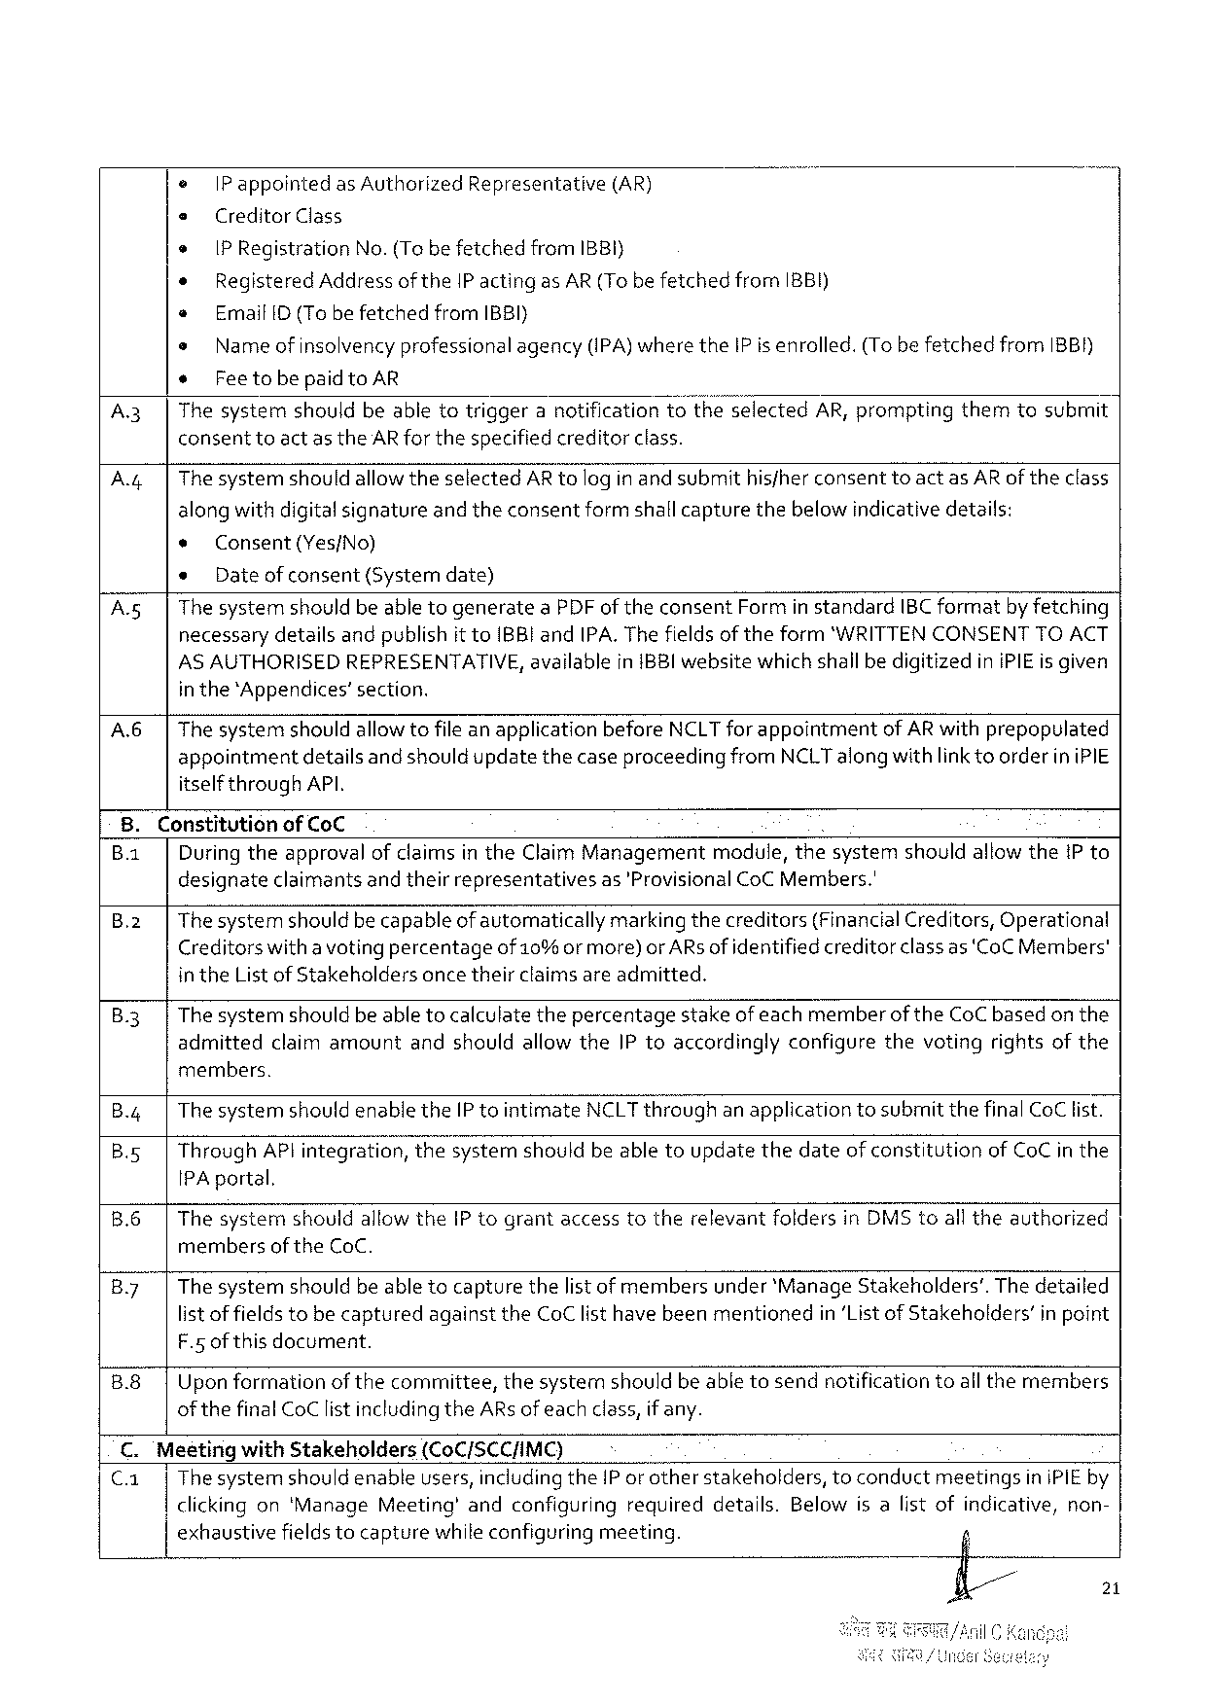

e |Pappointed asAuthorized Representative (AR)

e CreditorClass

* IPRegistration No.(Tobefetched from IBBI}

* RegisteredAddressoftheIP actingasAR(TobefetchedfromIBBI)

« EmailID (TobefetchedfromIBBI)

e Name of insolvencyprofessional agency(IPA)where theIPis enrolled.(TobefetchedfromIBBH)

¢ Feetobepaidto AR

A.3| ThesystemshouldbeabletotriggeranotificationtotheselectedAR,promptingthemtosubmit

consenttoact as theAR for thespecifiedcreditorclass.

A.4|ThesystemshouldallowtheselectedARtologin andsubmithisfherconsenttoactasARof theclass

alongwithdigitalsignatureand theconsentform shallcapturethebelowindicativedetails:

« Consent(Yes/No)

* Dateofconsent(Systemdate)

A.s| The systemshould beable togenerateaPDF of theconsentFormin standardIBC formatbyfetching

necessarydetailsandpublishit toIBBI andIPA. The fieldsof theform*"WRITTENCONSENTTOACT

ASAUTHORISEDREPRESENTATIVE, in the*Appendices’section.

availablein{BBIwebsitewhichshallbedigitizediniPIEis given

A.6| The systemshould allowtofile anapplicationbeforeNCLTforappointmentofARwithprepopulated appointmentdetailsand shouldupdatethecaseproceedingfromNCLTalongwith linkto orderin iPIE itself throughAPI.

8. Constitutionof CoC i   
B.1| Duringtheapprovalof claimsintheClaimManagementmodule,thesystemshouldallow thePto designateclaimantsandtheirrepresentativesas'ProvisionalCoC Members.'

B.2| Thesystemshould becapableof automaticallymarkingthecreditors(FinancialCreditors,Operational Creditorswitha voting percentageof 10% ormore)orARs ofidentifiedcreditor classas ‘CoCMembers' intheList ofStakeholdersonce theirclaimsareadmitted.

|  |  |
| --- | --- |
| B.3| | The systemshouldbe able tocalculatethepercentagestakeofeachmemberoftheCoC basedon the admittedclaimamountandshouldallowtheIPtoaccordinglyconfigurethevotingrightsofthe |

members.

B.4| The systemshouldenabletheIP tointimateNCLTthroughanapplicationtosubmitthefinalCoC list.

B.5| ThroughAPlintegration,thesystemshouldbeabletoupdatethedateof constitutionofCoC in the IPAportal.

B.6|ThesysternshouldallowtheIP tograntaccesstotherelevantfoldersinDMStoall theauthorized

members of theCoC.

B.7| The systemshouldbe able tocapturethelistof membersunder*ManageStakeholders’.The detailed listof fieldstobe capturedagainsttheCoClisthave beenmentionedin‘Listof Stakeholders’in point F.5 ofthisdocument.

B.8|Uponformationof thecommittee,thesystemshouldbeable tosendnotificationtoall themembers of the finalCoClist includingtheARsof eachclass,if any.

C. MesetingwithStakeholders (CoC/SCCIMC)

C.a| Thesystemshould enableusers,includingtheIP orotherstakeholders,toconductmeetingsin iPIEby clickingon‘ManageMeeting’andconfiguringrequireddetails.Belowisalistofindicative,non- exhaustivefieldstocapturewhileconfiguringmeeting.

21

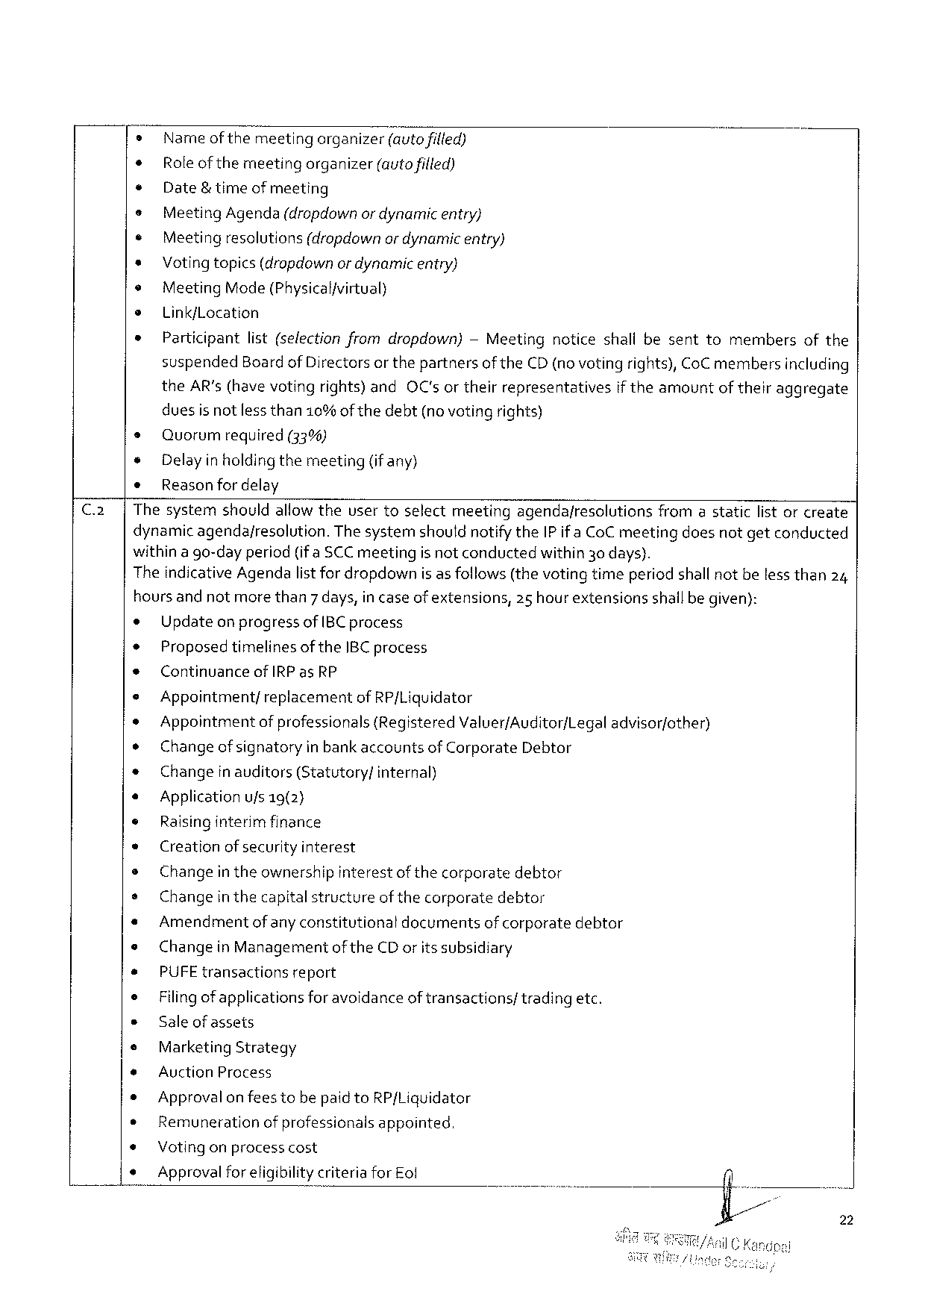

o Name ofthemeetingorganizer(Mautofified)

* Role of themeetingorganizer(autofilled)

¢ Date& timeofmeeting

e MeetingAgenda(dropdownor dynamicentry}

¢ Meetingresolutions(dropdownor dynamicentry)

* Voting topics(dropdownor dynamicentry)

¢ MeetingMode(Physicalfvirtual}

e Link/Location

* Participantlist(selectionfromdropdown)— Meetingnoticeshallbesenttomembersofthe

suspendedBoardof Directors or thepartnersof theCD(novoting rights),CoC membersincluding

|  |  |  |  |
| --- | --- | --- | --- |
| theAR’s (havevotingrights)and | OC'sortheirrepresentatives | iftheamount | oftheiraggregate |

duesisnotlessthan10%of thedebt(novotingrights)

s Quorum required (33%)

e Delayin holding themeeting(if any)

¢ Reasonfor delay

Thesystemshouldallow theusertoselectmeetingagendafresolutionsfromastaticlistor create

dynamic agendajresolution.The systemshoutdnotifytheIP ifa CoCmeetingdoesnotgetconducted

withina go-dayperiod(ifa SCCmeetingis notconductedwithin30 days).

TheindicativeAgendalist for dropdownis as follows (the votingtimeperiodshallnotbeless than24

hoursand notmorethan7 days,in caseofextensions,25 hour extensionsshallbegiven):

|  |  |  |  |  |  |  |  |  |  |  |
| --- | --- | --- | --- | --- | --- | --- | --- | --- | --- | --- |
| ¢ | UpdateonprogressofIBCprocess | | | | | | | | | 0. |
| * |
| ProposedtimelinesoftheIBC process | | | | | | | | |
| ¢ | Continuance | ofIRPasRP | | | | | | | |
| * |
| Appointment/ | replacement | | ofRP/Liquidator | | | | | |
| * |
| Appointmentof professionals{Registered Valuer/Auditor/Legal | | | | | | | | advisor/other) |
| ® |
| Changeof signatoryin bankaccountsof CorporateDebtor | | | | | | | | |
| + | Changeinauditors(Statutory/ | | | | internal) | | | | |
| « | Applicationufs 19(2} | | | | | | | | |
| © | Raisinginterimfinance | | | | | | | | |
| « | Creationof securityinterest | | | | | | | | |
| e | Changein theownershipinterestofthecorporatedebtor | | | | | | | | |
| e |
| Changein thecapitalstructureofthecorporatedebtor | | | | | | | | |
| « |
| Amendment | of anyconstitutional | | | | documents | ofcorporate | debtor | |
| e |
| ChangeinManagementofthe CDorits subsidiary | | | | | | | | |
| * | PUFE transactions | | report | | | | | | |
| e |
| Filingof applicationsforavoidanceof transactions/tradingetc. | | | | | | | | |
| e |
| Saleofassets | | | | | | | | |
| e | MarketingStrategy | | | | | | | | |
| e | AuctionProcess | | | | | | | | |
| * | Approvalon feestobepaidtoRP/Liquidator | | | | | | | | |
| * |
| Remunerationof professionalsappointed. | | | | | | | | |
| * |
| Votingonprocesscost | | | | | | | | |
| * |
| Approvalforeligibilitycriteriafor Eof | | | | | | n | | |

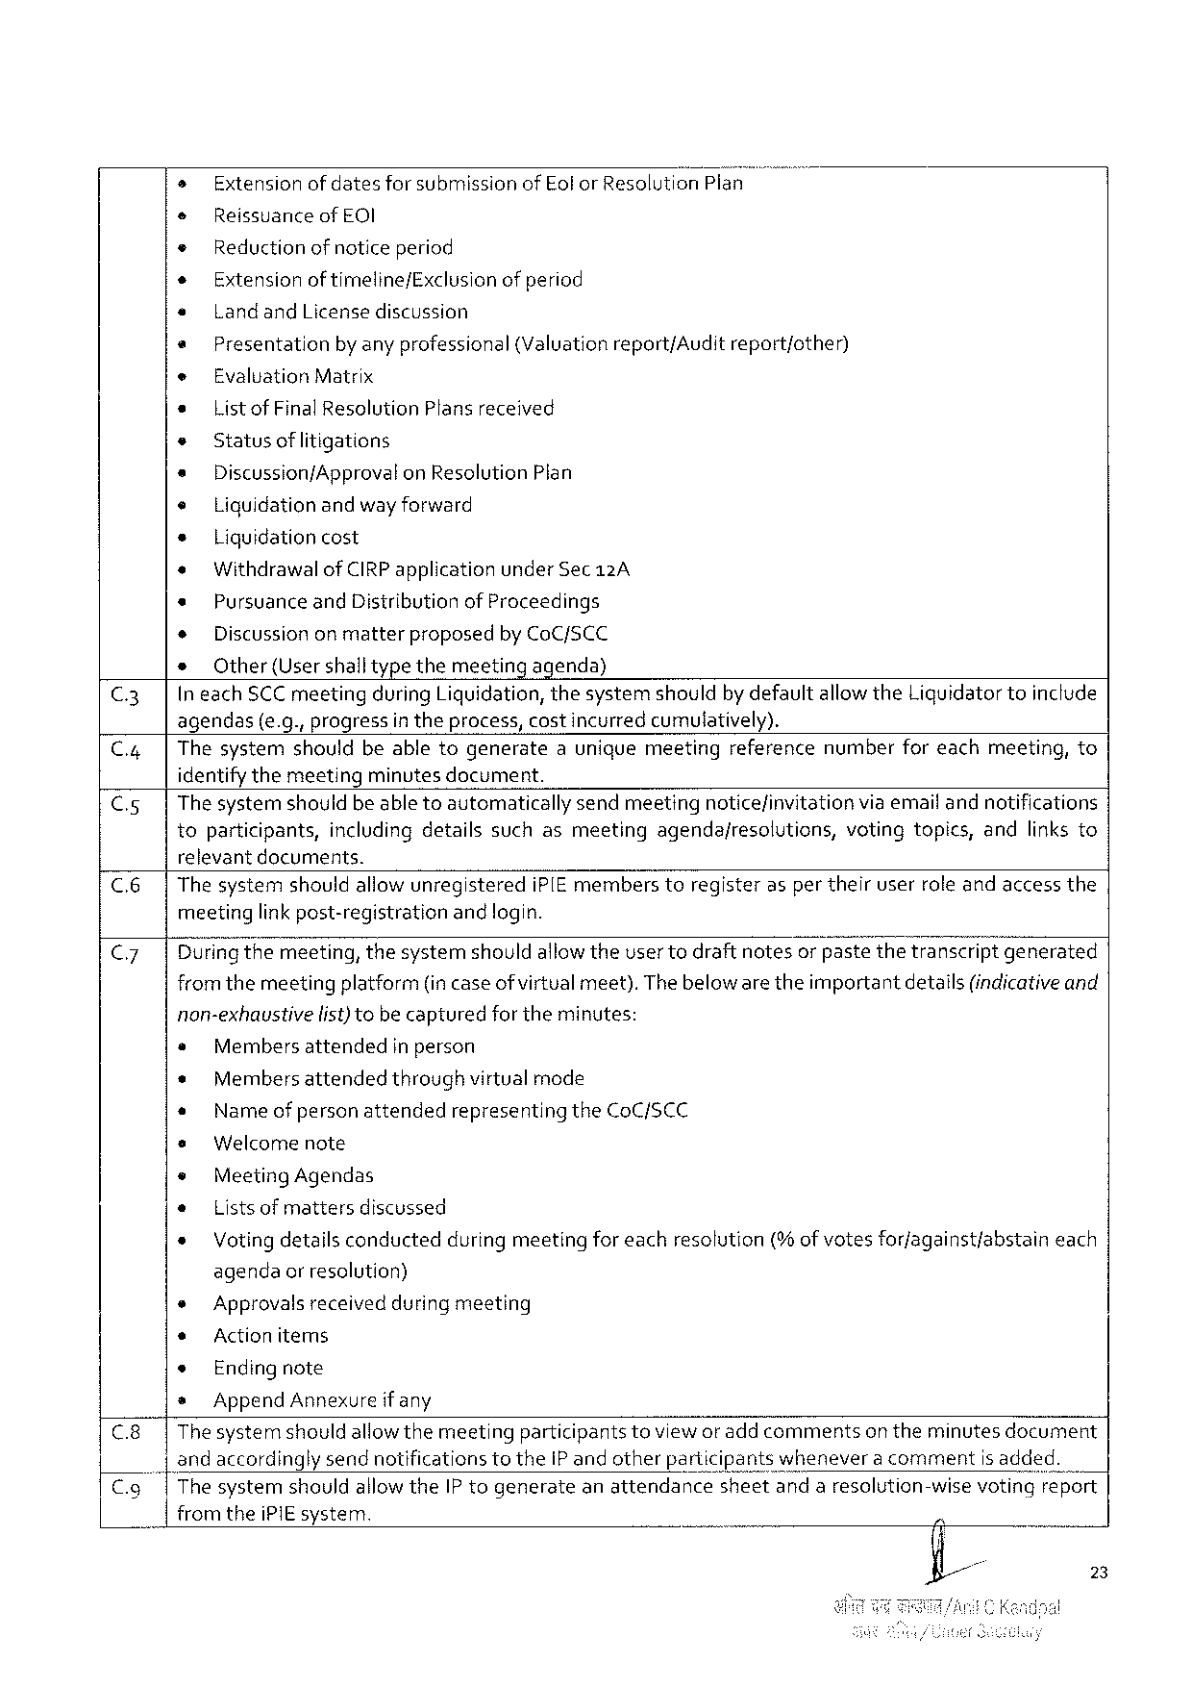

» Extensionofdatesfor submissionofEolor ResolutionPlan

e ReissuanceofEOI

* Reduction of notice period

+ Extensionof timeline/Exclusion of period

e LandandLicensediscussion

* Presentation by anyprofessional (Valuationreport/Audit report/other)

e EvaluationMatrix

* Listof FinalResolutionPlans received

s Statusof litigations

* DiscussionfApprovalon ResolutionPlan

¢ Liquidationandwayforward

+ Liquidationcost

« WithdrawalofCIRPapplicationunder Sec12A

* PursuanceandDistribution of Proceedings

+ Discussiononmatter proposed byCoC/SCC

s Other(Usershalltypethemeetingagenda)

C3| IneachSCC meetingduringLiquidation,thesystemshouldby defaultallowtheLiguidatortoinclude

agendas(e.g.,progressin theprocess,costincurred cumulatively).

C.4| Thesystemshouldbeabletogenerateauniquemeetingreferencenumberforeachmeeting,to

identifythemeetingminutesdocument.

C.5| The systemshouldbe able toautomaticallysendmeetingnoticefinvitationviaemaifandnotifications

toparticipants,includingdetailssuchasmeetingagendajresolutions, votingtopics,andlinksto

relevantdocuments.

C.6| The systemshouldallow unregisterediPIE memberstoregisterasper theiruserrole andaccessthe

meetinglink post-registrationand login.

C7 Dufingthemeeting,thesystemshouldallowtheuser todraftnotesor pastethetranscriptgenerated

fromthemeetingplatform(incaseof virtualmeet).Thebeloware theimportantdetails(indicativeand

non-exhaustive fist)tobecaptured fortheminutes:

e Membersattended in person

* Membersattendedthroughvirtualmode

« Name of personattendedrepresentingtheCoC/SCC

* Welcomenote

® MeetingAgendas

e Lists of mattersdiscussed

* Voting detailsconductedduring meetingfor eachresolution(%of votesforjagainst/abstaineach

agendaor resolution)

|  |  |  |  |  |  |  |
| --- | --- | --- | --- | --- | --- | --- |
| C.8| | * | Approvalsreceivedduringmeeting | | | toviewor addcomments | on theminutesdocument |
| s | Actionitems | | |
| * | Endingnote | | |
| » | AppendAnnexure | if any | |
| Thesystemshouldallowthemeeting | | | participants |

and accordingly sendnotificationstotheIP and otherparticipantswheneveracommentis added.

|  |  |  |  |  |
| --- | --- | --- | --- | --- |
| C.9| | ThesystemshouldallowtheIP togenerate | anattendance | sheetandaresolution-wise | votingreport |

fromtheiPIEsystem.

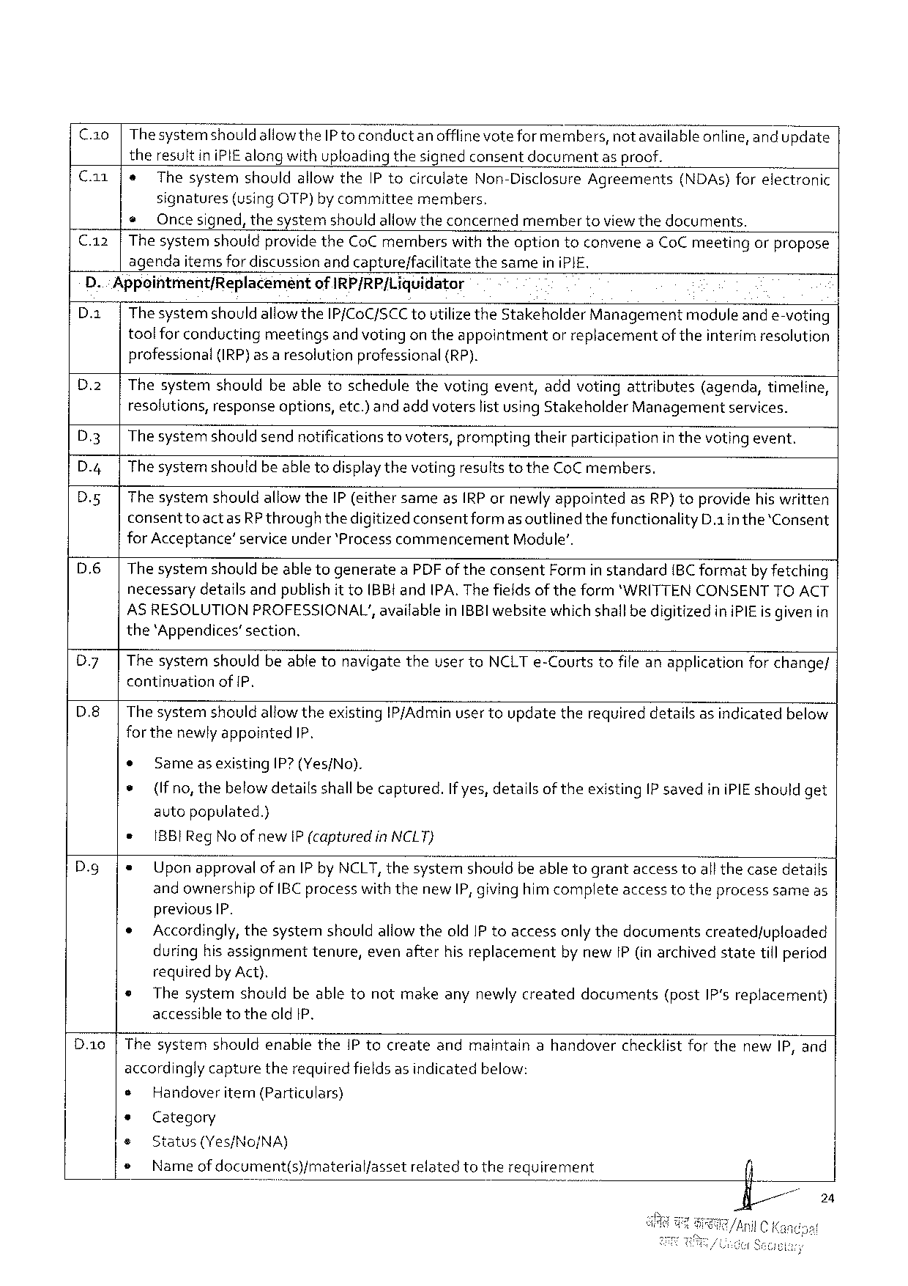

C.1o | ThesystemshouldallowtheIP to conductanofflinevoteformembers,notavailableonline,and update

theresultin iPIEalongwithuploadingthesignedconsentdocument asproof.

Ca1 e Thesystem shouldallowtheIPtocirculate Non-Disclosure Agreements (NDAs)forelectronic

signatures (usingOTP)by committee members,

@Oncesigned, thesystemshould allowtheconcernedmembertoviewthedocuments.

C.12 |ThesystemshouldprovidetheCoCmemberswith theoptiontoconveneaCoCmeetingorpropose

agendaitemsfordiscussionandcapture/facilitate thesameiniPIE,

D.: Appointment/ReplacemeéntofIRP/RP/Liquidator

D.2| Thesystemshould allowtheIP/CoC/SCC toutilizetheStakeholderManagementmoduleand e-voting

toolfor conductingmeetingsand votingon theappointmentor replacementof theinterim resolution

professional(IRP)as a resolutionprofessional {(RP).

D.2|Thesystemshouldbeabletoschedulethevotingevent,addvotingattributes(agenda,timeline,

resolutions,responseoptions,etc.) andadd voterslist using StakeholderManagementservices.

D.3| The systemshould sendnotifications tovoters,promptingtheirparticipationin thevoting event.

D.4|The systemshouldbe able todisplaythevotingresultsto theCoCmembers.

|  |  |  |
| --- | --- | --- |
| D.5|  D.6|  D7| | ThesystemshouldallowtheIP (eithersameasIRPornewly appointedasRP) toprovidehiswritten | |
| consenttoactas | RP throughthedigitizedconsentformas outlinedthefunctionality D.1inthe*Consent |
| forAcceptance’ serviceunder ‘ProcesscommencementModule’.  The systemshouldbeable togenerateaPDF oftheconsentForm in standard{BC formatby fetching necessarydetafls andpublishit toIBB!andIPA. Thefields of theform‘WRITTENCONSENTTOACT AS RESOLUTIONPROFESSIONAL’,availableinIBBIwebsitewhichshallbedigitizediniPIEis givenin the‘Appendices’section.  Thesystemshouldbeabletonavigatetheuser toNCLT e-Courtstofile anapplicationfor change/ | |

continuationofP,

D.8|The systemshouldallowtheexistingIP/Adminuser toupdatetherequireddetailsas indicatedbelow

forthenewlyappointedIP.

|  |  |  |  |  |
| --- | --- | --- | --- | --- |
| ® | Same | asexisting | IP?(Yes/No). | If yes,detailsoftheexistingIP savediniPIEshouldget |
| * | (Ifno,thebelow detailsshallbecaptured. | | |

autopopulated.)

|  |  |  |
| --- | --- | --- |
| D.g | * | BBlRegNo ofnewIP (capturedinNCLT} |
| {eUponapprovalof anIP byNCLT,thesystemshouldbeable tograntaccesstoall thecasedetails and ownershipofIBCprocesswiththenewIP, givinghimcompleteaccess totheprocesssameas | |

previousIP.

|  |  |
| --- | --- |
| *  ® | Accordingly,thesystemshouldallowtheold IP toaccessonlythedocumentscreatedfuploaded duringhisassignmenttenure,evenafterhis replacementby new[P(in archivedstatetillperiod requiredby Act).  Thesystemshouldbeabletonotmakeanynewly createddocuments(postIP's replacement) accessibletotheold 1P, |

D.10 |ThesystemshouldenabietheIP tocreateandmaintainahandoverchecklistforthenewIP,and

accordingly capturetherequiredfields as indicatedbelow:

|  |  |  |
| --- | --- | --- |
| e | Handoveritem(Particulars) | relatedtotherequirement |
| * | Category |
| e | Status(Yes/No/NA) |
| e | Nameof document(s)/materialfasset |

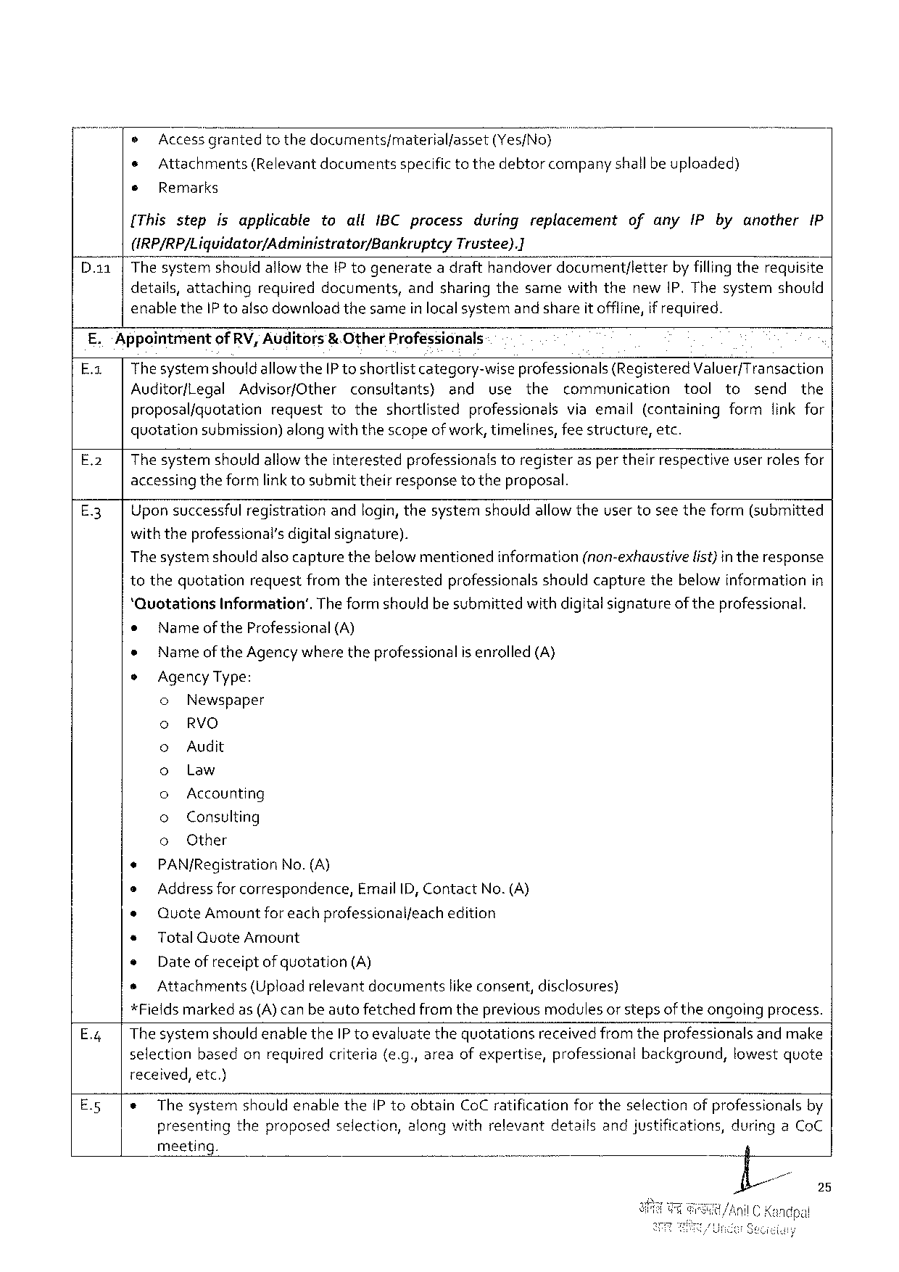

® Access_g“ranted tothedocuments/material/asset (Yes/No)m

¢ Attachments(Relevant documentsspecifictothedebtorcompanyshallbeuploaded)

® Remarks

[Thisstep isapplicable toallIBCprocess duringreplacement ofanyIPbyanother IP

(IRP/RP/Liguidator/Administrator/Bankruptcy Trustee).]

ThesystemshouldallowtheIP togenerateadrafthandoverdocument/letter by fillingtherequisite

details, attaching required documents, andsharingthesamewiththenewIP.Thesystem should

enabletheIP toalsodownloadthesameinlocalsystemand shareitoffline,if required.

E.‘Appointmentof RV, Auditors& OtherProfessionals

E.x| Thesystemshouldallowthe[P toshortlist category-wiseprofessionals (RegisteredValuer/Transaction

AuditorfLegal Advisor/Other consultants) and use the communication tool to send the

proposalfquotation requesttotheshortlisted professionalsviaemail(containingformfinkfor

quotationsubmission) along withthescopeofwork,timelines,feestructure,etc.

E.2| The systemshould allowtheinterestedprofessionalstoregisteras per theirrespectiveuserrolesfor

accessing theformlink tosubmittheirresponsetotheproposal.

E.3| Uponsuccessfulregistrationandlogin,thesystemshouldallowtheusertoseetheform(submitted

withtheprofessional’sdigitalsignature).

|  |  |  |  |
| --- | --- | --- | --- |
| Thesystemshouldalsocapturethebelowmentioned | information | (non-exhaustive | list)intheresponse |

tothequotationrequestfromtheinterestedprofessionalsshouldcapturethebelowinformationin

‘QuotationsInformation’.Theformshouldbesubmittedwithdigitalsignatureof theprofessional.

o Nameof the Professional (A)

* Nameof theAgencywhere theprofessionalis enrolled (A)

o AgencyType:

o Newspaper

o RVO

o Audit

o Law

o Accounting

o Consulting

o Other

+ PAN/Registration No.(A)

e Addressforcorrespondence, EmailID,ContactNo.(A)

¢ QuoteAmount foreachprofessionalfeachedition

* TotalQuoteAmount

e Date of receiptof quotation(A)

s Attachments (Uploadrelevantdocuments likeconsent,disclosures)

*Fieldsmarkedas(A)canbeautofetchedfromthepreviousmodulesorstepsoftheongoingprocess.

|  |  |  |
| --- | --- | --- |
| E.;| | Thesystemshould | enabletheIP toevaluatethequotationsreceived fromtheprofessionals andmake |

selectionbasedonrequiredcriteria(e.g.,areaof expertise,professionalbackground,lowestquote

received,etc.)

|  |  |  |  |  |  |  |
| --- | --- | --- | --- | --- | --- | --- |
| E.5| | ¢ | ThesystemshouldenabletheIP toobtainCoCratificationfortheselectionofprofessionalsby | | | | |
| presenting | theproposed | selection, | alongwithrelevant | detailsandju: |

meeting.

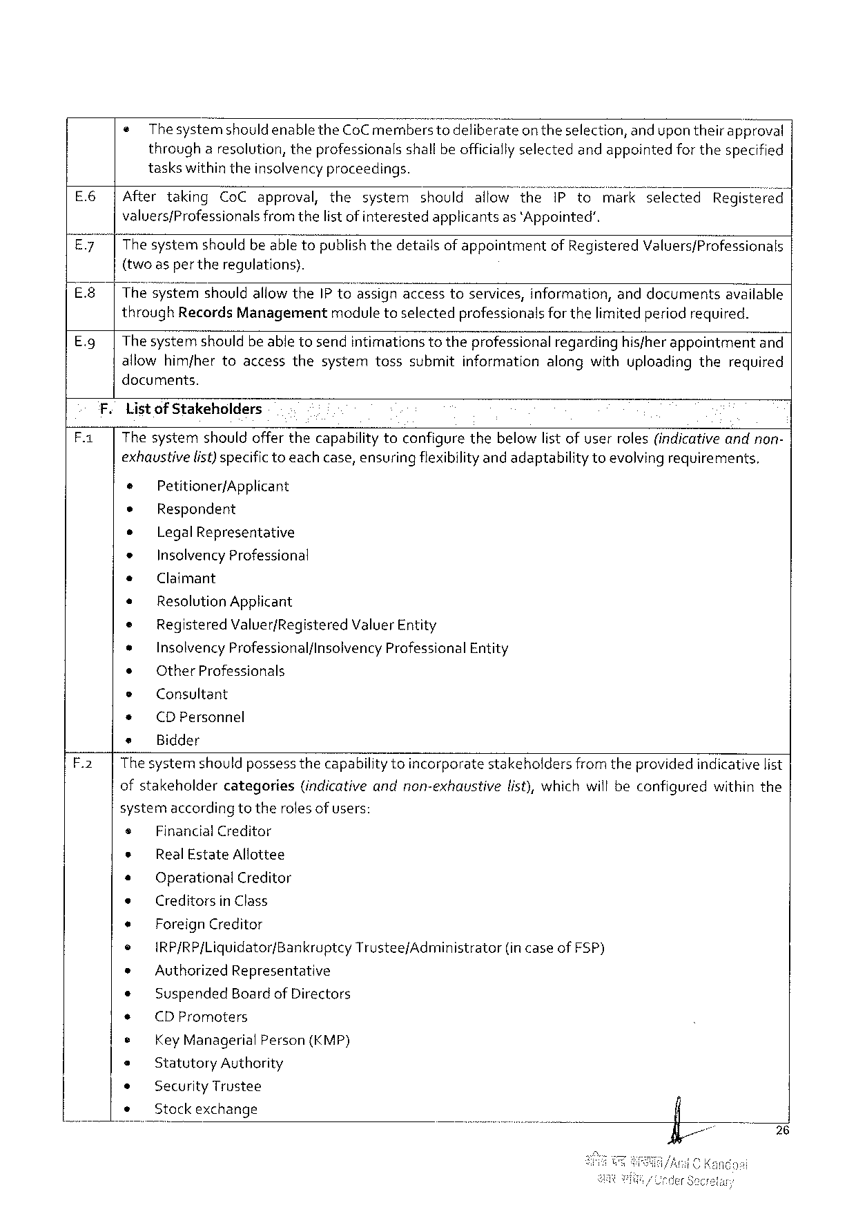

|  |  |  |
| --- | --- | --- |
| e | ThesystemshouldenabletheCoCmemberstodeliberate | on theselection,andupontheirapproval |
| througharesolution, theprofessionalsshall be officiallyselectedandappointedforthespecified | |

taskswithintheinsolvencyproceedings.

|  |  |  |  |  |  |  |  |
| --- | --- | --- | --- | --- | --- | --- | --- |
| E.6| | Aftertaking | CoCapproval,the | system | shouldallowthe | iPto | markselected | Registefé(’;! |

valuers/Professionalsfromthelist ofinterestedapplicantsas ‘Appointed’.

E.7| Thesystemshouldbeabletopublishthedetailsof appointmentof RegisteredValuers/Professionals

{two asper theregulations).

|  |  |  |  |  |  |  |
| --- | --- | --- | --- | --- | --- | --- |
| E8 | | | The s’ystemshouldallowtheIP toassignaccesstoservices,information,anddocumentsavailable | | | | |
| E.9 | | | throughRecordsManagementmodule toselectedprofessionals forthelimited periodrequired. | | | | |
| Thesystemshouldbeabletosendintimations | totheprofessional | regarding | hisfherappointment | and |

allowhim/hertoaccessthesystemtosssubmitinformationalongwithuploadingtherequired

documents.

F. Listof Stakeholders

F.1| Thesystemshouldofferthecapabilitytoconfigurethebelowlistofuserroles(indicativeandnon-

exhaustivelist) specifictoeachcase,ensuringflexibilityand adaptabilitytoevolving requirements,

e Petitioner/Applicant

* Respondent

e LegalRepresentative

* InsolvencyProfessional

e Claimant

* ResolutionApplicant

e RegisteredValuer/RegisteredValuerEntity

* InsolvencyProfessional/lnsolvencyProfessionalEntity

¢ OtherProfessionals

e Consultant

* (DPersonnel

e Bidder

F.2| Thesystemshouldpossess thecapabilitytoincorporatestakeholdersfromtheprovided indicativelist

ofstakeholder categories (indicative andnon-exhaustive list),whichwillbeconfigured withinthe

systemaccordingtotherolesof users:

|  |  |  |  |  |  |  |
| --- | --- | --- | --- | --- | --- | --- |
| s | FinancialCreditor | | | | TrusteefAdministrator | (incaseofFSP) |
| * | Real EstateAllottee | | | |
| * | OperationalCreditor | | | |
| e | CreditorsinClass | | | |
| e | ForeignCreditor | | | |
| ¢ |
| IRP/RP/Liquidator/Bankruptcy | | | |
| * | AuthorizedRepresentative | | | |
| ¢ | Suspended | BoardofDirectors | | |
| + | (DPromoters | | | |
| e |
| KeyManagerial | | Person | (KMP) |
| e | StatutoryAuthority | | | |
| * | SecurityTrustee | | | |
| s | Stock exchange | | | |

26

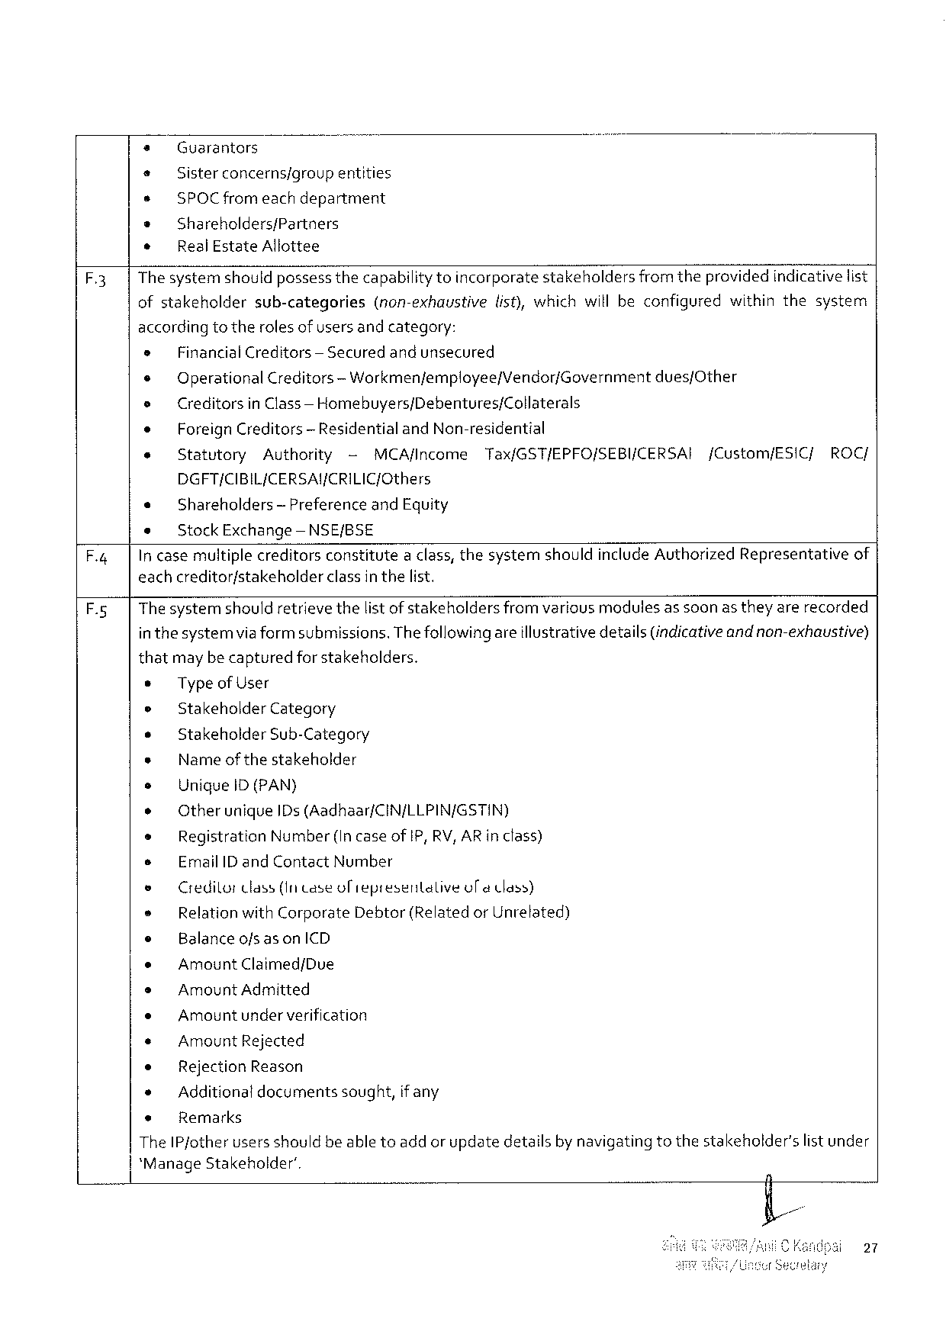

+ Guarantors

+ Sister concerns/group entities

s SPOCfromeachdepartment

s Shareholders/Partners

* RealEstateAllottee

F.3 Thesystemshouldpossessthecapabilitytoincorporate stakeholders fromtheprovidedindicativelist

ofstakeholdersub-categories (non-exhaustivelist),whichwillbeconfiguredwithinthesystem

accordingto therolesof users and category:

|  |  |  |  |  |  |  |  |  |  |
| --- | --- | --- | --- | --- | --- | --- | --- | --- | --- |
| » | FinancialCreditors | | | — Securedandunsecured | | | | | ROC/ |
| e |
| OperationalCreditors | | | | — Workmenfemployee/Vendor/Governmentdues/Other | | | |
| e | Creditorsin Class— Homebuyers/Debentures/Collaterals | | | | | | | |
| e | ForeignCreditors | | — Residential andNon-residential | | | | | |
| e | Statutory | Authority | | | - | MCA/Income | Tax/GST/EPFO/SEBI/CERSAI | [Custom/ESIC/ |

DGFT/CIBIL/CERSAY/CRILIC/Cthers

e Shareholders— PreferenceandEquity

e Stock Exchange —NSE/BSE

F.4| In casemultiplecreditorsconstitutea class, thesystemshouldincludeAuthorizedRepresentativeof

eachcreditor/stakeholderclassin thelist.

F.5| Thesystemshouldretrievethelist ofstakeholdersfrom variousmedulesas soonas they arerecorded

in thesystemvia formsubmissions. Thefollowingareillustrativedetails(indicativeandnon-exhaustive)

thatmaybecapturedforstakeholders.

* TypeofUser

e StakeholderCategory

* Stakeholder Sub-Category

e Name ofthestakeholder

s UniqueiD(PAN)

e Otherunique IDs(Aadhaar/CIN/LLPIN/GSTIN)

* RegistrationNumber(IncaseofIP, RV, ARinclass)

s EmailID and ContactNumber

o Credilortlass(Intase oliepresentalive ol@ Cass)

e RelationwithCorporate Debtor(RelatedorUnrelated)

e BalanceofsasonICD

o AmountClaimed/Due

s AmountAdmitted

e Amountunderverification

« AmountRejected

* RejectionReason

* Additionaldocumentssought,if any

+ Remarks

The IPjotherusers shouldbe abletoadd or updatedetailsby navigatingtothestakeholder'slist under

*ManageStakeholder’.

27

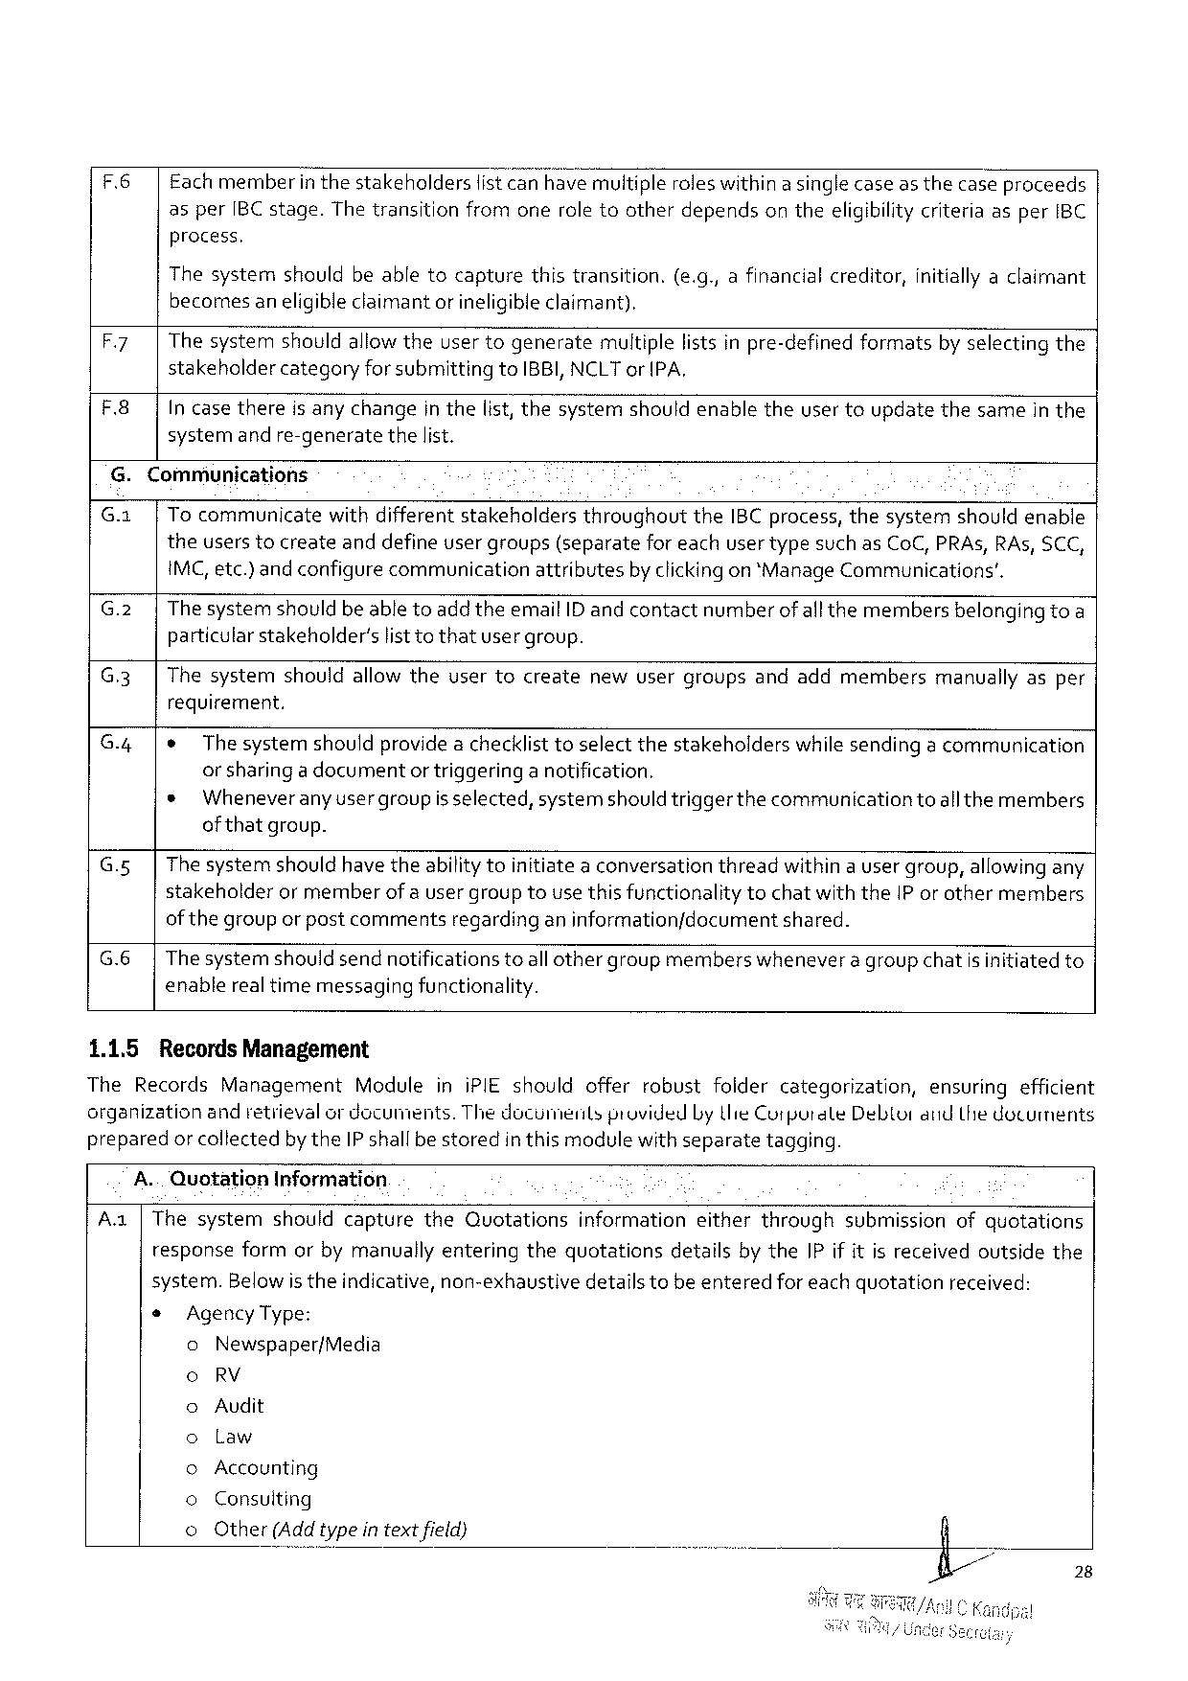

|  |  |
| --- | --- |
| F.6| | Eachmemberin thestakeholderslistcan have multipleroleswithin a singlecaseas thecase proceeds asper[BC stage.Thetransitionfromoneroletootherdependson theeligibilitycriteriaasperIBC process. |

Thesystemshouldbeabletocapturethistransition.(e.g.,afinancialcreditor,initiallyaclaimant becomesaneligibleclaimant or ineligibleclaimant).

|  |  |
| --- | --- |
| F.7|  F.8| | Thesystemshouldallowtheusertogeneratemultiplelistsinpre-definedformatsby selectingthe stakeholdercategoryforsubmittingtoIBBI,NCLTor IPA,  In casethereis anychangein thelist,thesystemshouldenabletheuser toupdatethesamein the systemand re-generatethelist. |

G.Communications

|  |  |  |  |  |  |  |
| --- | --- | --- | --- | --- | --- | --- |
| G.x|  G.2|  G.3| | TocommunicatewithdifferentstakeholdersthroughouttheIBC process,thesystemshouldenable theuserstocreateanddefineuser groups(separatefor eachuser typesuch asCoC,PRAs,RAs, SCC, IMC,etc.) and configurecommunicationattributesby clickingon *ManageCommunications’.  The systemshouldbe abletoadd theemailID andcontactnumberof allthemembersbelonging toa particularstakeholder’slisttothatusergroup. | | | | | |
| Thesystem | shouldallowtheusertocreate | newusergroups | andaddmembers | manuaily | asper |

requirement.

G.4|¢ The systemshouldprovidea checklist toselectthestakeholderswhile sendinga communication or sharinga documentor triggeringa notification.

* Wheneveranyusergroupis selected,systemshouldtriggerthe communicationtoallthemembers of thatgroup.

G.5| The systemshouldhave theabilitytoinitiatea conversationthreadwithin a usergroup,allowingany stakeholderormemberof auser grouptousethis functionalitytochatwiththeIP or othermembers of thegroupor pastcommentsregardinganinformationfdocumentshared.

G.6|The systemshould sendnotificationstoall othergroupmemberswhenevera groupchatis initiatedto enablereal timemessagingfunctionality.

1.1.5 RecordsManagement

TheRecordsManagement ModuleiniPIEshouldofferrobustfoidercategorization, ensuringefficient organizationandretievalor documents.ThedocumentsprovidedLythieCutpurateDebtorandLthe dotuments preparedor collectedby theIP shallbestoredinthis modulewith separatetagging.

A..QuotationInformation

Aa|ThesystemshouldcapturetheQuotationsinformationeitherthroughsubmissionofquotations

responseformorbymanuallyenteringthequotationsdetailsby theIPif itis receivedoutsidethe

system.Belowis theindicative, non-exhaustivedetails tobe enteredfor eachquotationreceived:

* AgencyType:

0 Newspaper/Media

0 RV

Audit

00 Law

Accounting

00 Consuiting

© Other(Add typein textfield}

28

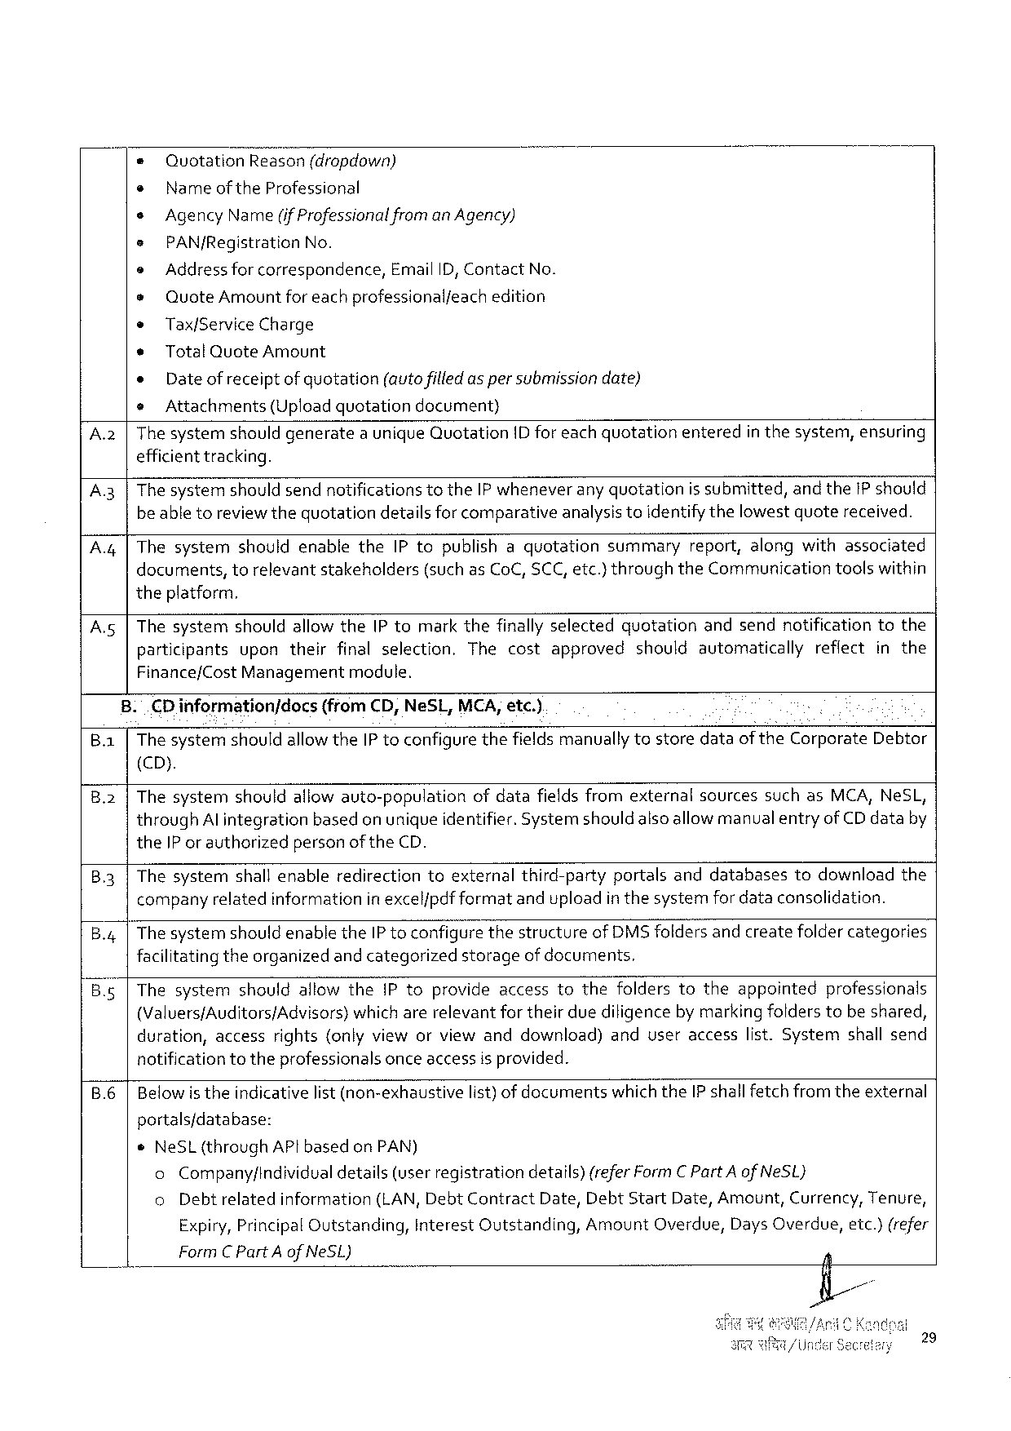

|  |  |  |  |  |  |  |  |  |  |
| --- | --- | --- | --- | --- | --- | --- | --- | --- | --- |
| * | Quotation | | Reason(dropdown) | | | | | entered | inthesystem,ensuring |
| ¢ | | Nameof theProfessional | | | | | |
| s | AgencyName(if Professionalfrom anAgency) | | | | | | |
| e | PAN/Registration | | | No. | | | |
| e | Address for correspondence,EmailID, ContactNo. | | | | | | |
| e | QuoteAmount foreachprofessionalfeachedition | | | | | | |
| e | Tax/ServiceCharge | | | | | | |
| * | | TotalQuoteAmount | | | | | |
| « | | Date of receiptof quotation(autofilledas per submissiondate) | | | | | |
| e | Attachments | | (Uploadquotation | | | decument) | |
| A.2|Thesystemshouldgenerate | | | | | auniqueQuotation | | ID foreachquotation |

efficient tracking.

A.3 |The systemshould sendnotificationstotheIP wheneverany quotationis submitted,andthe1P should beabletoreviewthequotationdetailsforcomparativeanalysistoidentifythelowestquotereceived.

A.4 |ThesystemshouldenabletheIPtopublishaquotationsummaryreport,alongwithassociated

|  |  |  |  |
| --- | --- | --- | --- |
| documents, | torelevantstakeholders | (suchasCoC,SCC, etc.)throughtheCommunication | toolswithin |

theplatform.

A.5|ThesystemshouldallowthePtomarkthefinallyselectedquotationandsendnotificationtothe

|  |  |  |  |  |
| --- | --- | --- | --- | --- |
| participants | upontheirfinalselection. | Thecostapproved | shouldautomatically | reflectinthe |

Finance/CostManagementmodule.

|  |  |  |  |
| --- | --- | --- | --- |
| Ba | . | .CDinformationjdocs | (from CD,NeSL, MCA,etc.) |
| The systemshouldallowtheIP toconfigurethefieldsmanually tostoredataof theCorporateDebtor | |

(CD).

B2 Thesystemshouldallowauto-populationofdatafieldsfromexternalsourcessuchasMCA,NeSL, throughAl integrationbasedon unique identifier. Systemshould alsoallowmanualentryofCDdataby theIP or authorizedpersonof theCD.

|  |  |
| --- | --- |
| B3 | Thesystemshallenableredirectiontoexternalthird-partyportalsanddatabasestodownloadthe companyrelatedinformationinexcelfpdfformatanduploadin thesystemfordataconsolidation. |

B.g4The systemshould enabletheIP toconfigurethestructureof DMS foldersand createfoldercategories facilitatingtheorganizedand categorizedstorageofdocuments.

ThesystemshouldallowthePtoprovideaccesstothefolderstotheappointedprofessionals

(Valuers/Auditors/Advisors) whicharerelevantfortheirduediligencebymarkingfolderstobeshared, duration,accessrights{onlyvieworviewanddownload)anduseraccesslist.Systemshallsend notificationtotheprofessionalsonceaccess isprovided.

|  |  |  |  |
| --- | --- | --- | --- |
| B.6 | Belowis theindicativelist(non-exhaustive | list) ofdocuments | whichtheIP shallfetchfromtheexternal |

portals/database:

eNeSL(throughAPtbased onPAN)

o Companyfindividual details(userregistrationdetails) (referFormCPartAof NeSL}

o Debtrelatedinformation (LAN, DebtContractDate,DebtStartDate,Amount,Currency,Tenure,

Expiry,PrincipalOutstanding, InterestQutstanding, AmountOverdue, DaysOverdue, etc.)(refer

FormC PartA ofNeSL)

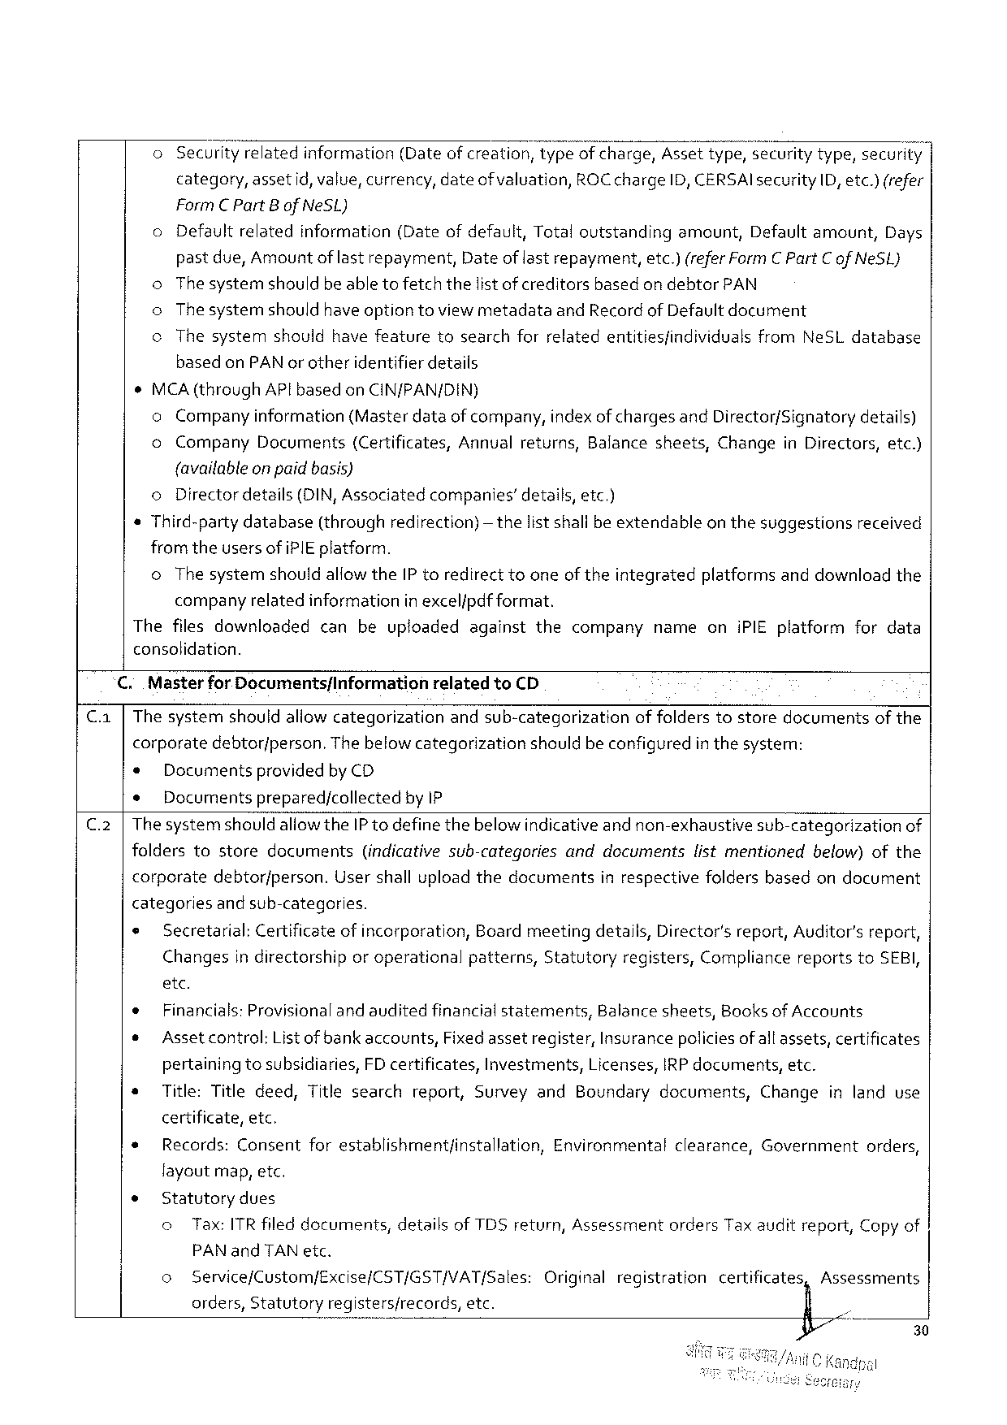

o Securityrelatedinformation (Dateofcreation,typeofcharge,Assettype,wsecuritytype,secur!t);

category,assetid,value,currency,dateofvaluation, ROCcharge ID, CERSAIsecurityID,etc.)(refer

FormC PartBofNeSL)

|  |  |  |  |  |  |  |
| --- | --- | --- | --- | --- | --- | --- |
| o | Defaultrelated | information | (Dateofdefault,Totaloutstanding | amount, | Defaultamount, | Days |

pastdue,Amountof last repayment,Dateof lastrepayment,etc.) (referFormC PartCof NeSL)

o Thesystemshouldbeable tofetchthelist ofcreditorsbasedon debtorPAN

o Thesystemshouldhave option toviewmetadataandRecordof Defaultdocument

¢ Thesystem should havefeature tosearchforrelatedentitiesfindividuals fromNeSLdatabase

based onPAN or otheridentifierdetails

MCA(throughAPlbasedonCIN/PAN/DIN)

oCompanyinformation (Masterdataof company,indexof chargesandDirector/Signatorydetails)

|  |  |  |  |  |  |  |  |  |
| --- | --- | --- | --- | --- | --- | --- | --- | --- |
| o | Company | Documents | (Certificates, | Annualreturns, | Balancesheets, | Change | inDirectors, | etc.) |

{availableon paidbasis)

oDirectordetails(DIN,Associatedcompanies’details,etc.)

Third-partydatabase(throughredirection) fromtheusers ofiPIEplatform.

— thelistshallbeextendableon thesuggestionsreceived

oThe systemshouldallowtheIP toredirecttooneoftheintegratedplatformsanddownloadthe

companyrelatedinformationin excel/pdf format.

Thefilesdownloaded canbeuploadedagainstthecompanynameoniPIEplatformfordata

consolidation.

C..Masterfor DocumentsfInformation relatedtoCD

C.a |Thesystemshouldallowcategorizationandsub-categorizationof folderstostoredocumentsofthe

corporatedebtor/person.Thebelow categorizationshouldbe configuredin thesystem:

* Documentsprovidedby CD

¢ Documentsprepared/collectedby IP

C.2|The systemshouldaliowtheIP todefinethebelowindicativeand non-exhaustivesub-categorizationof

|  |  |  |  |  |  |  |
| --- | --- | --- | --- | --- | --- | --- |
| folders | tostore | documents | (indicativesub-categories | anddocuments | listmentioned | below)ofthe |

corporatedebtorfperson.Usershalluploadthedocumentsinrespectivefoldersbasedondocument

categories andsub-categories.

e Secretarial: Certificate ofincorporation, Boardmeetingdetails, Director's report,Auditor’sreport,

Changes indirectorship oroperational patterns, Statutory registers, Compliance reportstoSEBI,

etc.

e Financials:Provisionalandauditedfinancialstatements, Balancesheets, Booksof Accounts

¢ Assetcontrol: List ofbankaccounts, Fixedassetregister,Insurancepoliciesof allassets,certificates

pertainingtosubsidiaries,FDcertificates,Investments,Licenses,IRP documents,etc.

|  |  |  |
| --- | --- | --- |
| * | Title:Titledeed,Titlesearchreport,SurveyandBoundarydocuments, | Changeinlanduse |

certificate,etc.

|  |  |  |
| --- | --- | --- |
| * | Records:Consentforestablishmentfinstallation, | Environmentalclearance,Governmentorders, |

layoutmap,etc.

e Statutorydues

o Tax:ITRfiled documents,detailsof TDSreturn,AssessmentordersTaxauditreport,Copyof

PAN andTANetc.

|  |  |  |  |  |  |  |
| --- | --- | --- | --- | --- | --- | --- |
| o | Service/Custom/Excise/CST/GST/VAT/Sales: | Original | registration | certificatesn | Assessments | 30 |
| orders,Statutoryregistersfrecords,etc. | § . | ; |

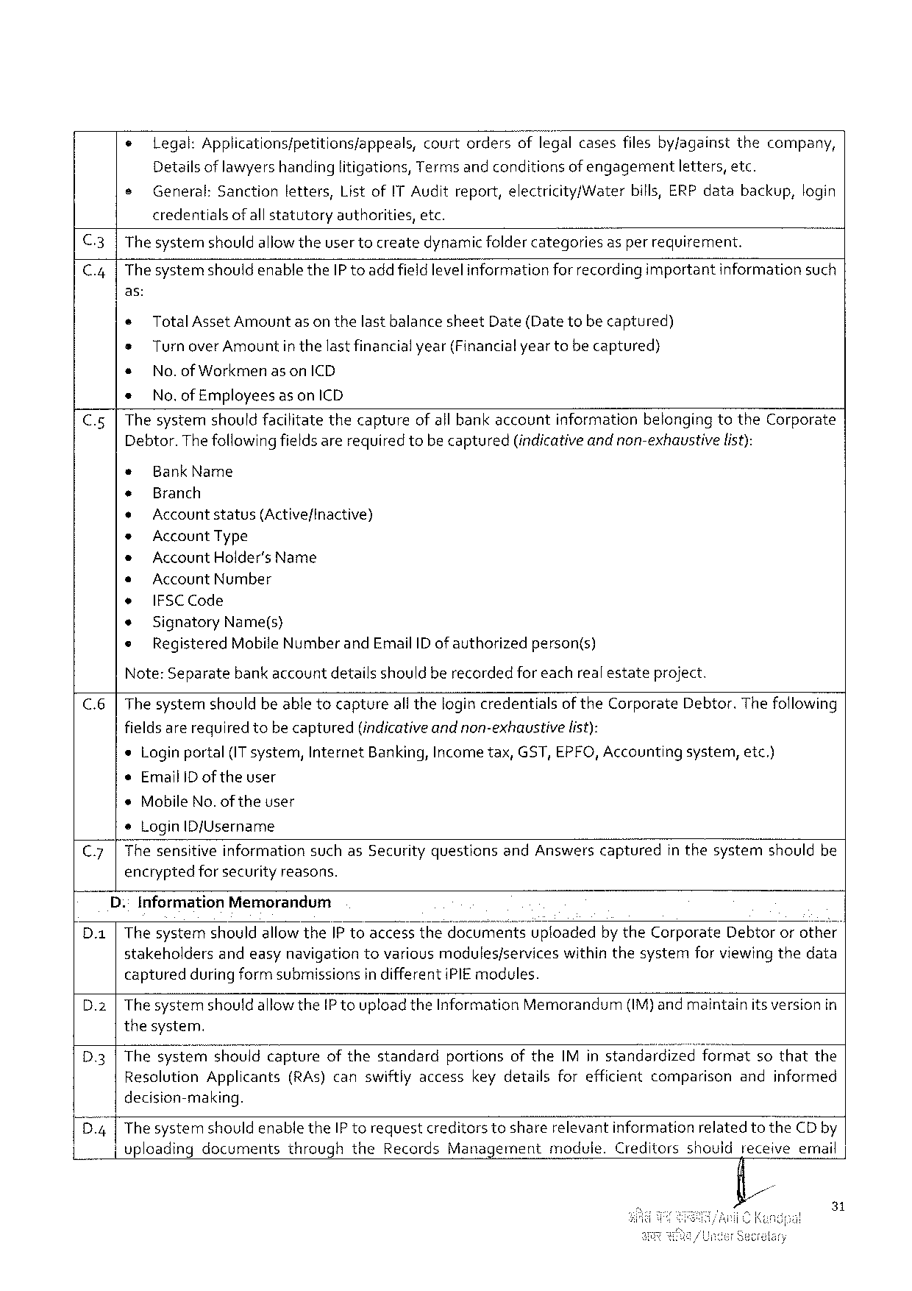

|  |  |  |
| --- | --- | --- |
| e | legal:Applications/petitions/appeals, | courtordersoflegalcasesfilesby/againstthecompany, |

Detailsof lawyers handinglitigations,Terms and conditionsof engagementletters,etc.

|  |  |  |  |  |  |  |  |  |
| --- | --- | --- | --- | --- | --- | --- | --- | --- |
| e | General: | Sanction | letters, | ListofIT Auditreport,electricity/Water | | bills,ERPdata | backup, | login |
| credentials | ofallstatutory | | authorities, | etc. |

C.3|Thesystemnshouldallowtheuser tocreatedynamicfoldercategoriesas per requirement.

|  |  |  |  |  |
| --- | --- | --- | --- | --- |
| C.4| | ThesystemshouldenabletheIP toaddfieldlevelinformation | forrecordingimportant | information | such |

as:

« TotalAssetAmountasonthelastbalancesheetDate(Datetobecaptured)

® TurnoverAmount inthelastfinancialyear(Financialyeartobecaptured)

* No.ofWorkmen as onICD

* No.of Employees as onICD

C.5|Thesystemshouldfacilitatethecaptureof all bankaccountinformationbelongingtotheCorporate Debtor.Thefollowingfieldsarerequiredtobecaptured(indicativeand non-exhaustive list):

|  |  |  |  |
| --- | --- | --- | --- |
| * | BankName | | person(s) |
| + | Branch | |
| + |
| Accountstatus(Active/inactive) | |
| * |
| AccountType | |
| * | AccountHolder's Name | |
| s | Account Number | |
| e | IFSCCode | |
| * |
| Signatory | Name(s) |
| ® | Registered | MobileNumberandEmailID ofauthorized |

Note:Separatebank accountdetailsshould berecordedfor eachrealestateproject.

C.6|The systemshouldbeable tocaptureall thelogincredentialsoftheCorporateDebtor.Thefollowing

|  |  |  |
| --- | --- | --- |
| fieldsarerequiredtobecaptured | (indicativeandnon-exhaustive | list): |

*Loginportal(IT system,InternetBanking,Incometax,GST,EPFO,Accountingsystem,etc.)

¢EmailIDof theuser

*MobileNo.of theuser

®LoginID/Username

|  |  |  |  |  |  |  |  |
| --- | --- | --- | --- | --- | --- | --- | --- |
| C.7| | Thesensitive | information | suchasSecurityquestions | andAnswers | captured | inthesystem | shouldbe |

encryptedfor securityreasons.

D.:InformationMemorandum

D.a|ThesystemshouldallowtheIP toaccessthedocumentsuploadedbytheCorporateDebtororothei stakeholdersandeasynavigationtovariousmodules/serviceswithinthesystemforviewingthedata capturedduring form submissionsin differentiPIEmodules.

D.2 |The systemshould allowtheIP toupload theInformationMemorandum(IM)and maintainitsversion in thesystem.

D3|ThesystVe»n:-swhouid captureofthestandardportionsoftheIMinstandardizedformatsothatthe ResolutionApplicants(RAs)canswiftlyaccesskeydetailsforefficientcomparisonandinformed decision-making.

D4 |The systemshouldenabletheIP torequestcreditorstosharerelevantinformationrelated totheCDby vploadingdocumentsthroughtheRecordsManagementmodule.Creditorsshouidreceiveemnail

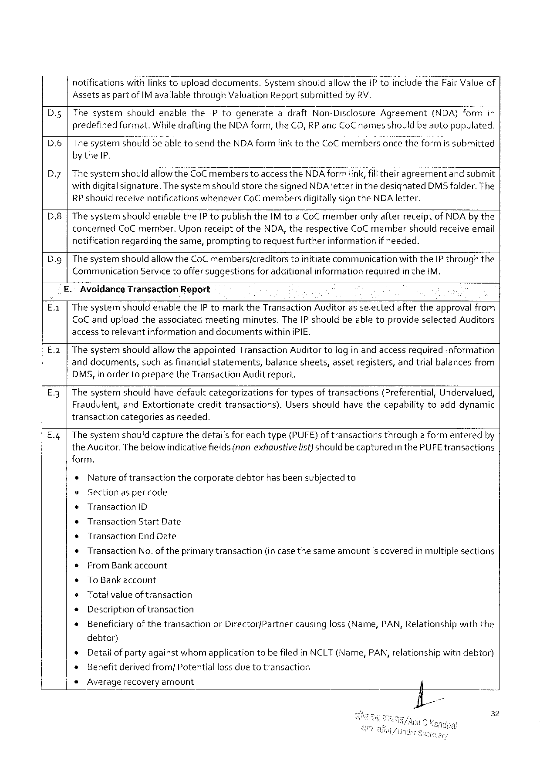

notificationswithlinkstouploaddocuments.Systemshouldallowthe1PtoincludetheFair Valueof

Assetsas partofIMavailablethroughValuationReport submittedbyRV.

|  |  |  |
| --- | --- | --- |
| D.g | ThesystemshouldenabletheIP togenerateadraftNon-DisclosureAgreement | (NDA)formin |

predefinedformat.Whiledrafting theNDAform, theCD, RPandCoCnamesshouldbeautopopulated.

|  |  |  |
| --- | --- | --- |
| D.6 | ThesystemshouldbeabletosendtheNDAformlinktotheCoCmembers | oncetheformissubmitted |

by theIP.

|  |  |
| --- | --- |
| D7 | The systemshouldallow theCoCmemberstoaccess theNDAform link,fill theiragreementandsubmit with digitalsignature.Thesystemshould storethesignedNDAletterin thedesignatedDMSfolder.The |

RP shouldreceive notifications wheneverCoC membersdigitallysigntheNDAletter.

D8 The systemshouldenabletheIP topublish theIM toaCoCmemberonlyafterreceiptof NDAby the

concernedCoCmember.UponreceiptoftheNDA, therespectiveCoCmembershouldreceiveemail

notificationregardingthesame,promptingtorequestfurtherinformationif needed.

Dy The systemshouldallowtheCoC members/creditorstoinitiatecommunicationwiththeIP throughthe

CommunicationServicetooffersuggestionsforadditionalinformationrequiredin theIM.

AvoidanceTransactionReport

The systemshouldenabletheIP tomarktheTransactionAuditoras selectedaftertheapprovalfrom

CoCanduploadtheassociatedmeetingminutes.TheIP shouldbeabletoprovideselectedAuditors

accesstorelevantinformation anddocuments withiniPIE.

E.2 The systemshouldallowtheappointedTransactionAuditor tolog in andaccessrequiredinformation

anddocuments, suchasfinancialstatements, balancesheets, assetregisters, andtrialbalancesfrom

DMS,inordertopreparetheTransactionAudit report.

|  |  |  |  |  |  |
| --- | --- | --- | --- | --- | --- |
| E3 | Thesystemshouldhavedefault | categorizations | fortypesoftransactions | (Preferential, | Undervalued, |

Fraudulent,andExtortionatecredittransactions).Usersshouldhavethecapabilitytoadddynamic

transactioncategoriesas needed.

E.q Thesystemshouldcapturethedetailsforeachtype(PUFE)of transactionsthrougha formenteredby

theAuditor.Thebelowindicativefields(non-exhaustive list)shouldbecaptured in thePUFEtransactions

form.

*Natureof transactionthecorporatedebtorhasbeensubjectedto

®Sectionas per code

|  |  |  |  |  |
| --- | --- | --- | --- | --- |
| e | Transaction | D | (in casethesameamount | iscoveredinmultiplesections |
| s | Transaction | StartDate |
| « | Transaction | EndDate |
| ¢ | Transaction | No.oftheprimarytransaction |
| e | FromBankaccount | |

sToBankaccount

¢Totalvalueof transaction

* Descriptionoftransaction

* Beneficiaryof thetransactionorDirector/Partnercausingloss (Name,PAN,Relationshipwiththe

debtor)

* Detailofpartyagainstwhomapplicationtobefiled in NCLT(Name,PAN,relationshipwithdebtor)

» Benefitderivedfrom/Potential lossduetotransaction

e Averagerecoveryamount

32

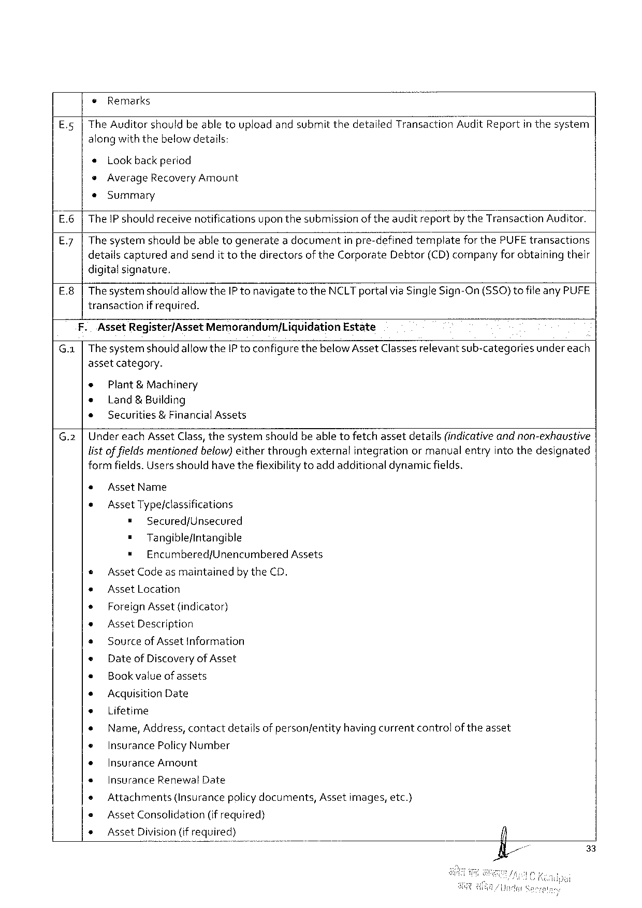

¢ Remarks

E.5 |The Auditorshouldbeabletouploadandsubmit thedetailedTransactionAuditReportin thesystem

alongwiththebelowdetails:

« Lookbackperiod

*AverageRecoveryAmount

e«Summary

E.6 |TheIP shouldreceive notificationsuponthesubmissionoftheauditreportby theTransactionAuditor.

E.7 |The systemshouldbe abletogeneratea documentin pre-definedtemplateforthePUFE transactions

detailscapturedandsendit tothedirectorsof theCorporateDebtor(CD)companyfor obtainingtheir

digitalsignature.

E.8|ThesystemshouldallowtheIP tonavigatetotheNCLTportalviaSingleSign-On(SSO)tofile anyPUFE

transactionif required.

|  |  |  |
| --- | --- | --- |
| F. | AssetRegister/AssetMemorandumjLiquidation | Estate |

G.1 |Thesystemshould allowtheIP toconfigurethebelowAssetClassesrelevantsub-categoriesundereach

assetcategory.

e Plant& Machinery

* Land& Building

* Securities&FinancialAssets

G.2 |Under eachAssetClass,thesystemshouldbe abletofetchassetdetails(indicativeandnon-exhaustive

listoffieldsmentionedbelow)eitherthroughexternalintegrationormanualentryinto thedesignated

formfields.Usersshouldhave thefiexibilitytoadd additionaldynamicfields.

« AssetName

* AssetType/classifications

= Secured/Unsecured

= Tangible/intangible

* Encumbered/UnencumberedAssets

© AssetCodeas maintainedbytheCD.

* AssetLocation

* ForeignAsset {indicator)

e AssetDescription

s Sourceof AssetInformation

e DateofDiscoveryof Asset

« Bookvalueof assets

* AcquisitionDate

e Lifetime

* Name, Address, contactdetailsof personfentityhavingcurrentcontrolof theasset

« InsurancePolicyNumber

* InsuranceAmount

« InsuranceRenewalDate

* Attachments (Insurancepolicydocuments, Assetimages,etc.)

e AssetConsolidation (if required)

* AssetDivision(ifrequired)

33

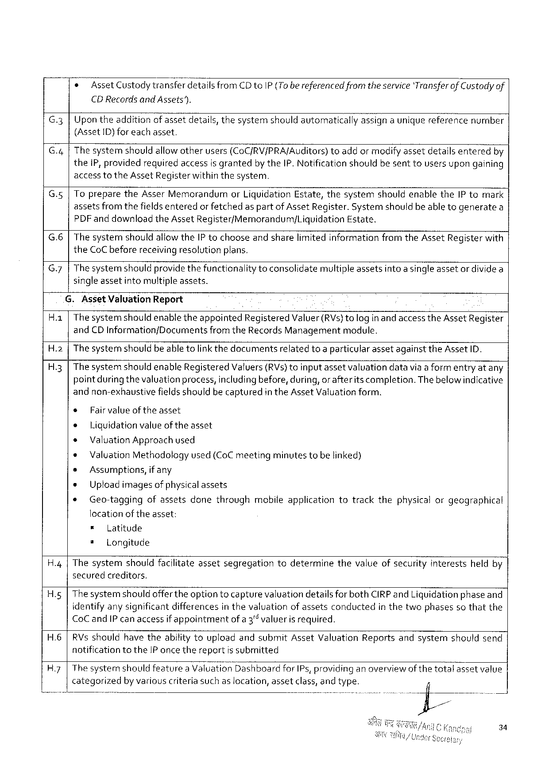

* Asset Custodytransferdetails fromCD toIP(Tobe referencedfromthe service‘Transferof Custodyof

CDRecordsandAssets”).

G.3 Upontheadditionofassetdetails,thesystemshould automaticallyassigna uniquereferencenumber

(Asset{D) foreachasset.

G.4 The systemshouldallowotherusers(CoC/RV/PRA/Auditors)toaddor modify assetdetailsenteredby

the1P, providedrequiredaccessisgranted by theIP.Notificationshouldbesenttousersupongaining

accesstotheAssetRegisterwithinthesystem.

|  |  |  |  |  |  |  |  |  |
| --- | --- | --- | --- | --- | --- | --- | --- | --- |
| Gs  G.6 | Toprepare | theAsserMemorandum | | | orLiquidation | Estate, | thesystem | shouldenabletheIPtomark |
| assetsfromthefieldsenteredor fetchedas partofAssetRegister.Systemshouldbe able togeneratea | | | | | | | |
| PDFanddownload | | theAsset | Register/Memorandum/Liguidation | | | Estate. | |
| ThesystemshouldallowtheIP tochooseand sharelimited informationfromtheAssetRegisterwith | | | | | | | |

theCoC beforereceivingresolutionplans.

G.7 Thesystemshouldprovidethefunctionality toconsolidatemultipleassetsintoasingleassetor dividea

singleassetintomultipleassets.

G.AssetValuationReport

|  |  |  |
| --- | --- | --- |
| Ha | Thesystemshouldenabletheappointed | RegisteredValuer(RVs)tologin andaccesstheAssetRegister |

andCDInformation/DocumentsfromtheRecords Managementmodule.

|  |  |  |  |  |  |
| --- | --- | --- | --- | --- | --- |
| H.2  H3 | The systemshouldbe able tolink thedocumentsrelatedtoa particularassetagainsttheAssetID. The systemshouldenableRegisteredValuers(RVs)toinputassetvaluationdatavia aform entryatany pointduringthevaluation process,includingbefore, during, orafterits completion.Thebelow indicative andnon-exhaustivefieldsshouldbecapturedin theAssetValuationform. | | | | |
| ¢ | Fairvalue | | oftheasset. | |
| e | Liquidationvalue of the asset | | | |
| ¢ | | ValuationApproachused | | |
| * | | ValuationMethodologyused (CoCmeetingminutes tobe linked) | | |
| s | Assumptions, | | | if any |
| » | Uploadimagesof physicalassets | | | |
| * | Geo-taggingofassetsdonethroughmobileapplicationtotrackthephysicalorgeographical | | | |

locationoftheasset:

|  |  |  |  |  |  |  |  |  |  |
| --- | --- | --- | --- | --- | --- | --- | --- | --- | --- |
| H.4 | = | | Latitude | | assetsegregation | todetermine | thevalueofsecurity | interests | heldby |
| s | Longitude | | |
| Thesystem | | | shouldfacilitate |

securedcreditors.

H.g Thesystemshouldofferthe optiontocapturevaluationdetailsfor bothCIRPandLiguidationphaseand

identifyany significantdifferencesin thevaluationofassetsconductedin thetwophasesso thatthe

|  |  |  |
| --- | --- | --- |
| CoC andIP canaccess | ifappointment | ofa 3"valuerisrequired. |

H.6|RVs shouldhavetheabilitytouploadandsubmitAssetValuationReportsandsystemshouldsend

notificationtotheIP once thereportis submitted

|  |  |  |  |  |
| --- | --- | --- | --- | --- |
| H.7|Thesystemshouldfeaturea ValUationDashboard | | forIPs, providinganoverview | of the | totalassetvalue |
| categorized | by variouscriteriasuchaslocation,assetclass,andtype. | |

34

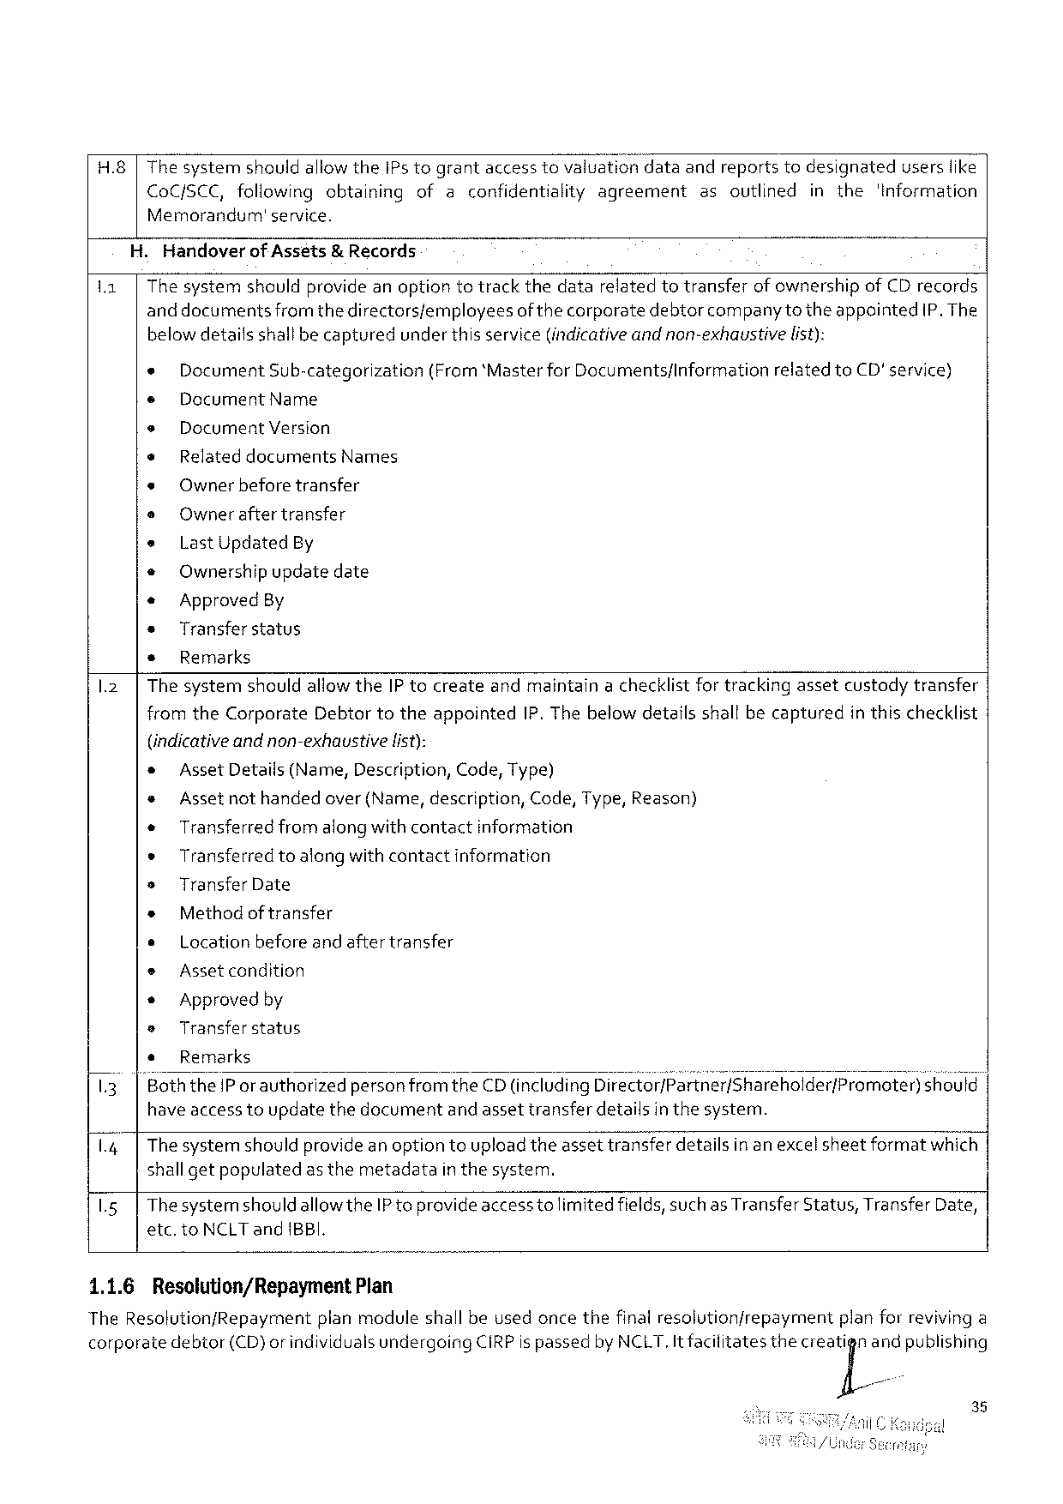

H.8|The systemshouldallowtheIPs tograntaccess tovaluationdataandreportstodesignateduserslike

|  |  |  |  |  |  |
| --- | --- | --- | --- | --- | --- |
| CoCfSCC, followingobtaining | | ofaconfidentialityagreement | asoutlined | inthe | 'Information |
| Memorandum' | service. |

.HandoverofAsséts& Records

11| The systemshouldprovideanoptiontotrackthedatarelatedtotransferof ownershipof CD records

anddocuments fromthedirectorsfemployees of thecorporate debtor companytotheappointed IP. The

belowdetailsshallbecaptured underthisservice(indicativeandnon-exhaustive list):

e Document Sub-categorization (From‘Master forDocuments/Information related toCD'service)

¢ DocumentName

e Document Version

e RelateddocumentsNames

e Owner beforetransfer

e Owner after transfer

e LastUpdated By

* Ownershipupdatedate

« Approved By

* Transferstatus

s Remarks

1.2| The systemshouldallowtheIP tocreateandmaintaina checklistfor trackingassetcustodytransfer

fromtheCorporateDebtortotheappointedIP. Thebelowdetailsshallbecapturedin thischecklist

|  |  |  |  |  |  |  |  |  |
| --- | --- | --- | --- | --- | --- | --- | --- | --- |
| 13 | (indicativeandnon-exhaustive | | | | list): | | | should |
| * | | AssetDetails(Name,Description, Code,Type) | | | | |
| * | Assetnothandedover(Name,description, | | | | | Code,Type,Reason) |
| « | | Transferredfromalongwith contactinformation | | | | |
| e | Transferredtoalongwithcontactinformation | | | | | |
| s | TransferDate | | | | | |
| * | | Methodof transfer | | | | |
| ¢ | | Locationbefore and aftertransfer | | | | |
| e | Asset condition | | | | | |
| * | | Approved by | | | | |
| e | Transfer status | | | | | |
| * | | Remarks | | | | |
| |"BoththeIP or authorized | | | personfrom | | theCD(includingDlrsctor/}séf{né;/shareho!der/Promoter) | |

have access toupdatethedocumentand assettransferdetailsin thesystem.

1.4| Thesystemshouldprovideanoptiontoupload theassettransferdetailsin an excelsheetformatwhich |

shallgetpopulated as themetadata inthesystem.

1.5| Thesystemshouldallow theIP toprovideaccesstolimitedfields,such as TransferStatus,TransferDate,

etc.toNCLTandIBBI.

|  |  |  |
| --- | --- | --- |
| 1.1.6 | Resolution/Repayment | Plan |

TheResolution/Repaymentplanmoduleshall beusedoncethefinalresolutionfrepaymentplanforrevivinga

|  |  |  |  |  |  |
| --- | --- | --- | --- | --- | --- |
| corporate | debtor | (CD)orindividualsundergoing | CIRPispassedbyNCLT,Itfaciiitates | thecleaj[iand | publishing |

35

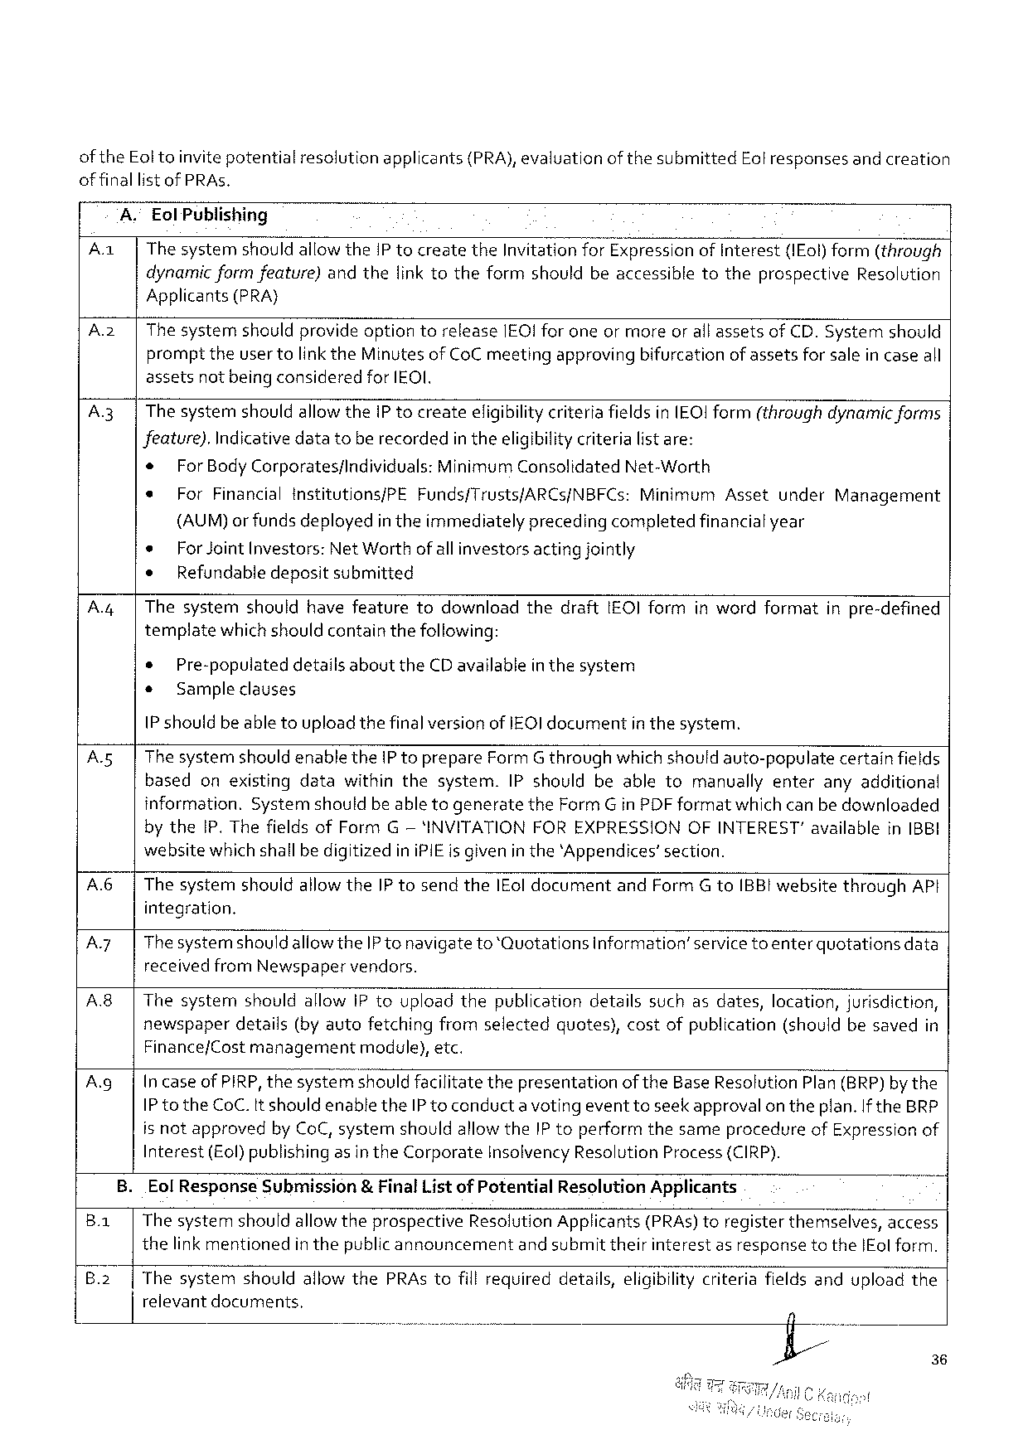

of theEoltoinvitepotentialresolutionapplicants(PRA), evaluationof thesubmittedEolresponsesand creation

offinallistof PRAs.

A." EolPublishing

|  |  |
| --- | --- |
| A | |The systemshould allowtheIP tocreatetheInvitationforExpressionofInterest(IEol) form(through dynamicformfeature)andthefinktotheformshouldbeaccessibletotheprospectiveResolution |

Applicants(PRA}

|  |  |  |
| --- | --- | --- |
| A2 | | | The systemshouldprovideoptiontoreleaseIEO! foroneor moreorall assetsofCD.Systemshould |
| prompttheuser tolinktheMinutes of CoC meetingapprovingbifurcationof assetsfor salein caseall |

assetsnot being consideredfor [EOI.

A.3| ThesystemshouldallowtheiP tocreateeligibilitycriteria fieldsinIEO!Iform(throughdynamic forms

Jeature).Indicativedatatoberecordedin theeligibilitycriteria listare:

|  |  |  |  |  |  |  |
| --- | --- | --- | --- | --- | --- | --- |
| * | ForBodyCorporates/individuals:MinimumConsolidatedNet-Worth | | | Asset | under | Management |
| e |
| ForFinancialinstitutions/PE | Funds/Trusts/ARCS/NBFCs: | Minimum |

(AUM)or fundsdeployedin theimmediatelyprecedingcompletedfinancialyear

|  |  |  |  |  |  |  |  |  |  |  |
| --- | --- | --- | --- | --- | --- | --- | --- | --- | --- | --- |
| A.4| | * | ForJointInvestors: | | | NetWorthofallinvestorsactingjointly | | | | inwordformat | inpre-defined |
| ¢ | Refundabledepositsubmitted | | | | | | |
| Thesystem | | should | havefeature | | todownload | thedraft | 1EOIform |
| templatewhichshouldcontainthefollowing: | | | | | | | |
| * | Pre-populateddetailsabouttheCDavailablein thesystem | | | | | | |
| o | Sample clauses | | | | | | |

1P shouldbeable toupload thefinalversionofIEQ] documentin thesystem.

|  |  |  |
| --- | --- | --- |
| A5 | | | The systemshould enabletheIP toprepareFormG throughwhichshouldauto-populatecertainfields |

basedonexistingdatawithinthesystem.IPshouldbeabletomanuallyenteranyadditional

information.Systemshouldbe able togeneratetheFormGin PDF formatwhich can bedownloaded

by theIP. ThefieldsofFormG— 'INVITATIONFOREXPRESSIONOFINTEREST"availablein1BBI

websitewhichshallbedigitizediniPIEis givenin the‘Appendices’section.

|  |  |  |  |  |  |  |
| --- | --- | --- | --- | --- | --- | --- |
| A.6| | | ThesystemshouldallowtheIP tosendtheIEoldocumentandFormG toIBBI websitethroughAPt integration. | | | | |
| A7 | | | Thesystemshould | aliowtheIP tonavigateto‘Quotations | | information’servicetoenterquotations | data |
| A8| | | receivedfromNewspaper | | vendors. | | |
| ThesystemshouldallowIPtouploadthepublicationdetailssuchasdates,location,jurisdiction, newspaperdetails(byautofetchingfromselectedquotes),costofpublication(shouldbesavedin | | | | |

Finance/Cost managementmodule),etc.

|  |  |
| --- | --- |
| A.g| | IncaseofPIRP,thesystemshouldfacilitatethepresentationof theBaseResolutionPlan(BRP)by the IP totheCoC.It shouldenabletheIP toconducta voting eventtoseekapprovalon theplan. If theBRP |

is notapprovedby CoC, systemshouldallowtheIP toperformthesameprocedureofExpressionof

Interest(Eol) publishingasin theCorporateInsolvencyResolutionProcess {CIRP).

B.EolResponseSubmission& FinalListof PotentialResolutionApplicants q

Ba | The systemshouldallowtheprospectiveResolutionApplicants(PRAs) toregisterthemselves,access

thelinkmentionedin thepublic announcement and submit theirinterestas responsetotheIEol form.

B.2| ThesystemshouldallowthePRAstofillrequireddetails,eligibility criteriafieldsanduploadthe

relevantdocuments,

36

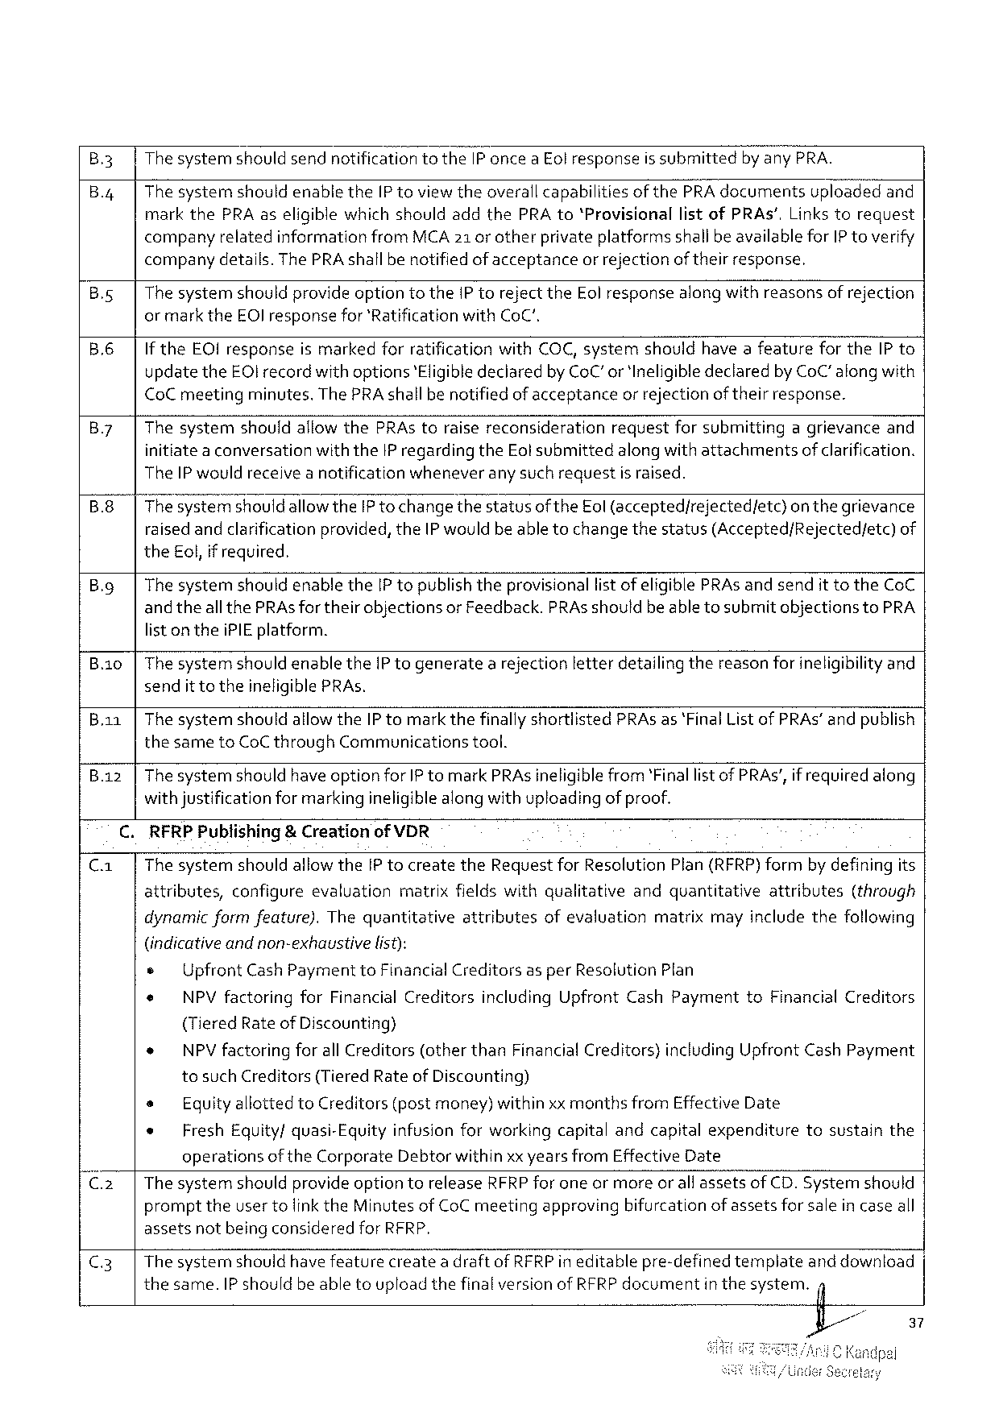

B3 ThesystemshouldsendnotificationtotheIP onceaEol response is submitted by anyPRA.

B.4 ThesystemshouldenabletheIP toviewtheoverallcapabilities of thePRAdocumentsuploadedand markthePRAaseligible whichshouldaddthePRA to‘ProvisionallistofPRAs’,Links torequest companyrelatedinformation fromMCA21 or otherprivateplatformsshallbeavailableforIP toverify

|  |  |  |  |
| --- | --- | --- | --- |
| B.s  B.6 | company | details.ThePRAshallbenotifiedof acceptance | orrejectionof theirresponse. |
| Thesystemshouldprovideoptiontothe1P torejecttheEol responsealongwithreasonsof rejection or marktheEOIresponsefor'Ratification withCoC".  If theEOIresponseis markedforratificationwithCOC,systemshouldhave afeaturefortheIP to | | |

updatetheEOI record withoptions‘Eligible declaredbyCoC’or 'IneligibledeclaredbyCoC” alongwith CoCmeetingminutes.ThePRAshallbe notifiedof acceptanceor rejection of theirresponse.

|  |  |  |  |  |  |  |
| --- | --- | --- | --- | --- | --- | --- |
| B.7 | Thesystem | shouldallowthePRAstoraisereconsideration | request | forsubmitting | agrievance | and |

initiate a conversationwiththeIP regardingtheEolsubmittedalong withattachmentsofclarification. TheIP wouldreceive a notificationwheneverany such requestis raised.

B.8 ThesystemshouldallowtheIP tochangethestatusof theEol(accepted/rejectedfetc)on thegrievance raised andclarificationprovided, theIP would beable tochangethestatus(Accepted/Rejected/etc)of theEol,if required.

|  |  |
| --- | --- |
| B.g | ThesystemshouldenabletheIP topublishtheprovisionallist of eligiblePRAs andsendittotheCoC and theall thePRAsfortheirobjectionsor Feedback.PRAsshouldbeabletosubmit objectionsto PRA |

list ontheiPIEplatform.

B.io ThesystemshouldenabletheIP togeneratea rejectionletterdetailing thereasonforineligibilityand sendit totheineligiblePRAs.

|  |  |
| --- | --- |
| B.aa  B.az | ThesystemshouldallowtheIP tomark thefinallyshortlistedPRAs as‘Final ListofPRAs” andpublish thesametoCoCthroughCommunicationstool.  Thesystemshouldhave optionforIP tomarkPRAsineligiblefrom‘Finallist of PRAs’, ifrequired along |

withjustificationfor markingineligiblealong with uploadingof proof.

RFRPPubtishing& CreationofVDR

Thesystemshouldallowthe[P tocreatetheRequestforResolutionPlan(RFRP)formby definingits

|  |  |  |  |  |  |  |
| --- | --- | --- | --- | --- | --- | --- |
| attributes, | configure | evaluation | matrixfieldswithqualitative | andquantitative | attributes | (through |

dynamicformfeature).Thequantitativeattributesofevaluationmatrixmayincludethefollowing

(indicativeandnon-exhaustive list):

e UpfrontCashPayment toFinancialCreditorsasperResolutionPlan

e NPVfactoringforFinancial CreditorsincludingUpfrontCashPaymenttoFinancialCreditors

(TieredRateofDiscounting)

* NPV factoringforallCreditors(otherthanFinancialCreditors}includingUpfrontCash Payment

tosuchCreditors(TieredRateofDiscounting)

|  |  |  |  |  |  |
| --- | --- | --- | --- | --- | --- |
| s | EquityallottedtoCreditors (postmoney)withinxxmonthsfromEffectiveDate | | | tosustain | the |
| * | FreshEquity/quasi-Equity | | infusionforworkingcapitalandcapitalexpenditure |
| operations | oftheCorporate | Debtorwithinxx yearsfromEffectiveDate |

The systemshouldprovide optiontereleaseRFRPfor eneormoreor all assetsofCD. Systemshould prompttheuser tolink theMinutesof CoC meetingapprovingbifurcation of assetsfor salein case all assetsnotbeing consideredfor RFRP,

|  |  |  |  |  |
| --- | --- | --- | --- | --- |
| C3 | Thesystemshouldhavefeaturecreatea draftofRFRPineditablepre-defined | | template | anddownload |
| thesame.IP shouldbeabletouploadthefinalversionofRFRPdocument | inthesystem. | | fl |

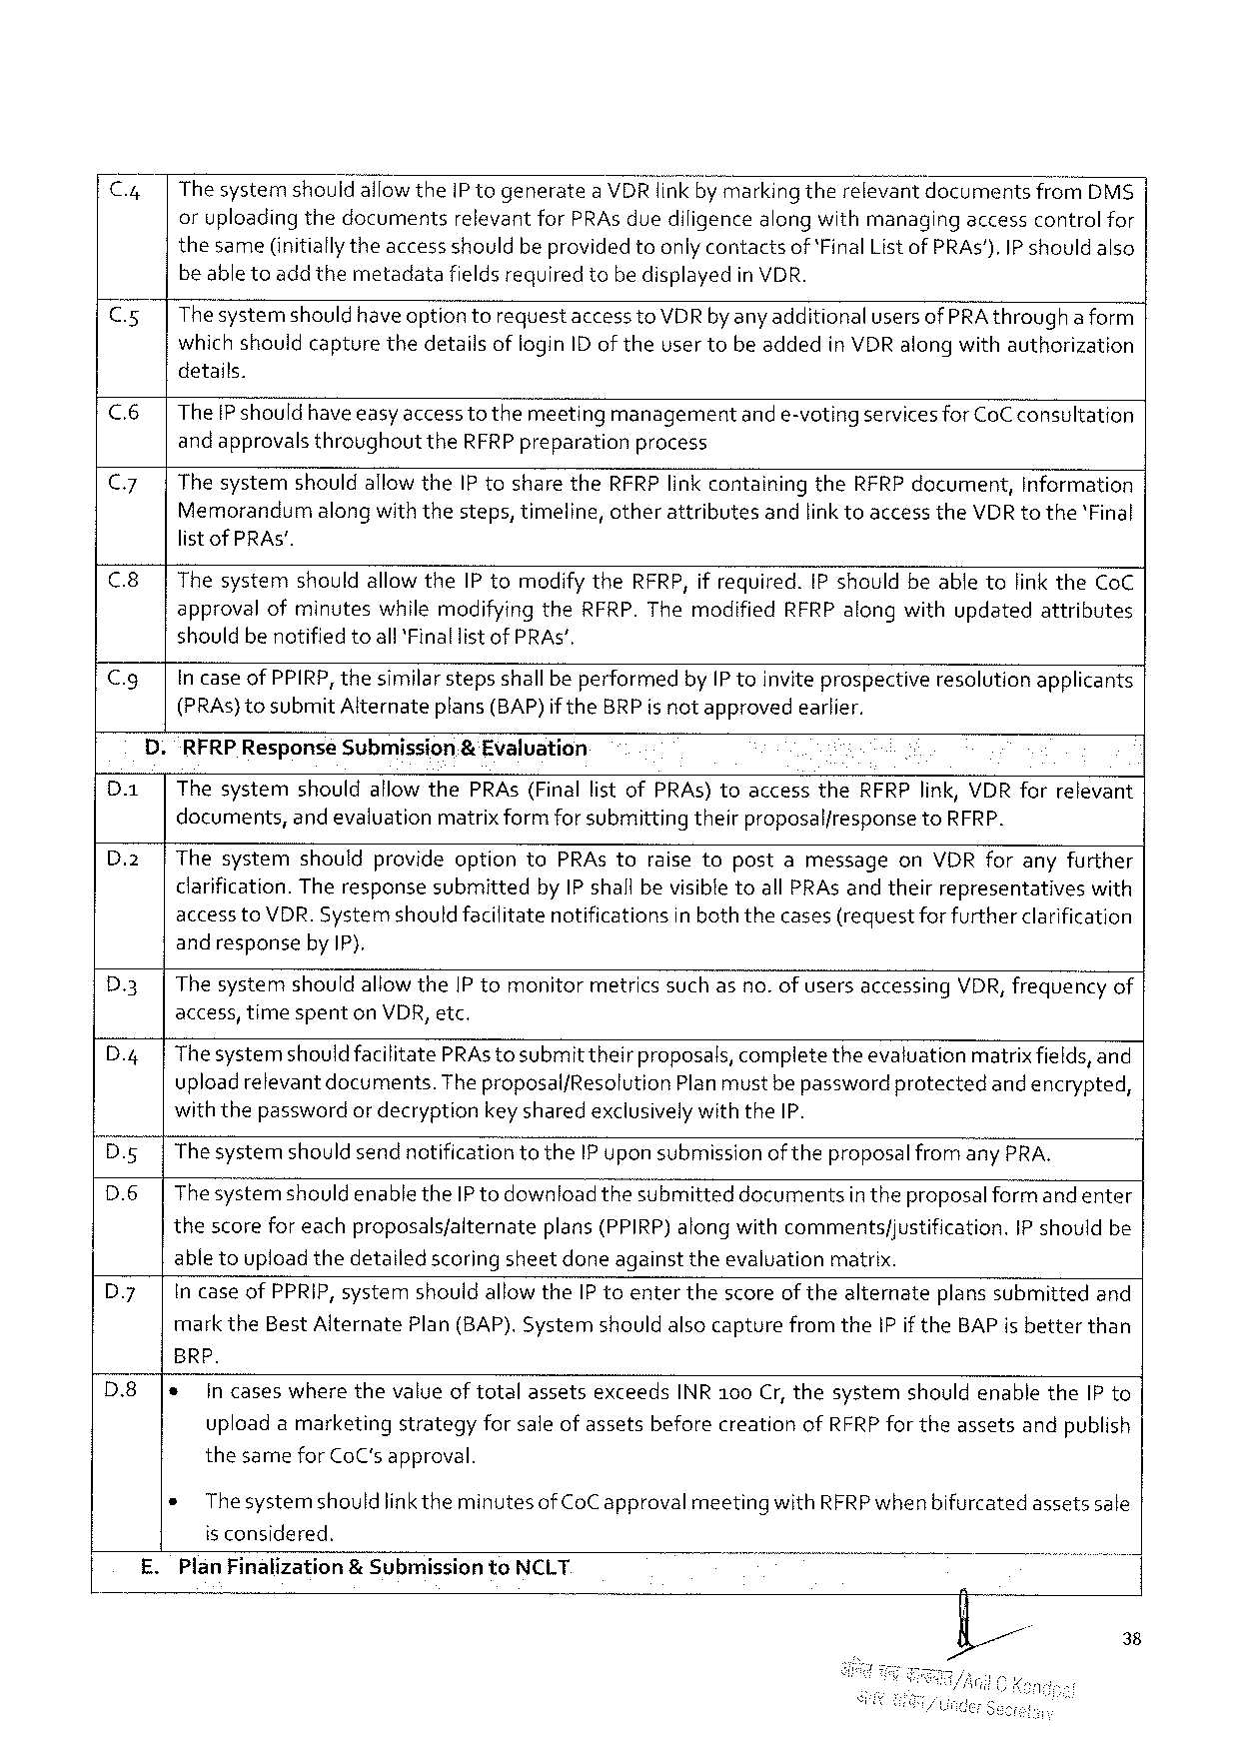

|  |  |  |  |  |  |
| --- | --- | --- | --- | --- | --- |
| Cy  Cxs | ThesystemshouldallowtheIP togenerate | | a VDRlinkby markingtherelevantdocuments | | fromDMS$ |
| oruploadingthedocuments | relevantforPRAs duediligencealongwithmanaging | | accesscontrolfor | |
| thesame(initiallytheaccess shouldbeprovided toonly contactsof‘FinalList of PRAs').IP shouldalso beabletoadd themetadatafieldsrequiredtobedisplayedin VDR.  Thesystemshould have optiontorequestaccessto VDRby anyadditionalusersofPRA througha form which shouldcapturethedetailsoflogin IDof theusertobeaddedinVDR alongwithauthorization | | | | |

details.

|  |  |
| --- | --- |
| c6  Cy  c8 | TheIP should haveeasyaccessto themeetingmanagementand e-votingservicesforCoCconsultation and approvals throughouttheRFRPpreparationprocess  ThesystemshouldallowtheIP tosharetheRFRPlinkcontainingtheRFRP document,Information Memorandumalongwiththesteps,timeline,otherattributesandlinktoaccesstheVDRtothe'Final listof PRAS’.  Thesystemshouldallow theIP tomodify theRFRP,if required.IP shouldbeabletolinktheCoC |

approvalofminuteswhilemodifyingtheRFRP.ThemodifiedRFRPalongwithupdatedattributes shouldbenotified toall*Finallistof PRAS’,

|  |  |  |
| --- | --- | --- |
| Cg | . | in caseof PPIRP,thesimilarstepsshallbe performedbyIP toinvite prospectiveresolutionapplicants |
| (PRAs)tosubmitAlternateplans(BAP)if theBRPis not approvedearlier. |
| “RFRP ResponseSubmission& Evaluation |

Thesystemshouldaflow thePRAs(FinallistofPRAs)toaccesstheRFRPlink,VDR forrelevant documents,and evaluationmatrixform forsubmittingtheirproposaliresponsetoRFRP.

ThesystemshouldprovideoptiontoPRAstoraisetopostamessageonVDRforanyfurther clarification.Theresponsesubmittedby IP shall bevisibletoallPRAsandtheirrepresentativeswith access toVDR. Systemshould facilitatenotificationsin boththecases(requestfor furtherclarification and responseby IP),

|  |  |  |  |  |  |
| --- | --- | --- | --- | --- | --- |
| D3 | Thesystem | shouldallowtheIPtomonitor | metricssuchasno.ofusersaccessing | VDR,frequency | of |

access,timespentonVDR,etc.

|  |  |
| --- | --- |
| D.4 | ThesystemshouldfacilitatePRAstosubmittheirproposals, compietetheevaluationmatrixfields,and uploadrelevantdocuments.TheproposalfResolutionPlanmustbe passwordprotectedand encrypted, |

withthepasswordor decryptionkeysharedexclusivelywith theIP.

D.g Thesystemshould sendnotificationtotheIP uponsubmissionofthe proposalfrom any PRA.

D.6 Thesystemshould enabletheIPto downloadthesubmitteddocumentsin theproposal form and enter

thescorefor eachproposalsfalternateplans (PPIRP)alongwithcommentsfjustification. IP shouldbe

abletouploadthedetailedscoringsheetdoneagainsttheevaluation matrix.

D.y Incase ofPPRIP,systemshouldallowtheIP toenterthescoreof thealternateplanssubmittedand

mark theBestAlternatePlan (BAP).SystemshouldalsocapturefromtheIP iftheBAP isbetterthan

BRP.

|  |  |  |
| --- | --- | --- |
| D.8 | * | in caseswherethevalue oftotalassetsexceedsINR100 Cr,thesystemshouldenabletheIP to |

uploadamarketingstrategyforsale ofassetsbeforecreationofRFRPfor theassetsandpublish

thesameforCoC'sapproval.

® The systemshould linkthe minutesofCoC approvalmeetingwithRFRP whenbifurcatedassetssale

is considered.

£. PlanFinalization& SubmissiontoNCLT

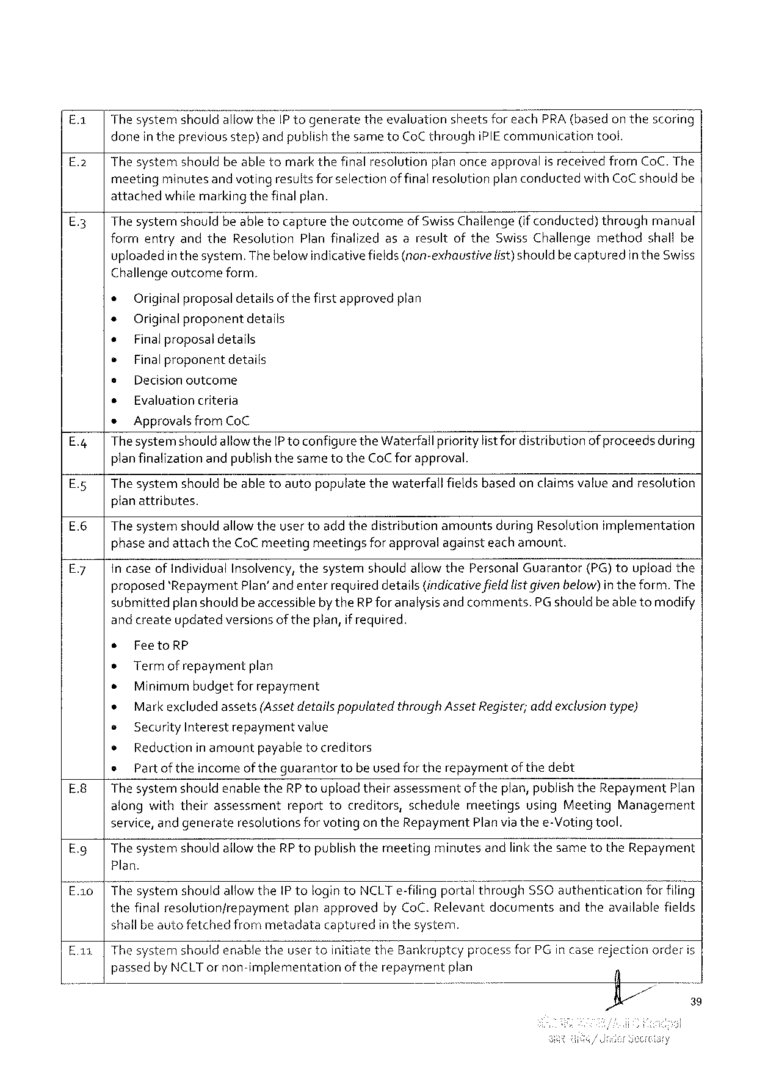

|  |  |  |  |  |  |  |
| --- | --- | --- | --- | --- | --- | --- |
| £.1 | ThesystemshouldallowtheIP togenerate | theevaluation | sheetsforeachPRA(basedonthescoring | | | |
| E.2 | doneinthepreviousstep)andpublishthesametoCoCthrough | | | iPIEcommunication | | tool. |
| Thesystemshouldbeabletomarkthefinalresolutio—r\"E!anonceapproval | | | | is receivedfromCoC.The | |

meetingminutesand voting resultsforselectionof finalresolutionplanconductedwithCoC shouldbe attachedwhilemarkingthefinalplan.

E.3| Thesystemshouldbeable tocapturetheocutcomeof SwissChallenge(ifconducted)throughmanual formentryandtheResolutionPlanfinalizedasaresultoftheSwissChallengemethodshallbe

uploadedin the system.Thebelowindicativefields(non-exhaustive

Challengeoutcome form.

* Originalproposaldetailsof thefirst approvedplan

+ Original proponentdetails

+ Final proposal details

e Finalproponent details

s Decisionoutcome

s Evaluationcriteria

* ApprovalsfromCoC

list) should becapturedin theSwiss

|  |  |  |
| --- | --- | --- |
| E.4| | Thesystemshould | allowtheIP toconfiguretheWaterfallprioritylistfordistributionof proceedsduring |

planfinalization andpublishthesametotheCoCfor approval.

E.5|Thesystemshouldbeabletoautopopulatethewaterfall fieldsbasedon claimsvalue andresolution

planattributes.

E.6|Thesystemshouldallowtheusertoadd thedistributionamountsduringResolutionimplementation

phaseand attachtheCoC meetingmeetingsforapprovalagainsteachamount.

E.7| In caseofIndividualInsolvency,thesystemshouldallow thePersonal Guarantor(PG)touploadthe

proposed‘Repayment Plan’ andenter requireddetails(indicativefieldlistgiven below)intheform.The

submittedplanshouldbeaccessibleby theRPforanalysisand comments.PG shouldbe abletomodify

and createupdatedversions of theplan,if required.

s FeetoRP

» Term of repaymentplan

e Minimumbudgetfor repayment

* Markexcluded assets(Assetdetails populatedthroughAssetRegister;addexclusiontype)

e SecurityInterest repayment value

* Reductionin amountpayabletocreditors

o Partoftheincomeof theguarantortobeused fortherepaymentofthedebt

E.8| ThesystemshouldenabletheRP toupload theirassessmentoftheplan,publishtheRepaymentPlan

alongwiththeirassessment reporttocreditors,schedulemeetingsusingMeetingManagement

service, andgenerateresolutionsforvotingon theRepaymentPlanvia thee-Votingtool.

E.g| ThesystemshouldallowtheRPtopublishthemeetingminutesandlinkthesametotheRepayrment

Plan.

E.a0|ThesystemshouldallowtheIP tologintoNCLTe-filingporté’\ throughSSO authenticationfor fi!ing’

|  |  |  |  |
| --- | --- | --- | --- |
| thefinalresolutionfrepayment | planapproved | byCoC.Relevantdocuments | andtheavailablefields |

shallbeautofetchedfrommetadatacapturedin thesystem.

E.1 |ThesystemshouldenabletheusertoinitiatetheBankruptcy processforPGincaserejectionorderis

passedbyNCLTornon-implementation oftherepayment plan

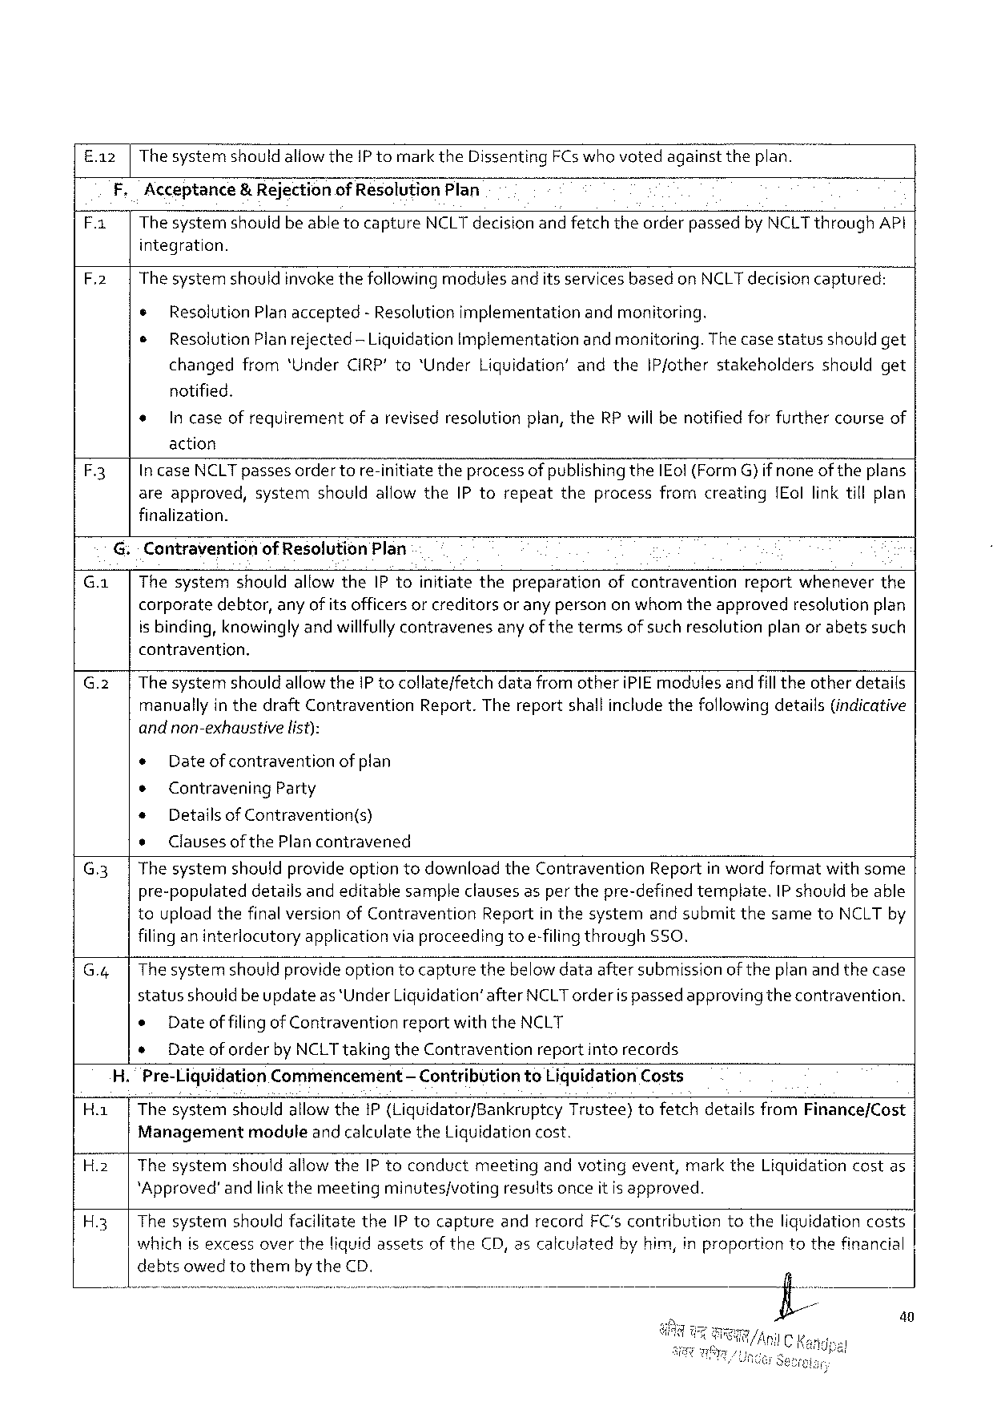

E.a2 |The systemshould allowtheIP tomarktheDissentingFCs whovotedagainsttheplan.

F,Acceptance& Rejectionof ResolutionPlan

|  |  |  |
| --- | --- | --- |
| F.1 | Thesystemshouldbeabletocapture | NCLTdecisionandfetchtheorderpassedbyNCLTthroughAPI |

integration.

F.2| The systemshouldinvokethefollowingmodulesanditsservices basedonNCLTdecisioncaptured:

¢ ResolutionPlanaccepted- Resolutionimplementationandmonitoring.

¢ ResolutionPlanrejected-LiquidationImplementation andmonitoring. Thecasestatusshouldget

changedfrom‘UnderCIRP'to“UnderLiquidation’ andtheIP/otherstakeholdersshouldget

notified.

* Incaseofrequirementof arevisedresolutionplan,theRP willbenotifiedforfurthercourseof

action

F3 IncaseNCLTpassesordertore-initiate theprocessofpublishingtheIEol(FormG} ifnoneof theplans

areapproved, system should allowthe IPtorepeat theprocess fromcreating IEollinktillplan

finalization.

G:- Contraventionof ResolutionPlan

G.a| ThesystemshouldallowtheIPtoinitiatethepreparationofcontraventionreportwheneverthe

corporate debtor,anyofitsofficersorcreditors oranypersononwhomtheapproved resolution plan

is binding,knowinglyandwillfullycontravenesany ofthetermsof suchresolutionplan or abetssuch

contravention.

|  |  |  |  |
| --- | --- | --- | --- |
| G.2 | | | Thesystem | shouldallowtheIP tocollate/fetch | datafromotheriPIEmodulesandfill theotherdetails |

manuallyin thedraftContraventionReport.Thereportshall includethefollowing details(indicative

andnon-exhaustive list):

« Dateof contraventionof plan

¢ Contravening Party

e DetailsofContravention(s)

e Clausesof thePlancontravened

G.3| ThesystemshouldprovideoptiontodownloadtheContraventionReportin wordformatwithsome

pre-populateddetailsandeditablesampleclauses asper thepre-definedtemplate. IP shouldbeable

touploadthefinalversionofContraventionReportin thesystemand submitthesametoNCLT by

filinganinterlocutory application viaproceeding toe-filingthrough SSO.

G.4| Thesystemshouldprovide optiontocapturethebelowdataaftersubmissionof theplan and thecase

statusshould beupdateas*UnderLiquidation’after NCLT orderispassedapprovingthecontravention.

e Dateof filingofContraventionreportwiththeNCLT

* Dateof orderbyNCLTtakingtheContraventionreportinto records

H. Pre-LiquidationCommencement — ContributiontoLiquidationCosts

Ha | ThesystemshouldallowtheiP (Liquidator/BankruptcyTrustee)tofetchdetailsfromFinance/Cost

Management module andcalculatetheLiquidationcost.

H.2| Thesystem shouldallowtheIP toconduct meeting andvotingevent,marktheLiquidationcostas

*Approved’andlinkthemeetingminutes/voting resultsonceitis approved.

H.3| ThesystemshouldfacilitatetheIP tocaptureandrecordFC'scontributiontotheliquidationcosts

whichisexcessovertheliquidassetsof theCD,ascalculatedby him,in proportiontothefinancial

debtsowedtothembytheCD.

40

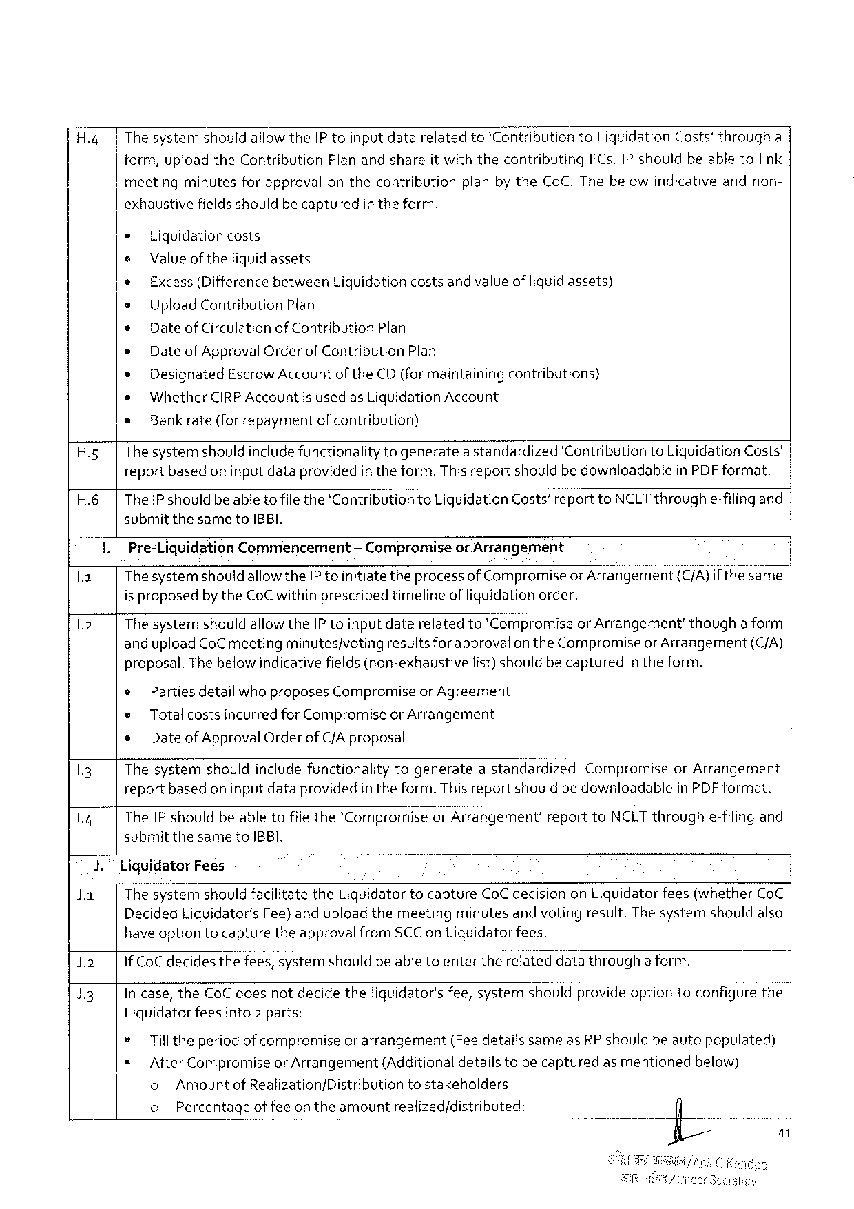

H.4| The systemshouldallowtheIP toinputdatarelatedto‘Contribution toLiquidation Costs’througha

form,uploadtheContributionPlanandshareit withthecontributingFCs.IP shouldbeabletolink

meeting minutesforapproval onthecontribution planbytheCoC.Thebelowindicativeandnon-

exhaustive fieldsshouldbecaptured intheform.

e Liquidationcosts

e Valueof theliquidassets

* Excess(Differencebetween Liquidationcostsandvalueof liquidassets)

s UploadContributionPlan

» Date ofCirculationofContributionPlan

e DateofApprovalOrderofContributionPlan

e Designated EscrowAccountof theCD(formaintaining contributions)

o WhetherCIRPAccountis usedas LiquidationAccount

« Bankrate(for repaymentofcontribution)

H.5| Thesystemshouldincludefunctionality togeneratea standardized'Contribution toLiquidationCosts'

reportbasedon inputdataprovidedin theform.This reportshouldbe downloadableinPDFformat.

H.6|ThePshouldbeable to filethe‘ContributiontoLiquidationCosts’reporttoNCLTthroughe-filingand

submit thesametoIBBI.

I.-Pre-LiquidationCommencement — Compromiseor Arrangement

la Thesystemshould allowtheIPtoinitiatetheprocessof CompromiseorArrangement(C/A}if thesame

is proposedby theCoCwithinprescribed timelineof liquidationorder.

1.2 ThesystemshouldallowtheIP toinputdatarelatedto*Compromiseor Arrangement’thougha form

anduploadCoCmeetingminutes/votingresultsforapprovalon theCompromiseor Arrangement(C/A)

proposal.The below indicativefields(non-exhaustivetist)should becapturedin theform.

|  |  |  |  |
| --- | --- | --- | --- |
| 13  L4 | * | | Parties detailwho proposesCompromiseor Agreement |
| e | Total costsincurredfor CompromiseorArrangement | |
| e | DateofApprovalOrderofC/Aproposal | |
| Thesystemshouldinclude functionalitytogenerateastandardized'CompromiseorArrangement' reportbasedon inputdataprovidedin the form.ThisreportshouldbedownloadableinPDFformat.  TheIP shouldbeabletofilethe*Compromiseor Arrangement’reporttoNCLTthroughe-filingand | | |

submitthesametoIBBI.

|  |  |  |  |  |
| --- | --- | --- | --- | --- |
| Ja | 3. | LiquidatorFees | | |
| The systemshould facilitatetheLiquidatortocaptureCoCdecisiononLiquidatorfees(whetherCoC | | |
| DecidedLiguidator’sFee)anduploadthemeeting | minutes | andvotingresult.Thesystemshouldalso |

have optiontocapturetheapprovalfromSCCon Liguidatorfees.

)2 IfCoCdecidesthefees,systemshouldbeable toentertherelateddatathroughaform.

13 In case,theCoCdoesnotdecidetheliquidator'sfee,systemshouldprovideoptiontoconfigurethe

Liguidatorfeesinto2 parts:

* Tilltheperiod of compromiseor arrangement(FeedetailssameasRP shouldbeautopopulated)

= AfterCompromiseor Arrangement(Additionaldetailstobecapturedas mentionedbelow)

o Amountof Realization/Distribution tostakeholders

o Percentageoffee ontheamountrealized/distributed:

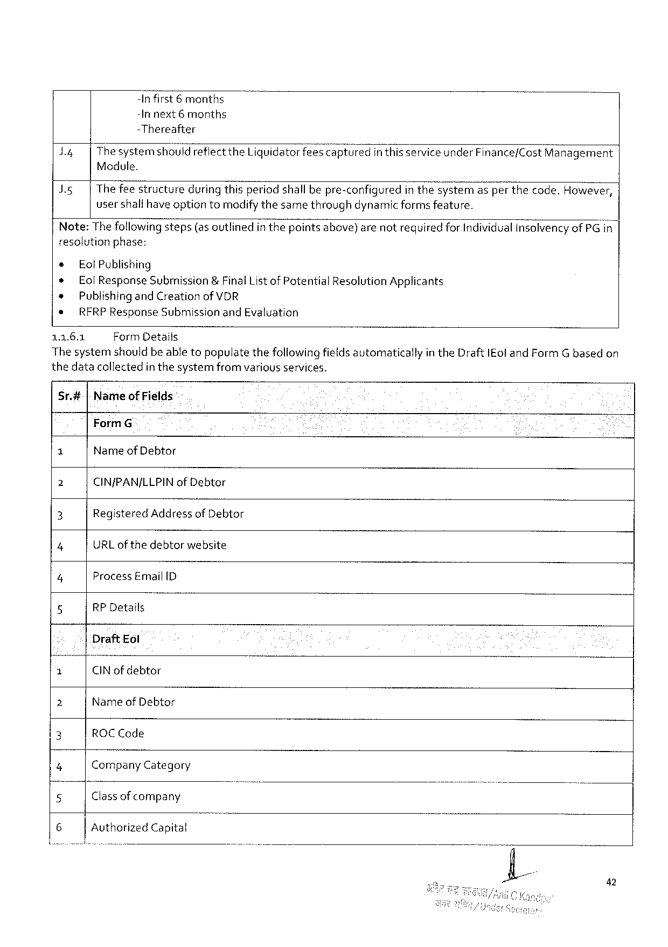

-Infirst 6months

-In next6months

-Thereafter

|  |  |  |
| --- | --- | --- |
| d4  IR | ThesystemshouldreflecttheLiquidatorfeesca;;tured | in thisserviceunder Finance/CostManagement |
| Module.  Thefeestructureduring thisperiodshall bepre-configuredin thes?stemasper thecode.However, usershallhave optiontomodifythesamethroughdynamic formsfeature. | |

resolutionphase:

|  |  |
| --- | --- |
| e ® *  *  1162 | Eol Publishing  EolResponseSubmission&FinalList of PotentialResolutionApplicants PublishingandCreation ofVDR  RFRP ResponseSubmissionand Evaluation  FormDetails |

The systemshouldbe abletopopulatethefollowingfieldsautomaticallyin theDraftIEoland FormGbasedon

thedatacollectedin thesystemfrom variousservices.

Sr.#[Nameof Fields -

FormG

G Name of Debtor

2 CIN/PAN/LLPIN ofDebtor

3 Registered Addressof Debtor

7 URLof thedebtorwebsite

4 Process EmailID

5 RP Details

DraftEol

|  |  |  |  |
| --- | --- | --- | --- |
| 3 | CINof debtor | - | ) |
| 2 | Name of Debtor |
| 3 |
| ROCCode |
| 4 |
| Company Category |
| 5 | Classof company |
| 6 |
| AuthorizedCapital |

42

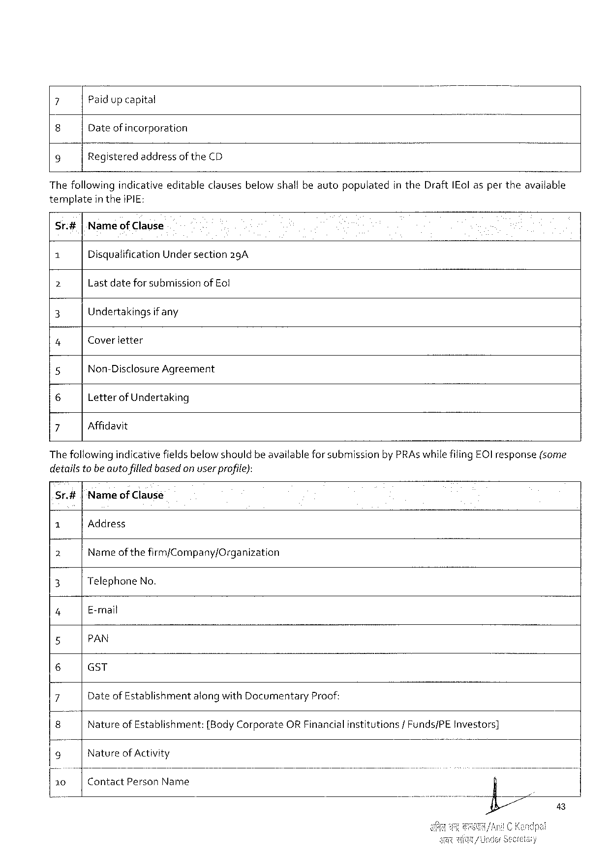

7 Paidup capital

8 Dateof incorporation

9 Registeredaddressof theCD

Thefollowing indicativeeditableclausesbelowshallbeavtopopulatedin theDraftIEol asper theavailable

templatein theiPIE:

Sr.#|Nameof Clause

1 DisqualificationUndersection2gA

b Lastdatefor submissionof Eol

3 Undertakings ifany

4 Coverletter

5 Non-Disclosure Agreement

6 LetterofUndertaking

7 Affidavit

Thefollowingindicativefieldsbelow shouldbe availableforsubmissionbyPRAswhilefilingEC) response(some

detailsto beauto filled based on userprofite):

Sr.#|Nameof Clause

|  |  |  |  |  |  |  |  |  |  |
| --- | --- | --- | --- | --- | --- | --- | --- | --- | --- |
| 1 | Address | | | | | | institutions | /Funds/PE | Investors] |
| Name | ofthe | firm/Company/Organization | | | |
| 2 |
| 3 | TelephoneNo. | | | | | |
| 4 | E-mail | | | | | |
| 5 | PAN | | | | | |
| 6 | GST | | | | | |
| 7 | DateofEstablishment | | | alongwithDocumentary | | Proof: |
| 8 | Nature | ofEstablishment: | | {BodyCorporate | ORFinancial | |
| 9 | Natureof Activity | | | | | |
| 10 | ContactPersonName | | | | | |

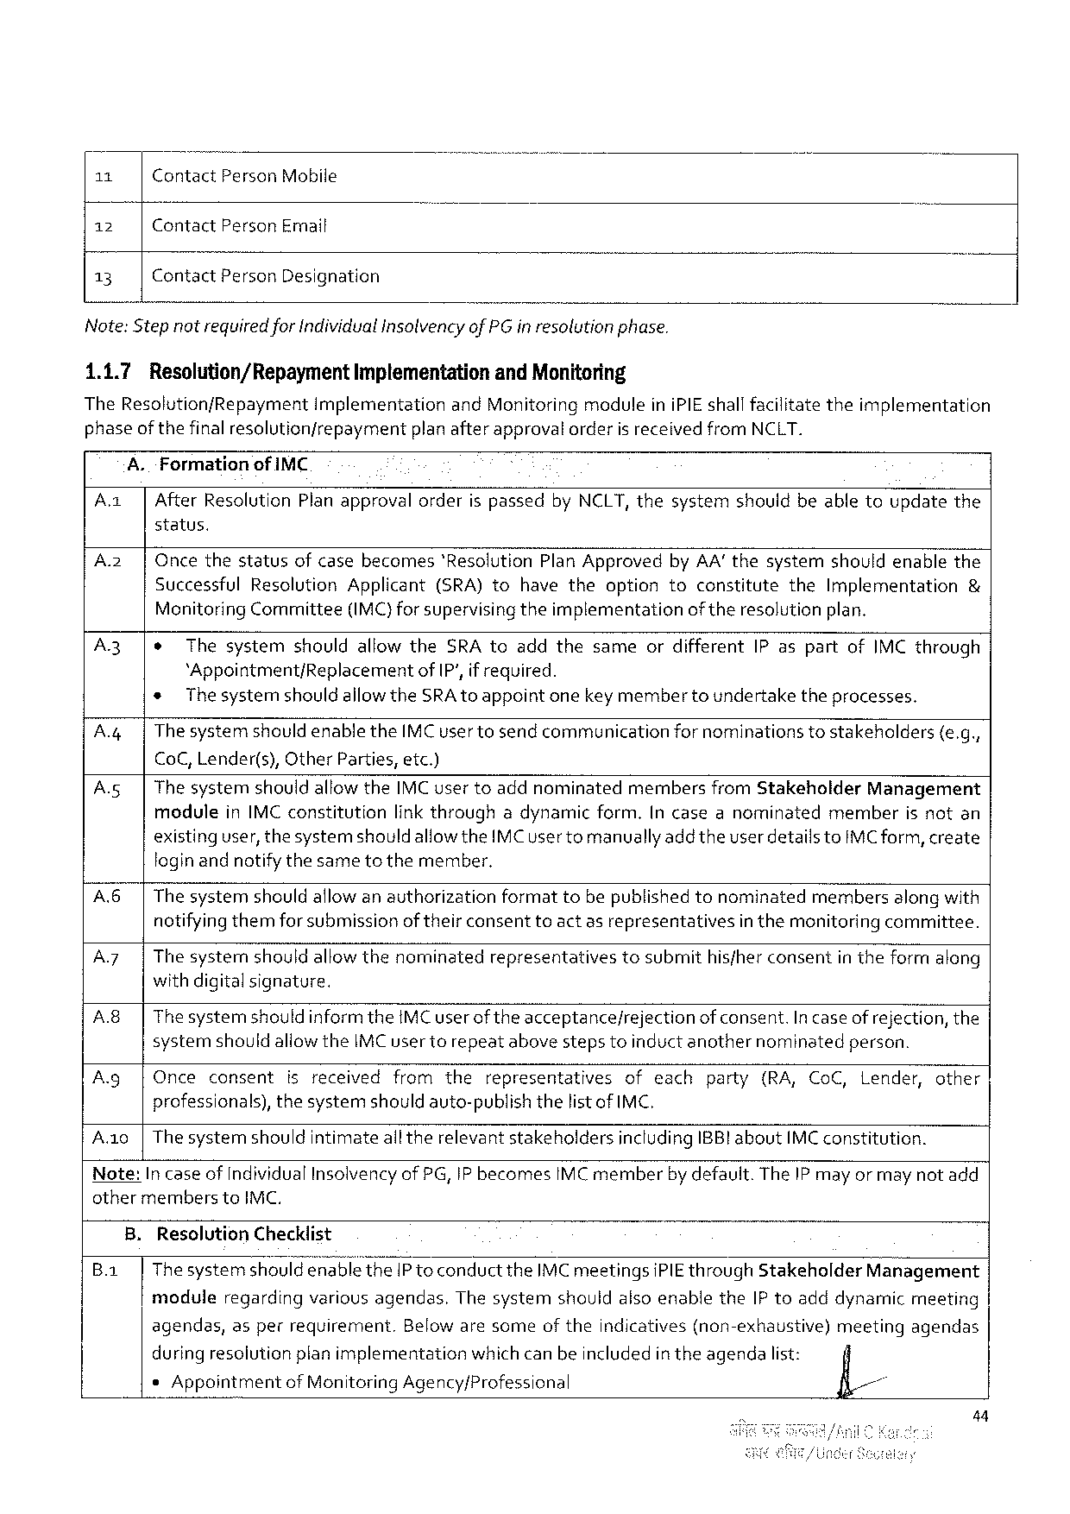

|  |  |  |
| --- | --- | --- |
| 11 | ContactPersonMobile | o |
| 12 | ContactPersonEmail |
| 13 | ContactPersonDesignation |

Note:Step notrequiredforIndividualinsolvencyofPG inresolutionphase.

1.1.7 Resolution/Repayment Implementationand Monitoring

TheResolution/RepaymentimplementationandMonitoring moduleiniPIEshallfacilitatetheimplementation

|  |  |  |  |
| --- | --- | --- | --- |
| phase | of the | finalresolutionfrepayment | planafterapprovatorderisreceivedfromNCLT. |

A.FormationofIMC

Az AfterResolutionPlanapprovalorderis passedbyNCLT, thesystemshouldbeabletoupdatethe

status.

Az Oncethestatusofcasebecomes'ResolutionPlanApprovedbyAA’thesystemshouldenablethe SuccessfulResolutionApplicant(SRA)tohavetheoptiontoconstitutetheImplementation & MenitoringCommittee(IMC)forsupervisingtheimplementationofthe resolutionplan.

|  |  |  |  |  |  |
| --- | --- | --- | --- | --- | --- |
| A3  A | e | ThesystemshouldallowtheSRAtoaddthesameordifferentIP aspartofIMC through | | | |
| *Appointment/Replacementof IP',if required. | | | | |
| * | The systemshouldallowtheSRAtoappointonekeymembertoundertaketheprocesses. | | | |
| ThesystemshouldenabletheIMCusertosendcommunication | | fornominations | tostakeholders | {e.g., |

CoC,Lender(s),OtherParties,etc.)

|  |  |  |  |
| --- | --- | --- | --- |
| As | ThesystemshouldallowtheIMCusertoaddnominatedmembersfromStakeholder | | Management |
| moduleinIMC constitution | linkthroughadynamicform.[n caseanominatedmemberis notan | |

existinguser,thesystemshould allowtheIMC user tomanuallyaddtheuser detailstoIMCform,create foginandnotifythesametothemember.

Ab Thesystemshould allowanauthorizationformattobepublishedtonominatedmembersalongwith notifying themforsubmissionof theirconsenttoact asrepresentativesin themonitoringcommittee.

A7 Thesysternshouldallowthenominatedrepresentativestosubmithisfherconsentin theformalong withdigitalsignature.

|  |  |  |  |  |  |  |
| --- | --- | --- | --- | --- | --- | --- |
| A8  Ag  Ao | Thesystemshould informtheIMCuserofthe acceptance/rejectionofconsent.In caseofrejection, the systemshouldallowtheIMC usertorepeatabovestepstoinductanothernominatedperson. | | | | | |
| Once | consent | isreceivedfromthe | representatives | ofeach | party(RA,CoC,Lender,other |
| professionals),thesystemshouldauto-publishthelistof IMC,  The systemshouldintimateall therelevantstakeholdersincludingIBB!aboutIMC constitution. | | | | | |

Note:In caseof IndividualInsolvencyof PG,IP becomesIMC memberby default.TheIP may or may notadd other memberstoIMC.

B.ResolutionChecklist

B.a Thesystemshould enablethe IPto conducttheIMC meetingsiPIE throughStakeholderManagement

moduleregardingvariousagendas.ThesystemshouldalsoenabletheIP toadddynamicmeeting

|  |  |  |  |  |  |
| --- | --- | --- | --- | --- | --- |
| agendas, | asperrequirement. | Belowaresomeoftheindicatives | (non-exhaustive) | meeting | agendas |

during resolutionplan implementationwhichcanbeincluded in theagendalist:

sAppointmentof MonitoringAgency/Professional fl//

44

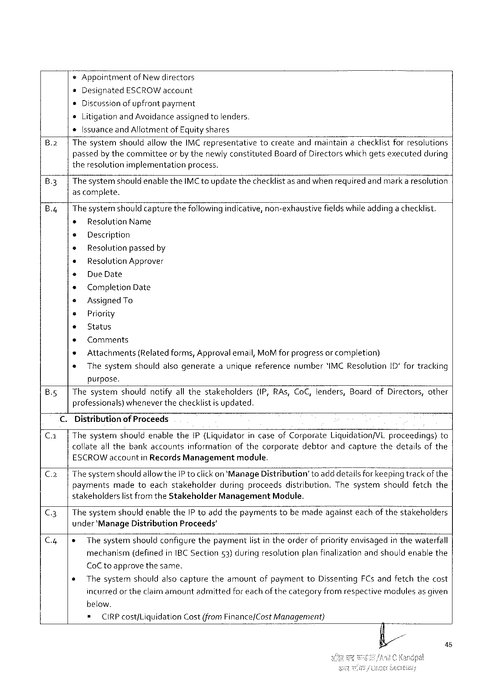

*Appointment ofNewdirectors

eDesignated ESCROWaccount

s Discussionofupfrontpayment

oLitigationandAvoidanceassignedtolenders.

*[ssuanceandAllotmentofEquityshares

B.2| ThesystemshouldallowtheIMC representativetocreateandmaintainachecklistforresolutions

passedbythecommitteeorby thenewlyconstitutedBoard of Directors which getsexecutedduring

theresolutionimplementationprocess.

|  |  |  |  |
| --- | --- | --- | --- |
| B.3| | Thesystem | shouldenablethe | IMCtoupdatethechecklistasandwhenrequiredandmarkaresolution |

ascomplete.

B.4|Thesystemshould capturethefollowingindicative, non-exhaustivefieldswhileaddingachecklist.

* ResolutionName

e Description

e Resolution passedby

* ResolutionApprover

« DueDate

s CompletionDate

e AssignedTo

¢ Priority

* Status

+ Comments

* Attachments(Relatedforms,Approvalemail, MoM for progressor completion)

s Thesystemshouldalsogenerateauniquereferencenumber'IMCResolution1D fortracking

purpose.

B.5| Thesystemshouldnotifyall thestakeholders(IP,RAs, CoC,tenders,BoardofDirectors,other

professionals)whenever thechecklistis updated.

C. Distributionof Proceeds

C.1| Thesystermshouldenablethe1P(LiquidatorincaseofCorporateLiquidation/VLproceedings)to

collateall thebankaccountsinformationofthecorporatedebtorandcapturethedetailsofthe

ESCROWaccountin RecordsManagementmodule.

C.2| The systemshould allowtheIP toclick on‘ManageDistribution’toadd detailsforkeepingtrackof the

paymentsmadetoeachstakeholderduringproceedsdistribution.Thesystemshouldfetchthe

stakeholderslist from theStakeholderManagement Module.

C.3| Thesystemshouldenablethe[P toaddthepaymentstobemadeagainsteachof thestakeholders

under‘ManageDistributionProceeds’

|  |  |  |  |  |  |
| --- | --- | --- | --- | --- | --- |
| C.4 | |+ | Thesystemshouldconfigurethepaymentlist in theorderofpriority envisagedin thewaterfall | | | |
| mechanism | (definedinIBCSection | 53)duringresolution | planfinalizationandshouldenablethe |

CoC toapprovethesame.

* ThesystemshouldalsocapturetheamountofpaymenttoDissentingFCsandfetchthecost

incurredor the claimamountadmittedforeachof thecategoryfromrespectivemodulesas given

below.

|  |  |  |  |
| --- | --- | --- | --- |
| = | CIRPcostfLiquidation | Cost(fromFinance/Cost | Management) |

45

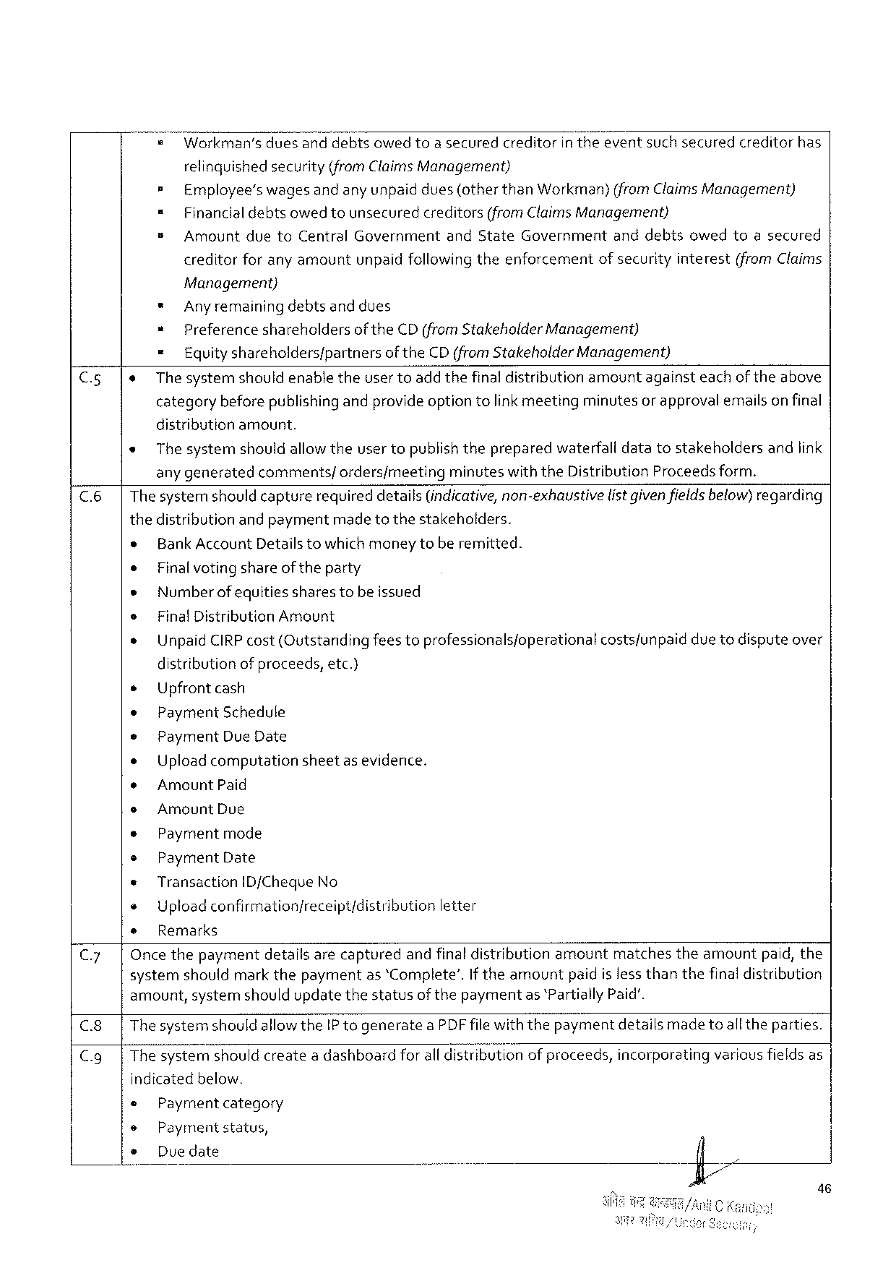

|  |  |  |  |
| --- | --- | --- | --- |
| = | Workman's | duesanddebtsowedtoasecuredcreditorintheeventsuchsecured | creditorhas |

relinquished security(fromClaimsManagement)

= Employee’swagesandanyunpaiddues(otherthanWorkman)(fromClaimsManagement)

= Financialdebtsowed tounsecuredcreditors(fromClaimsManagement)

s AmountduetoCentralGovernmentandStateGovernmentanddebtsowedtoasecured

creditorforanyamountunpaidfollowing theenforcementof securityinterest(fromClaims

Management)

* Anyremainingdebtsanddues

= Preferenceshareholdersof theCD(from Stakeholder Management)

= Equityshareholders/partners of theCD (from StakeholderManagement)

C.5|e The systemshouldenabletheuser toadd thefinaldistributionamountagainsteachoftheabove

categorybeforepublishingandprovideoption tolink meetingminutesor approvalemailson final

distributionamount.

e The systemshouldallowtheusertopublishthepreparedwaterfalldatatostakeholdersandlink

any generatedcomments/ordersfmeetingminuteswiththeDistribution Proceedsform.

C.6|Thesystemshould capturerequireddetails(indicative,non-exhaustive listgivenfieldsbelow)regarding

thedistributionandpaymentmade tothestakeholders.

* BankAccountDetailstowhichmoneytoberemitted.

e Finalvoting shareoftheparty

* Numberofequitiessharestobeissued

s FinalDistribution Amount

e UnpaidCIRPcost(Qutstandingfeestoprofessionalsjoperationalcostsfunpaiddue todisputeover

distribution ofproceeds,etc.}

e Upfront cash

e PaymentSchedule

e Payment DueDate

e Uploadcomputationsheetasevidence.

* AmountPaid

s AmountDue

* Paymentmode

e Payment Date

® Transaction ID/ChequeNo

+ Upload confirmationjreceipt/distribution letter

e Remarks

C.7| Oncethepaymentdetailsarecapturedandfinal distributionamountmatchestheamountpaid,the

systemshouldmarkthepaymentas ‘Complete’.If theamountpaidislessthanthefinaldistribution

amount,systemshouldupdatethestatusof thepaymentas *PartiallyPaid’.

C.8|ThesystemshouldallowtheIP togenerateaPDF filewiththepaymentdetailsmade toall theparties.

C.g|Thesystemshouldcreatea dashboardforall distributionof proceeds,incorporatingvariousfieldsas

indicatedbelow.

Paymentcategory

Paymentstatus,

Duedate

46

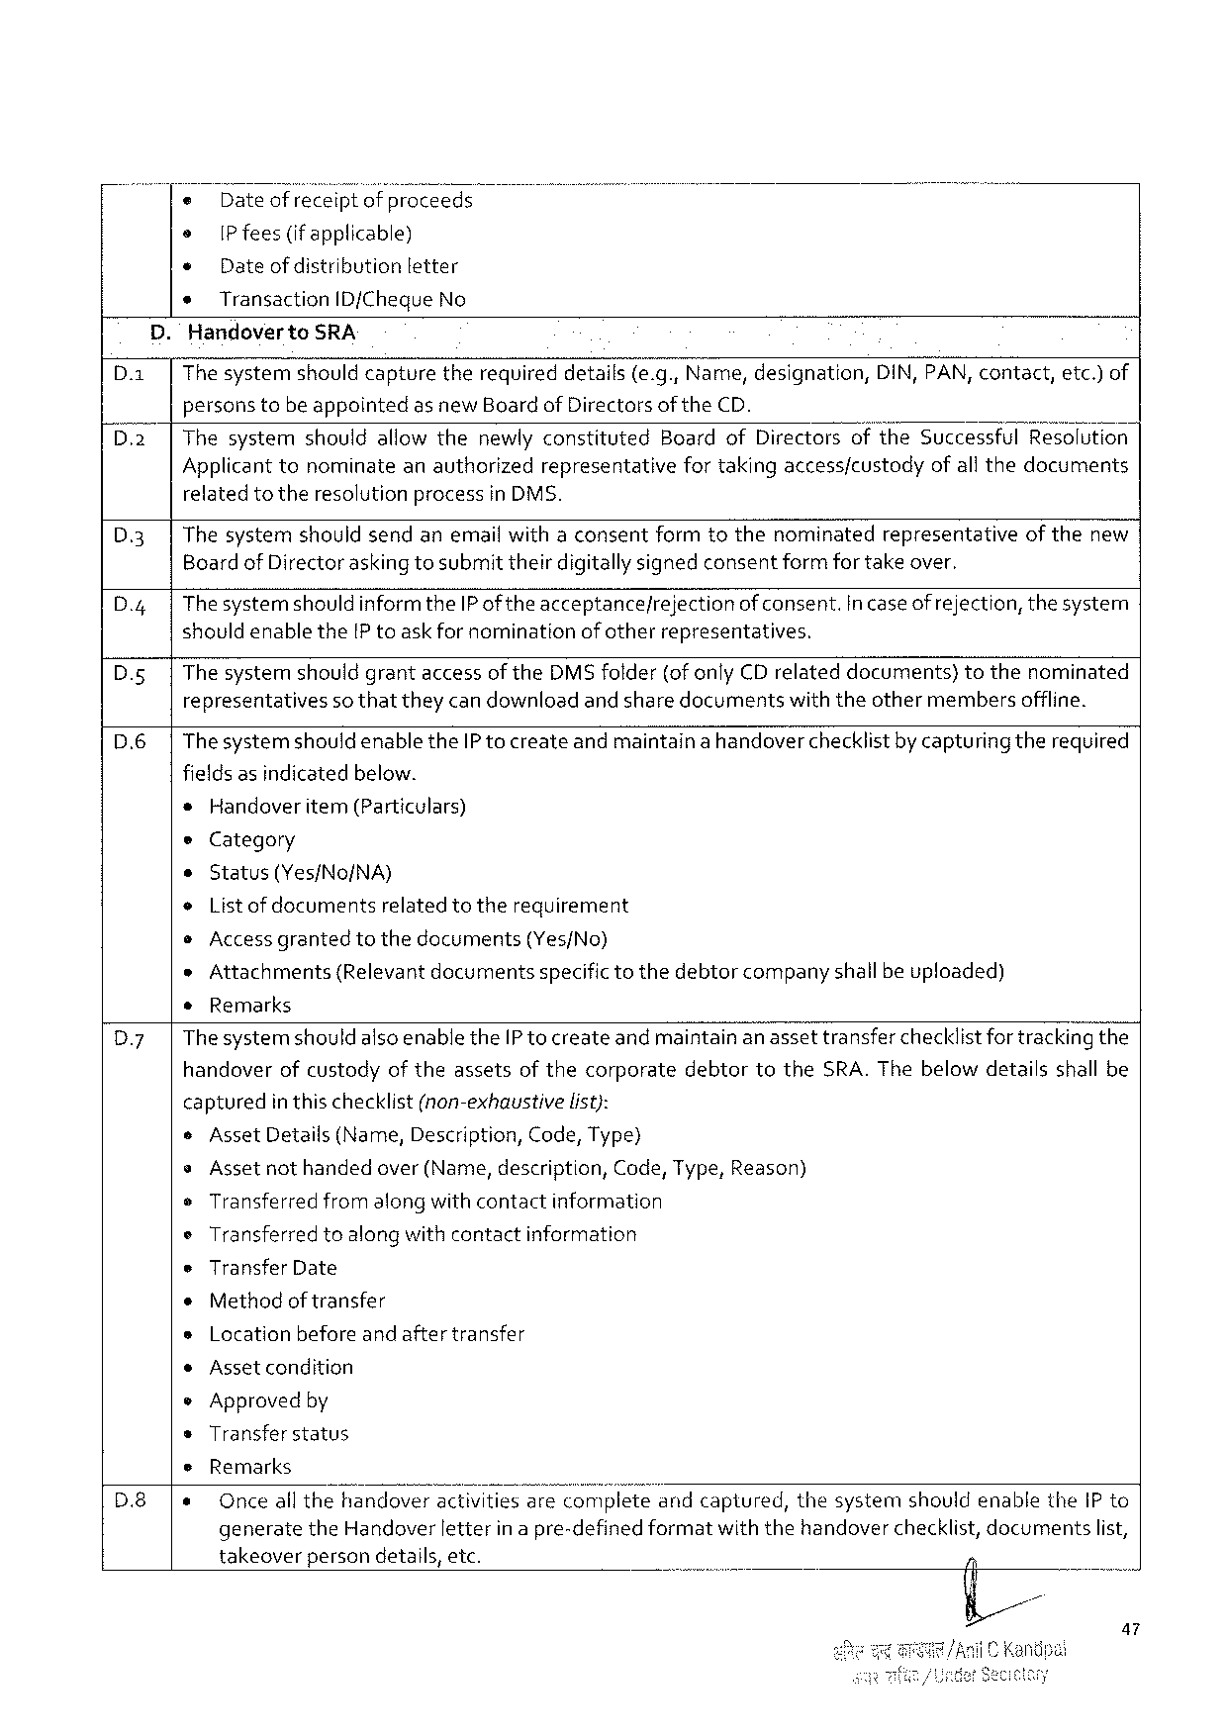

o Dateof receiptofproceeds

o [P fees(ifapplicable)

¢ Dateof distribution letter

* TransactionID/ChequeNo

.HandovertoSRA

|  |  |  |  |  |
| --- | --- | --- | --- | --- |
| D.a | Thesystemshouldcapture | therequireddetails(e.g.,Name,designation, | DIN, PAN,contact, | etc.)of |

personstobeappointedas newBoardof Directorsof theCD.

ThesystemshouldallowthenewlyconstitutedBoardofDirectorsoftheSuccessfulResolution

Applicant tonominateanauthorizedrepresentativefortakingaccessfcustodyofall thedocuments

relatedtotheresolutionprocessin DMS.

|  |  |  |  |
| --- | --- | --- | --- |
| D3  D.4  D.s | Thesystemshouldsendanemailwithaconsentformtothenominatedrepresentativeof thenew Boardof Directoraskingtosubmittheirdigitallysignedconsentformfor takeover. | | |
| Thesystemshould informtheIPof theacceptance/rejection | | of consent.incaseof rejection,thesystem |
| shouldenablethe[P toaskfornomination | ofotherrepresentatives. | |
| The systemshouldgrantaccessoftheDMSfolder(ofonlyCD relateddocuments)tothenominated | | |

representativesso thattheycan downloadand sharedocumentswiththeothermembersoffline.

D.6 Thesystemshould enabletheIP to createandmaintainahandoverchecklistby capturingtherequired

fieldsas indicatedbelow.

=Handoveritem(Particulars)

eCategory

o Status(Yes/No/NA)

o List ofdocuments relatedtotherequirement

e Accessgranted tothedocuments (Yes/No)

»Attachments(Relevant documentsspecifictothedebtorcompanyshallbe uploaded)

*Remarks

Dy ThesystemshouldalsoenabletheIP tocreateand maintainan assettransferchecklistfortracking the

handoverofcustodyof theassetsof thecorporatedebtortotheSRA.Thebelowdetailsshall be

|  |  |  |
| --- | --- | --- |
| captured | inthischecklist(non-exhaustive | list): |

¢AssetDetails(Name,Description, Code,Type)

s Assetnothandedover(Name,description, Code,Type,Reason)

e Transferred fromalongwithcontact information

oTransferredtoalongwith contactinformation

eTransferDate

¢Methodof transfer

sLocation beforeand aftertransfer

¢Assetcondition

e Approvedby

sTransfer status

|  |  |  |  |  |  |
| --- | --- | --- | --- | --- | --- |
| D.8 | e | Remarks | | | |
| Onceall thehandoveractivitiesareLo;vplwetueandcaptured,thesystemshouldenabletheIP to | | | |
| generate | theHandoverletterinapre-definedformat | withthehandoverchecklist,documents | list, |

takeoverpersondetails,etc.

a7

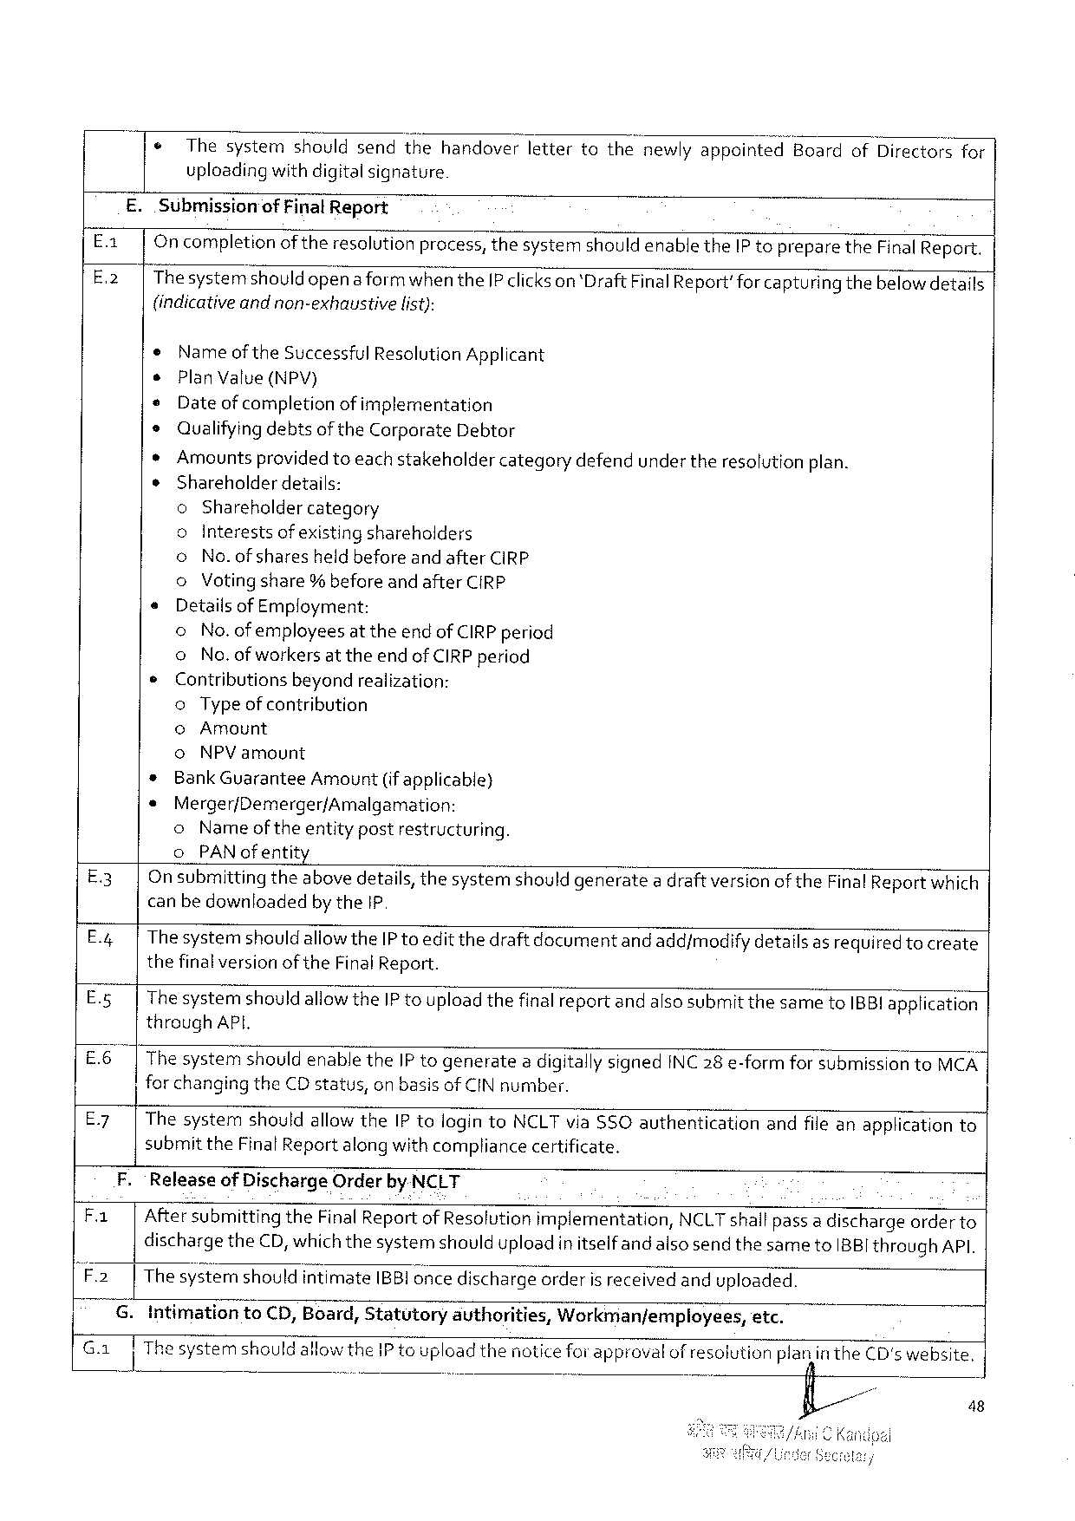

|  |  |  |
| --- | --- | --- |
| ¢ | Thesystemshouldsendthehandoverlettertothenewlyappointed“Board | ofDirectorsfor |
| uploadingwithdigitalsignature |

E.Submissionof FinalReport

|  |  |  |  |  |
| --- | --- | --- | --- | --- |
| Ex  E-2 | Oncompletionof theresolutionpracess,thesystemshould enabletheIP topreparetheFinalReport. Thesystemshouldopenaformwhen theIP clickson ‘DraftFinal Report'forcapturingthebelowdetails | | | |
| (indicative | | andnon-exhaustive | list): |
| e | Nameof theSuccessful ResolutionApplicant | | |
| s | PlanValue(NPV) | | |
| * | Dateof completionof implementation | | |
| ¢ | Qualifyingdebtsof theCarporateDebtor | | |

*Amountsprovidedtoeach stakeholdercategorydefendundertheresolutionplan.

¢Shareholderdetails:

oShareholdercategory

|  |  |  |  |
| --- | --- | --- | --- |
| s  ¢ | oInterestsofexisting shareholders | | |
| o | No.of sharesheldbeforeand afterCIRP | |
| o | Votingshare% beforeand afterCIRP | |
| Detailsof Employment: | | |
| o | No.ofemployeesat theend ofCIRP period | |
| o | No.ofworkers attheend ofCIRP period | |
| Contributions | | beyondrealization: |
| oType ofcontribution | | |

©Amount

o NPV amount

* BankGuaranteeAmount(if applicable)

* Merger/Demerger/Amalgamation:

o Nameoftheentitypostrestructuring.

o PAN ofentit

E3 On submittingtheabovedetails,thesystemshould generatea draft version oftheFinalReportwhich canbe downloadedby the1P

E.4 Thesystemshould allowtheIP toeditthedraftdocumentand add/modifydetailsas requiredtocreate thefinalversion oftheFinalReport.

E.5 ThesystemshouldallowtheIP touploadthefinalreportandalsosubmit thesametoIBBI application throughAPI.

E6 The systemshouldenabletheIP togenerate2digitallysignedINC28 e-formforsubmission toMCA | for changingtheCDstatus,on basisof CINnumber.

E7 ThesystemshouldallowtheIP tologintoNCLT via$SOauthenticationandfileanapplicationto

submittheFinalReport along withcompliancecertificate.

F. ‘ReleaseofDischargeOrderby NCLT

Fa | AftersubmittingtheFinalReport of Resolutionimplementation,NCLTshallpass a dischargeorderto dischargetheCD,whichthesystemshoulduploadin itselfand alsosendthesametoIBBI throughAPI.

F2 |The systernshouldintimateIBBI once dischargeorderisreceived anduploaded.

G. Intimation toCD,Board,Statutory authorities, Workman/employees, etc.

Ga gl T Thesystemshouldallow the1P toupload thenotice forapprovalofresolutionpiax}lintheCD's website, o

fi/ - 48

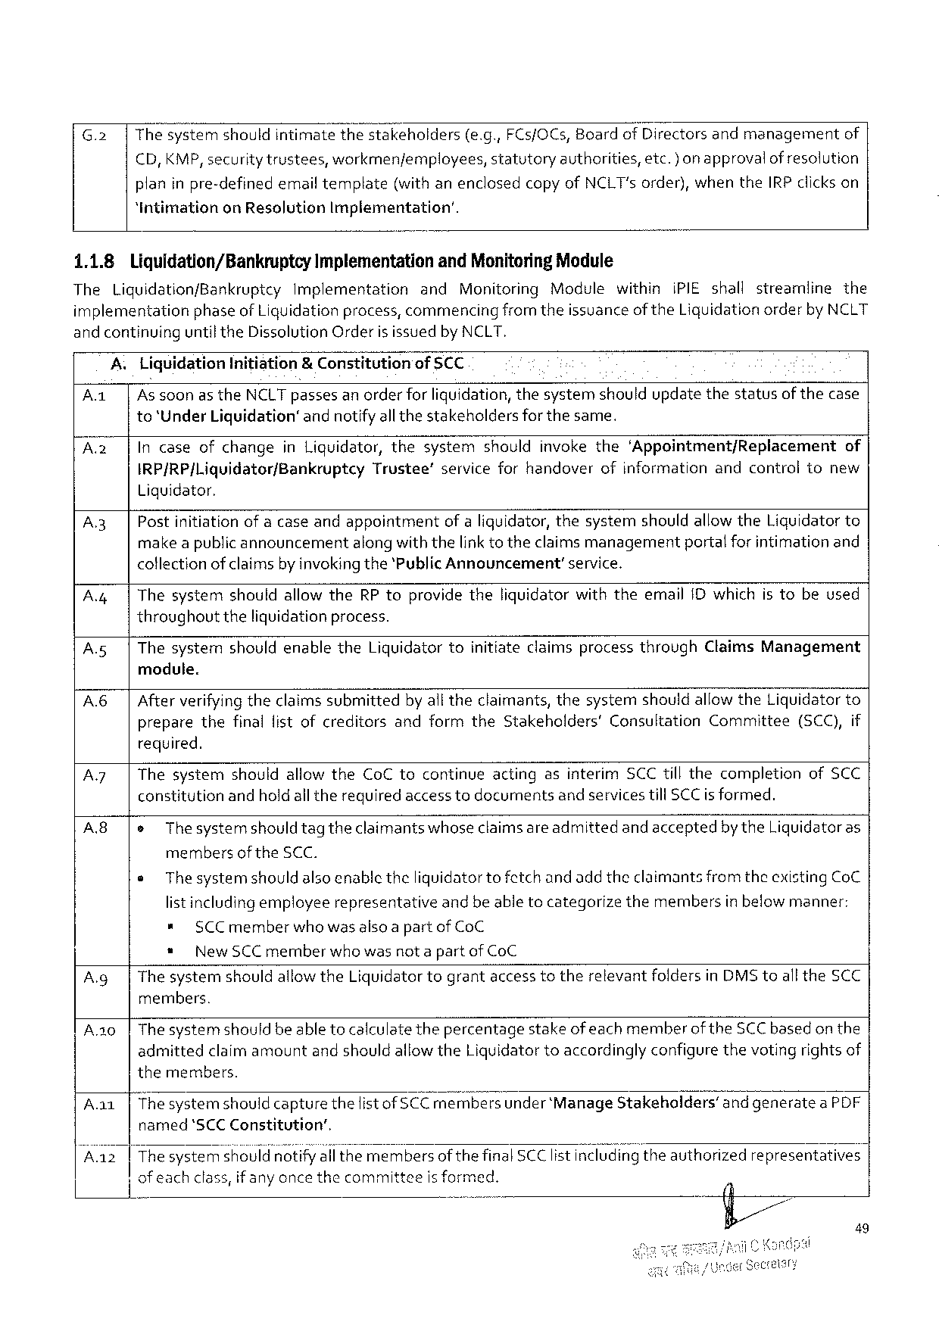

|  |  |  |  |  |  |  |  |  |
| --- | --- | --- | --- | --- | --- | --- | --- | --- |
| G.2 | Thesystemshouldintimate | thestakeholders | | (e.g.,FCs/OCs,BoardofDirectorsandmanagement | | | | of |
| €D,KMP,securitytrustees, | workmenjemployees, | | | statutory | authorities, | etc.) on approvalof resolution | |
| planinpre-definedemail template | | (withanenclosedcopyofNCLT's order),whentheIRP clickson | | | | | |

“Intimationon ResolutionImplementation’.

1.1.8 Liquidation/Bankruptcy ImplementationandMonitoringModule

TheLiquidation/BankruptcyImplementation and MonitoringModulewithiniPIEshallstreamline the

implementationphaseof Liquidationprocess, commencingfromtheissuanceof theLiguidationorderby NCLT

and continuinguntiltheDissolutionOrderis issuedby NCLT.

|  |  |  |  |  |  |  |
| --- | --- | --- | --- | --- | --- | --- |
| A1 | A | Llquldatlan | Initiation | | &Constitution | ofSCC |
| | | Assoonasthe | | NCLTpassesanorderfor liquidation, thesystemshouldupdatethestatusof thecase | | |

to‘UnderLiquidation®andnotifyall thestakeholdersfor the same.

|  |  |  |  |
| --- | --- | --- | --- |
| A2 | | | IncaseofchangeinLiquidator,thesystemshouldinvokethe‘Appointment/Replacement | of |

IRP/RP|Liquidator/Bankruptcy Liquidator.

Trustee’serviceforhandoverofinformationandcontroltonew

A.3| Postinitiationofa caseandappointmentofa liquidator,thesystemshouldallowtheLiquidatorto make apublicannouncementalongwiththelink totheclaimsmanagementportalforintimationand collectionof claimsby invokingthe‘PublicAnnouncement’service.

|  |  |  |
| --- | --- | --- |
| A4 | | | ThesystemshouldallowtheRPtoprovidetheliquidatorwiththeemailIDwhichis tobeused |

throughouttheliquidationprocess.

A.5| ThesystemshouldenabletheLiquidatortoinitiateclaimsprocessthroughClaimsManagement

module.

|  |  |
| --- | --- |
| A6| | Afterverifyingtheclaimssubmittedby alltheclaimants,thesystemshouldallow theLiquidator to preparethefinallistofcreditorsandformtheStakeholders’ConsultationCommittee(SCC),if |

required.

|  |  |  |  |
| --- | --- | --- | --- |
| A7  A8 | | | ThesystemshouldallowtheCoC tocontinueactingasinterimSCCtillthecompletionofSCC | |
| constitutionandholdall therequiredaccesstodocumentsandservicestillSCCisformed. | | |
| |e | | Thesystemshouldtagtheclaimants whoseclaimsare admittedand acceptedbytheLiquidatoras |

membersof theSCC.

e Thesystemshouldalsoenabletheliquidator to fetchand addtheclaimantsfrom theexisting CoC

list includingemployeerepresentativeandbe abletocategorizethemembersin below manner:

* SCCmemberwhowas alsoa partofCoC

* NewSCC memberwhowasnot a partof CoC

A.g|Thesystemshould allowtheLiquidatortograntaccesstotherelevantfoldersinDMS toalltheSCC members.

A.20|Thesystemshouldbe able tocalculatethepercentagestakeofeachmemberoftheSCCbased on the admittedclaimamountandshouldallowtheLiquidatortoaccordingly configure thevotingrightsof themembers.

Aa1|Thesystemshould capturethefist ofSCCmembersunder ‘ManageStakeholders’and generatea PDF named‘SCCConstitution’,

.......... a

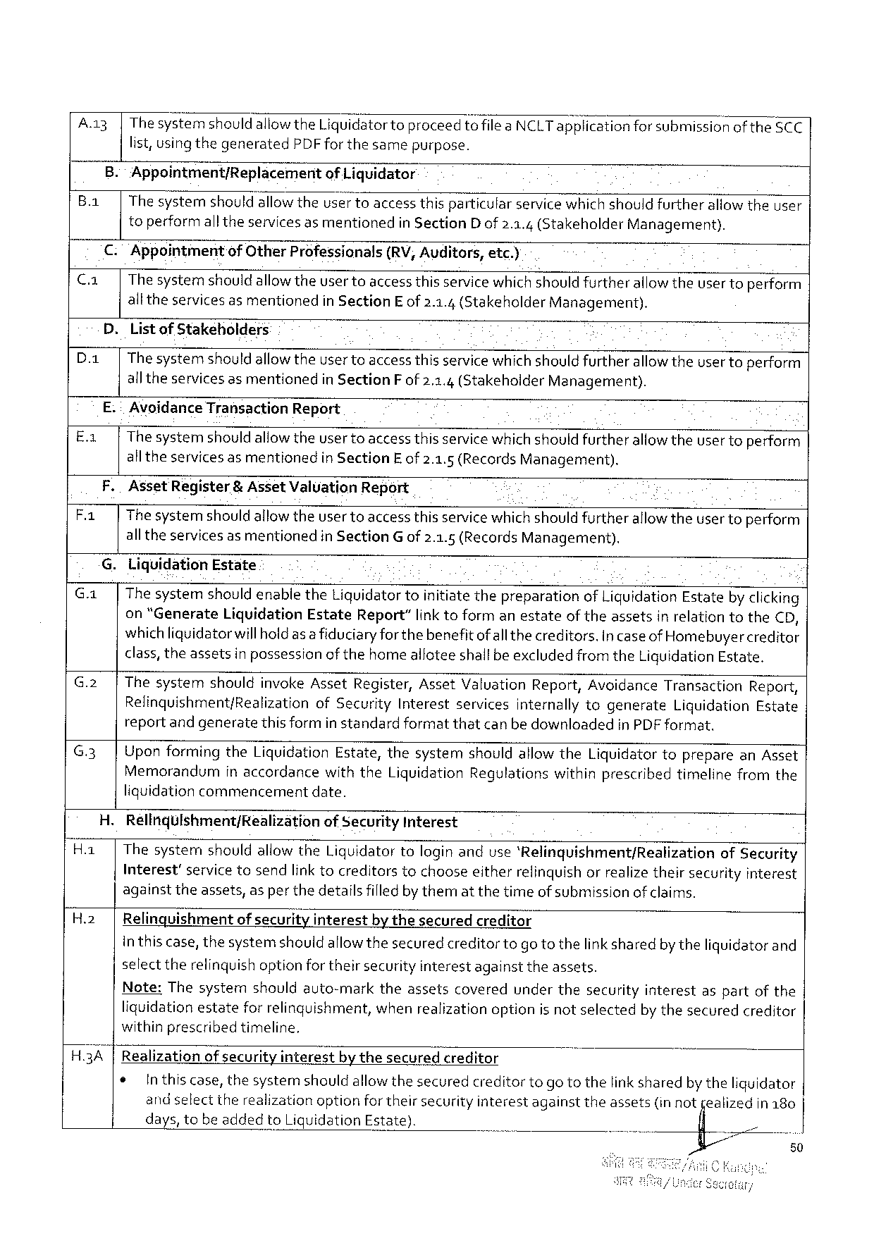

A.a3|Thesystemshould aliow theLiquidatortoproceedtofileaNCLTap‘EIicationforsubmissionof the5CC

list,usingthegenerated PDF forthesamepurpose.

B.:Appointment/Replacement of Liquidator

B.a| The systemshould allowtheuser toaccessthisparticularservicewhich shouldfurtherallowtheuser

toperformalltheservicesasmentionedin SectionD of 2.3.4(StakeholderManagement).

€. Appointment of OtherProfessionals (RV,Auditors,etc.)

C.a| Thesystemshouldallowtheusertoaccess thisservicewhichshould furtherallowtheuser toperform

alltheservices as mentionedin SectionE of2.1.4(StakeholderManagement).

D.Listof Stakeholders

|  |  |
| --- | --- |
| D.a| | Thesystemshould allowtheusertoaccess thisservicewhichshould furtherallow theuser toperform  alltheservicesasmentioned in Section F of2.1.4(Stakeholder Management). |

E.:AvoidanceTransactionReport

E.1| Thesystemshould allowtheuser toaccess thisservicewhichshouldfurtherallowtheuser toperform

all theservices asmentionedin SectionEof 2.1.5 (RecordsManagement).

F.AssetRegister & AssetValuationReport .

Fa The systemshould allowtheusertoaccess thisservicewhich shouldfurtherallowtheusertoperform

alltheservicesasmentioned in Section G of2.1.5(RecordsManagement).

G.LiquidationEstate

|  |  |  |  |  |  |  |  |  |  |  |  |  |
| --- | --- | --- | --- | --- | --- | --- | --- | --- | --- | --- | --- | --- |
| G.1| | | ThesystemshouldenabletheLiquidator toinitiatethepreparationof LiquidationEstateby clicking on "Generate LiquidationEstateReport”link toformanestateof theassetsin relationtothe€D, whichliquidatorwillholdasa fiduciaryforthebenefitofall thecreditors.Incaseof Homebuyercreditor  class,theassetsin possessionofthehomealloteeshallbe excludedfromtheLiquidationEstate. | | | | | | | | | | |
| G.2 | | | Thesystem | shouldinvokeAssetRegister, | | | AssetValuation | | | Report,Avoidance | | Transaction | Report, |
| Relinquishment/Realization | | ofSecurity | Interest | | services | internally | | togenerate | Liquidation | Estate |
| reportand generatethis formin standardformatthatcanbe downloadedinPDFformat. | | | | | | | | | | |

G.3]UponformingtheLiquidationEstate,thesystemshouldallowtheLiquidatortoprepareanAsset

Memorandumin accordancewiththeLiquidationRegulationswithinprescribedtimelinefromthe

liquidationcommencementdate.

H.Relinqulshment/Realization of SecurityInterest

H.1| ThesystemshouldallowtheLiquidatortologinanduse‘Relinquishment/Realization ofSecurity

Interest’ servicetosendlinktocreditors tochooseeitherrelinquish orrealizetheirsecurity interest

againsttheassets,asper thedetailsfilledby thematthetimeof submissionof claims.

H.2| Relinquishmentof securityinterestbythesecuredcreditor

inthiscase,thesystemshouldallowthesecuredcreditortogotothelinksharedby theliquidator and

select therelinquishoptionfortheirsecurityinterestagainsttheassets.

|  |  |  |  |  |  |  |
| --- | --- | --- | --- | --- | --- | --- |
| Note:Thesystem | shouldauto-mark | theassets | covered | underthesecurity | interest | aspartofthe |
| liquidationestate | forrelinguishment, | whenrealizationoptionisnotselected | | | by thesecuredcreditor | |
| withinprescribed | timeline, |

H.3A |Realizationof securityinterestbythesecuredcreditor

|  |  |  |
| --- | --- | --- |
| ¢ | Inthiscase,thesystemshouldallowthesecuredcreditortogo tothelink sharedby theliquidator | |
| andselecttherealizationoptionfortheirsecurityinterestagainsttheassets(in not | jealizedin180 |
| days,tobeaddedtoLiquidationEstate). | fi |

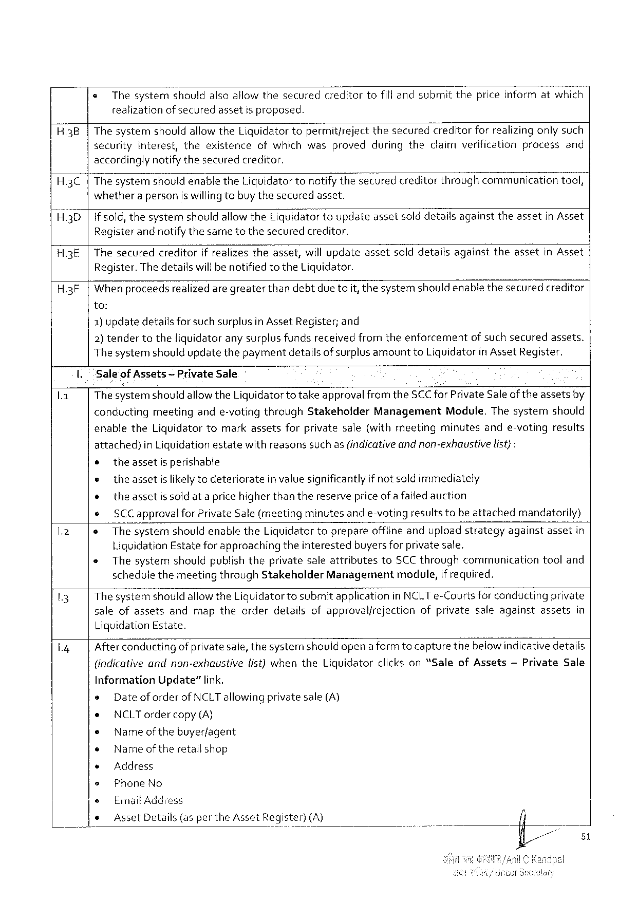

« Thesystemshouldalsoallowthesecuredcreditortofillandsubmitthepriceinformatwhich realizationofsecuredassetisproposed.

|  |  |  |  |
| --- | --- | --- | --- |
| H.3B | Thesystem | shouldallowtheLiquidatortopermitfreject | thesecuredcreditorforrealizingonlysuch |
| securityinterest,theexistenceofwhichwasprovedduringtheclaimverificationprocessand | | |

accordinglynotifythesecuredcreditor.

H.3C The systemshould enabletheLiguidatortonotifythesecuredcreditorthroughcommunicationtool, whethera personiswilling tobuy thesecuredasset.

H.3D if sold, thesystemshould allowtheLiquidatortoupdateassetsolddetailsagainsttheassetin Asset Registerandnotifythesametothesecuredcreditor.

H.3E Thesecuredcreditorif realizestheasset,willupdateassetsolddetailsagainsttheassetin Asset Register. Thedetailswill benotified totheLiquidator.

H.3F Whenproceedsrealizedaregreaterthan debtdue toit, thesystemshould enablethesecuredcreditor

to:

1)updatedetailsfor suchsurplusin AssetRegister;and

2) tendertotheliquidatorany surplus fundsreceivedfromtheenforcementof suchsecuredassets. Thesystemshouldupdatethepaymentdetailsofsurplus amounttoLiquidatorin AssetRegister.

Sale of Assets— PrivateSale

Thesystemshould allowtheLiquidatortotakeapprovalfrom theSCCfor PrivateSaleof theassetsby

|  |  |  |
| --- | --- | --- |
| conductingmeetingande-votingthroughStakeholder | Management | Module.Thesystemshould |

enabletheLiquidatortomarkassetsforprivatesale(withmeetingminutesande-votingresults

attached) inLiquidationestatewithreasonssuchas(indicativeandnon-exhaustivelist):

o theassetisperishable

e theassetis likely todeterioratein valuesignificantlyif notsold immediately

o theassetis sold at apricehigher thanthereservepriceofafailedauction

e SCCapproval for PrivateSale(meetingminutesand e-votingresults tobe attachedmandatorily)

o Thesystem shouldenabletheLiquidatortoprepare offlineanduploadstrategy against assetin

LiquidationEstate for approachingtheinterestedbuyers for private sale.

|  |  |  |
| --- | --- | --- |
| e | Thesystemshouldpublish theprivatesaleattributestoSCC throughcommunicationtooland | |
| schedulethemeetingthroughStakeholderManagement | module,if required. |

The systemshouldallowtheLiguidatortosubmitapplicationinNCLTe-Courts for conductingprivate saleofassetsandmaptheorderdetailsofapprovalfrejectionofprivatesaleagainstassetsin LiquidationEstate.

Afterconductingof privatesale,thesystemshould opena formto capturethebelowindicativedetails

|  |  |  |  |  |  |
| --- | --- | --- | --- | --- | --- |
| (indicativeandnon-exhaustive | list)whentheLiquidator | clickson“Sale | ofAssets | ~Private | Sale |

InformationUpdate”link.

s Dateoforderof NCLTallowingprivatesale(A)

e NCLTorder copy(A)

e Nameof thebuyerfagent

e Nameof theretailshop

© Address

» PhoneNo

e EmailAddress

e Asset Details (aspertheAsset Register) (A)

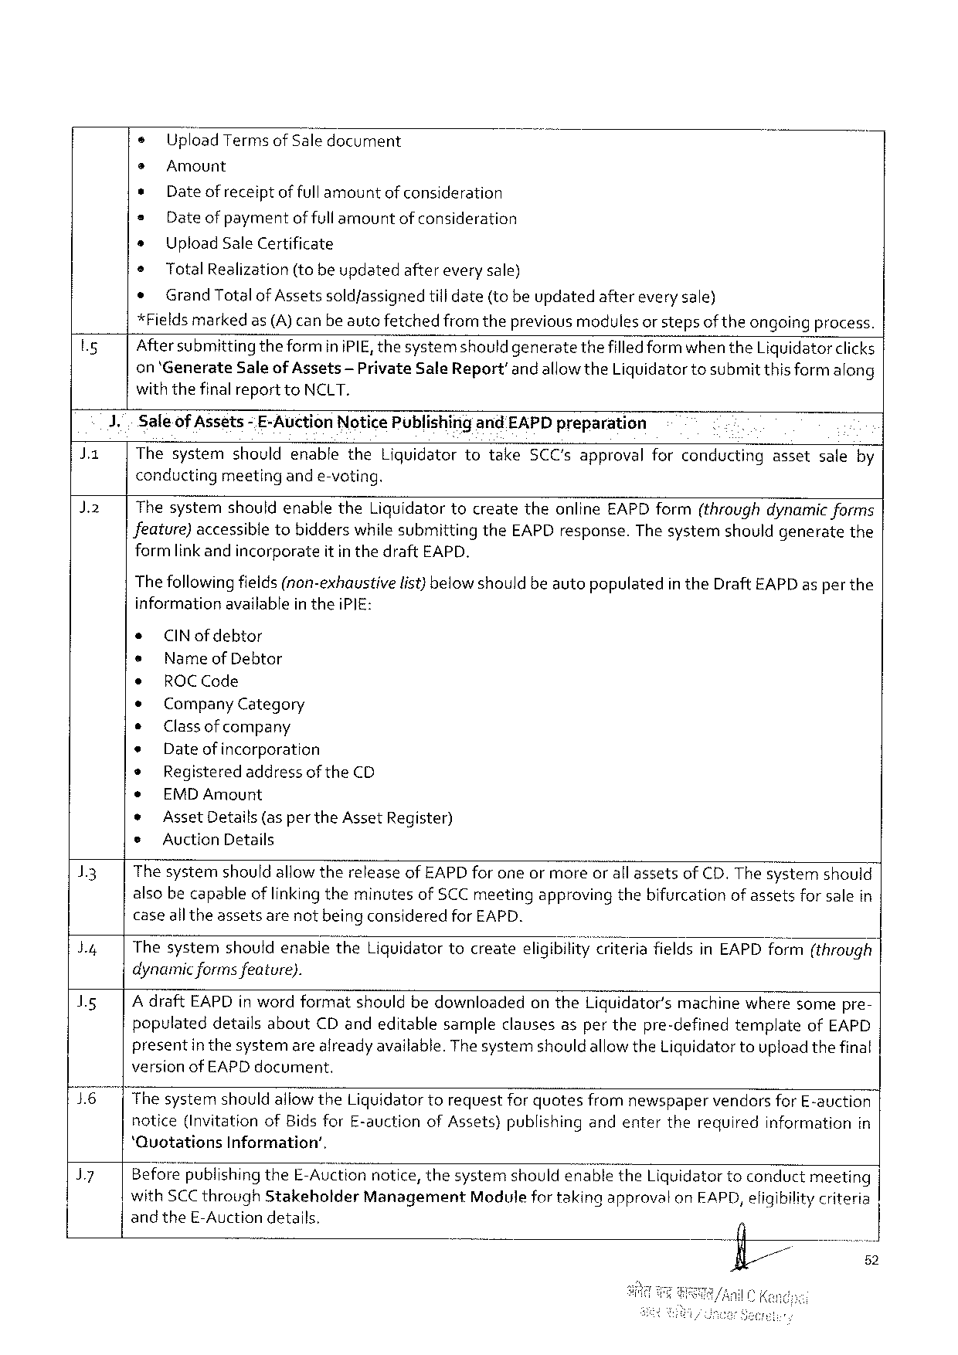

o UploadTermsofSaledocument

s Amount

* Date of receiptoffull amountof consideration

= Date of paymentof fullamountof consideration

s UploadSaleCertificate

® TotalRealization(tobe updatedafterevery sale)

e Grand TotalofAssetssold/assignedtill date(tobeupdatedaftereverysale)

*Fieldsmarked as(A)canbeautefetchedfrom theprevious modules or stepsof theongoingprocess.

|  |  |  |  |  |
| --- | --- | --- | --- | --- |
| Ly | 1. | Aftersubmitting theforminiPIE,thesystemshould generatethefilled form when theLiquidatorclicks | | |
| Ja | on‘GenerateSaleof Assets-PrivateSale Report’andallowtheLiquidatortosubmitthis formalong | | |
| withthefinalreporttoNCLT. | | |
| Saleof Assets | - E-AuctionNoticePublishirgandEAPDpreparation | |
| ThesystemshouldenabletheLiquidatortotakeSCC'sapprovalforconductingassetsaleby | | |
| J2 | conducting | meetingande-voting. | |
| ThesystemshouldenabletheLiquidatortocreatetheonlineEAPDform(throughdynamic forms | | |
| Jeature)accessibletobidderswhilesubmittingtheEAPDresponse.The systemshouldgeneratethe | | |
| formlink andincorporate | | itinthedraftEAPD. |

Thefollowingfields(non-exhaustive

informationavailable in theiPIE:

* CINofdebtor

s Name of Debtor

¢ ROCCode

¢ CompanyCategory

s Classof company

e Dateofincorporation

® RegisteredaddressoftheCD

e EMDAmount

list) below shouldbeautopopulatedin theDraftEAPD as per the

|  |  |  |  |  |  |  |  |  |  |  |  |  |
| --- | --- | --- | --- | --- | --- | --- | --- | --- | --- | --- | --- | --- |
| 13  by  Is  76|  J7 | * | | AssetDetails(as per theAssetRegister) | | | | | | | | | |
| e | AuctionDetails | | | | | | | | | | |
| ThesystemshouldallowthereleaseofEAPD forone ormoreor all assetsof CD.The systemshould alsobecapableoflinkingtheminutesofSCC meetingapprovingthebifurcationof assetsforsalein caseall theassetsarenotbeing consideredfor EAPD. | | | | | | | | | | | |
| ThesystemshouldenabletheLiguidatortocreateeligibiiit;}‘iriteria | | | | | | | fieldsinEAPDform(through | | | | |
| dynamicformsfeature).  AdraftEAPDin wordformatshouldbedownloadedontheLiquidator'smachinewheresomepre-populateddetailsaboutCDandeditablesampleclausesasperthepre-definedtemplateofEAPD presentin thesystemarealready available.ThesystemshouldallowtheLiquidatortouploadthefinal versionof EAPD document. | | | | | | | | | | | |
| ThesystemshouldallowtheLiquidatortorequestforquotesfromnewspaper | | | | | | | | vendorsforE-auction | | | |
| notice(InvitationofBidsforE-auction | | | | ofAssets)publishing | | andenter | therequired | | information | | in |
| ‘QuotationsInformation’, | | | | | | | | | | | |
| BeforepublishingtheE-Auctionnotice,thesystemshouldenabletheLiquidatortoconduct | | | | | | | | | | meeting | |
| withSCCthroughStakeholder | | | Management | | ModulefortakingapprovalonEAPD,eligibilitycriteria | | | | | | |
| and theE-Auctiondetails. | | | | | | | 4 | | | | |
| fl/// | | | | | | | | | 52 | | |
| i | | | | | | | | | 3 | | |

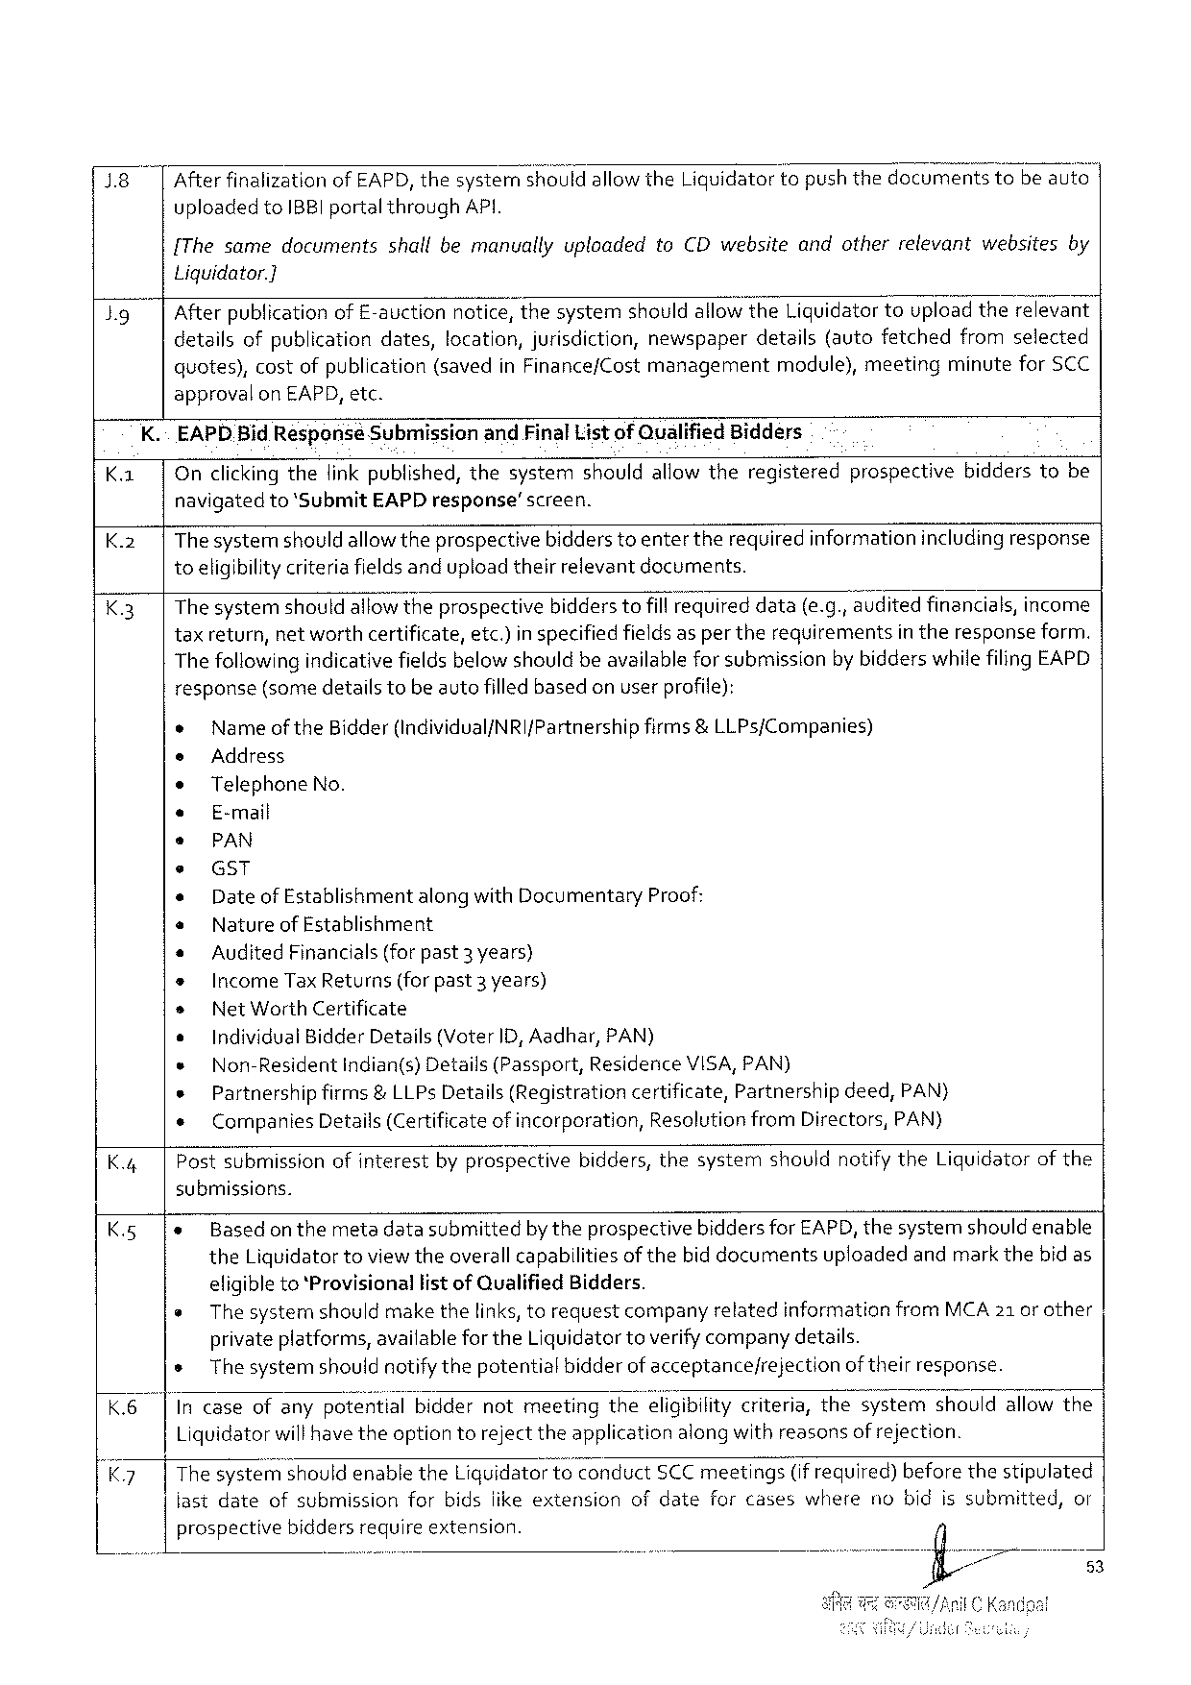

1.8 After finalizationof EAPD, thesysternshould allowtheLigquidatortopushthedocomentstobe auto|

uploadedtoIBBIportalthroughAPI.

{The samedocumentsshallbemanuallyuploadedtoCDwebsiteandotherrelevantwebsitesby

Liquidator.]

|  |  |  |  |  |  |  |  |
| --- | --- | --- | --- | --- | --- | --- | --- |
| Jg | Afterpublicationof E-auctionnotice,thesystemshouldallowtheLiquidatortoupload therelevant detailsofpublicationdates,location,jurisdiction,newspaperdetails(autofetchedfromselected | | | | | | |
| quotes), | costofpublication | (savedinFinance/Cost | management | module), | meeting | minuteforSCC |

approvalon EAPD, etc.

K.~ EAPD.BidResponseSubmissionandFinalList of QualifiedBidders

|  |  |  |  |  |
| --- | --- | --- | --- | --- |
| K. | | | Onclicking thefink published,thesystemshouldallowtheregisteredprospectivebidderstobe navigatedto‘SubmitEAPD response’screen.  Thesystemshould allowtheprospectivebidderstoenter therequiredinformationincludingresponse toeligibilitycriteriafieldsandupload theirrelevantdocuments.  Thesystemshould allowtheprospectivebidders tofillFequned data(e.g.,auditedfinancials,income | | |
| K.2|  K3| | |
| taxreturn,networthcertificate, | etc.)inspecifiedfieldsaspertherequirements | intheresponseform. |
| Thefollowing indicativefieldsbelow shouldbeavailablefor submissionby bidderswhilefilingEAPD | | |

response(some detailstobe autofilledbasedonuser profile):

e Nameof theBidder(Individual/NRIfPartnership firms&LLPs{Companies)

e Address

e TelephoneNo.

e E-mail

e PAN

e GST

s Date of EstablishmentalongwithDocumentaryProof:

e Nature of Establishment

* AuditedFinancials(forpast3 years)

IncomeTaxReturns(forpast3 years)

Net Worth Certificate

|  |  |  |  |  |  |
| --- | --- | --- | --- | --- | --- |
| K.4| | o | IndividualBidderDetails(VoterID,Aadhar,PAN) | | | |
| « | Non-Resident | | indian(s)Details(Passport, | ResidericeVISA,PAN) |
| s | Partnershipfirms&LLPs Details(Registrationcertificate,Partnershipdeed,PAN) | | | |
| ¢ | | CompaniesDetails(Certificateof incorporation,ResolutionfromDirectors, PAN) | | |
| Postsubmissionofinterestbyprospectivebidders,thesystemshouldnotify theLiquidatorof the | | | | |

submissions.

|  |  |  |  |
| --- | --- | --- | --- |
| K.5 | |e | Basedonthe | metadatasubmittedby theprospectivebiddersfor EAPD,thesystemshould enable |
| theLiquidatortoviewtheoverallcapabilitiesofthebid documentsuploadedandmarkthebidas | |

eligibleto‘ProvisionallistofQualifiedBidders.

s The systemshouldmake thelinks,torequestcompanyrelatedinformationfromMCA21 orother

privateplatforms,availablefor theLiquidatortoverifycompanydetails.

s The systemshould notifythepotentialbidderof acceptancefrejection oftheirresponse.

K.6| Incaseofanypote‘fi’tlalbiddernotmeetingthe;Iigib«lltycriteria,thesystemshouldallowthe

Liquidatorwillhave theoption torejecttheapplicationalongwithreasonsof rejection.

K7 |The syste‘rfi;houldenabletheLiquidatortoconductSCC meetings(if required)beforethestipulated

fastdate ofsubmission forbidsiikeextension ofdate forcases where nobidissubmitted, or

prospective biddersrequireextension.

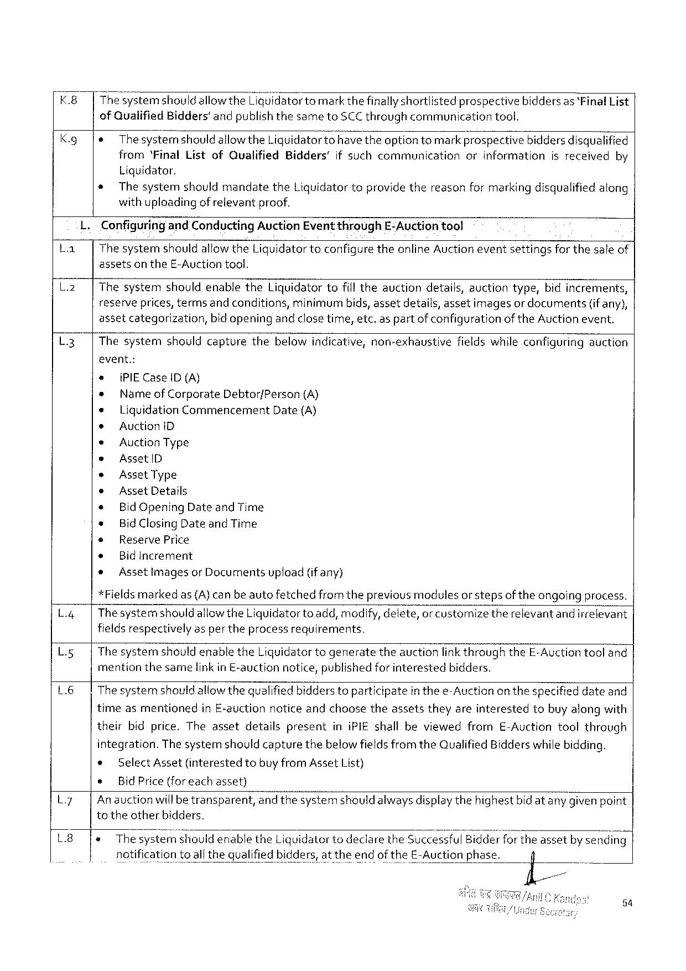

|  |  |  |  |
| --- | --- | --- | --- |
| K.8  K.g | The";ystem should allowtheLiquidatortomarkthefinallyshortlistedprospectivebidders as ‘FinalList of QuaiifiedBidders'andpublishthesametoSCCthroughcommunicationtool. | | |
| e | Thesystemshould | allowtheLiquidatortt)have theoption tomarkprospectivebiddersdisqualified |

from‘FinalListofQualifiedBidders'if suchcommunicationorinformationisreceivedby

Liquidator.

s ThesystemshouldmandatetheLiquidator toprovidethereasonfor markingdisqualified along

withuploading of relevantproof.

ConfiguringandConductingAuctionEvent throughE-Auction tool

|  |  |  |
| --- | --- | --- |
| La | | | ThesystemshouldallowtheLiquidatortoconfigure theonline Auctioneventsettingsfor thesale of |

assetsontheE-Auctiontool.

L.2| ThesystemshouldenabletheLiquidatortofilltheauctiondetails,auctiontype,bidincrements,

reserveprices,termsandconditions,minimum bids,assetdetails,assetimagesordocuments (if any),

assetcategorization,bidopeningandclosetime,etc.aspart ofconfigurationof theAuction event,

L3 Thesystemshouldcapturethebelowindicative,non-exhaustivefieldswhileconfiguringauction

event.:

e {PIECaseID(A)

* NameofCorporate DebtorfPerson (A)

* LiquidationCommencement Date(A)

s AuctioniD

« AuctionType

* AssetlD

* Asset Type

® AssetDetails

* BidOpeningDate and Time

* BidClosingDate and Time

s ReservePrice

* BidIncrement

* Assetlmagesor Documentsupload(if any)

*Fieldsmarkedas(A)canbe autofetchedfromtheprevious modulesor stepsof theongoing process.

L.4| Thesystemshould allowtheLiquidatorto add,modify,delete,orcustornize therelevantandirrelevant

fieldsrespectively aspertheprocessrequirements.

L.g The systemshouldenabletheLiquidatortogeneratetheauctionlink throughtheE-Auctiontooland

mention thesamelinkinE-auctionnotice,publishedforinterested bidders.

L6 Thesystemshould allowthequalified bidderstoparticipatein thee-Auctionon thespecifieddateand

timeasmentionedinE-auction noticeandchoosetheassetstheyareinterestedtobuyalongwith

theirbidprice.TheassetdetailspresentiniPIE shallbeviewedfromE-Auctiontoolthrough

integration.The systemshouldcapturethebelowfieldsfromtheQualified Bidderswhilebidding.

|  |  |  |  |  |  |  |  |
| --- | --- | --- | --- | --- | --- | --- | --- |
| L7  L8 | * | SelectAsset | (interested | tobuyfromAsset | | List) | |
| s | Bid Price(foreachasset) | | | | | |
| An auctionwill betransparent,and thesystemshouldalwaysdisplaythehighestbid atanygivenpoint totheotherbidders.  1eThesystemshouldenabletheLiquidatortodeclaretheSuccessfulBidderfortheassetby sending | | | | | | |
| notification | | toallthequalified | | bidders,attheendoftheE-Auctionphase. | | il |

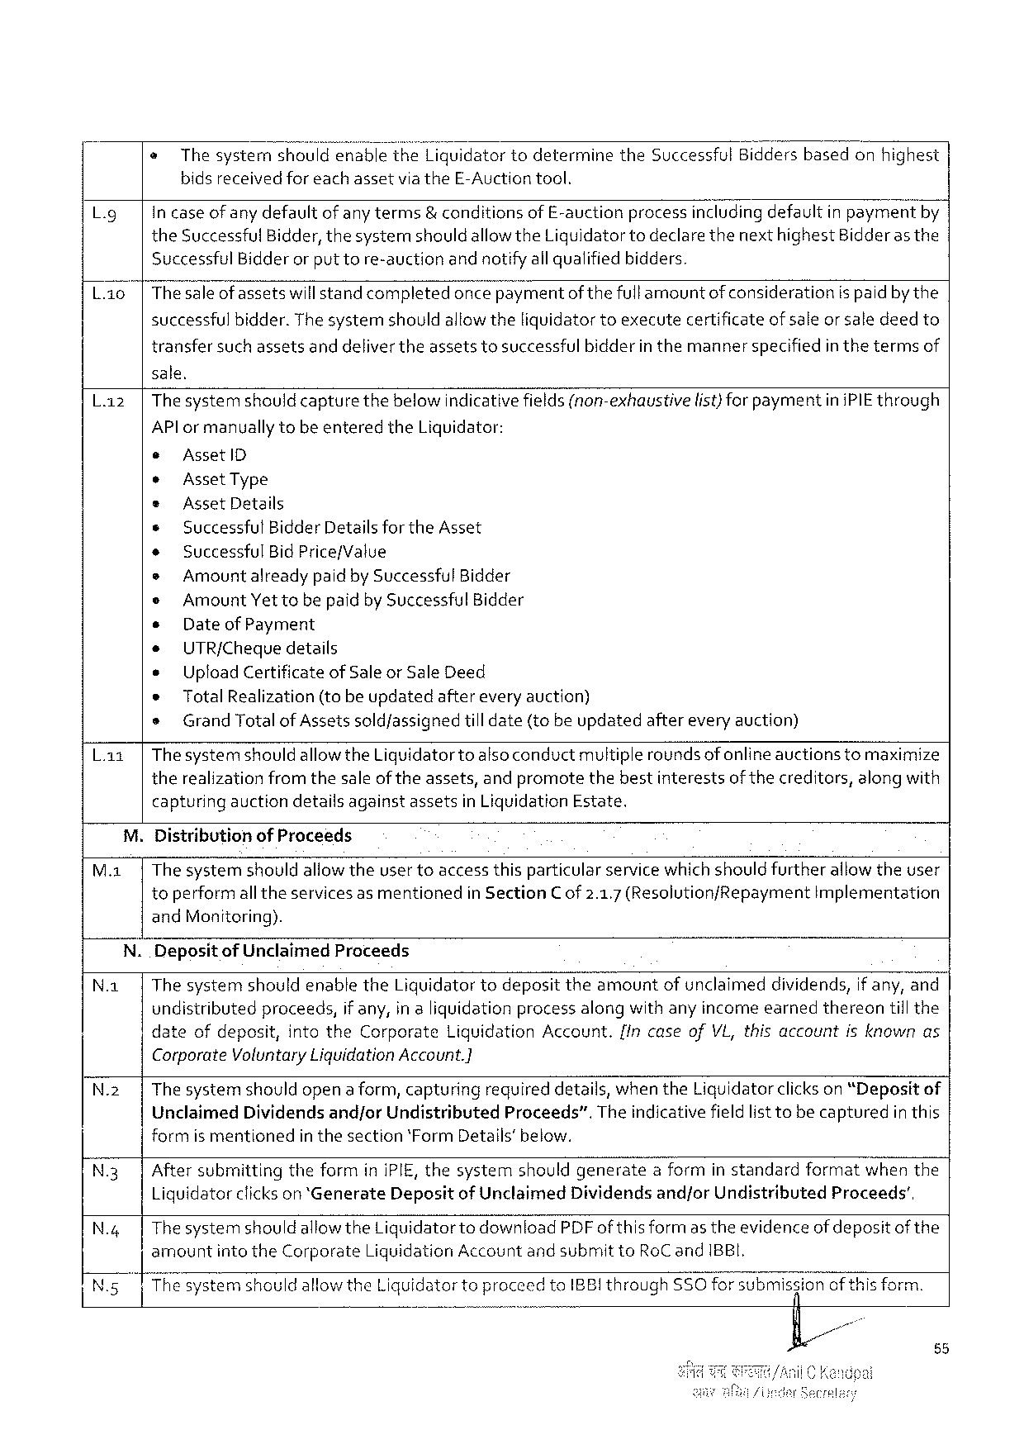

@ThesystemshouldenabletheLiquidator todeterminetheSuccessfulBiddersbasedonhighest

bidsreceivedforeachassetvia theE-Auctiontool.

Lg in case of any defaultof anyterms& conditionsof E-auctionprocessincludingdefaultinpaymefitby

theSuccessfulBidder,thesystemshould allowtheLiquidatortodeclare thenext highestBidderas the

Successful Bidderor puttore-auctionandnotifyallqualified bidders.

L.ao|Thesaleof assetswillstandcompletedonce pa\;mentof thefullamountof considerationispaidbythe

successfulbidder.Thesystemshouldallowtheliquidator toexecutecertificateofsaleor saledeedto

transfersuchassetsanddelivertheassetstosuccessful bidderin themannerspecifiedin thetermsof

sale.

|  |  |  |
| --- | --- | --- |
| L.z | |Thesystemshould capturethebelowindicativefields(non-exhaustive | list)for paymentiniPIE through |

APlor manually tobe enteredtheLiquidator:

e AssetlD

e AssetType

e Asset Details

* SuccessfulBidderDetails fortheAsset

e SuccessfulBid Price/Value

e Amountalreadypaidby Successful Bidder

e Amount Yettobe paidby SuccessfulBidder

e Date of Payment

* UTR/Chequedetails

e UploadCertificateof Saleor Sale Deed

* TotalRealization(tobeupdated aftereveryauction)

s Grand Totalof Assetssoldfassignedtill date(tobe updatedaftereveryauction)

L.az|ThesystemshouldallowtheLiquidatortoalsoconductmultiplerounds of onlineauctionstomaximize

therealization fromthesale of theassets,andpromotethebestinterestsof thecreditors,alongwith

capturingauctiondetailsagainstassetsinLiquidationEstate.

M.DistributionofProceeds

M.1|The systemshouldallowtheuser toaccessthisparticular service whichshould furtherallowtheuser

toperformall theservicesas mentionedin SectionC of 2.1.7 (ResolutionfRepaymentImplementation

andMonitoring).

N.DepositofUnclaimedProceeds

N.a| ThesystemshouldenabletheLiquidator todeposittheamountof unclaimeddividends,if any,and

undistributedproceeds,if any,in aliquidationprocessalongwithanyincomeearnedthereontill the

|  |  |  |  |  |  |
| --- | --- | --- | --- | --- | --- |
| date | ofdepesit, | intotheCorporate | Liquidation | Account. | {In caseofVL,thisaccountisknownas |

CorporateYoluntaryLiquidationAccount.]

N.2 | Thesystemshouldopena form,capturing requireddetails,whentheLiquidatorclickson“Deposit of

Unclaimed Dividends and/orUndistributed Proceeds”. Theindicativefieldlist tobecaptured inthis

formismentioned inthesection‘FormDetails’below.

N.3| AftersubmittingtheforminiPIE, thesystemshouldgeneratea formin standardformatwhenthe

Liquidatorclickson *‘GenerateDepositof UnclaimedDividendsandforUndistributedProceeds’,

|  |  |
| --- | --- |
| N.4| | Thesystemshould allowtheLiquidatorto downloadPDFof this formas theevidence of depositof the amountintotheCorporateLiquidationAccountand submittoRoCand IBBI.  |ThesystemshouldallowtheLiquidatortoproceedtoIBBIthrough ,,,,,A SSOforsubmisfiianof thisform. e |

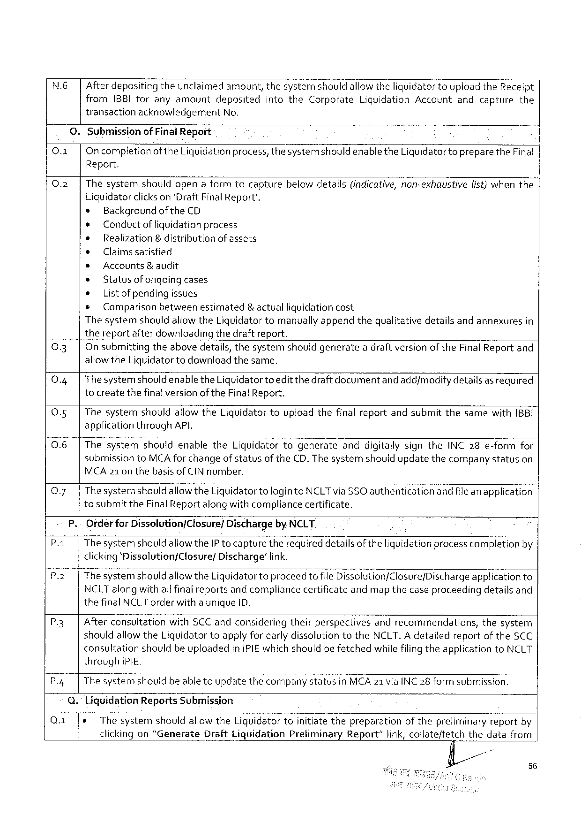

N.6| Afterdeposit\r\gtheunclaimedamount,thesystemshouidallowtheliquidator touploadtheReceipt

from IBBIforanyamount deposited intothe Corporate Liquidation Account and capture the

transactionacknowledgementNo.

0. Submissionof Final Report

O |Oncompletion oftheLiquidationprocess,thesystemshouldenabletheLiquidatortopreparetheFinal

Report.

|  |  |  |
| --- | --- | --- |
| 0.2 | | | Thesystemshouldopenaformtocapturebelowdetails(indicative,non-exhaustivelist)whenthe |

Liquidatorclickson 'DraftFinalReport'.

s Background ofthe CD

e Conductof liquidationprocess

¢ Realization & distributionof assets

o Claimssatisfied

* Accounts& audit

e Statusof ongoingcases

» Listof pending issues

e Comparison betweenestimated &actualliguidationcost

ThesystemshouldallowtheLiquidatortomanually appendthequalitativedetailsandannexuresin

thereportafterdownloadingthedraftreport.

|  |  |  |
| --- | --- | --- |
| 0.3 | | | On submittingtheabovedetails,thesystemshouldgeneratea draftversionof theFinalReportand |
| 0.4 | | | allowtheLiquidatortodownloadthesame. |
| Thesystemshouldenable theLiquidatortoeditthe draft documentand add/modifydetailsas required |
| 0.5 | | | tocreatethefinalversionof theFinalReport. |
| Thesystemshouldallow theLiquidatortouploadthefinalreportandsubmitthesamewith(BB{ |

applicationthroughAP,

0.6 |ThesystemshouldenabletheLiquidatortogenerateanddigitallysigntheINC 28e-formfor

submissiontoMCAfor changeof statusoftheCD.The systemshouldupdatethecompanystatuson

MCA21on thebasisofCIN number.

|  |  |  |
| --- | --- | --- |
| Q.7| | Thesystemshould | allowtheLiquidatortologintoNCLTviaSSOauthenticationandfile anapplication |

tosubmit theFinalReport along withcompliancecertificate.

P.-OrderforDissolution/Closure/Dischargeby NCLT

P.1| Thesystemshould allowtheIP tocapturetherequireddetailsof theliquidationprocess completionby

clicking‘Pissolution/Closure/ Discharge’ link.

P2 |Thesystemshould allowtheLiquidatortoproceedto fileDi5;31ution/CIosure/Discharge app!fcationto

NCLTalongwithall final reportsand compliancecertificateandmap thecaseproceedingdetailsand

thefinalNCLTorderwitha uniqueID.

|  |  |
| --- | --- |
| P.3| | AfterconsultationwithSCC andconsideringtheirperspectivesandrecommendations,thesystem shouldallowtheLiquidatortoapplyforearlydissolutiontotheNCLT. A detailedreportof theSCC |

consultationshouldbeuploadediniPIEwhich shouldbefetchedwhilefilingtheapplicationtoNCLT

through iPIE.

P.4| The systemshouldbe able toupdatethecompanystatusinMCA21 viaINC28 form submission.

Q.LiquidationReportsSubmission

|  |  |  |  |  |  |
| --- | --- | --- | --- | --- | --- |
| Q.1 | e | Thesystem | shouldallowtheLiquidatortoinitiatethepreparation | ofthepreliminary | reportby |

56

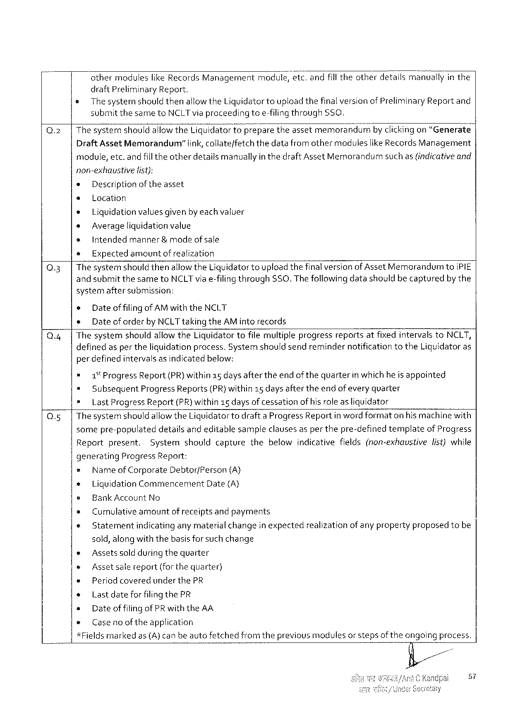

athermoduleslikeRecordsManagementmodule,etc.andfilltheotherdetailsmanuallyin the

draftPreliminaryReport.

¢ Thesystemshould thenallowtheLiquidatortoupload thefinalversionof Preliminary Report and

submit thesametoNCLTviaproceedingtoe-filingthrough$50.

|  |  |  |  |  |
| --- | --- | --- | --- | --- |
| Q.2 | ThesystemshouldallowtheLiquidatortoflpreparetheassetmemorandum | | | byclickingon“Generate |
| DraftAssetMemorandum” | link, collateffetch | thedatafromothermodulieslike RecordsManagement | |

module,etc.andfill theotherdetailsmanuallyin thedraft AssetMemorandumsuch as(indicativeand

non-exhaustive list):

* Descriptionof theasset

s Location

» Liquidationvaluesgiven byeach valuer

* Averageliquidationvalue

» Intendedmanner& mode ofsale

e Expected amountof realization

Q.3| The systemshould thenallowtheLiquidatortoupload thefinalversionof AssetMemorandumtoIPIE

and submitthesametoNCLTvia e-filingthroughSSO.Thefollowingdatashouldbe capturedby the

systemaftersubmission:

o Dateof filingofAMwiththeNCLT

e Dateof orderbyNCLTtakingtheAM intorecords

Q.4| Thesystemshouldallow theLiquidator tofilemultipleprogressreportsatfixedintervals toNCLT,

definedasper theliquidationprocess.SystemshouldsendremindernotificationtotheLiguidatoras

perdefinedintervals asindicatedbelow:

* 1% ProgressReport(PR) within15days aftertheendof thequarterin which he is appointed

= Subsequent ProgressReports(PR)within15 daysaftertheendof everyquarter

= LastProgressReport(PR)within15daysofcessation ofhisroleasliquidator

Q.5|Thesystemshould allowtheLiquidatortodrafta ProgressReportinwordformaton hismachinewith

somepre-populateddetailsandeditablesampleclausesas per thepre-definedtemplateof Progress

Reportpresent. Systemshouldcapturethebelowindicativefields(non-exhaustivelist)while

generating ProgressReport:

= NameofCorporate Debtor/Person (A)

+ Liguidation Commencement Date(A}

e Bank AccountNo

» Cumulativeamountof receiptsandpayments

e Statement indicatinganymaterialchangeinexpected realization of anyproperty proposed tobe

sold,alongwiththebasisforsuchchange

|  |  |  |  |  |  |  |  |  |  |  |
| --- | --- | --- | --- | --- | --- | --- | --- | --- | --- | --- |
| * | | Assetssoldduring thequarter | | | | fromtheprevious | modules | orsteps | oftheongoing | process. |
| ¢ | Assetsale | | | report(forthequarter) | |
| e | Period coveredunder thePR | | | | |
| * | | LastdateforfilingthePR | | | |
| * | | Dateof filingofPRwiththeAA | | | |
| * | Caseno of theapplication | | | | |
| *Fields | | | marked | as(A)canbeauto | fetched |

57

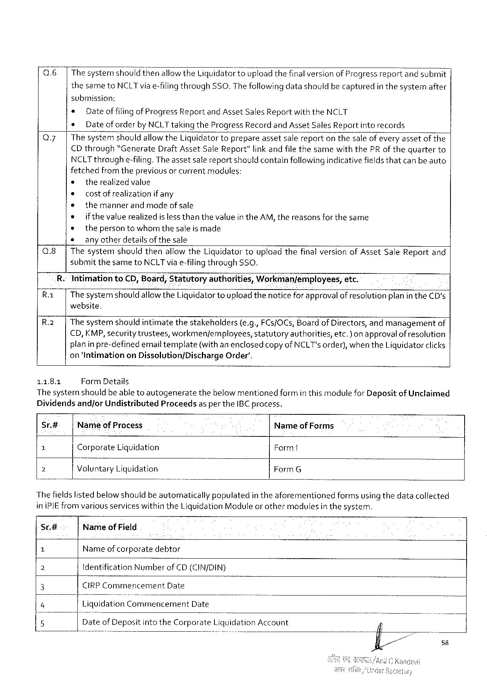

Q.6 |ThesystemshouldthenallowtheLiquidatortoupload thefinalversionof Progress reportandsubmit |

thesametoNCLTviae-filingthroughSSO.Thefollowingdatashouldbecapturedin thesystemafter

submission:

s Dateof filingof ProgressReport and AssetSales ReportwiththeNCLT

e Dateof orderbyNCLTtakingtheProgressRecordand AssetSales Report into records

Q7| ThesystemshouldallowtheLiquidatortoprepareassetsalereporton thesaleof everyassetof the

CDthrough“GenerateDraftAssetSale Report”linkandfile thesamewiththePRof thequarterto

NCLTthroughe-filing.Theassetsalereportshouldcontainfollowingindicativefieldsthatcanbe auto

fetchedfrom thepreviousor currentmodules:

¢ therealizedvalue

o costofrealization ifany

e themannerandmodeof sale

e ifthevalue realizedislessthanthevalue intheAM, thereasonsforthesame

* thepersontowhomthesaleis made

* _any otherdetailsofthesale

Q.8| Thesystemshouldthenallow theLiguidatortouploadthefinal versionofAssetSaleReportand

submitthesametoNCLTviae-filingthroughSSO.

R.-IntimationtoCD,Board;Statutoryauthorities,Workman/employees; etc.

R | Thesystemshould allowtheLiquidatortouploadthenoticeforapprovalof resolution planin theCD's

website.

R.2| The systemshouldintimatethestakeholders(e.g.,FCs/OCs,Board of Directors,andmanagementof

€D,KMP,securitytrustees,workmen/employees, statutory authorities, etc.)on approvalof resolution

planin pre-definedemailtemplate(withan enclosedcopy ofNCLT's order), when theLiquidatorclicks

on ‘IntimationonDissolution/DischargeOrder’.

11.8.1 FormDetails

The systemshouldbeable toautogeneratethebelowmentionedformin thismodule for Depositof Unclaimed

Dividendsand/orUndistributedProceedsas pertheIBC process.

|  |  |  |  |
| --- | --- | --- | --- |
| Sr.# | Nameof Process | | NameofForms |
| 1 | Corporate | Liquidation |
| Form |
| 3 | VoluntaryLiquidation | |
| FormG |

Thefieldslistedbelow shouldbeautomaticallypopulatedin theaforementionedformsusingthedatacollected

iniPIE from variousserviceswithintheLiquidationModuleor othermodulesin thesystem.

Sr.# NameofField

1 Nameof corporatedebtor

2 fdentification NumberofCD (CIN/DIN)

3 CIRPCommencement Date

4 Liquldat»on“CoI’r‘\mencememDate

5 VD”at‘e‘ofDepositintotheCorporate L’u;mdatlonAccount

58

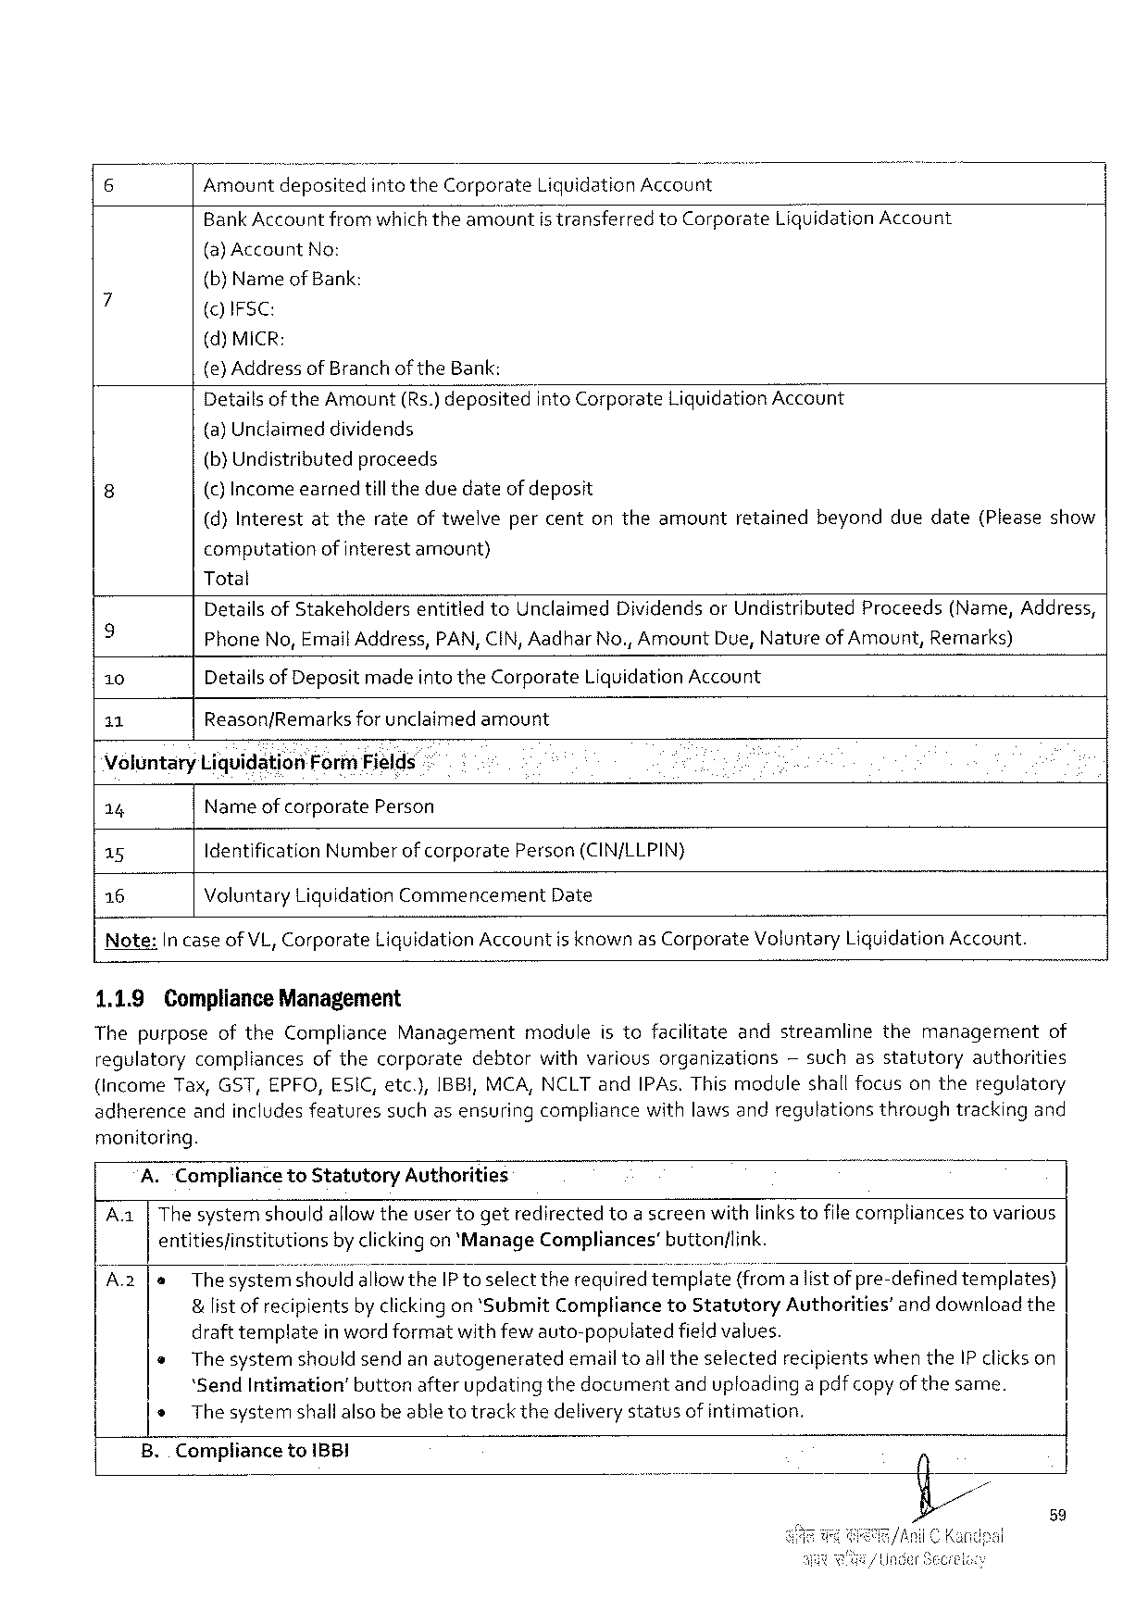

|  |  |  |  |  |  |
| --- | --- | --- | --- | --- | --- |
| Amountdeposited | | intotheCorporate | LiquidationAccount | | LiquidationAccount |
| BankAccountfromwhichtheamount | | | istransferred | toCorporate |
| (a)Account | No: | |

(b)NameofBank:

()IFSC:

(d)MICR:

(e) AddressofBranchof theBank:

|  |  |  |
| --- | --- | --- |
| Detailsofthe Amount(Rs.)deposited | intoCorporate | LiquidationAccount |

(a) Unclaimeddividends

|  |  |  |  |  |  |  |  |  |
| --- | --- | --- | --- | --- | --- | --- | --- | --- |
| (b}Undistributed | | proceeds | | retained | beyond | duedate | (Please | show |
| (c) Incomeearned | | tilltheduedateofdeposit | |
| (d)Interest | attherateoftwelve | | percentontheamount |

computationofinterestamount)

Total

|  |  |  |  |  |  |  |  |
| --- | --- | --- | --- | --- | --- | --- | --- |
| 9  10  11 | DetailsofStakeholders | | entitied | toUnclaimed | DividendsorUndistributed | Proceeds | (Name,Address, |
| PhoneNo,EmailAddress,PAN, CIN,AadharNo.,AmountDue,NatureofAmount,Remarks) Detailsof Depositmade intetheCorporateLiquidationAccount | | | | | | |
| Reason/Remarks | forunclaimed | | amount | | | |

VoluntaryLiquidationFormFields

14 Nameofcorporate Person

15 Identification Numberof corporate Person(CIN/LLPIN}

16 VoluntaryLiquidationCommencementDate

Note: In caseof VL, Corporate LiquidationAccountisknownasCorporate VoluntaryLiguidationAccount.

1.1.9 ComplianceManagement

ThepurposeoftheComplianceManagementmoduleistofacilitateandstreamlinethemanagement of

regulatory compliances ofthecorporate debtor withvarious organizations ~suchasstatutory authorities

(income Tax,GST,EPFO,ESIC,etc.),IBBI,MCA, NCLTandIPAs.Thismodule shallfocusontheregulatory

adherenceandincludesfeaturessuchasensuringcompliancewithlaws andregulationsthroughtrackingand

monitoring.

A.CompliancetoStatutoryAuthorities

Aa|Thesystemshouldallowtheusertogetredirectedtoa screenwithlinkstofilecompliancestovarious

entities/institutionsby clickingon‘ManageCompliances’button/link.

|  |  |  |
| --- | --- | --- |
| A2 | le | Thesyster'fids'l{o‘t‘,'ld'allowtheIP toselect therequiredteerIé?:e(f}om alistofpre-definedtemplates) |

&list of recipientsby clickingon ‘SubmitCompliancetoStatutoryAuthorities’and downloadthe

draft templateinwordformatwithfew auto-populatedfieldvalues.

|  |  |  |  |
| --- | --- | --- | --- |
| o | Thesystemshouldsendanautogenerated | emailtoalltheselected | recipientswhentheIP clickson |

‘SendIntimation’buttonafterupdatingthedocumentanduploadinga pdfcopyof the same.

o Thesystemshallalsobe able totrackthedeliverystatusof intimation.

B.. Compliance to1BBI

59

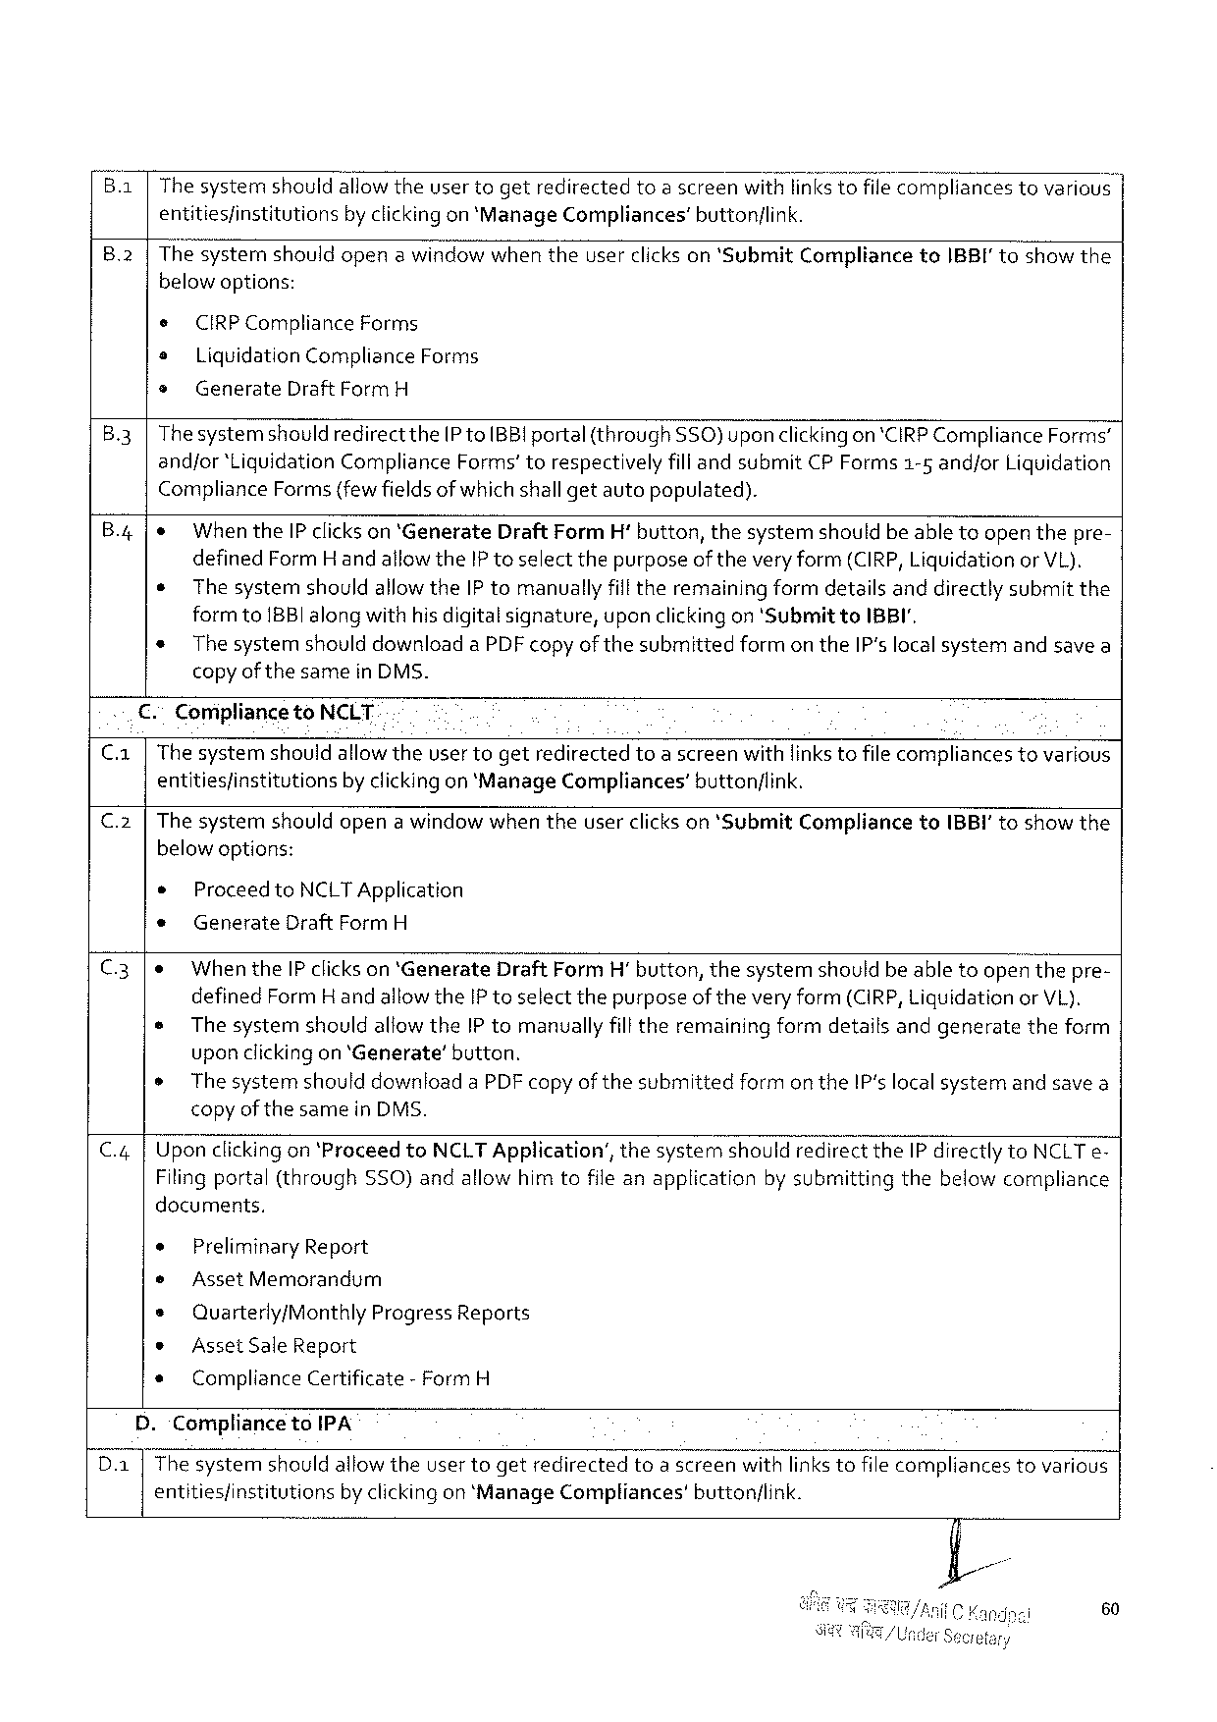

B.1|The systemshouldallowtheuser togetredirectedtoa screenwithlinkstofilecompliancestovarious | entities/institutionsby clickingon ‘ManageCompliances’buttonlink.

|  |  |  |  |  |  |
| --- | --- | --- | --- | --- | --- |
| B.2|Thesysternshouldopenawindowwhentheuserclickson‘Submit | | | | Compliance | toIBBI'toshowthe |
| below options: | | | |
| ¢ | CIRPCompliance | | Forms |
| o | LiquidationComplianceForms | | |
| » | Generate | DraftFormH | |

B.3|Thesystemshouldredirectthe[P toBB!portal(throughSSO)upon clickingon*CIRPCompliance Forms’andjor‘LiguidationComplianceForms’torespectivelyfill andsubmitCP Forms1-5 andforLiquidation Compliance Forms{fewfieldsof whichshallgetautopopulated).

B.4|& When theIP clickson ‘GenerateDraftFormH' button,thesystemshouldbe abletoopenthepre- definedFormHandallowtheIP toselectthepurposeoftheveryform(CIRP, LiquidationorVL). e The systemshouldallowtheIP tomanuallyfilltheremainingformdetailsanddirectlysubmitthe formto1BBIalong withhisdigitalsignature,upon clickingon 'SubmittoIBBI',   
 * Thesystemshould downloadaPDF copyof thesubmittedformon theIP'slocalsystemandsavea copyof the samein DMS.

|  |  |  |
| --- | --- | --- |
| Ca | €. | ComipliancetoNCLT |
| The systemshouldallowtheuser togetredirectedtoa screenwithlinkstofilecompliancestovarious |
| entitiesfinstitutionsby clickingon ‘ManageCompliances’buttonflink. |

C.2|The systemn shouldopena windowwhen theuserclickson *SubmitCompliancetoIBBI' toshowthe below options:

® Proceed toNCLTApplication

* GenerateDraftFormH

C.3|e Whenthe IP clickson ‘GenerateDraftFormH’button,thesystemshouldbeabletoopenthepre- definedFormH andallowtheIP toselectthepurposeof theveryform (CIRP, Liguidationor VL). s The systemshouldallowtheIPtomanuallyfilltheremainingformdetailsandgeneratetheform uponclickingon ‘Generate’button.

o The systemshoulddownloadaPDF copy ofthesubmittedformon theIP‘slocalsystemandsavea copy of thesamein DMS.

C.4|Upon clickingon ‘ProceedtoNCLT Application’,thesystemshouldredirecttheIPdirectlytoNCLTe-Filingportal(throughSSO)andallowhimtofileanapplicationby submittingthebelowcompliance documents,

e Preliminary Report

* AssetMemorandum

s Quarterly/MonthlyProgressReports

* AssetSale Report

s ComplianceCertificate- FormH

D.‘CompliancetoIPA

Da [ The systemshould allowtheuser togetredirectedtoa screenwithlinkstofilecompliancestovarious entities/institutions by clickingon‘ManageCompliances’ button/link.

60

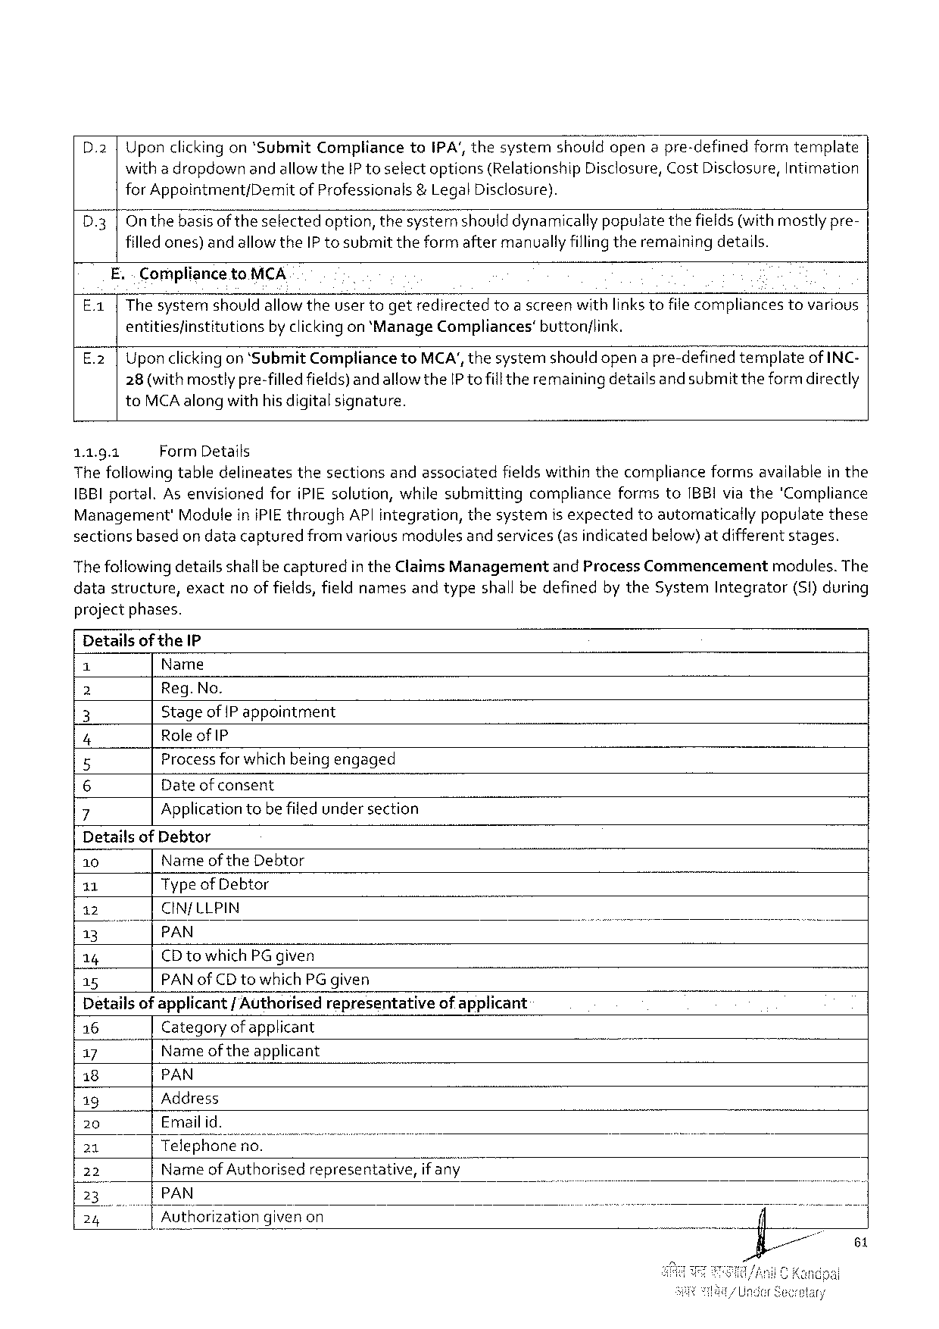

Uponclickingon*SubmitCompliancetoIPA’, thesystemshouldopena pre-definedformtemplate with a dropdownandallowtheIP toselectoptions(RelationshipDisclosure,Cost Disclosure,Intimation

|  |  |  |  |
| --- | --- | --- | --- |
| D3 | forAppointment/Demit | ofProfessionals | &LegalDisclosure). |
| Onthebasisof theselectedoption,thesystémshould dynamically populatethefields(withmostlypre-filledones) andallowtheIP tosubmittheformaftermanually fillingtheremainingdetalls. | | |

E. . CompliancetoMCA

|  |  |  |  |
| --- | --- | --- | --- |
| E1 | Thesystemshouldallowtheusertogetredirected | toascreenwithlinks tofile compliances | tovarious |

entitiesfinstitutionsby clickingon ‘ManageCompliances’button/link.

E.2 |Uponclickingon ‘SubmitCompliancetoMCA',thesystemshould opena pre-definedtemplateof INC-28(withmostlypre-filledfields)andallowtheIP tofillthe remainingdetailsand submit theformdirectly toMCAalongwithhis digitalsignature.

1.1.9.1 FormDetails   
The following tabledelineatesthesectionsandassociatedfields withinthecomplianceformsavailablein the 1BBI portal.As envisionedforiPIEsolution,whilesubmittingcomplianceformstoIBBIviathe'‘Compliance Management'Modulein iPIEthroughAP| integration,thesystemisexpectedtoautomaticailypopulatethese sectionsbasedon datacapturedfrom variousmodulesand services(as indicatedbelow)atdifferentstages.

Thefollowingdetailsshallbe capturedin theClaims Managementand ProcessCommencement modules. The datastructure,exactnoof fields,fieldnamesandtypeshall bedefinedby theSystemIntegrator(S1)during projectphases.

Detailsof theIP

|  |  |
| --- | --- |
| e  (e  |  e | Name  Reg.No.  Stageof |Pappointment  Role ofIP |

Process forwhich beingengaged   
o   
 Dateof consent

|  |  |
| --- | --- |
| ~Nov | Applicationtobe filed undersection |

DetailsofDebtor

|  |  |  |  |  |  |  |  |  |
| --- | --- | --- | --- | --- | --- | --- | --- | --- |
| 10 | Name oftheDebtor | | | | | | [,1 | B |
| 11 | Typeof Debtor | | | | | |
| 12 | CIN/LLPIN | | | | | |
| 13 | |PAN | | | | | |
| 14 | CD towhichPG given | | | | | |
| 15 | PAN ofCDtowhich PG given | | | | | |
| Detailsof applicant | | | | / Authorisedrepresentative | | ofapplicant |
| 16 | Category ofapplicant | | | | | |
| 17 | " | | Nameoftheapplicant | | | |
| 18 | PAN | | | | | |
| ig | Address | | | | | |
| 20 | Emailid. | | | | | |
| 21 | |Telephoneno. | | | | | |
| 22 | Name ofAuthorisedrepresentative,ifan\/‘" | | | | | |
| I3 | PAN | | | | | |
| 24 | B | Authorization | | | givenon | |

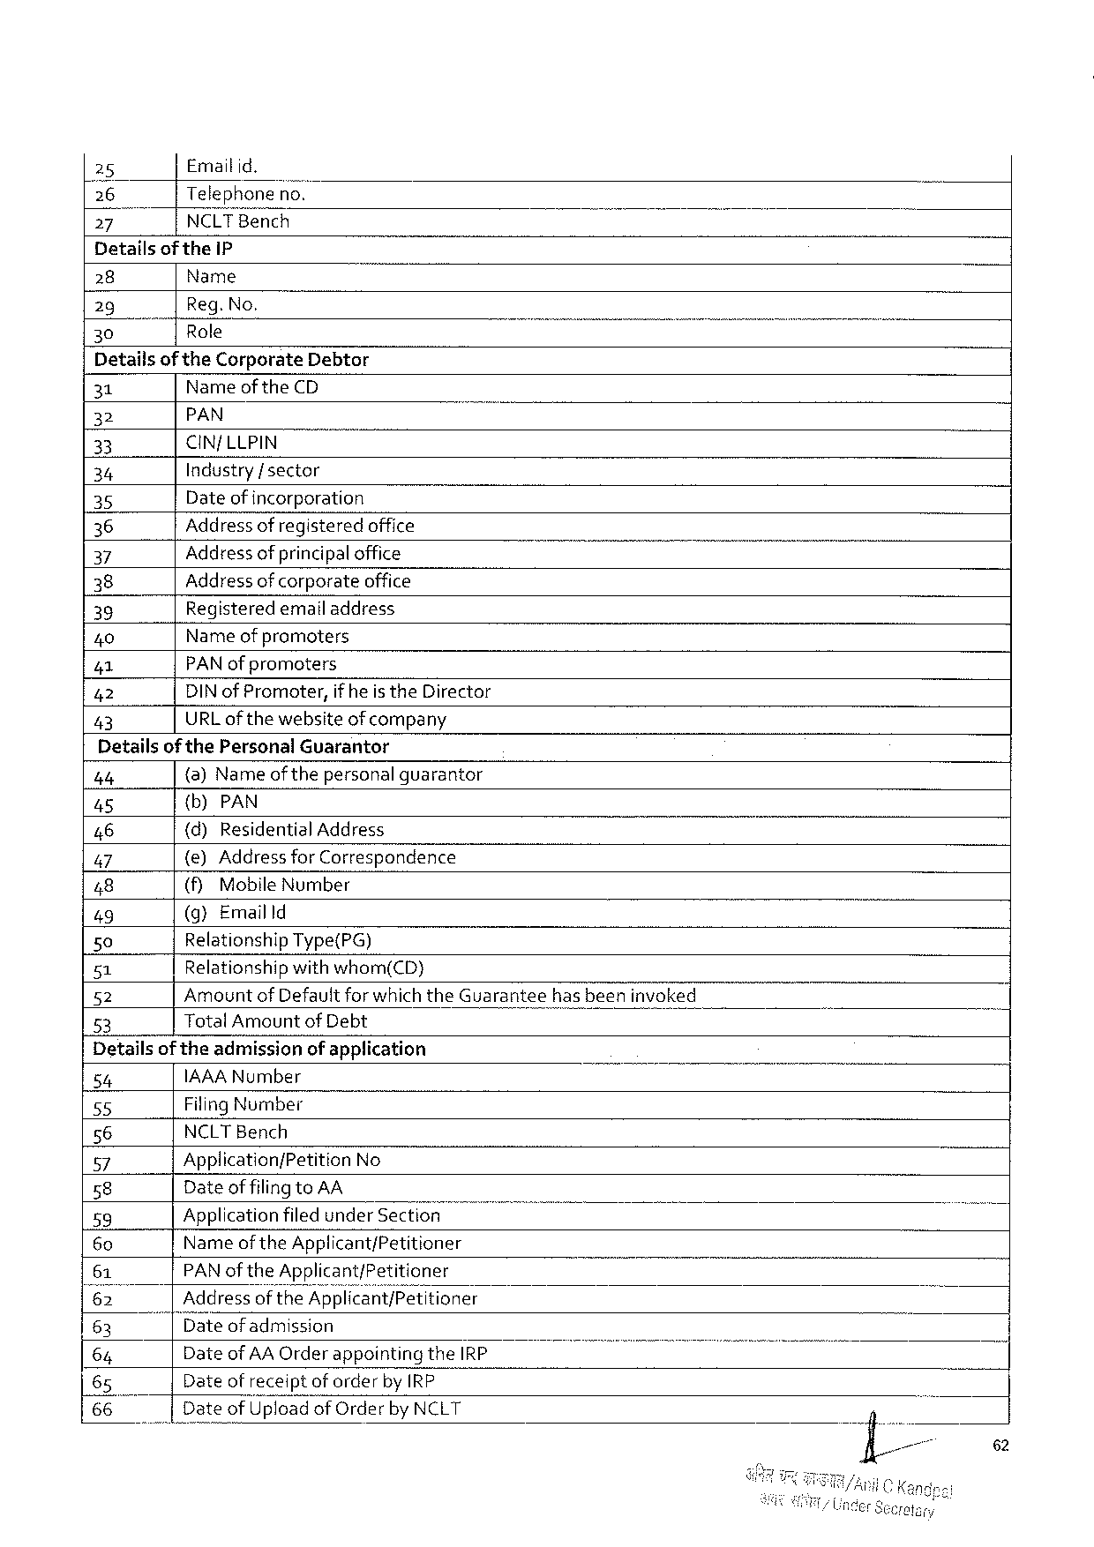

25 Emailid.

[26 Telephoneno.

27 NCLTBench

Detailsof theIP

|  |  |  |  |
| --- | --- | --- | --- |
| 28 | Name | | /00T |
| Reg.No. | |
| 29 |
| 30 | “TRole | — |

Detailsof theCorporateDebtor

|  |  |  |  |
| --- | --- | --- | --- |
| 31 | Nameof theCD | | o |
| 32 | PAN | - |
| 33 | CIN/LLPIN | |
| 34 | Industry/ sector | |
| 35 |
| Dateof incorporation | |
| 36 | Address of registeredoffice | |
| 37 | Address of principaloffice | |
| 38 | Address ofcorporateoffice | |
| 39 | Registeredemail address | |
| 40 | Name of promoters | |
| 41 |
| PAN ofpromoters | |
| 42 | DINof Promoter,if heis theDirector | |
| 43 | URLof thewebsiteof company | |

Detailsof thePersonalGuarantor

|  |  |  |  |  |  |  |
| --- | --- | --- | --- | --- | --- | --- |
| 44 | {a) Name of thepersonal guarantor | | | | hasbeeninvoked | ] |
| 45 | {b)PAN | | | |
| 46 | (d)Residential | | | Address |
| 47 | {e)Address for Correspondence | | | |
| 48 | (fy | Mobile | Number | |
| 49 | (g)Emailld | | | |
| 50 | RelationshipType(PG) | | | |
| 51 | Relationshipwithwhom(CD) | | | |
| 52 | AmountofDefaultforwhich theGuarantee | | | |
| 53 | TotalAmountof Debt | | | |

Detailsoftheadmissionof application

|  |  |  |  |  |  |  |
| --- | --- | --- | --- | --- | --- | --- |
| 54 | IAAANumber | | | T | . | - |
| 55 | Filing Number | | |
| 56 | NCLTBench | | |
| 57 | Application/PetitionNo | | |
| 58 | DateoffilingtoAA | | |
| 59 |
| Applicationfiled underSection | | |
| 60 | Nameof theApplicant/Petitioner | | |
| 61 | PAN of theApplicant/Petitioner | | |
| 62 | ddressoftheApplwcant/P’e‘t\tioner | | |
| 63 | ateof admission | | |
| DateofAA Orderappointing | | theIRP |
| 64 |
| 65 | Dateofreceiptof orderby IRP | | |
| 66 | DateofUpIoad | ofOrderbyNCLT | |

62

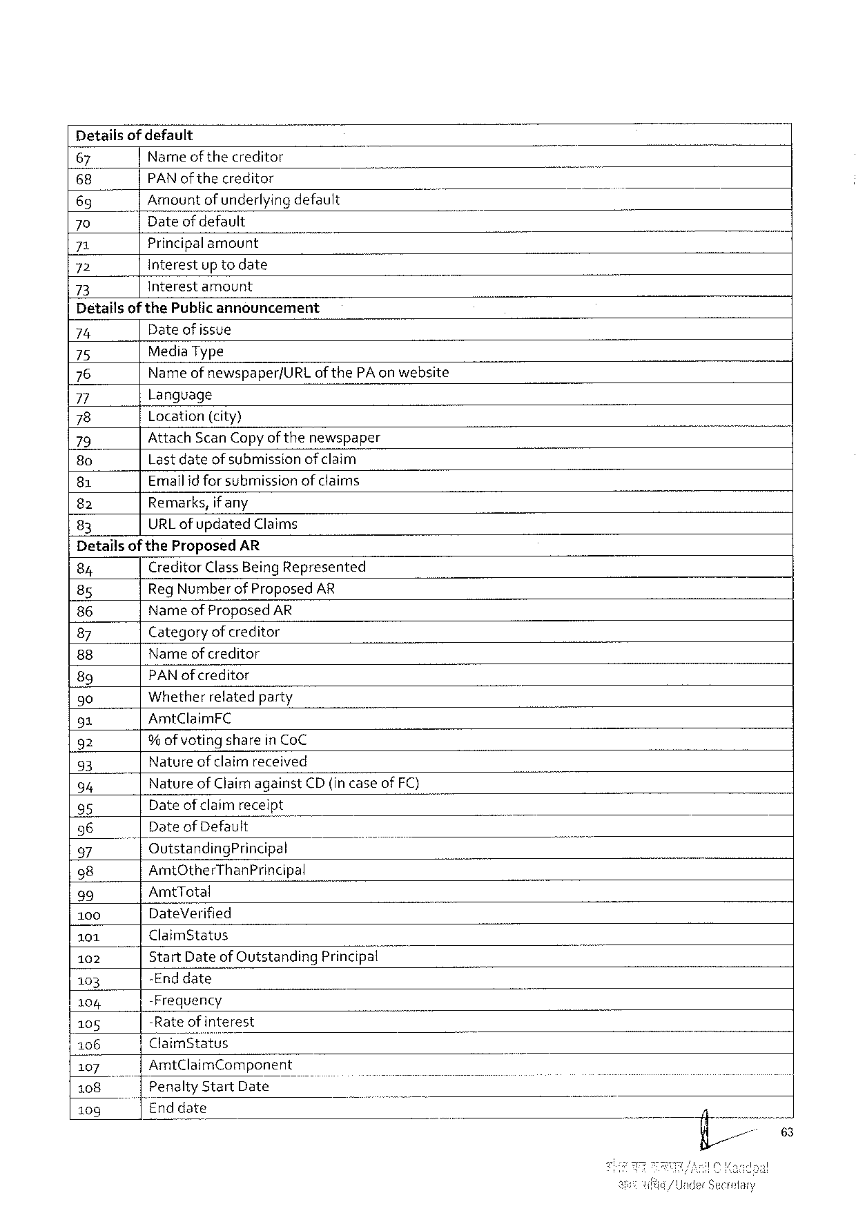

Detailsof default

|  |  |  |  |  |
| --- | --- | --- | --- | --- |
| 67 | Nameofthecreditor | i | o | - |
| 68 | PAN of the creditor |
| 69 | Amountof underlyingdefault |
| 70 | Dateofdefault |
| 71 | Principalamount |
| 72 | Interestup todate |
| 73 | Interestamount |

Detailsof thePublic announcement

|  |  |  |  |
| --- | --- | --- | --- |
| 74 | Date of issue | | T |
| 75 | MediaType | |
| 76 | Name of newspaper/URLof thePAon website | |
| Language | |
| 77 |
| 78 | Location(city) | |
| 79 | AttachScanCopyof thenewspaper | |
| 80 | Lastdateof submissionofclaim | |
| Emailid for submissionof claims | |
| 81 |
| Remarks,if any | |
| 82 |
| URLofupdated | Claims |
| 83 |

DetailsoftheProposedAR

|  |  |  |  |  |  |  |
| --- | --- | --- | --- | --- | --- | --- |
| 84 | CreditorClassBeingRepresented | | | ) | o | - |
| RegNumber of ProposedAR | | |
| 85 |
| Name of ProposedAR | | |
| 86 |
| Category of creditor | | |
| 87 |
| Name ofcreditor | | |
| 88 |
| PAN ofcreditor | | |
| 89 |
| Whetherrelatedparty | | |
| 90 |
| 91 | AmtClaimFC | | |
| 92 | % ofvoting sharein CoC | | |
| Nature of claimreceived | | |
| 93 |
| Nature of Claimagainst | | CD (in case of FC) |
| 94 |
| Dateof claimreceipt | | |
| 95 |
| 96 | Date of Default | | |
| OutstandingPrincipal | | ) |
| 97 |
| 98 | AmtOtherThanPrincipal | | | o |
| 39 | AmtTotal | | |
| 100 | DateVerified | | |
| 101 | ClaimStatus | | |
| 102 | StartDateofOutstandingPrinclpa{u | | |
| -Enddate | | |
| 103 |
| -Frequency | | |
| 104 |
| -Rateofinterest | | |
| 105 |
| ClaimStatus | | |
| 106 |
| 4107 | AmtClaimComponent | | |
| Penalty | StartDate | ) |
| 108 |
| Enddate | | |
| 109 |

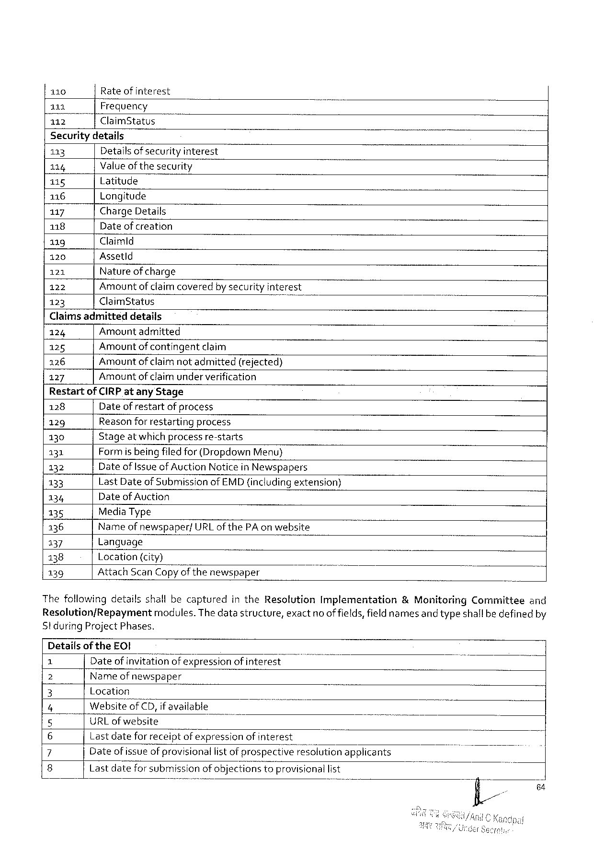

|  |  |  |  |  |  |  |
| --- | --- | --- | --- | --- | --- | --- |
| 110 | Rateofinterest | | o | i | o | ’ |
| 111 | Frequency | |
| 112 | ClaimStatus | |
| Securitydetails | | |
| 113 | Detailsofsecurity interest | |
| 114 | Valueof thesecurity | |
| 115 | Latitude | |
| 116 | Longitude | |
| 117 | ChargeDetails | |
| 118 | Date of creation | |
| 119 | Claimld | |
| 120 | Assetld | |
| 121 | Natureof charge | |
| 122 | Amountof claimcoveredby securityinterest | |
| 123 | ClaimStatus | ) |

Claims admitteddetails

124 Amountadmitted

125 Amountof contingentclaim

126 Amountofclaimnotadmitted (rejected)

127 Amountofclaimunderverification

Restartof CIRPatany Stage

128 Dateof restartofprocess

129 Reasonforrestarting process

130 Stageat which processre-starts

131 Formis being filedfor (Dropdown Menu)

132 Dateof Issue of AuctionNotice in Newspapers

133 LastDateof SubmissionofEMD(includingextension)

134 Dateof Auction

135 MediaType

136 Nameof newspaper/URLof thePAon website i

137 Language

138 Location(city)

139 AttachScan Copyofthenewspaper T B

ThefollowingdetailsshallbecapturedintheResolution Implementation &MonitoringCommittee and

Resolution/Repayment modules.Thedatastructure,exact no of fields,fieldnamesand typeshallbedefinedby

StduringProjectPhases.

Detailsof theEOI

Dateofinvitation ofexpressionofinterest

Narne of newspaper

Wi Location

e Website’o‘fCD,if available

URLof website

|  |  |  |
| --- | --- | --- |
| o | Lastdatefor receiptofexpressionof interest | applicants |
| o~ | Dateof issueofprovisionallist ofprospectrv’e”feso!ution |
| Lastdateforsubmissionof objectionstoprovisionallist |

64

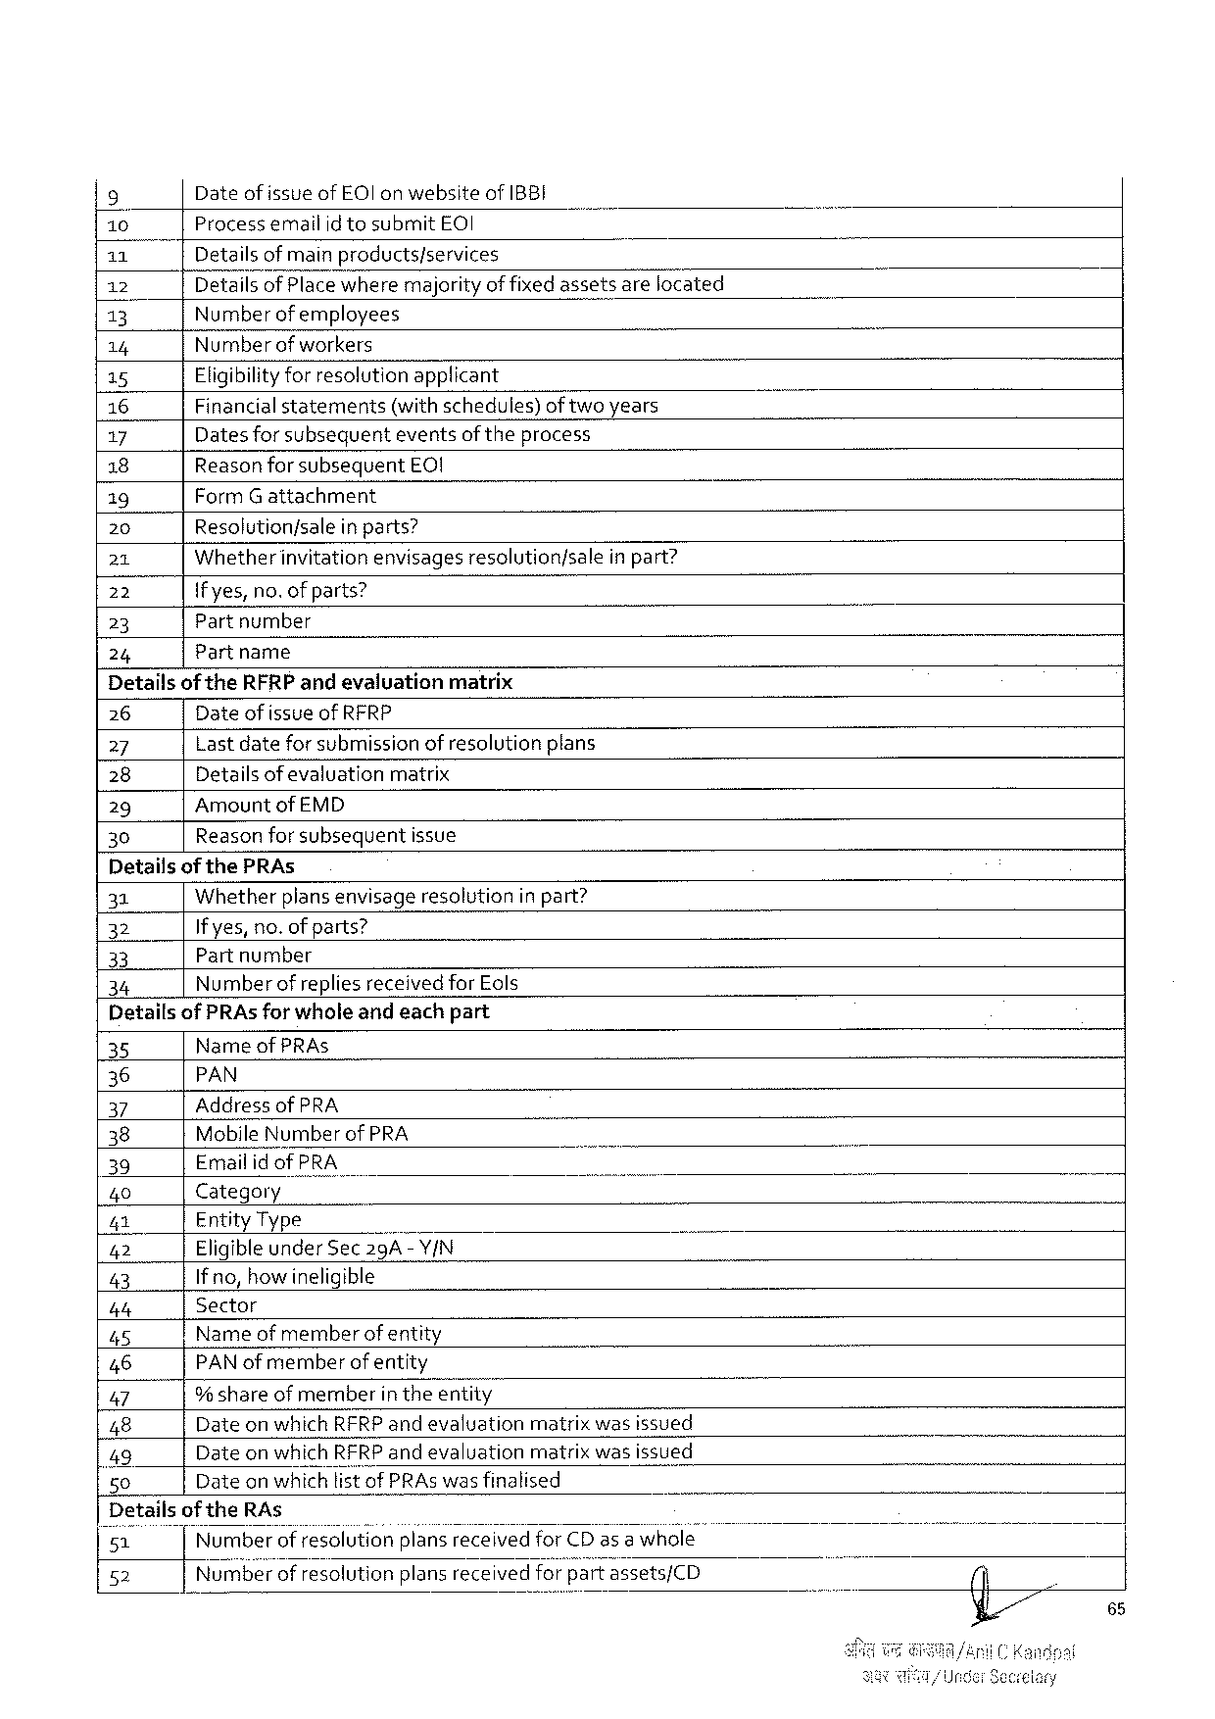

|  |  |  |  |  |  |  |
| --- | --- | --- | --- | --- | --- | --- |
| 9 | Dateofissueof EOl on websiteof IBBI | | | | | B |
| [10 | ProcessemailidtosubmitEOI | | | ) | |
| 11 | Detailsof main products/services | | | | |
| 12 | Detailsof Placewheremajorityof fixedassetsarelocated | | | | |
| 13 | Number ofemployees | | | | |
| 14 | Numberof workers | | | | |
| 15 | Eligibilityforresolutionapplicant | | | | |
| 16 | Financialstatements(withschedules)of twoyears | | | | |
| 17 | Dates for subsequenteventsof theprocess | | | | |
| 18 | Reasonforsubsequent | EQ! | | | |
| 19 | FormGattachment | | | | |
| 20 | Resolution/salein parts? | | | | |
| 21 | Whetherinvitationenvisages | | resolution/sale | | inpart? |
| 22 | {fyes,no.of parts? | | | | |
| 23 | Partnumber | | | | |
| 24 | Partname | | | | |

Detailsof theRFRP andevaluationmatrix

26 Dateof issueof RFRP

27 Lastdateforsubmission of resolutionplans

28 Detailsof evaluation matrix

29 AmountofEMD

30 Reasonforsubsequentissue

Detailsof thePRAs

31 Whether plansenvisage resolution in pant?

32 If yes,no.of parts?

33 Partnumber

34 Number ofreplies receivedfor Eols

Detailsof PRAsfor wholeandeachpart

35 NameofPRAs

36 PAN

37 AddressofPRA

38 MobileNumberof PRA -~

39 EmailidofPRA e

40 Category

|42 EntityType

42 EligibleunderSec29A-Y/N

43 Ifno,howineligible

b4 Sector

45 Nameof memberof entity

46 PAN of memberofentity

47 9% shareof member intheentity

48 DateonwhichRFRPandevaluation matrixwasissued

49 DateonwhichRFRPandevaluation matrixwasissued

50 Date on whichlist of PRAs wasfinalised

Details oftheRAs _

51 NumberofresolutionplansreceivedforCDas a whole

52 Numberofresolution plansreceived for‘;;a‘v"tassets/CD

65

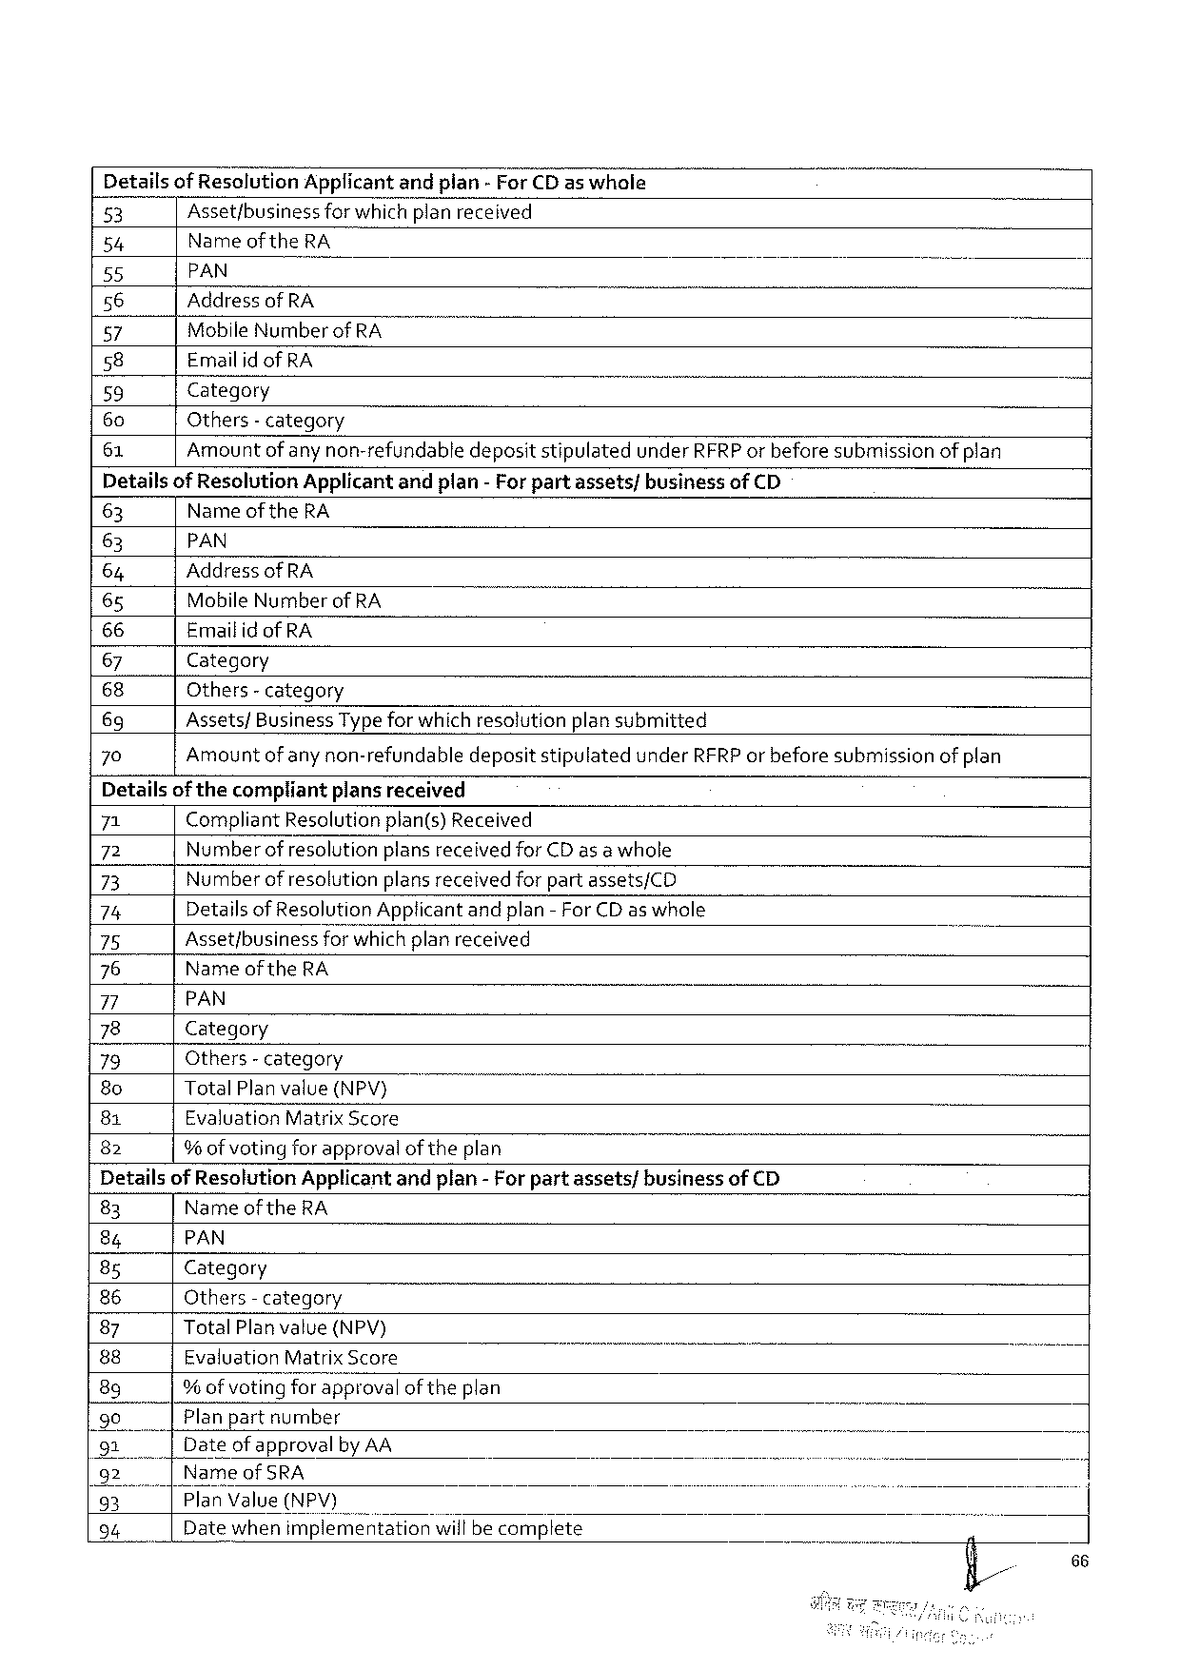

Detailsof ResolutionApplicantandpian- ForCDas whole

|  |  |  |  |  |
| --- | --- | --- | --- | --- |
| 53 | Asset/business | forwhichplanreceived | | ] |
| 54 | Name of theRA | | |
| 55 | PAN | ) | - |
| 56 |
| AddressofRA | | |
| 57 | MobileNumber ofRA | | |
| 58 |
| EmailidofRA | | |
| 59 | Category | - | |
| 60 |
| Others- category | | |
| 61 |
| Amount ofany non-refundabledepositstipulatedunderRFRPor beforesubmissionof plan | | |

DetailsofResolutionApplicantandplan-For partassets/businessofCD

63 Name of theRA

63 PAN

64 AddressofRA

65 MobileNumber of RA

66 Emailid of RA

67 Category

68 Others- category

69 Assets/BusinessTypefor which resolutionplansubmitted

70 Amountof any non-refundabledepositstipulatedunderRFRPor beforesubmissionof plan

Detailsofthecompliantplansreceived

|  |  |  |  |  |
| --- | --- | --- | --- | --- |
| 71 | CompliantResolutionplan(s)Received | | | - |
| 72 | Number ofresolutionplans receivedforCDas awhole | | |
| 73 |
| Numberofresolution | | plansreceivedforpartassets/CD |
| 74 | DetailsofResolutionApplicantandplan-ForCDaswhole | | |
| 75 | Asset/business | forwhichplanreceived | |
| 76 |
| NameoftheRA | | |
| 7 |
| PAN | | |
| 78 | Category | | |
| 79 | Others- category | | |
| 8o |
| TotalPlanvalue(NPV) | | T |
| 81 | EvaluationMatrixScore | | |
| 82 |
| %of voting forapprovalof theplan | | |

DetailsofResolutionApplicantandplan-For partassets/businessof CD

|  |  |  |  |  |  |
| --- | --- | --- | --- | --- | --- |
| 83 | Name of theRA | B | ) | - | - |
| 84 | PAN |
| 8s | Category |
| 86 | Others- category |
| 87 | TotalPlanvalue{(NPV) |
| 88 | EvaluationMatrixScore |
| 8g | % ofvoting forapprovalof theplan |
| 90 |
| Planpartnumber |
| 91  92| | Dateof approvalby AA  Nameof SRA |
| 95 | |PlanValue(NPV) |
| 94 | Datewhenxmplemé’ntationrwifibecomplete |

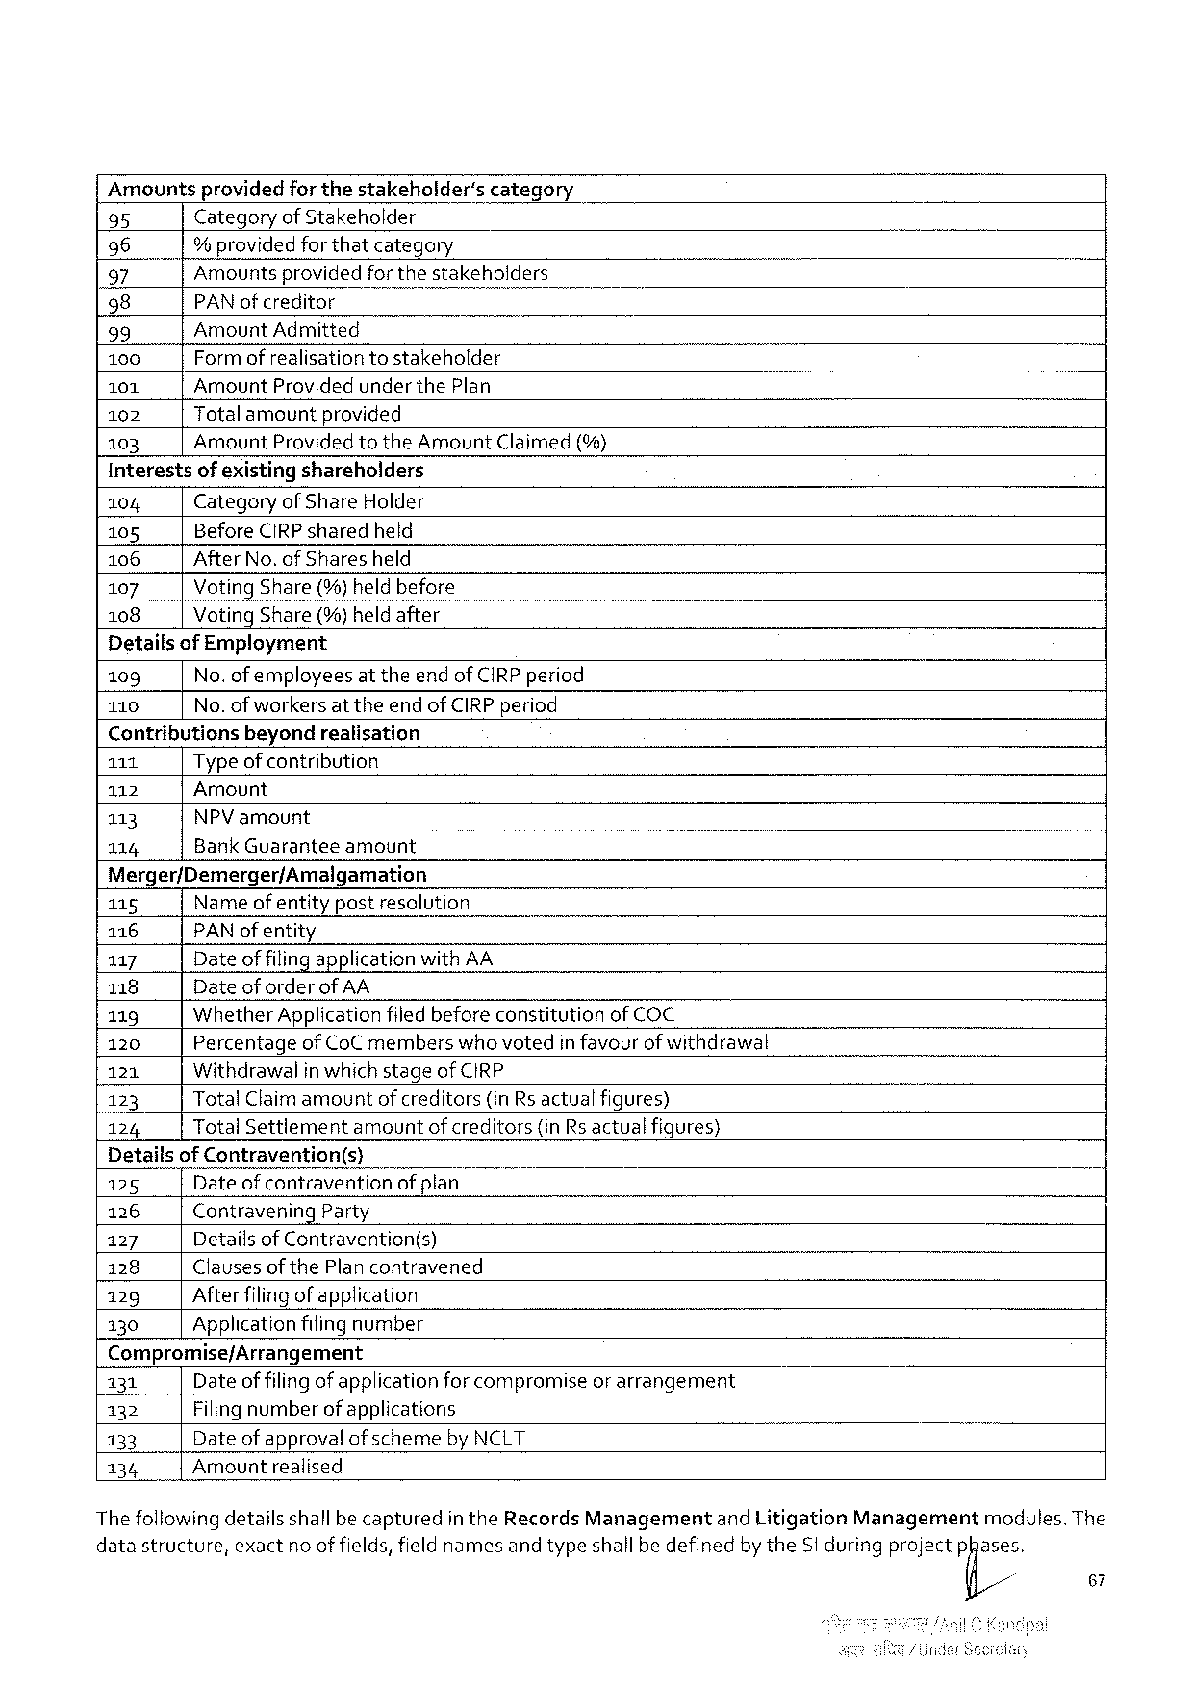

|  |  |  |  |  |  |  |  |  |  |
| --- | --- | --- | --- | --- | --- | --- | --- | --- | --- |
| Amountsprovidedfor thestakeholder's | | | | | | category | . | . | - |
| 95 | CategoryofStakeholder | | | | | |
| 96 | | | | % providedforthatcategory | | | |
| 97 | Amountsprovidedforthestakeholders | | | | | | N |
| 98 | PAN ofcreditor | | | | B | - |
| 99 | Amount Admitted | | | | | |
| 100 | Formofrealisationtostakeholder | | | | | |
| 101 | AmountProvidedunderthePlan | | | | | |
| 102 | | Totalamountprovided | | | | |
| 103 | Amount | | | ProvidedtotheAmountClaimed(%) | | |

Interestsof existingshareholders

104 CategoryofShareHolder

105 BeforeCIRPsharedheld

106 AfterNo.of Sharesheld

107 Voting Share (%)heldbefore

108 VotingShare(%)heldafter

Detailsof Employment

109 No.of employeesat theendofCIRP period

110 No.of workersat theendofCIRP period

Contributionsbeyondrealisation

111 Typeof contribution

112 Amount

113 NPVamount

114 BankGuarantee amount

Merger/Demerger/Amalgamation

|  |  |  |  |  |
| --- | --- | --- | --- | --- |
| 115 | Nameof entitypostresolution | | | J |
| 116 | PAN ofentity | | |
| 117 | Dateof filingapplicationwithAA | | |
| 118 | Dateof orderofAA | | |
| 119 | WhetherApplicationfiledbeforeconstitutionof COC | | |
| 120 | PercentageofCoC memberswhovotedin favourof withdrawal | | |
| 121 | Withdrawalin which stageofCIRP | | |
| 123 | TotalClaimamount | | ofcreditors(inRsactualfigures) |
| 124 | TotalSettlement | amountofcreditors(inRs actualfigures) | |

Detai!iofggtravention(s)

125 Dateof contravention of plan

126 ContraveningParty

127 Detailsof Contravention(s)

128 Clauses of the Plancontravened

129 Afterfilingof application

130 Applicationfilingnumber

Compromise/Arrangement

|  |  |  |
| --- | --- | --- |
| 131| | Dateof filingofapplicationforcompromiseorarrangement | . |
| 132 | Filingnumberof applications |
| 133 | Dateof approvalofschemeby NCLT |
| 134 | Amountrealised |

Thefollowingdetailsshallbecapturedin theRecordsManagementand LitigationManagementmodules. The

datastructure,exact noof fields,field namesand typeshallbedefinedby theSt duringprojectp@is,

67

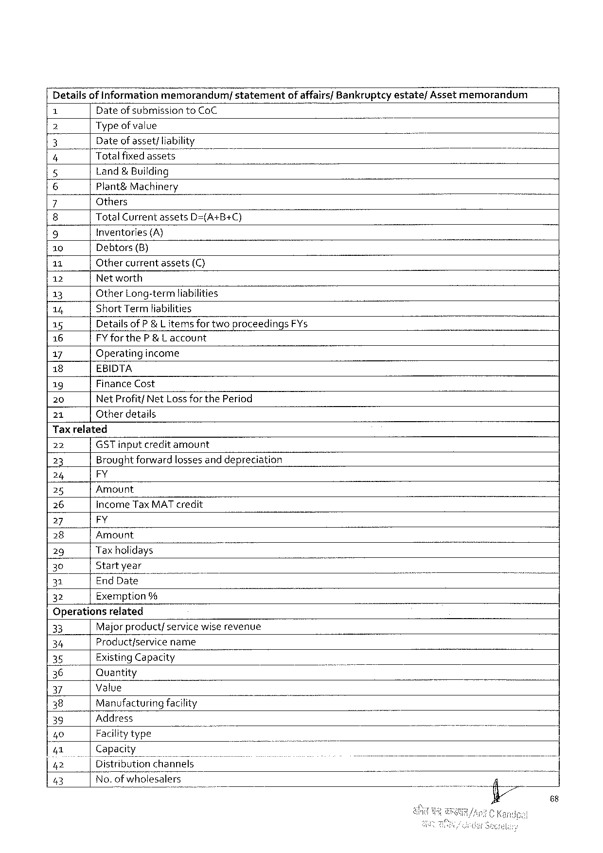

Detailsof informationmemorandum/ statement of affairs/Bankruptcyestate/Assetmemorandum

Dateof submission toCoC

2 Type of value

3 Dateof asset;liability } 7

4 Totalfixedassets -

5 Land& Building

6 Plant&Machinery

7 Others

8 TotalCurrentassetsD=(A+B+C)

9 Inventories (A}

10 Debtors(B)

11 Othercurrentassets(C)

12 Networth

13 OtherLong-termliabilities

14 ShortTermliabilities

15 DetailsofP &L items for twoproceedingsFYs

16 FY fortheP&L account

17 Operatingincome

18 EBIDTA

19 FinanceCost

20 NetProfitfNetLossforthePeriod

21 Otherdetails

Tax related

|  |  |  |  |  |  |
| --- | --- | --- | --- | --- | --- |
| 22 | GST inputcredit amount | | - | . | - |
| 23 | Brought forwardlossesand depreciation | |
| 24 | e | |
| 25 | Amount | |
| 26 | IncomeTaxMATcredit | |
| 27 | FY | |
| 28 | Amount | |
| 29 | Taxholidays | |
| 30 | Startyear | |
| 33 | EndDate | ) |
| 32 | Exemption% | |

Operations related

|  |  |  |  |  |  |  |
| --- | --- | --- | --- | --- | --- | --- |
| 33 | Majorproduct/servicewiserevenue | " | - | o | o | i |
| 34 | Productfservice name |
| 35 | ExistingCapacity |
| 36 | Quantity |
| 37 | Value |
| 38 | Manufacturingfacility |
| 39 | Address |
| 40 | Facilitytype | T |
| Vz,1 | Capacity |
| Z,z | Distributionchannels |
| 43 | No.ofwholesalers |

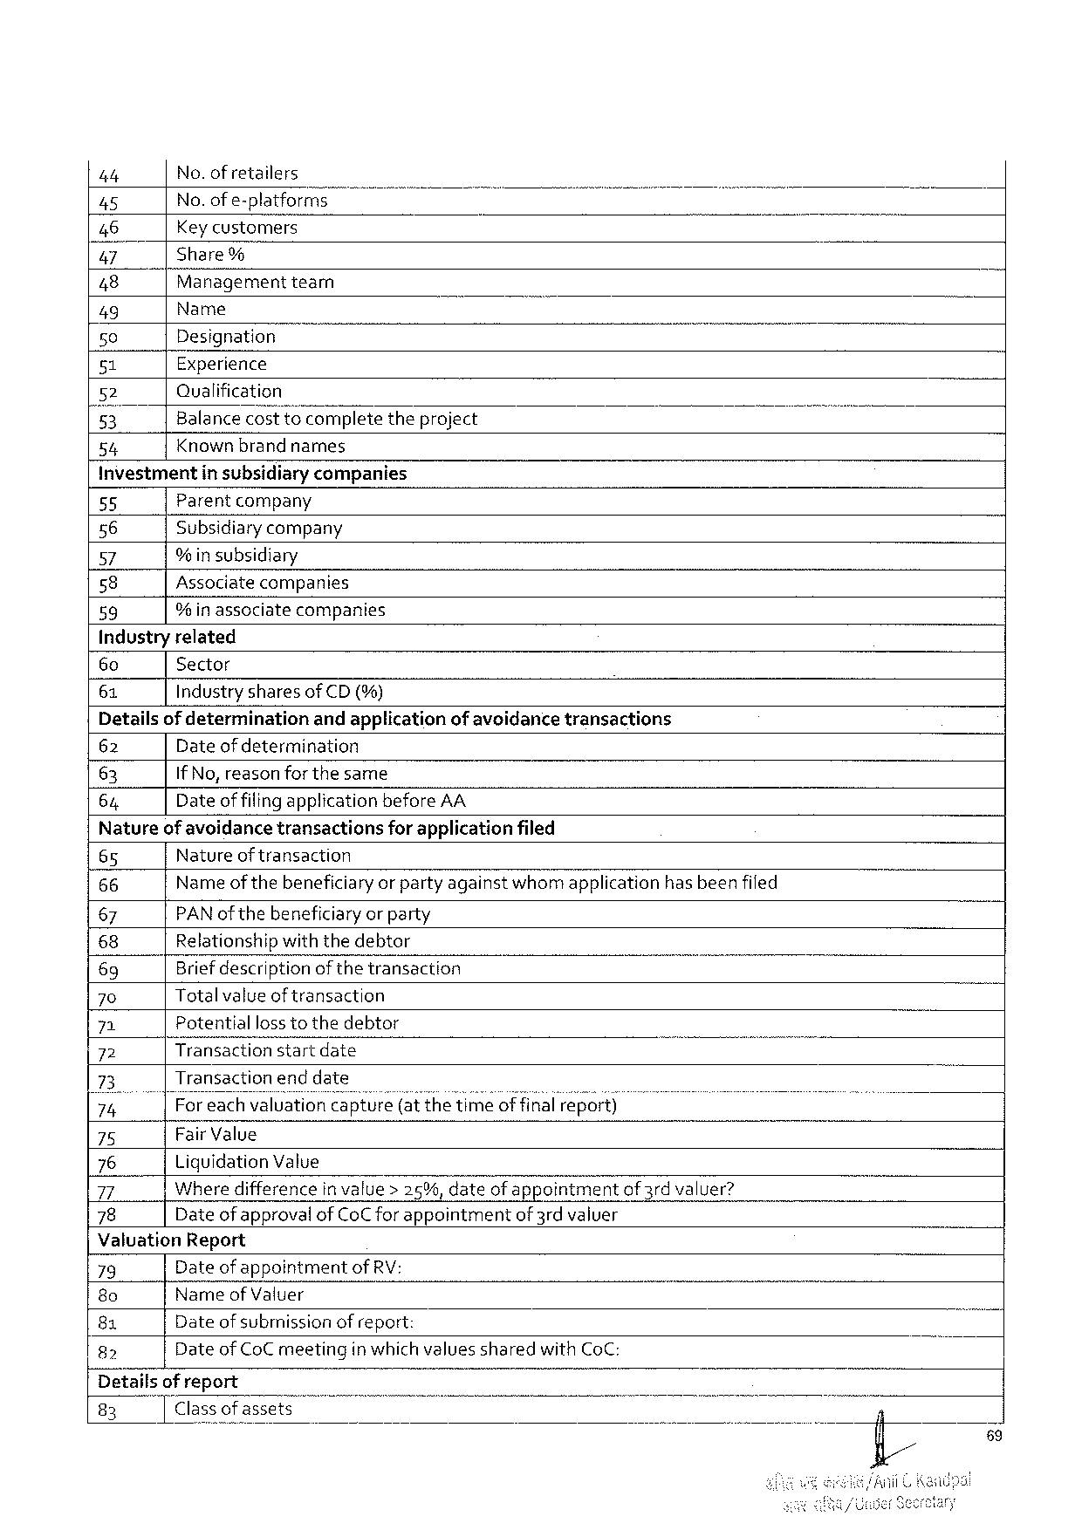

|  |  |  |  |  |
| --- | --- | --- | --- | --- |
| 4t | No.ofretailers | " | B | - |
| 45 |
| No. ofe-platformsm |
| 46 | Key customers | theproject |
| 47 | Share% |
| 48 | Managementtearn |
| 49 | Name |
| 50 | Designation |
| 51 | Experience |
| 52 | Qualification |
| 5}, | Balancecosttocomplete |
| 54 | Knownbrandnarmes |

Investmentin subsidiarycompanies   
55 Parentcompany   
56 Subsidiarycompany   
57 % insubsidiary   
58   
 Associatecompanies 59 % inassociatecompanies   
Industryrelated

|  |  |  |  |  |  |  |  |  |  |
| --- | --- | --- | --- | --- | --- | --- | --- | --- | --- |
| 60 | Sector | | | | | | ) | B | I |
| 61 | IndustrysharesofCD (%) | | | | | |
| Detailsof determination | | | andapplicationof avoidancetransactions | | | |
| 62 | Dateofdetermination | | | | | |
| 63 | IfNo,reasonforthesame | | | | | |
| 64 | Dateof filingapplicationbefore AA | | | | | |
| Natureof avoidancetransactions | | | | for applicationfiled | | |
| 65 | Natureof transaction | | | | | |
| 66 | Nameofthebeneficiaryorpartyagainstwhomapplication | | | | hasbeenfiled | |
| 67 | PAN of thebeneficiaryor party | | | | | |
| 68 | Relationshipwith thedebtor | | | | | |
| 69 | Briefdescriptionof thetransaction | | | | T | |
| 70 | Totalvalueof transaction | | | | | |
| 71 | Potential | losstothedebtor | | | | |
| 72 | Transactionstartdate | | | | - | T |
| 73 | Transactionend date | | | | | |
| 74 | |Foreachvaluation capture(at thetimeof final report) | | | | | |
| 75 | Fair Value | | | | | |
| 76 | LiquidationValue | | | | | |
| 77 | Wheredifferencein value> 25%, dateofappointmentof 3rdvaluer? | | | | | |
| 78 | Dateof approvalofCoCfor appointmentof3rdvaluer | | | | | |

ValuationReport

|  |  |  |  |  |
| --- | --- | --- | --- | --- |
| 79 | Dateof appointmentofRV: | | T | N |
| 8o | Nameof Valuer | |
| 81 | Dateof subrnissionof report: | |
| 82 | Dateof CoCmeeting | inwhichvaluessharedwithCoC: |

Detailsof report

|  |  |  |
| --- | --- | --- |
| 83 | Classof assets | 4 |

89

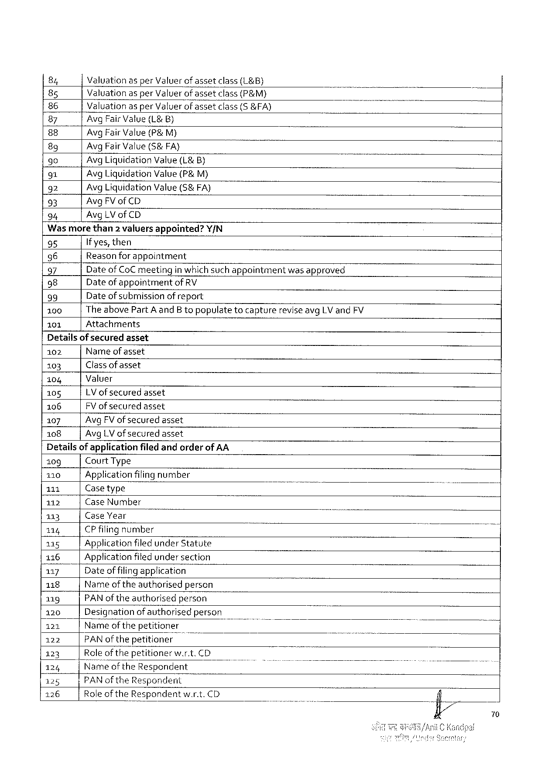

|  |  |  |  |  |  |
| --- | --- | --- | --- | --- | --- |
| 84 | Valuation | asperValuer | ofasset | class(L&B) | B |
| 85 | ValuationasperValuerofassetclass(P&M) | | | |
| 86 | Valuationas per Valuerofassetclass(S &FA) | | | |
| 87 | Avg Fair Value(L& B) | | | |
| 88 |
| Avg Fair Value(P& M) | | | |
| 89 | Avg Fair Value(S&FA} | | | |
| 90 | Avg LiquidationValue(L& B) | | | |
| 91 | Avg LiquidationValue(P& M) | | | |
| 92 | Avg LiquidationValue(5& FA) | | | |
| 93 |
| AvgFV ofCD | | | |
| 94 |
| AvgLV of CD | | | |

Wasmorethan2 valuersappointed?Y/N

|  |  |  |  |
| --- | --- | --- | --- |
| 95  96  97  98  99  100 101 | If yes,then  Reasonforappointment | | |
| Dateof CoC meeting | inwhichsuchappointment | wasapproved |
| Dateof appointmentof RV  Dateof submissionofreport  The abovePartA andB topopulatetocapturereviseavgLV and FV Attachments | | |

Detailsof securedasset   
102 Nameof asset   
103 Classofasset   
104 Valuer   
105   
 LVof securedasset 106 FV of securedasset   
107 AvgFV ofsecuredasset   
108 AvgLV ofsecuredasset   
Detailsof applicationfiledandorderof AA

|  |  |  |  |  |  |  |  |
| --- | --- | --- | --- | --- | --- | --- | --- |
| 109 | CourtType | | | o | ) | o | ) |
| 110 | Applicationfilingnumber | | |
| 111 | Casetype | | |
| o |
| 112 | CaseNumber | | |
| 113 | CaseYear | | |
| 114 | CP filing | number | |
| 115 | ApplicationfiledunderStatute | | |
| 116 | Applicationfitedundersection | | |
| 117 | Dateoffilingapplication | | |
| 118 | Name oftheauthorisedperson | | |
| 119 | PAN oftheauthorisedperson | | |
| 120 | Designationof authorisedperson | | |
| 121 | Name of thepetitioner | | |
| 122 | PAN ofthepetitioner | | o |
| 123 | Roleof thepetitionerw.r.t.CD | | |
| 124 |
| Nameof theRespondent | | |
| 125 | PAN of theRespondent | | |
| 126 | RoleoftheRespondentw.r.t.CD | | |

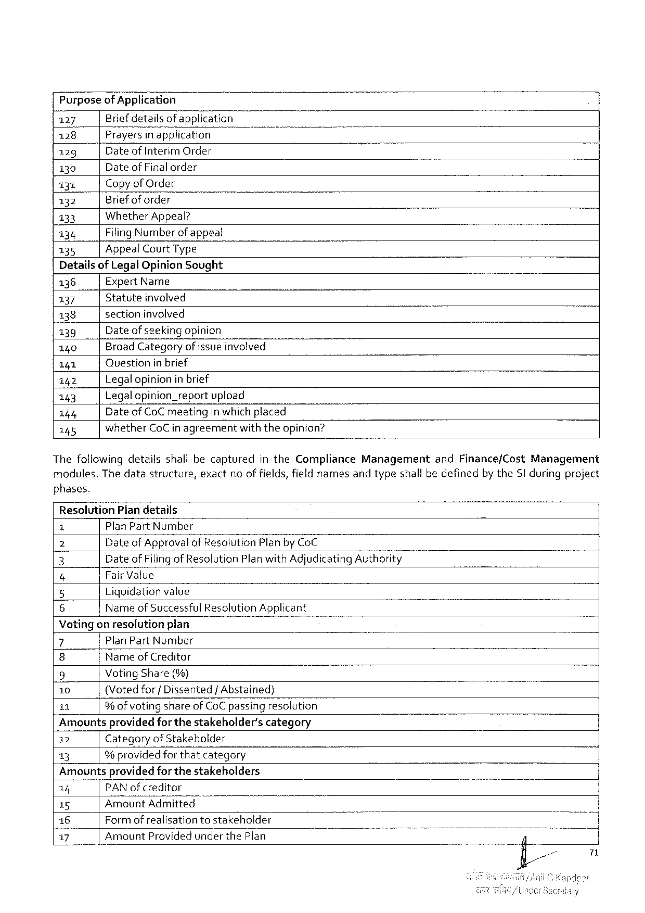

PurposeofApplication

|  |  |  |  |  |  |
| --- | --- | --- | --- | --- | --- |
| 127 | Briefdetailsof application | ) | T | B | i |
| 128 | Prayers|r7;pplicahon |
| 129 | Date of InterimOrder |
| 130 | Date of Final order |
| 131 | CopyofOrder |
| 132 | Briefof order |
| WhetherAppeal? |
| 133 |
| Filing Number ofappeal |
| 134 |
| 135 | AppealCourtType |

Detailsof Legal OpinionSought

136 Expert Name

137 Statute involved

138 sectioninvolved

139 Dateof seekingopinion

140 BroadCategoryofissueinvolved

141 Question inbrief

142 Legalopinionin brief

143 Legalopinion_reportupload

144 Dateof CoCmeetingin which placed

145 whetherCoC in agreementwiththeopinion?

Thefollowingdetailsshallbecaptured intheComplianceManagement andFinance/CostManagement

modules.Thedatastructure,exactno offields,fieldnamesandtypeshall bedefinedby theSiduringproject

phases.

ResolutionPlandetails

1 PlanPartNumber

Z Dateof Approvalof ResolutionPlan by CoC

3 Date of Filing of ResolutionPlanwith AdjudicatingAuthority

4 Fair Value

5 Liquidationvalue

6 Name of Successful ResolutionApplicant

Votingonresolutionplan

|  |  |  |  |  |
| --- | --- | --- | --- | --- |
| 7 | PlanPartNumber | - | o | - |
| 8 | NameofCreditor |
| 9 | VotingShare(%) |
| 10 | (Votedfor{ Dissented/Abstained) |
| 11 | % ofvotingshareof CoC passingresolution |

Amountsprovidedfor thestakeholder’scategory

12 Categoryof Stakeholder

13 %providedforthatcategory

Amountsprovidedfor thestakeholders

|  |  |  |  |
| --- | --- | --- | --- |
| 14 | "TPANofcreditor | - | o |
| 15 | AmountAdmitted |
| 16 | Formofrealisationtostakeholder |
| 17 | AmountProvidedunderthePlan |

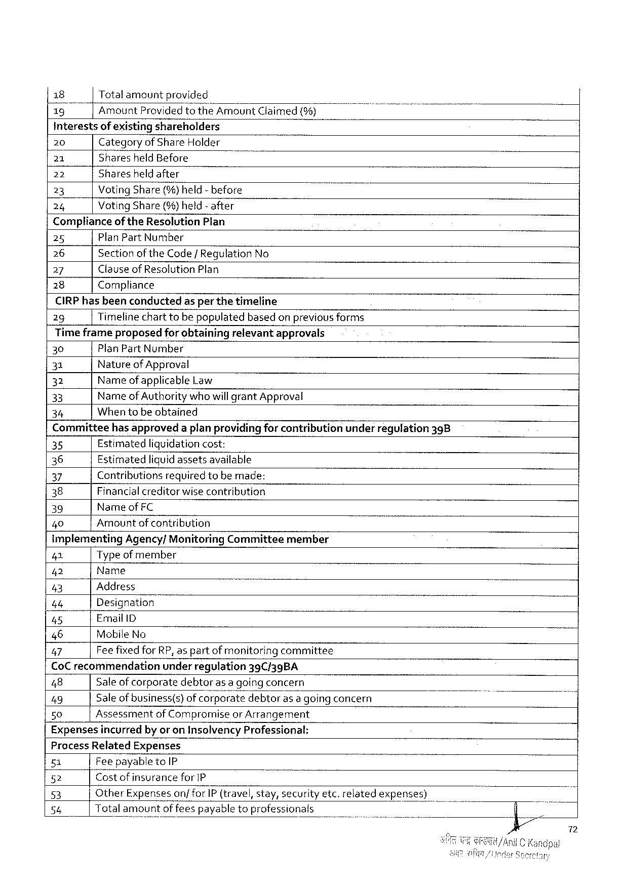

|  |  |  |  |  |  |
| --- | --- | --- | --- | --- | --- |
| 18 | Totalamountprovided | | AmountClaimed(%) | - | T |
| 13" |
| AmountProvided | to the |

interestsof existingshareholders

|  |  |  |  |
| --- | --- | --- | --- |
| 20 | Categoryof ShareHolder | | - |
| 21 | SharesheldBefore | - |
| 22 |
| Sharesheldafter | |
| 23 | VotingShare(%)held-before | |
| 24 |
| VotingShare(%)held- after | |

Complianceof theResolutionPlan

25 PlanPartNumber

26 Sectionof theCode/RegulationNo

27 ClauseofResolutionPlan

28 Compliance

CIRP hasbeenconductedasper the timeline

29 Timelinechart tobepopulatedbasedon previousforms

Timeframeproposedfor obtainingrelevantapprovals

30 PlanPartNumber

31 Natureof Approval

32 Name ofapplicableLaw

33 Name ofAuthoritywhowill grantApproval

34 Whentobeobtained

Committeehasapproveda planprovidingfor contributionunderregulation398

35 Estimatedliquidationcost:

36 Estimatedliquid assetsavailable

37 Contributionsrequiredtobe made:

38 Financialcreditorwise contribution

39 NameofFC

40 Amountof contribution

ImplementingAgency/MonitoringCommitteemember

41 Type ofmember

42 Name

43 Address )

46 Designation

45 EmailID

46 MobileNo ]

47 FeefixedforRP, as partof monitoringcommittee

CoCrecommendation underregulation 39C/39BA

48 Saleofcorporatedebtoras a goingconcern

49 Saleofbusiness(s)ofco’rpmjs;étedebtorasa going concern )

50 Assessmentof Compromiseor Arrangement

Expensesincurredby or onInsolvencyProfessional:

ProcessRelatedExpenses

51 FeepayabletoIP

52 Costof insurance forIP

53 OtherExpenseson/forIP (travel,stay,securityetc.relatedexpenses)

54 Totalamountoffeespayabletoprofessionals

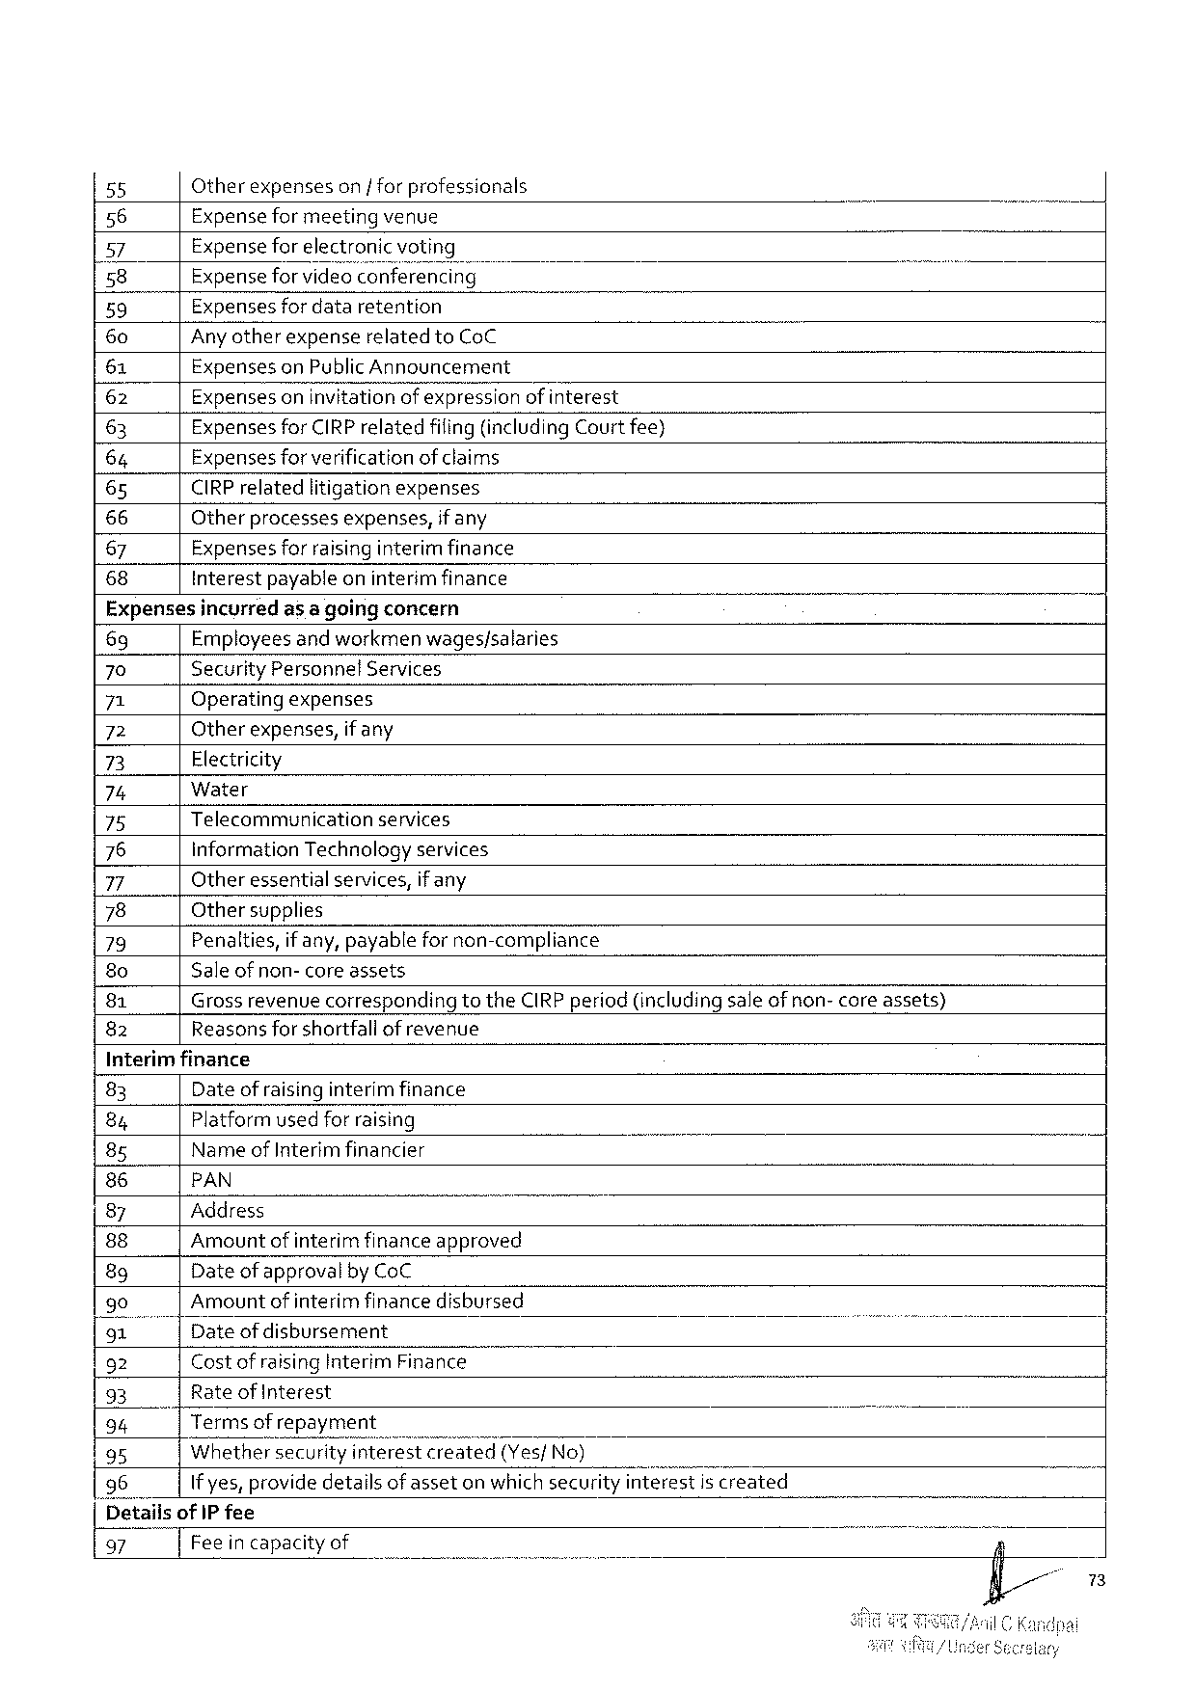

|  |  |  |  |  |  |  |
| --- | --- | --- | --- | --- | --- | --- |
| 55 | Otherexpenseson |forprofessionals | | | - | B | T |
| 56 | Expenseformeetingvenue | | |
| 57 | Expensefor electroni | | |
| 58 | Expenseforvideo2n‘fewrencing | | |
| 59 | Expensesfordataretention | o | |
| 60 | Anyotherexpenserelated toCoC | | |
| 61 | ExpensesonPublicAnnouncement | | |
| (62 | Expensesoninvitationof expression | | ofinterest |
| 63 | ExpensesforCIRPrelatedfiling(includingCourt fee) | | |
| 64 | Expensesforverificationof claims | | |
| 65 | CIRPrelatedlitigationexpenses | | |
| 66 | Otherprocessesexpenses, | ifany | |
| 67 |
| Expensesforraisinginterim finance | | |
| 68 | Interestpayableoninterimfinance | | |

Expensesincyrredas a goingconcern

69 Employees and workmenwages/salaries

70 SecurityPersonnel Services

71 Operatingexpenses

72 Otherexpenses,if any

73 Electricity

74 Water

75 Telecommunication services

76 informationTechnologyservices

77 Otheressentialservices,ifany

78 Othersupplies

79 Penalties, if any,payablefornon-compliance

8o Saleof non- core assets

81 Grossrevenue correspondingtotheCIRPperiod (includingsaleof non- core assets)

82 Reasonsforshortfallof revenue

Interimfinance

|  |  |  |  |  |  |  |
| --- | --- | --- | --- | --- | --- | --- |
| 83 | Dateofraisinginterim finance | | | T | T | i |
| 84 | Platformusedfor raising | | |
| 8g | Name of Interimfinancier | | |
| 86 | PAN | | |
| 87 | Address | | - |
| 88 | Amountof interim financeapproved | | |
| 8g | Date of approval byCoC | | |
| 90 | Amountof interim financedisbursed | | |
| 91"] | Dateof disbursement | | |
| } |
| 92 | CostofraisingInterimFinance | | |
| 93 | Rate of Interest | | |
| 94 | | | Terms of repayment | | B |
| 95 | Whethersecurity‘?fi{érescreated(Yes/No) | | |
| 96 | If yes, providedetailsof asseton whichsecurity interestis created | | |
| [DetailsofIP fee | | | |
| 97 | Feeincapacityof | | |

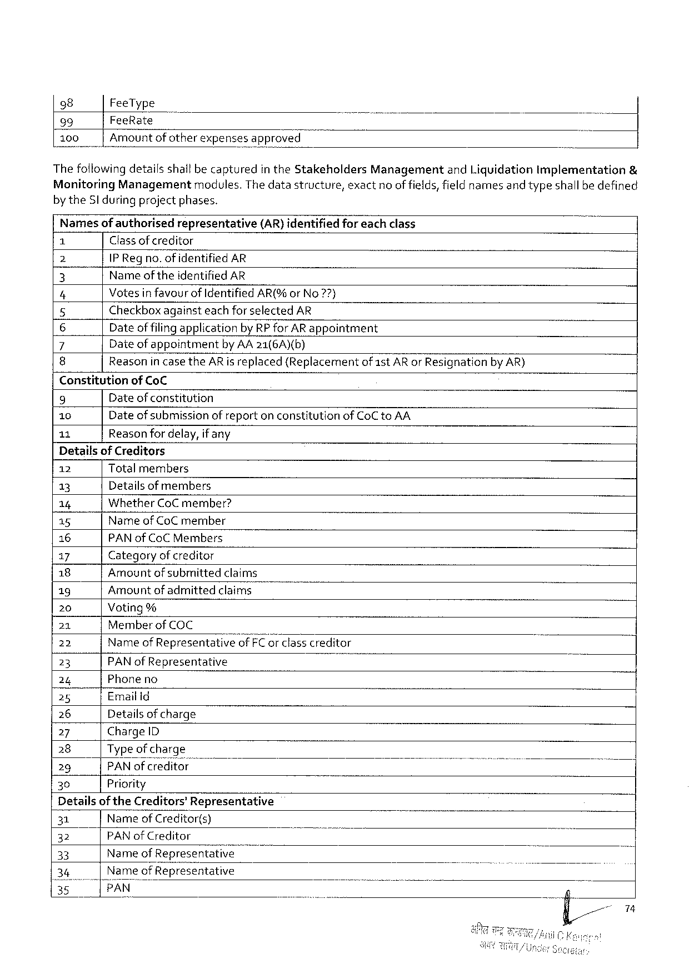

|  |  |  |  |
| --- | --- | --- | --- |
| 98 | FeeType | ManagementandLiquidationimplementation | & |
| 99 | FeeRate |
| 100 | Amount of otherexpensesapproved |
| Thefollowingdetailsshallbecapturedin theStakeholders | |

MonitoringManagementmodules.Thedatastructure,exactno of fields,fieldnamesand typeshallbedefined

by theSl during projectphases.

|  |  |  |  |  |
| --- | --- | --- | --- | --- |
| Names | ofauthorised | representative | (AR)identified | foreachclass |

Classofcreditor

2 IP Regno.of identified AR

3 Name of theidentified AR

4 Votesinfavourof IdentifiedAR(%orNo7?7}

5 CheckboxagainsteachforselectedAR

6 Dateof filingapplicationbyRP forAR appointment

7 Dateofappointment byAA21(6A)(b)

8 Reasonin case theARis replaced(Replacementof1stARor ResignationbyAR)

Constitutionof CoC

9 Dateof constitution

10 Dateof submissionof reporton constitutionofCoCtoAA

11 Reasonfordelay,ifany

Detailsof Creditors

|  |  |  |  |  |  |
| --- | --- | --- | --- | --- | --- |
| 12 | Total members | | - | o | b |
| 13 |
| Detailsof members | |
| 14 | WhetherCoC member? | |
| 15 |
| NameofCoCmember | |
| 16 | PAN of CoC Members | |
| 17 | Categoryofcreditor | |
| 18 |
| Amountofsubmitted | claims |
| 19 | Amountofadmitted | claims |
| 20 | Voting% | | classcreditor |
| 21 | Memberof COC | |
| 22 | Name of RepresentativegffiF‘Eg‘r | |
| 23 | PAN ofRepresentative | |
| 24 |
| Phoneno | |
| 25 | EmailId | |
| 26 | Details of charge | |
| 27 | ChargeID | |
| 28 | Type ofcharge | |
| 29 | PAN ofcreditor | |
| 30 | Priority | |

Detailsof theCreditors’Representative

|  |  |  |  |  |  |  |  |
| --- | --- | --- | --- | --- | --- | --- | --- |
| 31 | Nameof Creditor(s) | | wwwww | o | ) | ) | - |
| 32 | PAN of Creditor | |
| 33 | Name | ofRepresentati\); |
| ofRepresentative | |

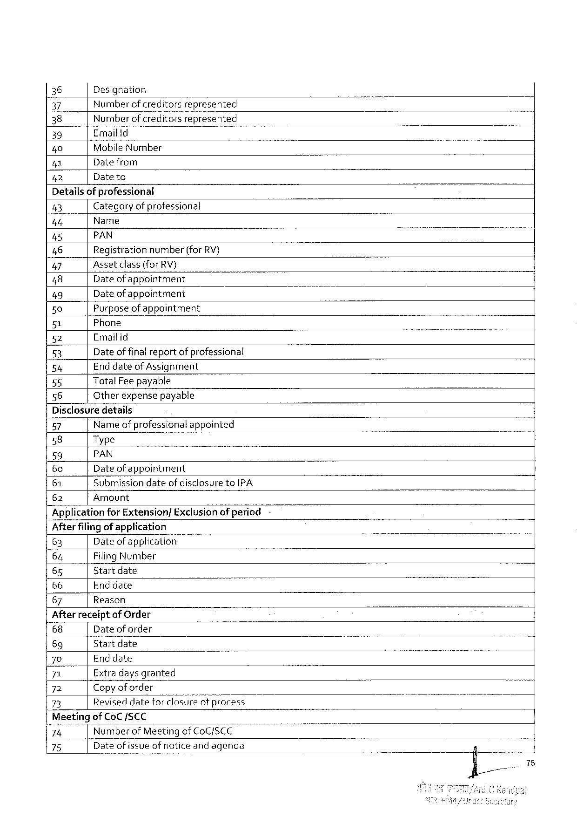

|  |  |  |  |  |
| --- | --- | --- | --- | --- |
| 36 | | | Designation | | B |
| 37 | Numberof creditors | represented |
| 38 | Number of creditorsrepresented | |
| 35 | Emailld | T |
| 40 | MobileNumber | |
| 41 | Datefrom | |
| Dateto | |
| 42 |

Detailsofprofessional

43 Categoryof professional

4t Name

45 PAN

46 Registration number(forRV)

47 Assetclass(forRV}

48 Date ofappointment

49 Date ofappointment

50 Purposeof appointment

51 Phone

52 Emaitid

53 Date offinalreportof professional

54 End dateofAssignment

55 TotalFeepayable

56 Otherexpensepayable

Disclosuredetails

57 Name of professionalappointed

58 Type

59 PAN

60 Date ofappointment

61 Submission dateofdisclosuretoIPA

62 Amount

ApplicationforExtension/Exclusion ofperiod

Afterfilingof application

63 Dateof application

64 Filing Number

65 Start date

66 Enddate

67 Reason

Afterreceiptof Order

|  |  |  |  |  |  |
| --- | --- | --- | --- | --- | --- |
| 68 | Date oforder | " | T | i | 7 |
| 69 | Startdate |
| 70 | Enddate |
| 71 | Extradays granted |
| 72 | Copyof order |
| 73 | Reviseddateforclosur’eflgfwfirocess |

‘MeetingofCoCSCC

’72," Number of MeetingofCoC/SCC

75 Dateof issueofnoticeandagenda

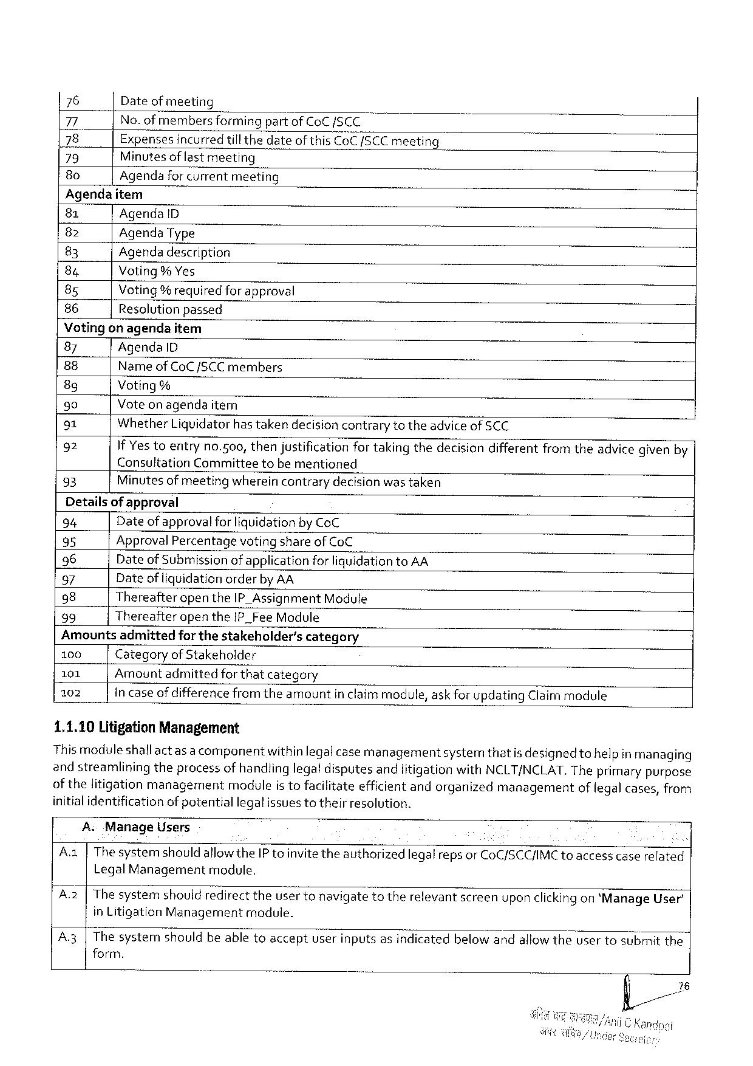

|  |  |
| --- | --- |
| 76  77  |78   79  8o | Dateofmeeting  No. ofmembersformingpartofCoC/SCC  Expenses incurredtill thedateof thisCoC/SCCmeeting Minutesof last meeting  Agendaforcurrentmeeting |

Agendaitem

|  |  |  |
| --- | --- | --- |
| 81 | AgendaD | il |
| 82 | AgendaType |
| 83 |
| Agendadescription |
| 84 |
| Voting% Yes |
| 85 |
| Voting% requiredforapproval |
| 86 |
| Resolutionpassed |

Votingon agendaitem

|  |  |
| --- | --- |
| 87  88  8g  90  91  92  93 | AgendaID  Name ofCoC/SCC members  Voting%  Voteon agendaitem  WhetherLiquidatorhastakendecisioncontrarytotheadviceof SCC  If Yestoentryno.500, thenjustificationfor takingthedecisiondifferentfromtheadvicegivenby ConsultationCommitteetobe mentioned  Minutes of meetingwhereincontrarydecision wastaken |

Detailsof approval

94 Date of approval for liquidationby CoC

95 ApprovalPercentagevoting shareof CoC

96 Dateof Submissionof applicationforliquidationtoAA

97 Dateof liquidationorderby AA

98 ThereafteropentheIP_Assignment Module

99 ThereafteropentheIP_FeeModule

Amountsadmittedfor thestakeholder’scategory

100 Categoryof Stakeholder

101 Amountadmittedforthatcategory

102 Incaseof difference from theamountinclaimmodule,askfor updatingClaimmodule

1,1.10LitigationManagement

This moduleshallactas a componentwithinlegalcase managementsystemthatis designedtohelpin managing

andstreamliningtheprocessofhandlinglegaldisputesandlitigationwithNCLT/NCLAT.Theprimarypurpose

of thelitigationmanagementmoduleis tofacilitateefficientandorganizedmanagementoflegal cases,from

initialidentificationofpotentiallegalissuestotheirresolution.

A ManageUsers

A.a|Thesystemshould allowtheIP toinvitetheauthorizedlegalreps orCoC/SCC/IMCtoaccess caserelated

LegalManagement module.

A.2|Thesystem shouldredirecttheusertonavigatetotherelevantscreenuponclickingon*ManageUser’

inLitigationManagement module.

A3|Thesystemshouldbeabletoacceptuserinputsasindicatedbelow andallowtheusertosubmitthe

form.

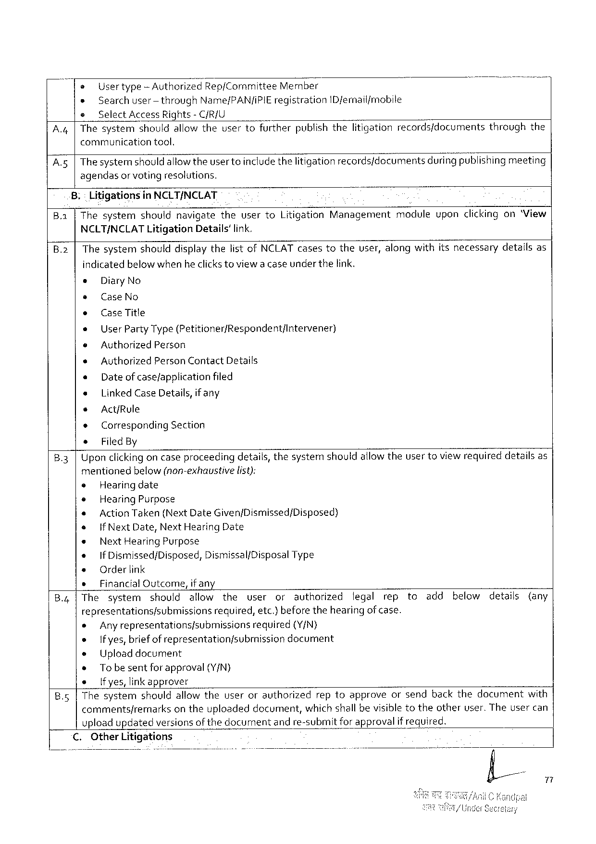

|  |  |  |  |  |  |
| --- | --- | --- | --- | --- | --- |
| A, | e | Usertype‘AuthorizegRep/Comm\ttee | | Member | throughthe |
| » | Searchuser-throughName/PAN/IPIEregistrationIDfemail/mobile | | |
| e | Select Access Rights- C/R/U | | |
| |Thesystemshouldallowtheusertofurtherpublishthelitigationrecords/documents | | | |
| communication | | tool. | |

A5|Thesystemshould allowtheuser toincludethelitigationrecords/documentsduring publishing meeting

agendasor votingresolutions.

Litigationsin NCLT/NCLAT

B.a ThesystemshouldnavigatetheusertoLitigationManagementmoduleuponclickingon‘View

NCLT/NCLAT Litigation Details’ link.

B.2|ThesystemshoulddisplaythelistofNCLATcasestotheuser,alongwithitsnecessarydetailsas

indicatedbelow whenheclicks toviewa caseunderthelink.

s DiaryNo

* CaseNo

e CaseTitle

e UserPartyType(Petitioner/Respondent/Intervener)

e AuthorizedPerson

* AuthorizedPersonContactDetails

« Dateof case/applicationfiled

« LinkedCaseDetails,if any

s Act/Rule

* Corresponding Section

* FiledBy

B.3|Upon clickingoncaseproceedingdetails,thesystemshouldallowtheuser toviewrequireddetailsas

mentioned below(non-exhaustive list):

e Hearingdate

e HearingPurpose

e ActionTaken(NextDateGiven/Dismissed/Disposed)

e |f NextDate,NextHearingDate

e NextHearingPurpose

« If Dismissed/Disposed,Dismissal/Disposal Type

e Orderlink

» FinancialOutcome,if any

B.4|The system should allow the user or authorized legal rep to add below details (any

representations/submissions required,etc.)beforethehearingof case.

e Anyrepresentations/submissions required (Y/N)

s Ifyes,briefof representationfsubmissiondocument

e Uploaddocument

* Tobesentforapproval(Y/N)

e [fyes,linkapprover

B.5|Thesystemshouldallowtheuserorauthorizedreptoapproveorsendbackthedocumentwith

commentsfremarksontheuploadeddocument,which shall bevisible totheotheruser.Theusercan

upload updatedversionsof thedocumentand re-submitfor approvalifrequired.

C.OtherLitigations

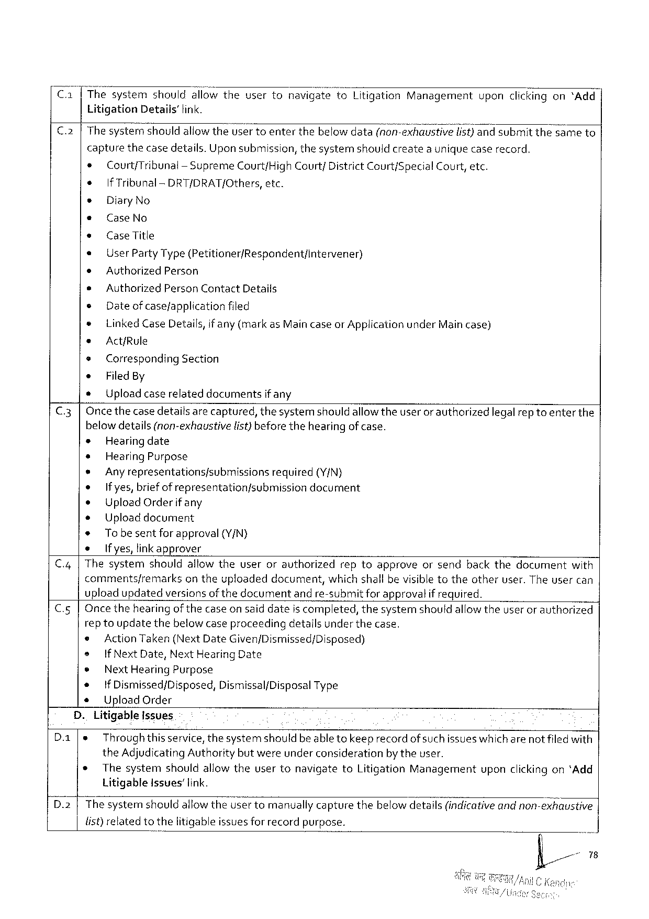

Ca[Thesystem should allowthe usertonavigate}o Litigation Management upon clickingon“Add

LitigationDetails'fink.

C.2|ThesystemshouldallowtheUsertoenterthebelowdata(nonrekl;a’trs't?vglfl/‘s“t‘)kgr‘la submit thesame to|

capturethecasedetails.Uponsubmission, thesystemshouldcreateauniquecaserecord,

* Court/Tribunal-SupremeCourt/HighCourt/ DistrictCourt/Special Court, etc.

e If Tribunal -DRT/DRAT/Others,etc.

e DiaryNo

e CaseNo

s CaseTitle

* UserPartyType(Petitioner/Respondent/intervener)

e AuthorizedPerson

s Authorized PersonContactDetails

e Dateof casefapplicationfiled

* LinkedCase Details,if any (markas MaincaseorApplication underMain case)

s Act/Rule

* CorrespondingSection

e FiledBy

e Uploadcaserelateddocumentsif any

C.3|Oncethecase detailsare captured,thesystemshouldallow theuseror authorizedlegalrep toenter the

belowdetails(non-exhaustive list)beforethehearingof case.

* Hearingdate

* HearingPurpose

* Anyrepresentationsfsubmissions required (Y/N)

o Ifyes,briefof representation/submissiondocument

® UploadOrderifany

+ Uploaddocument

* Tobe sentforapproval (Y/N)

s Ifyes,linkapprover

C.4|Thesystemshouldallowtheuserorauthorizedreptoapproveorsendbackthedocumentwith

comments/remarksontheuploadeddocument,whichshall bevisibletotheotheruser.The usercan

uploadupdatedversionsof thedocumentand re-submitfor approvalif required.

C.5|Oncethehearingofthecase on saiddateis completed,thesystemshouldallowtheuser or authorized

rep toupdatethebelow caseproceedingdetailsunder thecase.

© ActionTaken(NextDateGiven/Dismissed/Disposed)

® IfNext Date,NextHearingDate

|  |  |  |
| --- | --- | --- |
| ® | NextHearingPurpose | Type |
| IfDismissed/Disposed,Dismissal/Disposal |

UploadOrder

D.LitigableIssues

|  |  |  |  |  |  |  |
| --- | --- | --- | --- | --- | --- | --- |
| Da  D.2 | e | Throughthisservice,thesystemshouldbeabletokeeprecord of suchissueswhichare notfiledwith | | | | |
| theAdjudicating Authority butwereunderconsiderationby theuser. | | | | | |
| * | Thesystem | shouldallowtheusertonavigate | toLitigation | Management | uponclickingon*Add |
| LitigableIssues’ link.  The systernshouldallowtheuser tomanually capturethebelow details(indicativeand non-exhaustive | | | | | |

list)relatedtothelitigableissuesfor recordpurpose.

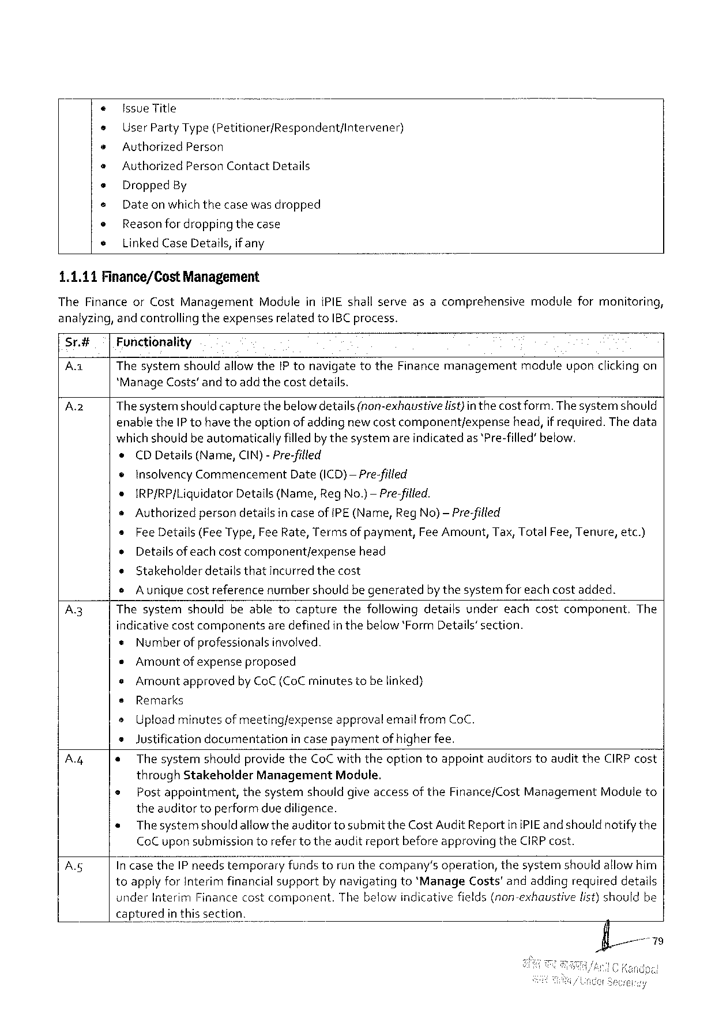

IssueTitle

UserPartyType(Petitioner/Respondent/Intervener)

AuthorizedPerson

Authorized PersonContactDetails

Dropped By

Dateonwhichthecasewasdropped

Reasonfor dropping thecase

LinkedCaseDetails,if any

1.1.11Finance/CostManagement

TheFinanceorCostManagementModuleiniPIEshallserveasacomprehensivemoduleformonitoring, analyzing,andcontrollingtheexpensesrelatedtoIBC process.

Sr.# Fonctionality

Aa Thesystemshouldallowthe[P tonavigatetotheFinance managementmaduleuponclickingon *ManageCosts’andtoadd thecostdetails.

|  |  |  |
| --- | --- | --- |
| Az | Thesystemshould capturethebelowdetails(non-exhaustive | list)in thecostform. Thesystemshould |

enabletheIP tohave theoption of addingnew costcomponent/expensehead,if required.The data whichshouldbe automaticallyfilledbythesystemareindicatedas *Pre-filled’below.

e CDDetails(Name,CIN)-Pre-filled

¢ InsolvencyCommencement Date(ICD)—Pre-filled

s IRP/RP[LiquidatorDetails(Name,RegNo.)— Pre-filled.

oAuthorizedpersondetailsin caseof[PE(Name,RegNo)— Pre-filled

|  |  |  |
| --- | --- | --- |
| s | FeeDetails(FeeType,FeeRate,Termsof payment, | FeeAmount,Tax,TotalFee,Tenure,etc.) |
| o | Details of eachcostcomponentjexpensehead |
| ¢ |
| Stakeholderdetailsthatincurredthecost |

oAuniquecostreferencenumbershould begeneratedbythesystemfor each costadded.

A3 Thesystemshouldbeabletocapturethefollowingdetailsundereachcostcomponent.The indicativecostcomponentsaredefinedinthebelow‘FormDetails’section.

« Number of professionalsinvolved.

¢Amountof expenseproposed

oAmountapprovedby CoC (CoC minutestobelinked)

s Remarks

o Uploadminutesof meeting/expenseapprovalemail fromCoC.

»Justification documentation in casepaymentof higherfee.

Ay « The systemshouldprovidetheCoCwiththeoptiontoappointauditorstoaudittheCIRP cost throughStakeholderManagementModule.

e Post appointment,thesystemshouldgiveaccessof theFinance/CostManagementModuleto theauditortoperformdue diligence.

« Thesystemshould allowtheauditortosubmitthe CostAuditReportiniPIEand shouldnotifythe CoC uponsubmissiontorefertotheauditreportbeforeapprovingtheCIRPcost.

A IncasetheIP needstemporaryfundstorunthecompany’soperation,thesystemshouldallowhim toapplyforInterim financial supportby navigatingto*Manage Costs'andaddingrequireddetails

|  |  |  |  |  |
| --- | --- | --- | --- | --- |
| {_ | | underInterimFinancecostcomponent. | | Thebelowindicativefields(non-exhaustive | list)shouldbe |
| | capturedin | thissection. |

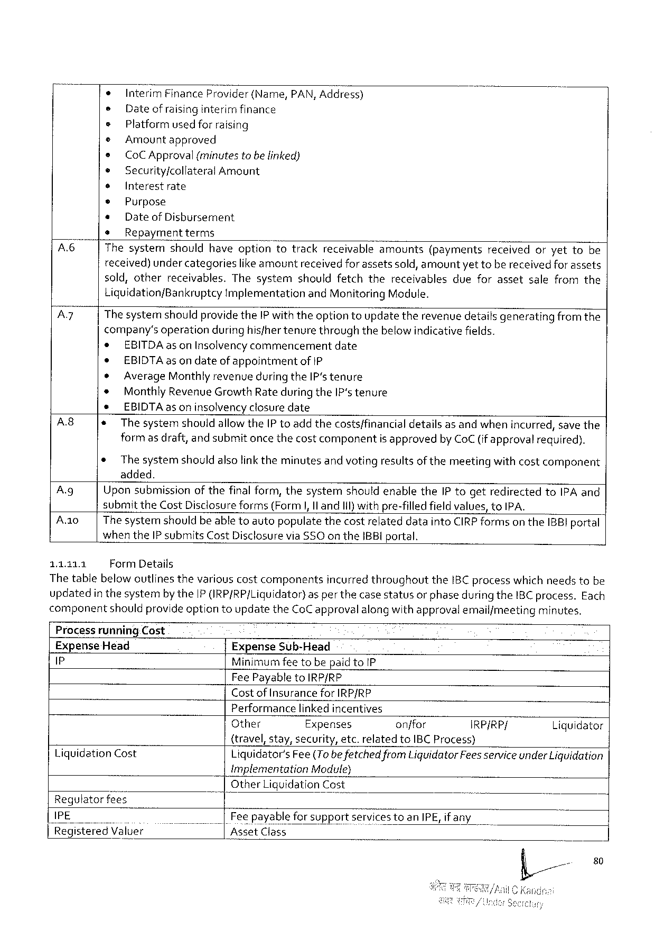

|  |  |  |  |  |  |  |  |  |  |  |  |  |  |  |
| --- | --- | --- | --- | --- | --- | --- | --- | --- | --- | --- | --- | --- | --- | --- |
| A  Ay | * | Interim | | Finance | Provider | (Name, | | PAN,Address) | | | | | | |
| s | Date of raisinginterirrifinance | | | | | | | | | | | | |
| s | Platformused for raising | | | | | | | | | | | | |
| © | | Amountapproved | | | | | | | | | | | |
| e | CoCApproval(minutes tobe linked) | | | | | | | | | | | | |
| ® | | Security/collateralAmount | | | | | | | | | | | |
| s | Interestrate | | | | | | | | | | | | |
| © | Purpose | | | | | | | | | | | | |
| + | Date of Dishursement | | | | | | | | | | | | |
| * | Repaymentterms | | | | | | | | | | | | |
| Thesystem | | | should | haveoption | | totrack | | receivable | amounts | (payments | received | oryetto | be |
| received) under categorieslike amountreceived forassetssold, amountyet tobe receivedforassets sold,otherreceivables.Thesystemshouldfetchthereceivablesdueforassetsalefromthe Liquidation/BankruptcyimplementationandMonitoring Module.  ThesystemshouldprovidetheIP withtheoption toupdatetherevenue detailsgeneratingfromthe company’s operationduringhisfhertenurethroughthebelowindicativefields. | | | | | | | | | | | | | |
| e | EBITDAas onInsolvencycommencementdate | | | | | | | | | | | | |
| e | EBIDTAas on dateofappointmentof1P | | | | | | | | | | | | |

AverageMonthlyrevenueduring theIPstenure   
Monthly Revenue GrowthRate during theIP‘stenure   
EBIDTAas on insolvencyclosure date

|  |  |  |
| --- | --- | --- |
| A8  Ag  A0  11311 | * | ThesystemshouldallowtheIP toaddthecosts/financialdetailsas andwhenincurred,save the |
| formas draft,and submitonce thecostcomponentis approvedby CoC (ifapprovalrequired). | |
| ¢ | The systemshouldalsolinktheminutesand votingresultsof themeetingwithcostcomponent |
| added.  Upon submissionofthefinal form,thesystemshouldenabletheIP togetredirectedtoIPA and submittheCostDisclosureforms(Form|,Il andIil)withpre-filledfieldvalues,toIPA.  The systemshouldbe abletoautopopulatethecostrelateddataintoCIRPformson theIBBI portal when theIP submitsCostDisclosureviaSSOon theIBBI portal.  FormDetails | |

Thetablebelow outlinesthevariouscostcomponentsincurred throughouttheIBCprocesswhich needstobe updatedin thesystemby theIP IRP/RP/Liquidator)as perthecase statusor phaseduringtheIBC process.Each componentshouldprovide optiontoupdatetheCoCapprovalalong withapprovalemail/meetingminutes.

Processrunning.Cost   
ExpenseHead ExpenseSub-Head   
P MinimumfeetobepaidtoIP

FeePayabletoIRP/RP

Costof Insurance for IRP/RP   
Performancelinkedincentives

|  |  |  |  |  |  |
| --- | --- | --- | --- | --- | --- |
| LiquidationCost | Other | Expenses | onffor | IRP/RP/ | Liguidator |
| {travel,stay,security,etc.relatedtoIBCProcess)  Liquidator'sFee(Tobe fetchedfromLiquidatorFees serviceunderLiquidation ImplementationModule) | | | | |

OtherLiquidationCost Regutatorfees

|  |  |  |
| --- | --- | --- |
| IPE | | | Fee payable for supportservicestoanIPE,if any |
| |flRieg|5t;re'd"\'/a_IBe} | AssetClass |

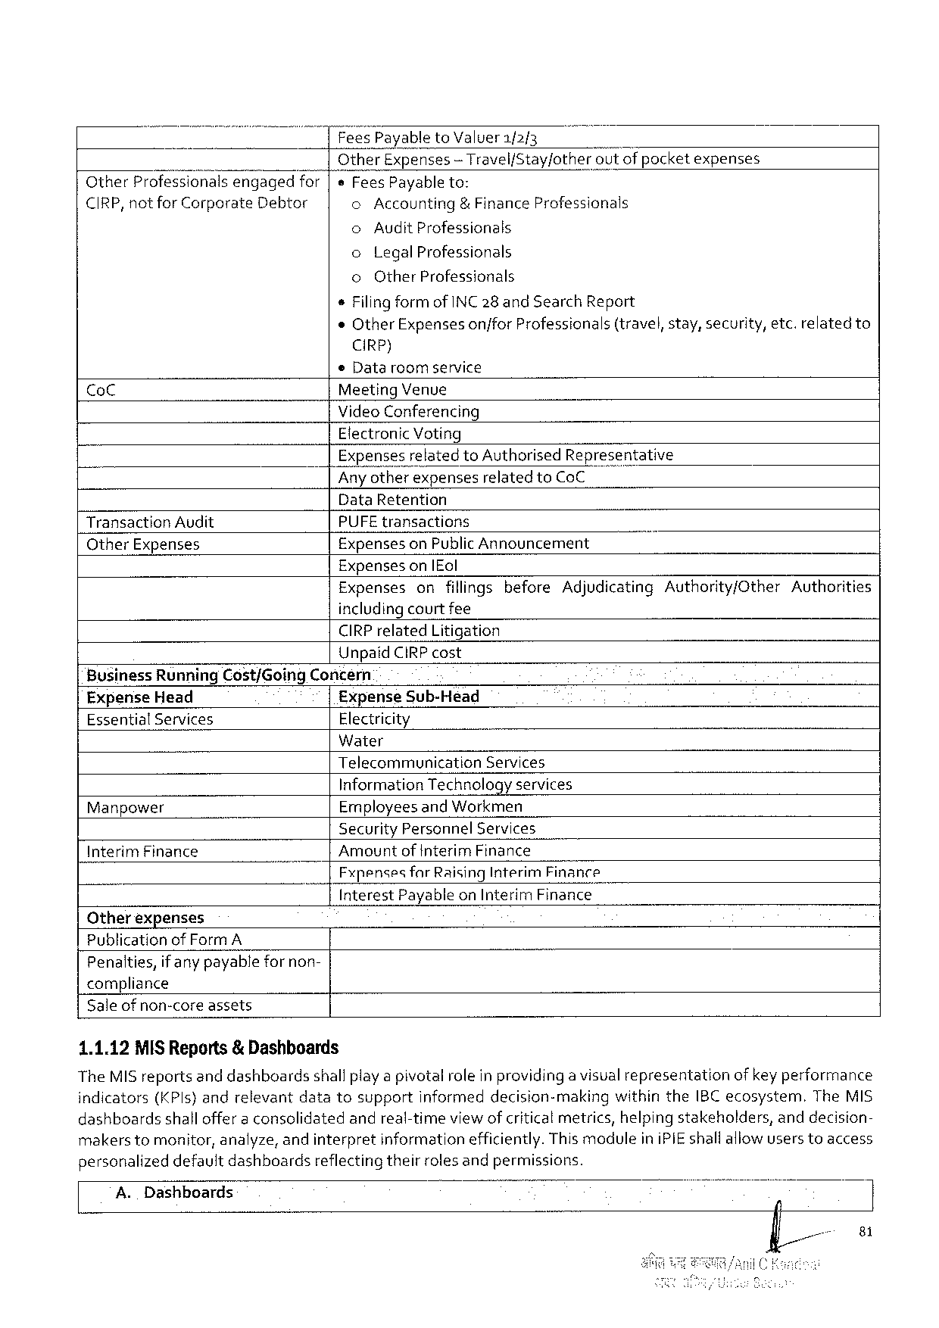

Fees Payable toValuer1/2{3

OtherExpenses — Travel/Stay/other outof pocketexpenses

OtherProfessionalsengagedfor eFeesPayableto:

CIRP, notforCorporate Debtor o Accounting & FinanceProfessionals

o Audit Professionals

o LegalProfessionals

o OtherProfessionals

sFiling form ofINC 28 and SearchReport

«OtherExpensesonjforProfessionals(travel,stay,security,etc.relatedto

CIRP)

© Data roomservice

CoC MeetingVenue

VideoConferencing

ElectronicVoting

ExpensesrelatedtoAuthorisedRepresentative

Any otherexpensesrelated toCoC

DataRetention

TransactionAudit PUFE transactions

OtherExpenses ExpensesonPublicAnnouncement

Expenseson|Eol

|  |  |  |
| --- | --- | --- |
| Expensesonfillingsbefore | AdjudicatingAuthority/Other | Authorities |

includingcourtfee

CIRPrelatedLitigation

UnpaidCIRPcost

BusinessRunningCost/GoingConcern

ExpenseHead ExpenseSub-Head

EssentialServices Electricity

Water

Telecommunication Services

Information Technologyservices

Manpower Employees andWorkmen

SecurityPersonnel Services

InterimFinance Amountof InterimFinance

Fxpenses farRaisingInterimFinance

InterestPayableonInterimFinance

Otherexpenses

Publication of FormA

Penalties,if anypayablefor non-

compliance

Saleofnon-coreassets

1.1.12MISReports& Dashboards

TheMISreportsand dashboardsshallplaya pivotalroleinprovidinga visualrepresentationof keyperformance

indicators(KPls}andrelevantdatatosupportinformeddecision-makingwithintheIBC ecosystem.TheMIS

dashboardsshalloffer a consolidatedandreal-timeviewof criticalmetrics,helping stakeholders,anddecision-

makers tomonitor,analyze,and interpretinformationefficiently.ThismoduleiniPIEshallaliowusers toaccess

personalizeddefaultdashboardsreflecting theirrolesandpermissions.

A. Dashboards

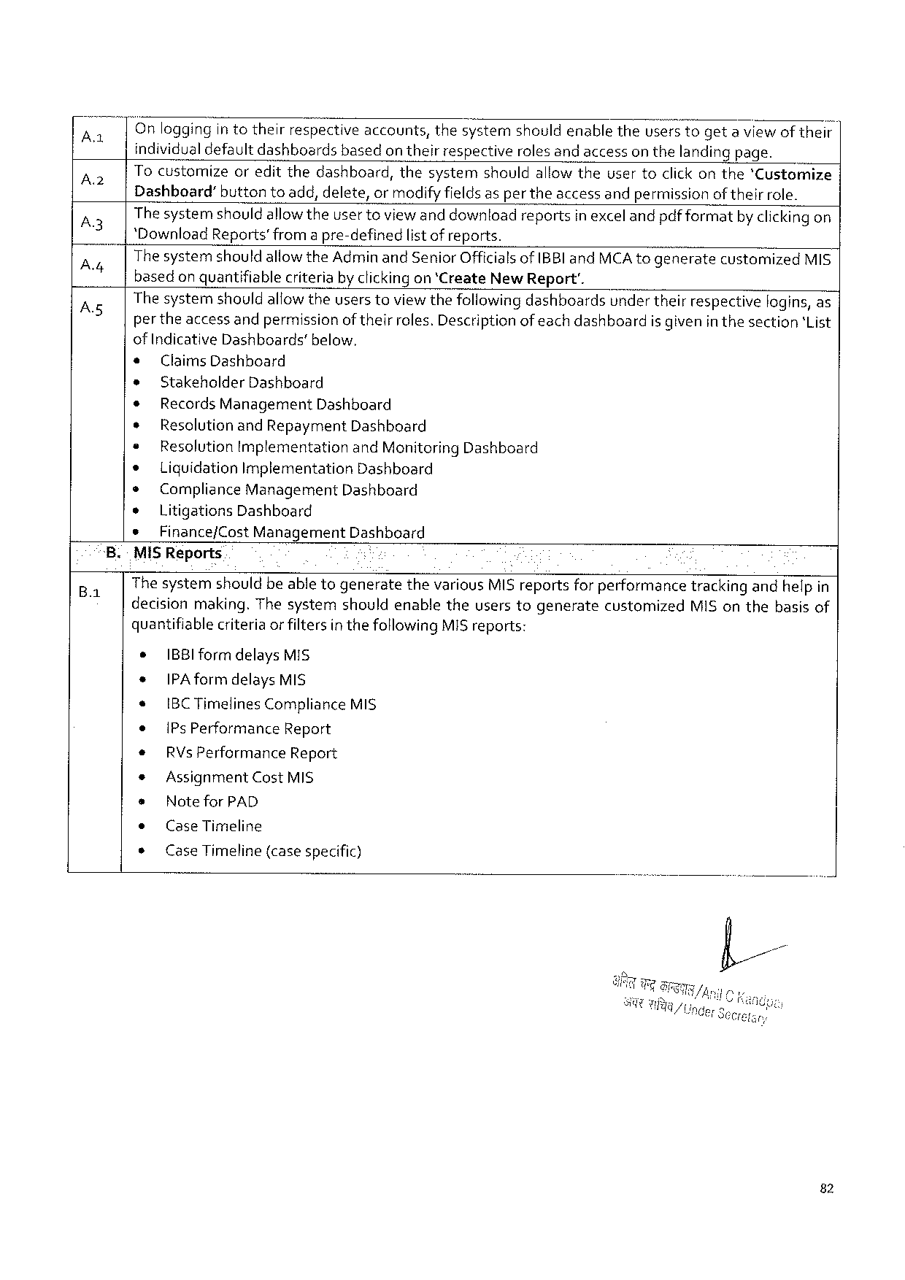

|  |  |  |  |
| --- | --- | --- | --- |
| A  A  A3 A  As | on | loggingin totheirrespectiveaccounts,thesystemshouldenabletheuserstogeta viewof their | |
| individualdefaultdashboardsbasedon theirrespectiverolesand accesson thelandingpage. | | |
| |Tocustomize | | oreditthedashboard,thesystemshouldallow theusertoclickonthe'Customize |
| Dashboard”buttontoadd,delete,ormodifyfieldsasper theaccessandpermission oftheirrole. Thesystemshouldallowtheuser toviewand downloadreportsinexcelandpdfformatby clickingon‘DownloadReports’from a pre-definedlist of reports.  Thesystemshould allowtheAdminand SeniorOfficialsofIBBI andMCAtogeneratecustomizedMIS basedon quantifiablecriteriaby clickingon ‘CreateNew Report'.  The systemshouldallowtheuserstoviewthefollowing dashboardsunder theirrespectivelogins, as per theaccessandpermissionof theirroles.Descriptionofeachdashboardis given in thesection‘List of IndicativeDashboards’below. | | |
| e | ClaimsDashboard | |
| ® | StakeholderDashboard | |
| * | Records ManagementDashboard | |
| ¢ | ResolutionandRepaymentDashboard | |
| * | ResolutionImplementationandMonitoring Dashboard | |
| * | Liguidation ImplementationDashboard | |
| ¢ | Compliance ManagementDashboard | |
| * | Litigations Dashboard | |
| s | Finance/Cost ManagementDashboard | |

.-MiSReports

The systemshouldbeable togeneratethevariousMIS reportsfor performancetrackingandhelpin

decisionmaking.ThesystemshouldenabletheuserstogeneratecustomizedMIS onthebasisof

quantifiablecriteria or filtersin thefollowingMISreports:

¢ IBBIformdelaysMIS

+ IPAformdelays MIS

* IBCTimelinesComplianceMIS

e |PsPerformance Report

* RVsPerformanceReport

* AssignmentCostMIS

s Notefor PAD

¢ CaseTimeline

s CaseTimeline(casespecific)

82

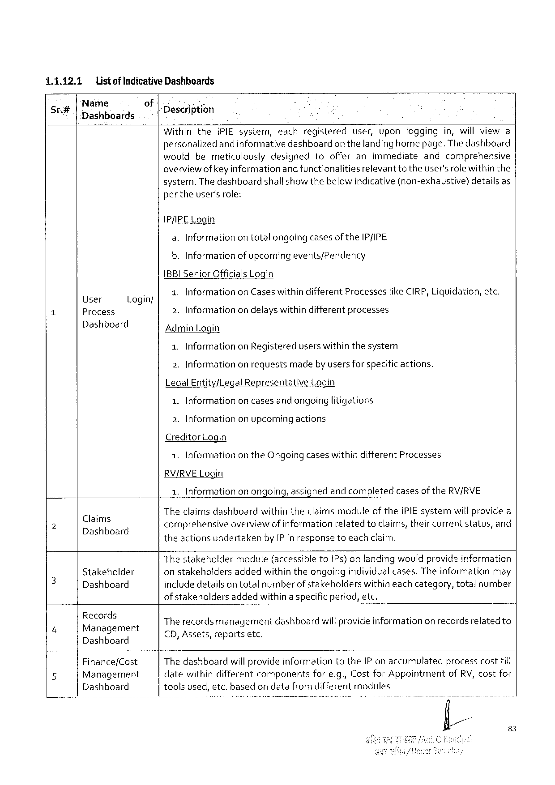

|  |  |  |  |  |  |  |  |  |  |  |  |
| --- | --- | --- | --- | --- | --- | --- | --- | --- | --- | --- | --- |
| 1.1.12.1 | Listof indicativeDashhoards | | | | iPIEsystem, | each | registered | user, | upon | logging | in,willviewa |
| Sr.# | Name | of | Description | |
| Dashboards |
| Within | | | the |

personalizedandinformativedashboardon thelandinghomepage.Thedashboard wouldbemeticulouslydesignedtoofferanimmediateandcomprehensive overviewofkeyinformationandfunctionalities relevantto theuser'srolewithinthe system.Thedashboard shallshowthebelowindicative(non-exhaustive) detailsas per theuser'srole:

IP/IPE Login   
 a.Informationontotalongoingcasesof theIP/IPE   
 b.Informationof upcomingevents/Pendency   
IBBI Senior OfficialsLogin

|  |  |  |  |
| --- | --- | --- | --- |
| i | User | Login/ | 1.Informationon CaseswithindifferentProcesseslikeCIRP, Liquidation,etc. |
| 2.Informationon delayswithindifferentprocesses |
| Process |
| Dashboard | AdminLogin |

1.InformationonRegistereduserswithinthesystem   
2.Information onrequestsmadeby usersforspecificactions.

LegalEntity/LegalRepresentativeLogin

1.Information oncasesandongoinglitigations

2.Informationon upcoming actions   
CreditorLogin

|  |  |  |
| --- | --- | --- |
| 1.Information | on theOngoingcaseswithindifferent | Processes |

RV/RVELogin   
 1.Informationon ongoing,assignedand completedcasesof theRV/RVE

|  |  |  |
| --- | --- | --- |
| ) | p  Claims  DEERbaE | Theclaims dashboardwithintheclaimsmoduleof theiPIE systemwillprovidea  q i i . N h  comprehensive overviewof information relatedtoclaims, their current status,and |

theactionsundertakenbyIP in responsetoeachclaim.

Thestakeholdermodule(accessibletoIPs) onlandingwouldprovideinformation

|  |  |  |  |  |  |  |  |
| --- | --- | --- | --- | --- | --- | --- | --- |
| 3 | Stakeholder | onstakeholdersaddedwithin theongoingindividualcases.Theinformationmay | | | | | |
| Dashboard | includedetailsontotalnumberofstakeholderswithineachcategory,totalnumber | | | | | |
| ofstakeholdersaddedwithinaspecificperiod, etc. | | | | | |
| Records |
| . P .  The recordsmanagementdashboardwill provideinformationon recordsrelatedto | | | | | |
| “ |
| Magagement Dashboard |
| CD,Assets,reportsetc ! A | | ) | | | |
| 5 | Thedashboard | will provideinformation | | | totheIPonaccumulated | processcosttill |
| Finance/Cost |
| Management | datewithindifferent | | components | fore.g.,CostforAppointment | | ofRV,costfor |
| Dashboard | toolsused,etc.basedon datafromdifferentmodules | | | | | |

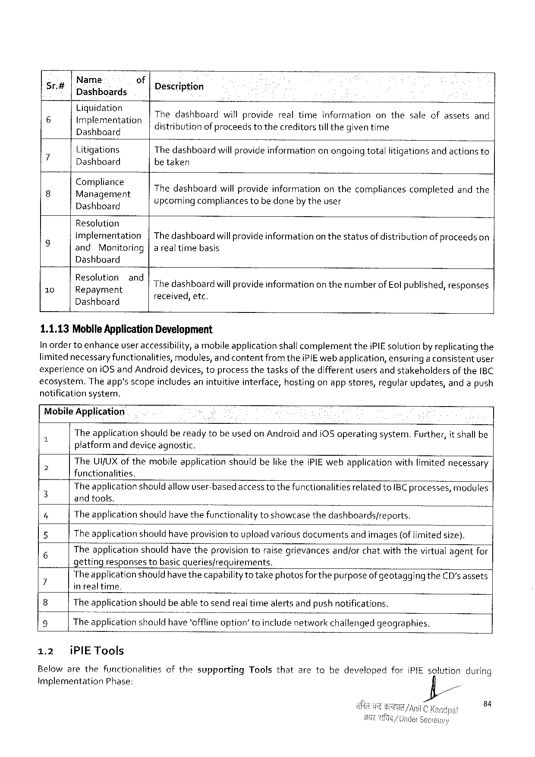

|  |  |  |  |  |
| --- | --- | --- | --- | --- |
| Sr# | Name  Dashboards | of | Description | |
| 6 | Liquidationg Implementation | |
| Thedashboard distributionof proceedstothecreditorstillthegiventime . willproviderealtimeinformationonthesaleofassets A s | and |
| Dashboard | |
| 7 | Litigations | | The dashboardwill provideinformationonongoingtotallitigationsand actionsto | |
| Dashboard | | betaken | |
| P | :\:A‘)a:]:g:rr::nt | |
| Thedashboardwillprovideinformationonthecompliancescompletedandthe | |
| Dashboard | | upcomingcompliances tobe donebytheuser | |

Resalution

|  |  |  |  |
| --- | --- | --- | --- |
| g | Implementation | | |Thedashboardwillprovideinformationon thestatusof distributionofproceedson |
| and | Monitoring|arealtime basis | |

Dashboard

|  |  |  |
| --- | --- | --- |
| 10 | E:S(;Iu:nigztBndThe dashboardwillprovide informationonthenumberof Eol published,responses | |
| pay  Dashboard | received,etc. |

1.1.13Mobile ApplicationDevelopment

In ordertoenhanceuser accessibility, amobileapplicationshallcomplementtheiPIEsolutionby replicating the

limitednecessary functionalities,modules,and contentfromtheiPIEweb application,ensuring a consistentuser

experienceoni0Sand Androiddevices,toprocessthetasksof thedifferentusersandstakeholdersof theIBC

ecosystem.Theapp’sscopeincludesanintuitiveinterface,hostingonappstores,regularupdates,andapush

notificationsystem.

Mobile Application:

Theapplicationshouldbereadytobeusedon AndroidandiOSoperatingsystem.Further,it shall be

platformand deviceagnostic.

TheUI/UXof themobileapplicationshouldbeliketheiPIEwebapplicationwithlimitednecessary

a functionalities.

The application should allowuser-basedaccesstothefunctionalitiesrelated toIBC processes,modules

3 and tools. 5

4 The applicationshould have thefunctionalitytoshowcasethedashboards/reports.

5 The applicationshould haveprovisiontoupload variousdocumentsand images(oflimited size).

6 Theapplicationshouldhave theprovisiontoraisegrievancesand/orchatwiththevirtualagentfor

getting responses tobasicqueries/requirements.

7 Theapplication shouldhavethecapabilityto takephotosfor the purposeof geotaggingtheCD'sassets . *

in realtime.

8 The applicationshouldbe abletosendrealtimealertsandpush notifications.

9 The applicationshouldhave‘offfineoption”toincludenetworkchallengedgeographies.

1.2 iPIETools

Belowarethefunctionalities ofthe supporting Tools that aretobedeveloped for iPIEsolution during

ImplementationPhase: =

84

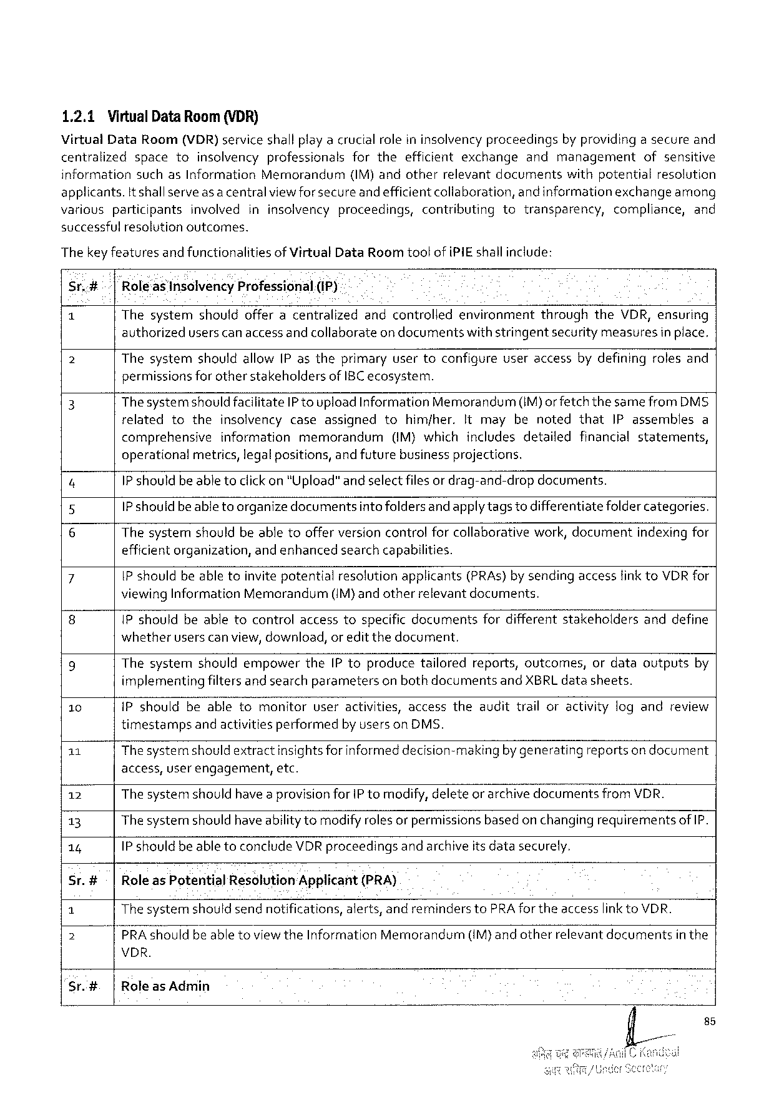

1.2.1Virtual DataRoom (VDR)

VirtualDataRoom(VDR) serviceshallplayacrucialroleininsolvencyproceedings byprovidingasecureand

centralized space to insolvency professionals forthe efficient exchange and management ofsensitive

information suchasInformation Memorandum (IM)andotherrelevant documents withpotential resolution

applicants. Itshallserveas a centralviewforsecureandefficientcollaboration, andinformationexchange among

various participants involved ininsolvency proceedings, contributing to transparency, compliance, and

successful resolutionoutcomes.

Thekey featuresand functionalitiesofVirtualDataRoom too! of iPIEshallinclude:

Sr.# ‘Rkoleas Insolvency Professional.(IP)

1 ThesystemshouldofferacentralizedandcontrolledenvironmentthroughtheVDR,ensuring

authorizeduserscan access andcollaborateon documentswithstringentsecurity measuresin place,

2 Thesystemshouldallow(P astheprimaryusertoconfigureuseraccessbydefiningrolesand

permissionsforother stakeholdersofIBC ecosystem.

3 ThesystemshouldfacilitateIP to upload InformationMemorandum(IM)or fetch thesamefromDMS

relatedtotheinsolvencycaseassignedtohimjher.Itmaybenotedthat IPassemblesa

comprehensive information memorandum (IM)which includes detailed financial statements,

operational metrics,legalpositions,andfuturebusinessprojections.

4 1Pshouldbeable toclick on "Upload"andselectfilesor drag-and-dropdocuments.

5 1P should beable to organizedocumentsintofoldersandapplytagstodifferentiatefoldercategories.

6 Thesystemshouldbeabletoofferversioncontrolforcollaborativework,documentindexing for

efficientorganization,andenhancedsearchcapabilities.

7 IP shouldbeabletoinvite potentialresolutionapplicants(PRAs)bysendingaccessfink toVDRfor

viewingInformation Memorandum (IM)andotherrelevantdocuments.

8 IP shouldbeabletocontrolaccesstospecificdocumentsfordifferentstakeholdersanddefine

whetheruserscanview,download,or editthedocument.

9 ThesystemshouldempowertheIPtoproducetailoredreports,outcomes,ordataoutputsby

implementingfiltersand searchparametersonbothdocumentsandXBRLdatasheets.

10 iPshouldbeabletomonitoruseractivities,accesstheaudittrailoractivitylogandreview

timestamps andactivitiesperformed by usersonDMS.

11 Thesystemshould extractinsightsfor informeddecision-makingby generatingreportson document

access,user engagement,etc.

12 The systemshouldhave aprovisionforIP tomodify,deleteor archivedocumentsfromVDR.

13 Thesysternshouldhave abilitytomodifyrolesor permissionsbasedon changingrequirementsof IP.

14 1P shouldbe able toconcludeVDRproceedingsand archiveits datasecurely.

Sr.#- |RoleasPotential Resolution‘Applicant (PRA)

1 Thesystemshouldsendnotifications,alerts,andreminderstoPRAfortheaccesslink toVDR.

2 PRAshouldbeabletoviewtheInformation Memorandurm (IM)andotherrelevantdocuments inthe

VDR.

Sr.#. |Role as Admin

fi/ss

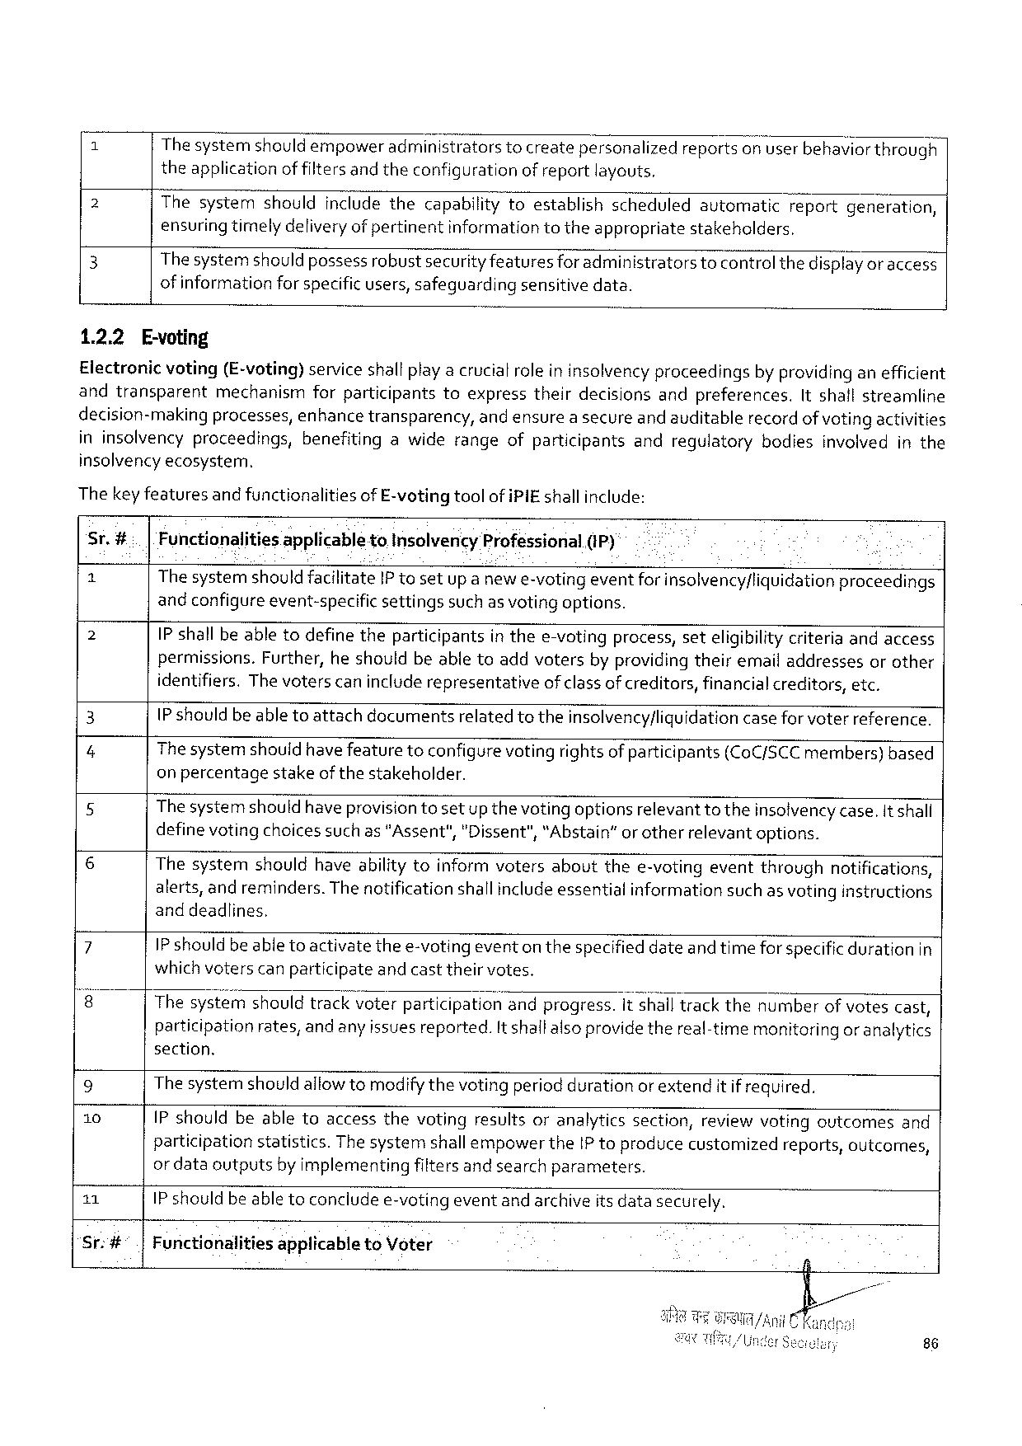

Thesystemshouldempower administrators tocreatepersonalized reportson userbehavior through

theapplicationof filtersand theconfigurationof reportlayouts.

2 Thesystemshouldincludethecapabilitytoestablishscheduledautomaticreportgeneration, ensuring timelydeliveryof pertinentinformation totheappropriatestakeholders.

3 Thesystemshould possessrobustsecurity featuresforadministratorstocontrol thedisplay or access

of information forspecificusers,safeguardingsensitivedata.

1.2.2 E-voting

Electronicvoting(E-voting) serviceshallplayacrucialrole ininsolvencyproceedingsby providing anefficient andtransparent mechanismforparticipantstoexpresstheirdecisionsandpreferences,Itshallstreamline

decision-makingprocesses,enhancetransparency,andensurea secureand auditablerecordof votingactivities ininsolvencyproceedings,benefitingawiderangeofparticipantsandregulatorybodiesinvolvedinthe

insolvencyecosysterm.

The keyfeaturesand functionalitiesof E-vetingtoolof iPIE shallinclude:

Sr.#.. |FunctionalitiesapplicabletoInsolvencyProfessional(iP)

|  |  |  |  |  |  |  |
| --- | --- | --- | --- | --- | --- | --- |
| 2  2  3  4  5  6  7  8  9  10  11 | The systemshould facilitateIP tosetupanewe-votingeventforinsolvency/liquidationproceedings | | | | | |
| andconfigureevent-specific | | | settings | suchas votingoptions. | |
| IP shallbeabletodefinetheparticipantsin thee-votingprocess,seteligibilitycriteriaandaccess permissions.Further,heshouldbeabletoaddvotersbyproviding theiremailaddressesorother identifiers. Thevoterscanincluderepresentative ofclassof creditors,financialcreditors, etc.  IP shouldbe able toattachdocumentsrelated totheinsolvency/liquidation case for voterreference.  Thesystemshouldhave featuretoconfigure voting rightsof participants(CoC/SCCmembers)based on percentagestakeofthestakeholder.  Thesystemshouldhaveprovisiontosetup thevotingoptionsrelevant totheinsolvencycase.It shall definevotingchoicessuchas"Assent","Dissent",“Abstain”orotherrelevantoptions.  Thesystemshouldhaveabilitytoinformvotersaboutthee-votingeventthroughnotifications, alerts,andreminders.The notificationshallincludeessentialinformationsuch as votinginstructions and deadlines,  IP should beable toactivatethee-votingeventonthespecified dateand timefor specificdurationin | | | | | |
| whichvoterscanparticipate | | | andcasttheirvotes. | | |
| Thesystgfi'}shouldtrackvoterparticlpahon‘andprogress.it shalltrackthenumberof votescast, participationrates,and any issues reported.It shallalso providethereal-timemonitoringor analytics section.  The systemshouldallowtomodifythevotingperiod durationorextendit if required.  IPshouldbeabletoaccessthevotingresultsoranalyticssection,reviewvotingoutcomesand | | | | | |
| participation | statistics. | ThesystemshallempowertheIP toproducecustomized | | | reports,outcomes, |
| or dataoutputsby implementingfiltersand searchparameters.  IP should beable toconcludee-votingevent andarchiveits datasecurely. | | | | | |

Sr:#°.|FunctionalitiesapplicabletoVoter

86

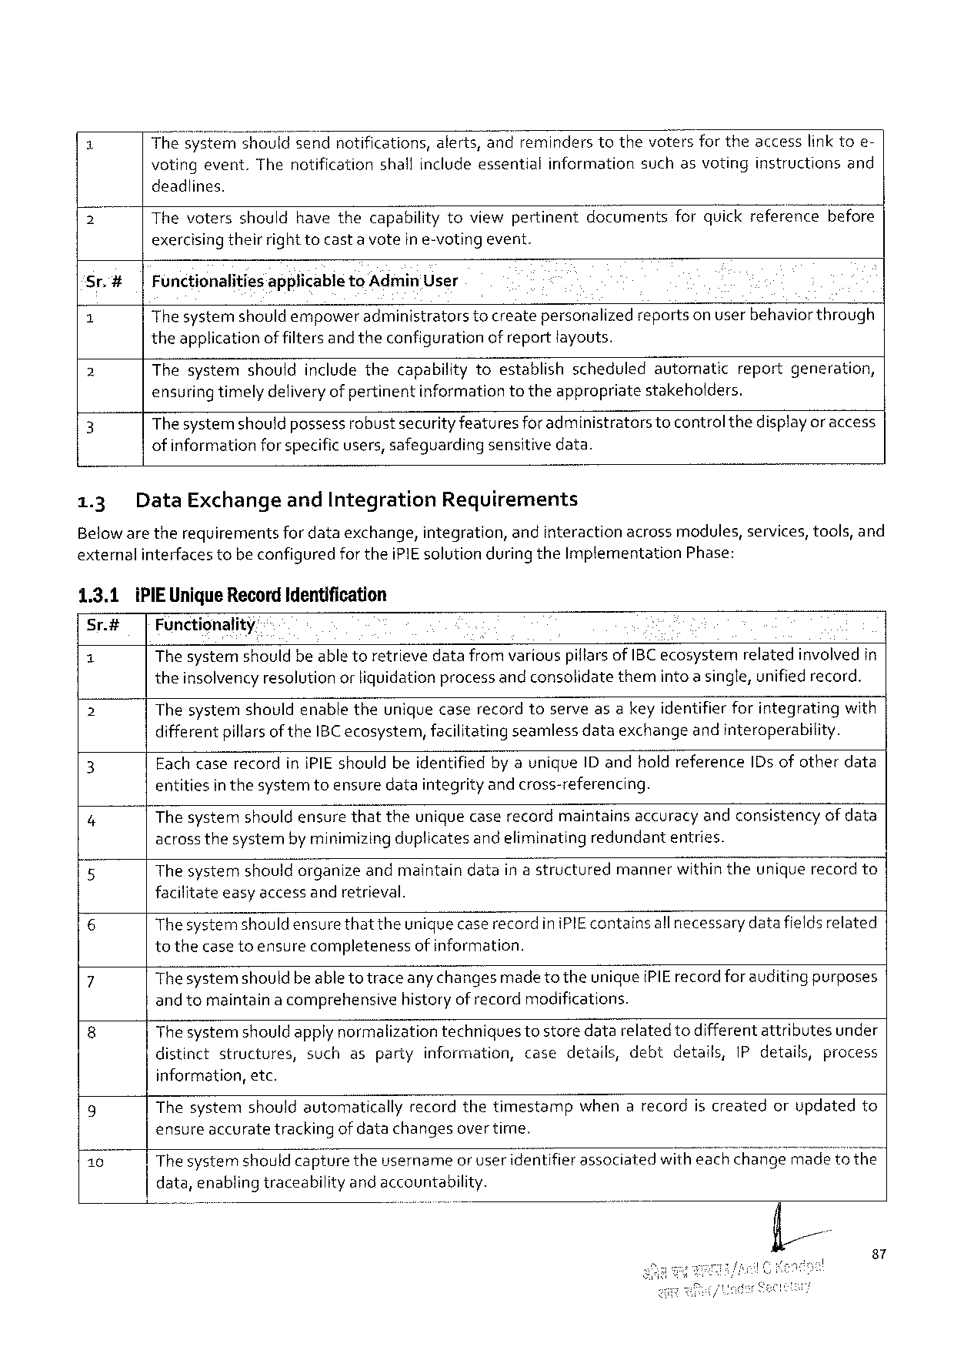

1 Thesy:mshouldsendnotifications,alerts,andreminderstothevotersfortheaccesslinktoe-

votingevent.Thenotification shallincludeessential information suchasvoting instructions and

deadlines.

2 Thevotersshouldhavethecapabilitytoviewpertinentdocumentsforquickreferencebefore exercisingtheirrighttocasta voteine-votingevent.

|  |  |  |  |
| --- | --- | --- | --- |
| Sr.# | | | FunctionalitiesapplicabletoAdmin'User | |
| 1 | The systemshould empoweradministratorstocreatepersonalizedreportson userbehavior through | |
| 2 | theapplication | of filtersand theconfigurationof reportlayouts. |
| Thesystemshouldincludethecapabilitytoestablishscheduledautomaticreportgeneration, | |
| 3 | ensuring timelydeliveryof pertinentinformationtotheappropriatestakeholders. | |
| Thesystemshould possessrobustsecurityfeaturesforadministratorstocontrolthedisplayor access | |

of informationforspecificusers, safeguardingsensitivedata.

|  |  |  |  |
| --- | --- | --- | --- |
| 1.3 | DataExchange | andIntegration | Requirements |

Belowaretherequirementsfor dataexchange,integration,andinteractionacrossmodules,services,tools,and externalinterfacestobeconfiguredfortheiPIEsolution during theImplementationPhase:

|  |  |
| --- | --- |
| 1.3.1 Sr.#  1  2 | iPIE UniqueRecordIdentification   Functionality-  The systemshouldbeable toretrievedatafrom variouspiflarsofIBC ecosystemrelatedinvolved in theinsolvencyresolution orliquidationprocessand consolidatethemintoa single,unifiedrecord.  Thesystemshouldenabletheuniquecaserecordtoserveasa keyidentifierforintegratingwith |

differentpillarsoftheIBC ecosystem,facilitatingseamlessdataexchangeand interoperability.

|  |  |
| --- | --- |
| 3  4 | EachcaserecordinIPIEshouldbeidentifiedby auniqueIDandholdreferenceIDs ofotherdata entitiesin thesystemtoensuredataintegrityand cross-referencing.  Thesystemshouldensurethattheunique caserecordmaintainsaccuracy andconsistencyofdata |

acrossthesystembyminimizingduplicatesand eliminatingredundantentries.

5 Thesystemshouldorganizeandmaintaindatain astructuredmannerwithintheuniquerecordto facilitateeasyaccessandretrieval.

6 Thesystemshould ensurethattheuniquecase recordiniPIE containsall necessarydata fieldsrelated tothecase toensurecompletenessof information.

|  |  |  |  |
| --- | --- | --- | --- |
| 7  8 | Thesystemshouldbeabletotraceany changesmade to theuniqueiPIErecordforauditing purposes and tomaintaina comprehensivehistoryof recordmodifications.  Thesystemshould apply normalizationtechniquestostoredatarelatedtodifferentattributesunder | | |
| distinctstructures, | suchaspartyinformation,casedetails,debt | details,IPdetails,process |

information,etc.

|  |  |  |
| --- | --- | --- |
| g  10 | Thesystemshouldautomaticallyrecordthetimestampwhenarecordiscreatedorupdatedto ensureaccuratetrackingofdatachangesover time. | |
| Thesystemshould capturetheusernameor useridentifier associatedwitheaEk"w’EH;@e | madetothe |

data,enablingtraceabilityandaccountability.

87

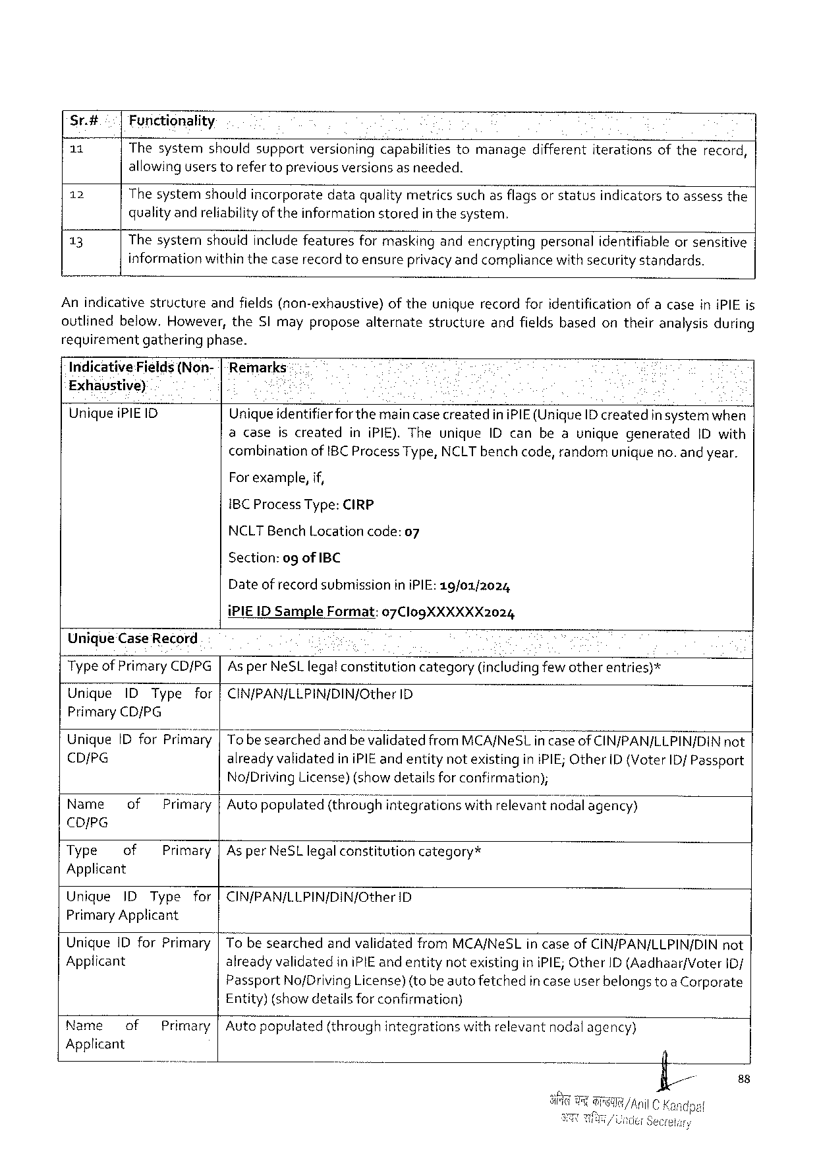

Sr.4# Functionality

11 Thesystem shouldsupport versioning capabilities tomanage different iterations oftherecord,

allowinguserstorefertopreviousversionsasneeded.

12 Thesystemshouldincorporatedataqualitymetricssuchasflagsor statusindicatorstoassessthe

qualityandreliabilityof theinformationstoredin thesystem.

13 Thesystemshouldincludefeaturesformaskingandencryptingpersonalidentifiableorsensitive

informationwithinthecaserecord toensureprivacyand compliancewith security standards.

Anindicativestructure andfields(non-exhaustive) oftheuniquerecordforidentification ofacaseiniPIEis

outlinedbelow,However,theSI mayproposealternatestructureandfieldsbasedontheiranalysisduring

requirementgatheringphase.

Indicative Fields(Non-|Remarks

Exhaustive) ¢

UniqueiPIEID Uniqueidentifierforthemaincase creatediniPIE(UniqueID createdin systemwhen

acaseiscreatediniPIE).TheuniqueIDcanbeauniquegenerated IDwith

combinationofIBC Process Type,NCLTbenchcode,randomunigueno.and year.

For example,if,

1BCProcessType:CIRP

NCLTBenchLocationcode:07

Section:ogofIBC

Dateofrecordsubmission iniPIE:19/01/2024

UniqueCaseRecord

iPIE1DSample Format:07ClogXXXXXX2024

Typeof PrimaryCD/PG As perNeSLlegalconstitutioncategory(includingfewotherentries)*

Unique IDType for CIN/PAN/LLPIN/DIN/Other 1D

PrimaryCD/PG

UnigueIDforPrirfiéw

CD/PG alreadyvalidatedin iPIEand entitynot existinginiPIE;OtherID (Voter 1D/Passport

No/DrivingLicense)(showdetailsforconfirmation);

|  |  |  |  |  |  |
| --- | --- | --- | --- | --- | --- |
| Name | of | Prfljfiary | Autopopulated | (thrOCQhintegrations | withrelevantnodalagency) |

CDIPG

|  |  |  |  |
| --- | --- | --- | --- |
| Type | of | Primary|AsperNeSLlegalconstitution | category* |

Applicant

|  |  |  |  |  |
| --- | --- | --- | --- | --- |
| Unique | IDType | for | CIN/PAN/LLPIN/DIN/Other | ID |

PrimaryApplicant

|  |  |
| --- | --- |
| Unique1D forPrimary Applicant | To besearchedandvalidatedfromMCA/NeSLin caseof CIN/PAN/LLPIN/DINnot alreadyvalidatediniPIEand entitynotexistinginiPIE;OtherID(Aadhaar/Voter iD/ |

Passport No/DrivingLicense)(tobeautofetched

Entity)(showdetailsforconfirmation)

incaseuserbelongstoa Corporate

|  |  |  |  |
| --- | --- | --- | --- |
| Name | of | Primary | Auto populated(throughintegrationswithrelevantnodal agency) |

Applicant

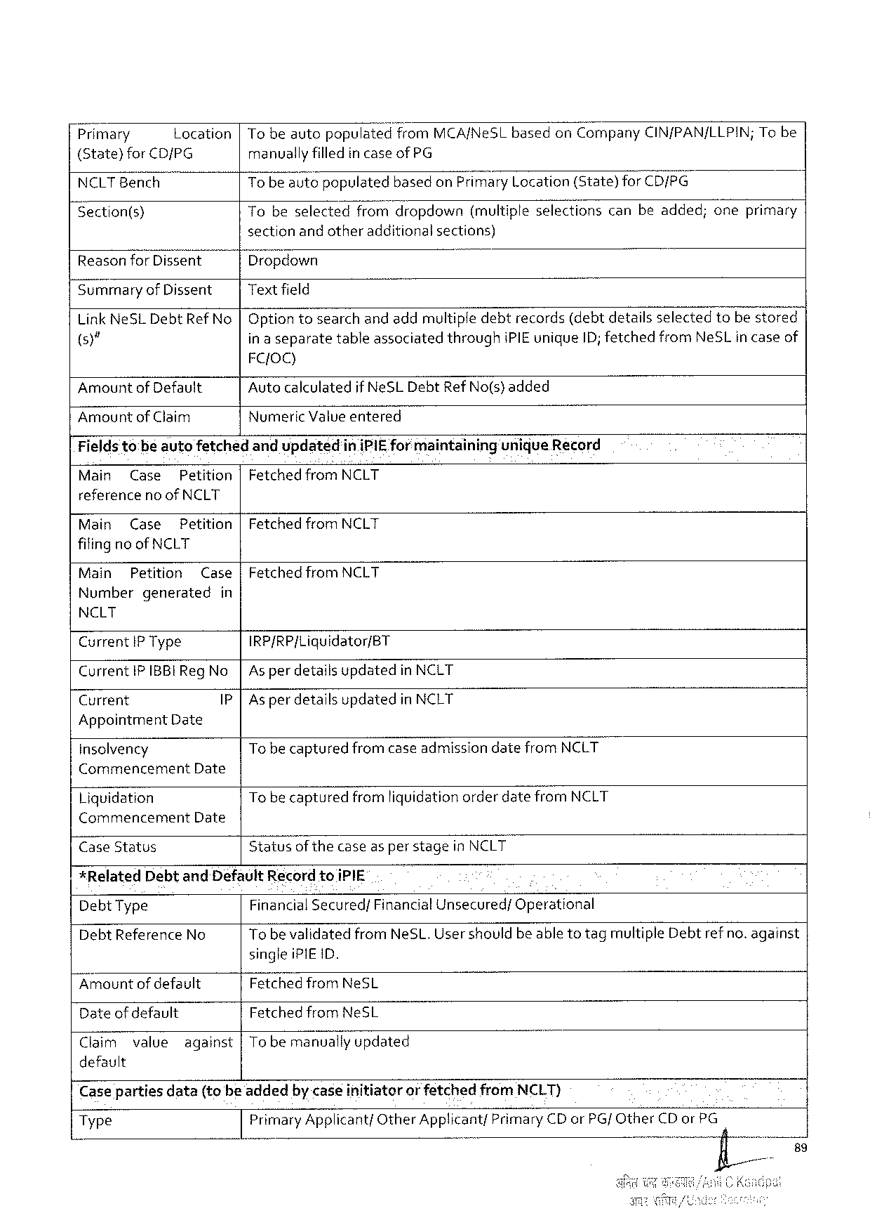

7Primary Location|Tobeautopopu\atea?rom MCA/NeSLbasedonCompany CIN/PAN/LLPIN;Tobe

(State)forCD/PG manuallyfilledincaseofPG

NCLTBench To beautopopulatedbasedon Pr;n“aryLocation(State)forCD/PG

[Section(s) Tobeselected fromdropdown (multiple selections canbeadded; oneprimary

sectionandotheradditionalsections)

|  |  |
| --- | --- |
| Reason for Dissent  Summary of Dissent  LinkNeSLDebtRefNo )"  Amountof Default Amountof Claim | Dropdown  Textfield  Optiontosearchand addmultipledebtrecords(debtdetailsselectedtobestored in a separatetableassociatedthroughiPIEuniqueID; fetchedfromNeSLin caseof FC{OQ)  Auto calculatedif NeSLDebtRefNo(s) added  NumericValueentered |

Fields tobeauiofetched andupdatediniPIEformaintaininguniqueRecord

|  |  |  |  |
| --- | --- | --- | --- |
| Main | Case | Petition | Fetched frorfi NCLT |

referenceno ofNCLT

|  |  |  |
| --- | --- | --- |
| Main | Case | Petition|Fetched fromNCLT |

filingno ofNCLT

Main Petition Case|Fetched fromNCLT

Numbergenerated in

NCLT

Current IP Type IRP/RP/Liquidator/BT

Current IPIBBI RegNo As perdetailsupdatedin NCLT

Current P As perdetailsupdatedin NCLT

Appointment Date

insolvency Tobe capturedfromcaseadmissiondatefromNCLT

Commencement Date

Liquidation TobecapturedfromliquidationorderdatefromNCLT

Commencement Date

CaseStatus Statusof the caseas per stagein NCLT

*RelatedDebtandDefaultRecord toiPIE

DebtType FinancialSecured/FinancialUnsecured/Operational

DebtReferenceNo TobevalidatedfromNeSL.User shouldbe able totagmultipleDebtrefno.against

singleiPIE ID.

Amountofdefault FetchedfromNeSL

Dateof default FetchedfromNeSL

Claim value against|To bemanually updated

default

Caseparties data(tobeadded bycaseinitiator orfetched fromNCLT)

Type PrimaryApplicant/OtherApplicant/PrimaryCDor PG/ OtherCDor PG

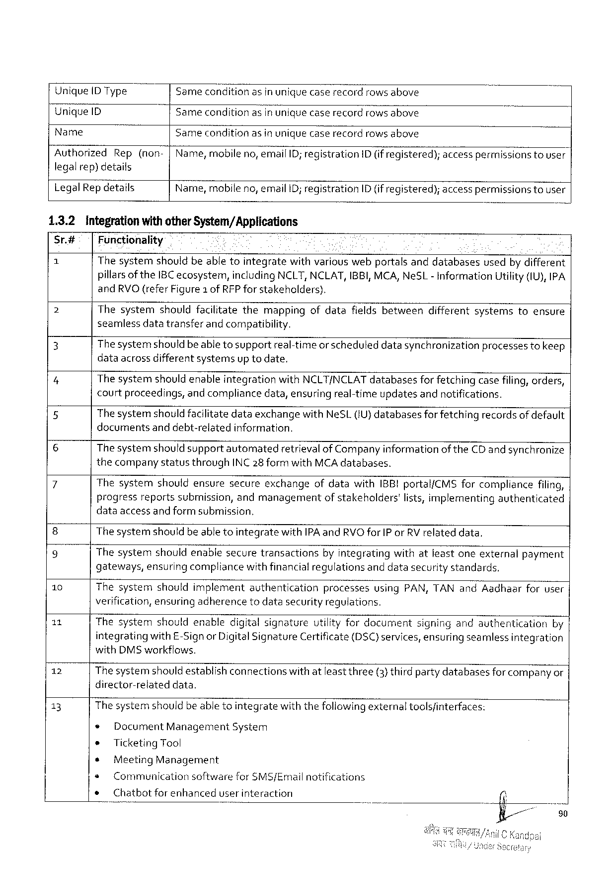

UniqueDType Samecondition asinuniquecaserecordrowsabove

UniqueID Samecondition asinuniguecaserecordrowsabove

Name Sameconditionasin uniquecaserecordrowsabove

Authorized Rep(non-|Name,mobileno,emailID;registration ID (if registered); accesspermissions tousar

legalrep)details

LegalRep details Name,mobileno, email ID; registrationID (if registered);access permissionstouser

1.3.2 integrationwithotherSystem/Applications

Sr.# | Functionality

2l Thesystemshouldbeabletointegratewithvariouswebportalsanddatabasesusedby different

pillarsof the1BC ecosystem,includingNCLT, NCLAT, IBBI,MCA, NeSL- InformationUtility(1U), IPA

andRVO(referFigure1 ofRFP forstakeholders).

|  |  |  |  |  |  |  |  |  |
| --- | --- | --- | --- | --- | --- | --- | --- | --- |
| 2  3  4  5  6  7  8  9  10  11  12  13 | Thesystemshouldfacilitatethemappingofdatafieldsbetweendifferentsystemstoensure seamlessdatatransferand compatibility.  Thesystemshould beabletosupportreal-timeor scheduleddatasynchronizationprocessestokeep dataacrossdifferentsystemsup todate.  ThesystemshouldenableintegrationwithNCLT/NCLAT databasesfor fetchingcasefiling,orders, courtproceedings,andcompliancedata,ensuringreal-timeupdatesandnotifications.  Thesystemshould facilitatedataexchangewithNeSL(U} databasesforfetchingrecordsofdefault documentsanddebt-relatedinformation.  The systemshould supportautomatedretrievalof Companyinformationof theCDandsynchronize thecompanystatusthroughINC28 formwithMCAdatabases.  ThesystemshouldensuresecureexchangeofdatawithIBBI portal/CMSforcompliancefiling, progressreportssubmission,andmanagementof stakeholders'lists,implementingauthenticated dataaccessand formsubmission.  The systemshouldbeabletointegratewithIPA andRVOforIP orRV relateddata. | | | | | | | |
| Thesystem | | shouldenablesecuretransactions | | | byintegrating | withatleastoneexternal | payment |
| gateways,ensuringcompliancewithfinancial requlationsanddatasecuritystandards. | | | | | | | |
| Thesystemshouldimplementauthentication | | | | | processesusingPAN,TANandAadhaarforuser | | |
| verification,ensuringadherencetodatasecurity regulations.  Thesystemshouldenabledigitalsignatureutilityfordocumentsigningandauthenticationby | | | | | | | |
| integrating | | with£-SignorDigitalSignatureCertificate(DSC) services,ensuringseamlessintegration | | | | | |
| withDMSworkffows.  The systemshouldestablishconnectionswithatleast three(3) thirdpartydatabasesforcompanyor director-relateddata.  The systemshouldbeabletointegratewiththefollowingexternaltoolsfinterfaces: | | | | | | | |
| ¢ | DocumentManagementSystem | | | | | | |
| * | Ticketing Tool | | | | | | |
| ¢ | MeetingManagement | | | | | | |
| s | Communication | | softwareforSMS/Emailnotifications | | | | |
| ¢ | Chatbotforenhanced | | | userinteraction | | | |

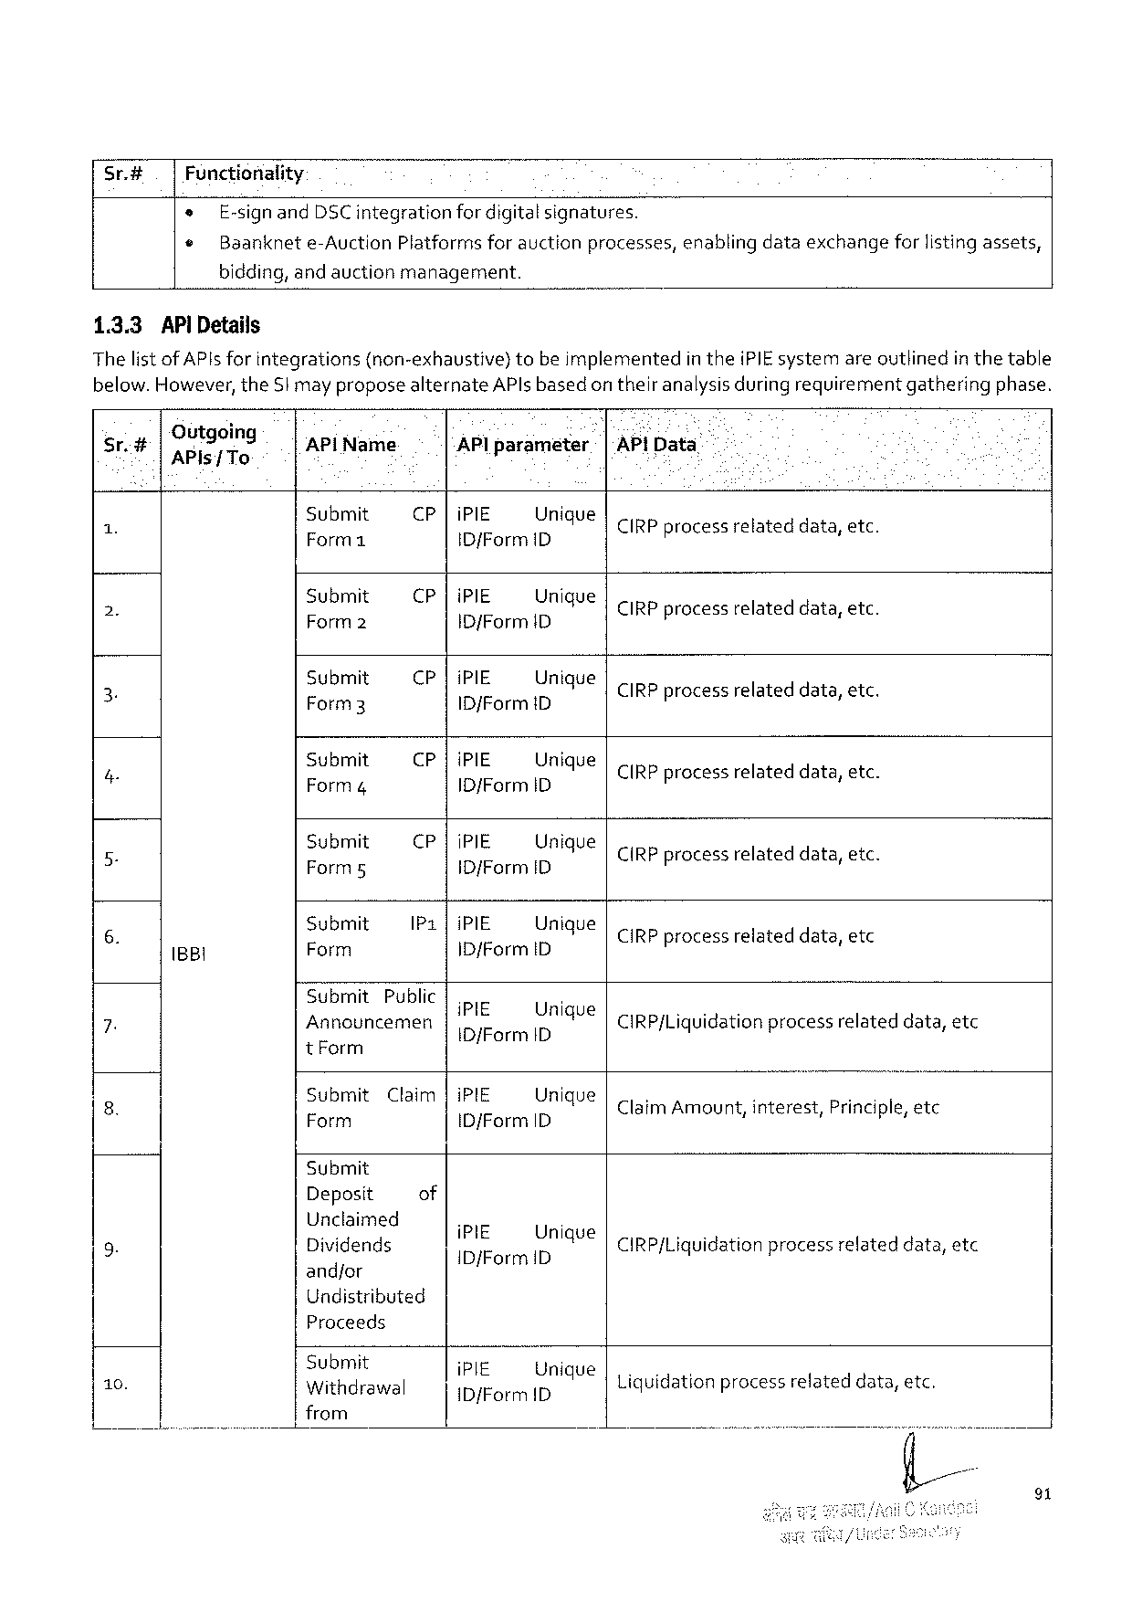

|  |  |  |  |  |  |  |  |
| --- | --- | --- | --- | --- | --- | --- | --- |
| Sr.# | Functionality | | | | | enablingdataexchange | forlistingassets, |
| e | E-signandDSCintegration | | | fordigitalsignatures. |
| © | Baanknet | e-Auction | Platformsforauctionprocesses, | |

bidding,andauctionmanagement.

1.3.3AP Details

Thelist ofAPIsfor integrations(non-exhaustive)tobeimplementedintheiPIE systemareoutlinedin thetable below.However,theStmay proposealternateAPlsbasedon theiranalysisduringrequirementgatheringphase.

|  |  |  |  |  |  |  |  |  |  |  |  |  |
| --- | --- | --- | --- | --- | --- | --- | --- | --- | --- | --- | --- | --- |
| Sr.# | | Outgoing APls/ To | AP!Name | APlparameter | | | | e | & - [AP]Data | | | |
| 1 X | | B8l | Submit [— | CP |iPIE Unigue  ID/FormID | | | | | | CIRPprocessrelated lateddata, data, | | etc. etc |
| Submit  R & | CP |iPIE Unique  IDfFormID4 | | | | | | CIRPprocessrelateddata,etc. | | |
| 2. | |
| Submit Form3 | CP |iPIE Unique  ID/FormiD | | | | | | CIRPprocessrelateddata,etc. | | |
| 3 | |
| Submit  Form4 | CP| | | iPIE Unique  |D/Form ID | | | CIRPprocessrelated | | data, etc data, etc. | |
| 4 | 3 |
| Submit Form5 | CP |iPIE Unique  ID/FormID | | | | | | CIRPprocessrelated lateddata, data, etc etc. | | |
| 5 B | |
| Submit [y | IP1|iPIE Unique  ID/FormID | | | | | | CIRPprocessrelateddata,etc | | |
| 6. | |
| Submit | Public | PIE | | Urigoa | | | | | |
| 7. | |
| Annocuncemen | | | IDJFormID4 | | | CIRP/Liquidationprocessrelateddata,etc | | | |

tForm

|  |  |  |  |
| --- | --- | --- | --- |
| 8. | Submit  5T | Claim|iPIE Unique  ID/FormID. | : s i  ClaimAmount,interest,Principle,etc |

Submit

|  |  |  |  |  |
| --- | --- | --- | --- | --- |
| 9. | Deposit | of | iPIE Unique  IDfFormD | CIRP/Liquidationprocessrelateddata,etc |
| Unclaimed  Dividends |

and/or   
Undistributed   
Proceeds

|  |  |  |
| --- | --- | --- |
| 10. | Submit  Withdrawal | i  ;EfiormIlémqueLiquidation processrelateddata,etc. |

from

91

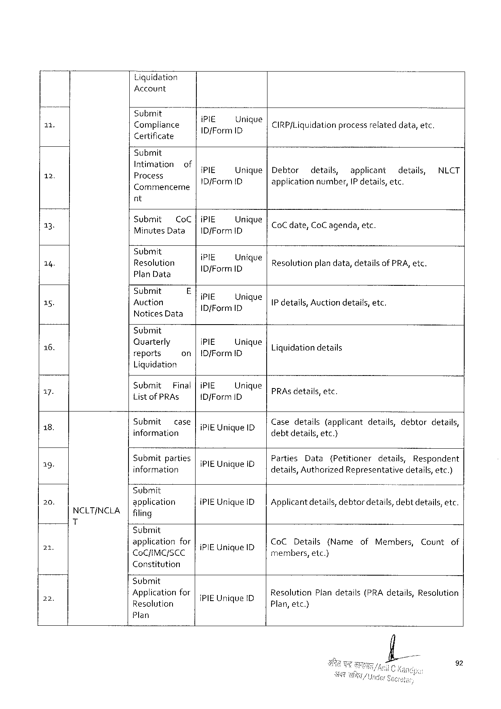

Liquidation

Account

|  |  |  |  |
| --- | --- | --- | --- |
| 11 | Submit | - | . |
| Compliance | :!I;‘/EForm IL[})nlqueCIRP{Liquidationprocessrelateddata,etc. | |

Certificate

Submit   
Intimati

|  |  |  |  |  |  |  |  |  |  |
| --- | --- | --- | --- | --- | --- | --- | --- | --- | --- |
| T | ) | ;:OIZB:SIOHof | iPIE | Unique|Debtor | | details, | applicant | details, | NLCT |
| Commenceme | ID{Form ID | | applicationnumber,IP details,etc. | | | |

nt

|  |  |  |  |  |  |  |
| --- | --- | --- | --- | --- | --- | --- |
| 13.  14. | Submit CoC |iPIE Unique  MinutesData | ID/FormID | | | CoCdate, | CoC agenda, | etc. |
| Submit | i | - | | | |
| Resolution | :FI;I/iorrnILIJ)mqueResolutionplandata,detailsofPRA,etc. | | | | |

PlanData

|  |  |  |  |  |  |
| --- | --- | --- | --- | --- | --- |
| 15. | Submit | E | i | Unique | IP details,Auctiondetails,etc. |
| Auction |
| NoticesData | B/FerlR |

Submit

|  |  |  |  |
| --- | --- | --- | --- |
| 1 6. | Quarterly  reports | on|10/Form1D iPIE Unique| | . . . .  Liquidationdetails |

Liquidation

|  |  |  |  |  |  |  |  |  |
| --- | --- | --- | --- | --- | --- | --- | --- | --- |
| g4 | Submit Final|iPIE Unique  ListofPRAs | IDjForm ID | | | .  PRAs details, etc. | | | | |
| 8.  b | Submit case|. .  F :  information RIEURiquelD | | | Casedetails(applicantdetails,debtordetails, d ! : debtdetails,etc.) | | | | |
| B3 | Submit | parties| | |
| Parties | Data | (Petitioner | details, | Respondent |
| information | | IPIEURique,iD | details,AuthorizedRepresentativedetails,etc.) | | | | |

“Submit

|  |  |  |  |  |
| --- | --- | --- | --- | --- |
| 20. | NCLT/NCLA T | application | iPIEUniqueID| | Applicantdetails, debtordetails,debtdetails,etc. |
| filing |

Submit

|  |  |  |  |
| --- | --- | --- | --- |
| 2 | applicationfor|. . CoCDetails(Name  cocnmersce |PBUMQUEIDo bers, etc) | ofMembers, | Countof |

Constitution

Submit

|  |  |  |  |  |
| --- | --- | --- | --- | --- |
| 2 | ) | Applicationfor | {PIE Unique ID | ResolutionPlandetails(PRAdetails,Resolution |
| Resolution | 4 | Plan,etc.) |

Plan

92

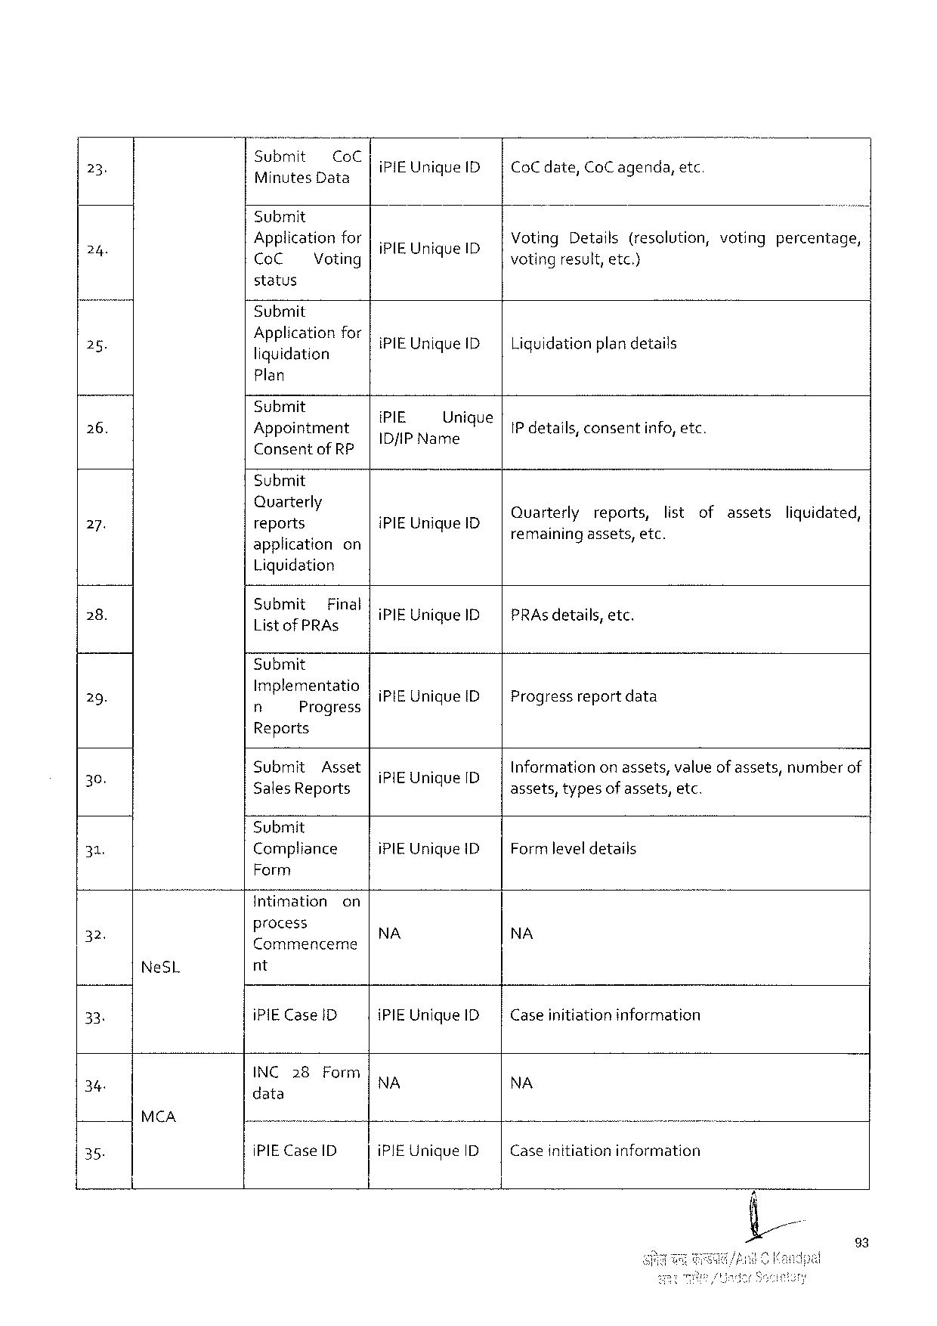

|  |  |  |  |  |
| --- | --- | --- | --- | --- |
| 23 | Submit CoC  NETEIDaTS | iPIEUniqueID| | CoC date,CoC agenda, | etc |

Submit

|  |  |  |  |  |  |  |  |  |
| --- | --- | --- | --- | --- | --- | --- | --- | --- |
| 24 | Applicationfor|. | | | N | ID | VotingDetails(resolution,votingpercentage, | | |
| CoC | Voting | iPIEUnique | | voting | result, | etc.) |

status

Submit

|  |  |  |  |
| --- | --- | --- | --- |
| 28. | Application  liquidation | for|.  iPIEUniqueID| | i = g  Liquidationplandetails |

Plan

|  |  |  |  |  |
| --- | --- | --- | --- | --- |
| 26. | Submit | . | . | IP details,consentinfo,etc. |
| Appointment | :;I;IEP Nan:JnlqUe | |
| ConsentofRP | € | |

Submit

|  |  |  |  |  |  |  |  |  |
| --- | --- | --- | --- | --- | --- | --- | --- | --- |
| 2. | Quarterly  reports | IPIEUniqueI | Ouarte‘rly | reports, | i  list | of | assets | ol  liquidated, |
| applicationon . | remainingassets,etc. | | |

Liquidation

|  |  |  |
| --- | --- | --- |
| 28. | Submit Final|. :  ListofPRAS iPIEUniqueID| | 8  PRAs details,etc. |

Submit

|  |  |  |
| --- | --- | --- |
| 29. | Implementatio|. .  n Progress iPIEUniqueID | Progressreportdata |

Reports

|  |  |  |  |  |
| --- | --- | --- | --- | --- |
| o | Submit | Asset | {PIEUnique ID | Informationonassets,valueof assets,numberof |
| 30 | SalesReports | | q | assets,typesof assets,etc. |

Submit

|  |  |  |  |
| --- | --- | --- | --- |
| 31, | Compliance | iPIEUniqueID| | Formleveldetails |

Form

|  |  |  |  |  |
| --- | --- | --- | --- | --- |
| = | Intimation | on | NA | NA |
| process |

Commenceme

|  |  |  |  |  |  |  |
| --- | --- | --- | --- | --- | --- | --- |
| 33 | NeSL | nt | | iPIEUniqueID| | Caseinitiationinformation | . |
| iPIECase1D | |
| 34 | MCA | INC28 | Form | NA | NA |
| data | |
| —— | | U |
| 35. | iPIECaseID | | iPIEUniqueID | Caseinitiationinformation |

23

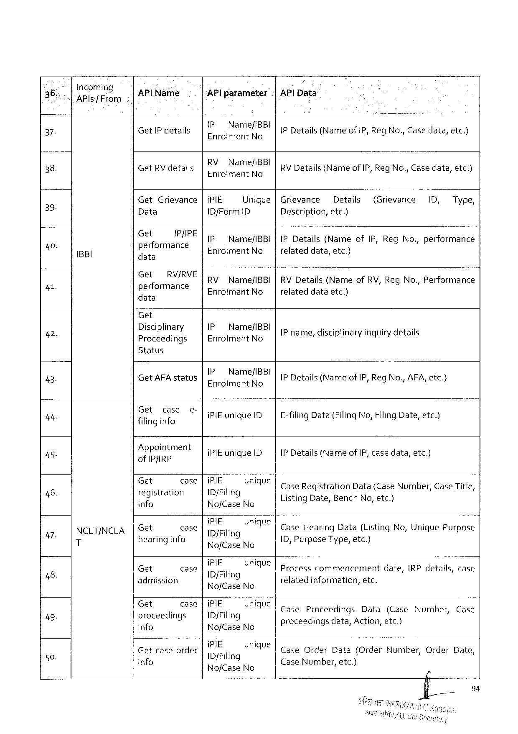

|  |  |  |  |  |  |  |  |  |  |  |  |  |
| --- | --- | --- | --- | --- | --- | --- | --- | --- | --- | --- | --- | --- |
| 36, | incoming  APIs fFrom | APlName | | APlparameter | | |APlData | | | | | | |
| 37. | iBBI | GetIP details | | IP Name/IBBI  EnrolmentNo | | IP Details(Name of IP, RegNo.,Casedata,etc.) | | | | | | |
| .  GetRV details | | RVName/IBB! EnrdimenaNe | | | ;  RV Details(NameofIP,Reg No.,Casedata,etc.} | | | | | |
| 38. |
| Get | Grievance|iPIE | | Unique|Grievance | | | Details | | (Grievance | 1D, | Type, |
| 39 |
| Data | | IDfFormD | | Description,etc.) | | | | | | |
| Get | IR/IRE | IP | Name/IBBI|IPDetails(Name | | | | ofIP,RegNo.,performance | | | |
| 4 |
| performance data | | EnrolmentNo | | relateddata,etc.) (s | | | | | | |
| 41 | Get RV/RVERV Name/IBBI|RVDetails(NameofRV,RegNo.,Performance  performance EnrolmentNo relateddataetc.)  data | | | | | | | | | | |

Get

|  |  |  |  |
| --- | --- | --- | --- |
| 42. | Disciplinary  Proceedings | IP Name/IBBI  ERFGIFERtNG | IPname,disciplinaryinquirydetails AN [ .I |

Status

|  |  |  |  |  |  |  |  |  |  |  |  |  |  |  |  |  |  |  |  |  |  |  |  |
| --- | --- | --- | --- | --- | --- | --- | --- | --- | --- | --- | --- | --- | --- | --- | --- | --- | --- | --- | --- | --- | --- | --- | --- |
| 43. | NCLTINCLA T | GetAFAstatus | | | | 1P Name/IBBI  EnrolmentNo | | | s  IP Details{(NameofIP, Reg No.,AFA,etc.) | | | | | | | | | | | | | | |
| 4ty | fG”?,:gi\:?;e | | | & | lireunique 1D | | E-filingData(FilingNo,Filing Date, etc.) | | | | | | | | | | | | | | | |
| 7 | Appointment ofIPJIRP | | | | [.  iPIEuniqueID | | .  IP Details(NameofIP, casedata,etc.) | | | | | | | | | | | | | | | |
| 46. | et | oeoe | | | IP}E_ | UMV | ]caseRegistration | | | | | | | | Data(CaseNumber,CaseTitle, | | | | | | | |
| registration info | | | | IDjFiling  NofCaseNo | | ListingDate,Bench No, etc.)  9 < = | | | | | | | | | | | | | | | |
| 47 | Get | case | | | hiE | unique | Case | | | Hearing | | | Data | | (Listing | | | No,Unique | | | Purpose | |
| hearinginfo 9 | | | | DfFiling  Noj/CaseNo | | 1D,Pur s | | | | | ose'lg' e,etc.)  PUTPype, etc. | | | | | 9T | | § | | | i |
| 48. | Get   o  admission | | case | | iPIE  ID/Filing | vnique | Process commencement  .  relatedinformation,etc. | | | | | | | | | date,IRPdetails, | | | | | | case |
| No/CaseNo | |
| 49- | Gt | oS28 | | | IPIE_ | UMV | Case | | | | Proceedings | | | | Data | (Case | | | Number, | | | Case |
| proceedings info | | | | ID/Filing  NofCaseNo | | p | | roceedingsdata, 9 | | | | | ! | Action, | etc.)  A | | | | | | |
| 59 | i5IE_UMAUe | | |coce | | | Order | | | Data | | {OrderNumber, | | | | | Order | | Date, |
| Getcaseorder | | | |
| info | | | | ID/Filing  NofCaseNo | | CaseNumber,etc.)   L | | | | | | | | | | | | | | | |

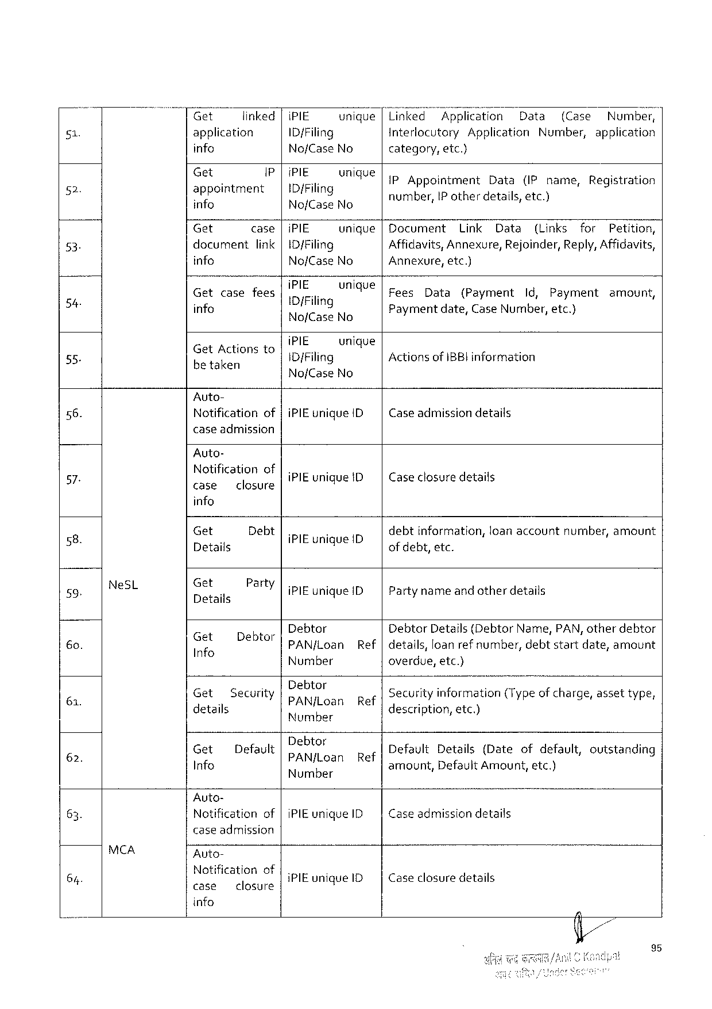

|  |  |  |  |  |  |  |  |  |  |  |  |  |  |  |  |  |  |  |  |  |  |  |  |  |
| --- | --- | --- | --- | --- | --- | --- | --- | --- | --- | --- | --- | --- | --- | --- | --- | --- | --- | --- | --- | --- | --- | --- | --- | --- |
| 51  2  53.  54  55. | Get | | | linked| | | | | | iPIE | unique|Linked | | | | TAppIication | | | | | Data | | (Case | | Numbe?, | |
| application | | | | | | | | ID/Filing | | Interlocutory | | | | | Application | | | | Number, | | | application | |
| info | | | | | | | | No/CaseNo | | category, | | | etc.) | | | | | | | | | | |
| Gt | s | | | | i | | | (PIE.ounique | | | Appointment | | | | | Data | | (IPname, | | | | Registration | |
| appointment info | | | | | | | | | ID/Filing  No/CaseNo | | number,IP otherdetails,etc.) E === | | | | | | | | | | | | | |
| Get | | | | case|iPIE | | | | | unique|Document | | | | Link | | | Data | | (Links | | | for | | Petition, |
| docurnent | | | | | | link |ID/Filing | | | | Affidavits,Annexure, | | | | | | | Rejoinder,Reply,Affidavits, | | | | | | |
| info | | | | | | | | No/CaseNo | | Annexure,etc.) | | | | | | | | | | | | | |
| Get | | case | | | fees | | | IPIE,. | UMAY€|Fees | | | Data | | (Payment | | | | Id, | Payment | | | amount, | |
| info | | | | | | | | [DiFiling  No/fCaseNo | | Paymentdate,Case Number, etc.)  Y/ £ L | | | | | | | | | | | | | |
| . | | | | | | | | iPIE | unique | | | | | | | | | | | | | | |
| GetActionsto betaken | | | | | | | | 1D{Filing | | ActionsofIBBI information | | | | | | | | | | | | | |
| NofCase | No |

Auto-

|  |  |  |
| --- | --- | --- |
| 56. | Notificationof |iPIEunique ID| | Caseadmissiondetails |

case admission

Auto-

|  |  |  |  |  |  |  |  |  |  |  |
| --- | --- | --- | --- | --- | --- | --- | --- | --- | --- | --- |
| 57 | NeSL | Notificationof case closure | | iPIEunique ID | | Caseclosure details | | | | |
| g | info | | | | | | | | |
| Get | Debt | iPIEuniqueID | | debtinformation, | | loanaccount | | number,amount |
| 2 | Details | | q | | of debt,etc. | | | | |
| 59. | Get  Details | Party|. .  iPIEuniqueID | | | i Partynameandotherdetails | | | | |
| 6o. | Gif | IDabE | Debtor | | DebtorDetails(DebtorName,PAN,otherdebtor | | | | |
| Info | = | PAN/fLoan | Ref |details,loanref number, | | | | debtstartdate,amount | |
| 61. | Number | | | | overdue,etc.) | | | | |
| Get   3 details | SecurityDebtor   PAN/jLoan | | Ref | Securityinformation(Typeof charge,assettype, e  description,etc.) | | | | |
| 62. | Number | |
| Get | Default | D   ebtos  PAN/Loan | Ref | 5 s  DefaultDetails(Dateofdefault,outstanding | | | | |
| Info | amount, | DefaultAmount,etc.) | | | |
| Number |

Auto-

|  |  |  |
| --- | --- | --- |
| 63. | Notificationof |iPIEuniqueID | Case admissiondetails |

case admission

|  |  |  |  |  |
| --- | --- | --- | --- | --- |
| 64. | MCA | Auto- | iPIEunigue1D | Caseclosuredetails |
| Notification of  case closure |

info

95

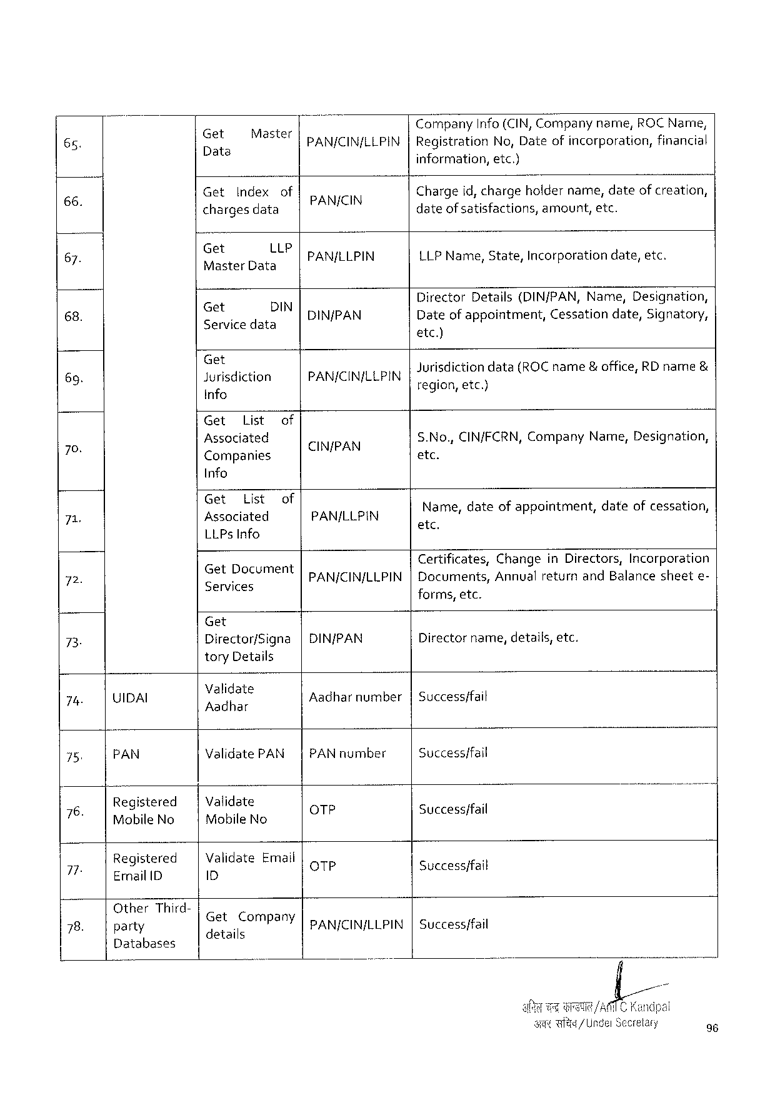

|  |  |  |  |  |  |  |  |  |  |  |  |  |
| --- | --- | --- | --- | --- | --- | --- | --- | --- | --- | --- | --- | --- |
| 65. | Get  e | Master | | PAN/CIN/LLPIN | Company | Info(CIN,Companyname,ROCName, | | | | | | |
| Registration | | No,Dateofincorporation, | | | | | financial |
| el | information, | | etc.) | | | | | |
| Get | Index | of |
| 66: | Chargeid,chargeholdername,dateofcreation, | | | | | | | |
| chargesdata | | | dateof satisfactions,amount,etc. | | | | | | | |
| Get LLP  MasterData | | | PAN/LLPIN | {LPName,State, | | | " Incorporation | | date,etc. | | |
| 67. |
| DIN/PAN | Director | Details(DIN/PAN,Name, | | | | | Designation, | |
| Get | DIN | |
| 68. |
| Servicedata | | | Dateofappointment, | | | | Cessation | date,Signatory, | | |

etc)

|  |  |  |  |  |  |  |  |
| --- | --- | --- | --- | --- | --- | --- | --- |
| 69. | Get  Jurisdiction | | of | PAN/CIN/LLPIN | Jurisdictiondata(ROC name& office, RDname& 3 ‘  region,etc.) | | |
| info | |
| 70. | Get | List | CIN/PAN | S.No.,CIN/FCRN,Company | Name, | Designation, |
| Assoclat.ed | |
| Companies | | etc. | | |

Info

|  |  |  |  |  |  |  |  |  |
| --- | --- | --- | --- | --- | --- | --- | --- | --- |
| 7 | Get — | List | of | PAN/LLPIN | .  el:came,dateofappointment, | | date | .  ofcessation, |
| ) | | | | |
| LLPs Info | | |
| 72 | GetDocument | | | Certificates,ChangeinDirectors,Incorporation | | | | |
| .  Services | | | PAN/CIN/LLPIN|Documents, | | AnnualreturnandBalancesheete- | | |
| forms,etc. | | | | |

Get

|  |  |  |  |
| --- | --- | --- | --- |
| 73 | Director/Signa | |DIN/PAN | Directorname,details,etc. |

toryDetails

|  |  |  |  |  |  |  |
| --- | --- | --- | --- | --- | --- | --- |
| 74 | UIDAI | | Validate  P | | Aadharnumber|Successffail | |
| ValidatePAN| | | PAN number | Success/fail |
| 75. | PAN | |
| Validate MobileNo | | QoTP | i  Successffail |
| Registered MobileNo | |
| 76. |
| ValidateEmaii D | | QTP | .  Success/fail |
| Registered Ermail1D | |
| 77- |
| PANJCIN/LLPIN | | Successffail |
| Other | Third- | GEEIGOBaT | |
| 78. |
| party | | 5 details | pany |
| Databases | |

96

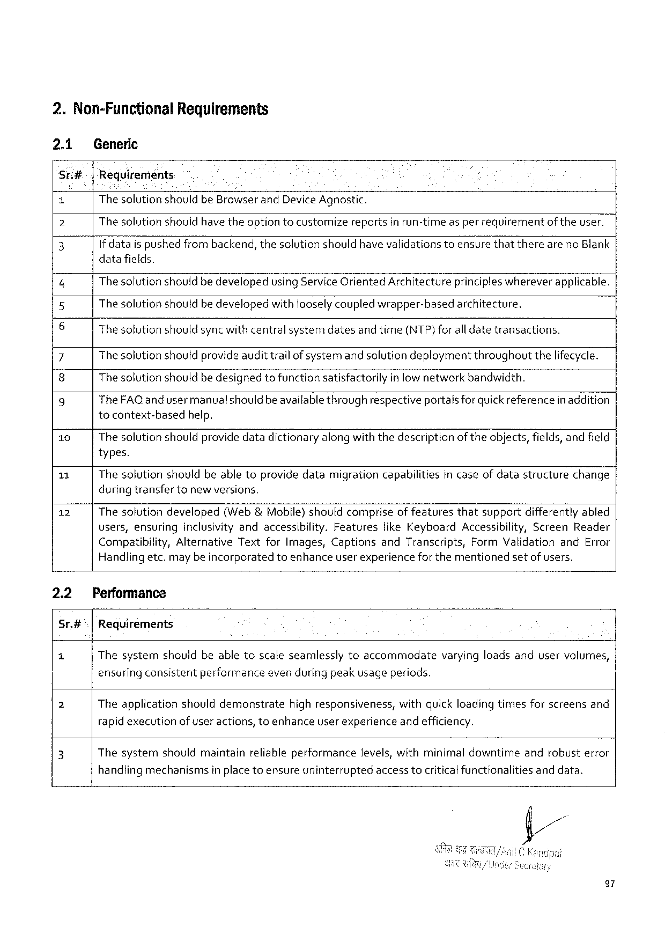

2.Non-FunctionalRequirements

2.1 Generic

Sr.#- |Requirements. .

1 The solutionshould beBrowserandDeviceAgnostic.

2 The solutionshould have theoption tocustomizereportsin run-time asper requirementof theuser.

3 If dataispushedfrombackend,thesolutionshouldhavevalidationstoensurethattherearenoBlank

datafields.

4 Thesolutionshouldbe developedusingServiceOrientedArchitectureprincipleswhereverapplicable.

Thesolutionshould bedevelopedwithlooselycoupled wrapper-basedarchitecture,

6 Thesolutionshouldsyncwithcentralsystemdatesandtime(NTP)foralldatetransactions.

7 Thesolutionshouldprovideaudittrailof systemand solutiondeploymentthroughoutthelifecycle.

8 Thesolutionshouldbedesignedtofunctionsatisfactorilyinlow networkbandwidth.

9 TheFAQ and usermanualshould beavailablethroughrespectiveportalsforquickreferencein addition

tocontext-basedhelp.

10 Thesolutionshouldprovide datadictionaryalong withthedescriptionof theobjects,fields, and field

types.

11 Thesolutionshouldbeabletoprovidedatamigrationcapabilitiesin caseof datastructurechange

during transfertonewversions,

12 Thesolutiondeveloped(Web &Mobile)shouldcompriseof featuresthatsupportdifferentlyabled

users,ensuring inclusivityandaccessibility. Features likeKeyboard Accessibility, Screen Reader

Compatibility,AlternativeTextforImages,CaptionsandTranscripts,FormValidationandError

Handlingetc.may be incorporatedtoenhanceuserexperiencefor thementionedsetofusers,

|  |  |  |
| --- | --- | --- |
| 2.2 | Performance | varyingloadsanduservolumes, |
| Sr.#| | Requirements |
| a | Thesystemshouldbeabletoscaleseamlesslytoaccommodate |

ensuringconsistentperformanceeven during peakusageperiods.

|  |  |  |
| --- | --- | --- |
| 2 | Theapplicationshoulddemonstrate | highresponsiveness,withquick loadingtimesforscreensand |

rapidexecutionof useractions, toenhanceuser experienceand efficiency.

|  |  |  |  |  |  |
| --- | --- | --- | --- | --- | --- |
| 3 | Thesystem | shouldmaintain | reliableperformance | levels,withminimaldowntime | androbusterror |

handlingmechanismsinplacetoensureuninterruptedaccess tocriticalfunctionalitiesand data.

97

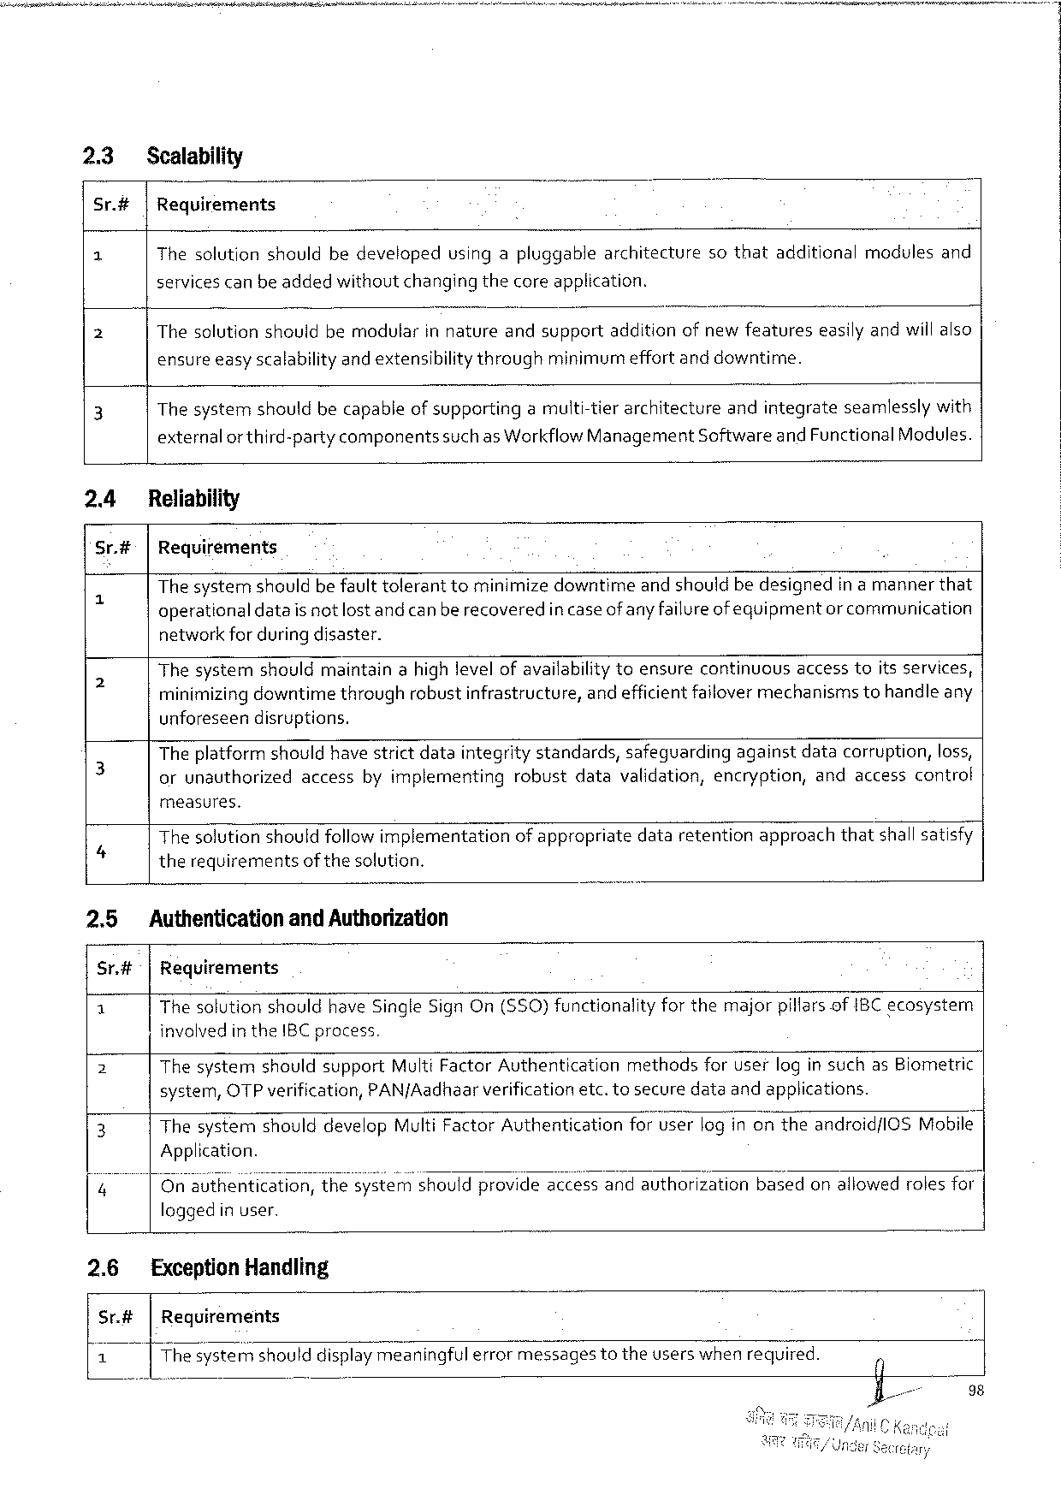

23 Scalability

Sr.#|Requirements

1 Thesolutionshouldbedevelopedusingapluggablearchitecturesothatadditionalmodulesand

servicescanbe addedwithoutchangingthecore application.

2 Thesolutionshouldbemodvlarinnature andsupport additionofnewfeatures easilyandwiilalso

ensureeasyscalabilityandextensibilitythrough minimurm effortanddowntime.

3 Thesystemshouldbecapableof supportingamuiti-tierarchitectureandintegrateseamlesslywith

externalor third-partycomponentssuchas WorkflowManagementSoftwareandFunctionalModules.

24 Reliability

Sr.#|Requirements

|  |  |  |
| --- | --- | --- |
| 5 | The systemshouldbe faulttoleranttominimizedowntimeand shouldbedesignedin amannerthat | |
| operationaldatais not lostand canberecoveredin caseof anyfailureof equipment | or communication |

network for during disaster.

|  |  |
| --- | --- |
| 2 | Thesystemshouldmaintainahighlevelofavailabilitytoensurecontinuousaccesstoitsservices, minimizingdowntimethroughrobustinfrastructure,andefficientfailover mechanismstohandleany |

unforeseendisruptions.

|  |  |
| --- | --- |
| 3 | Theplatformshouldhave strictdataintegritystandards,safeguardingagainstdatacorruption,loss, orunauthorizedaccessbyimplementingrobustdatavalidation,encryption,andaccesscontrot |

measures.

Thesolutionshouldfollowimplementationofappropriatedataretentionapproachthatshallsatisfy

4 therequirementsofthesolution.

2.5 Authenticationand Authorization

Sr.#t|Requirements

|  |  |
| --- | --- |
| £  2  3 | The solutionshouldhave SingleSign On($50)functionalityforthemajorpillarsofIBC ecosystem involvedin theIBC process.  ThesystemshouldsupportMultiFactorAuthenticationmethodsforuserlogin suchasBiometric system,OTPverification,PAN/Aadhaarverificationetc.tosecuredataandapplications.  ThesystemshoulddevelopMultiFactorAuthenticationforuserlog inontheandroid/lOSMobile| |

Application.

|  |  |  |
| --- | --- | --- |
| 4 | On authentication, | thesy's’tye’m’shomdprovideaccessandauthorizationbasedonallowedrolesfor| |

loggedin user.

2.6 ExceptionHandling

Sr.#|Requirements

|  |  |  |  |
| --- | --- | --- | --- |
| 1 | Thesysterfishoulddisplayme_aningful errormessages | totheuserswhenrequired. | 0 |

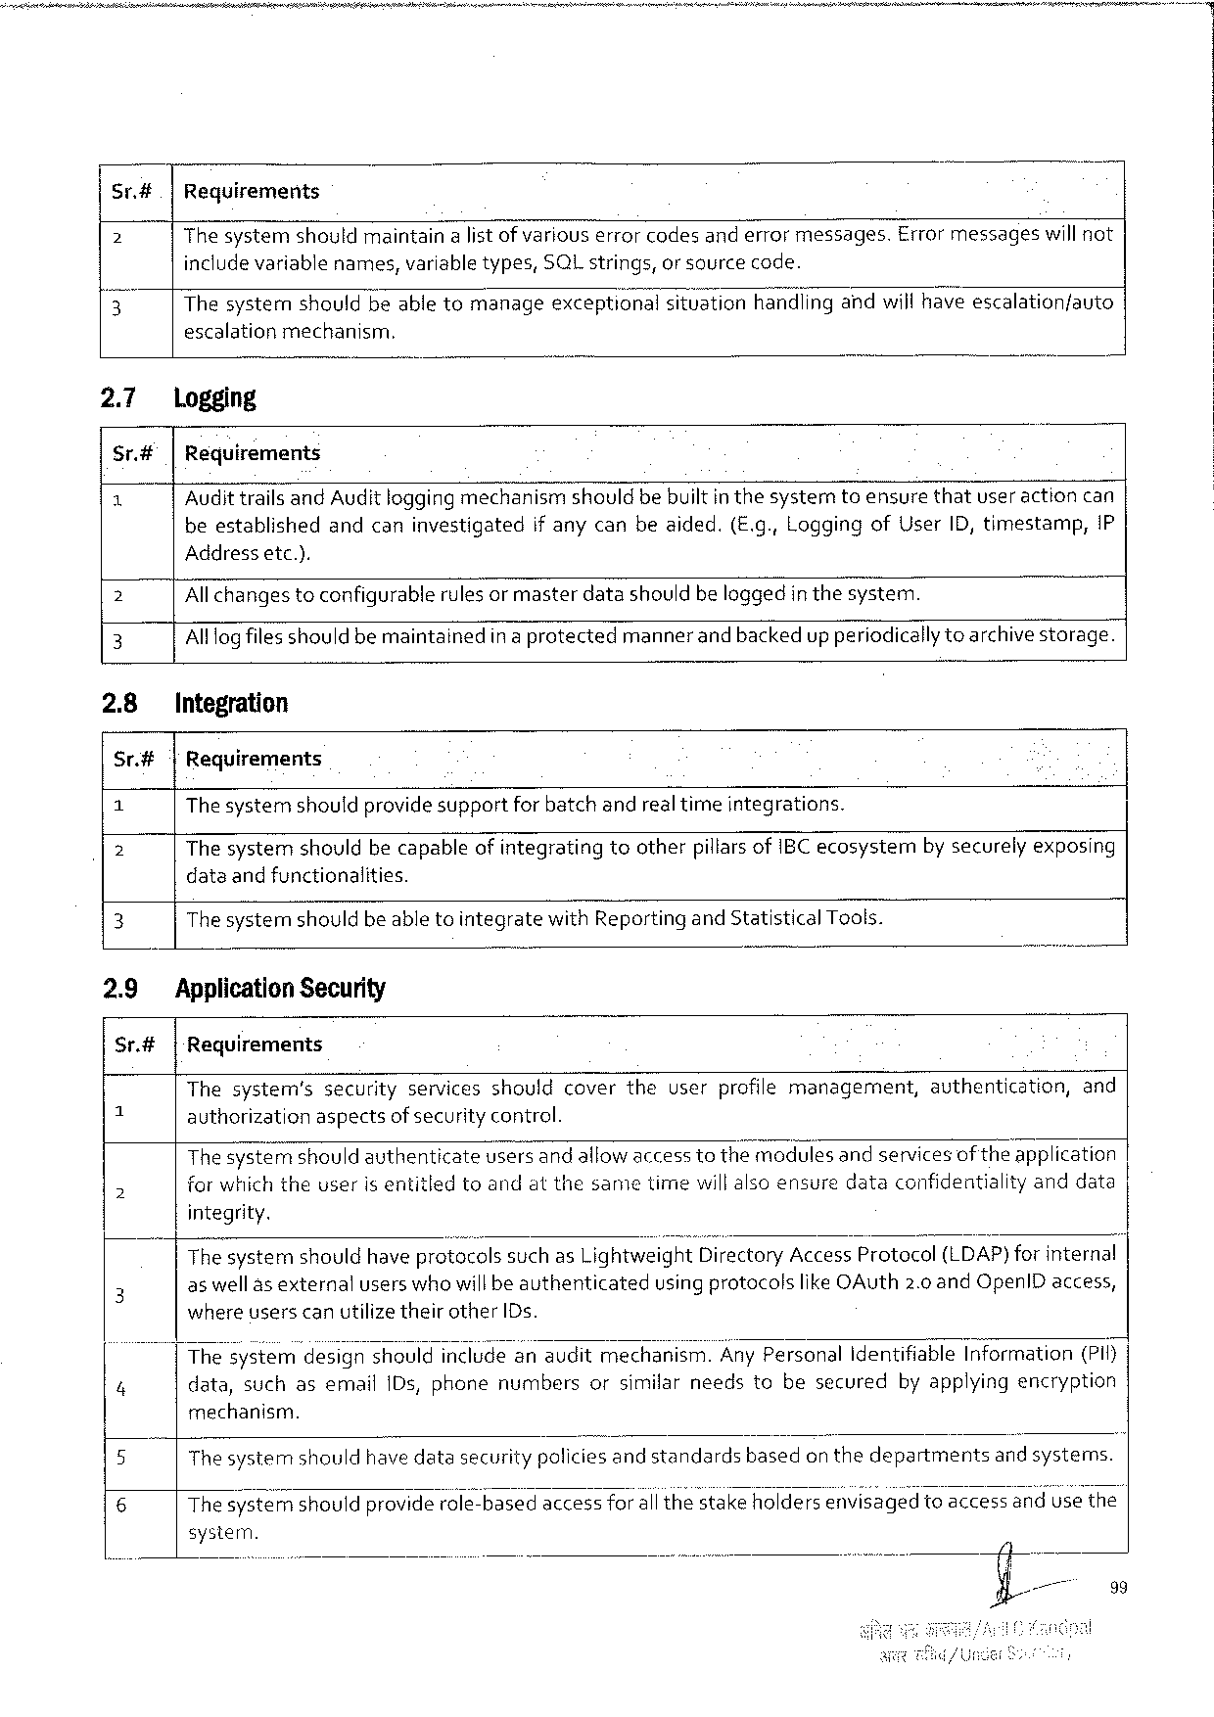

Sr.#|Requirements

2 The systemshouldmaintainalistof variouserrorcodesand errormessages.Errormessageswill not

includevariablenames,variabletypes,SQLstrings,orsourcecode.

? Thesysternshouldbeable tomanageexceptionalsituationhandiingandwillhaveescalation/auto

escalationmechanism.

|  |  |  |
| --- | --- | --- |
| 2.7  Sr# e | logging  |Requirements | |
| Audittrails and Audit loggingmechanismshouldbe builtin thesyster | toensurethatuser action can |
| beestablishedandcaninvestigatedif anycanbeaided.(E.g., LoggingofUserID, timestamp,{P | |

Addressetc.).

2 Allchangestoconfigurablerulesor masterdatashouldbe loggedinthesystem. ~

3 Alllogfilesshould bemaintainedin a protectedmannerand backedup periodicallytoarchivestorage.

2.8 Integration

Sr.#| Requirements

1 Thesystemshouldprovidesupportfor batchandrealtimeintegrations.

2 ThesystemshouldbecapableofintegratingtootherpillarsofIBCecosystemnby securelyexposing

dataand functionalities.

3 Thesystemshouldbe abletointegratewithReporting andStatistical Tools.

2.9 ApplicationSecurity

Sr.#|Requirements

|  |  |  |  |
| --- | --- | --- | --- |
| =  5 | Thesystem’ssecurityservicesshouldcovertheuserprofilemanagement, | authentication, | and |
| authorizationaspectsof security control.  Thesystemshouldauthenticateusersandallowaccesstothemodules andservicesof theapplication for which theuserIsentitledtoandatthesametimewillalsoensuredataconfidentialityanddata | | |

integrity.

|  |  |  |
| --- | --- | --- |
| 3  4 | Thesystemshouldhave protocolssuchas LightweightDirectoryAccessProtocol(LDAP)for internal | |
| as well as externalusers whowill beauthenticated | usingprotocolslike OAuth2.0 andOpenlDaccess, |
| where userscanutilizetheirotherIDs.  Thes’yst’em'desrlgnshouldincludeanauditmechanism.AnyPersonalIdentifiableInformation(PIf) data,suchasemail1Ds,phonenumbersorsimilarneedstobesecuredbyapplyingencryption | |

mechanism.

5 Thesystemnshouldhavedatasecuritypoliciesandstandards basedon thedepartments andsystems.

6 ThesyEFémshouldproviderole-basedaccessfor all thestakeholdersey’wi’s’ége‘d’toaccessandusethe

system.

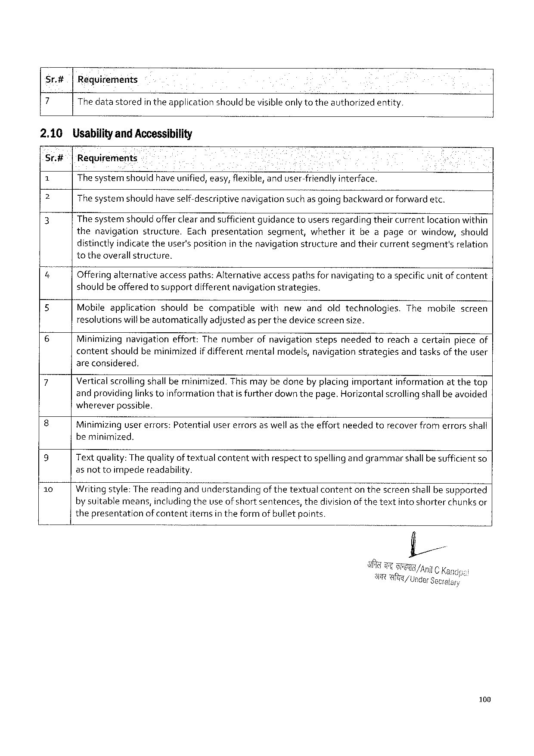

Sr.#|Reguirements

7 Thedatastoredin theapplication shouldbevisibleonly totheauthorizedentity.

2.10 UsabilityandAccessibility

Sr.#| 'Requirements

1 Thesystemshouldhaveunified,easy,flexible,anduser-friendly interface.

e Thesystemshouldhave self-descriptive navigationsuch as going backwardor forwardetc.

3 The systemshouldofferclear andsufficientquidancetousersregardingtheircurrentlocationwithin

the navigation structure. Eachpresentation segment, whether itbeapage orwindow, should

distinctlyindicate theuser'spositionin thenavigationstructureand theircurrentsegment'srelation

totheoverallstructure.

|  |  |  |  |
| --- | --- | --- | --- |
| &  5 | Offering alternativeaccesspaths:Alternativeaccesspathsfor navigatingtoaspecificunit of content shouldbeofferedtosupportdifferentnavigationstrategies. | | |
| Mobileapplicationshouldbecompatible | withnewandoldtechnologies. | Themobilescreen |

resolutionswilfbeautomaticallyadjustedasper thedevice screensize.

6 Minimizing navigationeffort:Thenumberofnavigationstepsneededtoreachacertainpieceof

contentshouldbeminimizedif differentmentalmodels,navigationstrategiesandtasksof theuser

areconsidered.

|  |  |
| --- | --- |
| 7  8  9 | Verticalscrollingshall beminimized.Thismay bedoneby placingimportantinformationatthetop andprovidinglinks toinformationthatis furtherdown thepage.Horizontalscrollingshallbe avoided whereverpossible.  Minimizingusererrors:Potentialusererrorsaswellas theeffortneededtorecover fromerrorsshall beminimized.  Text quality:The qualityof textualcontentwithrespecttospellingandgrammarshallbesufficient so |

as nottoimpedereadability.

10 Writingstyle: Thereading andunderstandingof thetextualcontenton thescreen shall besupported

by suitablemeans,includingtheuseof short sentences,thedivisionof the textintoshorterchunks or

thepresentationof contentitemsin theform of bulletpoints.

6t /AnilC Ka

AT Wl/UngarSetrelary

100

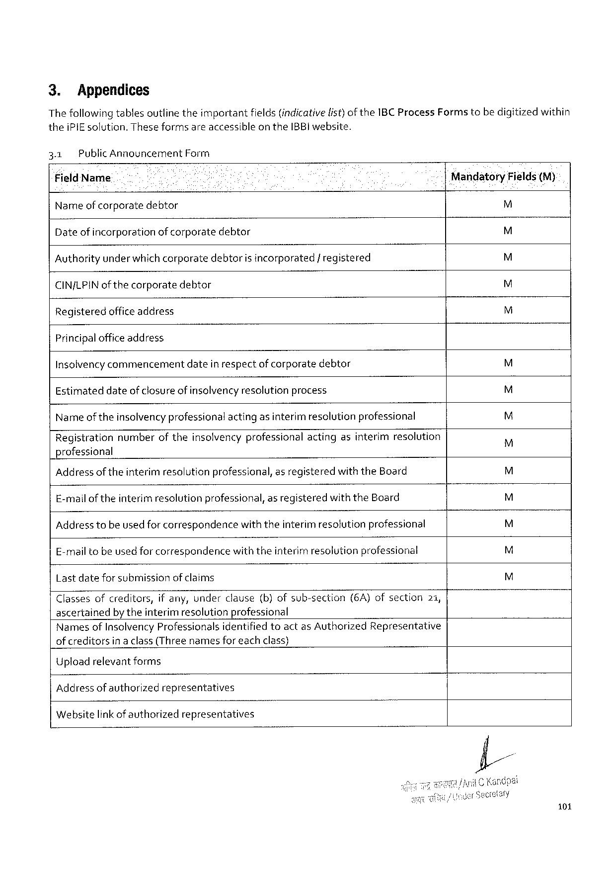

3. Appendices   
The followingtablesoutline theimportantfields(indicativelist)ofthe1BCProcessFormstebe digitizedwithin theiPIEsolution. TheseformsareaccessibleontheIBBIwebsite.

|  |  |  |  |  |
| --- | --- | --- | --- | --- |
| 3.1 | PublicAnnouncementForm | | Mandatory | Fields(M) |
| FieldName | | |
| M |
| Nameof corporatedebtor | | |
| M |
| Date of incorporationofcorporatedebtor | | |
| M |
| Authorityunder whichcorporatedebtoris incorporated/ registered | | |
| M |
| CINJLPINofthecorporate | | debtor |
| M |
| Registeredofficeaddress | | |

Principalofficeaddress   
Insolvencycommencementdatein respectof corporatedebtor M Estimateddateof closure of insclvency resolutionprocess M Nameoftheinsolvencyprofessionalacting asinterim resolutionprofessional M Registrationnumberoftheinsolvencyprofessionalactingasinterimresolution   
 M professional

|  |  |  |  |  |  |  |  |  |
| --- | --- | --- | --- | --- | --- | --- | --- | --- |
| Address of theinterimresolutionprofessional,asregisteredwiththeBoard E-malloftheinterim resolutionprofessional,as registeredwiththeBoard Address tobe used for correspondencewiththeinterim resolutionprofessional E-mailtobeused forcorrespondencewiththeinterim resolutionprofessional Lastdatefor submissionof claims | | | | | | | | M  M  M  M  M |
| Classesofcreditors, | | ifany,underclause | | (b)ofsub-section | (6A)ofsection | | 21, |
| ascertainedby theinterim resolutionprofessional | | | | | | | |
| NamesofInsolvencyProfessionals | | | identifiedtoactasAuthorized | | | Representative | |
| of creditors | inaclass(Threenamesforeachclass) | | | | | | |

Upload relevantforms   
Address of authorizedrepresentatives   
Websitelink of authorizedrepresentatives

101

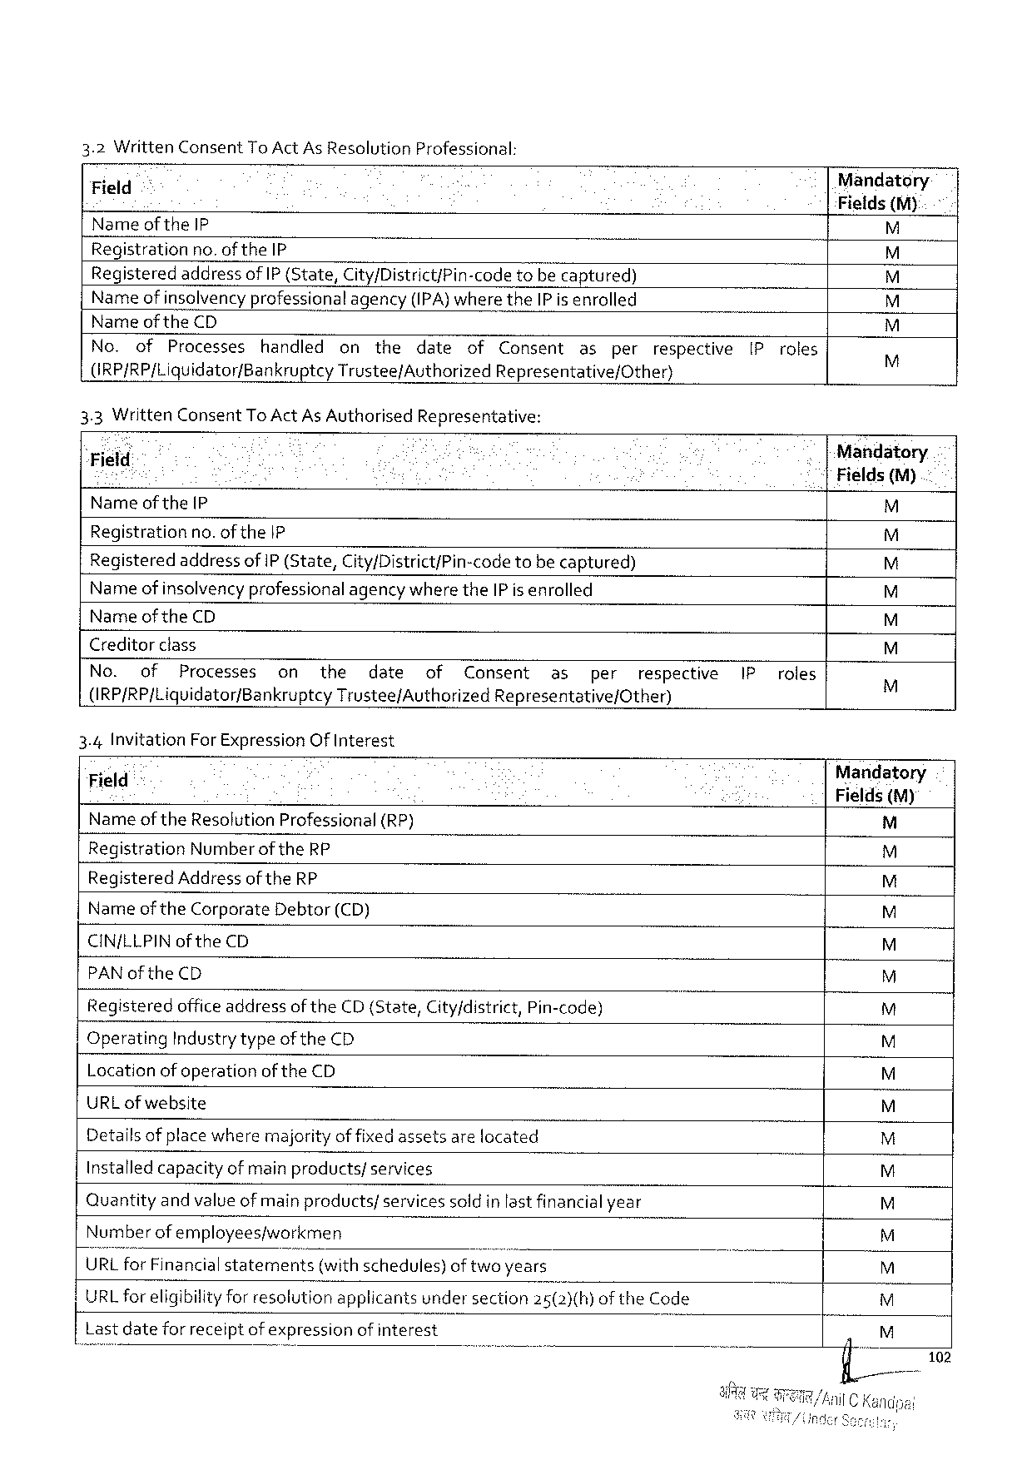

|  |  |  |
| --- | --- | --- |
| 3.2WrittenConsentTo ActAs Resolution | Professional: | Mandatory |
| Field |
| Fields (M) |
| Nameof theIP |

Registrationno.of theIP

|  |  |  |  |  |  |  |  |  |  |  |  |  |  |
| --- | --- | --- | --- | --- | --- | --- | --- | --- | --- | --- | --- | --- | --- |
| Registered | | addressofIP {State,City/District/Pin-code | | | | | | tobecaptured) | | | | [Proles | EE4E4E4E4ES |
| Nameof insolvencyprofessionalagency(IPA)where theIPis enrolled | | | | | | | | | | | |
| Nameof theCD | | | | | | | | | | | |
| No. | of | Processes | handled | on | the | date | of | Consent | as | per | respective |
| (RP/RP/Liquidator/BankruptcyTrustee/AuthorizedRepresentative/Other) | | | | | | | | | | | |
| 3.3WrittenConsentTo ActAs Authorised | | | | | | Representative: | | | | | | Mandatory.  |Fields (M) |
| “Field | | | | | | | | | | | |
| Nameof the(P | | | | | | | | | | | | M |

Regjistrationno. of the|P

|  |  |  |
| --- | --- | --- |
| RegisteredaddressofIP (State,City/District/Pin-code | tobe captured) | 4 |

Nameof insolvencyprofessionalagency wheretheIPis enrolled

Nameof theCD

Creditorclass

|  |  |  |  |  |  |  |  |  |  |  |  |  |  |
| --- | --- | --- | --- | --- | --- | --- | --- | --- | --- | --- | --- | --- | --- |
| No. | of | Processes | on | the | date | of | Consent | as | per | respective | IP | roles | EEYE4E4 |
| (IRP/RP/Liquidator/Bankruptcy | | | | Trustee/AuthorizedRepresentative/Other) | | | | | | |

3.4InvitationForExpressionOfInterest

|  |  |  |  |
| --- | --- | --- | --- |
| Field | " | (RP) | Mandatory |
| Fields(M) |
| NameoftheResolutionProfessional | |

RegistrationNumberoftheRP

RegisteredAddress ofthe RP

Nameof theCorporate Debtor(CD)

CIN/LLPIN of theCD

PAN of theCD

Registeredofficeaddressof theCD(State,City/district,Pin-code)

OperatingIndustrytypeofthe CD

Locationof operationof theCD |z|z|glg|g2ig|g|

URLofwebsite

Detailsof placewheremajorityof fixedassetsare located

Installed capacityof main products/services

|2z Quantityandvalueofmain products/servicessold inlastfinancialyear

|  |  |  |
| --- | --- | --- |
| Numberofemployeesjworkmen | | |I2 |
| URLforFinancialstatements | (withschedules)oftwoyears |

URL foreligibilityfor resolutionapplicantsundersection25(2)(h)of theCode

Lastdatefor receiptof expressionof interest gz

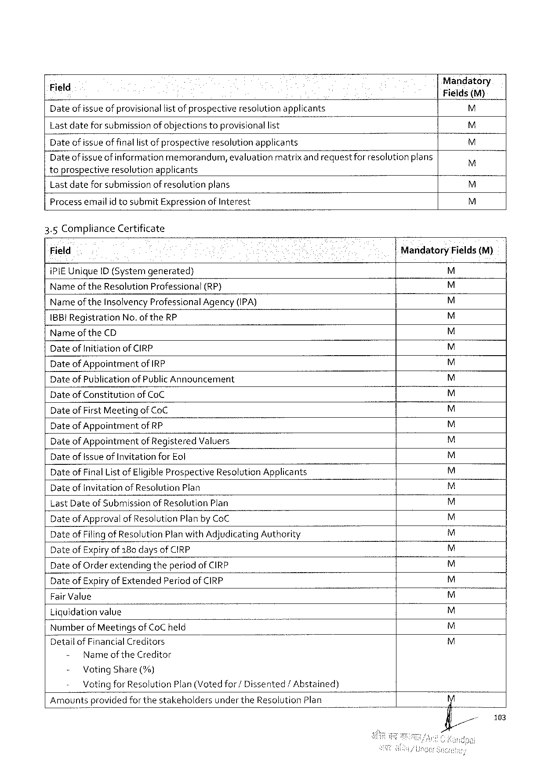

Date of issueof provisionallist of prospectiveresolutionapplicants [\

Lastdateforsubmission of objectionstoprovisionallist

Date of issueof finallist of prospectiveresolution applicants M Dateof issueof information memorandum,evaluationmatrixand requestforresolution plans M toprospectiveresolutionapplicants   
Lastdateforsubmissionof resolutionplans M

Processemailid tosubmitExpressionof Interest M

3.5ComplianceCertificate

|  |  |  |  |  |
| --- | --- | --- | --- | --- |
| Field | | | Mandatory | Fields(M) |
| iPIEUniqueID (Systemgenerated) | | | = |
| Nameof theResolutionProfessional | | (RP) | 4TS |
| Nameof theInsolvencyProfessionalAgency (IPA) | | |
| IBB!Registration | No.oftheRP | | 44 |
| Narme of theCD | | |

Date ofInitiationofCIRP   
DateofAppointmentof IRP   
Date ofPublicationof PublicAnnouncement E4ESES

Date of ConstitutionofCoC 4

Date ofFirstMeetingofCoC   
Date ofAppointmentof RP   
Date ofAppointmentof RegisteredValuers   
Date ofIssueof Invitationfor Eol   
Date ofFinalList of EligibleProspectiveResolutionApplicants   
DateofInvitationofResolutionPlan   
LastDateof Submissionof Resolution Plan   
Date ofApprovalof ResolutionPlanbyCoC   
Date ofFiling of ResolutionPlanwith AdjudicatingAuthority   
Date ofExpiry of 180days ofCIRP   
Date ofOrderextendingtheperiod ofCIRP   
Date of Expiryof ExtendedPeriodof CIRP   
Fair Value   
Liquidationvalue   
Numberof MeetingsofCoC held   
DetallofFinancialCreditors EHE4E4E4E4E4EdE<SEdE4ESESESESESEY

- Name of theCreditor  
 - VotingShare(%)   
 VotingforResolutionPlan(Votedfor/Dissented/Abstained) Amountsprovidedforthestakeholdersunder theResolutionPlan

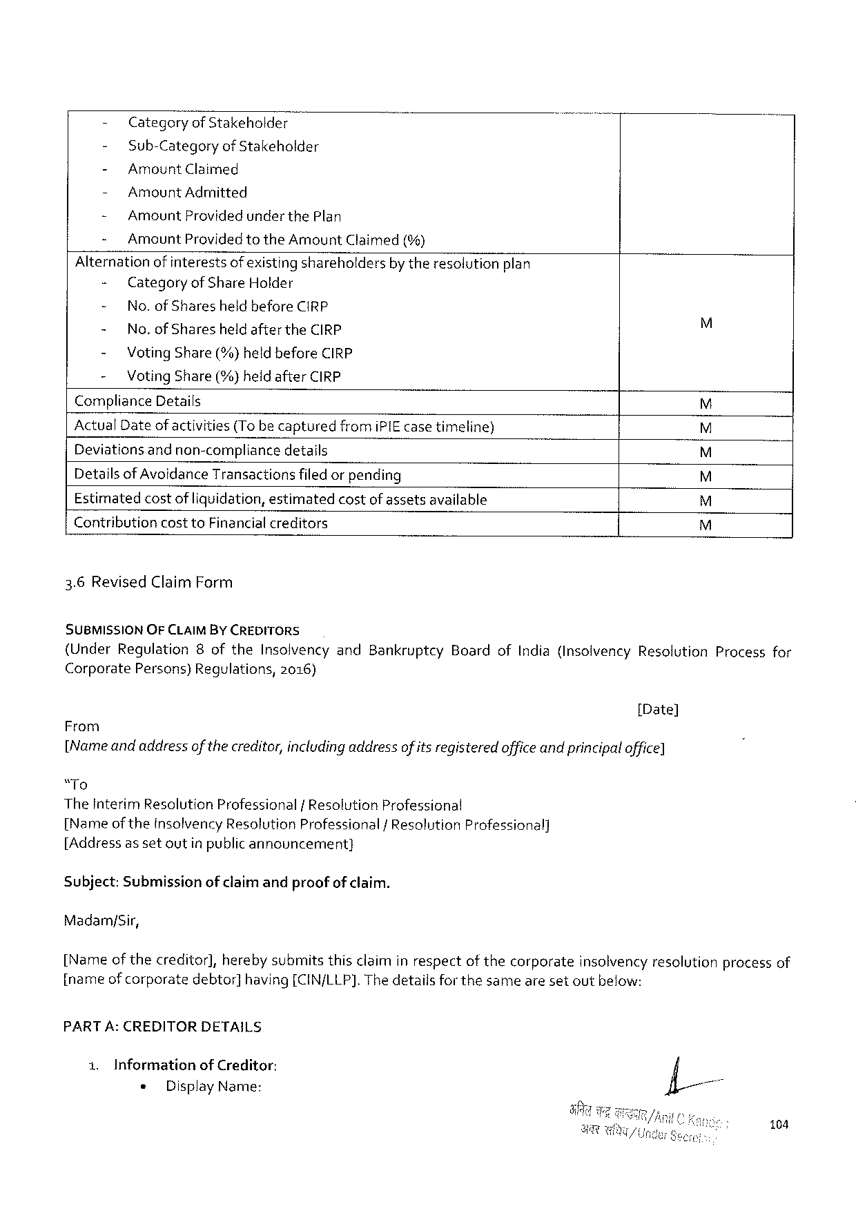

- Categoryof Stakeholder-

- Sub-CategoryofStakeholder

- AmountClaimed

- AmountAdmitted

- AmountProvidedunder thePlan

- AmountProvidedtotheAmountClaimed(%)

Alternationof interestsofexisting shareholdersby theresolutionplan

|  |  |  |  |
| --- | --- | --- | --- |
| - | CategoryofShareHolder | | ES  R  ES  R |
| - | No.ofSharesheld beforeCIRP | |
| - | No.ofSharesheldaftertheCIRP | |
| - | VotingShare (%)heldbeforeCIRP | |
| - | VotingShare (%)heldafterCIRP | |
| ComplianceDetails | | |
| ActualDateofactivities(To becaptured | | fromiPIEcasetimeline) |
| Deviationsand non-compliancedetails  Detailsof AvoidanceTransactionsfiledorpending | | |

Estimatedcostof liquidation, estimatedcostofassetsavailable

ContributioncosttoFinancialcreditors EHEY

3.6RevisedClaimForm

SUBMISSION OFCLAIMBY CREDITORS

(UnderRegulation8oftheInsolvencyandBankruptcyBoardofIndia(InsolvencyResolutionProcessfor

Corporate Persons)Regulations, 2016)

[Date]

From

[Nameandaddressof thecreditor,includingaddressofitsregisteredoffice andprincipaloffice]

“To

TheInterimResolutionProfessional/ResolutionProfessional

[NameoftheInsolvencyResolutionProfessional/ResolutionProfessional]

[Addressassetoutinpublicannouncement}

Subject:Submissionof claimandproofof claim.

Madam/Sir,

[Name of thecreditor],herebysubmitsthisclaiminrespectof thecorporateinsolvencyresolutionprocessof

[nameofcorporate debtor] having[CIN/LLP]. Thedetailsforthesamearesetoutbelow:

PART A:CREDITORDETAILS

1. Informationof Creditor:

« DisplayName:

104

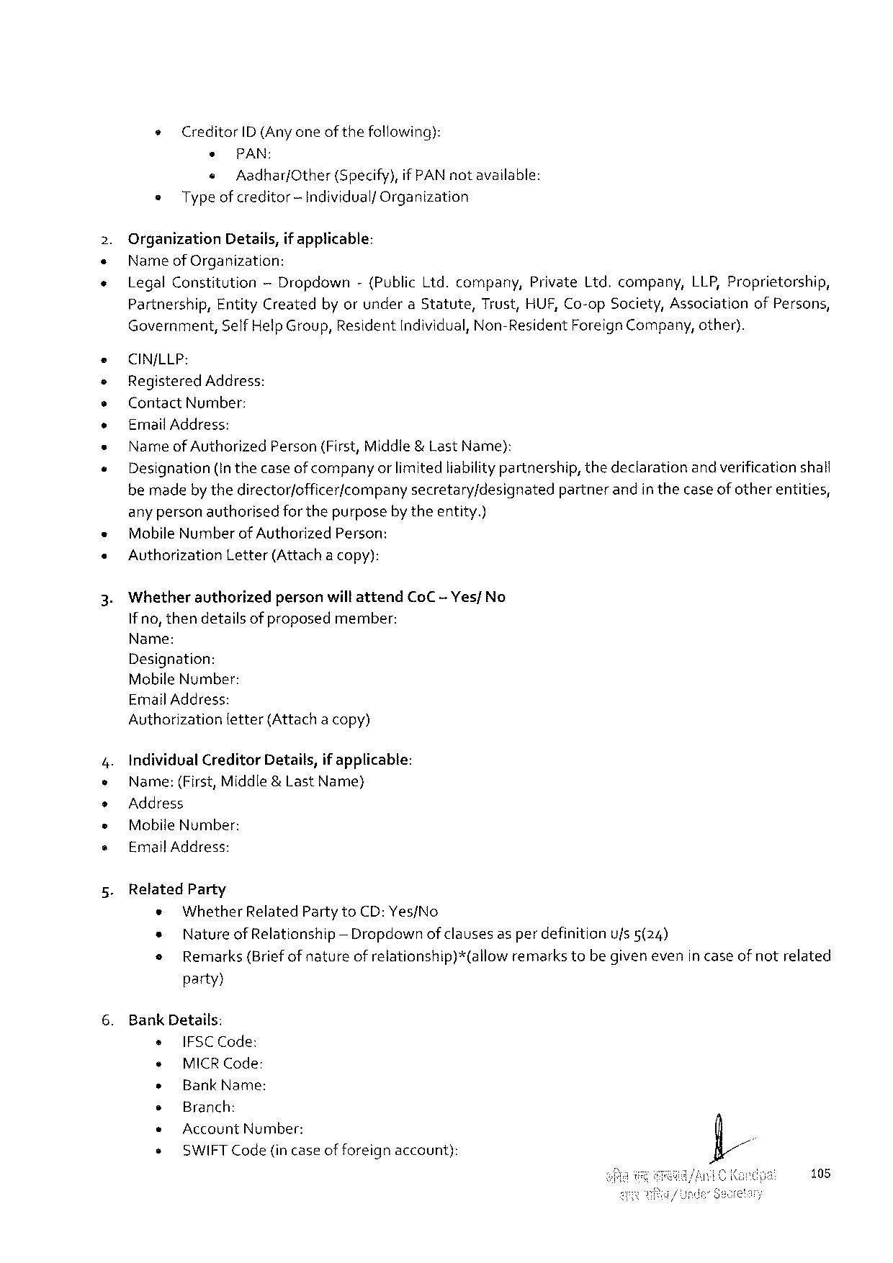

» CreditorID (Any oneofthefollowing):

* PAN:  
 « Aadhar/Other (Specify),if PAN notavailable: = Typeof creditor-IndividualfOrganization

OrganizationDetails,if applicable:   
Nameof Organization:

|  |  |  |  |  |
| --- | --- | --- | --- | --- |
| LegalConstitution | — Dropdown | -(PublicLid.company, | PrivateLtd.company, | LLP, Proprietorship, |

Partnership,EntityCreatedby orunderaStatute,Trust,HUF, Co-opSociety, AssociationofPersons, Government,SelfHelpGroup, Residentndividual,Non-ResidentForeignCompany, other).

CIN/LLP:   
RegisteredAddress:   
ContactNumber:   
ErmnailAddress:   
Nameof Authorized Person(First,Middle&LastName):   
Designation(In thecaseof companyor limited liabilitypartnership,thedeclarationand verificationshalf bemadeby thedirector/officer/companysecretary/designatedpartnerandin thecase of otherentities, any personauthorisedfor thepurposeby theentity.)   
MobileNumber ofAuthorizedPerson:   
AuvthorizationLetter(Attachacopy):

WhetherauthorizedpersonwillattendCoC -Yes/ No Ifno,thendetailsof proposedmember:   
Name:   
Designation:   
MobileNumber:   
EmailAddress:   
Authorization fetter(Attachacopy)

IndividualCreditorDetails,if applicable:   
Name:(First,Middle&LastName)   
Address   
MobileNumber:   
EmailAddress:

RelatedParty   
 * WhetherRelatedPartytoCD:Yes/No   
 * Natureof Relationship — Dropdown of clausesas per definitionufs 5(24)   
 o Remarks(Briefof natureof relationship)*(allowremarkstebe given evenin caseof notrelated

party}

BankDetails:

|  |  |  |  |
| --- | --- | --- | --- |
| s | IFSCCode: | account): | . |
| ¢ |
| MICRCode: |
| » |
| BankName: |
| * |
| Branch: |
| AccountNumber: |
| * |
| + | SWIFTCode(incaseofforeign |

108

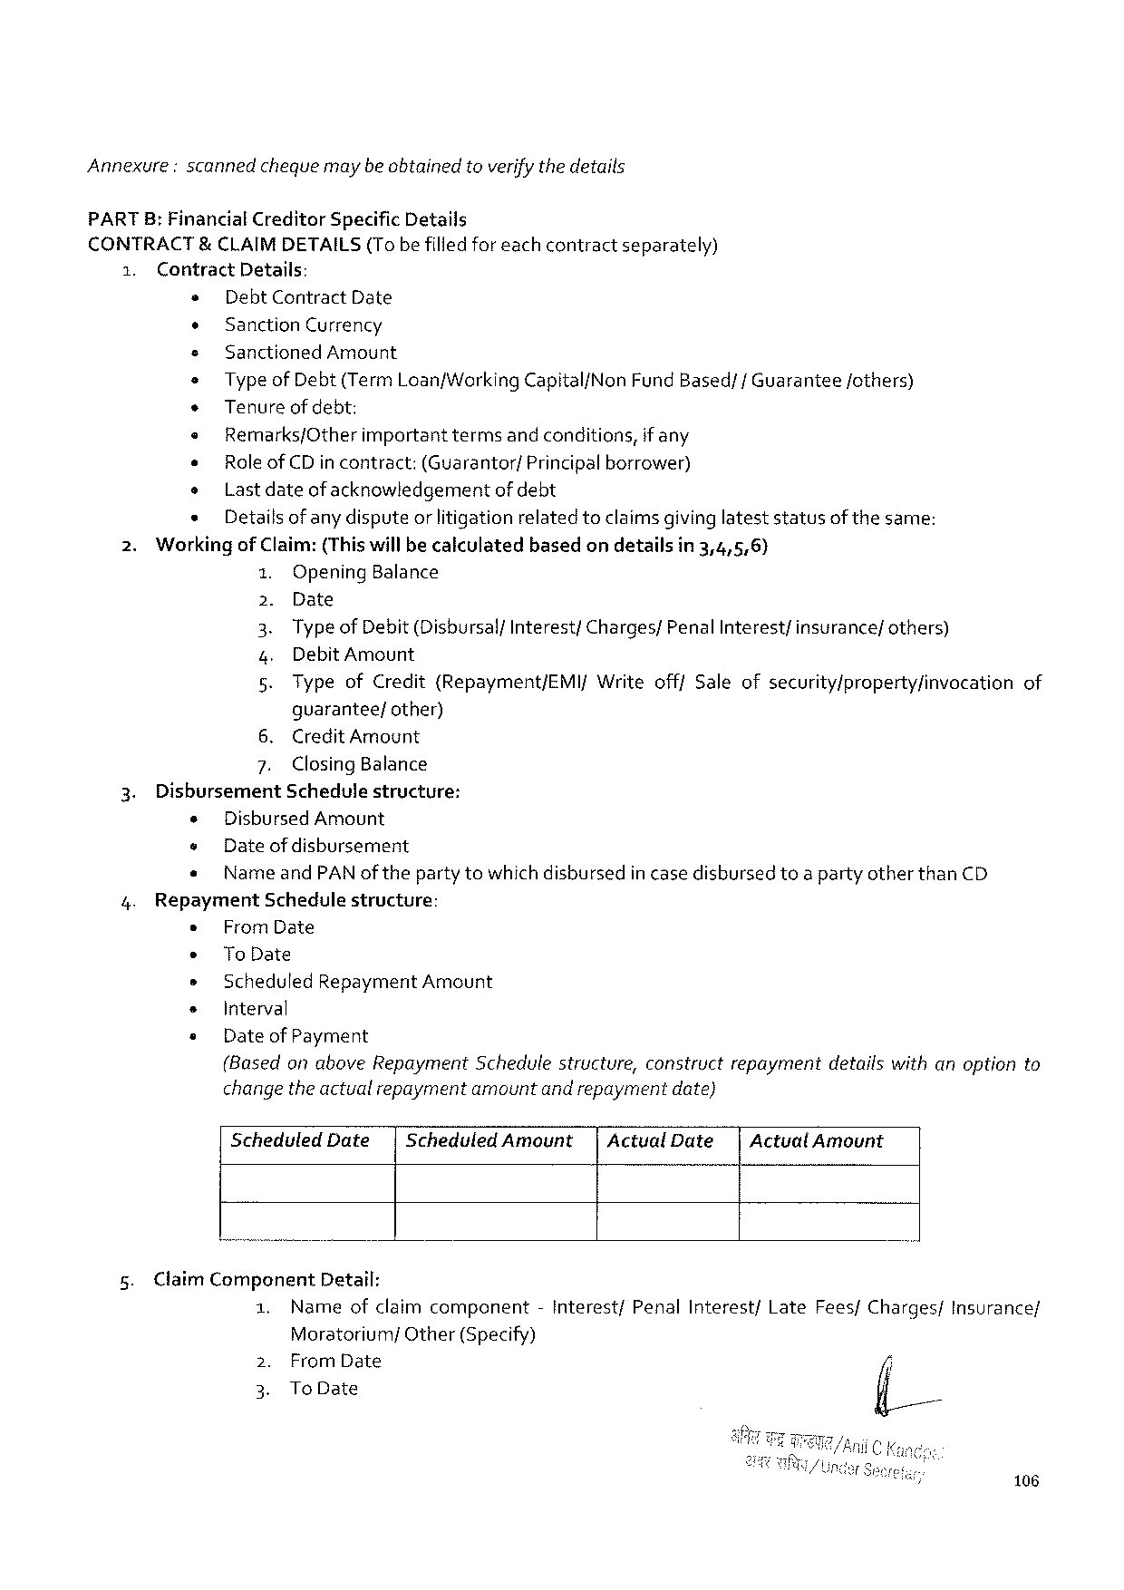

Annexure:scannedchequemaybeobtained toverify the details

PARTB: FinancialCreditorSpecificDetails

CONTRACT&CLAIMDETAILS (Tobefilledforeachcontract separately)

1. ContractDetails:

» Debt ContractDate

¢ SanctionCurrency

+ SanctionedAmount

s Type of Debt(Term Loan/WorkingCapital/Non FundBased/fGuarantee fothers)

* Tenureofdebt:

« Remarks/Other important termsandconditions, if any

« RoleofCD incontract: (Guarantor/ Principalborrower)

o Lastdateof acknowledgement of debt

s Detailsofany disputeorlitigationrelatedtoclaimsgivinglateststatusofthe same:

2. Workingof Claim:(Thiswillbe calculatedbasedon detailsin 3,4,5,6)

1. OpeningBalance

2. Date

3. TypeofDebit(DisbursalfInterest/Charges/PenalInterest/insurance/others)

4. DebitAmount

5. TypeofCredit(Repayment/EMI/WriteofffSaleofsecurity/property/invocation of

guarantee/other)

6. CreditAmount

7. ClosingBalance

3. DisbursementSchedulestructure:

¢ DisbursedAmount

e Dateofdisbursement

¢ NameandPANof the party towhichdishbursedin case disbursedtoa partyotherthanCD

4. RepaymentSchedulestructure:

« FromDate

s ToDate

» ScheduledRepaymentAmount

s Interval

« Date of Payment

(Basedon aboveRepaymentSchedulestructure,constructrepaymentdetailswithanoptionto

change the actualrepaymentamountand repaymentdate}

|  |  |  |  |  |
| --- | --- | --- | --- | --- |
| 5. | ScheduledDate| | ScheduledAmount| | ActualDate| | ActualAmount |
| Claim ComponentDetail: |

|  |  |  |  |  |  |  |
| --- | --- | --- | --- | --- | --- | --- |
| 1. | Nameofclaimcomponent | | -Interest/ | PenalInterest/ | LateFees/Charges/ | Insurance/ |
| 2. | Moratorium/ | Other(Specify) |
| FromDate | |
| 3. | ToDate | |

106

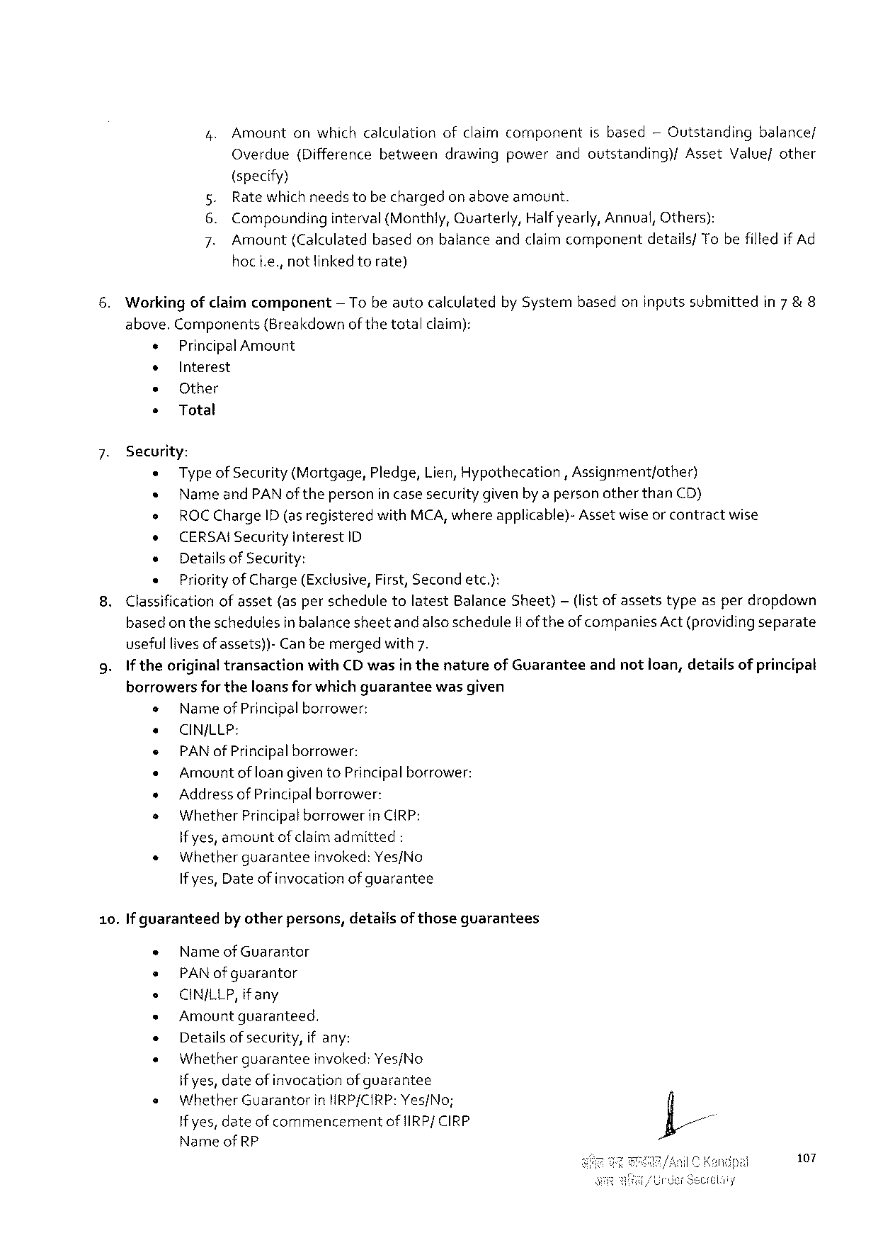

4.Amountonwhichcalculationofclaimcomponentisbased— Outstandingbalance/

|  |  |  |  |  |  |  |
| --- | --- | --- | --- | --- | --- | --- |
| Overdue | (Difference | between | drawing | power | andoutstanding)/ | AssetValue/other |

(specify)

5. Rate whichneedstobe chargedon aboveamount.

6. Compounding interval(Monthly,Quarterly, Halfyearly,Annual,Others):

7. Amount (Calculated basedonbalanceandclaimcomponent details/ Tobefilledif Ad

hoci.e.,notlinkedtorate)

6. Workingofclaimcomponent — Tobe autocalculatedby Systembasedoninputssubmittedin7 & 8

above.Components {Breakdownof thetotalclaim):

« Principal Amount

¢ Interest

* Other

* Total

7. Security:

« Typeof Security(Mortgage,Pledge,Lien, Hypothecation, Assignment/other)

« NameandPAN oftheperson incasesecuritygivenby apersonotherthanCD)

o ROCChargeID (asregisteredwithMCA,whereapplicable)-Asset wiseor contractwise

o CERSAISecurityInterest ID

« Detailsof Security:

« Priority of Charge(Exclusive,First,Secondetc.):

8.Classificationof asset(asperscheduletolatestBalanceSheet)— (listof assetstypeasperdropdown

basedon theschedulesin balancesheetandalsoscheduleIlof theofcompaniesAct(providingseparate

usefullivesof assets))-Canbemergedwith7.

9. If theoriginaltransactionwithCDwasin thenatureofGuaranteeandnotioan,detailsof principal

borrowersfor theloansfor which guarantee wasgiven

o Nameof Principalborrower:

e CINJLLP:

e PAN of Principalborrower:

« Amount of loangiventoPrincipalborrower:

» Addressof Principalborrower:

s WhetherPrincipalborrower inCIRP:

if yes,amountof claimadmitted:

|  |  |  |
| --- | --- | --- |
| « | Whetherguarantee | invoked:Yes/No |

If yes,Date of invocationof guarantee

10.If guaranteed by otherpersons,detailsof thoseguarantees

« Nameof Guarantor

= PAN of guarantor

o CIN/LLP, ifany

« Amountguaranteed.

« Detailsofsecurity,ifany:

« Whetherguarantee invoked:Yes/No

if yes,dateof invocationof guarantee

|  |  |  |
| --- | --- | --- |
| s | WhetherGuarantor | inHRP/CIRP:Yes/No; |

If yes,dateof commencementof{IRP/ CIRP

|  |  |
| --- | --- |
| Nameof RP | 107 |

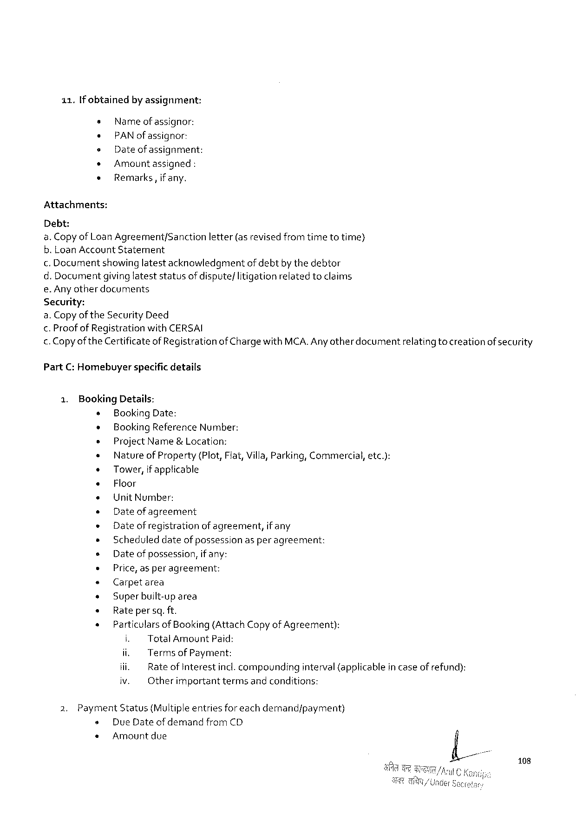

11.[f obtained by assignment:

s Name ofassignor:

* PAN of assignor:

e Dateof assignment:

+ Amountassigned :

e Remarks,if any.

Attachments:

Debt:

a. Copyof LoanAgreement/Sanctionletter(asrevised fromtimetotime)

b. LoanAccount Statement

.Documentshowinglatestacknowledgmentof debtby thedebtor

d. Documentgivinglateststatusof dispute/litigationrelatedtoclaims

e.Anyother documents

Security:

a. Copyof theSecurityDeed

<.Proof of Registrationwith CERSAI

.Copyofthe Certificateof Registrationof Charge withMCA.Any otherdocumentrelating tocreationof security

PartC:Homebuyerspacific details

15 BookingDetails:

s BookingDate:

¢ BookingReferenceNumber:

s ProjectName&Location:

+ Natureof Property (Plot,Flat,Villa, Parking, Commercial,etc.):

* Tower,if applicable

« Floor

e UnitNumber:

e Dateof agreement

« Date of registrationof agreement, if any

» Scheduleddateof possessionasper agreement:

s Dateofpossession, if any:

+ Price,asperagreement:

« Carpetarea

¢ Superbuilt-up area

« Rate persq.ft.

« Particulars of Booking(AttachCopyof Agreement):

i. Total AmountPaid:

ii. Terms of Payment:

iii. RateofInterestincl.compoundinginterval(applicablein caseofrefund):

iv. Otherimportanttermsandconditions:

2. PaymentStatus(Multipleentriesforeachdemand/payment)

s DueDateof demand fromCD

* Amountdue

108

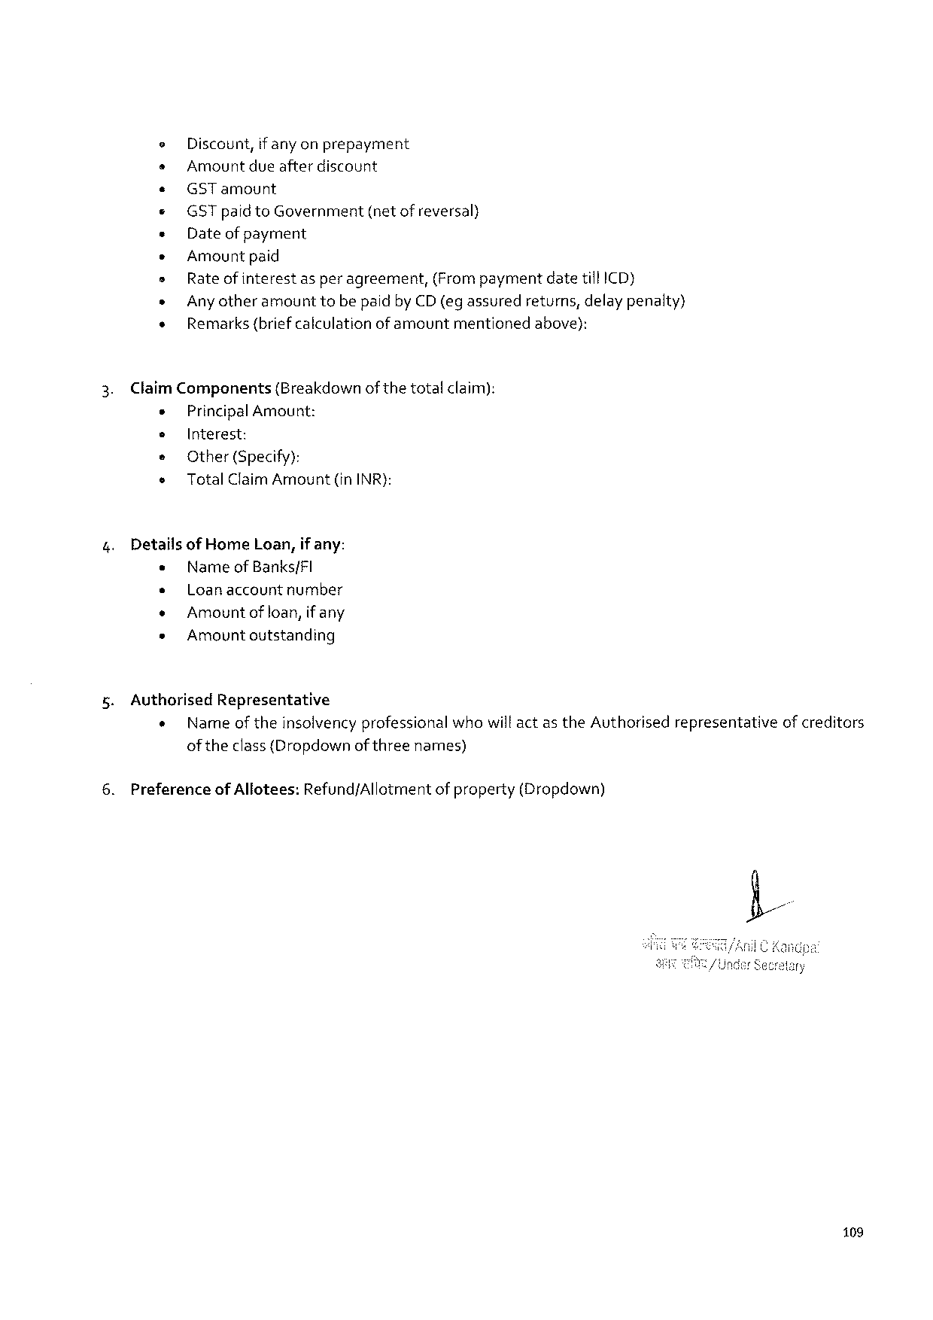

e Discount, if anyonprepayment

s Amountdueafterdiscount

e« GSTamount

« GST paidtoGovernment (netofreversal)

« Dateofpayment

e Amount paid

s Rate ofinterestas per agreement,(Frompaymentdatetill ICD)

» Any otheramounttobepaidby CD(egassured returns,delaypenalty)

s Remarks(briefcalculationofamount mentioned above):

ClaimComponents (Breakdownof thetotalclaim):

« Principal Amount:

e Interest:

e Other(Specify):

o TotalClaimAmount (inINR):

DetailsofHomeLoan,if any:

e Nameof Banks/FI

» Loanaccountnumber

« Amountof loan,if any

* Amount outstanding

AuthorisedRepresentative

« Nameof theinsolvencyprofessionalwhowill actas theAuthorisedrepresentativeof creditors

oftheclass{Dropdownof threenames)

Preferenceof Allotees:Refund/Allotmentof property(Dropdown)

109

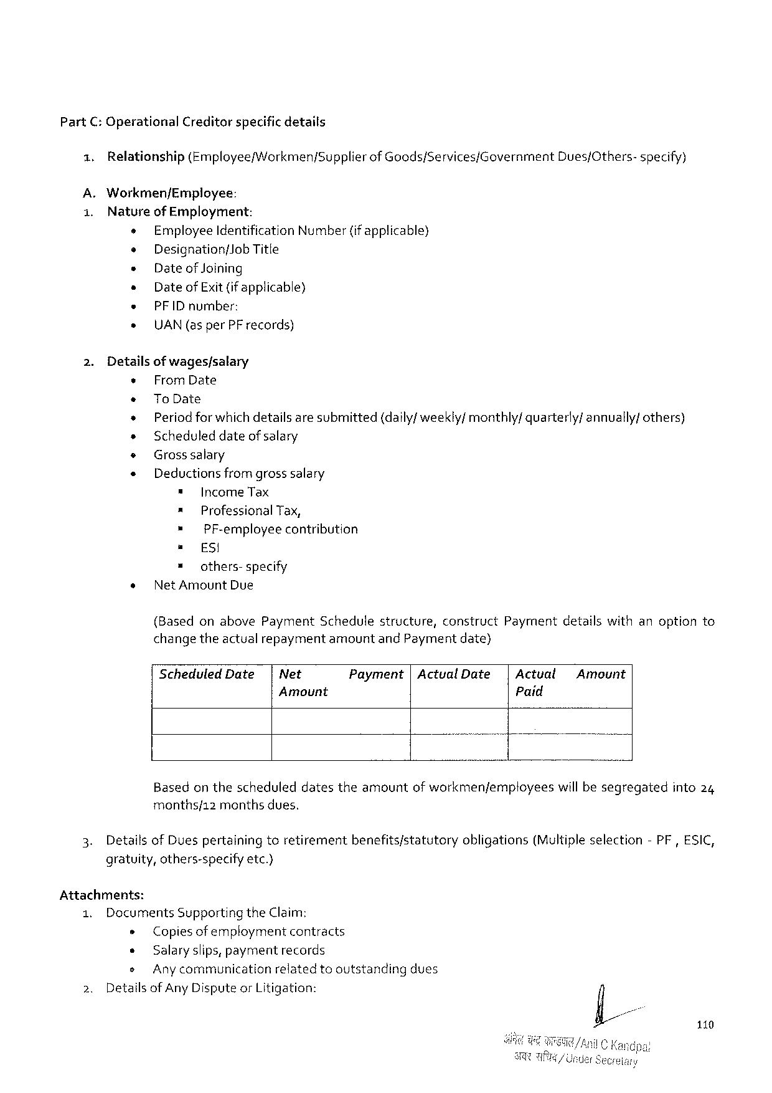

PartC: OperationalCreditorspecific details

1. Relationship(Employee/Workmen/Supplierof Goods/Services/GovernmentDues/Others-specify)

A.Workmen/Employee:

1. Natureof Employment:

+ EmployeeIdentification Number(if applicable)

o DesignationfJob Title

» Dateof Joining

» DateofExit (if applicable)

e PFIDnumber:

» UAN(asperPF records)

2. Detailsof wages/salary

« FromDate

+ ToDate

+ Period forwhichdetailsaresubmitted(daily/weekly/ monthly/quarterly/annually/ others)

» Scheduleddateofsalary

* Grosssalary

« Deductions from grosssalary

" IncomeTax

= ProfessionalTax,

= PF-employeecontribution

= ES!

» others-specify

* NetAmountDue

(BasedonabovePaymentSchedulestructure,constructPaymentdetailswithanoptionto

changetheactualrepaymentamountandPaymentdate)

ScheduledDate| Net Payment|ActualDate|Actval Amount

Amount Paid

Basedon thescheduleddatestheamountof workmen/employees willbesegregatedinto24

months/12monthsdues.

3. Details ofDuespertainingtoretirementbenefits/statutoryobligations(Multipleselection-PF,ESIC,

gratuity,others-specifyetc.)

Attachments:

|  |  |  |  |  |  |
| --- | --- | --- | --- | --- | --- |
| 1. | DocumentsSupportingtheClaim; | | | | dues |
| 2. | » | | Copiesofemploymentcontracts | |
| « | | Salaryslips,paymentrecords | |
| s | Anycommunication | | relatedtooutstanding |
| Detailsof AnyDisputeorLitigation: | | | |

110

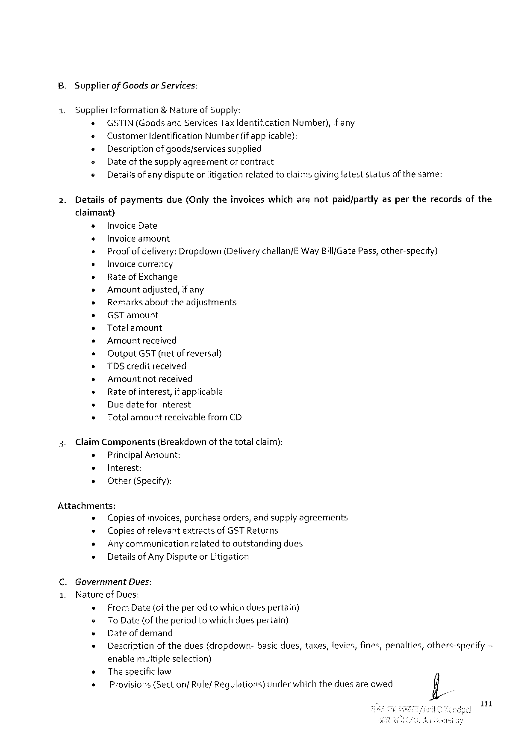

B. Supplier of GoodsorServices:

1. SupplierInformation& Natureof Supply:

o GSTIN(GoodsandServicesTaxIdentificationNumber),if any

e CustomerIdentificationNumber(if applicable):

« Descriptionofgoods/services supplied

= Dateof thesupplyagreementor contract

« Details of any disputeor litigationrelatedtoclaimsgivinglateststatusof thesame:

2. Detailsofpayments due(Onlytheinvoiceswhicharenotpaid/partlyaspertherecordsofthe

claimant)

|  |  |  |  |  |  |  |  |  |  |
| --- | --- | --- | --- | --- | --- | --- | --- | --- | --- |
| + | | invoiceDate | | | | | | | ~ |
| + | | Invoiceamount | | | | | | |
| + | | | Proof ofdelivery:Dropdown {Deliverychallan/EWayBill/GatePass, other-specify) | | | | | |
| s | | Invoicecurrency | | | | | | |
| * | | Rateof Exchange | | | | | | |
| * | | Amountadjusted,if any | | | | | | |
| * | | Remarksabouttheadjustments | | | | | | |
| + | | GSTamount | | | | | | |
| » | | Totalamount | | | | | | |
| s | | Amountreceived | | | | | | |
| o | | OutputGST(netof reversal) | | | | | | |
| e | | TDScreditreceived | | | | | | |
| * | | Amountnotreceived | | | | | | |
| « | | Rateofinterest, | | | | if applicable | | |
| « | | Duedateforinterest | | | | | | |
| « | | Totalamount | | | receivablefromCD | | | |
| 3. | ClaimComponents(Breakdown of thetotalclaim): | | | | | | | |
| * | | PrincipalAmount: | | | | | | |
| e | | Interest: | | | | | | |
| « | | Other(Specify): | | | | | | |
| Attachments: | | | | | | | | |
| « | | Copiesof invoices,purchaseorders,and supplyagreements | | | | | | |
| « | | Copies of relevantextractsof GST Returns | | | | | | |
| « | | Any communicationrelatedtooutstandingdues | | | | | | |
| « | | DetaifsofAny DisputeorLitigation | | | | | | |
| C.Government | | | | Dues: | | | | |
| 1. | Natureof Dues: | | | | | | | |
| « | | FromDate{of theperiodtowhichduespertain) | | | | | | |
| = | | | ToDate (of the periodtowhichduespertain) | | | | | |
| o | | Dateof demand | | | | | | |
| s | | Descriptionofthedues(dropdown- | | | | | basicdues,taxes,levies,fines,penalties, | others-specify |

enablemultipleselection)

|  |  |  |  |
| --- | --- | --- | --- |
| s | Thespecific law | underwhichtheduesareowed | fi/ |
| « |
| Provisions(SectionfRule/Regulations) |

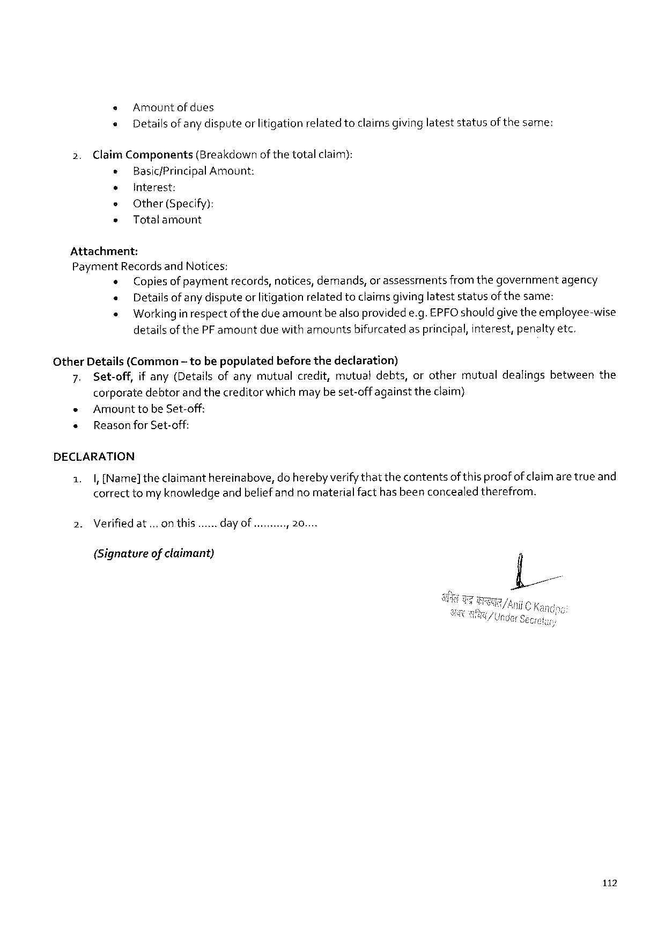

« Amountofdues

« Details ofanydisputeorlitigationrelatedtoclaimsgivinglateststatusofthesame:

2. ClaimComponents(Breakdown of thetotalclaim):   
 e Basic/PrincipalAmount:

e Interest:   
e Other (Specify):  
» Totalamount

Attachment:   
PaymentRecordsandNotices:  
 « Copiesof paymentrecords,notices,demands,or assessmentsfromthegovernmentagency « Detailsof any disputeor litigationrelatedtoclaimsgivinglateststatusofthesame:  
 « Working inrespectof thedue amountbealsoprovidede.g.EPFOshould givetheemployee-wise detailsof thePFamountduewith amountsbifurcatedasprincipal,interest,penaltyetc.

OtherDetails(Common~ tobepopulatedbeforethedeclaration)   
 7. Set-off,if any(Detailsofanymutualcredit,mutualdebts,orothermutualdealingsbetweenthe corporatedebtorand thecreditorwhich may be set-offagainst theclaim)  
 « Amount tobe Set-off:  
 « Reasonfor Set-off:

DECLARATION

|  |  |  |  |
| --- | --- | --- | --- |
| 1.  2. | |,[Name]theclaimanthereinabove,do herebyverifythatthecontentsofthis proofof claimare trueand correcttomy knowledgeand beliefandno materialfacthasbeenconcealedtherefrom. | | |
| Verifiedat...on this... | day of .oy | 2000 |

(Signatureof claimant)

112



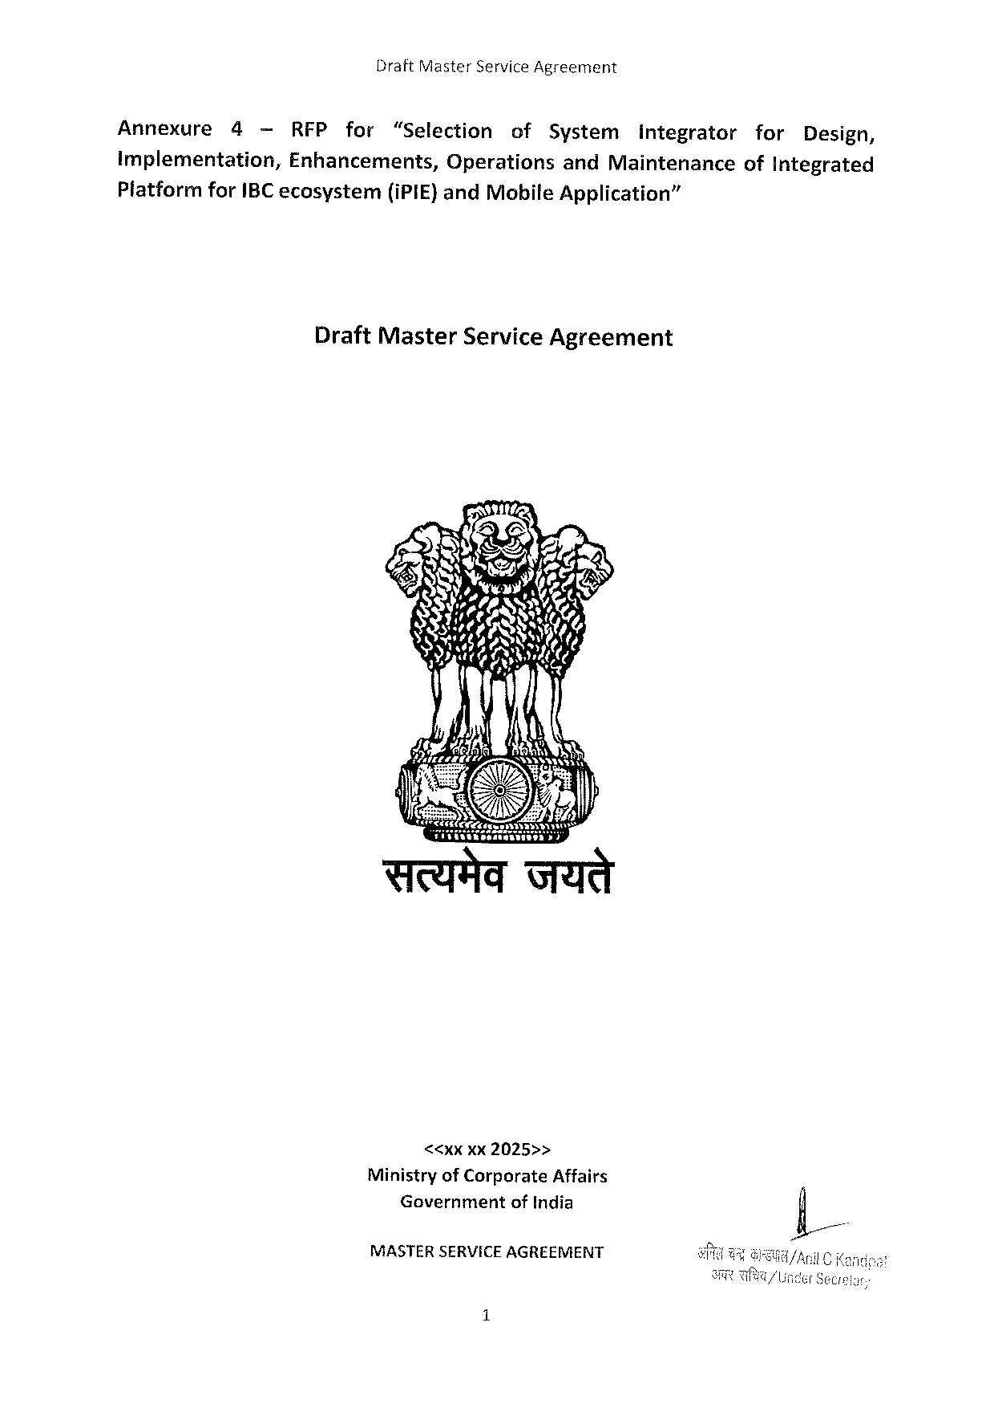

DraftMasterServiceAgreement

Annexure 4 —RFP for “Selection of System integrator for Design,

Implementation,Enhancements,OperationsandMaintenanceofIntegrated

Platform forIBCecosystem (iPIE}andMobileApplication”

DraftMasterServiceAgreement

74

Sty 57< & N««A

Sy oS AR,

SN-~

MASTERSERVICE AGREEMENT

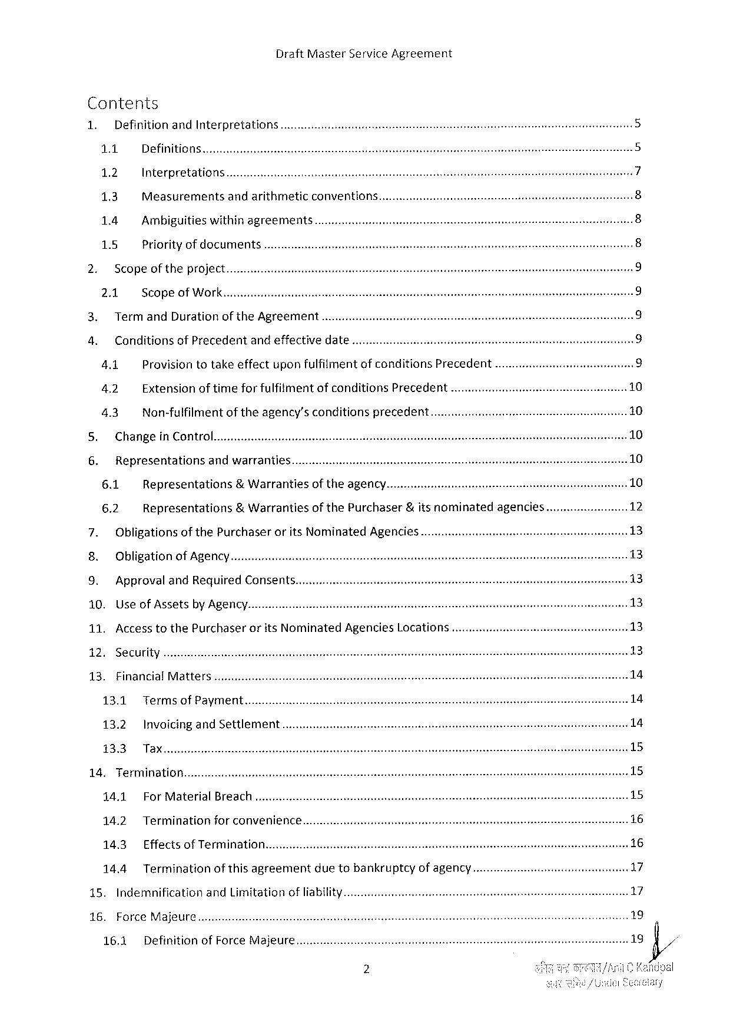

DraftMasterServiceAgreement

Contents

|  |  |  |  |  |  |  |  |  |  |  |
| --- | --- | --- | --- | --- | --- | --- | --- | --- | --- | --- |
| 1. | DefinitionandInterpretations............. | | | | | | | | ... | U |
| U |
| 1.1 | Definitions | | | | | | |
| 1.2 | Interpretations | | | | | | | N |
| 13 | Measurements | andarithmetic | | | conventions............ | | | e |
| ~ |
| 1.4 | Ambiguitieswithinagreements........ | | | | | | | G |
| 1.5 | Priorityof documents | | | .... | | | | ® |
| Scopeoftheproject........... | | | | | | | |
| W |
| 2.1 | ScopeofWork | | | | | | | O |
| TermandDurationoftheAgreement | | | | | | | | © |
| ConditionsofPrecedent | | | andeffectivedate... | | | | |
| 4.1 | Provisiontotakeeffectuponfulfilimentofconditions | | | | | Precedent | |
| 4.2 | Extensionoftimefor fulfitment | | | | ofconditionsPrecedent | | ..... |
| 4.3 | Non-fulfilmentof theagency’sconditionsprecedent.... | | | | | | |

Changein Control

|  |  |  |  |  |  |  |
| --- | --- | --- | --- | --- | --- | --- |
| LRy Representations | | andwarranties.. | | of theagency. | &itsnominated | agencies...... |
| 6.1 | Representations | | &Warranties |
| of thePurchaser |
| 6.2 | Representations | | &Warranties |

Obligationsof thePurchaseroritsNominatedAgencies.............

Obligationof Agency

ApprovalandRequiredConsents....

10. UseofAssetsbyAgency.

11. AccesstothePurchaseroritsNominatedAgenciesLocations.

12. Security

13. FinancialMatters...

13.1 Terms ofPayment

13.2 InvoicingandSettlement.

14. Termination........

14.1 For MaterialBreach

14.2 Terminationforconvenience.....

14.3 EffectsofTermination

14.4 Termination of thisagreement duetobankruptcy of agency....

15. Indemnification andLimitationofliability..............

16. ForceMajeure

16.1 Definition ofForceMajeure...

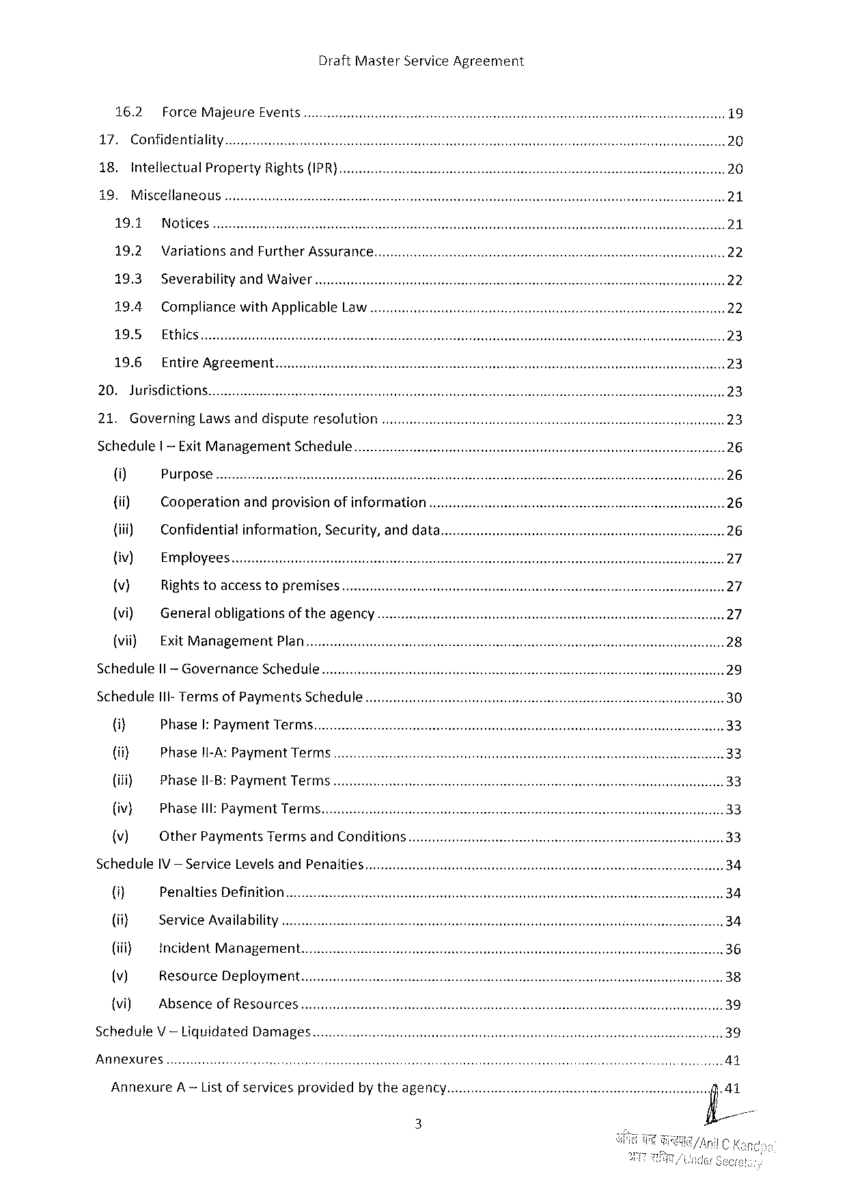

16.2 ForceMajeure Events

17. Confidentiality

18. IntellectualPropertyRights {IPR}

19. Miscellaneous

19.1 Notices

19.2 VariationsandFurtherAssurance

19.3 SeverabilityandWaiver

19.4 CompliancewithApplicableLaw

19.5 Ethics........

19.6 EntireAgreement

20. Jurisdictions.

21. GoverningLaws anddispute resolution

Schedule | -ExitManagement Schedule

{i) Purpose

{ii) Cooperation andprovisionofinformation

{iii) Confidentia!information, Security,anddata....

{iv) Employees

(v) Rights toaccesstopremises

(vi) Generalobligationsoftheagency

(vii) ExitManagement Plan

ScheduleIl-Governance Schedule

Schedule I1I-TermsofPayments Schedule..........

(i} PhaseI: PaymentTerms.

(ii} Phaseli-A: Payment Terms...........c.....

(iii) Phase1I-B:PaymentTerms.

{iv} Phase1I: PaymentTerms

{v) OtherPaymentsTermsandConditions........

Schedule IV — ServiceLevelsandPenalties

4] PenaltiesDefinition

(it} ServiceAvailability

(i} incidentManagement.

(v) ResourceDeployment...........

{vi) AbsenceofResources

ScheduleV— LiquidatedDamages

Annexures



DraftMasterServiceAgreement

Annexure B — RequiredDeliverablesandAssociatedTimelines.

Annexure€— Non-DisclosureAgreement

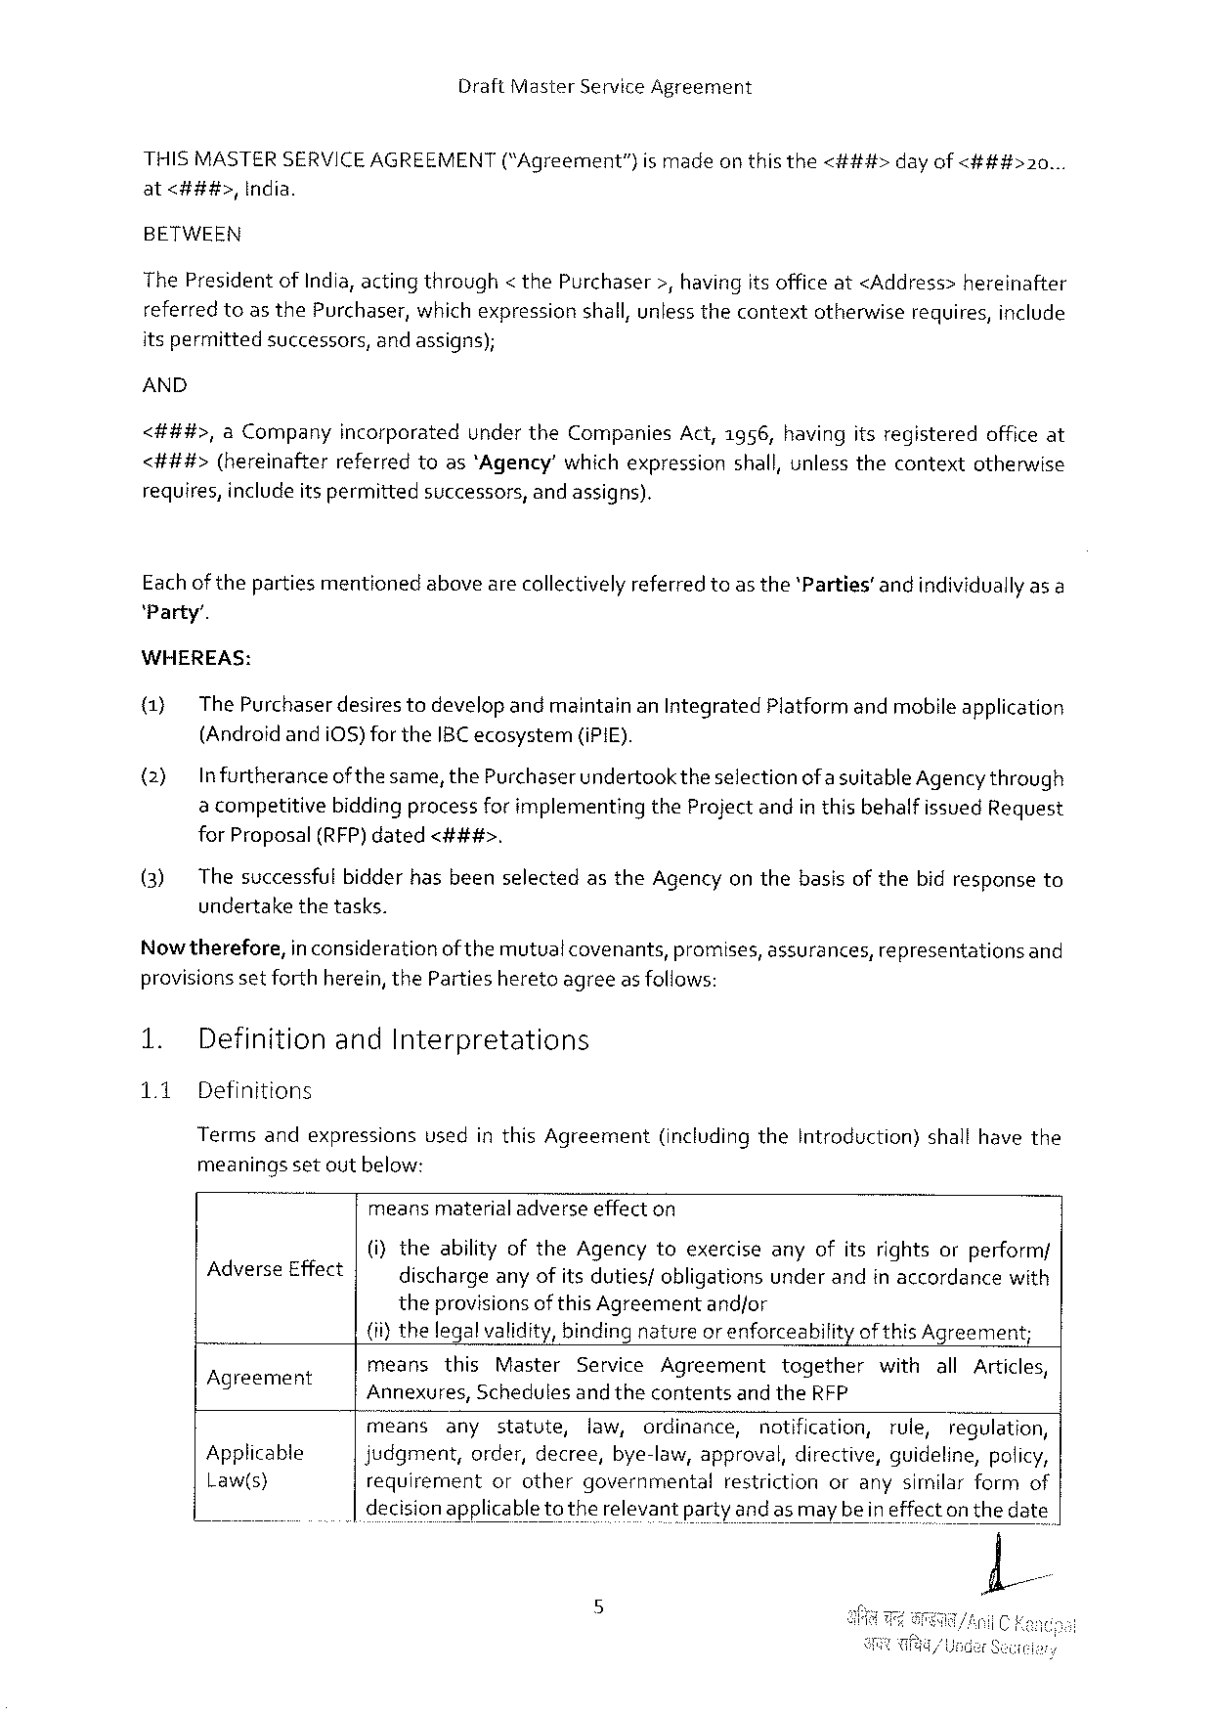

DraftMasterServiceAgreement

|  |  |  |  |  |  |  |
| --- | --- | --- | --- | --- | --- | --- |
| THISMASTERSERVICEAGREEMENT | | (“Agreement”} | ismade | onthisthe | <###> | dayof<###>20... |
| at<###>, | India. |

BETWEEN

ThePresidentofIndia,acting through< thePurchaser>,havingitsofficeat<Address>hereinafter

|  |  |  |  |  |  |  |  |
| --- | --- | --- | --- | --- | --- | --- | --- |
| referredtoasthePurchaser, | | | whichexpression | shall,unlessthecontext | otherwise | requires, | include |
| itspermitted | successors, | andassigns); | |

AND

<##4#>,aCompanyincorporatedundertheCompaniesAct,1956,havingitsregisteredofficeat <###t#>(hereinafterreferredtoas‘Agency’ whichexpressionshall,unlessthecontextotherwise

|  |  |  |
| --- | --- | --- |
| requires,includeitspermitted | successors, | andassigns). |

Eachof thepartiesmentionedabovearecollectivelyreferred toas the'Parties’andindividuallyas a‘Party’.

WHEREAS:

(1) ThePurchaser desirestodevelopand maintainanIntegratedPlatformand mobileapplication (Androidandi0S)fortheIBC ecosystem (iPiE).

(2) Infurtheranceof thesame,thePurchaserundertook theselectionofa suitableAgencythrough a competitivebiddingprocessfor implementingtheProjectandin this behalfissuedRequest forProposal(RFP)dated<###>.

(3) ThesuccessfulbidderhasbeenselectedastheAgencyon thebasisofthebidresponseto undertakethetasks.

Nowtherefore, in considerationofthemutual covenants,promises,assurances,representationsand provisionsset forthherein, thePartiesheretoagreeasfollows:

1. DefinitionandInterpretations

1.1 Definitions

TermsandexpressionsvsedinthisAgreement(includingtheIntroduction)shallhavethe meaningssetoutbelow:

meansmaterialadverseeffecton

|  |  |  |
| --- | --- | --- |
| AdverseEffect | (i)theabilityoftheAgencytoexerciseanyofitsrightsorperform/ dischargeanyofits duties/obligationsunderandinaccordancewith | |
| theprovisionsof thisAgreement | andfor |

(ii)thelegalvalidity,binding natureor enforceabilityof thisAgreement;

|  |  |  |  |  |  |  |  |  |  |  |  |  |  |  |  |
| --- | --- | --- | --- | --- | --- | --- | --- | --- | --- | --- | --- | --- | --- | --- | --- |
| Agreement g  Applicable  Law(s} | means | this | Master | | ServiceAgreement | | | | together | | withallArticles, | | | | |
| Annexures, | | Schedules | | andthecontents | | andtheRFP | | | | | | | | |
| means | any | statute, | | law, | ordinance, | | notification, | | | | rule, | | regulation, | |
| judgment,order,decree,bye-law,approval,directive,guideline,policy, | | | | | | | | | | | | | | |
| requirement | | or | other | governmental | | restriction | | | orany | | | similar | form | of |

decisionapplicabletotherelevantparty and as maybeineffecton thedate

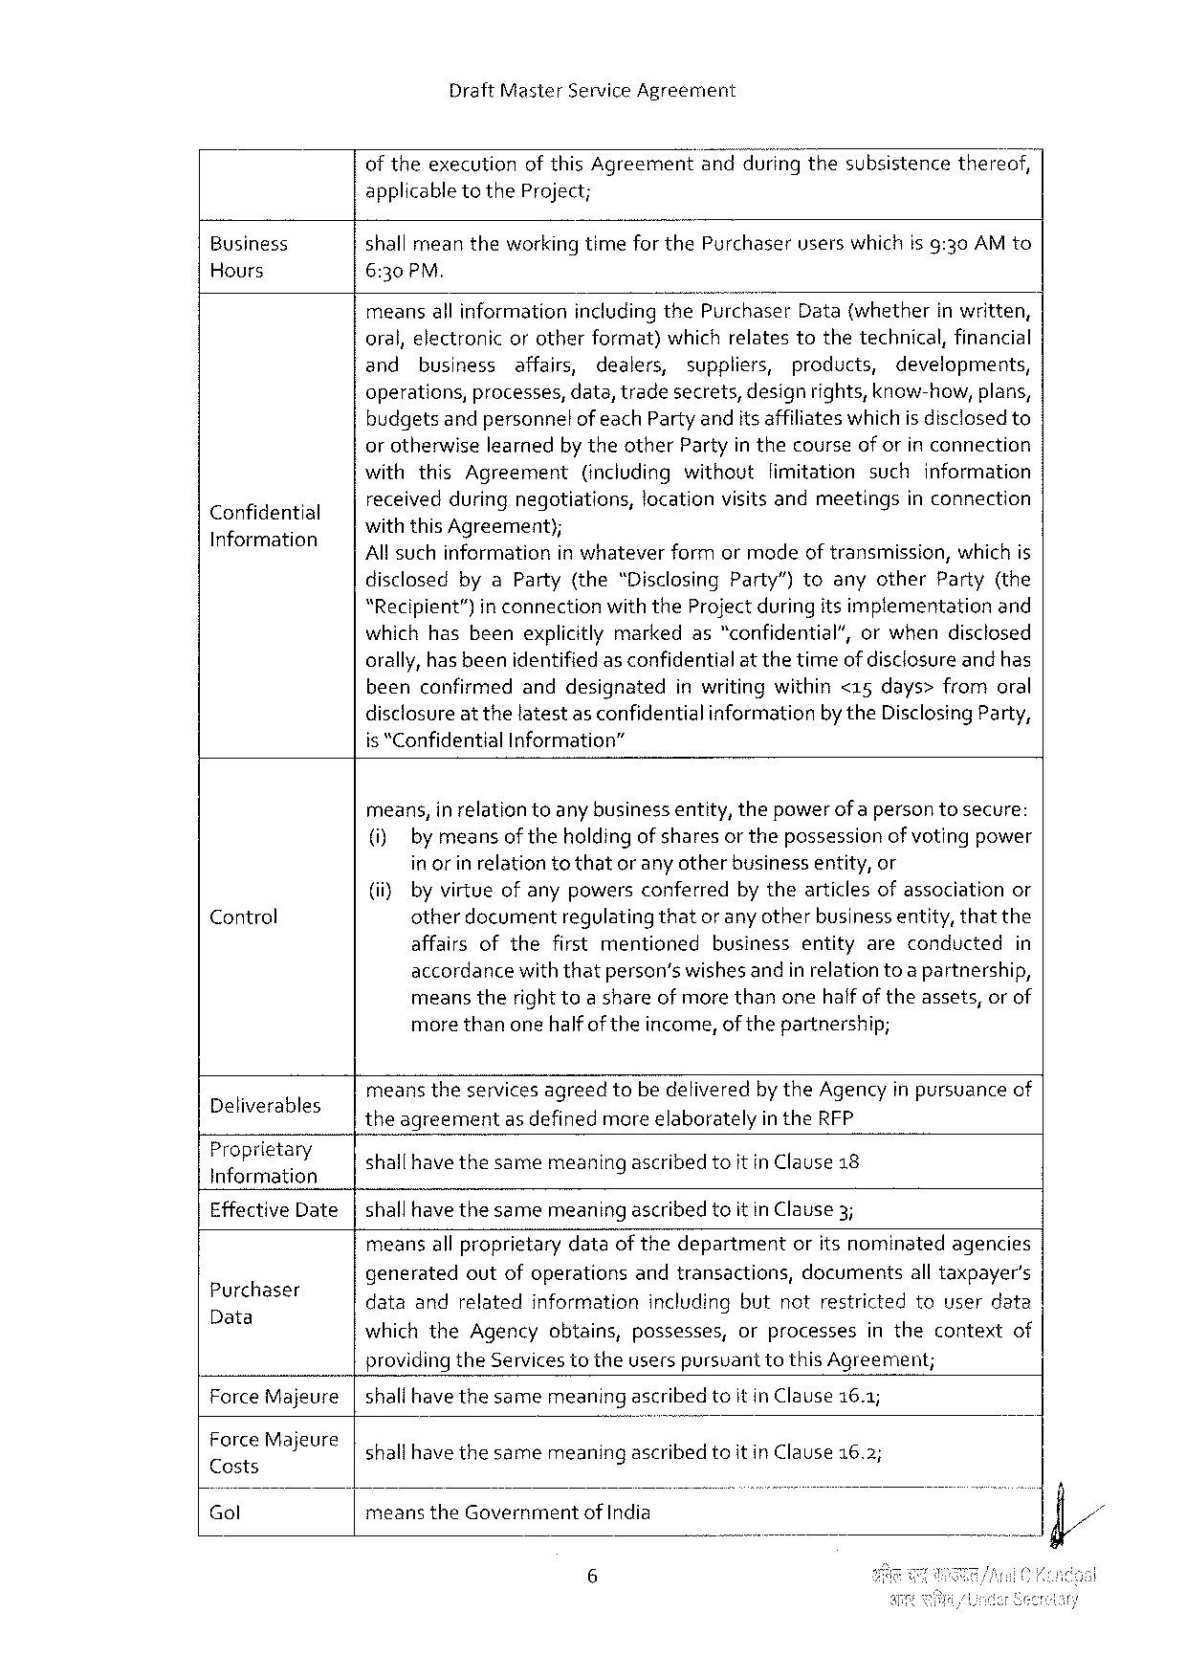

DraftMasterServiceAgreement

of theexecutionofthisAgreementand"duringthesubsistencethereof, applicable totheProject;

Business shall meantheworkingtimefor thePurchaseruserswhichisg:30AM to Hours 6:30PM,

meansall informationincludingthePurchaserData(whetherin written, oral,electronic orotherformat) whichrelatestothetechnical, financial

and business affairs, dealers, suppliers, products, developments,

operations, processes, data,tradesecrets,designrights,know-how, plans, budgetsandpersonnelof eachPartyandits affiliates whichisdisclosedto or otherwiselearnedby theotherPartyin thecourseof orin connection

|  |  |  |  |  |  |
| --- | --- | --- | --- | --- | --- |
| Confidential Information | withthisAgreement | | (includingwithoutfimitationsuchinformation | | |
| received | duringnegotiations, | | locationvisitsandmeetings | inconnection |
| withthisAgreement);  All suchinformationin whateverformormodeof transmission,which is | | | | |

disclosedbyaParty{the“DisclosingParty”)toanyotherParty(the“Recipient”)in connectionwith theProject during itsimptementationand whichhasbeenexplicitlymarkedas“confidential’,orwhendisclosed orally,has beenidentified as confidentialat thetimeof disclosureandhas beenconfirmedanddesignated inwritingwithin<15days>fromoral disclosure at thelatestas confidentialinformationbytheDisclosingParty, is “Confidential Information”

means,in relationtoany businessentity,thepowerofa person tosecure: (i) by meansoftheholdingof sharesor thepossessionof votingpower in or in relationtothator any otherbusinessentity,or

|  |  |  |  |  |
| --- | --- | --- | --- | --- |
| Control | (i} | by virtueofanypowersconferredby thearticlesofassociationor | | |
| otherdocumentregulatingthatorany otherbusiness entity,thatthe | | |
| affairsofthefirstmentioned | businessentityareconducted | in |

accordancewiththatperson’swishesandin relationtoa partnership, meanstherighttoa shareofmorethanonehalfof theassets,orof morethanonehalfof theincome, of thepartnership;

|  |  |
| --- | --- |
| Deliverables  Proprietary  Information  EffectiveDate | meanstheservicesagreedtobedeliveredby theAgencyin pursuanceof theagreementas definedmoreelaboratelyin theRFP  shallhave thesamemeaning ascribedtoitinClause18  shallhave thesamemeaning ascribedtoitinClause3; |

meansall proprietarydataofthedepartmentoritsnominatedagencies

|  |  |
| --- | --- |
| Purchaser Data | generatedoutofoperationsandtransactions,documentsall taxpayer's dataandrelatedinformationincludingbutnotrestrictedtouserdata whichtheAgencyobtains,possesses,orprocessesinthecontextof |

providingtheServicestotheuserspursuanttothisAgreement;

|  |  |  |
| --- | --- | --- |
| ForceMajeure ForceMajeure Costs  Gol | shallhave thesamemeaning ascribedtoit inClause16.1; shallhave thesamemeaning ascribedtoit inClause16.2; | |
| meanstheGovernment | ofIndia |

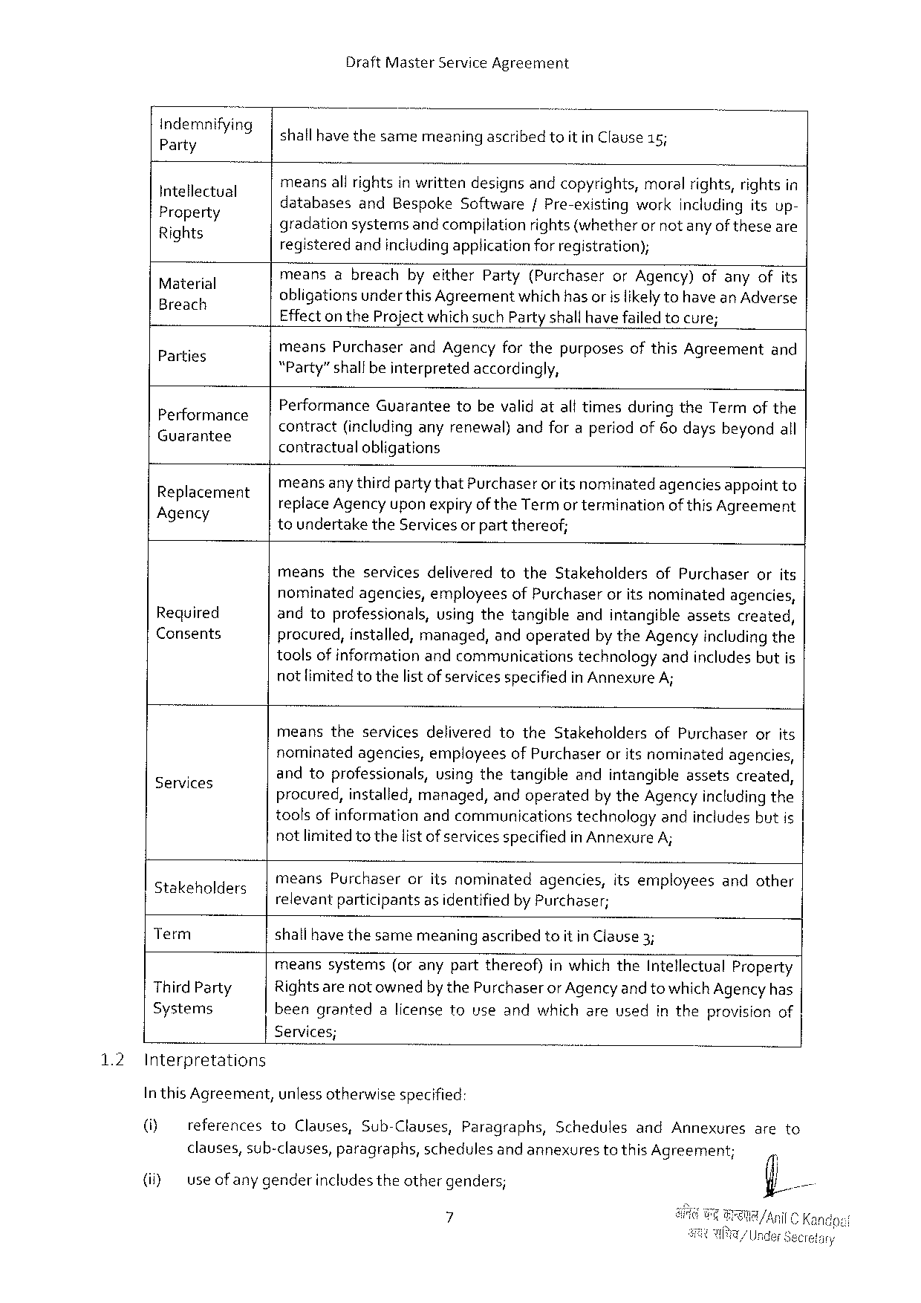

DraftMasterServiceAgreement

|  |  |  |  |  |
| --- | --- | --- | --- | --- |
| gfii;flmfi/mg  Intellectual Propert  RiEts¥  9  3  Material —  Parties q  GCUaTaTTES Performance  Replacement Agency  Required  Consents  Services  atakeholders  Term  ThirdParty Systems | shallhavethesamemeaningascribedtoit inClause15;  meansall rightsin writtendesignsandcopyrights,moralrights,rightsin  databases andBespokeSoftware/Pre-existingworkincludingitsup- S ) ==  gradationsystemsand compilationrights (whetheror not anyof theseare  registeredandincludingapplication for registration);  meansabreachbyeitherParty(PurchaserorAgency)ofanyofits  . A : A  obligationsunder this Agreementwhich hasorisiikely tohaveanAdverse  EffectontheProjectwhichsuchPartyshallhave failed tocure;  -meansPurchaserandAgencyforthepurposesofthisAgreementand  Party”shallbeinterpretedaccordingly, 3 3 3  contract(includinganyrenewal)andforaperiodof60daysbeyondall PerformanceGuaranteetobevalid atalftimesduringtheTermofthe . s 3  contractualobligations | | | |
| meansanythirdpartythatPurchaser | oritsnominated | agencies | appointto |
| replaceAgency upon expiryof theTermorterminationof this Agreement toundertaketheServicesor partthereof;  meanstheservicesdeliveredtotheStakeholdersofPurchaserorits nominatedagencies,employeesofPurchaseroritsnominatedagencies, andtoprofessionals,usingthetangibleandintangibleassetscreated, procured,installed,managed,andoperatedbytheAgencyincludingthe toolsof informationandcommunicationstechnologyandincludesbutis not limitedtothelist of services specifiedinAnnexureA;  meanstheservicesdeliveredtotheStakeholdersofPurchaserorits nominatedagencies,employeesofPurchaseroritsnominatedagencies, andtoprofessionals,usingthetangibleandintangibleassetscreated, procured,installed,managed,andoperatedby theAgencyincludingthe toolsofinformationandcommunicationstechnologyandincludesbutis notlimitedtothelistof services specifiedin Annexure A;  meansPurchaseroritsnominatedagencies,itsemployeesandother relevantparticipantsas identifiedby Purchaser;  shallhavethesamemeaningascribedtoit inClause3;  meanssystems(oranypartthereof)inwhichtheIntellectualProperty Rightsarenot ownedby thePurchaserorAgency and to whichAgencyhas beengrantedalicensetouseandwhichareusedintheprovisionof | | | |

Services;

1.2 Interpretations

In this Agreement,unlessotherwisespecified:

|  |  |  |  |  |  |  |  |  |  |  |  |  |  |
| --- | --- | --- | --- | --- | --- | --- | --- | --- | --- | --- | --- | --- | --- |
| [G] | references | to | Clauses, | | Sub-Clauses, | | Paragraphs, | | Schedules | | and | Annexures | areto |
| (i) | clauses,sub-clauses, | | | paragraphs, | | schedules | | andannexures | | tothisAgreement; | | |
| useofany genderincludestheothergenders; | | | | | | | | | | | |

7

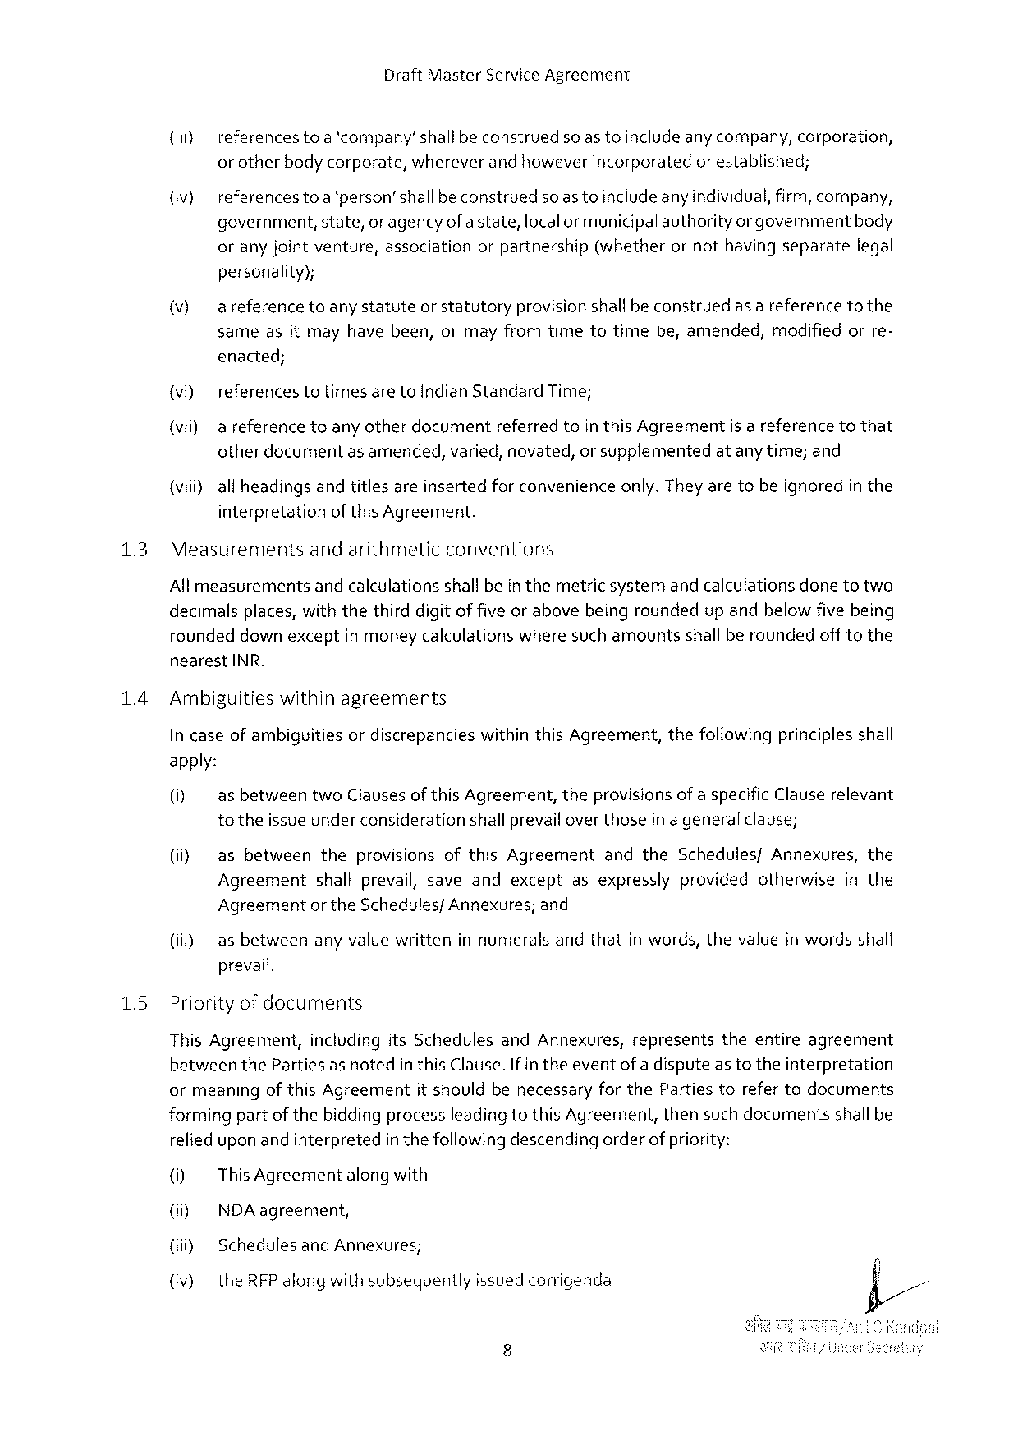

DraftMasterServiceAgreement

(iiy referencesto a'company’shall beconstrued soastoincludeanycompany, corporation,

or otherbodycorporate, whereverandhoweverincorporated or established;

(iv) referencestoa‘person’shallbeconstruedsoas toincludeanyindividual,firm,company,

government, state, or agencyofa state,localor municipalauthority orgovernmentbody

oranyjointventure, association orpartnership (whether ornothavingseparate legal

personality);

|  |  |  |  |
| --- | --- | --- | --- |
| (v) | areferencetoanystatuteorstatutory | provisionshallbeconstrued | asareferencetothe |

sameasitmayhavebeen,ormayfromtimetotimebe,amended,modifiedorre-

enacted;

|  |  |  |  |  |
| --- | --- | --- | --- | --- |
| (vi) | referencestotimes aretoIndianStandardTime; | | isareference | tothat |
| (vii) | a referencetoanyotherdocument | referredtointhisAgreement |

otherdocumentas amended,varied, novated,or supplementedatanytime;and

(viii)all headingsandtitlesareinsertedfor convenienceonly.They aretobeignoredin the

interpretationof this Agreement.

|  |  |  |
| --- | --- | --- |
| 13 | Measurements | andarithmeticconventions |

Allmeasurementsandcalculationsshalfbein themetricsystemand calculationsdonetotwo

decimalsplaces,withthethirddigitof five orabovebeingroundedupandbelowfive being

roundeddown exceptin moneycalculationswheresuch amountsshallberoundedofftothe

nearestINR.

14 Ambiguitieswithinagreements

In caseof ambiguitiesordiscrepancieswithinthisAgreement,thefollowingprinciples shall

apply:

|  |  |  |  |
| --- | --- | --- | --- |
| (i) | asbetween | twoClausesof thisAgreement, | theprovisionsofaspecificClauserelevant |

to theissue underconsiderationshallprevail overthosein a generalclause;

(i} as betweentheprovisionsofthisAgreementandtheSchedules/Annexures,the

Agreementshallprevail,saveandexceptasexpresslyprovidedotherwiseinthe

Agreementor theSchedulesfAnnexures;and

|  |  |  |  |  |  |
| --- | --- | --- | --- | --- | --- |
| (i) | as between | anyvaluewritten | innumerals | andthat | inwords,thevalueinwordsshall |

prevail.

|  |  |  |  |  |  |  |  |
| --- | --- | --- | --- | --- | --- | --- | --- |
| 15 | Priorityof documents | | itsSchedules | andAnnexures, | represents | theentire | agreement |
| ThisAgreement, | including |

betweenthePartiesas notedin thisClause. If in theeventof adispute as totheinterpretation

ormeaningof thisAgreementit shouldbenecessaryforthePartiestorefertodocuments

formingpartof thebiddingprocessleadingtothis Agreement,thensuch documentsshallbe

relied upon and interpretedin thefollowingdescendingorderofpriority:

[0} ThisAgreement alongwith

(i) NDAagreement,

{iiiy SchedulesandAnnexures;

(iv) the RFPalong withsubsequentlyissuedcorrigenda

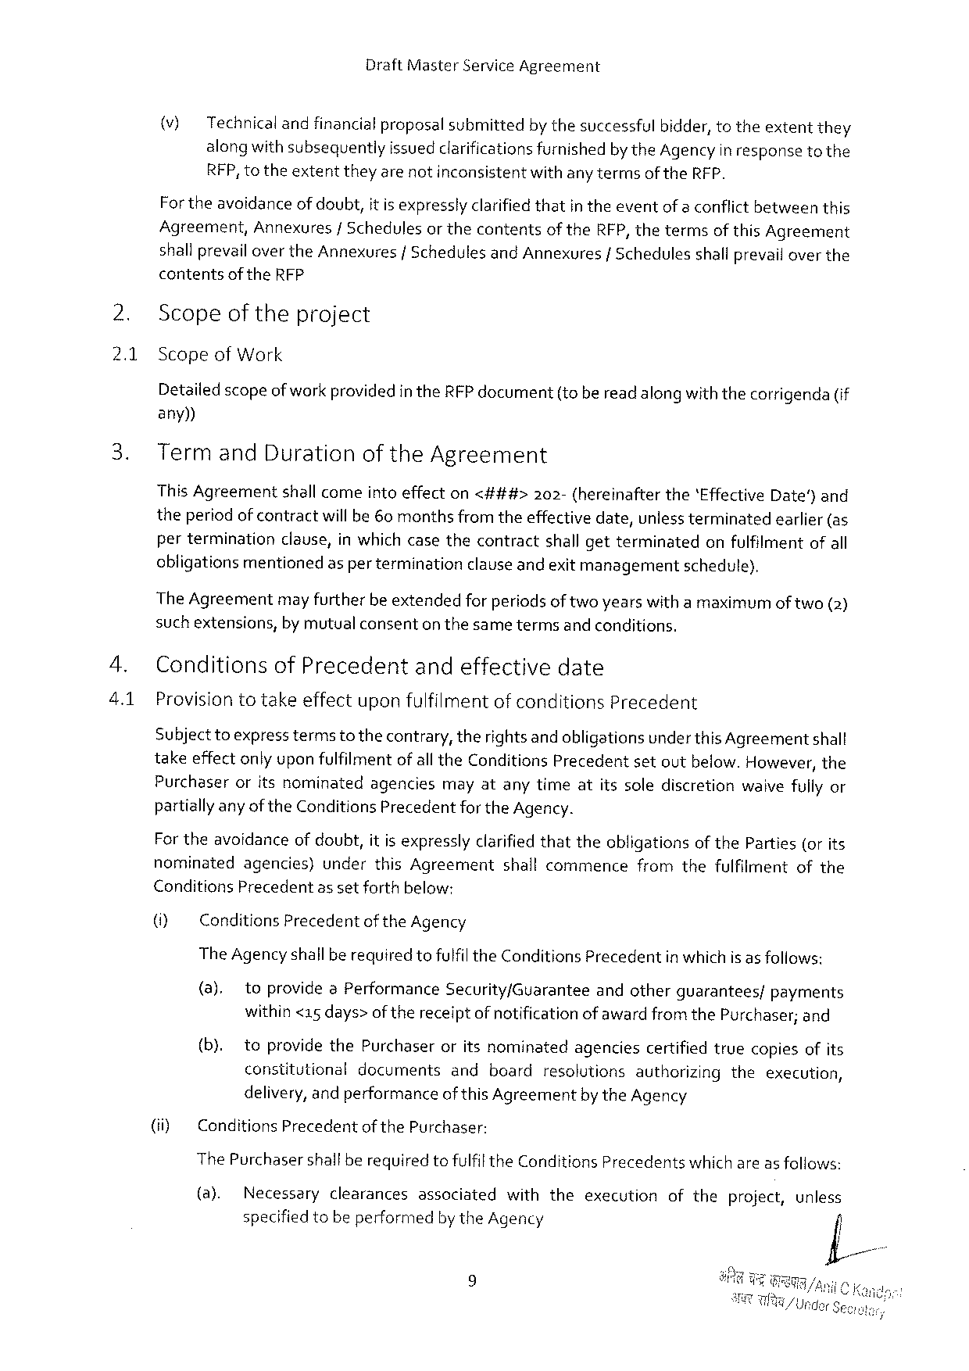

DraftMasterServiceAgreement

(v) Technicalandfinancial proposalsubmittedbythesuccessfulbidder, totheextentthey alongwith subsequentlyissuedclarificationsfurnishedbytheAgencyin responseto the RFP,totheextenttheyarenotinconsistentwithanytermsof theRFP.

For theavoidanceof doubt,it is expresslyclarifiedthatin theeventof a conflictbetweenthis Agreement,Annexures/Schedulesor thecontentsof theRFP, thetermsof this Agreement shallprevailovertheAnnexures |SchedulesandAnnexures | Schedules shallprevailoverthe

contentsof theRFP

Scopeof theproject

2.1 ScopeofWork

Detailed scopeofworkprovidedin theRFPdocument(oberead along withthecorrigenda(if any))

TermandDurationoftheAgreement

ThisAgreement shallcomeintoeffecton<###> 202-(hereinafter the‘EffectiveDate) and

theperiod ofcontractwillbe 60 monthsfromtheeffectivedate,unlessterminatedearlier (as perterminationclause,inwhichcasethecontractshall getterminatedonfulfilmentofall obligationsmentionedas per terminationclause andexitmanagementschedule),

The Agreementmay furtherbe extendedfor periodsof twoyearswitha maximumof two(2) suchextensions,by mutualconsenton thesametermsand conditions.

ConditionsofPrecedentandeffectivedate

Provisiontotakeeffectuponfulfilmentof conditionsPrecedent

Subject toexpress termsto thecontrary,therights andobligationsunder thisAgreementshall takeeffectonly uponfulfilmentof all theConditionsPrecedentsetoutbelow.However,the Purchaseroritsnominatedagenciesmayatanytimeatitssolediscretionwaivefully or partiallyany ofthe ConditionsPrecedentfortheAgency.

For theavoidanceofdoubt,it isexpresslyclarifiedthattheobligationsof theParties(or its nominatedagencies)underthisAgreement shallcommencefromthefulfilmentofthe ConditionsPrecedentas setforthbelow:

(i) ConditionsPrecedentof theAgency

TheAgency shallbe requiredtofulfil theConditionsPrecedentinwhich is as foliows:

|  |  |  |  |  |  |  |  |  |  |  |
| --- | --- | --- | --- | --- | --- | --- | --- | --- | --- | --- |
| (ii) | (a). | toprovideaPerformance | | | Security/Guarantee | andother | | guarantees/ | | payments |
| within<15days> of thereceiptof notificationofawardfromthePurchaser;and | | | | | | | | | |
| (b). | | toprovidethePurchaser | | oritsnominated | agencies | certified | | truecopiesofits | |
| constitutional | | | documents | andboardresolutionsautherizingtheexecution, | | | | | |
| delivery, andperformanceof this Agreementby theAgency | | | | | | | | | |
| ConditionsPrecedent | | | of thePurchaser: | | | | | | |

ThePurchasershallberequiredtofulfil theConditionsPrecedentswhich areas follows:

|  |  |  |  |  |  |  |  |  |  |
| --- | --- | --- | --- | --- | --- | --- | --- | --- | --- |
| (8). | Necessary | clearances | associated | with | the | execution | ofthe | project, | unless |
| specified tobe performedby theAgency | | | |

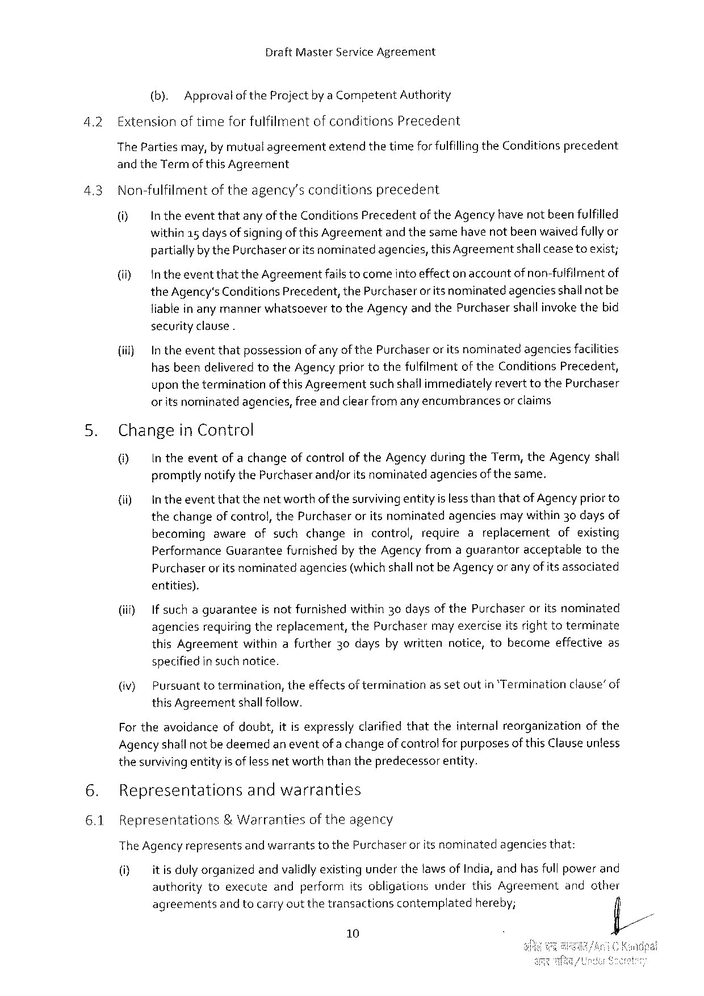

DraftMasterServiceAgreement

|  |  |  |  |  |
| --- | --- | --- | --- | --- |
| 4.2 | (b). | ApprovaloftheProjectby a CompetentAuthority | | precedent |
| ExtensionoftimeforfulfilmentofconditionsPrecedent | | |
| ThePartiesmay,by mutualagreement | | extendthetimeforfulfillingtheConditions |

andtheTermof thisAgreement

4.3 Non-fulfilmentoftheagency’sconditionsprecedent

(i) IntheeventthatanyoftheConditions Precedent oftheAgencyhavenotbeenfulfilled

within15 days of signingof thisAgreementandthesamehave notbeenwaived fullyor partiallybythePurchaseror itsnominatedagencies,thisAgreementshall ceaseteexist;

(il IntheeventthattheAgreementfails tocomeinto effectonaccountof non-fulfilmentof theAgency'sConditionsPrecedent,thePurchaserorits nominatedagenciesshallnotbe liablein any mannerwhatsoevertotheAgency andthePurchasershallinvokethebid securityclause.

|  |  |  |  |
| --- | --- | --- | --- |
| {iil) | In theeventthatpossession | ofanyofthePurchaseroritsnominated | agenciesfacilities |

hasbeendeliveredtotheAgencypriortothefuifilmentof theConditionsPrecedent, upon theterminationof thisAgreementsuch shailimmediatelyreverttothePurchaser or itsnominatedagencies,freeand clearfromany encumbrancesor claims

5. Changein Control

() In theeventofachangeofcontrolof theAgencyduringtheTerm,theAgencyshall promptlynotifythePurchaserandjorits nominatedagenciesof thesame.

(i) Intheeventthatthenetworthof thesurvivingentityisless thanthatof Agencypriorto thechangeof control,thePurchaseror itsnominatedagenciesmay within30daysof

|  |  |  |  |
| --- | --- | --- | --- |
| becomingawareofsuchchange | incontrol, | requireareplacement | ofexisting |

PerformanceGuaranteefurnishedby theAgencyfromaguarantoracceptabletothe

|  |  |  |
| --- | --- | --- |
| Purchaser | oritsnominated | agencies(whichshallnotbeAgencyor anyofitsassociated |

entities).

|  |  |  |  |  |
| --- | --- | --- | --- | --- |
| (i) | Ifsuchaguarantee | isnotfurnished | within30daysofthePurchaser | oritsnominated |

agencesrequiringthereplacement,thePurchasermay exerciseitsright toterminate thisAgreementwithinafurther30daysbywrittennotice,tobecomeeffectiveas specifiedin such notice.

|  |  |  |  |  |
| --- | --- | --- | --- | --- |
| (iv) | Pursuanttotermination, | theeffectsof termination | assetoutin‘Termination | clause’of |

this Agreementshallfollow.

Fortheavoidanceofdoubt,itis expresslyclarifiedthattheinternalreorganizationofthe Agencyshallnot bedeemedaneventof a changeof controlfor purposesofthisClauseunless thesurvivingentityis of lessnetworththanthepredecessorentity.

6. Representations andwarranties

6.1 Representations & Warranties oftheagency

TheAgencyrepresents andwarrantstothePurchaser oritsnominated agenciesthat:

(i) itisdulyorganizedandvalidlyexistingunderthetaws ofIndia,andhas fullpowerand

authority toexecute andperform itsobligations under thisAgreement andother

agreementsand tocarryoutthetransactionscontemplatedhereby; fil/

10

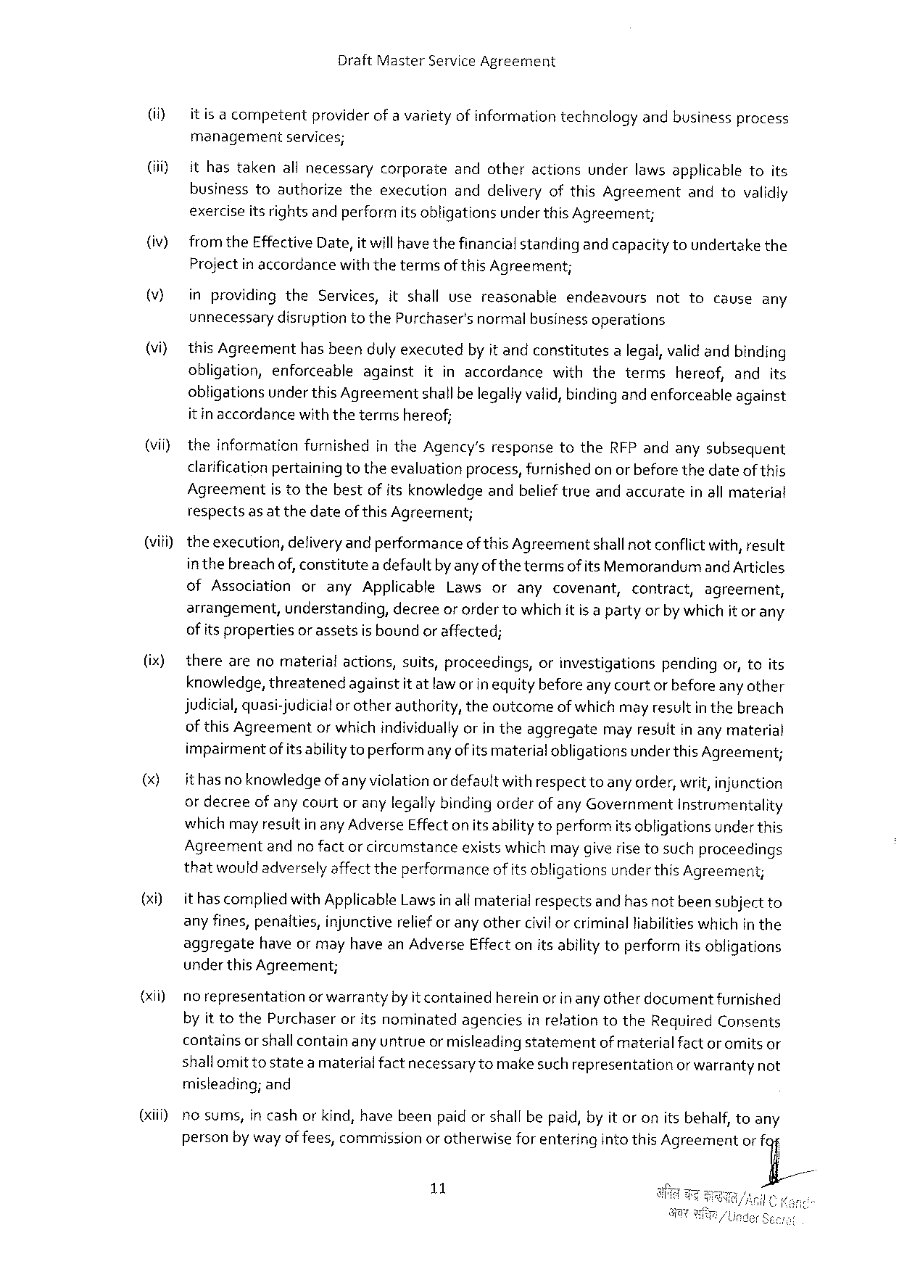

DraftMasterServiceAgreement

|  |  |  |  |  |  |  |  |  |
| --- | --- | --- | --- | --- | --- | --- | --- | --- |
| (i)  (i)  (iv)  (V)  (vi)  (vii) | itisacompetent | providerofavarietyofinformation | | | technology | andbusiness | | process |
| managementseivices;  ithastakenallnecessarycorporateandotheractionsunderlawsapplicabletoits businesstoauthorizetheexecutionanddeliveryofthisAgreementandtovalidly exerciseitsrights andperformits obligationsunder this Agreement;  from theEffectiveDate,it willhavethefinancialstandingandcapacity toundertakethe Projectin accordancewiththetermsof thisAgreement; | | | | | | | |
| inprovidingtheServices,itshallusereasonable | | | | endeavours | nottocauseany | | |
| unnecessarydisruptiontothePurchaser'snormalbusinessoperations  this Agreementhasbeendulyexecutedby it andconstitutesa legal, validandbinding | | | | | | | |
| obligation,enforceable | | against | itinaccordancewiththeterms | | | hereof,andits | |
| obligationsunder thisAgreementshallbelegallyvalid,bindingand enforceableagainst itinaccordancewiththetermshereof;  theinformationfurnishedin theAgency’sresponsetotheRFPandanysubsequent clarification pertainingtotheevalvationprocess,furnishedon or beforethedateofthis Agreementistothebestof itsknowledgeandbelieftrueandaccurateinall material | | | | | | | |

respectsas at thedateofthis Agreement;

(viii)- theexecution,defiveryandperformanceof this Agreementshallnotconflictwith,result inthebreach of, constitutea defaultby anyofthe termsof itsMemorandumandArticles ofAssociationoranyApplicableLawsoranycovenant, contract, agreement, arrangement,understanding,decreeor ordertowhich itis a partyorby whichit or any of its propertiesor assetsis boundor affected;

(ix) therearenomaterial actions, suits,proceedings, orinvestigations pendingor,toits knowledge, threatenedagainstitatlaw orin equitybefore any courtor before any other judicial,quasi-judicialor otherauthority,theoutcomeofwhich mayresultin thebreach of thisAgreementor whichindividuallyorin theaggregatemay resultin any material impairmentof its abilitytoperformanyofits materialobligationsunder this Agreement;

() ithasno knowledge ofanyviclationordefaultwithrespecttoanyorder,writ,injunction or decreeof anycourtor anylegallybindingorderof any GovernmentInstrumentality which may resultinanyAdverseEffecton itsabilitytoperformitsobligationsunderthis

|  |  |  |  |  |  |  |  |  |  |  |  |
| --- | --- | --- | --- | --- | --- | --- | --- | --- | --- | --- | --- |
| (xi)  {xii)  (il | Agreement | andnofactorcircumstance | | | | existswhichmaygiverisetosuchproceedings | | | | | |
| thatwouldadversely affecttheperformanceof its obligationsunderthis Agreemen;  ithascomplied withApplicableLawsinall materialrespectsand hasnot beensubject to any fines,penalties,injunctivereliefor any othercivilor criminalliabilitieswhichin the aggregatehaveor mayhaveanAdverseEffect onitsabilitytoperformitsobligations underthisAgreement; | | | | | | | | | | |
| norepresentation | | orwarranty | byitcontained | | | hereinor inanyotherdocument | | | furnished | |
| by it tothePurchaseroritsnominatedagenciesin relationtotheRequiredConsents | | | | | | | | | | |
| containsor shallcontainany untrueor misleadingstatement | | | | | | | | ofmaterialfactor omitsor | | |
| shallomit tostatea materialfactnecessary tomake such representationor warrantynot misleading;and  nosums,in cashor kind,havebeenpaid orshall bepaid,by it oronitsbehalf, toany | | | | | | | | | | |
| personby wayof fees,commission | | | | orotherwise | | | forenteringintothisAgreement | | | orfy/ |

11

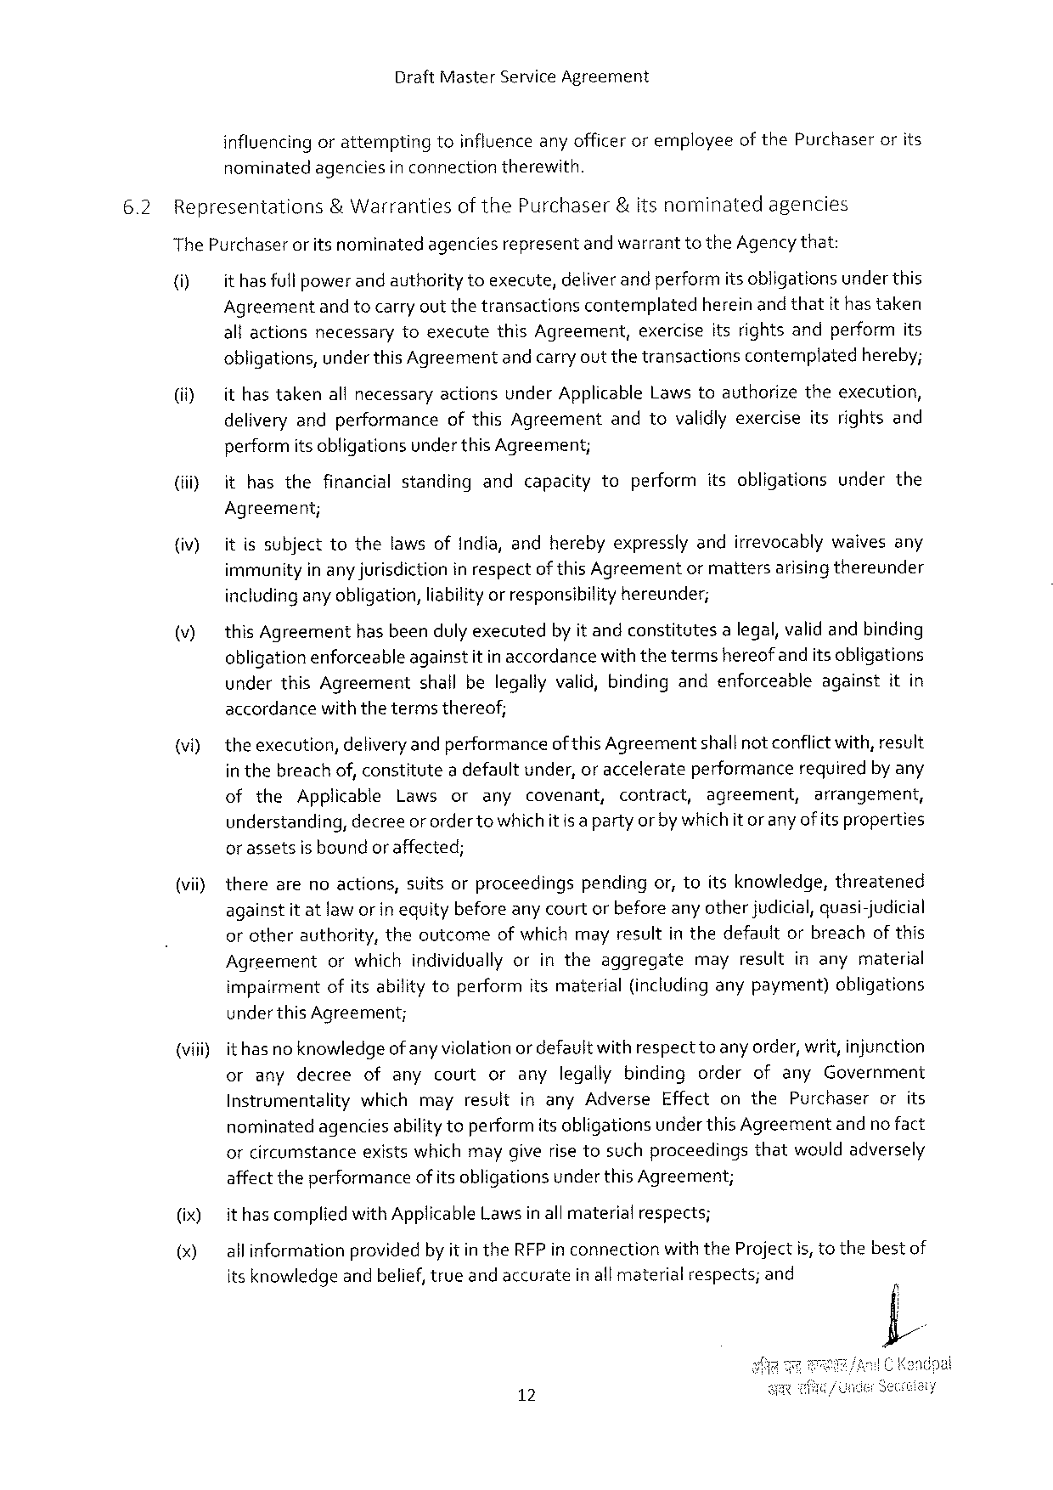

DraftMasterServiceAgreement

influencing orattemptingtoinfluence anyofficer oremployeeof thePurchaserorits nominatedagenciesin connectiontherewith.

|  |  |  |  |  |  |
| --- | --- | --- | --- | --- | --- |
| 6.2 | Representations | & Warranties | ofthePurchaser | &itsnominated | agencies |

ThePurchaseror itsnominatedagenciesrepresentand warranttotheAgencythat:

() ithasfull powerandauthoritytoexecute,deliverandperformitsobligationsunderthis

Agreement andtocarryoutthetransactions contemplated hereinandthatithastaken

allactionsnecessarytoexecutethisAgreement,exerciseitsrightsandperformits obligations,under thisAgreementandcarryoutthetransactionscontemplatedhereby;

(i) ithastakenallnecessaryactionsunderApplicableLaws toauthorizetheexecution, deliveryandperformanceofthisAgreementandtovalidlyexerciseitsrightsand performitsobligationsunderthisAgreement;

(iiiy ithasthefinancialstandingandcapacitytoperformitsobligationsunderthe

Agreement;

(iv) itissubjecttothelawsofIndia,andherebyexpresslyandirrevocablywaivesany immunityinanyjurisdiction in respectofthis Agreementormattersarisingthereunder includingany obligation,liabilityor responsibility hereunder;

|  |  |
| --- | --- |
| (v) | this Agreementhasbeendulyexecutedby itandconstitutesa legal, validandbinding obligationenforceableagainstitin accordancewiththetermshereofandits obligations |

underthisAgreementshallbelegallyvalid,bindingandenforceableagainstitin accordancewiththetermsthereof;

|  |  |  |  |  |  |  |  |  |  |  |  |  |  |
| --- | --- | --- | --- | --- | --- | --- | --- | --- | --- | --- | --- | --- | --- |
| (vi) | theexecution, | | | deliveryandperformance | | | | | of thisAgreement | | | shallnotconflictwith,result | |
| in thebreachof, constitutea defaultunder,or accelerateperformancerequiredby any | | | | | | | | | | | | |
| of | the | Applicable | | Laws | or | any | covenant, | | contract, | agreement, | | arrangement, |

understanding,decreeor orderto whichit is a partyorby whichitoranyof itsproperties orassetsisboundor affected;

(vii) therearenoactions,suitsorproceedingspendingor,toitsknowledge,threatened againstitatlawor in equitybeforeanycourtorbeforeany otherjudicial,quasi-judicial orotherauthority,theoutcomeof whichmayresultin thedefaultorbreachof this

|  |  |  |
| --- | --- | --- |
| Agreement | orwhichindividuallyorintheaggregate | mayresultinanymaterial |

impairmentofitsability toperformitsmaterial(includinganypayment)obligations

under thisAgreement;

(viii)ithasno knowledgeof anyviolation ordefaultwithrespectto any order, writ,injunction oranydecree ofanycourtoranylegallybindingorderofanyGovernment InstrumentalitywhichmayresultinanyAdverseEffectonthePurchaserorits nominatedagenciesabilitytoperformitsobligationsunder thisAgreementandno fact orcircumstanceexistswhichmaygiverise tosuchproceedingsthatwouldadversely affect theperformanceof itsobligationsunderthis Agreement;

(ix) it hascompliedwithApplicableLawsinall materialrespects;

() allinformationprovidedby itin theRFPin connectionwiththeProjectis,tothebestof

itsknowledge andbelief,trueandaccurate inallmaterial respects; and

12

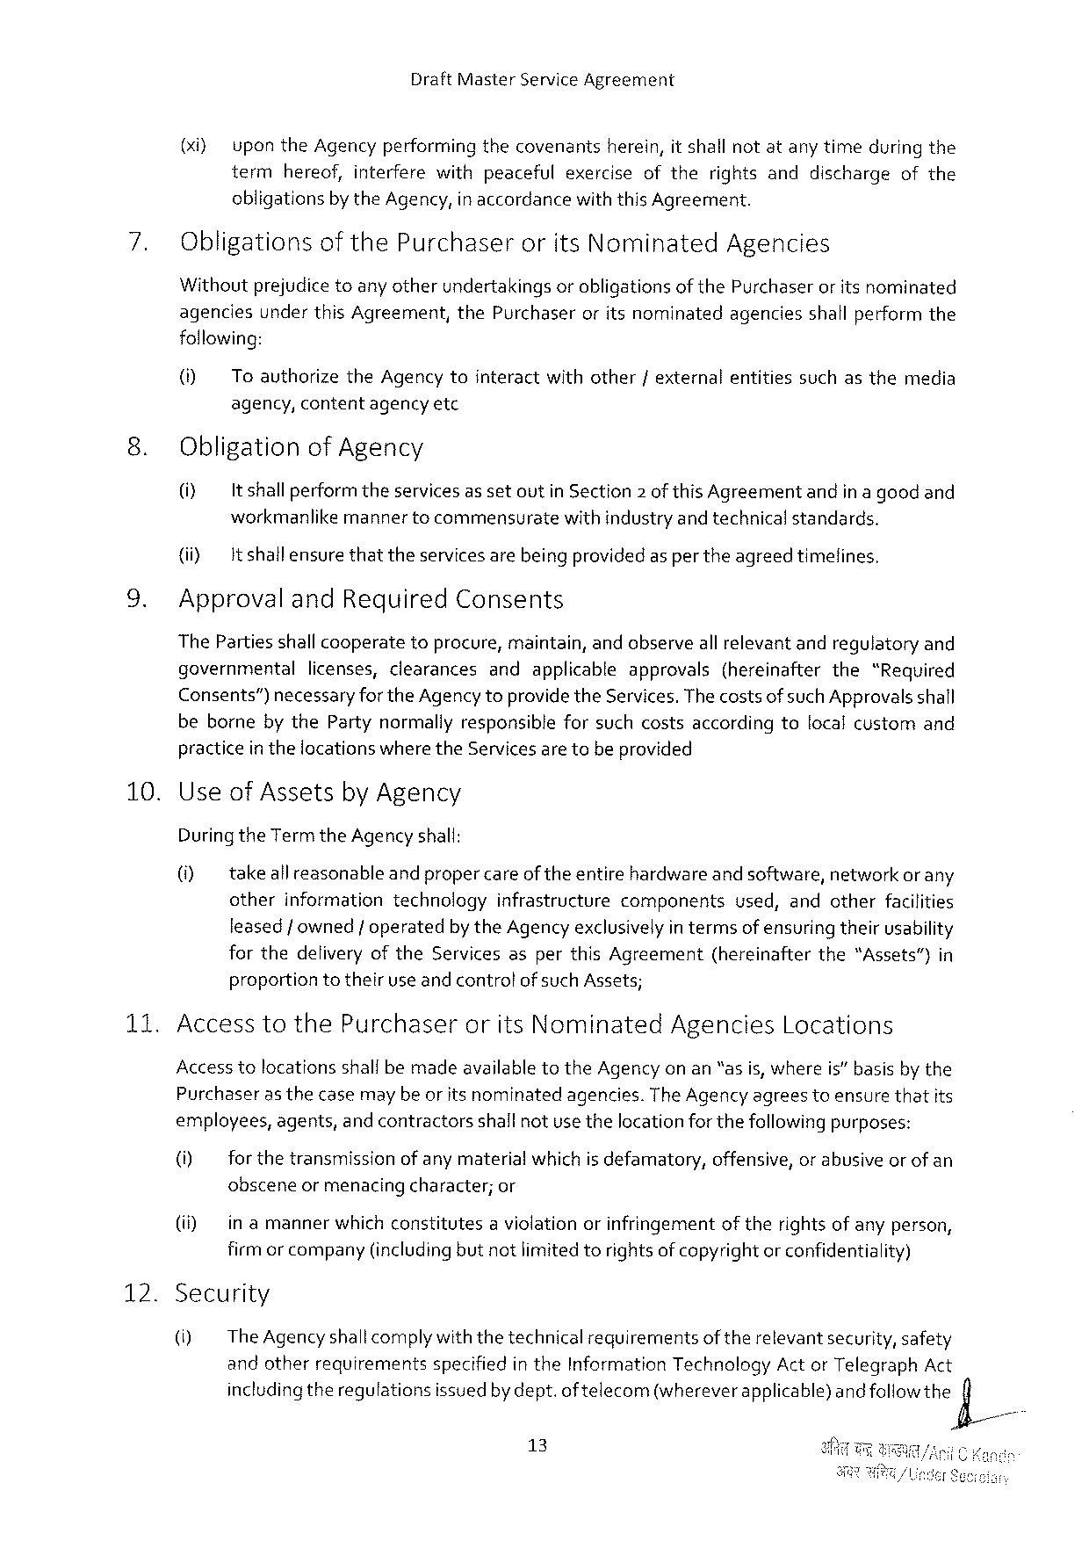

DraftMasterServiceAgreement

(xi} upontheAgencyperforming thecovenants herein,itshallnotatanytimeduringthe term hereof,interferewithpeacefulexerciseoftherightsanddischargeofthe

obligations by theAgency,in accordance withthisAgreement.

ObligationsofthePurchaser oritsNominated Agencies

Withoutprejudice toany otherundertakingsorobligationsof thePurchaseror itsnominated agenciesunderthisAgreement,thePurchaseroritsnominatedagenciesshallperformthe following:

(i) ToauthorizetheAgencytointeractwithother/externalentitiessuchasthemedia agency,contentagencyetc

ObligationofAgency

|  |  |  |
| --- | --- | --- |
| (i) | It shallperformtheservicesassetoutinSection2 ofthisAgreement | andinagoodand |

workmanlikemannertocommensuratewith industryand technicalstandards.

(i) It shallensurethattheservicesarebeingprovidedas per theagreedtimefines,

ApprovalandRequiredConsents

ThePartiesshallcooperatetoprocure,maintain,andobserveall relevantandregulatoryand

|  |  |  |
| --- | --- | --- |
| governmental | licenses,clearances | andapplicableapprovals(hereinafterthe“Required |

Consents”) necessaryfortheAgencytoprovidetheServices.ThecostsofsuchApprovalsshall bebornebythePartynormallyresponsibleforsuchcostsaccordingtolocalcustomand practicein thelocationswhere theServicesaretobeprovided

10. UseofAssetsby Agency

DuringtheTerm theAgency shall:

0] takeallreasonable andpropercareoftheentirehardwareandsoftware, networkorany

otherinformationtechnologyinfrastructurecomponents used,andotherfacilities leasedf owned/ operatedby theAgency exclusivelyin termsofensuring theirusability forthedeliveryoftheServicesasperthisAgreement(hereinafterthe“Assets”)in proportiontotheiruse andcontrolof suchAssets;

|  |  |  |  |
| --- | --- | --- | --- |
| 135 | AccesstothePurchaser | oritsNominated | AgenciesLocations |

AccesstolocationsshallbemadeavailabletotheAgency on an“as is, whereis” basisby the

|  |  |  |  |
| --- | --- | --- | --- |
| Purchaser | as thecasemaybeoritsnominated | agencies. | TheAgencyagreestoensurethatits |

employees,agents,and contractorsshallnotusethelocationforthefollowingpurposes:

(i) for thetransmissionof anymaterialwhichis defamatory,offensive,or abusiveor of an obsceneormenacing character;or

(i) in amannerwhichconstitutesa violationorinfringementoftherightsofanyperson, firmor company(includingbut notlimitedtorights ofcopyrightor confidentiality)

12. Security

() TheAgencyshallcomplywiththetechnicalrequirementsof therelevantsecurity, safety andotherrequirementsspecifiedin theInformationTechnologyAct or TelegraphAct includingtheregulationsissuedby dept.oftelecom(whereverapplicable)andfoHowthe)X/

13

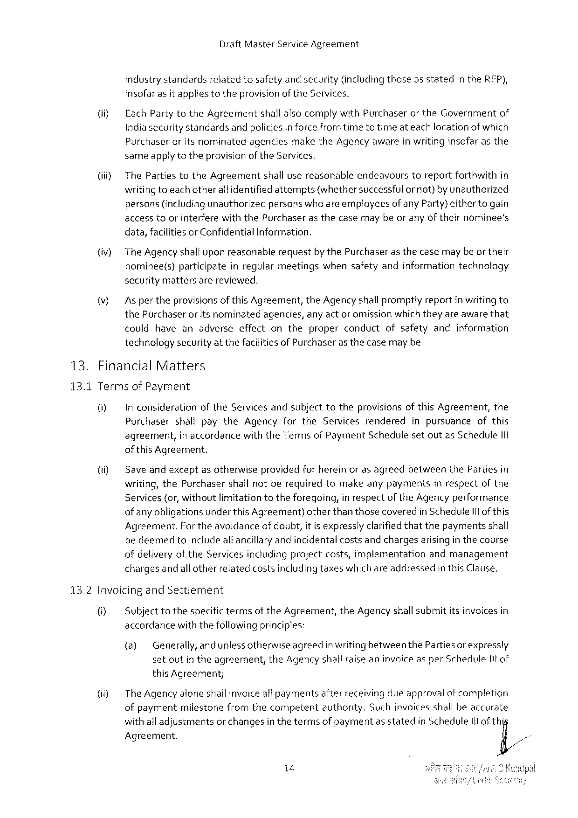

DraftMasterServiceAgreement

industry standardsrelatedtosafetyand security(includingthoseas statedin theRFP), insofarasit appliestotheprovisionoftheServices.

|  |  |  |  |  |
| --- | --- | --- | --- | --- |
| (ii) | Each PartytotheAgreementshall alsocomply withPurchaseror theGovernmentof Indiasecurity standardsandpoliciesin forcefromtimeto timeat eachlocationofwhich | | | |
| Purchaser | oritsnominated | agencies | maketheAgencyawareinwritinginsofarasthe |

sameapplyto theprovisionof theServices.

(jii} ThePartiestotheAgreementshall usereasonableendeavourstoreportforthwithin writingtoeach otherall identified attempts(whethersuccessful ornot)by unauthorized persons(includingunauthorizedpersonswho are employeesofany Party)eithertogain accesstoorinterferewiththePurchaserasthecasemaybeor anyof theirnominee’s

|  |  |  |
| --- | --- | --- |
| (iv) | data,facilitiesorConfidential | Information. |
| The Agency shalluponreasonablerequestby thePurchaseras thecasemay be ortheir nominee(s)participateinregularmeetingswhensafetyandinformationtechnology | |

securitymattersarereviewed.

Asper theprovisionsof this Agreement,theAgencyshall promptlyreportin writing to thePurchaseroritsnominated agencies,anyactor omissionwhichtheyareawarethat couldhaveanadverseeffectontheproperconductofsafetyandinformation technologysecurityat thefacilitiesof Purchaserasthecasemay be

|  |  |  |
| --- | --- | --- |
| 13. | Financial | Matters |

13.1TermsofPayment

0] In considerationof theServices andsubjecttotheprovisions of thisAgreement,the PurchasershallpaytheAgencyfortheServicesrendered inpursuanceofthis agreement,in accordancewiththeTermsof PaymentSchedulesetoutas Schedule11t of thisAgreement.

|  |  |  |
| --- | --- | --- |
| (i) | Saveandexceptasotherwiseprovidedfor hereinoras agreedbetweenthePartiesin writing,thePurchasershallnotberequiredtomakeanypaymentsinrespectofthe | |
| Services(or,withoutlimitationtotheforegoing, | in respectoftheAgencyperformance |

ofany obligationsunderthis Agreement)otherthanthosecoveredin ScheduleI1l of this Agreement.For theavoidanceof doubt,itis expresslyclarifiedthatthepaymentsshall be deemedtoincludealtancillaryandincidentalcostsandchargesarisingin thecourse ofdelivery oftheServicesincludingprojectcosts,implementationandmanagement chargesandallotherrelatedcostsincludingtaxeswhichareaddressedin thisClause,

13.2InvoicingandSettlement

@ Subjecttothespecifictermsof theAgreement,theAgencyshallsubmititsinvoicesin accerdancewiththefollowing principles:

(@ Generally,and unlessotherwiseagreedin writing betweenthePartiesor expressly setoutin theagreement,theAgency shall raise aninvoiceasper Scheduleitof this Agreement;

iy TheAgency aloneshailinvoiceall paymentsafterreceiving dueapprovalof completion ofpaymentmilestonefromthecompetentauthority.Suchinvoicesshallbeaccurate withall adjustmentsor changesin thetermsof paymentas statedin Schedule1lof thi Agreement.

14

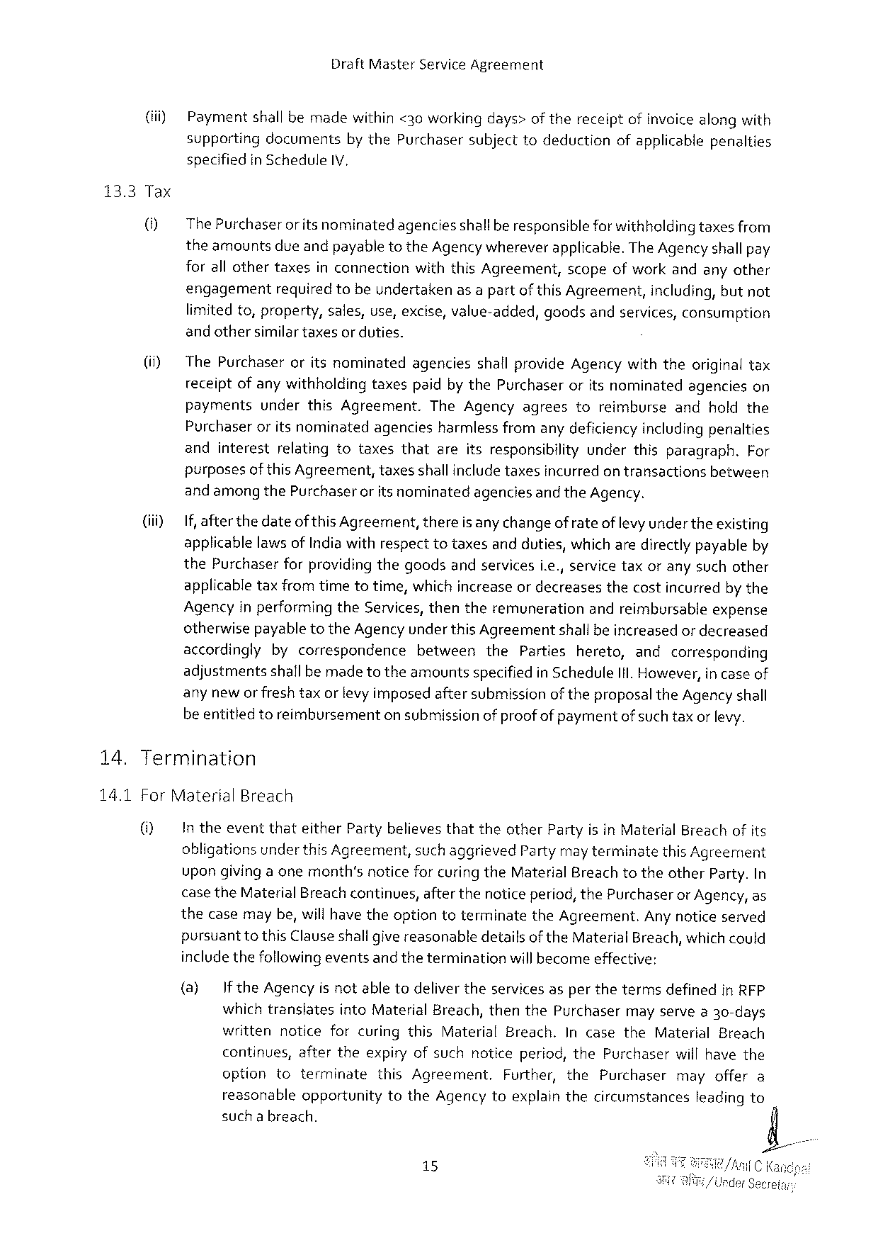

DraftMasterServiceAgreement

|  |  |
| --- | --- |
| (iii) | Paymentshall bemadewithin <30workingdays>of thereceiptofinvoicealongwith supportingdocumentsby thePurchasersubjecttodeductionofapplicablepenalties specifiedin ScheduleIV, |

13.3Tax

|  |  |  |
| --- | --- | --- |
| U} | The Purchaseror itsnominatedagenciesshallberesponsible forwithholding taxesfrom theamountsdue andpayabletotheAgencywhereverapplicable.TheAgency shallpay forall othertaxesinconnectionwiththisAgreement,scopeofworkandanyother | |
| engagement | requiredtobeundertakenasa partofthis Agreement,including, butnot |

limitedto,property, sales,use,excise,value-added,

and othersimilartaxesor duties.

goodsandservices,consumption

|  |  |  |
| --- | --- | --- |
| (i) | ThePurchaseroritsnominatedagenciesshallprovideAgencywiththeoriginaltax receiptofanywithholdingtaxespaidby thePurchaseroritsnominatedagencieson | |
| payments | underthisAgreement.TheAgencyagreestoreimburseandholdthe |
| Purchaseroritsnominatedagenciesharmlessfromany deficiencyincludingpenalties | |

andinterestrelatingtotaxesthatareitsresponsibilityunderthisparagraph.For purposesofthis Agreement,taxesshallincludetaxesincurred ontransactionsbetween

|  |  |  |
| --- | --- | --- |
| (iiiy | andamongthePurchaserorits nominated | agenciesandtheAgency. |
| If, after thedateof thisAgreement,thereis any changeof rateof levyunder theexisting applicablelaws of Indiawithrespecttotaxesandduties,which aredirectlypayableby thePurchaserforproviding thegoodsandservicesi.e., servicetaxoranysuchother | |

applicabletaxfromtimetotime,whichincreaseor decreasesthecostincurredby the Agencyin performingtheServices, thentheremunerationandreimbursableexpense otherwisepayable totheAgency underthis Agreementshallbeincreasedor decreased

|  |  |  |  |  |  |  |
| --- | --- | --- | --- | --- | --- | --- |
| 14. | accordinglybycorrespondence | | between | the | Partieshereto, | andcorresponding |
| adjustmentsshallbemadetotheamountsspecifiedin ScheduleIll. However,in caseof | | | | | |
| anynewor fresh | taxorlevy imposedaftersubmissionoftheproposaltheAgency shall | | | | |
| be entitledtoreimbursementon submissionof proofof paymentofsuch taxor levy. Termination | | | | | |

14.1ForMaterialBreach

|  |  |
| --- | --- |
| 0} | In theeventthateitherPartybelievesthattheotherPartyisinMaterialBreachofits obligationsunder thisAgreement,such aggrievedPartymayterminatethis Agreement upongivingaonemonth’snoticefor curing theMaterialBreach totheotherParty.In |

case theMaterial Breachcontinues,afterthenoticeperiod, thePurchaseror Agency, as thecasemaybe,willhavetheoptiontoterminatetheAgreement.Anynoticeserved pursuanttothisClauseshallgivereasonabledetailsof the MaterialBreach,whichcould includethefollowingeventsand theterminationwill becomeeffective:

|  |  |  |  |  |  |  |  |  |  |  |
| --- | --- | --- | --- | --- | --- | --- | --- | --- | --- | --- |
| (@) | If theAgencyisnotabletodelivertheservicesasperthetermsdefinedin RFP | | | | | | | | | Can |
| whichtranslates | | | intoMaterialBreach,thenthePurchaser | | | mayservea30-days | | |
| writtennoticeforcuringthisMaterialBreach.IncasetheMaterialBreach | | | | | | | | |
| continues,aftertheexpiryofsuchnoticeperiod,thePurchaserwillhavethe | | | | | | | | |
| option | toterminate | | | thisAgreement, | Further,thePurchasermayoffera | | | |
| reasonable | | opportunity | | totheAgencytoexplainthecircumstances | | | leadingto | |
| such a breach. | | | | | | | | |
| 15 | | | | | /i | | | C |

nderSec

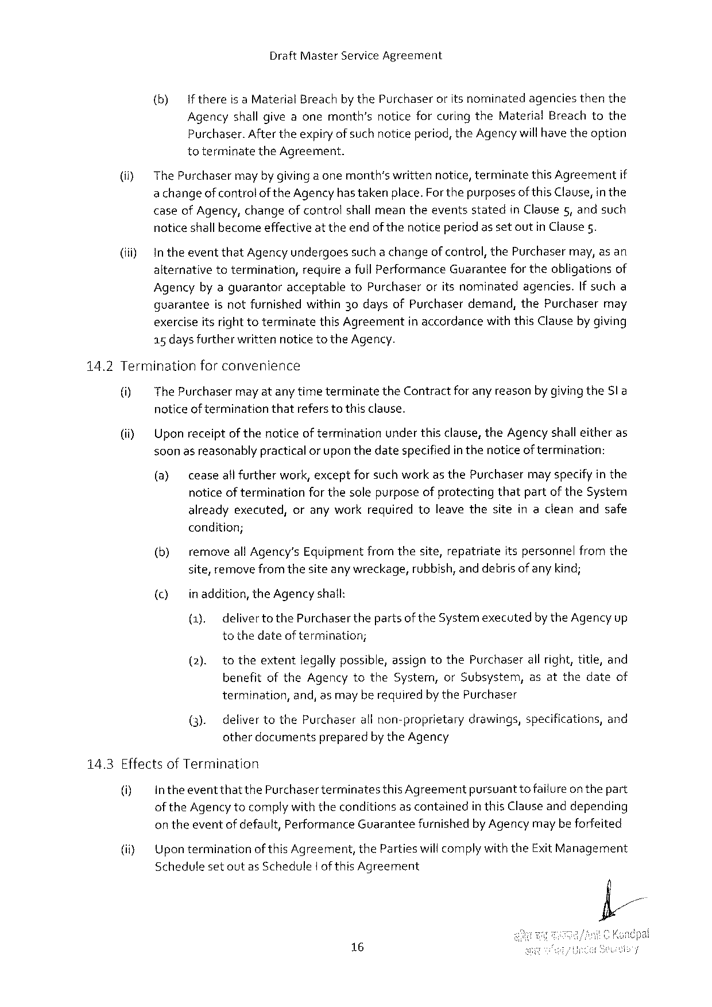

DraftMasterServiceAgreement

{(b) Ifthereisa MaterialBreach by thePurchaseroritsnominatedagenciesthenthe Agencyshall giveaonemonth’snoticeforcuringtheMaterialBreachtothe Purchaser.Aftertheexpiryofsuchnoticeperiod, theAgency willhave theoption toterminatetheAgreement.

|  |  |  |  |  |
| --- | --- | --- | --- | --- |
| (i) | ThePurchaser | mayby givingaonemonth’swrittennotice,terminate | thisAgreement | if |
| achangeofcontroloftheAgency hastaken place.ForthepurposesofthisClause,in the | | | |

caseofAgency, changeofcontrolshall meantheeventsstatedin Clause 5,andsuch noticeshallbecomeeffectiveatthe endof thenoticeperiod as setoutin Clause5.

(iii) IntheeventthatAgencyundergoessuch a changeofcontrol, thePurchasermay,asan alternativetotermination,requireafull PerformanceGuaranteefor theobligationsof Agencyby aguarantoracceptabletoPurchaseroritsnominatedagencies.If sucha guaranteeisnotfurnishedwithin30daysofPurchaserdemand,thePurchasermay exerciseitsrighttoterminatethisAgreementin accordancewiththisClauseby giving a5days furtherwrittennoticeto theAgency.

14.2Terminationforconvenience

|  |  |  |
| --- | --- | --- |
| 0]  (i) | The Purchasermayat any timeterminatetheContractforany reasonbygivingtheSl a noticeof terminationthatrefers tothis clause.  Upon receiptofthenoticeof terminationunderthisclause,theAgency shall eitheras soonas reasonablypractical or upon thedatespecifiedin thenoticeoftermination: | |
| (@) | ceaseall furtherwork,exceptforsuch workas thePurchasermay specifyin the |

noticeof terminationfor thesolepurposeof protectingthatpartof theSystem alreadyexecuted,oranyworkrequiredtoleavethesiteinacleanandsafe

condition;

(b) removeall Agency’s Equipmentfromthesite,repatriateitspersonnelfromthe site,remove fromthesiteanywreckage,rubbish, and debrisofany kind;

() inaddition,theAgency shall:

(1), delivertothePurchaser thepartsof theSystemexecutedby theAgencyup tothedateof termination;

(2). totheextentlegally possible,assigntothePurchaserall right,title,and benefitoftheAgencytotheSystem,orSubsystem,asatthedateof

termination, and,asmayberequiredby thePurchaser

(3). defivertothePurchaserall non-proprietarydrawings,specifications,and otherdocumentspreparedby theAgency

14.3Effectsof Termination

|  |  |  |  |
| --- | --- | --- | --- |
| 0] | intheeventthatthePurchaserterminates | thisAgreement | pursuanttofailureon thepart |
| ofthe Agency tocomplywith theconditionsascontainedin thisClauseanddepending | | |

on theeventofdefault,PerformanceGuaranteefurnishedby Agency maybeforfeited

(i}   
 SchedulesetoutasSchedule|of thisAgreement

16

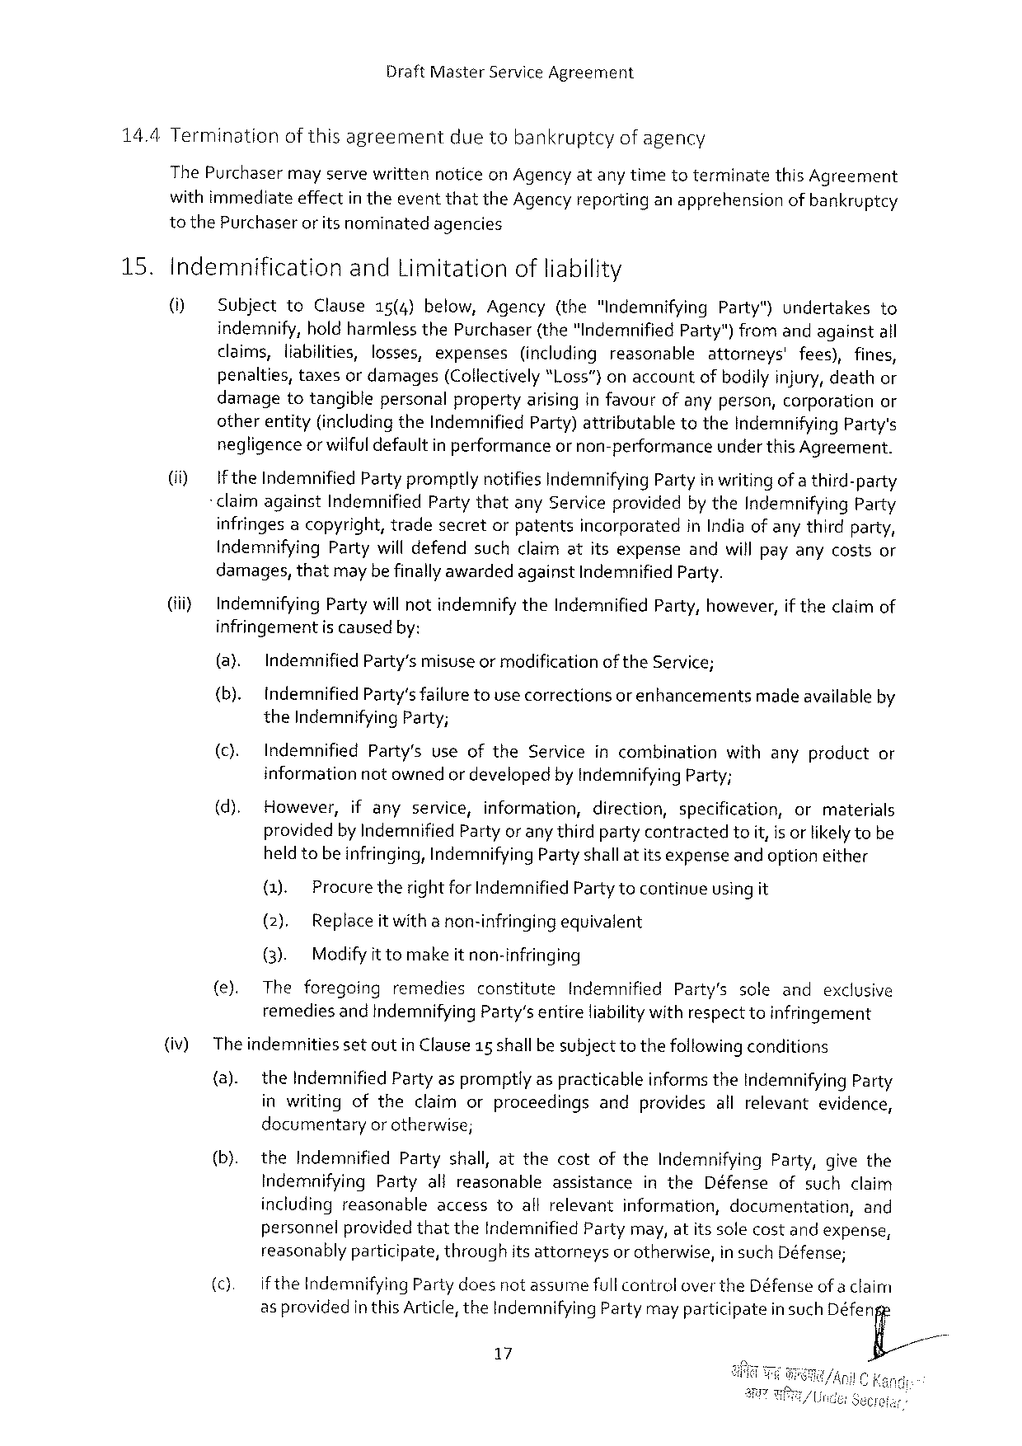

DraftMasterServiceAgreement

14.4Terminationofthisagreement duetobankruptcyofagency

ThePurchaser mayservewritten noticeonAgencyatanytimetoterminate thisAgreement

withimmediateeffectin theeventthattheAgencyreportinganapprehensionofbankruptcy

tothePurchaseror itsnominatedagencies

|  |  |  |  |  |  |  |  |  |  |  |  |  |  |  |  |  |  |  |  |  |  |
| --- | --- | --- | --- | --- | --- | --- | --- | --- | --- | --- | --- | --- | --- | --- | --- | --- | --- | --- | --- | --- | --- |
| 15. | Indemnification | | | | | andLimitationofliability | | | | | | | | | | | | | | | |
| () | SubjecttoClause15(4)below,Agency(the"IndemnifyingParty")undertakesto | | | | | | | | | | | | | | | | | | | |
| indemnify,holdharmlessthePurchaser(the“IndemnifiedParty")fromandagainstall | | | | | | | | | | | | | | | | | | | | |
| claims,liabilities,losses,expenses | | | | | | | | | (includingreasonable | | | | | attorneys' | | | fees),fines, | | | |
| penalties,taxesor damages(Collectively“l.oss”)onaccountofbodily injury,deathor damagetotangiblepersonalpropertyarisinginfavourofanyperson,corporationor otherentity(includingtheIndemnifiedParty)attributabletotheIndemnifying Party's negligenceor wilful defaultin performanceor non-performanceunder thisAgreement. | | | | | | | | | | | | | | | | | | | | |
| (i) | IftheIndemnifiedParty promptlynotifiesIndemnifying Partyin writing of a third-party | | | | | | | | | | | | | | | | | | | |
| -claimagainstIndemnifiedPartythatanyServiceprovidedbytheIndemnifyingParty infringes acopyright,tradesecretorpatentsincorporatedinIndiaof anythirdparty, IndemnifyingPartywill defendsuchclaimatitsexpenseandwill payanycostsor damages,thatmaybefinallyawardedagainstIndemnified Party. | | | | | | | | | | | | | | | | | | | | |
| (i) | IndemnifyingParty willnotindemnifytheIndemnifiedParty,however,if theclaimof | | | | | | | | | | | | | | | | | | | |
| infringementis causedby: | | | | | | | | | | | | | | | | | | | | |
| (@) | | Indemnified | | | Party’smisuseormodification | | | | | | oftheService; | | | | | | | | | |
| (b). | | IndemnifiedParty'sfailuretousecorrectionsor enhancementsmadeavailable by | | | | | | | | | | | | | | | | | | |
| theIndemnifying Party; | | | | | | | | | | | | | | | | | | | | |
| (). | | Indemnified | | | Party's | | useofthe | | Service | | incombination | | | with | | anyproduct | | | | or |
| informationnot ownedor developedby IndemnifyingParty; | | | | | | | | | | | | | | | | | | | | |
| (d). | | However, | | | ifany | | service, | information, | | | direction, | | specification, | | | or | | | materials | |
| providedbyIndemnified Partyor anythird partycontractedtoiit,is orlikelytobe heldtobeinfringing,Indemnifying Party shallatitsexpenseand optioneither | | | | | | | | | | | | | | | | | | | | |
| (). | | | Procuretheright for IndemnifiedPartytocontinueusing it | | | | | | | | | | | | | | | | | |
| (2). | | | Replaceit witha non-infringingequivalent | | | | | | | | | | | | | | | | | |
| (3). | | | Modifyit tomakeitnon-infringing | | | | | | | | | | | | | | | | | |
| (e). | | The | foregoing | | | remedies | | constitute | | Indemnified | | | Party's | | sole | and | | exclusive | | |
| remediesand indemnifyingParty’sentireliabilitywithrespecttoinfringement | | | | | | | | | | | | | | | | | | | | |
| (iv) | TheindemnitiessetoutinClause15 shallbe subjecttothefollowingconditions | | | | | | | | | | | | | | | | | | | |
| (a). | | the Indemnified Partyaspromptlyas practicableinformstheIndemnifying Party | | | | | | | | | | | | | | | | | | |
| inwritingoftheclaimorproceedingsandprovidesallrelevantevidence, documentaryorotherwise; | | | | | | | | | | | | | | | | | | | | |
| (b). | | theIndemnifiedPartyshall,atthecostoftheIndemnifyingParty,givethe | | | | | | | | | | | | | | | | | | |
| IndemnifyingPartyalireasonable | | | | | | | | | | assistance | | intheDéfenseofsuchclaim | | | | | | | | |
| includingreasonableaccesstoallrelevantinformation,documentation, | | | | | | | | | | | | | | | | | | | | and |
| personnel | | | | providedthattheIndemnified | | | | | | | Partymay,atitssolecostandexpense, | | | | | | | | | |
| reasonablyparticipate,throughitsattorneysor otherwise,in suchDéfense; | | | | | | | | | | | | | | | | | | | | |
| (c). | | iftheIndemnifying | | | | | Partydoesnotassumefull controlovertheDéfenseofa claim | | | | | | | | | | | | | |
| as providedin thisArticle,theIndemnifyingPartymayparticipatein such Déferfi | | | | | | | | | | | | | | | | | | | | |

=

17

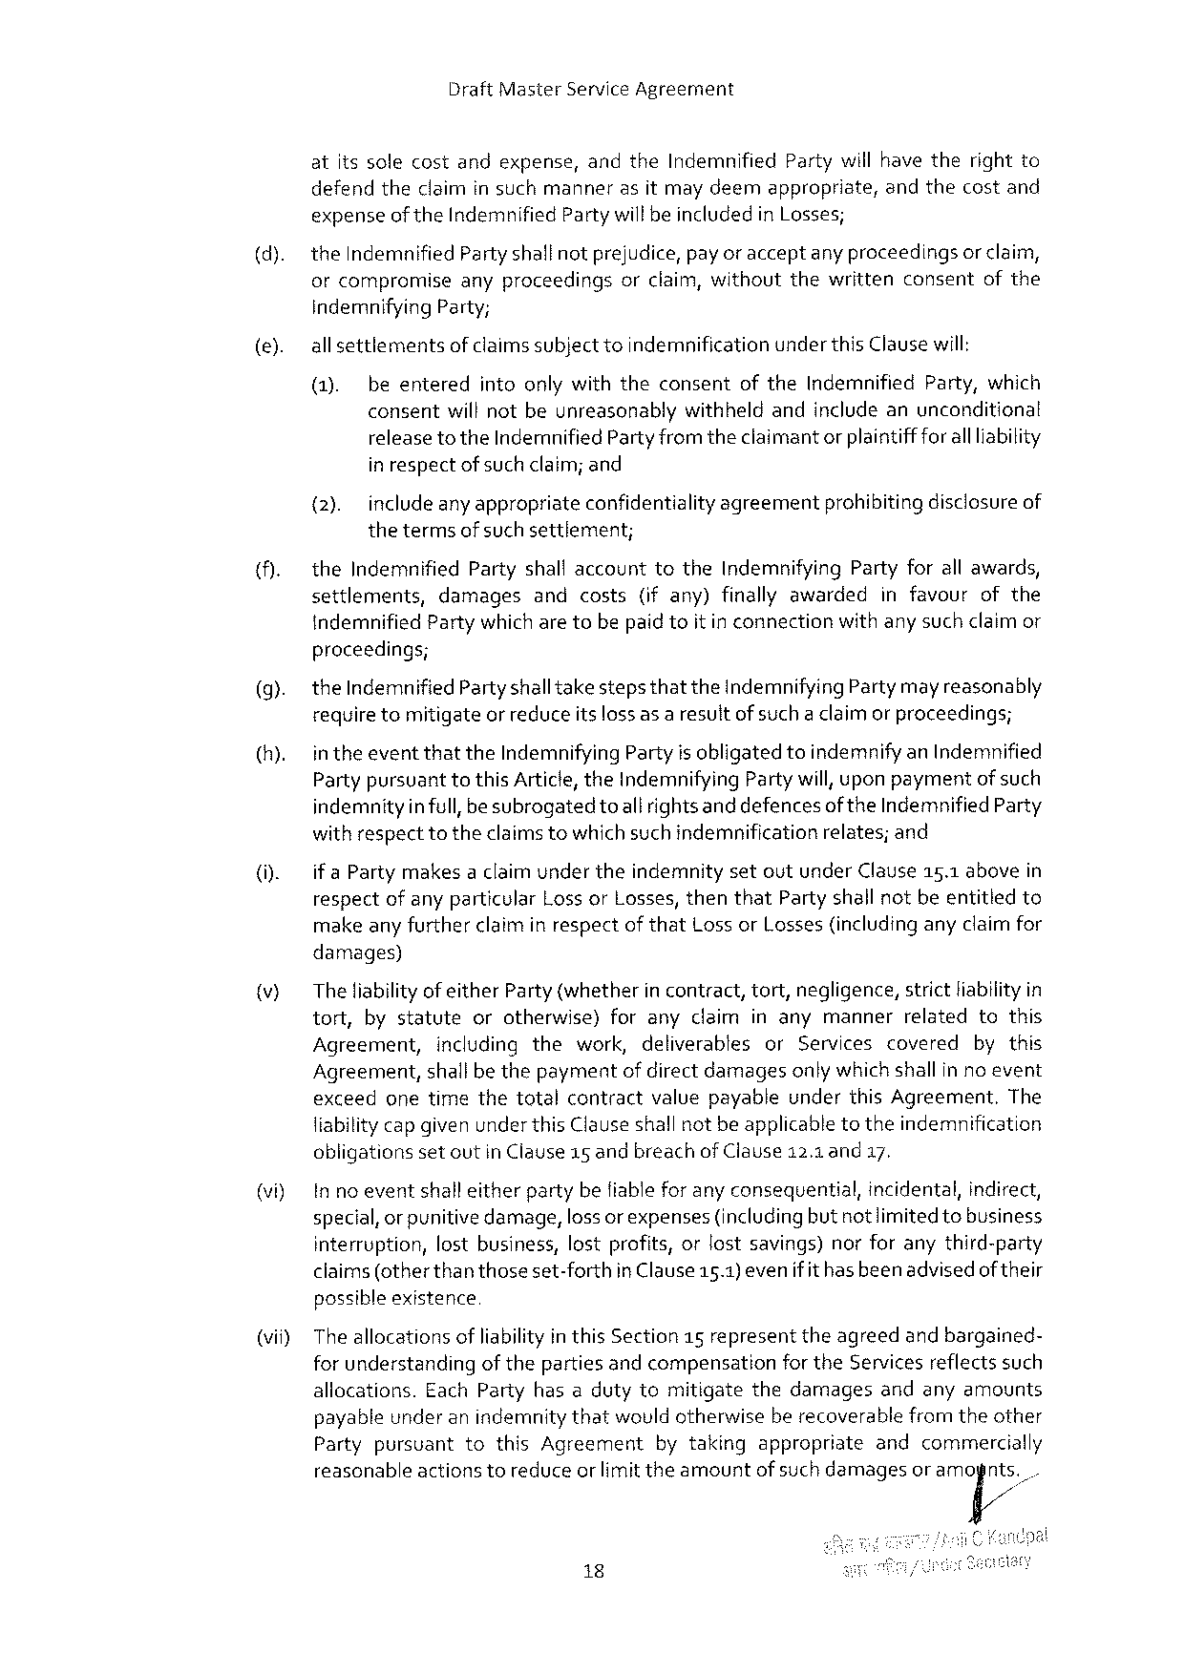

DraftMasterServiceAgreement

atitssolecostandexpense,andtheIndemnifiedPartywill havetherightto defendtheclaimin suchmannerasitmay deemappropriate,andthecostand expenseof theIndemnifiedPartywillbeincludedin Losses;

theIndemnifiedPartyshallnotprejudice,payor acceptany proceedingsor claim,

|  |  |  |  |  |  |
| --- | --- | --- | --- | --- | --- |
| orcompromise | anyproceedings | orclaim,without | thewritten | consent | ofthe |

indemnifyingParty;

|  |  |  |  |
| --- | --- | --- | --- |
| (e). | all settlements | | of claimssubject toindemnificationunderthisClausewill: |
| (1). | beenteredintoonlywiththeconsentoftheIndemnifiedParty,which | |
| consentwill notbeunreasonablywithheldandincludeanunconditional | | |

releasetotheIndemnified Partyfromtheclaimant or plaintiffforall liability in respectof such claim;and

{2). includeanyappropriateconfidentiality agreementprohibiting disclosureof

thetermsof suchsettlement;

|  |  |  |  |  |  |  |  |  |
| --- | --- | --- | --- | --- | --- | --- | --- | --- |
| (). | theIndemnifiedPartyshall accounttotheIndemnifyingPartyforall awards, | | | | | | | |
| settlements, | damages | and | costs | (ifany) | finallyawarded | infavour | ofthe |

indemnifiedPartywhicharetobepaidtoitin connectionwithany such claimor proceedings;

|  |  |
| --- | --- |
| (9).  (h). | theIndemnified PartyshalltakestepsthattheIndemnifyingPartymayreasonably requiretomitigateor reduceitslossas a resultofsuch a claimor proceedings;  in theeventthattheIndemnifyingPartyis obligatedtoindemnify anIndemnified PartypursuanttothisArticle,theIndemnifyingPartywill, uponpaymentof such |

indemnityinfull, besubrogatedtoall rights anddefencesof theIndemnified Party withrespecttotheclaimstowhichsuch indemnificationrelates;and

(). if a PartymakesaclaimundertheindemnitysetoutunderClause15.1abovein respectofanyparticularLoss orLosses, thenthatPartyshall notbeentitledto makeany furtherclaim in respectof thatLossorLosses(includinganyclaimfor

damages)

|  |  |  |  |  |  |  |  |  |
| --- | --- | --- | --- | --- | --- | --- | --- | --- |
| v) | Theliabilityof eitherParty(whether | | | | in contract, | tort,negligence, | strictliabilityin | |
| tort, | bystatute | | orotherwise)foranyclaiminanymannerrelatedtothis | | | | |
| Agreement, | | includingthework,deliverables | | | orServicescovered | | bythis |
| Agreement,shallbe thepaymentof directdamagesonlywhich shallin no event | | | | | | | |

exceedonetimethetotalcontractvaluepayableunderthisAgreement.The liabilitycapgivenunder thisClauseshallnotbe applicabletotheindemnification

|  |  |  |  |  |
| --- | --- | --- | --- | --- |
| (vi) | obligations | setoutinClause15andbreachofClause12.1and17. | | |
| In noeventshalleitherpartybefiableforanyconsequential, | | incidental, | indirect, |
| special,orpunitivedamage,loss orexpenses(includingbut notlimitedtobusiness interruption,lostbusiness,lostprofits,orlostsavings)norforanythird-party | | | |

claims(otherthanthoseset-forth possible existence

in Clause15.1)evenifit hasbeenadvisedof their

(vii) The allocationsofliabilityinthisSection15representtheagreedand bargained-

for understandingof thepartiesandcompensationfortheServices reflectssuch

allocations.EachPartyhasadutytomitigatethedamagesandanyamounts

payableunderanindemnitythatwouldotherwiseberecoverablefromtheother

Party pursuant to thisAgreement bytaking appropriate and commercially

reasonableactionstoreduceor limittheamountof such damagesor am(]n/ts‘/.

18

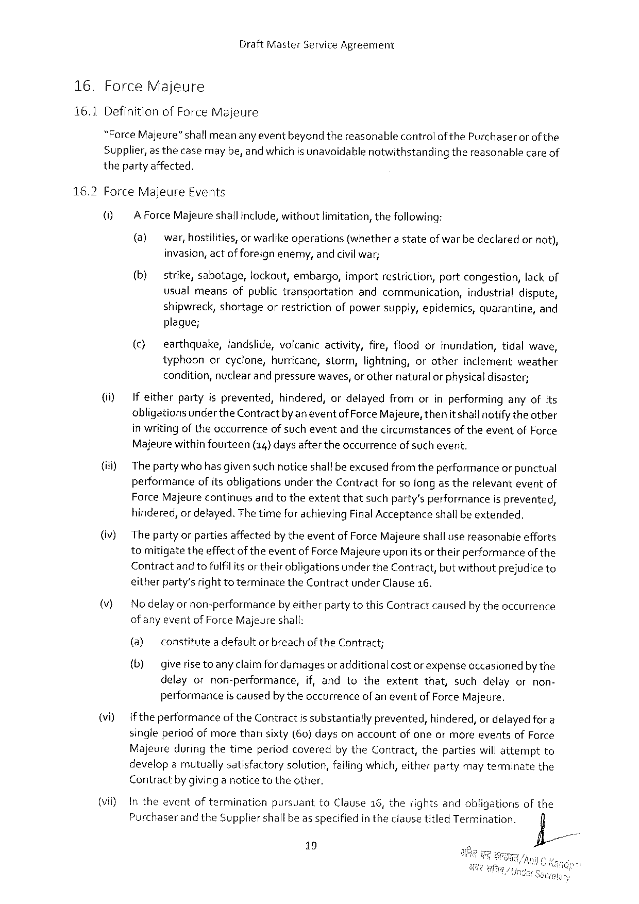

DraftMasterServiceAgreement

|  |  |  |
| --- | --- | --- |
| 16. | Force | Majeure |

16.1DefinitionofForceMajeure

“ForceMajeure”shall meananyeventbeyond thereasonablecontrolofthePurchaser or of the Supplier,as thecasemaybe,and which is unavoidablenotwithstandingthereasonablecare of thepartyaffected,

|  |  |  |  |  |  |  |
| --- | --- | --- | --- | --- | --- | --- |
| 16.2 | ForceMajeure | | | Events | | ornot), |
| () | A Force Majeureshallinclude, withoutlimitation, thefollowing: | | | |
| (a) | | war,hostifities,orwarlikeoperations | | (whetherastateofwarbedeclared |

invasion,actofforeign enemy,andcivilwar;

|  |  |  |
| --- | --- | --- |
| (b) | strike,sabotage,tockout,embargo,importrestriction,portcongestion,lack of | |
| usualmeansofpublictransportation | andcommunication,industrialdispute, |
| shipwreck,shortageorrestrictionofpowersupply,epidemics,quarantine,and | |

plague;

|  |  |  |  |  |  |  |  |  |  |
| --- | --- | --- | --- | --- | --- | --- | --- | --- | --- |
| (i)  (i)  (iv)  )  vi) | (c) | earthquake,landslide,volcanicactivity,fire,floodorinundation,tidalwave, | | | | | | | |
| typhoonorcyclone,hurricane,storm,lightning,orotherinclementweather condition,nuclear and pressurewaves, orothernaturalor physicaldisaster; | | | | | | | | |
| If eitherpartyisprevented, | | | | | hindered,ordelayedfromorinperforminganyofits | | | |
| obligationsundertheContractby aneventof ForceMajeure,thenitshallnotifytheother in writingof theoccurrenceof sucheventandthecircumstancesoftheeventofForce | | | | | | | | |
| Majeurewithinfourteen | | | | (14) daysaftertheoccurrence | | | | ofsuchevent. |
| The partywho hasgivensuch noticeshallbe excusedfrom theperformanceor punctual performanceofits obligationsundertheContractforso longas therelevanteventof ForceMajeurecontinuesand totheextentthatsuchparty’sperformanceisprevented, hindered,or delayed.Thetimefor achievingFinalAcceptanceshallbeextended.  Thepartyor partiesaffectedby theeventof Force Majeureshallusereasonableefforts tomitigatetheeffectoftheevent of ForceMajeureuponitsor theirperformanceof the Contractand tofulfil itsor their obligationsunder theContract,butwithoutprejudiceto eitherparty’srighttoterminatetheContractunderClause16.  Nodelay or non-performanceby eitherpartytothisContractcausedby theoccurrence of anyevent of Force Majeureshall: | | | | | | | | |
| (3) | constitutea defaultorbreachoftheContract; | | | | | | | |
| (b) giverise | | toany claimfordamagesor additionalcostor expenseoccasionedbythe | | | | | | |
| delayornon-performance, | | | | | | if,andtotheextentthat,suchdelayornon- | | |
| performance | | | is caused | | by theoccurrence | | of aneventofForceMajeure. | |
| iftheperformanceoftheContractis substantiallyprevented,hindered,or delayed for a singleperiodofmorethansixty(60} daysonaccountof oneormoreeventsofForce Majeureduring thetimeperiodcoveredby theContract,thepartieswillattemptto developamutuallysatisfactorysolution,failingwhich,eitherpartymay terminatethe | | | | | | | | |

Contractby givinganoticetotheother,

|  |  |  |  |  |  |
| --- | --- | --- | --- | --- | --- |
| (vil) | Intheevent | oftermination | pursuant | toClause16,therightsandobligations | ofthe |
| Purchaserand theSuppliershallbeas specifiedintheclausetitledTermination. | | | |
| fi/ |

19

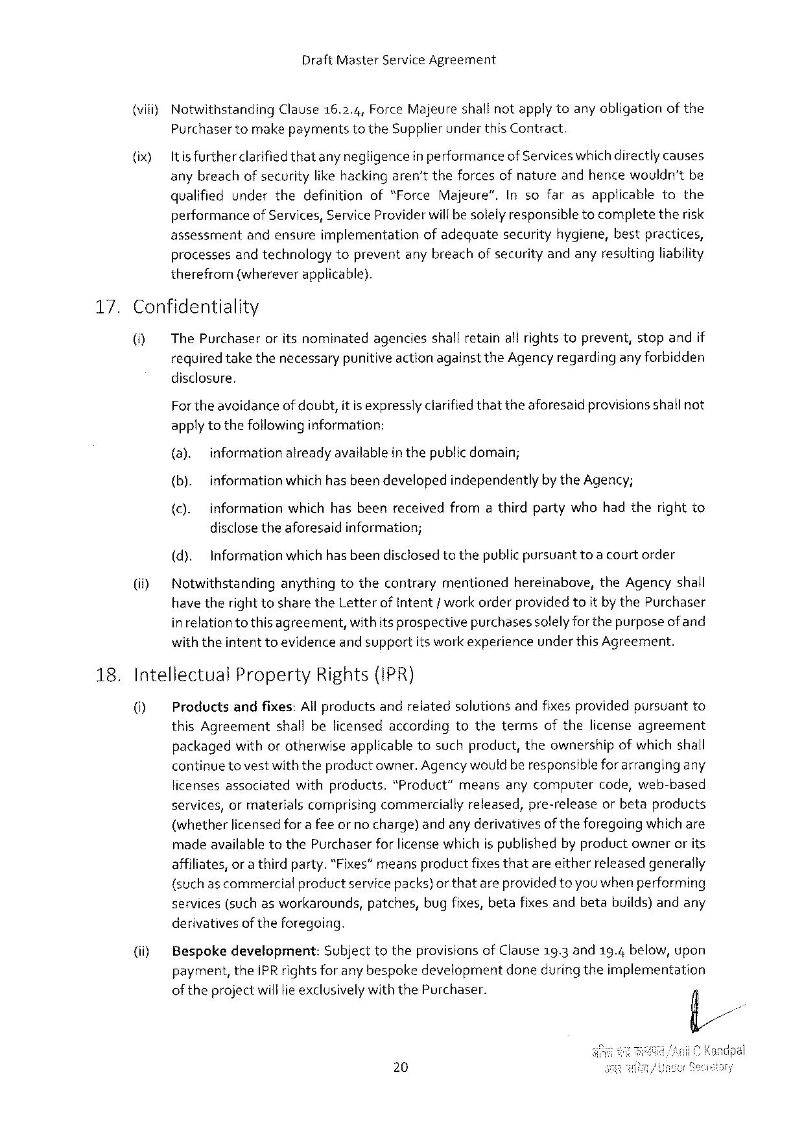

DraftMasterServiceAgreement

|  |  |  |  |
| --- | --- | --- | --- |
| (viii) | Notwithstanding | Clause16.2.4,ForceMajeureshallnotapplytoanyobligation | ofthe |

Purchasertomake paymentstotheSupplierunder this Contract.

|  |  |
| --- | --- |
| (ix) | Itis furtherclarifiedthatany negligencein performanceofServiceswhichdirectlycauses anybreachof securitylikehacking aren'ttheforcesofnatureandhencewouldn’tbe |

qualifiedunderthedefinitionof“ForceMajeure”.Insofarasapplicabletothe performanceof Services,ServiceProviderwillbe solelyresponsibletocompletetherisk assessmentandensureimplementationofadequatesecurityhygiene,bestpractices, processesand technologytopreventany breachofsecurityandanyresultingliability therefrom(whereverapplicable).

|  |  |  |
| --- | --- | --- |
| 17. | Confidentiality | |
| O] | ThePurchaseroritsnominatedagenciesshallretainall rightstoprevent,stopandif |
| requiredtakethenecessarypunitive actionagainsttheAgency regardinganyforbidden | |

disclosure,

Fortheavoidanceof doubt,itisexpresslyclarifiedthattheaforesaidprovisionsshallnot applytothefollowinginformation:

(a). informationalreadyavailableinthepublicdomain;

(b). informationwhich hasbeen developedindependentlyby theAgency;

{c). information whichhasbeenreceived fromathirdpartywhohadtherightto

disclosetheaforesaidinformation;

|  |  |  |  |
| --- | --- | --- | --- |
| (i) | (d). | Informationwhichhasbeendisclosedtothepublicpursuant | toa courtorder |
| Notwithstandinganythingtothecontrarymentionedhereinabove,theAgencyshall have therighttosharetheLetterof Intent/ workorderprovided toitby thePurchaser | | |

inrelationtothis agreement,withitsprospectivepurchasessolelyforthepurposeof and withtheintent toevidenceand supportits workexperienceunder this Agreement.

18.Intellectual Property Rights(IPR)

0] Productsandfixes:All productsandrelatedsolutionsandfixes providedpursuantto thisAgreementshallbelicensedaccordingtothetermsofthelicenseagreement packagedwithorotherwiseapplicabletosuchproduct,theownershipofwhichshall continue tovestwiththeproductowner.Agencywouldberesponsible forarrangingany licensesassociatedwithproducts."Product”meansanycomputercode,web-based services,ormaterialscomprisingcommerciallyreleased,pre-releaseorbetaproducts (whetherlicensedfor a feeor no charge) andany derivativesof theforegoingwhichare madeavailabletothePurchaserforlicense whichispublishedby productownerorits affiliates, or a thirdparty.“Fixes”meansproductfixesthatareeitherreleasedgenerally (suchascommercial productservicepacks)orthatareprovidedtoyouwhenperforming services(such as workarounds,patches,bugfixes, betafixes andbetabuilds)andany derivativesof theforegeing.

|  |  |  |
| --- | --- | --- |
| (i) | Bespokedevelopment: | Subject totheprovisions of Clause19.3and19.4below,upon |
| payment,theIPR rights for any bespokedevelopmentdoneduringtheimplementation | |

of theprojectwill lieexclusivelywiththePurchaser.

20

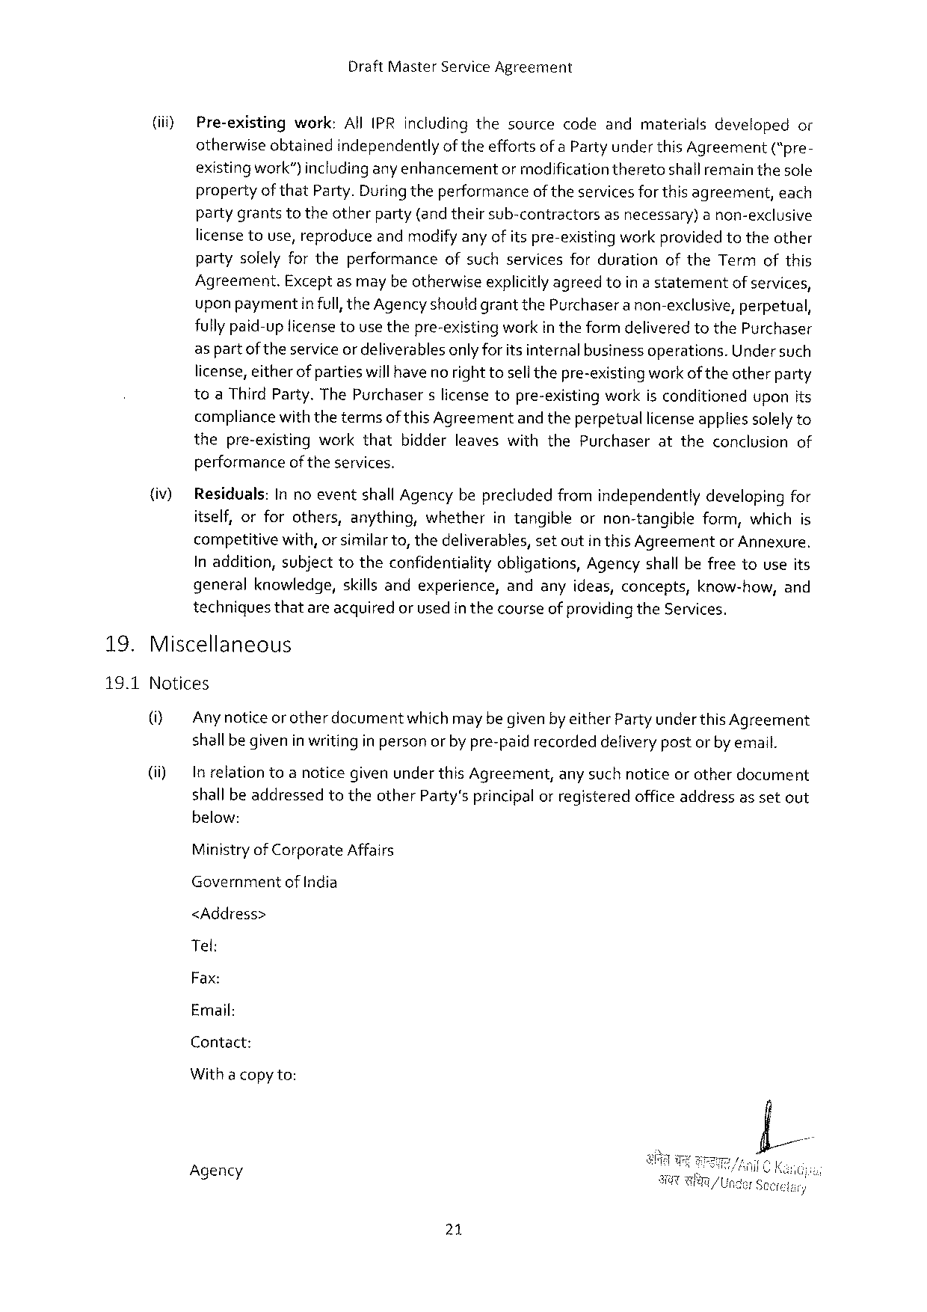

DraftMasterServiceAgreement

|  |  |  |  |
| --- | --- | --- | --- |
| (iif) | Pre-existing | work:AllIPRincludingthesourcecodeandmaterialsdeveloped | or |
| otherwiseobtainedindependentlyof theeffortsofa Party underthis Agreement(“pre- | | |

existingwork")includinganyenhancementormodificationtheretoshallremain thesole propertyofthatParty.Duringtheperformanceof theservices forthisagreement,each partygrantstotheotherparty(andtheirsub-contractorsasnecessary)a non-exclusive licensetouse,reproduceandmodifyany of itspre-existingworkprovidedtotheother partysolelyfortheperformanceofsuchservicesfordurationoftheTermofthis Agreement.Exceptasmaybe otherwiseexplicitlyagreedtoin a statementof services, upon paymentinfull,theAgencyshould grantthePurchaseranon-exclusive, perpetual, fullypaid-uplicensetousethepre-existingworkin theformdeliveredtothePurchaser aspartof theserviceordeliverablesonly for itsinternalbusinessoperations. Under such license,eitherof partieswillhave no righttosellthepre-existingwork oftheotherparty toaThirdParty.ThePurchaserslicensetopre-existingworkisconditioneduponits compliancewiththetermsofthis Agreementand theperpetuallicenseapplies solelyto thepre-existingworkthatbidderleaveswiththePurchaserattheconclusionof performanceof theservices.

(iv) Residuals:In noeventshall Agencybeprecludedfromindependentlydevelopingfor itself,orforothers,anything,whetherintangibleornon-tangibleform,whichis competitivewith,or similarto, thedeliverables,setoutin thisAgreementorAnnexure. Inaddition,subjecttotheconfidentialityobligations,Agencyshallbefreetouseits generalknowledge,skills andexperience,andanyideas,concepts,know-how,and techniquesthatareacquired or usedin thecourseofprovidingtheServices.

19. Miscellaneous

19.1Notices

(i) Any noticeorotherdocumentwhichmaybe givenby eitherPartyunder this Agreement shallbegivenin writingin personor by pre-paidrecordeddelivery postor by email.

(i) In relationtoa noticegivenunderthis Agreement,any suchnoticeorotherdocument shall beaddressedtotheotherPartysprincipalor registeredofficeaddressassetout below:

MinistryofCorporateAffairs

Government of India

<Address>

Tel:

Fax:

Email:

Contact:

Witha copyto:

Agency

21

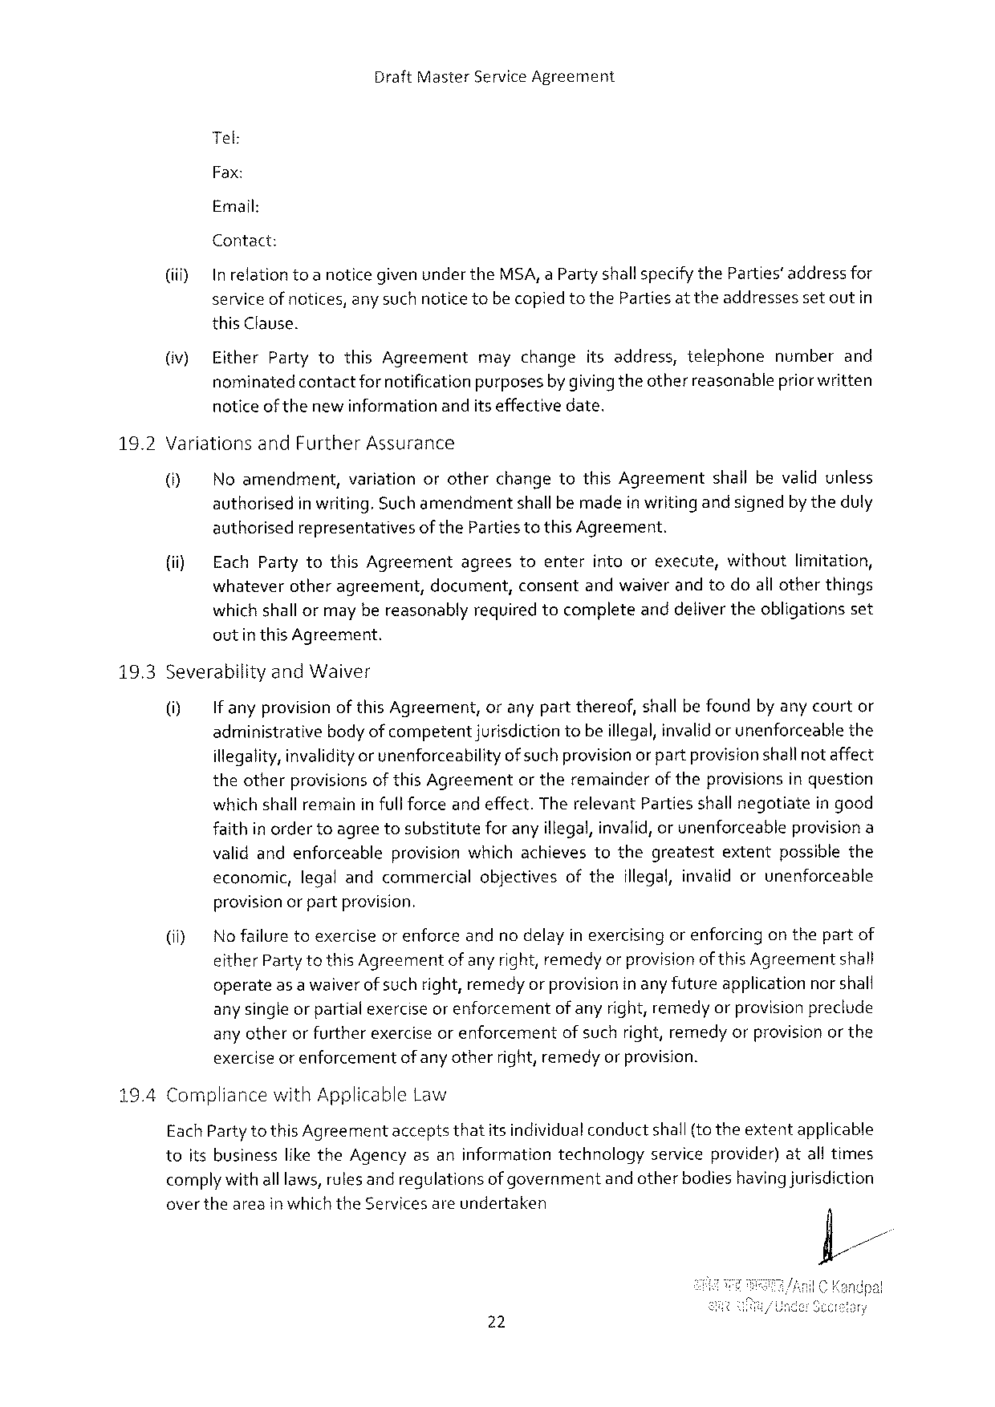

DraftMasterServiceAgreement

Tel:

Fax:

Email:

Contact:

(iiiy In relationtoa noticegiven under theMSA,a PartyshallspecifytheParties’addressfor service ofnotices,any suchnotice tobecopiedtotheParties at theaddressesset outin this Clause.

|  |  |  |  |
| --- | --- | --- | --- |
| (iv) | EitherPartytothisAgreement | maychangeitsaddress,telephone | numberand |
| nominatedcontactfornotificationpurposesby givingtheotherreascnablepriorwritten | | |

notice of thenewinformationanditseffectivedate.

|  |  |  |  |
| --- | --- | --- | --- |
| 16.2 | VariationsandFurtherAssurance | | |
| ® | Noamendment, | variationorotherchangetothisAgreementshallbevalidunless |
| authorisedin writing.Suchamendmentshallbemadein writing andsignedby theduly | | |

authorisedrepresentativesofthePartiestothisAgreement.

|  |  |  |  |  |  |  |
| --- | --- | --- | --- | --- | --- | --- |
| (ii) | EachPartytothisAgreement | agrees | toenter | intoorexecute, | without | limitation, |
| whateverotheragreement,document,consentandwaiver andtodoall otherthings | | | | | |

which shallormay bereasonablyrequiredtocompleteanddeliver theobligationsset outinthis Agreement.

|  |  |  |
| --- | --- | --- |
| 19.3 | SeverabilityandWaiver | |
| 0] | If anyprovisionof this Agreement,oranypartthereof,shall be foundby any courtor |
| administrativebodyofcompetent jurisdictiontobeillegal,invalid or unenforceablethe | |

illegality,invalidityor unenforceabilityof suchprovisionor partprovisionshallnot affect theotherprovisions of thisAgreementor theremainderof theprovisions inquestion which shall remaininfull forceand effect.TherelevantPartiesshall negotiatein good faithin ordertoagreetosubstitutefor anyillegal,invalid,or unenforceableprovisiona validandenforceableprovisionwhichachievestothegreatest extentpossiblethe

economic, legalandcommercial objectives ofthe illegal,invalidorunenforceable

provisionorpartprovision.

|  |  |  |  |
| --- | --- | --- | --- |
| (i) | Nofailuretoexerciseorenforce | andnodelayinexercisingorenforcing | onthepartof |
| eitherPartytothisAgreementof any right,remedyor provisionof thisAgreementshall | | |

operateas a waiverof suchright,remedyor provisioninanyfutureapplicationnorshall any single or partialexercise or enforcementof anyright,remedyor provisionpreclude any otherorfurtherexerciseorenforcementof suchright,remedyorprovisionor the exercise or enforcementofany otherright,remedyor provision.

CompliancewithApplicableLaw

EachPartytothisAgreementacceptsthatitsindividualconductshall{to theextentapplicable

|  |  |  |  |
| --- | --- | --- | --- |
| toitsbusiness | liketheAgencyasaninformation | technology | serviceprovider)atalltimes |

complywith alllaws,rulesandregulationsof governmentandotherbodieshavingjurisdiction overtheareainwhichtheServicesareundertaken

22

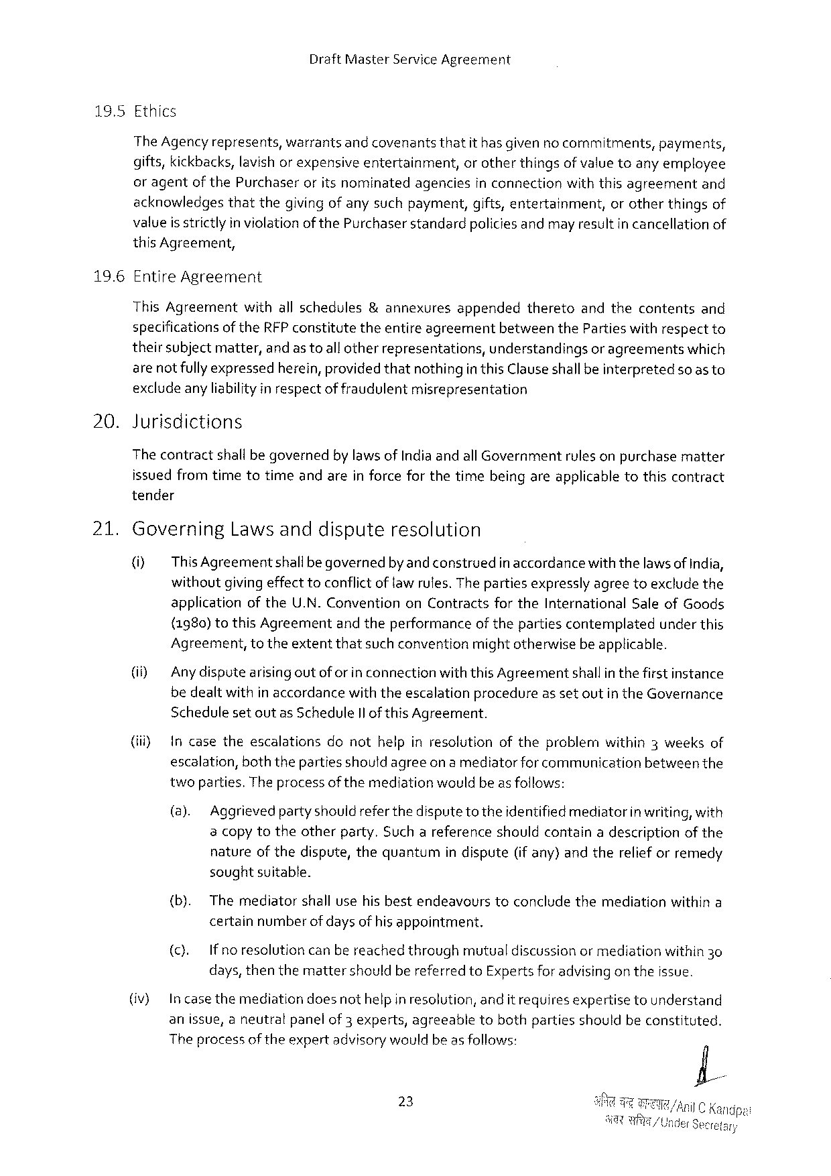

DraftMasterServiceAgreement

|  |  |  |  |  |  |  |
| --- | --- | --- | --- | --- | --- | --- |
| 19.5 | Ethics | | | | | |
| TheAgencyrepresents, | warrantsandcovenants | thatit hasgivenno commitments, | | | payments, |
| gifts,kickbacks,lavishor expensiveentertainment, | | | or otherthingsofvalue toany employee | | |
| or agentof thePurchaseroritsnominatedagenciesin connectionwiththisagreementand | | | | | |
| acknowledgesthatthegivingof anysuchpayment,gifts,entertainment, | | | | orotherthingsof | |

valueis strictly in violation of thePurchaserstandardpoliciesandmayresultin cancellationof this Agreement,

196 EntireAgreement

ThisAgreementwithallschedules&annexuresappendedtheretoandthecontentsand specificationsof theRFPconstitutetheentireagreementbetweentheParties withrespectto theirsubjectmatter,andastoall otherrepresentations,understandingsor agreementswhich are notfully expressedherein, providedthatnothingin thisClauseshallbeinterpretedsoasto exclude anyliabilityin respectof fraudulentmisrepresentation

20. Jurisdictions

The contractshallbe governedby lawsof Indiaandall Governmentrulesonpurchasematter issuedfromtimetotimeandareinforceforthetimebeingareapplicabletothiscontract tender

21. Governing Lawsanddispute resolution

(i) ThisAgreementshallbegovernedby and construedin accordancewiththelawsof India, withoutgivingeffect toconflict of law rules. The partiesexpresslyagreetoexclude the applicationoftheU.N. ConventiononContractsfortheInternationalSaleofGoods {1980) tothis Agreementandtheperformanceof thepartiescontemplatedunderthis Agreement,totheextentthatsuch conventionmightotherwisebe applicable.

(i) Anydisputearisingoutoforin connectionwiththis Agreementshallinthe firstinstance bedealtwithin accordancewiththeescalationprocedureas setoutin theGovernance Schedulesetoutas ScheduleIl of thisAgreement.

|  |  |  |  |  |  |
| --- | --- | --- | --- | --- | --- |
| (ii) | Incasetheescalations | donothelpinresolution | oftheproblem | within3weeks | of |

escalation,boththepartiesshould agreeon a mediatorforcommunicationbetweenthe twoparties.The process ofthemediationwouldbe asfollows:

(a). Aggrievedpartyshould refer thedispute to theidentified mediatorinwriting,with a copytotheotherparty.Suchareferenceshouldcontaina descriptionof the natureofthedispute,thequantumin dispute(if any)andtherelief orremedy soughtsuitable.

|  |  |  |  |  |
| --- | --- | --- | --- | --- |
| {b). | Themediator | shallusehisbestendeavours | toconcludethemediation | withina |

certainnumberofdays of hisappointment.

|  |  |  |  |  |
| --- | --- | --- | --- | --- |
| (). | Ifnoresolution | canbereachedthrough | mutualdiscussionormediation | within30 |

days, thenthemattershouldbereferred toExpertsforadvisingon theissue.

(iv) In casethemediationdoesnothelpin resolution, andit requires expertisetounderstand

anissue,aneutralpanelof3 experts, agreeable tobothpartiesshouldbeconstituted.

Theprocessoftheexpertadvisorywouldbeas follows:

23

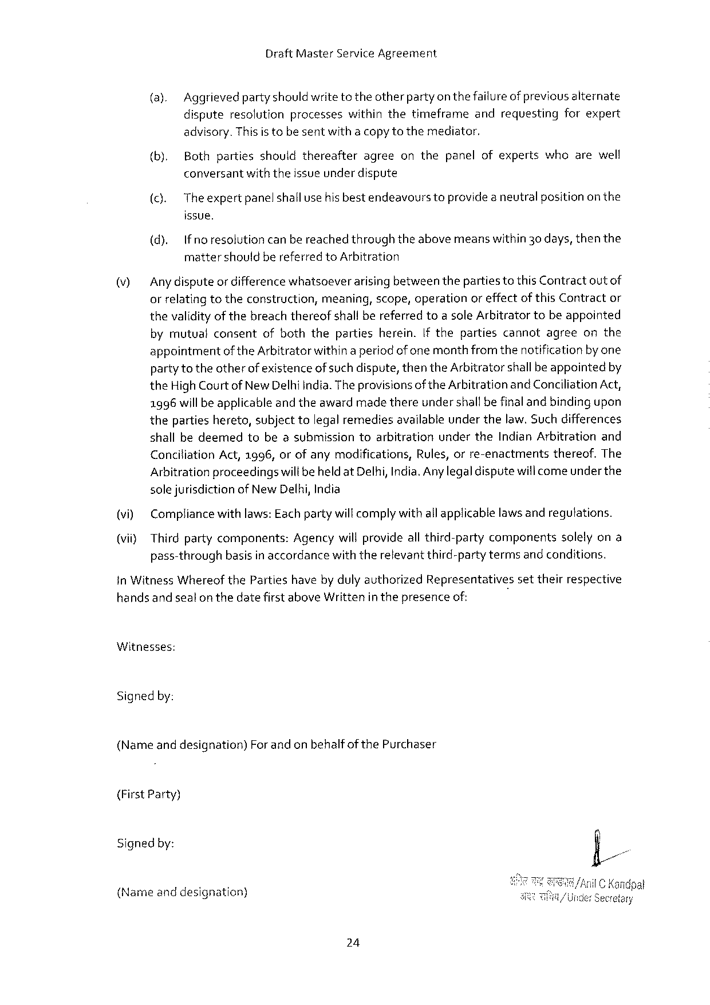

DraftMasterServiceAgreement

(a). Aggrievedpartyshouldwrite totheotherparty on thefailureof previousalternate dispute resolution processes withinthe timeframe and requesting forexpert

advisory.Thisis tobe sentwitha copytothemediator,

|  |  |  |
| --- | --- | --- |
| (b). | Bothpartiesshouldthereafter | agreeonthepanelofexpertswhoarewell |

conversantwiththeissueunderdispute

(c). Theexpertpanelshallusehisbestendeavourstoprovidea neutralpositionon the

issue.

(d). Ifnoresolutioncan bereachedthroughtheabovemeanswithin30days, thenthe mattershouldbereferred toArbitration

|  |  |
| --- | --- |
| \7] | Any disputeordifferencewhatsoeverarising betweentheparties tothis Contractoutof orrelatingtotheconstruction,meaning,scope,operationoreffectof thisContractor |

thevalidityof thebreachthereofshall bereferredtoa sole Arbitratortobeappointed bymutualconsentofboththepartiesherein.If thepartiescannotagreeonthe appointmentof theArbitratorwithina periodof one monthfromthenotificationby one party totheotherof existenceof such dispute,thentheArbitratorshallbeappointedby theHigh Court ofNewDelhiIndia.Theprovisionsof theArbitration andConciliationAct, 1996will be applicableandtheawardmadethereunder shallbefinaland bindingupon thepartieshereto,subjecttolegal remediesavailableunderthelaw.Suchdifferences shallbedeemedtobeasubmissiontoarbitrationundertheIndian Arbitrationand

|  |  |  |  |  |
| --- | --- | --- | --- | --- |
| Conciliation | Act,1996,orofanymodifications, | Rules,orre-enactments | thereof. | The |

Arbitrationproceedingswili beheldatDelhi,India.Any legaldisputewili comeunder the solejurisdictionof New Delhi,India

(vi) Compliancewithlaws:Eachpartywill complywith allapplicablelawsand regutations.

(vii} Thirdpartycomponents:Agencywill provideall third-partycomponentssolelyona pass-throughbasisin accordancewith therelevantthird-partytermsand conditions.

in WitnessWhereofthePartieshave by dulyauthorizedRepresentativessettheirrespective handsand sealon thedatefirst aboveWrittenin thepresenceof:

Witnesses:

Signedby:

(Nameanddesignation) ForandonbehalfofthePurchaser

(FirstParty)

Signedby:

{Nameanddesignation)

24



DraftMasterServiceAgreement

Agency

(SecondParty)

(Name anddesignation)For andon behalfofAgency Signedby:

25

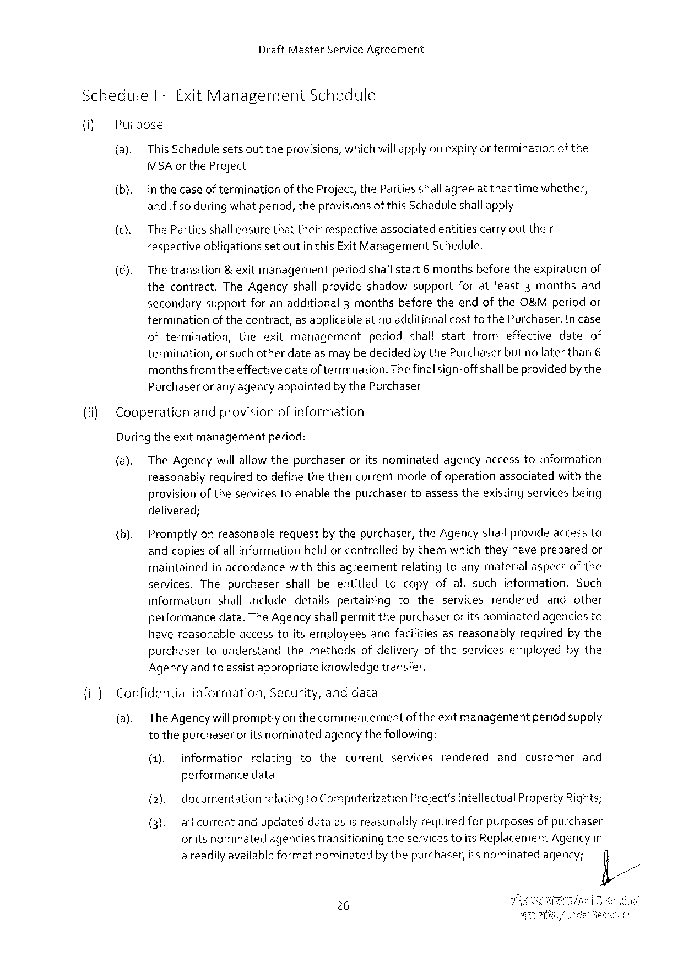

DraftMasterServiceAgreement

Schedule | -Exit Management Schedule

(i) Purpose

(a). This Schedulesetsouttheprovisions,whichwillapply on expiryor terminationofthe

MSA or the Project.

(b). Inthecaseof terminationoftheProject, thePartiesshallagreeat thattimewhether,

and ifso during whatperiod, theprovisionsof thisScheduleshall apply.

(c). ThePartiesshall ensurethattheirrespectiveassociatedentitiescarryout their

respectiveobligationssetoutin thisExitManagementSchedule.

|  |  |  |
| --- | --- | --- |
| (d). | The transition& exitmanagementperiodshallstart | 6 monthsbeforetheexpirationof |

thecontract.TheAgencyshallprovideshadowsupportforatleast3monthsand

secondarysupportforanadditional3monthsbeforetheendoftheO&Mperiodor

terminationof thecontract,as applicableat no additionalcosttothePurchaser.Incase

|  |  |  |
| --- | --- | --- |
| oftermination, | theexitmanagement | periodshallstartfromeffectivedateof |

termination,or such otherdateasmay be decidedby thePurchaserbutno laterthan6

monthsfromtheeffectivedateof termination. The finalsign-offshallbeprovidedby the

Purchaserorany agencyappointedbythePurchaser

{(ii)Cooperationandprovisionofinformation

Duringtheexitmanagement period:

(8). TheAgencywillallow thepurchaseroritsnominatedagencyaccesstoinformation

reasonablyrequiredtodefinethethencurrentmodeof operationassociatedwiththe

provisionof theservicestoenablethepurchasertoassesstheexistingservicesbeing

delivered;

(b). Promptlyonreasonablerequestby thepurchaser,theAgencyshall provideaccessto

andcopiesofall informationheldor controlledby themwhich theyhave preparedor

maintained inaccordance withthisagreement relatingtoanymaterial aspect ofthe

services.Thepurchasershallbeentitled tocopyofallsuchinformation.Such

information shallincludedetailspertaining totheservicesrendered andother

performancedata.TheAgency shallpermitthepurchaseror its nominatedagenciesto

|  |  |  |  |
| --- | --- | --- | --- |
| havereasonable | accesstoitsemployees | andfacilitiesasreasonably | requiredbythe |

purchasertounderstandthemethodsofdeliveryoftheservicesemployedbythe

Agencyandtoassistappropriate knowledge transfer.

{iii) Confidential information, Security,anddata

(a). TheAgencywillpromptlyon thecommencementofthe exitmanagementperiodsupply

tothepurchaser oritsnominatedagencythefollowing:

|  |  |  |  |  |  |  |  |  |  |  |
| --- | --- | --- | --- | --- | --- | --- | --- | --- | --- | --- |
| (1). | information | relating | to | the | current | services | rendered | and | customer | and |

performancedata

(2). documentation relatingtoComputerization Project’sIntellectualPropertyRights;

(3). allcurrentandupdateddataasisreasonablyrequiredforpurposesof purchaser

oritsnominated agenciestransitioning theservicestoitsReplacement Agencyin

areadilyavailableformatnominatedby thepurchaser,itsnominatedagency; fi/

~

26

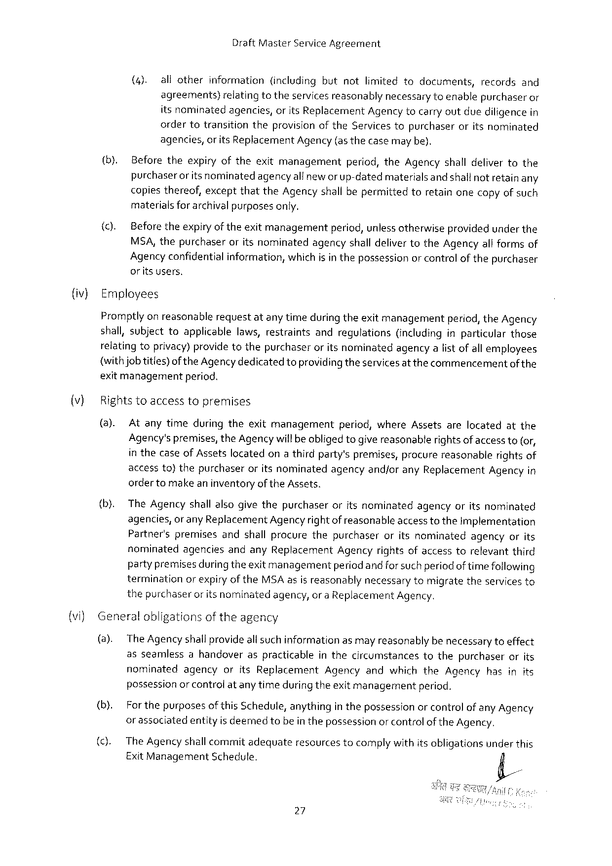

DraftMasterServiceAgreement

|  |  |  |  |  |  |  |  |  |  |  |  |  |  |  |  |  |  |  |  |  |  |  |  |  |
| --- | --- | --- | --- | --- | --- | --- | --- | --- | --- | --- | --- | --- | --- | --- | --- | --- | --- | --- | --- | --- | --- | --- | --- | --- |
| (iv)  )  {vi) | (4). | | | allother | | | information | | | (including | | | | but | | not | | limited | to | documents, | | records | | and |
| agreements)relatingtotheservices reasonablynecessary toenablepurchaseror itsnominatedagencies,or itsReplacementAgency tocarry outduediligencein | | | | | | | | | | | | | | | | | | | | | | | |
| ordertotransition | | | | | | | | theprovision | | | | oftheServicestopurchaser | | | | | | | | oritsnominated | | | |
| agencies,or its ReplacementAgency (asthecase may be). | | | | | | | | | | | | | | | | | | | | | | | |
| (b). | | Beforetheexpiryoftheexitmanagement | | | | | | | | | | | | | | period,theAgencyshalldelivertothe | | | | | | | |
| purchaserorits nominatedagencyallneworup-datedmaterialsandshallnotretain any copiesthereof,exceptthattheAgencyshall bepermittedtoretainonecopyofsuch materialsforarchivalpurposesonly. | | | | | | | | | | | | | | | | | | | | | | | |
| (c). | Before theexpiryof theexitmanagement | | | | | | | | | | | | | period, unlessotherwiseprovidedunderthe | | | | | | | | | |
| MSA,thepurchaseroritsnominatedagencyshalldelivertotheAgencyall formsof Agency confidentialinformation,whichis in thepossessionor controlof thepurchaser oritsusers,  Employees  Promptlyon reasonablerequestatany timeduring theexitmanagementperiod, theAgency shall,subjecttoapplicablelaws,restraintsandregulations(includinginparticularthose relatingtoprivacy)providetothepurchaseroritsnominatedagencyalist ofallemployees | | | | | | | | | | | | | | | | | | | | | | | |
| (withjob titles)of theAgencydedicatedtoprovidingtheservices atthecommencement | | | | | | | | | | | | | | | | | | | | | | ofthe | |
| exitmanagementperiod. | | | | | | | | | | | | | | | | | | | | | | | |
| Rightstoaccess | | | | | topremises | | | | | | | | | | | | | | | | | | |
| (a). | Atanytimeduringtheexitmanagement | | | | | | | | | | | | | | period,whereAssetsarelocatedatthe | | | | | | | | |
| Agency'spremises,theAgencywill beobliged togive reasonablerights of accessto(or, in thecaseof Assetslocatedona thirdparty'spremises,procurereasonablerightsof accessto)thepurchaseroritsnominatedagencyandjoranyReplacementAgencyin orderto makean inventoryof theAssets. | | | | | | | | | | | | | | | | | | | | | | | |
| (b). | TheAgencyshallalsogivethepurchaser | | | | | | | | | | | | oritsnominated | | | | | | agency | oritsnominated | | | |
| agencies, | | | | or anyReplacement | | | | | | Agencyrightofreasonable | | | | | | | | accesstotheImplementation | | | | | |
| Partner'spremisesandshallprocurethepurchaseroritsnominatedagencyorits nominatedagenciesandanyReplacementAgencyrightsofaccesstorelevantthird partypremises duringtheexitmanagementperiodandforsuch periodof timefollowing terminationor expiryof theMSAasis reasonablynecessarytomigratetheservicesto thepurchaseror itsnominatedagency,or a ReplacementAgency.  Generalobligationsoftheagency | | | | | | | | | | | | | | | | | | | | | | | |
| (a). | TheAgency shallprovideall suchinformationasmay reasonablybe necessarytoeffect | | | | | | | | | | | | | | | | | | | | | | |
| asseamlessahandoveraspracticableinthecircumstancestothepurchaserorits nominatedagencyoritsReplacementAgencyandwhichtheAgencyhasinits possessionor control atany timeduring theexitmanagementperiod. | | | | | | | | | | | | | | | | | | | | | | | |
| (b). | For thepurposesofthisSchedule,anythingin thepossessionor controlof any Agency | | | | | | | | | | | | | | | | | | | | | | |
| or assoclatedentityis deemedtobe inthepossessionor controlof theAgency. | | | | | | | | | | | | | | | | | | | | | | | |
| TheAgencyshallcommitadequate | | | | | | | | | | | resources | | | | tocomplywithitsobligations | | | | | | underthis | | |
| ExitManagement | | | | | | | Schedule. | | | | | | | | | | | | | | | | |

27

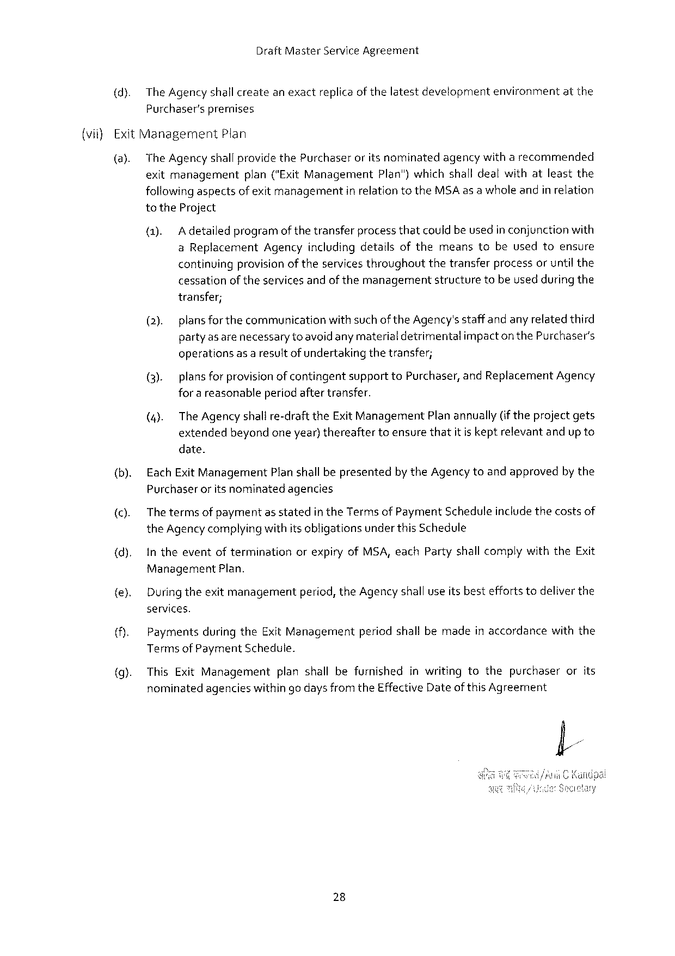

DraftMasterServiceAgreement

(dy. The Agency shallcreatean exactreplicaof thelatestdevelopmentenvironmentatthe Purchaser’spremises

(vii}ExitManagement Plan

(a). TheAgencyshallprovidethePurchaser oritsnominated agencywitharecommended

exitmanagement plan("Exit ManagementPlan")whichshall dealwithatleastthe followingaspectsof exit managementin relationtotheMSAas a whole andin relation totheProject

(1). Adetailedprogramof thetransferprocessthatcouldbe usedin conjunctionwith aReplacementAgencyincludingdetailsofthemeanstobeusedtoensure continuingprovisionof theservices throughoutthetransferprocessoruntil the cessationoftheservicesandofthemanagementstructuretobeused during the transfer;

(2). plansforthe communicationwithsuchoftheAgency'sstaffandany relatedthird partyas arenecessary to avoidany materialdetrimentalimpactonthePurchaser's operationsas a resultof undertakingthetransfer;

|  |  |  |  |  |
| --- | --- | --- | --- | --- |
| (3). | plansforprovisionofcontingent | supporttoPurchaser, | andReplacement | Agency |

for a reasonableperiodaftertransfer.

(4). TheAgency shalire-drafttheExitManagementPlan annually(iftheprojectgets extendedbeyondoneyear) thereaftertoensurethatitis keptrelevantandup to date.

(b). EachExitManagementPlanshall bepresentedby theAgency toandapprovedbythe Purchaseroritsnominatedagencies

(). Thetermsof paymentas statedintheTerms of PaymentScheduleincludethecostsof theAgencycomplying withitsobligationsunder thisSchedule

{d). In theeventofterminationorexpiryofMSA,eachPartyshall complywiththeExit

Management Plan.

{e). Duringtheexitmanagementperiod, theAgency shall useits besteffortstodeliverthe services.

PaymentsduringtheExitManagementperiodshallbemadein accordancewiththe Terms of PaymentSchedute.

ThisExitManagement planshallbefurnishedinwritingtothepurchaserorits nominatedagencieswithin go days fromtheEffective Dateof this Agreement

28

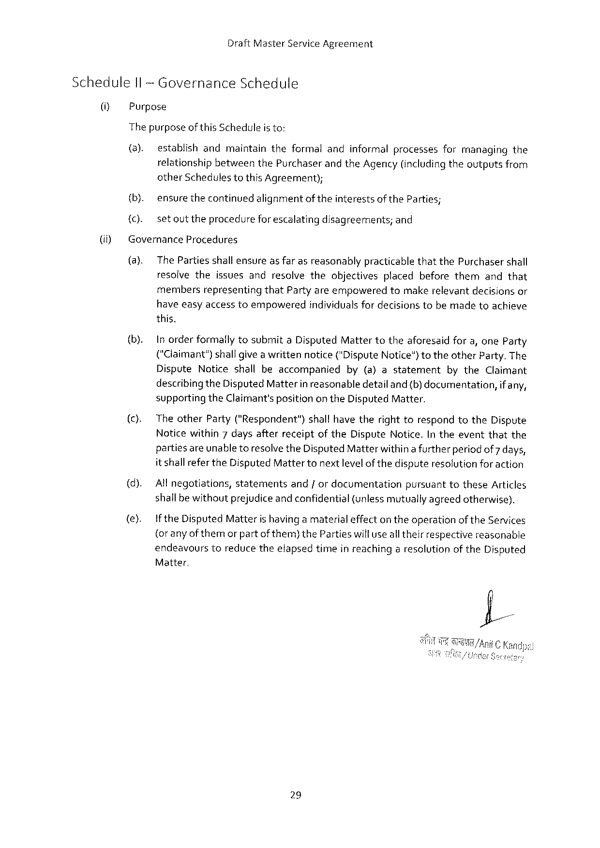

DraftMasterServiceAgreement

ScheduleIl -GovernanceSchedule

(i Purpose

The purposeof thisScheduleis to:

(a). establishandmaintaintheformalandinformalprocessesformanagingthe relationshipbetweenthePurchaserand theAgency (includingtheoutputsfrom otherSchedulestothisAgreement);

|  |  |  |
| --- | --- | --- |
| (if) | {b). | ensurethecontinuedalignmentoftheinterestsoftheParties; |
| {C). | setouttheprocedureforescalatingdisagreements;and |
| GovernanceProcedures | |
| (a). | ThePartiesshall ensureas farasreasonablypracticablethatthePurchasershall |
| resolvetheissuesandresolvetheobjectivesplacedbeforethemandthat | |

membersrepresentingthatPartyareempoweredtomakerelevantdecisionsor have easyaccesstoempoweredindividualsfor decisionstobemadetoachieve this.

(b). InorderformallytosubmitaDisputedMattertotheaforesaidfora,oneParty (“Claimant")shallgivea writtennotice("DisputeNotice")totheotherParty. The

|  |  |  |  |  |
| --- | --- | --- | --- | --- |
| (c). | DisputeNoticeshallbeaccompanied | by(a)astatement | bytheClaimant | |
| describingtheDisputedMatterin reasonabledetail and{b) documentation, | | | if any, |
| supportingtheClaimant'sposition on theDisputedMatter.  TheotherParty("Respondent”)shallhavetherighttorespondtotheDispute Noticewithin7daysafterreceiptoftheDisputeNotice.Intheeventthatthe | | | |

partiesareunabletoresolvetheDisputedMatterwithina furtherperiodof7 days, it shallrefertheDisputedMattertonextlevelof thedisputeresolution for action

|  |  |  |  |  |
| --- | --- | --- | --- | --- |
| (d).  (e). | All negotiations,statementsand/ordocumentationpursuanttotheseArticles | | | |
| shallbewithoutprejudiceandconfidential | | (unlessmutuallyagreedotherwise). | |
| If theDisputedMatterishavinga materialeffectontheoperationof theServices | | | |
| (or anyofthemorpart | ofthem)thePartieswillusealltheirrespective | | reasonable |
| endeavourstoreducetheefapsedtimeinreachinga resolutionof theDisputed | | | |

Matter,

29

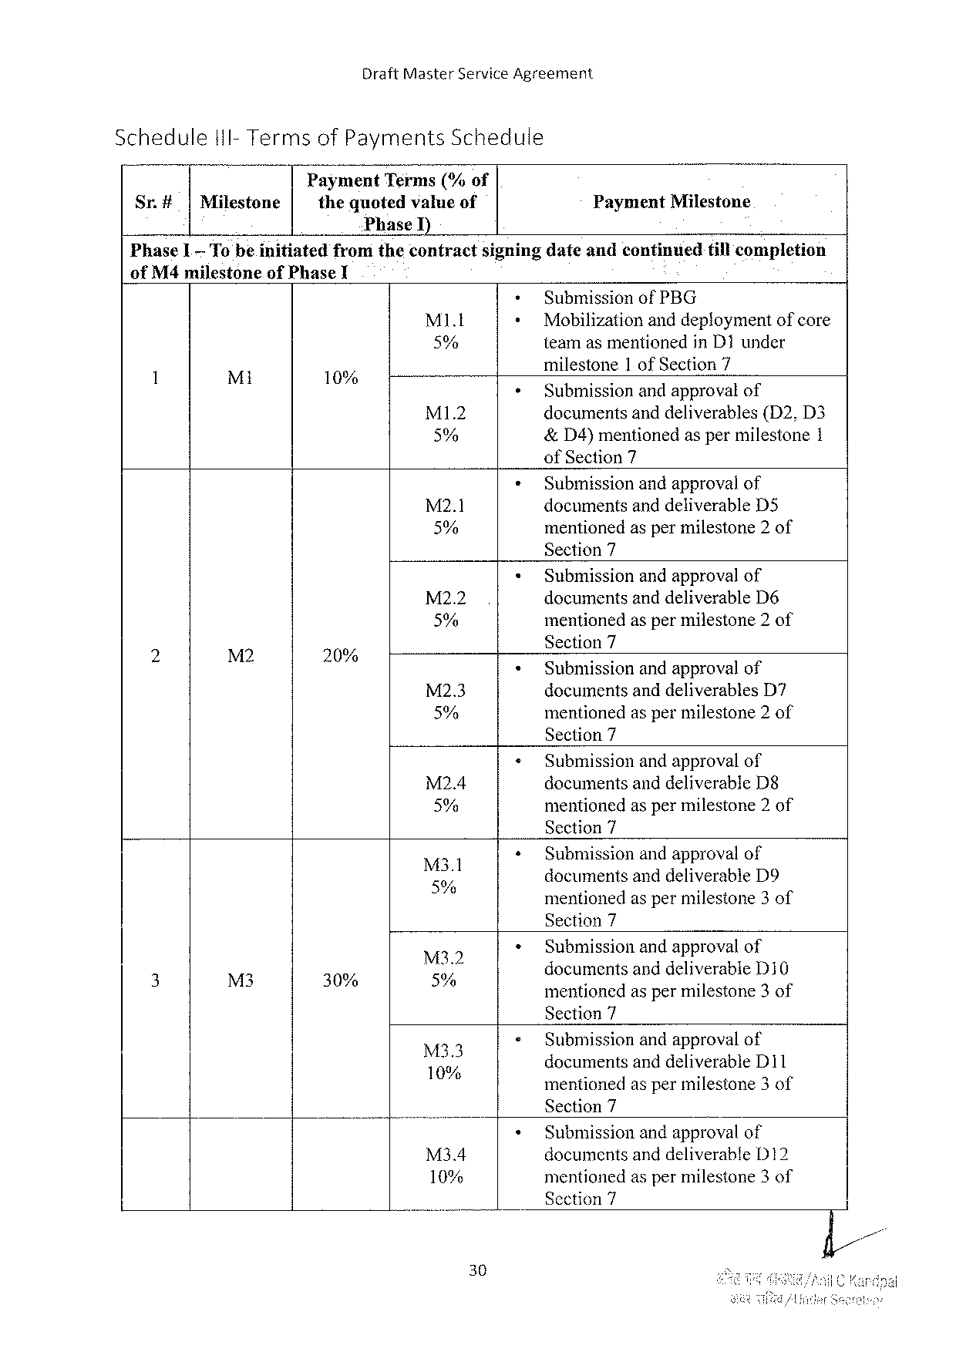

DraftMasterServiceAgreement

|  |  |  |  |  |  |
| --- | --- | --- | --- | --- | --- |
| Schedule | | l1I-Terms | ofPayments | Schedule | PaymentMilestone |
| Sr.# | |Milestone | | PaymentTerms(%of | |
| thequotedvalueof | |

PhaseI)

|  |  |  |  |  |
| --- | --- | --- | --- | --- |
| PhaseL | Tobe.initiated | fromthecontract | signingdateandcontinued | tillcompletion |

ofM4 milestoneofPhaseI   
 SubmissionofPBG

|  |  |  |  |  |  |
| --- | --- | --- | --- | --- | --- |
| 1 | Mi | 10% | MI.t | Mobilizationanddeploymentofcore | |
| 5% | teamasmentionedinD1under | |
| milestone | 1 ofSection7 |
| ° | MI1.2 | Submissionandapproval of | |
| documentsanddeliverables(D2,D3 | |
| 5% | &D4)mentionedaspermilestone1 | |

ofSection7

Submissionandapprovalof M2.1 documentsanddeliverableD5 5% mentionedaspermilestone2of Section7

Submissionandapprovalof

|  |  |  |  |  |  |
| --- | --- | --- | --- | --- | --- |
| e | M2 | o | M22 | documentsanddeliverableD6 | |
| 5% | mentionedaspermilestone2of | |
| Section7 | |
| 20% | M2.3 | Submissionandapprovalof | |
| documentsanddeliverables | D7 |
| 5% | mentionedaspermilestone2of | |

Section7

Submissionandapprovalof

|  |  |
| --- | --- |
| M2.4  5% | documentsanddeliverableD§mentionedasper milestone2 of |

Section7

|  |  |
| --- | --- |
| M3l  5% g | Submissionandapprovalof  documentsanddeliverableD9 " X )  mentionedaspermilestone3of |

Section7

Submissionandapprovalof

|  |  |  |  |  |  |  |
| --- | --- | --- | --- | --- | --- | --- |
| 3 | = | o | MZ'Z | documents | anddeliverable | D10 |
| M3 | 30% | % | mentionedaspermilestone3of | | |

Section7

Submissionandapprovalof Mo 10% documemsand and deliverableD11 mentionedaspermilestone3of Section7

Submissionandapprovalof M34 documentsanddeliverable312 10% mentionedaspermilestone3of Section7

30

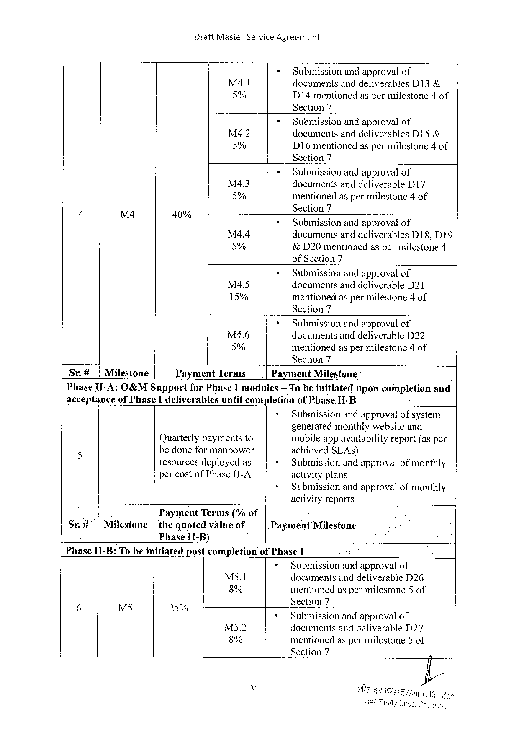

DraftMasterServiceAgreement

|  |  |  |  |
| --- | --- | --- | --- |
| M4l | = | Submissionandapprovalof | |
| documentsanddeliverables | D13& |
| 5% | D14mentionedaspermilestone4of | |

Section7

|  |  |  |  |
| --- | --- | --- | --- |
| M4.2 | * | Submissionandapprovalof | |
| documentsanddeliverables | D15& |
| 5% |
| D16mentionedaspermilestone4of | |

Section7

|  |  |  |  |  |  |
| --- | --- | --- | --- | --- | --- |
| 4 | M4 | 40% | M43 | » | Submissionandapprovalof |
| documentsanddeliverableD17 |
| 5% | « | mentioned aspermilestone 4of |
| Sectl({n7 |
| Submissionand approval of |
| M4.4 | + | documentsanddeliverablesD18,D19 |
| 5% | &D20mentionedaspermilestone4 |
| of Section7 |
| Submissionandapprovalof |
| M4.5 | documentsanddeliverableD21 |
| 15% | mentionedaspermilestone4of |

Section7

|  |  |  |
| --- | --- | --- |
| M4.6 | + | Submissionandapprovalof |
| documentsanddeliverableD22 |
| 5% |
| mentionedaspermilestone4of |

Section7

|  |  |  |  |  |  |
| --- | --- | --- | --- | --- | --- |
| Sr.#| | Miléstone | Payment | Terms | Payment | Milestone |

PhaseII-A:O&MSupportforPhaseImodules— Te be initiateduponcompletionand acceptanceofPhaseIdeliverablesuntilcompletionofPhaseII-B

|  |  |  |  |
| --- | --- | --- | --- |
| 5 | Quarterlypaymentsto | + | Submissionandapprovalofsystem |
| generatedmonthlywebsiteand |
| mobileappavailabilityreport(as per |
| bedoneformanpower | « | achievedSLAs) |
| resourcesdeployedas | Submissionandapprovalofmonthly |
| percostofPhaseII-A. | + | activityplans |
| Submissionandapprovalofmonthly |

activityreports

B PaymentTerms("/; of

Sr.#|Milestone|thequotedvalueof Phase1I-B)

PaymentMilestone

PhaseI1-B:Tobeinitiatedpostcompletionof PhaseI

|  |  |  |  |  |  |  |
| --- | --- | --- | --- | --- | --- | --- |
| S | e | o | 1 | Ms5.1 | + | Submissionandapproval of |
| documentsanddeliverableD26 |
| 8% | mentionedaspermilestone5of |
| Section7 |
| 254 | M52 | * |
| Submissionandapprovalof |
| documentsanddeliverableD27 |
| 8% | mentionedaspermilestone5 of |
| _Scction7 |

31

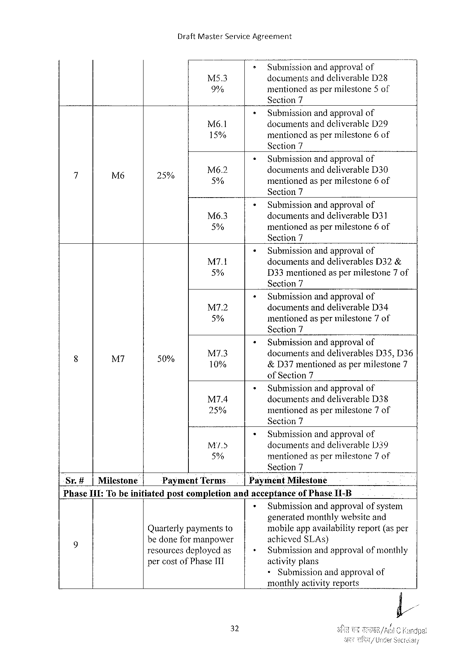

DraftMasterServiceAgreement

|  |  |  |
| --- | --- | --- |
| M5.3 | > | Submissionand approvalof |
| documentsanddeliverableD28 |
| 9% | mentionedaspermilestone5of |

Section7

|  |  |  |
| --- | --- | --- |
| Mé6.1 | * | Submissionandapprovalof |
| documentsanddeliverableD29 |
| 15% | mentionedaspermilestone 6 of |

Section7

|  |  |  |  |  |  |
| --- | --- | --- | --- | --- | --- |
| 4 | L | S | M6.2 | * | Submissionandapprovalof |
| documentsanddeliverableD30 |
| 2% | 5% | mentionedaspermilestone6of |

Section7

|  |  |  |
| --- | --- | --- |
| Mé6.3 | » | Submissionandapprovalof |
| documentsanddeliverableD31 |
| 5% | mentionedaspermilestone6 of |

Section7

|  |  |  |
| --- | --- | --- |
| M7.1 | * | Submissionandapprovalof |
| documentsanddeliverablesD32& |
| 5% | D33mentionedaspermilestone7of |

Section7

|  |  |  |
| --- | --- | --- |
| M7.2 | « | Submissionandapprovalof |
| documentsanddeliverableD34 |
| 5% | mentionedaspermilestone7of |

Section7

|  |  |  |  |  |  |
| --- | --- | --- | --- | --- | --- |
| 8 | M | o | M7.3 | « | Submissionandapprovalof |
| documentsanddeliverables D35,D36 |
| 50% | 10% | &D37mentionedaspermilestone7 |

ofSection7

|  |  |  |
| --- | --- | --- |
| M7.4 | * | Submissionandapprovalof |
| documentsanddeliverableD38 |
| 25% | mentionedaspermilestone7of |

Section7

|  |  |  |
| --- | --- | --- |
| M5 | « | Submissionandapprovalof |
| documentsanddeliverable1339 |
| 5% | mentionedas permilestone7 of |

Section7

|  |  |  |  |  |
| --- | --- | --- | --- | --- |
| Sr.# | |Milestone | PaymentTerms | PaymentMilestone | |
| PhaseI1I:Tobeinitiated | | postcompletion | andacceptance | ofPhaseI1-B |

Submissionandapprovalofsystem   
generatedmonthlywebsiteand

Quarterlypaymentsto   
bedoneformanpower   
resourcesdeployedas

mobileappavailabilityreport(asper achicvedSLAS)   
Submissionandapprovalofmonthly

percostofPhaseI1I activityplans

<Submissionandapprovalof

monthlyactivity reports

32

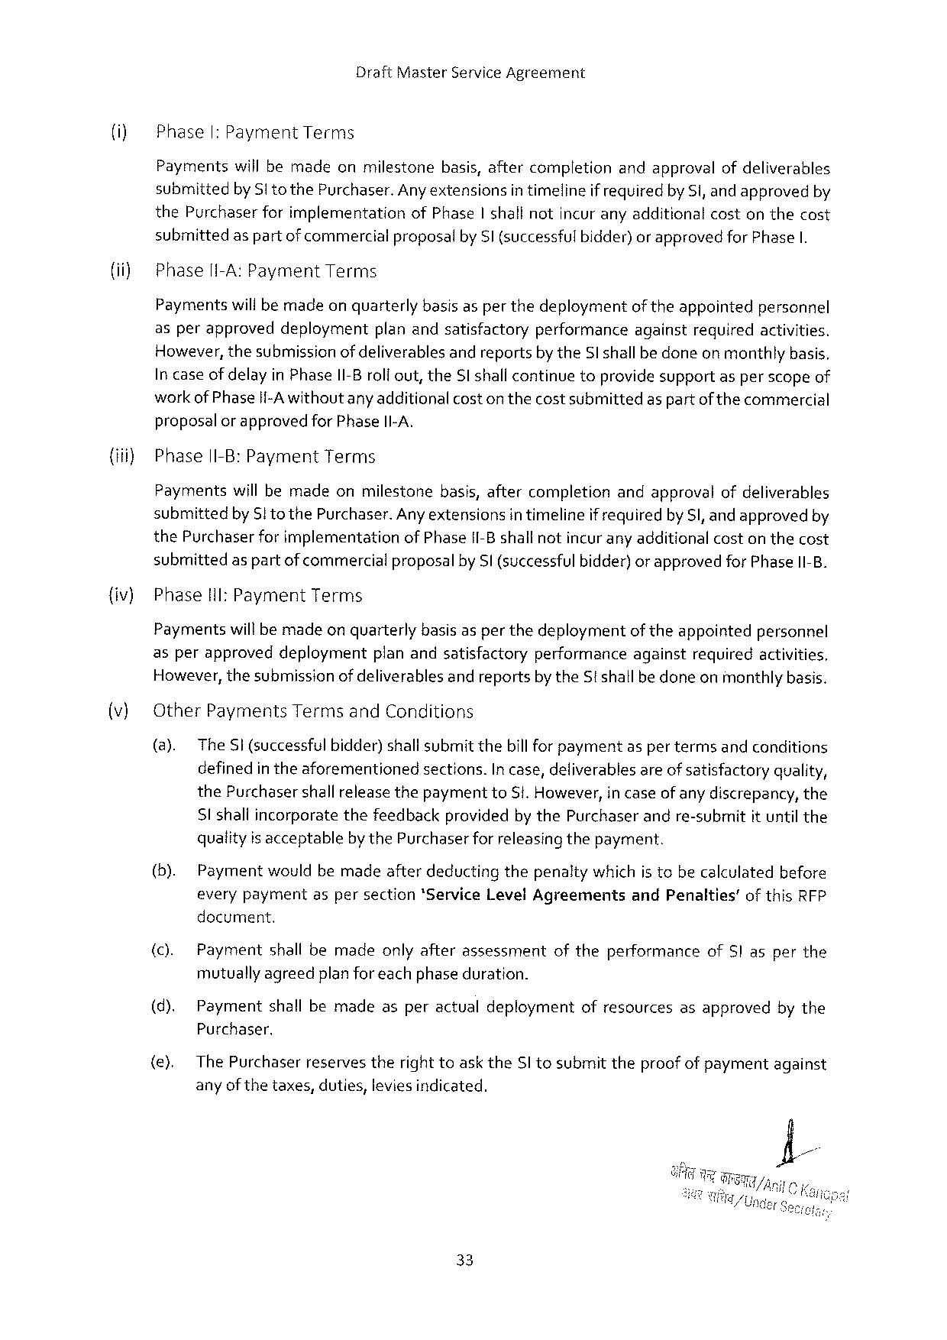

DraftMasterServiceAgreement

(i) PhaseI: PaymentTerms

Paymentswill bemadeonmilestonebasis,aftercompletionandapprovalofdeliverables submittedbySito thePurchaser.Any extensionsin timelineif requiredby Si, and approvedby thePurchaserforimplementationofPhase|shall notincuranyadditionalcostonthecost submittedas partofcommercialproposalbySl (successfulbidder)orapprovedfor PhaseI.

PhaselI-A:PaymentTerms

Paymentswillbemadeon quarterlybasis asper thedeploymentoftheappointedpersonnel

|  |  |  |  |  |  |  |
| --- | --- | --- | --- | --- | --- | --- |
| asperapproved | deployment | planandsatisfactory | performance | against | required | activities. |

However,thesubmissionofdeliverablesand reportsby theSl shallbe doneon monthlybasis. In caseof delayin PhaseI1-Broli out,theSl shallcontinuetoprovidesupportasper scopeof workofPhasei{-A withoutany additional coston thecostsubmittedas partof the commercial proposal or approvedfor PhaseII-A.

{iii) PhaseII-B:PaymentTerms

Paymentswill bemadeonmilestonebasis,aftercompletionandapprovalofdeliverables submittedbySto thePurchaser. Anyextensionsin timelineif requiredby S,and approvedby thePurchaserfor implementationofPhaseII-Bshallnotincurany additionalcoston thecost submittedas partofcommercialproposalby Sl (successful bidder) or approvedfor PhaseII-B.

|  |  |  |
| --- | --- | --- |
| {iv) | Phase | Hil: PaymentTerms |

Paymentswillbemadeon quarterlybasis asper thedeploymentof theappointedpersonnel asperapproveddeploymentplanandsatisfactoryperformanceagainstrequiredactivities. However,thesubmissionofdeliverablesand reportsby theSt shallbedoneonmonthlybasis.

(v) OtherPaymentsTermsandConditions

(@).TheSi (successful bidder)shallsubmitthebill for paymentas per termsand conditions definedin theaforementionedsections.In case,deliverablesareof satisfactoryquality, thePurchasershallreleasethepaymenttoSi. However, in caseof any discrepancy,the Sl shaliincorporatethefeedbackprovidedby thePurchaserandre-submitit until the qualityis acceptablebythePurchaserforreleasingthepayment.

(b). Paymentwouldbemadeafterdeductingthepenaltywhichis tobecalculatedbefore everypaymentaspersection*Service LevelAgreements andPenalties’of thisRFP docurment.

|  |  |  |  |  |  |
| --- | --- | --- | --- | --- | --- |
| (c). | Payment | shallbemade | onlyafterassessment | oftheperformance | ofS|asperthe |

mutuallyagreedplanforeach phaseduration.

(d). Paymentshallbemadeasperactualdeploymentofresourcesasapprovedbythe Purchaser,

(e). The Purchaserreservestheright toasktheSI tosubmittheproofof paymentagainst anyof thetaxes,duties,leviesindicated.

33

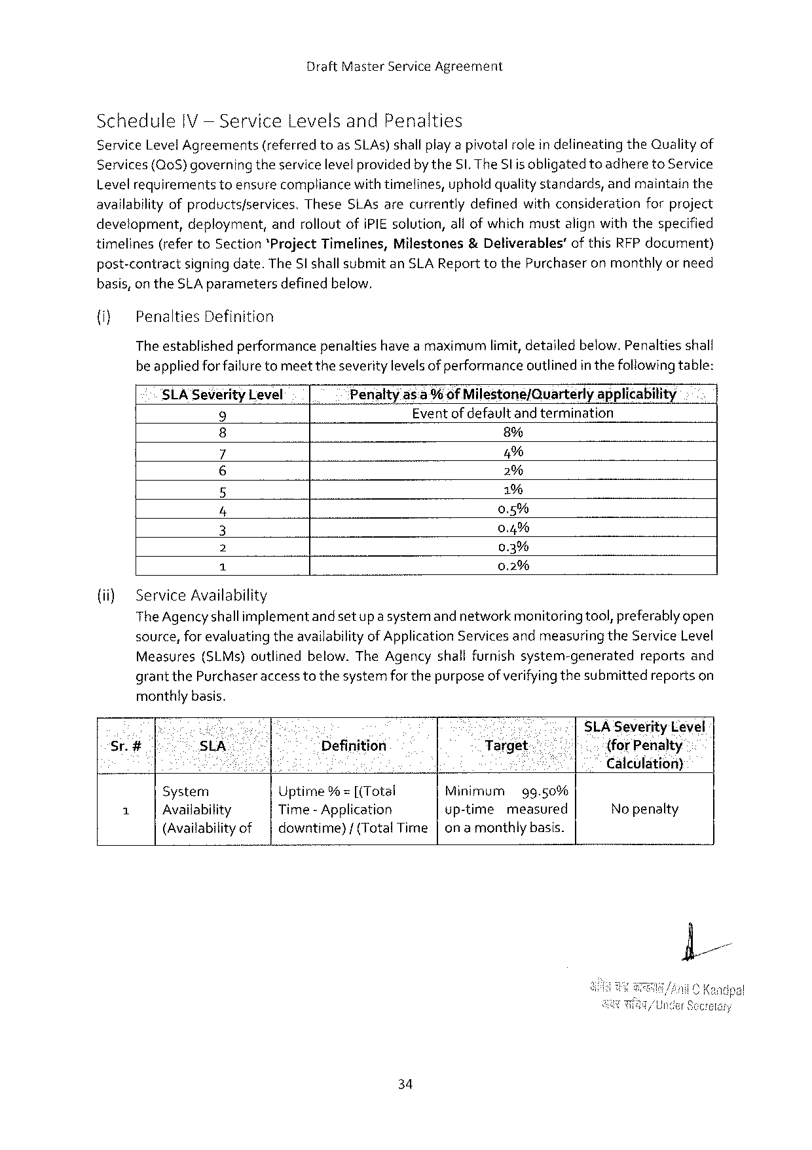

DraftMasterServiceAgreement

Schedule IV— ServiceLevelsandPenalties

ServiceLevelAgreements (referred toasSLAs) shallplayapivotalrolein defineating theQualityof Services(Q0S)governingtheservicelevelprovidedby theSI. TheSl is obligatedtoadheretoService

|  |  |  |
| --- | --- | --- |
| Levelrequirements | toensurecompliancewithtimelines,upholdqualitystandards, | andmaintainthe |

availabilityofproductsfservices.TheseSLAsarecurrentlydefinedwithconsiderationforproject development,deployment,androlloutofiPIE solution,all ofwhich mustalign withthespecified

|  |  |  |  |  |
| --- | --- | --- | --- | --- |
| timelines | (refertoSection*ProjectTimelines, | Milestones | &Deliverables’ | ofthisRFPdocument) |

post-contractsigning date.The Sl shallsubmitanSLA Report tothePurchaseronmonthlyor need basis, ontheSLAparametersdefinedbelow.

{i} PenaltiesDefinition

Theestablishedperformancepenaltieshave amaximumlimit,detailedbelow.Penaltiesshall beappliedforfailuretomeettheseveritylevelsof performanceoutlinedin thefollowingtable:

|  |  |  |  |
| --- | --- | --- | --- |
| SLA SeverityLevel | Penalty | ds:a % ofMilestone/Quarterly | applicability |
| Eventofdefaultandtermination | |
| 9 |
| 8% | |
| o |

5%

o~ 2%   
 1%   
 0.5%   
 0.4%   
 0.3%

|  |  |  |
| --- | --- | --- |
| {i) | BNl | 0.2% |
| ServiceAvailability |

The Agencyshallimplementandsetup a systemand networkmenitoringtool,preferably open source,for evaluatingtheavailabilityof ApplicationServicesandmeasuring theService Level Measures(SLMs)outlinedbelow.TheAgencyshallfurnishsystem-generated reportsand grantthePurchaseraccess tothesystemforthepurposeof verifyingthesubmittedreportson monthlybasis.

|  |  |  |  |  |  |  |  |  |  |
| --- | --- | --- | --- | --- | --- | --- | --- | --- | --- |
| Sr.# | . | e | % | | CUerl | | | e | SLA SeverityLevel |
| SLA | | Definition | | Target- | | | " | {for Penalty |
| S | | : | ; | K | | | | Calculation) |
| A | System | | Uptime% = [(Total | | Minimum | | gg.50% | |
| No penalty |
| Availability | | Time -Application | | up-time | measured | | |
| (Availabilityof | | downtime}/(TotalTime|onamonthlybasis. | | | | | |

34

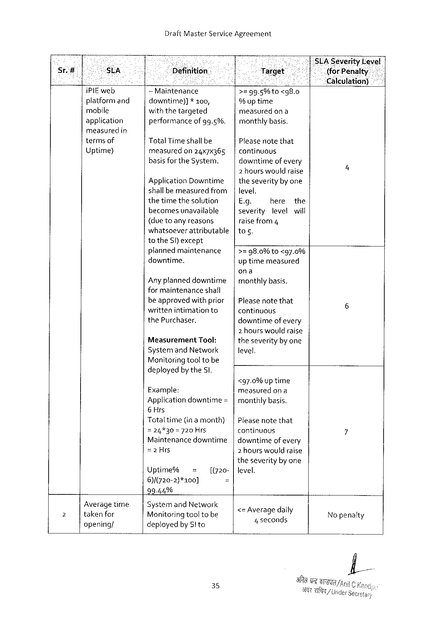

DraftMasterServiceAgreement

|  |  |  |  |  |  |  |  |  |  |
| --- | --- | --- | --- | --- | --- | --- | --- | --- | --- |
| ! | s | i | S | | Gl | | o SLASeverityDevel | | |
| Sr.i# | “HSLA | Définition | | | Target” | | | 71}" | (forPenalty |
| ] | ; | i | | | o | e | ee | | ‘Calculation) |
| iPIEweb | —Maintenance | | | >z 9g.5%to | <g8.0 | | | |
| platformand | downtime)] | * 100, | |
| % uptime | | | | |
| mobile |
| withthetargeted | | | measured | ona | | | |
| application | performance | | of9g.5%. |
| monthlybasis. | | | | |
| measuredin | TotalTimeshallbe | | |
| Pleasenotethat | | | | |
| termsof |
| Uptime) | measured | on24x7x365 | | continuous | | | | |

basisfortheSystem.

Application Downtime|

downtimeof every   
2 hourswouldraise 4 theseverityby one

|  |  |  |  |
| --- | --- | --- | --- |
| shallbe measuredfrom| | level. | here | the |
| thetimethesolution | E.g. |

becomesunavailable   
(duetoany reasons

severity levelwilf

raise from4

whatsoeverattributable|tos.   
totheS)except

plannedmaintenance   
downtime.

Any planneddowntime   
for maintenanceshail

>=98.0%10<g7.0%   
uptimemeasured

ona   
|monthlybasis.

|  |  |  |
| --- | --- | --- |
| beapprovedwith prior|Pleasenotethat | | 6 |
| writtenintimationto | continuous |
| thePurchaser. | downtimeof every |

MeasurementTool:

2 hours wouldraise   
theseverityby one

|  |  |
| --- | --- |
| SystemandNetwork Monitoringtooltobe | level. |

deployedbytheSI.

|  |  |
| --- | --- |
| Example: | <97.0%uptime  measuredon a |

Application downtime=|monthlybasis.   
6 Hrs

|  |  |  |  |  |  |  |
| --- | --- | --- | --- | --- | --- | --- |
| Totaltime | (inamonth) | | | | | Pleasenotethat | 7 |
| =24%30=720Hrs | | | continuous | | |
| Maintenancedowntime|downtimeofevery | | | | | |
| =2Hrs | | | 2 hourswouldraise | | |
| theseverityby one | | | | | |
| Uptime% | | = | [(720- |level. | | |
| 6)/(720-2)*100] | | | £ | | |

99.44%

|  |  |  |  |  |
| --- | --- | --- | --- | --- |
| p3 | Average time | SystemandNetwork | <= Average daily | No penalty |
| takenfor | Monitoringtooltobe |
| 4 seconds |
| opening/ | deployedbySlto |

35

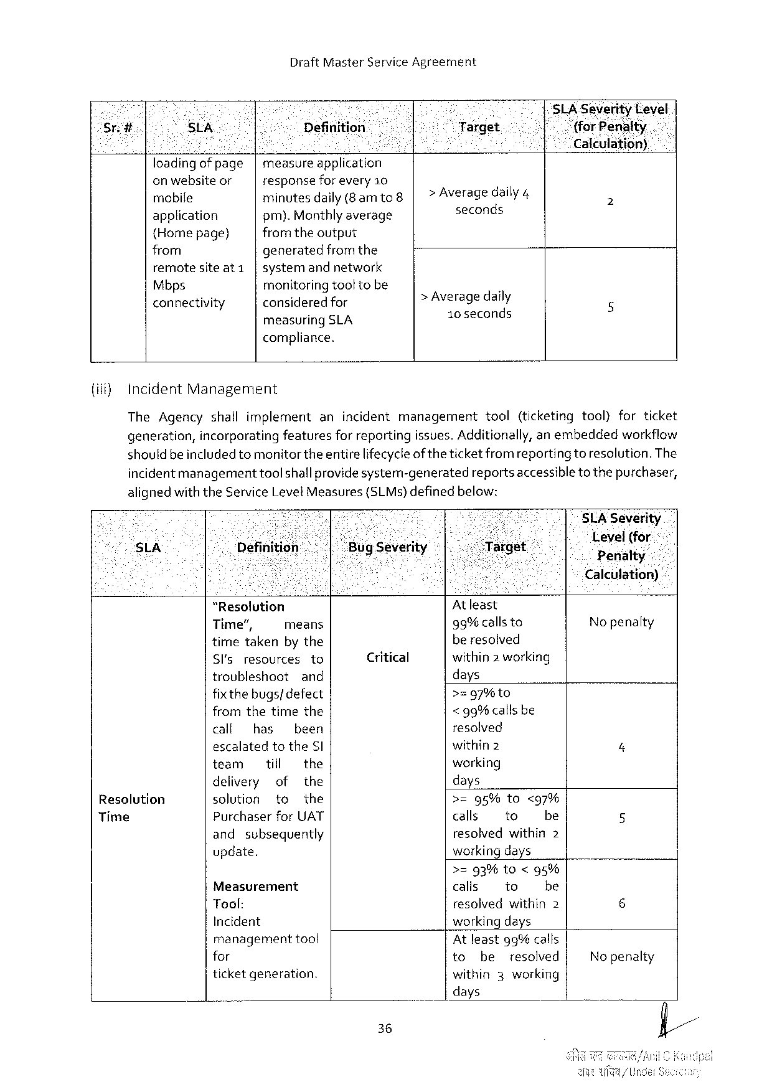

DraftMasterServiceAgreement

|  |  |  |  |  |  |  |  |
| --- | --- | --- | --- | --- | --- | --- | --- |
| Srg. | StA | Definition | | 8 | *1Target | | | SLA-SeverityLevel |
| h ‘(for‘Piefliilkt\yi |
| caleulation) |
| loadingofpage | measureapplication | |
| > Average daily4 |
| onwebsiteor | responseforevery 10 | |
| rnobile | minutesdaily(8amto | |
| seconds |
| application | pm).Monthlyaverage | |
| {Homepage) | from theoutput | | > Average daily |
| from | generatedfromthe | |
| remotesiteat1 | systemandnetwork | |
| Mbps | monitoring tooltobe | |
| connectivity | consideredfor | |
| 10 seconds |
| measuring | SLA |

compliance.

{iif) IncidentManagement

|  |  |  |  |
| --- | --- | --- | --- |
| TheAgencyshallimplement | anincidentmanagement | tool | (ticketingtool)forticket |

generation,incorporatingfeaturesfor reportingissues. Additionally,anembeddedworkflow

should be includedtomonitor theentire lifecycleof theticket fromreportingtoresolution. The

incidentmanagementtool shallprovidesystem-generatedreportsaccessibleto thepurchaser,

alignedwiththeServiceLevelMeasures

{(SLMs)definedbelow:

|  |  |  |  |  |  |  |  |  |  |  |
| --- | --- | --- | --- | --- | --- | --- | --- | --- | --- | --- |
| - | “Resolution | | | | Critical | At least | | | Level(for | - |
| sLA | Penalty |
| Calculation) |
| Resolution | Time”, | | means | | 99%callsto | | | Nopenalty |
| timetakenby the | | | | beresolved | | |
| Sl'sresources | | | to | within2 working | | |
| troubleshoot | | and | | days | | |
| fixthe bugs/defect | | | | >zg7%to | | | 4 |
| fromthetimethe | | | | < 99%callsbe | | |
| call | has | been | | resolved | | |
| escalatedtotheSl | | | | within2 | | |
| team | till | | the | working | | |
| delivery | | of | the | days | | |
| solution | | to | the | >=95%to<97% | | |
| PurchaserforUAT | | | | calls | to | be | 5 |
| Time |
| and | subsequently | | | resolvedwithin2 | | |
| update. | | | | workingdays | | |

>=93%to<95%

|  |  |  |  |  |  |  |
| --- | --- | --- | --- | --- | --- | --- |
| Measurement | | calis | | to | be | 6 |
| Tool: | | resolvedwithin2 | | | |
| Incident | | workingdays | | | | No penalty |
| management | toot | Atleast9g%calls | | | |
| for | | to | be | resolved | |
| ticketgeneration. | | within | | 3working | |

days

36

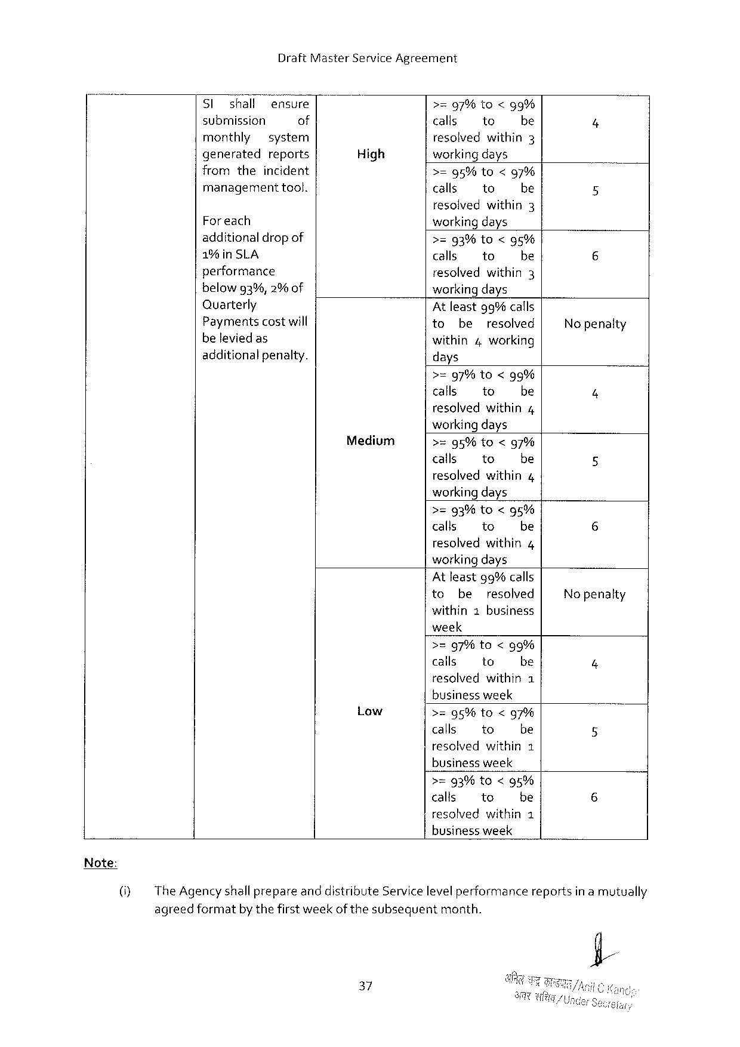

DraftMasterServiceAgreement

|  |  |  |  |  |  |  |
| --- | --- | --- | --- | --- | --- | --- |
| Sl | shall | ensure | High | >=97%to<gg% | | |
| submission | | of | calls | to | be |
| monthly | | system | resolvedwithin3 | | |
| generated | | reports | workingdays | | |

fromtheincident   
managementtool.

Foreach   
additionaldropof

1%in SLA   
performance   
belowg3%,2%of

>=95%to<97%

|  |  |  |
| --- | --- | --- |
| calls | to | be |
| resolved | within | 3 |

workingdays

>=g3%to<g5%

|  |  |  |
| --- | --- | --- |
| calls | to | be |

resolvedwithin3   
workingdays

|  |  |  |  |  |
| --- | --- | --- | --- | --- |
| Quarterly | At leastgg% calls | | | No penaity |
| Paymentscostwill |
| to | be | resolved |
| beleviedas | within4working | | |
| additionalpenalty. |
| days | | |

>=97%to<95%

|  |  |  |
| --- | --- | --- |
| calls | 1o | be |
| resolved | within | 4 |

workingdays

Medium >=95%to<g7%

calls to be

resolved within 4

workingdays

>=93%to<g5%

|  |  |  |
| --- | --- | --- |
| calls | to | be |
| resolved | within | 4 |

workingdays

Atleastg% calls

to be resolved Nopenalty

within1business

week

>=g7%to<9%

|  |  |  |
| --- | --- | --- |
| calls | to | be |

resolvedwithin1

businessweek

Low >=95%to<g7%

calls to be

resolved within 1

businessweek

>=93% to<95%

calls to be

resolvedwithin1

business week

(i} The AgencyshallprepareanddistributeServicelevelperformancereportsin a mutually

agreedformatby thefirstweek of thesubsequentmonth.

37

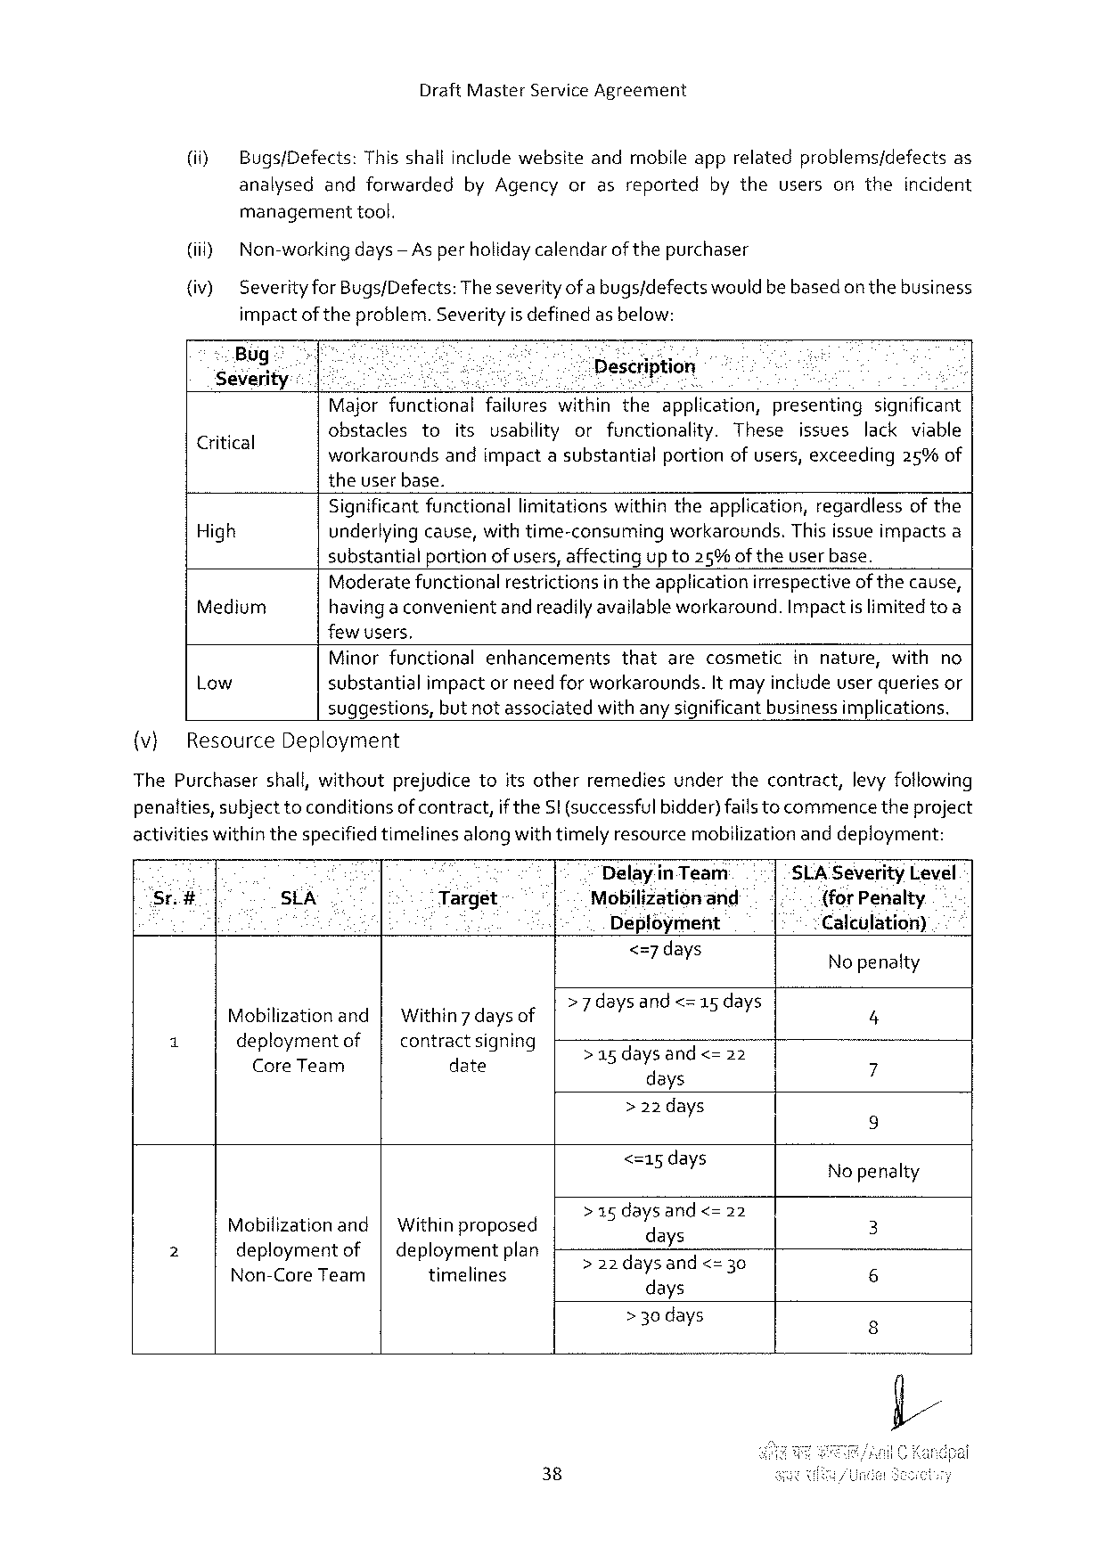

DraftMasterServiceAgreement

(i) Bugs/Defects:Thisshallinclude websiteandmobileapprelatedproblems/defectsas

analysedandforwarded byAgencyorasreported bytheusersontheincident

managementtool.

(i) Non-working days— As perholidaycalendarofthepurchaser

(iv) SeverityforBugs/Defects:Theseverityofa bugs/defectswouldbebasedon thebusiness

impact of theproblem.Severityis definedas below:

|  |  |  |  |  |  |  |
| --- | --- | --- | --- | --- | --- | --- |
| Bug -  ;  Severity  Critical | B | | et | Description   il o | | |
| Majorfunctionalfailureswithintheapplication,presentingsignificant | | | | | |
| obstacles | to | itsusabilityorfunctionality. | | These | issueslackviable |

workaroundsandimpactasubstantialportionofusers,exceeding25%of

theuserbase.

Significant functionallimitationswithintheapplication,regardlessof the

High underlyingcause,with time-consumingworkarounds.Thisissue impactsa

substantialportion of users, affectingup to25%oftheuserbase.

Moderatefunctionalrestrictionsintheapplicationirrespectiveof thecause,

Medium havinga convenientandreadilyavailable workaround.Impact islimitedtoa

few users,

Minorfunctionalenhancements thatarecosmeticinnature,withno

Low substantialimpactor need forworkarounds.It mayinclude userqueriesor

suggestions,but notassociatedwithany significantbusinessimplications.

(v} ResourceDeployment

ThePurchasershall,withoutprejudicetoitsotherremediesunderthecontract,levy fotlowing

penatties,subject toconditionsof contract,if theSI (successfulbidder)fails tocommencetheproject

activitieswithinthespecifiedtimelines alongwithtimelyresource mobilization anddeployment:

Delayin Team SLA SeverityLevel

Sr.# . SLA Target {forPenalty.

Deployment Calculation)

<=7days No penalty

d d <=15 days

Mobilizationand| Within7 daysof e YEIANCS8 5ICaY] 4

i deploymentof contractsigning Sasdaysandes o3

CoreTeam date 7

days

>22 days

i 9

<=15days Nopenalty

> 15 daysand<=

Mobilizationand| Withinproposed 2 \f:la " 2 3

2 deploymentof| deploymentplan e E yndT

Non-CoreTeam timelines 220ayEs =3 6

days

> 30 days 3

38

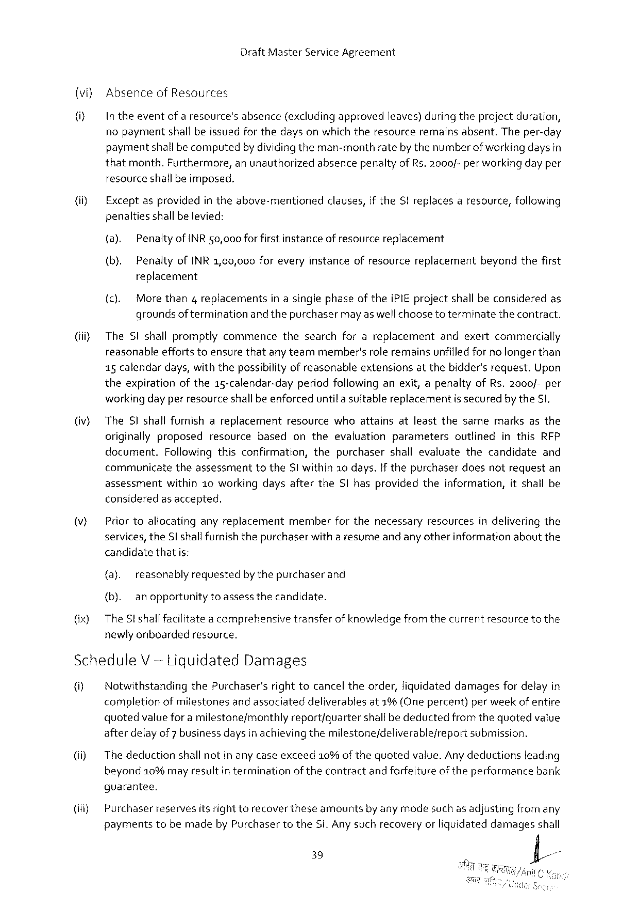

DraftMasterServiceAgreement

(vi) AbsenceofResources

Intheeventofaresource's absence (excludingapproved leaves)duringtheprojectduration,

nopayment shallbeissuedforthedaysonwhichtheresource remainsabsent. Theper-day paymentshallbe computedby dividingtheman-monthrateby thenumberofworkingdays in thatmonth.Furthermore,anunauthorizedabsencepenaltyof Rs. 2000/- per workingday per resourceshallbe imposed.

|  |  |  |  |  |  |  |  |  |
| --- | --- | --- | --- | --- | --- | --- | --- | --- |
| (i) | Exceptasprovided | | | intheabove-mentioned | clauses, | if theSIreplaces | aresource, | following |
| penaltiesshallbe levied: | | | | | | | |
| (a). | PenaltyofINR50,000forfirstinstanceofresourcereplacement | | | | | | |
| (b). | | PenaltyofINR 1,00,000foreveryinstanceofresourcereplacementbeyondthefirst | | | | | |

replacement

(c). More than4replacementsin asinglephaseof theiPIE projectshall beconsideredas groundsof terminationand thepurchasermayaswelfchooseto terminatethecontract.

(iii) TheSIshallpromptlycommencethesearchforareplacementandexertcommercially reasonableeffortstoensurethatanyteammember'srole remainsunfilledfor no longerthan 15 calendardays, withthepossibilityof reasonableextensionsatthebidder'srequest.Upon theexpirationof the15-calendar-dayperiodfollowing anexit,apenaltyofRs.2000/-per workingday per resourceshallbe enforceduntila suitablereplacementissecuredby theS,

(v} TheSI shallfurnishareplacementresourcewhoattainsatleastthesamemarksasthe originallyproposedresourcebasedontheevaluationparameters outlinedinthisRFP document. Followingthisconfirmation,thepurchasershallevaluatethecandidate and communicatetheassessmenttotheSI within2o days.If thepurchaserdoesnotrequestan assessment within10workingdaysaftertheSlhasprovidedtheinformation,itshallbe consideredas accepted.

|  |  |  |  |  |  |  |  |
| --- | --- | --- | --- | --- | --- | --- | --- |
| v) | Priortoallocating | anyreplacement | member | forthenecessary | resources | indelivering | the |

services, theSl shallfurnish thepurchaserwitha resumeand any otherinformationaboutthe candidatethatis:

{a). reasonablyrequestedby thepurchaserand

{b). anopportunity toassessthecandidate.

(ix) TheSt shallfacilitatea comprehensivetransferof knowledge fromthecurrentresourcetothe newlyanboardedresource.

ScheduleV -tiguidated Damages

U] NotwithstandingthePurchaser’srighttocanceltheorder,liquidateddamagesfordelayin completionofmilestonesand associateddeliverablesat1%(One percent)per weekof entire quotedvaluefor a milestone/monthlyreport/quartershallbedeductedfromthequotedvalue afterdelay of7 business daysin achieving themilestone/deliverablejreportsubmission.

(ii) Thedeductionshall notin any caseexceed10%of thequotedvalue. Anydeductionsleading beyond10%mayresultin terminationof thecontractand forfeitureoftheperformancebank

guarantee.

(iii) Purchaserreservesitsrighttorecover theseamountsby any modesuch as adjustingfromany paymentstobemadeby PurchasertotheSi.Anysuchrecoveryor liquidateddamagesshall

39



DraftMasterServiceAgreement

notin any wayrelievetheSi fromany of itsobligationstocompleteWorkor fromany other

obligationsand liabilities under theContract.

|  |  |  |  |  |  |  |  |  |  |  |  |  |
| --- | --- | --- | --- | --- | --- | --- | --- | --- | --- | --- | --- | --- |
| (iv) | Delaysnotattributable | | | toSi shaltbeconsidered | | | | forexclusionforthepurposeofcomputing | | | | |
| liquidateddamages. | | | is | the | amount | of | payment | due | against | a | particular |
| Note: | Quoted | valve |
| milestone/month/quarter | | | asper paymentschedule. | | | | | | | | |

40

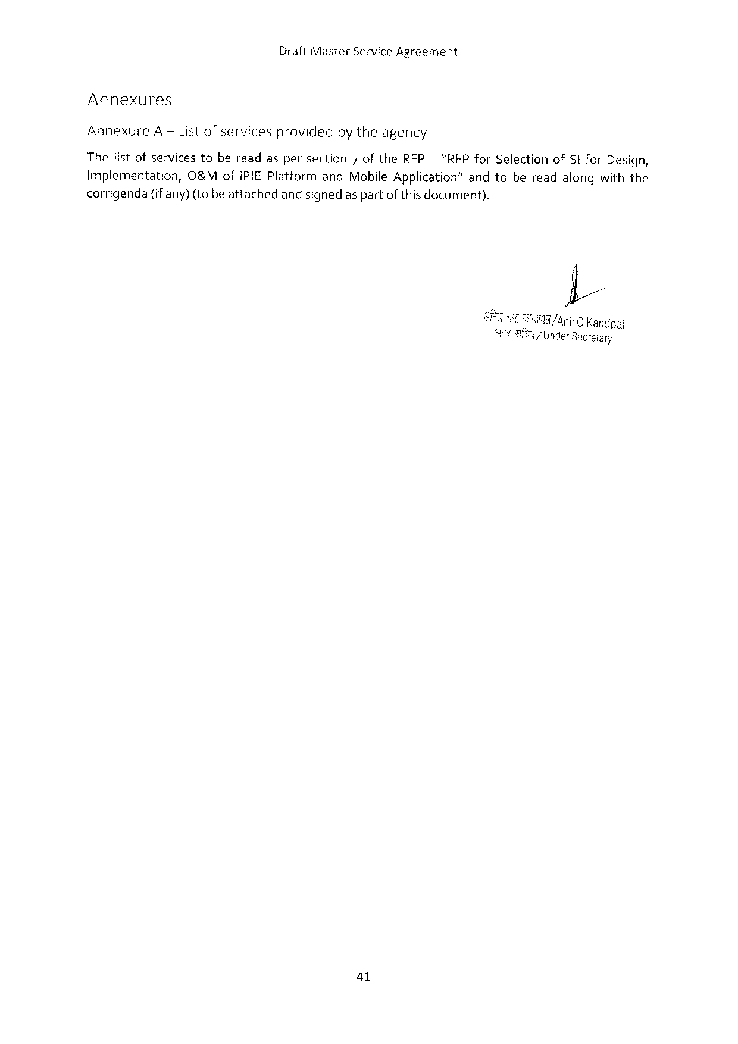

DraftMasterServiceAgreement

Annexures

AnnexureA— Listofservicesprovidedbytheagency

Thelist ofservicestobereadaspersection7oftheRFP— “RFPforSelectionofSt forDesign,

Implementation, O&MofiPIEPlatformandMobile Application”andtobereadalongwiththe

corrigenda(if any)(to beattachedandsignedas partof this document).

I

GG AnitKandpai

a3 9/ Under Secretary

41

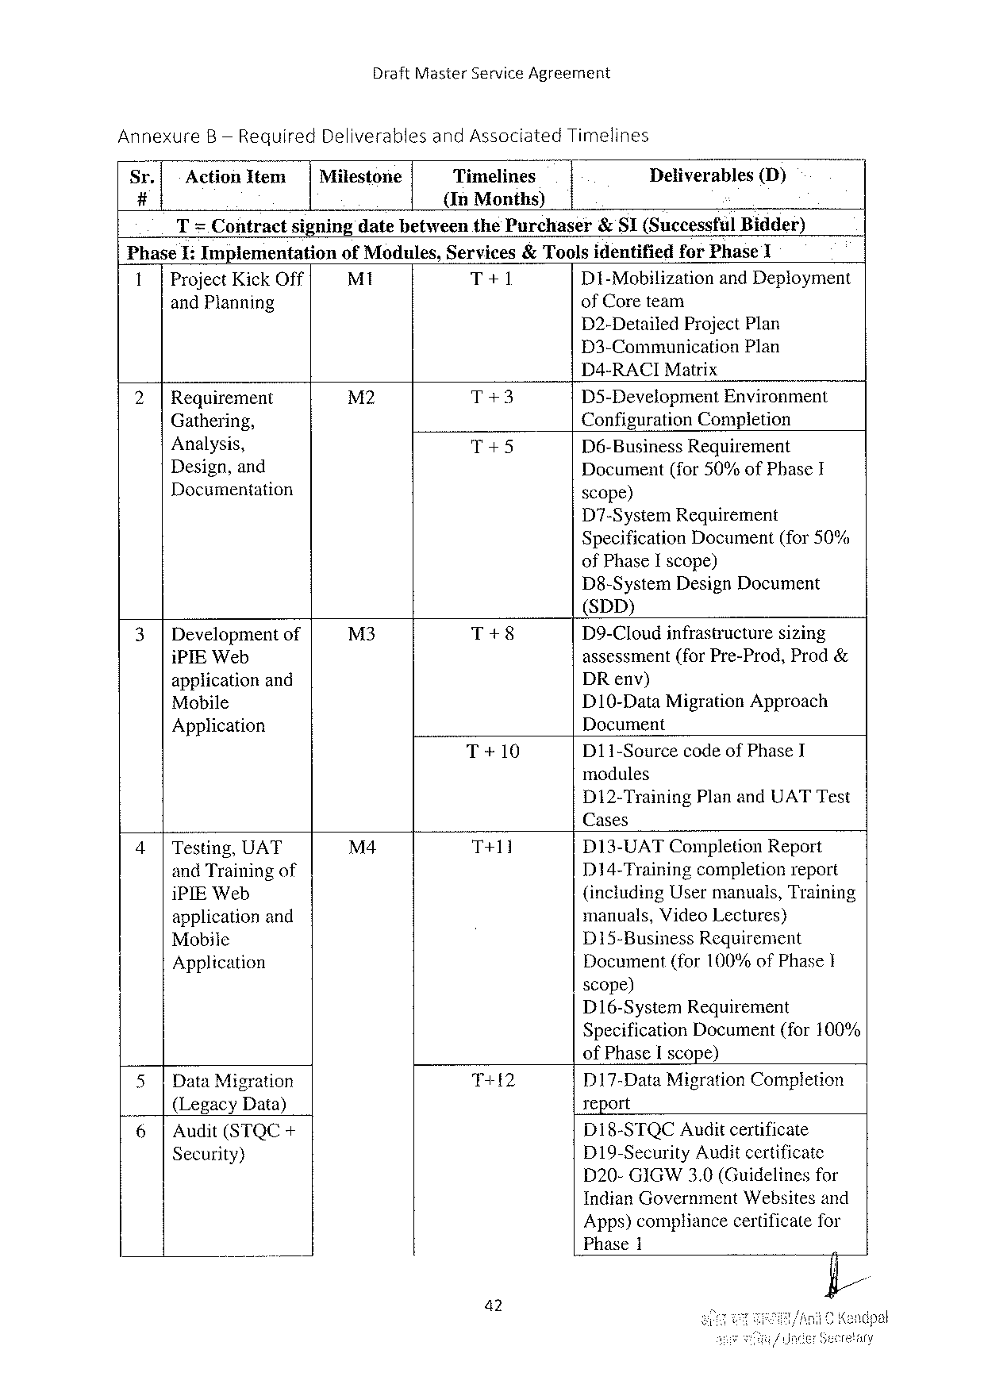

DraftMasterServiceAgreement

AnnexureB— RequiredDeliverablesandAssociatedTimelines

|  |  |  |  |  |  |
| --- | --- | --- | --- | --- | --- |
| Sr. | ActionItem | Milestone | Timelines | Deliverables | (D) |
| # | {InMonths) |

T= ContractsigningdatebetweenthePurchaser& SI(SuccessfulBidder)

PhaseI:Implementation of Modules,Services& ToolsidentifiedforPhase1

1|ProjectKickOff M1 T+1 D1-Mobilization andDeployment

andPlanning ofCoreteam

D2-DetailedProjectPlan

D3-Communication Plan

D4-RACIMatrix

|  |  |  |  |  |
| --- | --- | --- | --- | --- |
| 2| | Requirement | M2 | T+3 | D35-DevelopmentEnvironment |
| Gathering, | T+5 | ConfigurationCompletion |
| Analysis, | D6-BusinessRequirement |

Design,and   
Documentation

Document(for50%ofPhaseI scope)

D7-SystemRequirement   
Specification Document(for50% ofPhaseI scope)   
D8-SystemDesignDocument   
(SDD)

|  |  |  |  |
| --- | --- | --- | --- |
| 3|Development of | M3 | T+8 | D9-Cloudinfrastructure sizing |
| iPIEWeb | T+10 | assessment(forPre-Prod,Prod& |
| applicationand | DRenv) |
| Mobile | D10-DataMigrationApproach |
| Application | Document |
| D11-SourcecodeofPhaseI |

modules   
D12-TrainingPlanandUATTest   
Cases

|  |  |  |  |
| --- | --- | --- | --- |
| 4|Testing,UAT | M4 | T+11 | D13-UATCompletionReport |
| andTrainingof | D14-Trainingcompletionreport |
| iPIEWeb | (includingUsermanuals,Training |
| applicationand | manuals,VideoLectures) |
| D15-BusinessRequirement |
| Mobile |
| Document(for100%ofPhaseI |
| Application |

scope)   
D16-System Requirement   
Specification Document(for100%   
ofPhaseIscope)

|  |  |  |  |  |  |
| --- | --- | --- | --- | --- | --- |
| L. | 5|DataMigration | | T+12 | D17-DataMigrationCompletion | |
| report | |
| (LegacyData) | |
| D18-STQCAuditcertificate | |
| 6| | Audit(STQC+ |
| D19-SecurityAuditcertificate | |
| Security) | |
| D20-GIGW3.0(Guidelinesfor | |
| IndianGovernment | Websitesand |

Apps)compliancecertificatefor   
Phase1

42

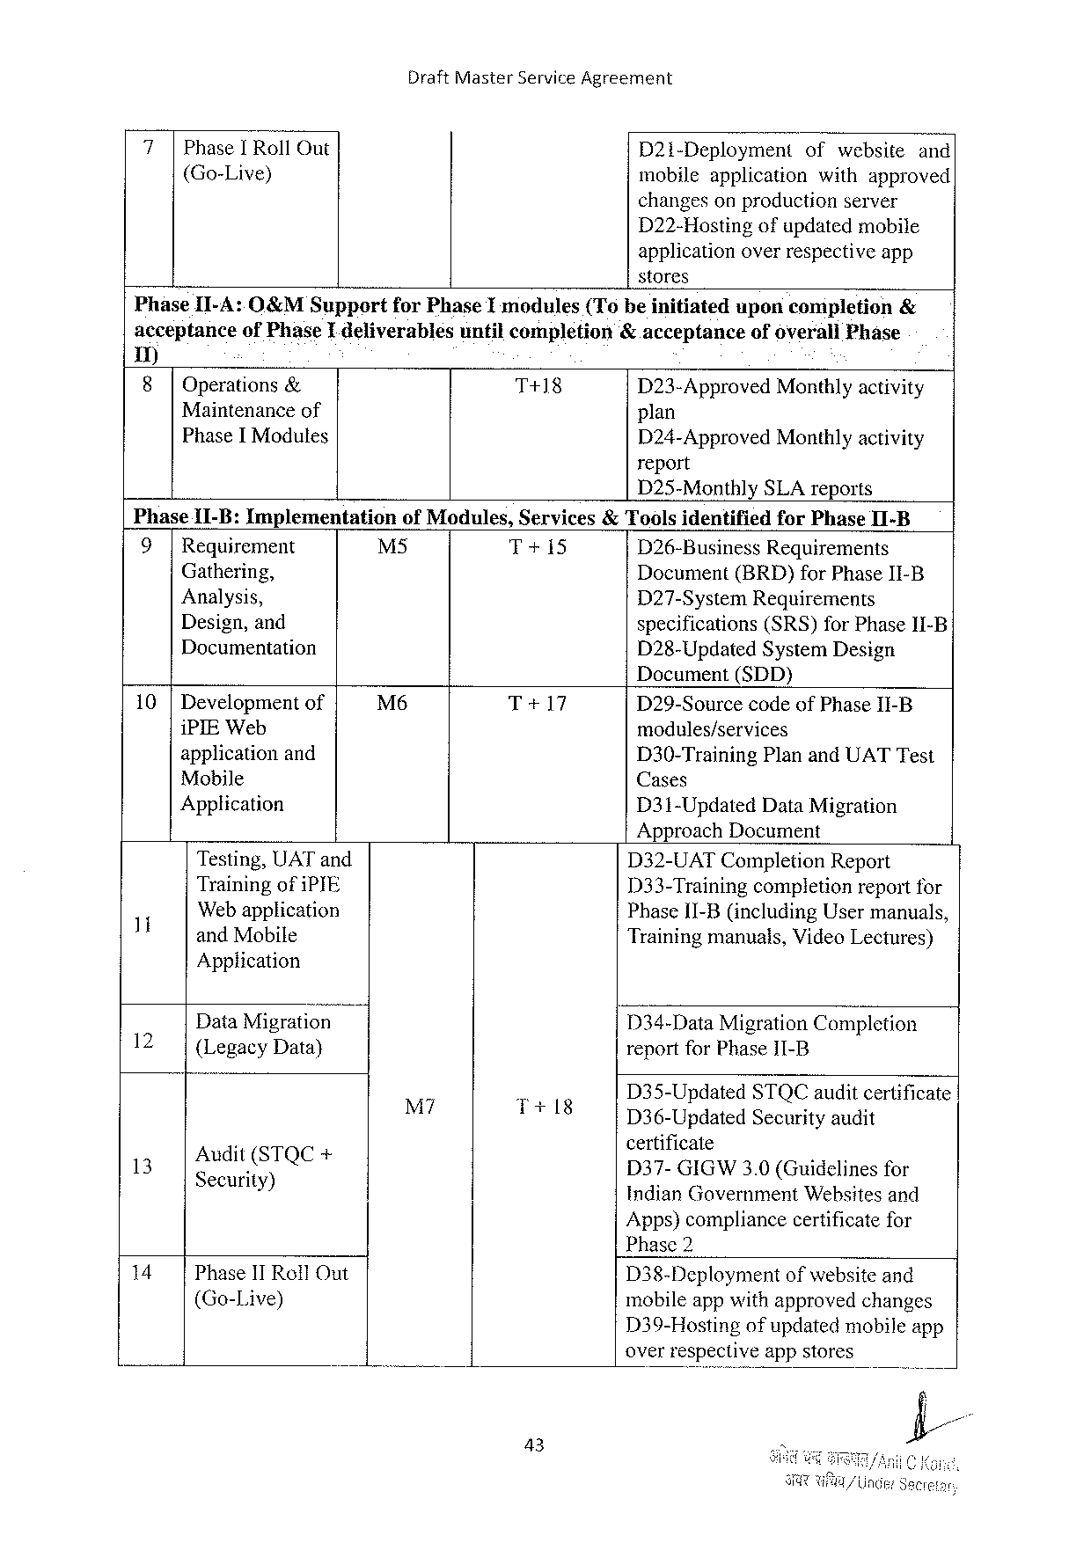

DraftMasterServiceAgreement

|  |  |  |  |
| --- | --- | --- | --- |
| PhaseI RollOut  (Go-Live) | D21i-Deployment | ofwebsite | and |
| mobileapplication | withapproved | |
| changesonproductionserver | | |

D22-Hostingofupdatedmobile

applicationoverrespectiveapp

stores

PhaseII-A:O&MSupport forPhaseImodules(Tobeinitiated uponcompletion &

acceptanceofPhaseI deliverablesuntilcompletion&acceptanceofoverallPhase

1)

8 Operations & T+18 D23-Approved Monthlyactivity

Maintenance of plan

PhaseI Modules

D24-ApprovedMonthlyactivity report

D25-MonthlySLAreports

|  |  |  |  |  |
| --- | --- | --- | --- | --- |
| Phase11-B: Implementation  9|Requirement  Gathering,  Analysis,  Design,and  Documentation | ofModules,Services&Toolsidentified | | | forPhaseI1-B |
| M5 | T+15 | D26-Business | Requirements |
| Document(BRD)forPhaseII-B D27-SystemRequirements  specifications(SRS)forPhase11-B D28-UpdatedSystemDesign | | | |

Document(SDD)

|  |  |  |  |
| --- | --- | --- | --- |
| 10 |Development of | M6 | T+17 | D29-Sourcecode ofPhaseII-B |
| iPIEWeb | modules/services |
| applicationand |
| D30-TrainingPlanandUATTest |
| Mobile |
| Cases |
| Application | D31-Updated DataMigration |

ApproachDocument

|  |  |  |  |  |  |
| --- | --- | --- | --- | --- | --- |
| 1 | Testing,UAT and | M7 | . | D32-UATCompletion Report | |
| TrainingofiPYE | D33-Trainingcompletionreportfor | |
| Web application | PhaseII-B(includingUsermanuals, | |
| andMobile | Trainingmanuals,VideoLectures) | |
| 12 | Application | D34-DataMigrationCompletion | |
| DataMigration |
| {LegacyData) | reportforPhaseI11-B | |
| D35-Updated | STQCauditcertificate |
| 13 | :  ?e“ci‘;is)TQe+ | T+18 | D36-UpdatedSecurityaudit | |
| certificate  D37-GIGW3.0 (Guidelines for | |
| IndianGovernmentWebsitesand | |

Apps)compliancecertificatefor   
Phase2

|  |  |  |  |
| --- | --- | --- | --- |
| 14 | Phase1T RollOut | D38-Deployment | ofwebsiteand |
| (Go-Live) | mobileappwithapprovedchanges | |
| D39-Hostingofupdatedmobileapp | |

overrespective app stores

43

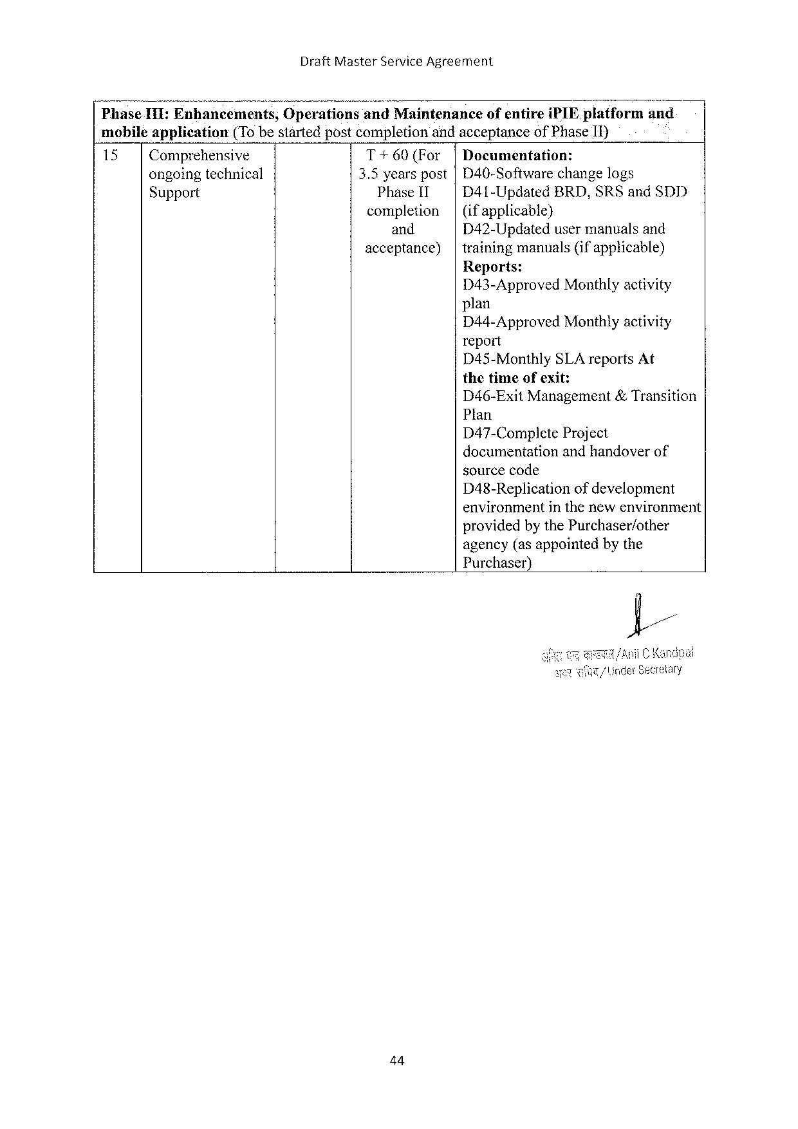

DraftMasterServiceAgreement

NPhase1118]Enhancem;n;s, Oper:;;ions‘;;;i Maintenance ofentireiPIEplatform and

mobiléapplication (To bestartedpostcompletionandacceptanceofPhaseII)

15 Comprehensive T+60(For Documentation:

ongoingtechnical 3.5yearspost D40-Softwarechangelogs

Support Phase11 D41-Updated BRD,SRSandSDD

completion (ifapplicable)}

and D42-Updatedusermanualsand

acceptance) trainingmanuals(ifapplicable)

Reports:

D43-ApprovedMonthlyactivity

plan

D44-ApprovedMonthlyactivity

report

D45-MonthlySLA reportsAt

thetimeofexit:

D46-ExitManagement&Transition

Plan

D47-Complete Project

documentationandhandoverof

sourcecode

D48-Replication ofdevelopment

environmentinthenewenvironment

providedby thePurchaser/other

agency(asappointedbythe

Purchaser)}

44

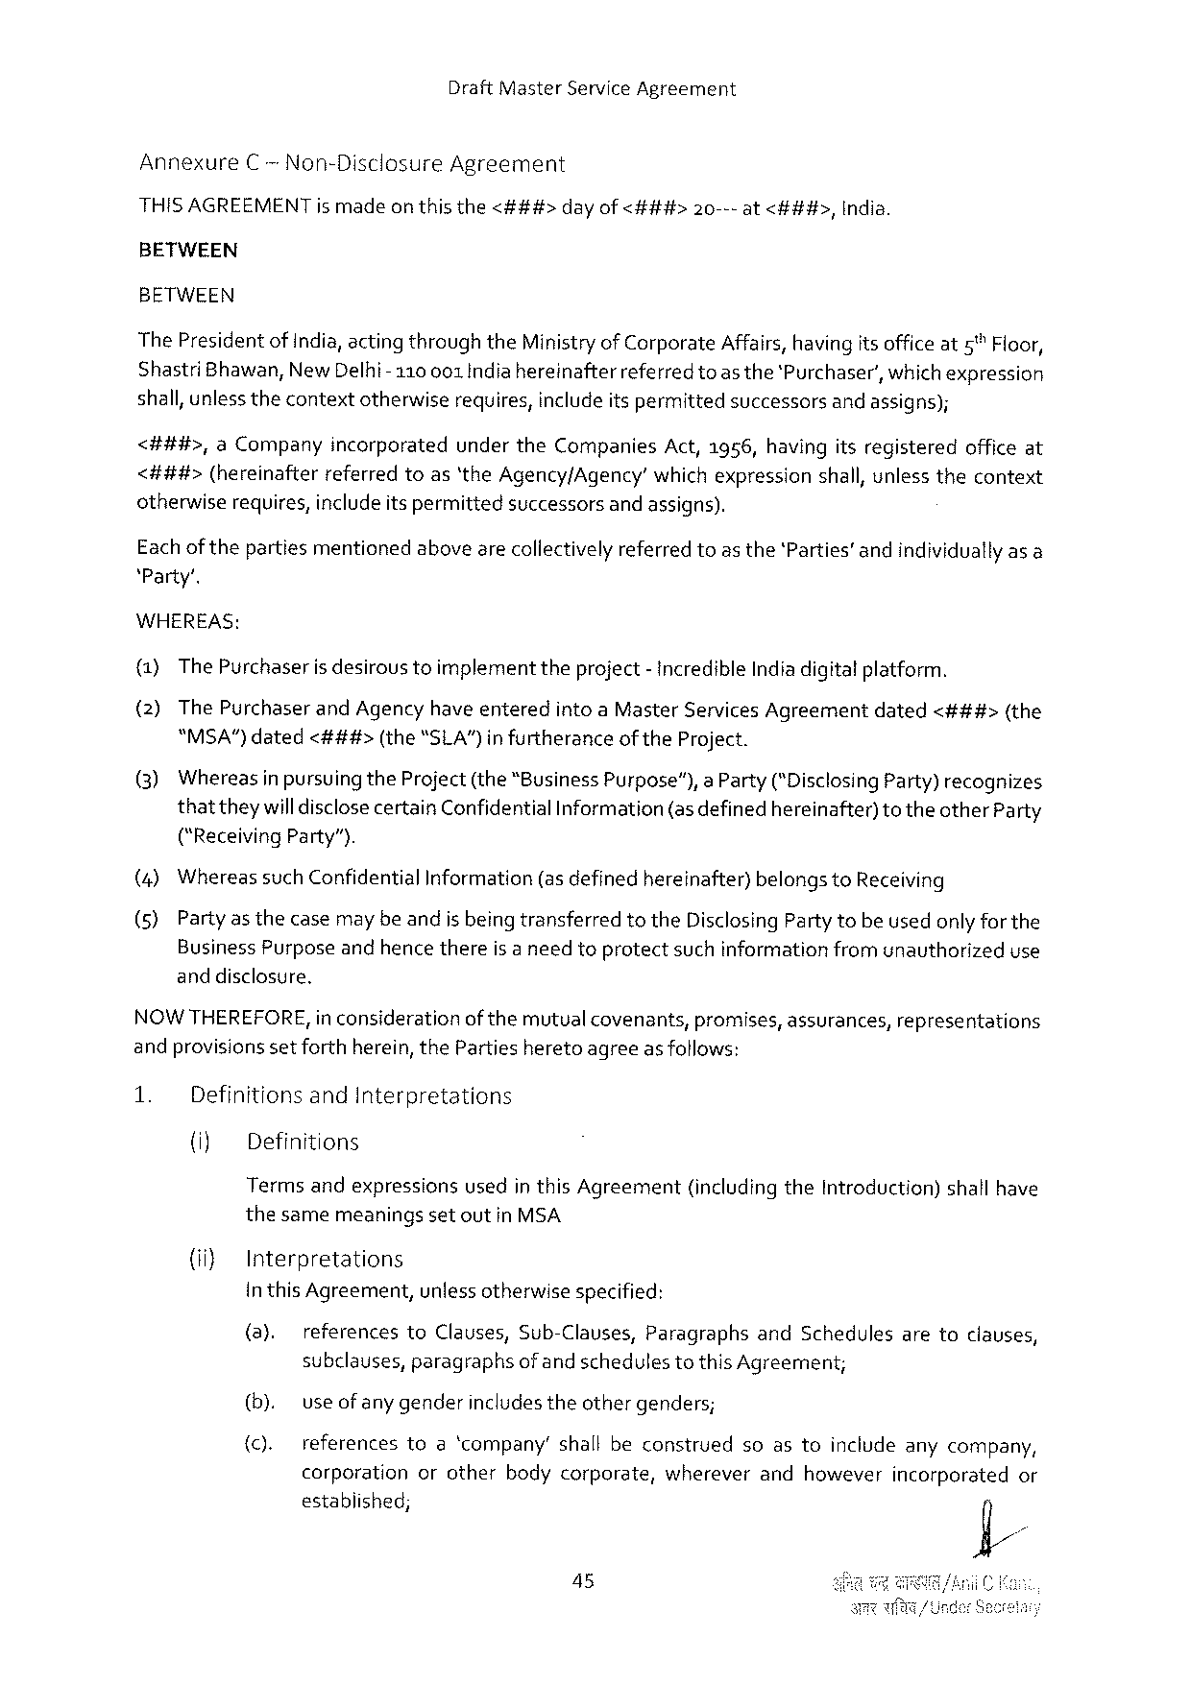

DraftMasterServiceAgreement

AnnexureC -Non-DisclosureAgreement

|  |  |  |  |
| --- | --- | --- | --- |
| HISAGREEMENTismadeon thisthe<###> | dayof<###> | 20---at<###>, | India. |

BETWEEN

BETWEEN

ThePresidentof India,acting throughtheMinistryof CorporateAffairs,havingits officeat5™Floor,

ShastriBhawan,NewDelhi-110001 Indiahereinafter referredtoas the‘Purchaser’,whichexpression

shall,unlessthecontextotherwiserequires,includeitspermittedsuccessorsand assigns);

<##4#>,a Company incorporated undertheCompanies Act,1956,havingitsregistered officeat

<###>(hereinafterreferredtoas‘theAgency/Agency’whichexpressionshall,unlessthecontext

otherwiserequires, includeitspermittedsuccessorsand assigns).

Eachofthepartiesmentionedabovearecollectivelyreferredtoas the‘Parties’andindividuallyasa

‘Party’.

WHEREAS:

(1)ThePurchaseris desiroustoimplementtheproject- incredibleIndiadigitatplatform.

(2)ThePurchaserandAgencyhave enteredintoaMasterServicesAgreementdated<###>(the

"MSA”)dated<###> (the“SLA")infurtherance oftheProject.

(3) Whereas inpursuingtheProject(the“BusinessPurpose”),aParty(*DisclosingParty)recognizes

thattheywilldisclosecertainConfidentialInformation (asdefinedhereinafter) totheotherParty

("ReceivingParty”).

|  |  |  |  |  |  |
| --- | --- | --- | --- | --- | --- |
| (4) | Whereas | suchConfidential | Information | (asdefinedhereinafter) | belongstoReceiving |

(5)Partyas thecasemaybeandis being transferredtotheDisclosingPartytobeusedonly for the

BusinessPurposeandhencethereis a needtoprotectsuchinformationfromunauthorizeduse

anddisclosure.

NOWTHEREFORE,in considerationof themutual covenants,promises,assurances,representations

andprovisionssetforthherein, thePartiesheretoagreeasfollows:

|  |  |  |  |  |  |
| --- | --- | --- | --- | --- | --- |
| 1. | DefinitionsandInterpretations | | | (includingtheIntroduction) | shallhave |
| (iy | Definitions | |
| Termsandexpressions | | usedin thisAgreement |

thesamemeaningsset outin MSA

(i} Interpretations

in thisAgreement,unlessotherwisespecified:

(a). referencestoClauses,Sub-Clauses,ParagraphsandSchedulesaretoclauses,

subclauses,paragraphsofand schedulestothis Agreement;

|  |  |  |  |  |  |  |  |  |  |
| --- | --- | --- | --- | --- | --- | --- | --- | --- | --- |
| (b). | use ofany genderincludestheothergenders; | | | | | | soastoincludeanycompany, | | |
| (c). |
| references | toa‘company’ | | | shallbeconstrued | |
| corporation | | orother | bodycorporate, | | wherever | andhowever | incorporated | or |

established;

45

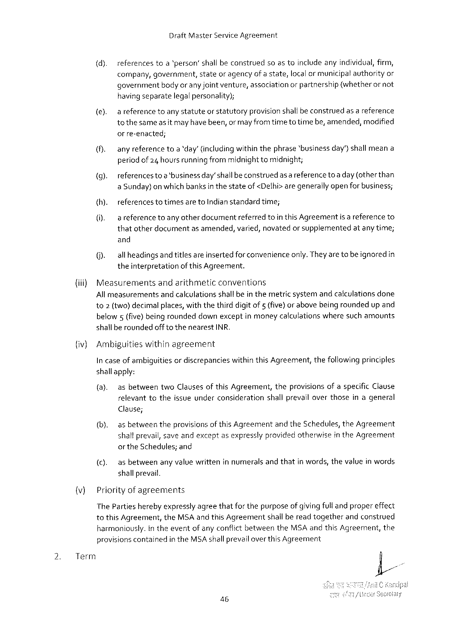

DraftMasterServiceAgreement

|  |  |  |  |  |  |  |  |
| --- | --- | --- | --- | --- | --- | --- | --- |
| (d). | references | toa‘person’shallbeconstrued | | soastoincludeanyindividual,firm, | | | |
| company, | government, | stateoragencyofastate, | | localormunicipal | | authorityor |
| bodyoranyjointventure,association | | | orpartnership | (whetherornot | |
| government |

havingseparatelegalpersonality);

(e). areferencetoanystatuteorstatutoryprovisionshallbe construedasa reference tothesameas it mayhave been,or mayfromtime totimebe,amended,modified

orre-enacted;

(). anyreferencetoa‘day’ (includingwithinthephrase‘businessday’)shall meana periodof 24 hoursrunningfrommidnighttomidnight;

(g). referencestoa‘businessday’shall beconstruedas a referencetoa day (otherthan aSunday)on which banksin thestateof <Delhi>aregenerally openfor business;

|  |  |  |  |  |
| --- | --- | --- | --- | --- |
| {h). | referencestotimesaretoIndianstandardtime; | | isareference | to |
| (i). | areference | toanyotherdocumentreferredtointhisAgreement |

thatotherdocumentasamended,varied,novatedor supplementedatanytime;

and

(). allheadingsand titlesareinsertedforconvenienceonly.Theyare tobe ignoredin theinterpretationof thisAgreement.

|  |  |  |
| --- | --- | --- |
| (iii) | Measurements | andarithmeticconventions |

All measurementsand calculationsshallbein themetric systemandcalculationsdone to2 (two)decimalplaces, withthethird digitof 5 (five}or abovebeingroundedup and

|  |  |  |
| --- | --- | --- |
| below5(five) beingrounded | downexceptinmoneycalculations | wheresuchamounts |

shallberoundedofftothenearestINR.

(iv) Ambiguitieswithinagreement

In caseof ambiguitiesordiscrepancieswithin thisAgreement,thefollowingprinciples

shallapply:

(a). asbetweentwoClausesofthisAgreement,theprovisions ofaspecificClause relevanttotheissueunderconsiderationshallprevailoverthoseinageneral

Clause;

(b). as betweentheprovisionsof thisAgreementandtheSchedules,theAgreement shallprevail,saveandexceptasexpresslyprovidedotherwisein theAgreement

|  |  |  |  |  |  |
| --- | --- | --- | --- | --- | --- |
| (c). | ortheSchedules; | | and | andthat | inwords,thevalueinwords |
| asbetween | anyvaluewritteninnumerals | |

shallprevail.

(v) Priorityof agreements

The Partiesherebyexpresslyagreethatfor thepurposeofgivingfulland propereffect tothis Agreement,theMSAand thisAgreementshallbereadtogetherandconstrued

|  |  |  |  |  |  |  |  |
| --- | --- | --- | --- | --- | --- | --- | --- |
| 2. | Term | harmoniously. | In theeventofanyconflictbetween | | | theMSAandthisAgreement, | the |
| provisionscontained | | intheMSAshallprevail | overthisAgreement | |

46

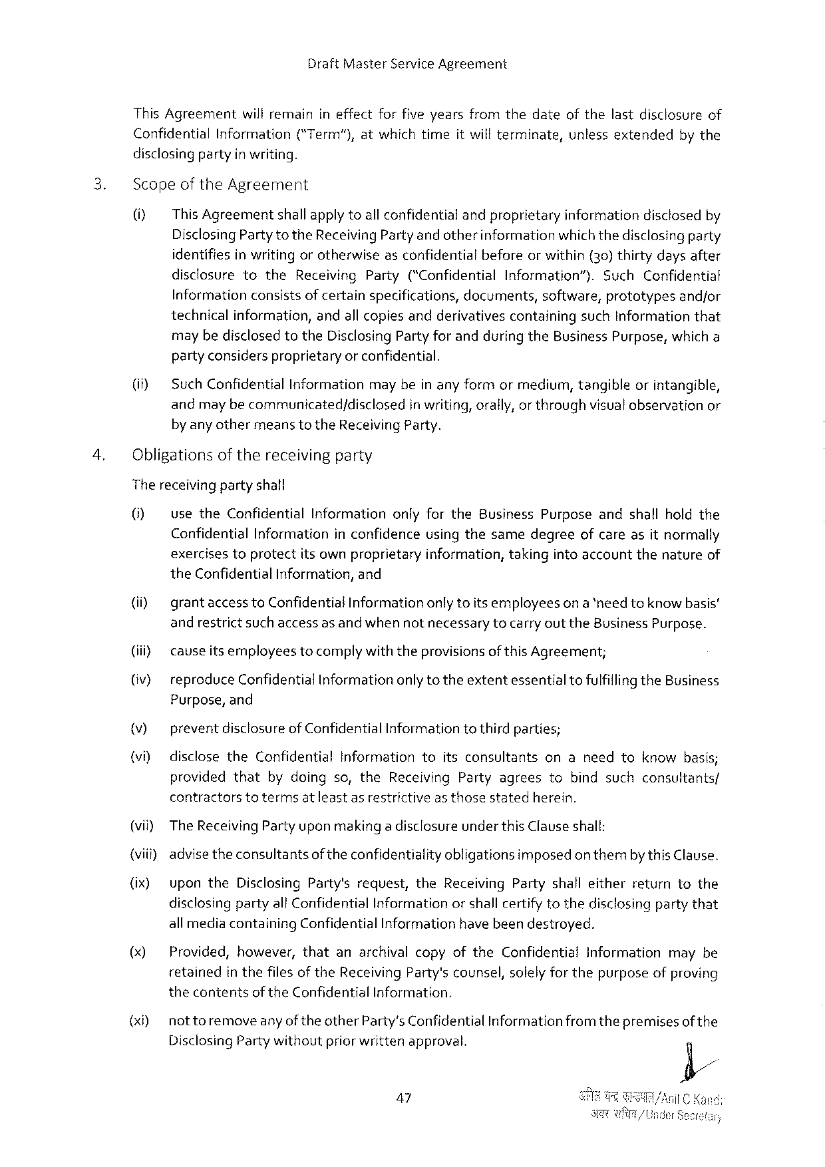

DraftMasterServiceAgreement

ThisAgreementwillremainineffectforfiveyearsfromthedateofthelastdisclosureof

|  |  |  |  |  |  |  |  |  |
| --- | --- | --- | --- | --- | --- | --- | --- | --- |
| Confidential | Information | (“Term"), | atwhich | time | itwillterminate, | unless | extended | bythe |

disclosingpartyin writing.

Scopeof theAgreement

0] ThisAgreementshallapplytoall confidentialandproprietaryinformationdisclosedby DisclosingPartytotheReceivingPartyand otherinformationwhichthedisclosingparty identifiesin writing orotherwiseasconfidentialbeforeorwithin (30)thirtydaysafter

|  |  |  |  |  |  |  |  |  |
| --- | --- | --- | --- | --- | --- | --- | --- | --- |
| disclosure | to | the | Receiving | Party | (“Confidential | Information”). | Such | Confidential |

Informationconsistsof certainspecifications,documents,software,prototypesandjor technicalinformation,andallcopiesandderivativescontainingsuchInformationthat maybedisclosed totheDisclosingPartyfor andduring theBusiness Purpose,which a partyconsidersproprietaryor confidential.

(i SuchConfidentialInformationmay bein anyformormediurm,tangibleorintangible, andmay becommunicated/disclosed in writing,orally, or throughvisualobservationor by anyothermeanstotheReceivingParty.

Obligationsofthereceivingparty

Thereceivingpartyshall

0] usetheConfidentialInformationonlyfortheBusinessPurposeandshallholdthe ConfidentialInformationin confidenceusingthesamedegreeofcareasitnormally

|  |  |  |  |  |  |  |
| --- | --- | --- | --- | --- | --- | --- |
| exercises | toprotect | itsownproprietary | information, | taking | intoaccountthenature | of |

theConfidentialInformation,and

(i) grantaccess toConfidential Informationonlytoitsemployeeson a *need toknow basis’ andrestrictsuch access as andwhen notnecessarytocarryout theBusiness Purpose.

(iii cavseitsemployeestocomplywiththeprovisionsof this Agreement;

(v} reproduceConfidential Informationonly totheextentessentialtofulfillingtheBusiness Purpose,and

v) preventdisclosureof ConfidentialInformationto thirdparties;

(i) disclosetheConfidentialInformationtoitsconsultantsonaneedtoknowbasis; providedthat bydoingso,theReceivingPartyagreestobindsuchconsultants/ contractorstotermsatleast asrestrictiveas thosestatedherein.

(vii) TheReceivingParty upon makinga disclosureunderthisClauseshall:

{viii) advisetheconsultantsoftheconfidentialityobligationsimposedon thembythis Clause.

(ix) upontheDisclosingParty'srequest,theReceivingPartyshalleitherreturntothe disclosingpartyallConfidentialInformationorshall certifytothedisclosingpartythat all mediacontainingConfidentialInformationhave beendestroyed.

() Provided,however,thatanarchivalcopyoftheConfidentialInformationmaybe retainedin thefiles of theReceivingParty'scounsel,solelyfor thepurposeofproving thecontentsof theConfidentialInformation.

(x0) nottoremoveanyof theotherParty’sConfidentialInformationfromthepremisesof the DisclosingPartywithoutpriorwrittenapproval.

47

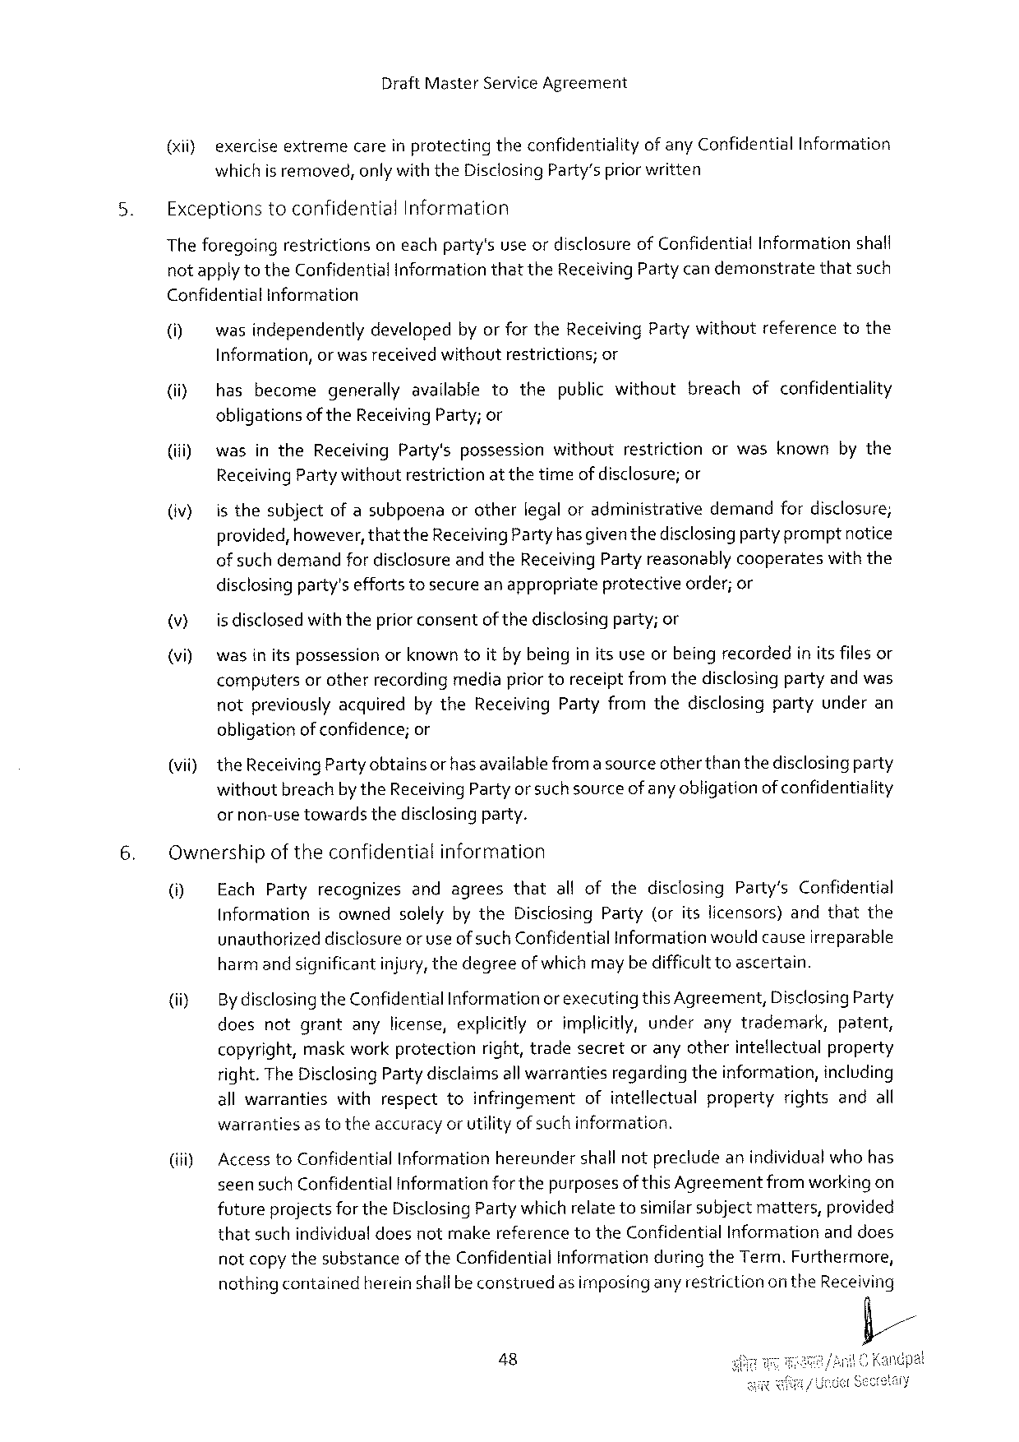

DraftMasterServiceAgreement

(it} exerciseextremecareinprotectingtheconfidentialityof any ConfidentialInformation whichis removed,onlywiththeDisclosingParty’spriorwritten

ExceptionstoconfidentialInformation

Theforegoingrestrictionsoneachparty'suseordisclosureof ConfidentialInformationshall notapplytotheConfidential InformationthattheReceivingParty candemonstratethatsuch

Confidential Information

|  |  |  |  |  |  |
| --- | --- | --- | --- | --- | --- |
| (M  (iiy  (iii)  (v} | wasindependentlydevelopedbyor fortheReceivingPartywithoutreferencetothe | | | | |
| Information, | orwas receivedwithoutrestrictions; | | | or |
| hasbecome | | generallyavailabletothepublicwithoutbreachofconfidentiality | | |
| obligations | oftheReceivingParty;or | | | |
| wasintheReceivingParty'spossessionwithoutrestrictionorwasknownbythe | | | | |
| ReceivingPartywithoutrestrictionat thetime | | | of disclosure;or | |
| isthesubjectofasubpoenaorotherlegaloradminisirativedemandfordisclosure; provided,however,thattheReceivingParty hasgiventhedisclosingparty promptnotice | | | | |

of such demandfor disclosureandtheReceivingPartyreasonablycooperateswith the

|  |  |  |  |
| --- | --- | --- | --- |
| v)  (vi) | disclosingparty'seffortstosecureanappropriate | protective | order;or |
| is disclosedwiththepriorconsentof thedisclosingparty; or  wasin itspossessionorknown toit by beinginits useorbeingrecordedinitsfilesor computersor otherrecordingmediapriortoreceiptfromthedisclosingpartyandwas | | |

notpreviouslyacquiredbytheReceivingPartyfromthedisclosingpartyunderan obligationof confidence;or

(vii) theReceivingPartyobtainsor has availablefroma sourceotherthan thedisclosingparty withoutbreachbytheReceivingParty orsuchsourceof anyobligationofconfidentiality

ornon-usetowardsthedisclosingparty.

Ownershipoftheconfidentialinformation

|  |  |
| --- | --- |
| 0] | EachPartyrecognizesandagreesthatallofthedisclosingParty’sConfidential InformationisownedsolelybytheDisclosingParty(oritslicensors)andthatthe |

unauthorizeddisclosureor useof suchConfidentialInformation wouldcauseirreparable harmand significantinjury,thedegreeof whichmay be difficulttoascertain.

|  |  |  |
| --- | --- | --- |
| (iiy | By disclosingtheConfidentialInformationor executingthisAgreement,DisclosingParty | |
| doesnotgrantanylicense,explicitlyorimplicitly,underanytrademark, | patent, |

copyright,maskworkprotectionright,tradesecretoranyotherintellectualproperty right.The DisclosingPartydisclaims allwarrantiesregardingtheinformation,including allwarrantieswithrespecttoinfringementofintellectualpropertyrightsandall warrantiesas totheaccuracyor utilityof suchinformation.

(iiiy AccesstoConfidentialInformationhereundershall notprecludeanindividualwho has seensuch ConfidentialInformationfor thepurposesof this Agreementfrom workingon futureprojects for theDisclosingParty which relatetosimilarsubjectmatters,provided thatsuchindividualdoesnotmakereferencetotheConfidentialInformationand does notcopy thesubstanceof theConfidentialInformationduring theTerm.Furthermore, nothingcontainedherein shallbeconstruedas imposingany restrictionon theReceiving

48

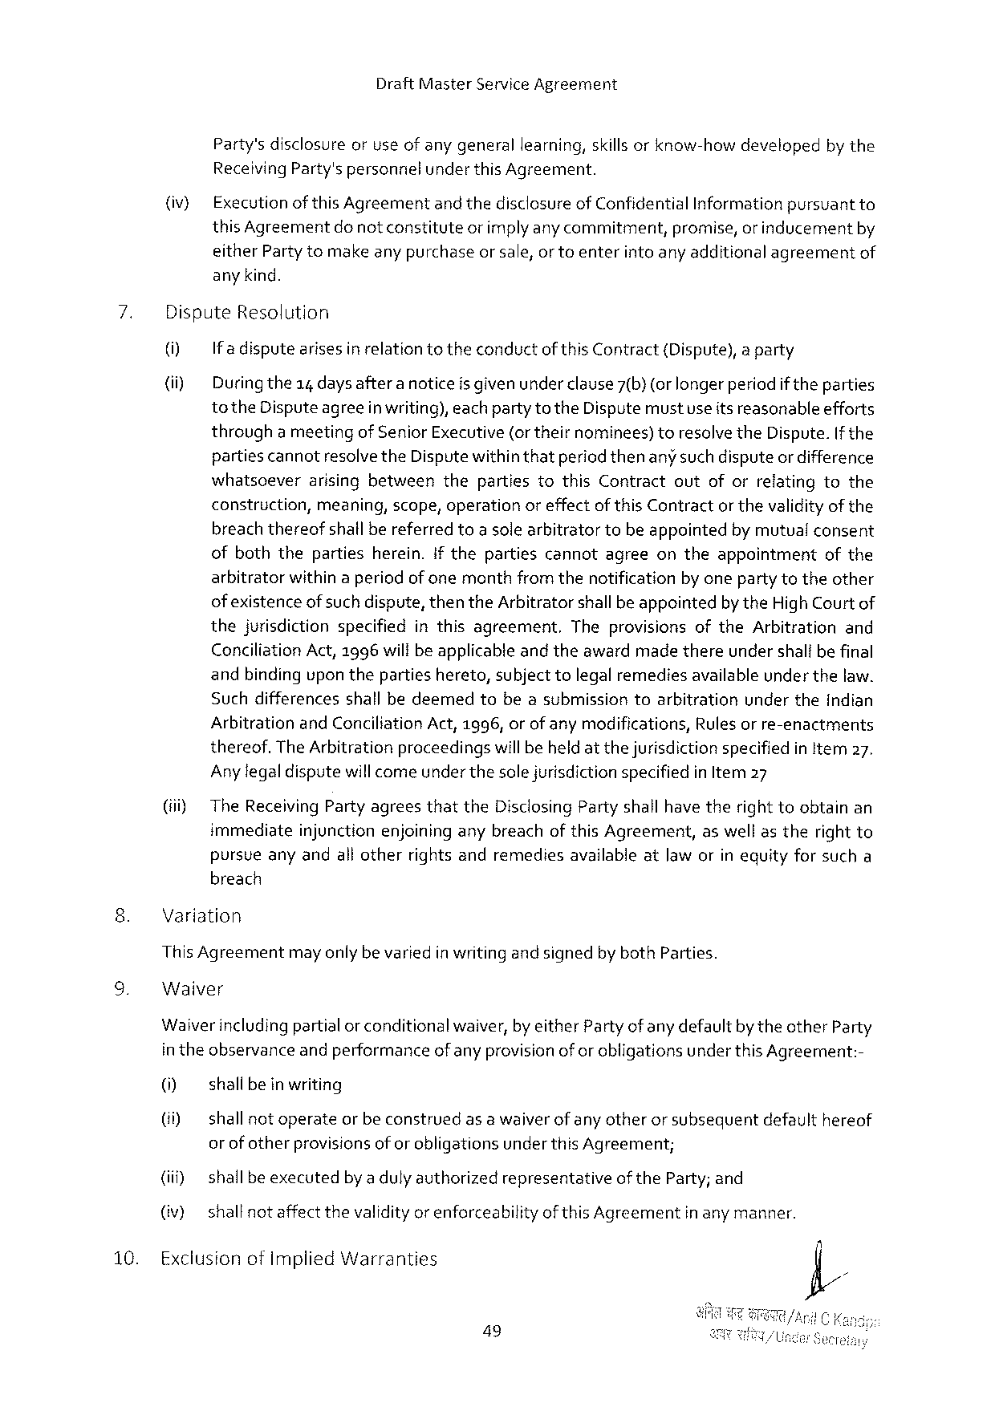

DraftMasterServiceAgreement

Party'sdisclosureoruseof anygenerallearning,skills orknow-howdevelopedby the ReceivingParty'spersonnielunderthis Agreement.

(iv} Executionofthis Agreementand thedisclosureof Confidential Informationpursuantto thisAgreement donotconstitute orimplyanycommitment, promise,or inducement by

eitherPartytomakeany purchaseor sale,or toenterinto any additionalagreementof any kind.

7. DisputeResolution

0] If adisputearises in relationtotheconductof this Contract{Dispute),a party

(ii) Duringthe14 days aftera noticeis given under clause7(b) (orlonger periodif theparties to theDisputeagreein writing),eachparty totheDisputemustuseitsreasonableefforts througha meetingof SeniorExecutive(ortheirnominees)toresclve theDispute.If the partiescannotresolvetheDisputewithinthatperiodthenany such disputeor difference whatsceverarisingbetweenthepartiestothisContractoutoforrelatingtothe construction,meaning,scope,operationoreffectofthis Contractorthevalidityof the breachthereofshallbereferredtoa solearbitratortobeappointedby mutualconsent ofboththepartiesherein.if thepartiescannotagreeontheappointment ofthe arbitratorwithin aperiodof onemonthfrom thenotificationby onepartytotheother of existenceofsuch dispute,thentheArbitratorshallbeappointedbytheHigh Court of thejurisdictionspecifiedinthisagreement. TheprovisionsoftheArbitrationand ConciliationAct,1996wiltbe applicabteand theawardmadethereundershalibefinal andbindingupon thepartieshereto,subjecttolegalremediesavailableunder thelaw. Suchdifferencesshallbedeemedtobeasubmissiontoarbitrationundertheindian ArbitrationandConciliationAct,1996, orof anymodifications,Rulesor re-enactments thereof.The Arbitrationproceedingswill beheldat thejurisdictionspecifiedin ltem27.

Anylegaldisputewillcomeunder thesole jurisdictionspecifiedin Item 27

(i) TheReceivingPartyagreesthattheDisclosingPartyshallhave therighttoobtainan immediateinjunctionenjoininganybreachofthis Agreement,as wellastherightto pursueanyandall otherrightsandremediesavailableatlaw orin equityforsucha breach

Variation

This Agreementmayonlybevariedin writing and signedbybothParties.

Waiver

Waiverincludingpartialorconditionalwaiver,by eitherPartyof any defaultby theotherParty in theobservanceand performanceof anyprovisionof or obligationsunderthis Agreement:-

0] shallbe in writing

(ii) shallnotoperateor beconstruedas awaiverof any otheror subsequentdefaulthereof or ofotherprovisionsof or obligationsunderthisAgreement;

(iii) shallbeexecutedby adulyauthorizedrepresentativeoftheParty; and

(iv) shallnotaffect thevalidityorenforceabilityof this Agreementinany manner.

10. ExclusionofImpliedWarranties

49

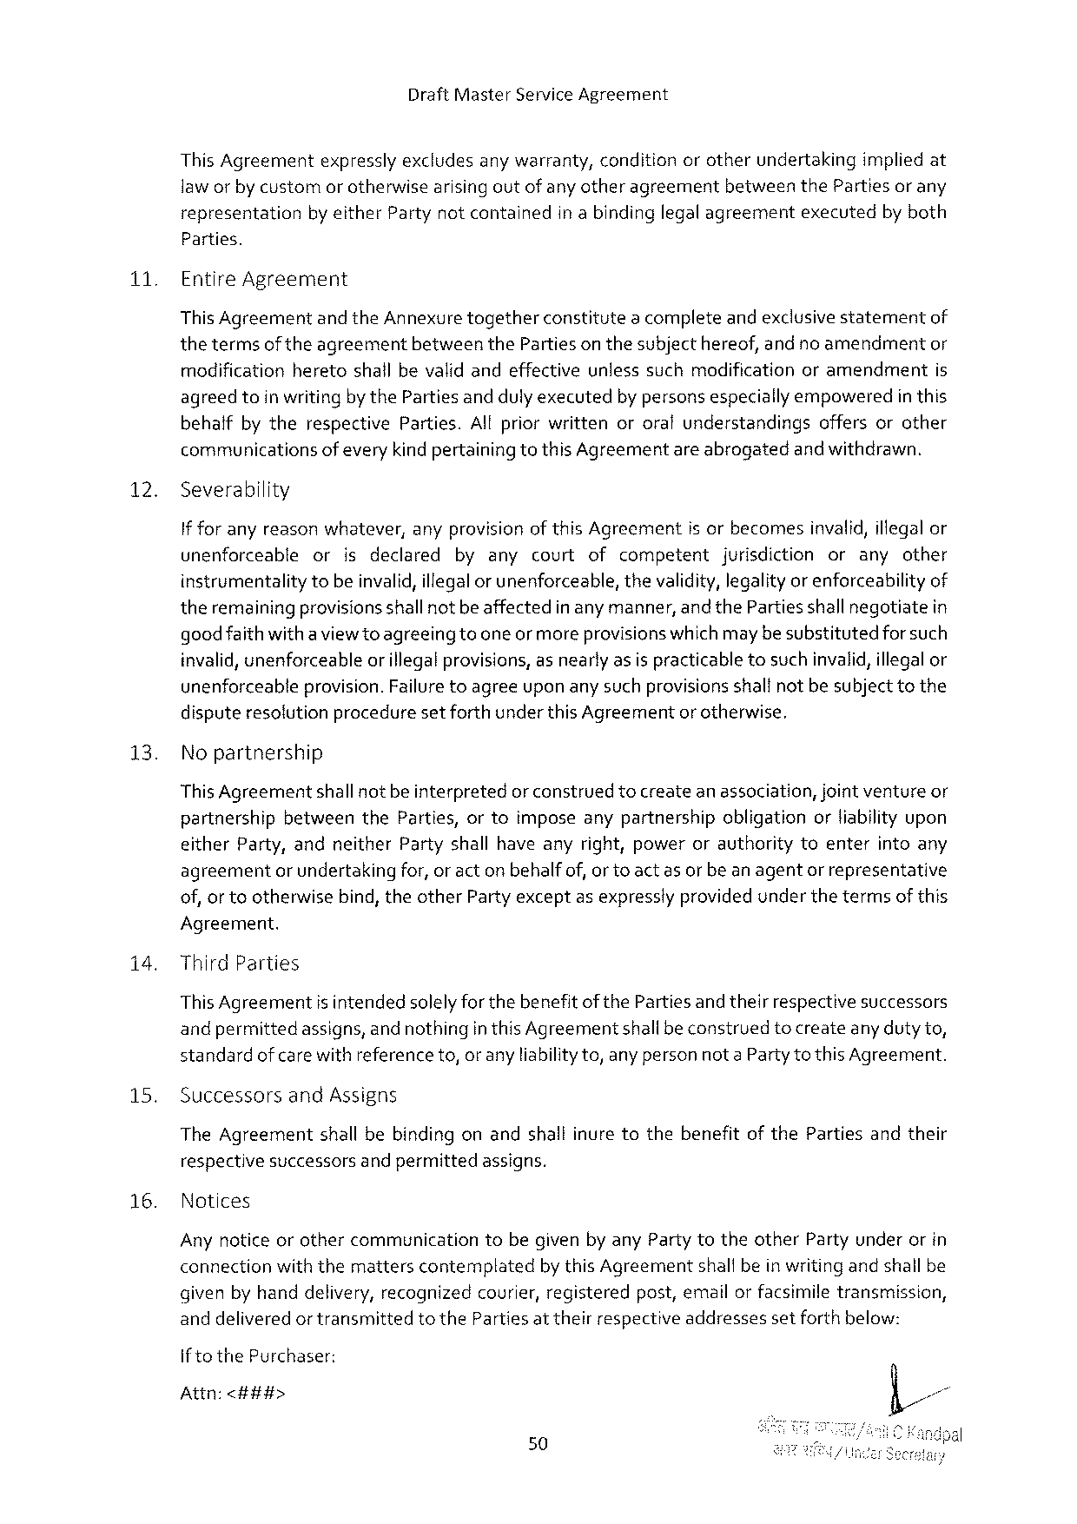

DraftMasterServiceAgreement

ThisAgreement expresslyexcludesanywarranty, condition orotherundertaking impliedat

laworby customorotherwise arisingoutofanyotheragreement between thePartiesorany

representation by either Partynotcontained inabindinglegalagreement executed byboth

Parties.

11 EntireAgreement

This Agreementand theAnnexuretogetherconstitutea completeandexclusivestatementof thetermsof theagreementbetweentheParties on thesubjecthereof,and no amendmentor modificationheretoshallbevalidandeffectiveunlesssuchmodificationoramendmentis agreedtoin writingby theParties andduly executedby personsespeciallyempoweredin this behaifbytherespectiveParties.All priorwrittenororalunderstandingsoffersorother communicationsofevery kindpertainingtothis Agreementare abrogatedand withdrawn.

12. Severability

If foranyreasonwhatever,anyprovision of thisAgreementisorbecomesinvalid,illegalor

|  |  |  |  |  |  |  |
| --- | --- | --- | --- | --- | --- | --- |
| unenforceable | or | isdeclared | byanycourtof | competent | jurisdiction | oranyother |

instrumentalitytobeinvalid,illegalor unenforceable,thevalidity,legalityor enforceabilityof theremainingprovisionsshallnot beaffectedin any manner, andthePartiesshallnegotiatein goodfaith withaviewtoagreeingtooneormoreprovisionswhichmaybesubstitutedforsuch invalid,unenforceableor illegalprovisions,as nearly asis practicabletosuchinvalid,illegalor unenforceableprovision.Failuretoagreeuponany suchprovisionsshalfnot besubjecttothe disputeresolutionproceduresetforthunderthis Agreementor otherwise,

|  |  |  |  |  |  |  |
| --- | --- | --- | --- | --- | --- | --- |
| 13. | Nopartnership | shallnotbeinterpreted | orconstrued | tocreateanassociation, | jointventure | or |
| ThisAgreement |

partnershipbetweentheParties,ortoimposeanypartnershipobligationorliabilityupon eitherParty,andneitherPartyshallhaveanyright,powerorauthoritytoenterintoany agreementor undertakingfor,or act on behalfof, orto act as or beanagentor representative of, or tootherwisebind, theotherPartyexceptas expresslyprovidedunderthetermsof this

Agreement.

i4. ThirdParties

This Agreementis intendedsolelyfor thebenefitof thePartiesand theirrespectivesuccessors andpermittedassigns,and nothingin thisAgreementshallbeconstruedtocreateanyduty to, standardof care withreference to,oranyliability to,anypersonnota Partyto this Agreement.

|  |  |  |
| --- | --- | --- |
| 15. | Successors | andAssigns |

TheAgreementshallbebindingonandshallinuretothebenefitofthePartiesandtheir

|  |  |  |  |  |
| --- | --- | --- | --- | --- |
| 16. | respective | successors | andpermitted | assigns. |
| Notices |

Any noticeorothercommunicationtobegivenby anyParty totheotherPartyunderorin connectionwiththemattersconternplatedbythis Agreementshallbein writing andshall be givenbyhanddelivery,recognizedcourier, registeredpost,emailor facsimiletransmission, anddeliveredor transmittedtotheParties at theirrespectiveaddressessetforthbelow:

if to thePurchaser:

Attn:<###>

50

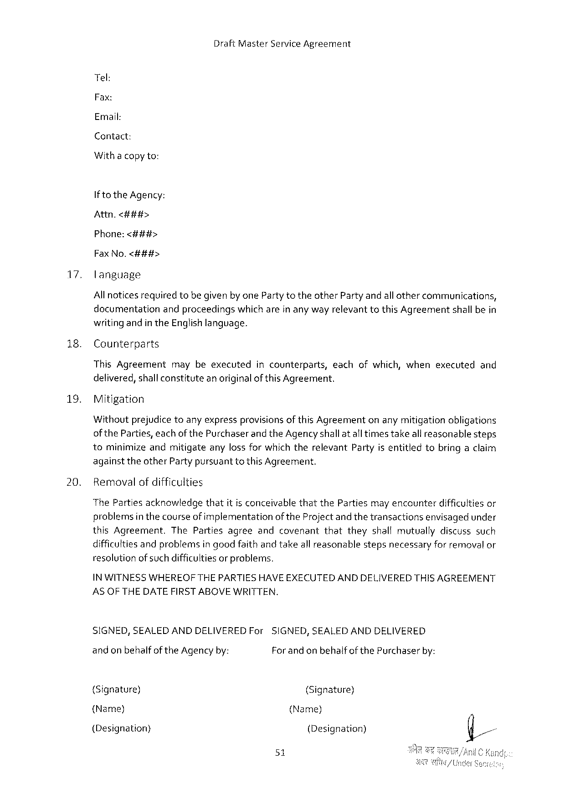

DraftMasterServiceAgreement

Tel:

Fax:

Email:

Contact:

Withacopyto:

Ifto theAgency:

Attn.<##i#>

Phone:<###>

FaxNo.<###>

17. language

Allnoticesrequiredtobe givenby onePartytotheotherParty andallothercommunications, documentationandproceedingswhich arein any wayrelevanttothisAgreementshall bein writing andin theEnglishlanguage.

|  |  |  |  |  |
| --- | --- | --- | --- | --- |
| 18. | Counterparts | maybeexecuted | incounterparts, | eachofwhich,whenexecutedand |
| ThisAgreement |

delivered,shallconstitutean originalof this Agreement.

19. Mitigation

Withoutprejudicetoanyexpressprovisionsof thisAgreementonanymitigationobligations of theParties,eachofthe PurchaserandtheAgencyshallat altimestakeall reasonablesteps tominimizeandmitigateanylossfor whichtherelevantPartyis entitledtobringaclaim againsttheotherPartypursuanttothis Agreement.

20. Removalof difficulties

ThePartiesacknowledgethatit isconceivablethatthePartiesmay encounterdifficulties or problemsin thecourseof implementationof theProject and thetransactionsenvisagedunder thisAgreement.ThePartiesagreeandcovenantthattheyshallmutuallydiscusssuch difficultiesandproblemsin goodfaithand takeallreasonablestepsnecessaryforremoval or resolutionofsuch difficultiesor problems.

IN WITNESSWHEREOFTHEPARTIESHAVEEXECUTEDAND DELIVEREDTHISAGREEMENT ASOFTHE DATE FIRSTABOVE WRITTEN.

SIGNED,SEALEDANDDELIVEREDFor andonbehalf of theAgency by:

SIGNED,SEALEDANDDELIVERED For and on behalfof thePurchaserby:

{Signature) (Signature)

(Name) (Name)

(Designation) (Designation)

51



DraftMasterServiceAgreement

|  |  |  |
| --- | --- | --- |
| (Address) | (FaxNo.) | (Address) |
| (FaxNo.) | (Signature) |
| (Signature) |

Inthepresenceof:

I

2.

52